Supplementary Information

A: The NAVIGATE inequality dataset at the income decile level for use in IAMs
A standardized input data template has been defined and data has been collected using household surveys from a number of developed and OECD countries.
Available countries (for the latest year, between 2008 and 2017, available):
- India, Brazil, France, South Africa, United States of America, China, Mexico
- 26 EU member states based on a common survey.
The data is all structured around income deciles. Units of observations for the deciles are households. The OECD modified equivalence scale has been applied to compute household income per person. (1 plus 0.5 per adult (older than 14 years) and 0.3 per child (14 or less years)). Note this definition differs slightly from the OECD’s original definition where adults are 14 years and older. This has been chosen since many demographic projections report populations by age cohorts of five years, so we consider 15+ years old as adults.
Available variables (all for deciles D1 to D10):
- Income share
- Expenditure share
- Expenditure share in
  - Energy for Transportation
  - Energy for Housing
  - Food
- Education of the household head
- Average savings rate
- Household size
- Income by type (labour, capital, transfers, other)
- Wealth share (where available)
The dataset is available at https://github.com/witch-team/NAVIGATE-inequality-dataset.

The energy expenditure shares for housing and transportation are key variables for IAMs, and here the expenditure shares across countries, which show a strong regressive pattern for residential energy consumption while for transportation it appears in most countries to be progressive.
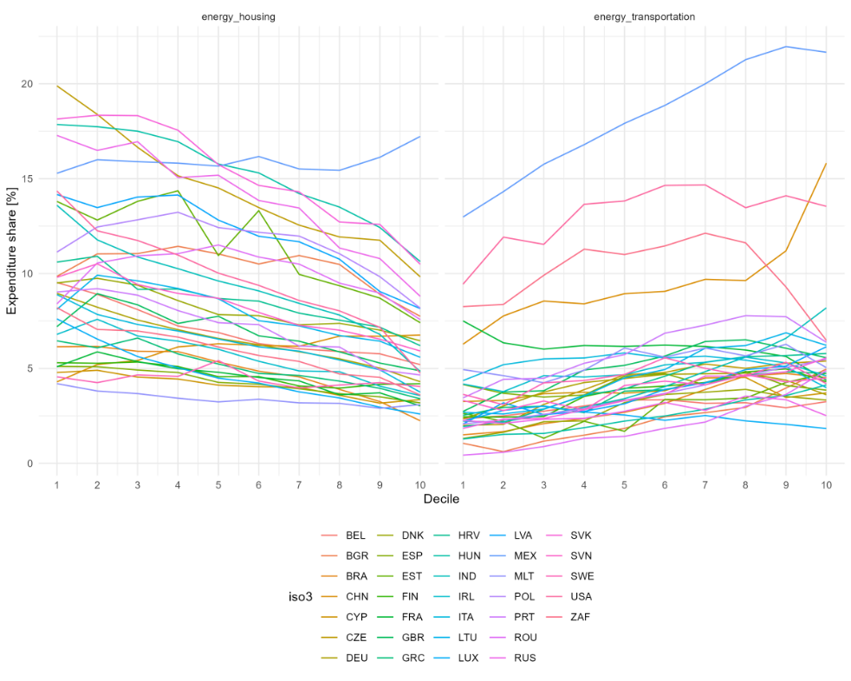

Household survey data sources:
- Brazil: Consumer Expenditure Survey from IBGE (2009): “Pesquisa de Orçamentos Familiares 2008-2009 - Despesas, Rendimentos e Condições de Vida,”Technical report, Rio de Janeiro, Brazil, for the year 2008. Retrieved from https://portaldeboaspraticas.iff.fiocruz.br/biblioteca/esquisa-de-orcamentos-familiares-2008-2009/
- Mexico: 2018 wave, National Survey of Household Income and Expenditure (ENIGH). The National Institute of Statistics, Geography and Informatics (INEGI). Retrieved from https://en.www.inegi.org.mx/programas/enigh/nc/2018/
- Russia: 2019 wave, Russia Longitudinal Monitoring Survey (RLMS-HSE). Higher School of Economics and ZAO “Demoscope” together with Carolina Population Center, University of North Carolina at Chapel Hill and the Institute of Sociology RAS. Retrieved from https://rlms-hse.cpc.unc.edu
- India: 2012 wave, National Sample Survey 2011-2012 (68th round) - Consumer Expenditure. Ministry of Statistics & Programme Implementation, Government of India. Retrieved from http://microdata.gov.in/nada43/index.php/catalog/1
- China: Chinese Household Income Project, 2013 wave (CHIP) – CHIP Dataset Homepage. Retrieved from http://www.ciidbnu.org/chip/index.asp
- United States of America: US Consumer Expenditure Surveys, 2019 wave (CE) - Consumer Expenditure Surveys Public Use Microdata (PUMD). Retrieved from https://www.bls.gov/cex/pumd.htm
- South Africa: South Africa National Income Dynamics Study, waves 1-5 (NIDS) - NIDS Data Access. Retrieved from http://www.nids.uct.ac.za/nids-data/data-access
- EU member states: EUROSTAT Household Budget Surveys (HBS) for all EU member states (plus Serbia and the United Kingdom), latest full wave from 2010, Retrieved from https://ec.europa.eu/eurostat/web/household-budget-surveys/overview
- France: Household Budget Survey (Budget de Famille, BdF) from INSEE for the year 2011, Retrieved from: https://www.insee.fr/fr/statistiques/2015691

C: Implementation of inequality in the different models
AIM: AIM implements the consumption distribution assessment by soft-linking a poverty, household and income distribution modelling tool called the AIM/PHI to a CGE model (AIM/Hub). The poverty, household, and income distribution modelling tool embody a lognormal assumption and a nonlinear demand system (Fujimori, Hasegawa and Oshiro, 2020; Zhao et al., 2022). The lognormal distribution captures the national average household consumption in the CGE and matches the Gini projections by Rao et al. (2019). The distributional effects of climate policies are introduced by passing the commodity prices to the AIDADS model, where the household consumption patterns in each country are calibrated to global and national household consumption survey databases. Carbon tax revenues redistribution is modelled in the CGE as a lump-sum transfer to the representative household, but the redistribution is then altered in the poverty, household, and income distribution modelling tool.

E3ME: In E3ME-FTT, the GINI coefficient is computed from disposable incomes before social transfers. The method is expenditure-based and does not include differential changes in sectoral employment. A further limitation is that the method does consider how income groups differ in their response to higher (energy) prices, for instance by insulating homes. The data for EU countries is based on equivalized disposable income before social transfers from Eurostat, whereas data outside of the EU is based on World Bank development indicators.

GEM-E3: In GEM-E3, the Gini index is computed from disposable incomes before social transfers. The method to represent multiple households in GEM-E3 is based on the soft-linkage of the standard CGE model with a single representative household with a satellite module with multiple households (representing ten income deciles), through a sequential exchange of prices, incomes and demands until an equilibrium is established (Fragkos et al., 2021). The satellite module is first calibrated using the aggregate consumption, wage and non-wage income, population and labour demand and supply of the GEM-E3 model and the distribution data by decile. Then, GEM-E3 projects total income, sectoral production, end-user prices and demand for skills until 2050. Total wage and non-wage income, transfers, prices of goods and services, wages by skill and skill requirements are passed on to the satellite model to compute the income and consumption for income deciles and estimate the impacts on different households. Then, the consumption by decile is aggregated to the single representative household and is plugged into GEM-E3 where a new set of prices and wages are computed. This loop continues until the change in prices and demand is below a certain threshold ensuring general equilibrium. The satellite model aggregates households in 10 income classes with different income sources, consumption and saving patterns. The equivalized household size by decile and the type of labour skills supplied by each decile are assumed to remain constant. The link between skills, sectoral activity and income deciles depends on the skills acquired by each household and the evolution of sectoral production. The analysis of climate policy impacts on energy poverty may require a finer resolution of individual households to capture the effects at the tales of the distribution, but data are not available at more granular level (Fragkos et al., 2021).

Imaclim: In Imaclim, we calibrate baseline deciles over time using country income Gini projections until 2100 in the SSP2 scenario, as provided by (Rao et al., 2019), and using GDP and population data for year 2014 from the World Bank Development Indicators database (GDP is expressed in constant 2015 USD, population in number of individuals). We assume that for each country, income is distributed across deciles according to a lognormal distribution. We can deduce standard deviations from country Gini indices, and then a Lorenz curve for each country and each time step. The Lorenz curve represents the share of overall income, consumption or wealth detained as a function of the cumulative share of the population. We then aggregate country Lorenz curves into regional Lorenz curves, following the regional definition of the model (12 world regions in the case of Imaclim). In the case of country regions (US, Canada, India, China, Brazil), we directly use the Lorenz curves deduced from the income Gini indices available in (Rao et al., 2019). The regional consumption deciles obtained from the calibration are then fed into the model. They are modified depending on the climate scenario considered. Mitigation costs and carbon tax burdens are distributed across deciles using consumption elasticities. The initial burden of a carbon tax is the distribution of mitigation costs and carbon tax payments before tax revenues are recycled and redistributed. We follow the approach of (Budolfson et al., 2021) and write total consumption $C_{rjt}$ of decile j in region r and at date t as$C_{rjt}=C_{rt}^{gross}⋅q_{rjt}-C_{rt}^{gross}⋅λ_{rt}⋅τ_{rjt}+E_{rt}⋅tax_{t}⋅δ_{rjt}$. The first term is total gross consumption of decile j. Total baseline (gross) consumption of region r at date t is noted $C_{rt}^{gross}$. The second term is the mitigation cost. The third term is tax repayment. $E_{rt}$ is the emissions from region r at date t, $E_{rt}⋅tax_{t}$ is the carbon tax revenue from region r at date t. Within each country, mitigation costs (i.e., the initial burden) are assumed to be distributed across deciles using the same consumption elasticity for a given country at a given time ($τ_{rjt}$). Consumption elasticities of the initial burden depend on regional GDP per capita at each time step and are calibrated using the estimation provided in (Budolfson et al., 2021), which the authors derive from a review of the literature on the initial burden of carbon taxation across countries before the redistribution of tax revenues. The distributional weights $τ_{rjt}$ are calculated as a function of the consumption elasticity of the initial burden $w_{r,t}$ as (recall that $n_{q}$ is the number of quantiles) $τ_{rjt}=n_{q}⋅q_{rjt}^{w_{rt }}/ \sum_{k}{q_{rkt}^{w_{rt}}}$.
Finally, the value of $δ_{rjt}$ determines the mode of carbon tax revenue recycling. If we set $δ_{rjt}=0$, the recycling of carbon tax revenues does not alter the initial burden distribution, and we have $C_{rjt}=C_{rt}^{gross}⋅q_{rjt}-C_{rt}^{gross}⋅λ_{rt}τ_{rjt}$. If we set $δ_{rjt}≠0$, the recycling of carbon tax revenues alters the initial burden distribution, and we have $C_{rjt}=C_{rt}^{gross}⋅q_{rjt}-C_{rt}^{gross}⋅λ_{rt}τ_{rjt}+E_{rt}⋅tax_{t}⋅δ_{rjt}$.
In the case of equal per capital recycling, we set $δ_{rjt}=\frac{1}{n_{q}}$.

NICE: We use the same calibration steps as described in the case of Imaclim (above) to obtain baseline consumption deciles over time in the NICE model. The regional consumption deciles obtained from the calibration are then fed into the model. Again, as in (Budolfson et al., 2021), mitigation costs and carbon tax burdens are distributed across deciles using consumption elasticities. The initial burden of a carbon tax is the distribution of mitigation costs and carbon tax payments before tax revenues are recycled and redistributed. The modelling steps are described in the methods section of (Budolfson et al., 2021). We assume that, within a region, the mitigation costs and the tax payments are distributed according to the same weights across deciles. Using the same notations as above, we write total consumption of decile j in region $r$ at date $t$ as $C_{rjt}=C_{rt}^{gross}⋅q_{rjt}-C_{rt}^{net}⋅D_{rt}⋅d_{rjt}-C_{rt}^{gross}⋅λ_{rt}⋅τ_{rjt}-E_{rt}⋅tax_{t}⋅τ_{rjt}+E_{rt}⋅tax_{t}⋅δ_{rjt}$. $C_{rt}^{net}⋅D_{rt}⋅d_{rjt}$ is the damage cost of decile j of region r at date t. Carbon tax revenues are either refunded within each region according to the distribution of the initial burden ($δ_{rjt}=τ_{rjt}$) or are distributed equally per capita within each region ($δ_{rjt}=\frac{1}{n_{q}}$).

ReMIND: ReMIND implements the consumption distribution using a log-normal assumption. The distribution in each region is calibrated so that average consumption matches a baseline SSP2 consumption path and future inequality matches the Gini projections by Rao et al. (2019). The effects of climate policy, redistribution and climate impacts on the consumption distribution is then calculated via changes in energy expenditure compared to the baseline, carbon tax revenue redistribution and the effects of climate damages. The resulting new average consumption is distributed keeping with the log-normal assumption. The elasticity of energy expenditures is estimated through an empirical approach, described in Soergel et al. (2021). The elasticity of damages is assumed to be 0.5.

RICE50+: We implemented income deciles based on a baseline specification based on (Rao et al., 2019), and climate policy costs and climate impacts are distributed from the macrolevel among household deciles based on income elasticities as described in (Emmerling, Andreoni and Tavoni, 2023): Policy costs, computed using calibrated marginal abatement cost curves, are distributed using an elasticity that varies with GDP per capita as estimated in (Budolfson et al., 2021), while impacts, that are computed used the damage function of (Kalkuhl and Wenz, 2020) are distributed using an elasticity of 0.5.

WITCH: The WITCH model implemented the climate policies based on its bottom-up energy system model including land-use coupling with GLOBIOM. The model results are then in terms of energy expenditures, energy prices, and GDP fed into a soft-coupled “inequality module” used also in (Emmerling and Malerba, 2022), where a dynamic household optimization problem is solved using the inequality dataset described in part A and taking into account energy expenditures, wealth inequality, heterogeneous wages, returns on capital, and savings, resulting in an endogenous distribution of income and consumption consistent with the macroeconomic results from WITCH.

B: Additional results and figures
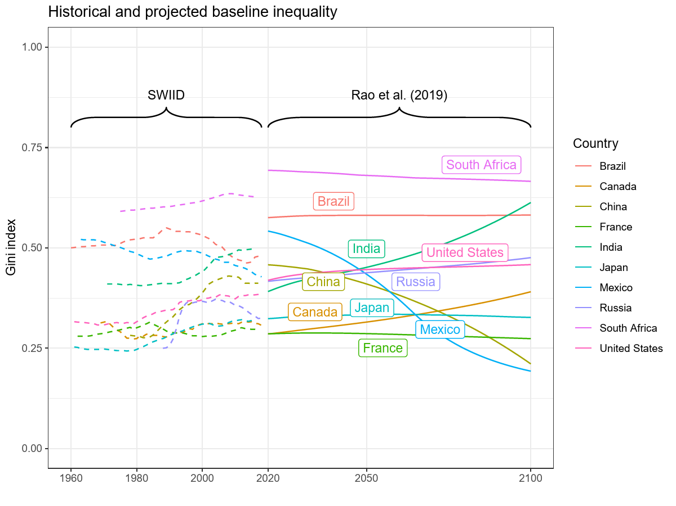
Figure 5: The Gini index of income inequality in the countries of this study. Dashed lines show the historical values based on the Standardized Income Inequality Database (SWIID) and the solid lines the baseline SSP2 projections from Rao et al. (2019).

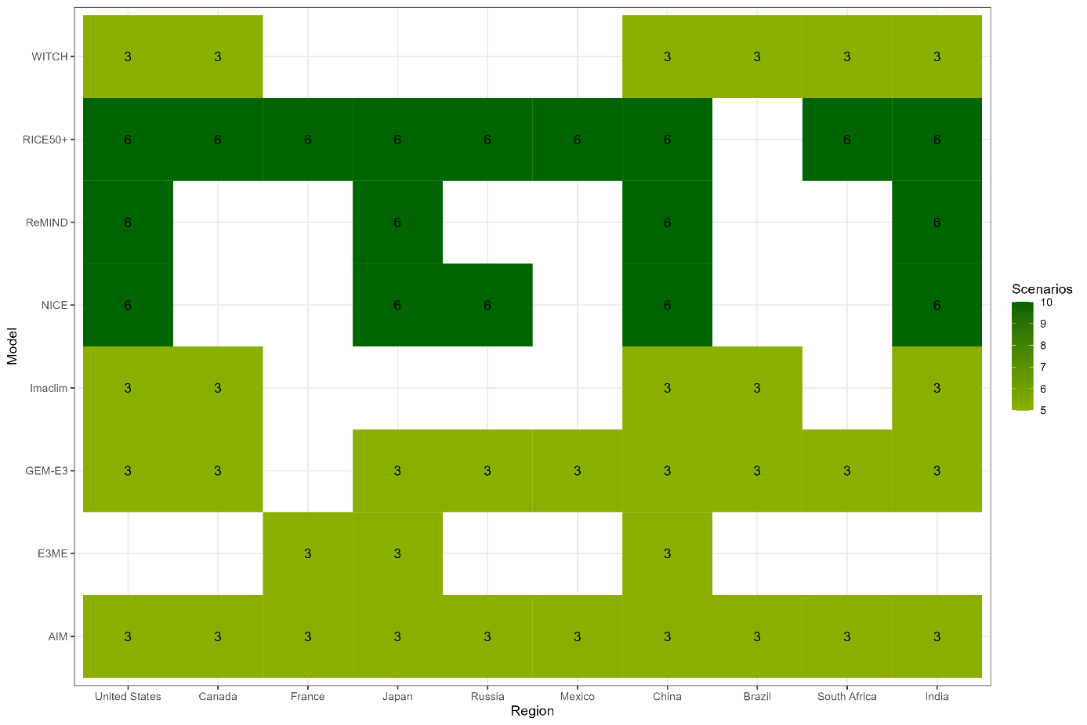
Figure 6: Models and regional coverage of the data used in this analysis

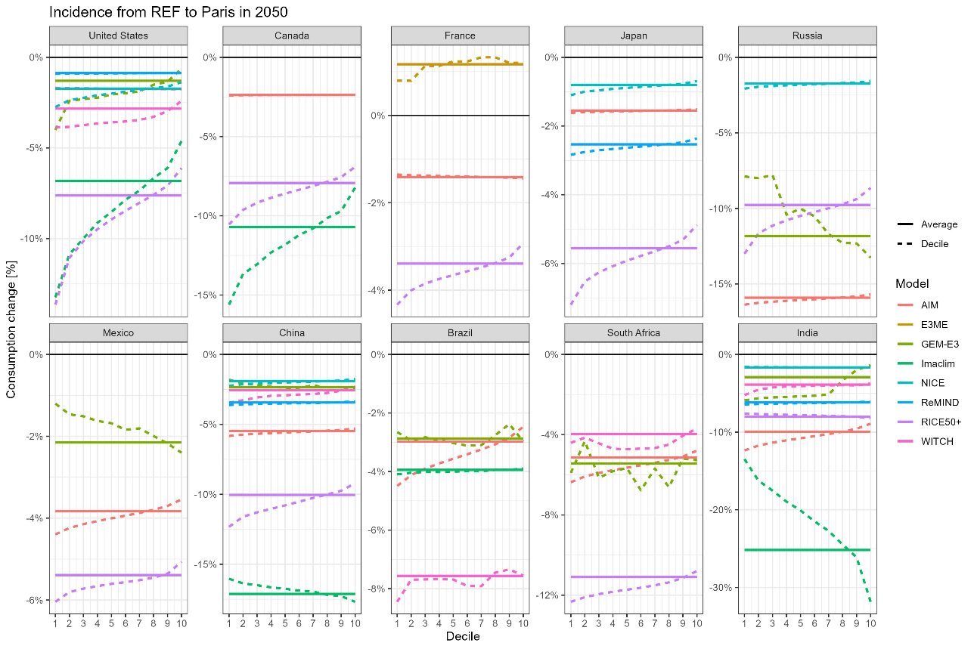
Figure 7: Average policy cost and incidence curves, Paris vs. REF scenario

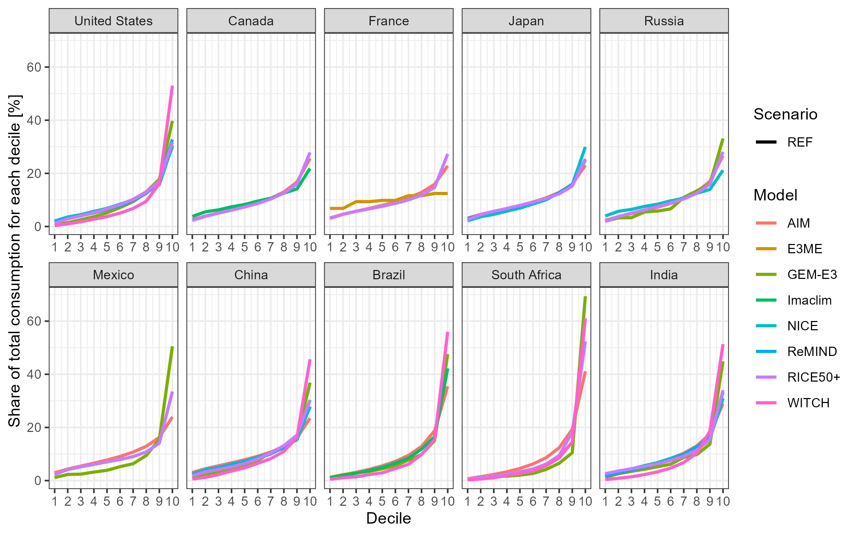
Figure 8: Consumption share for income deciles across countries in 2050

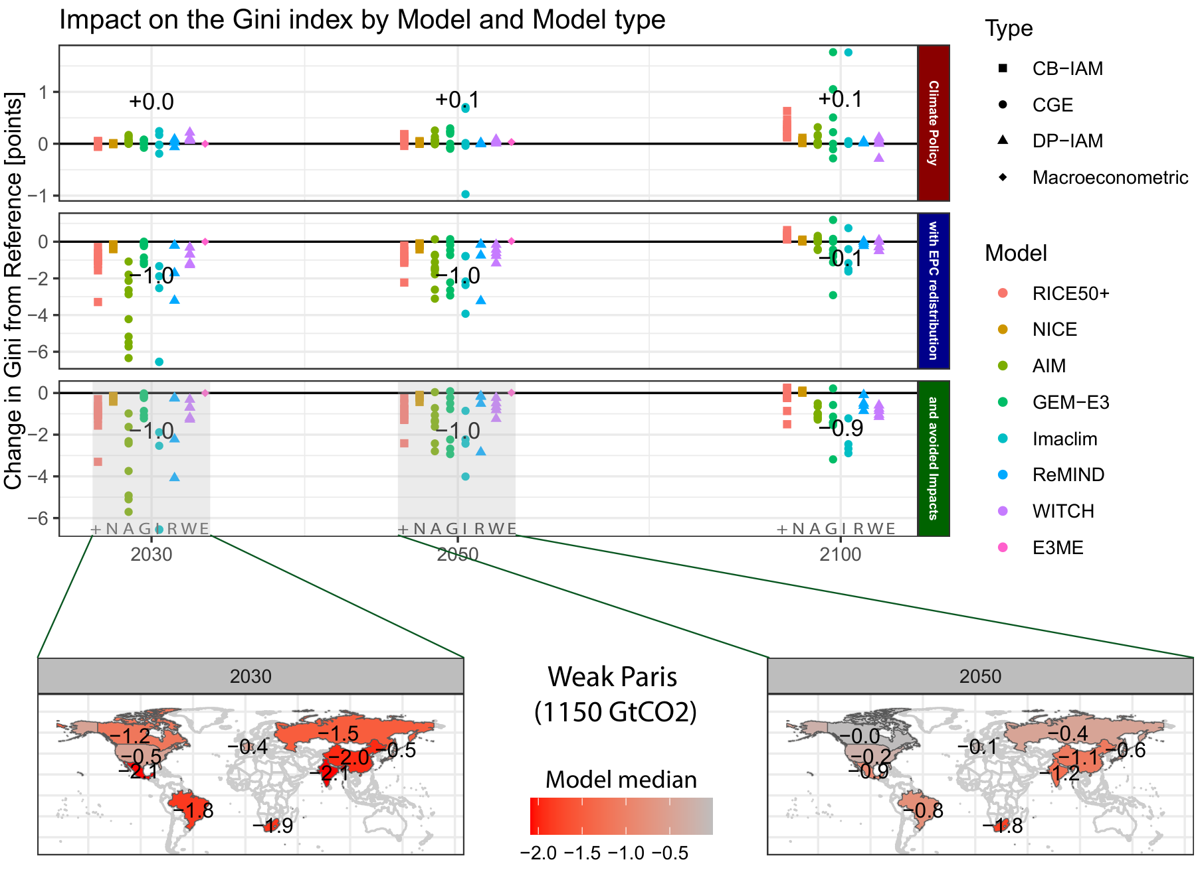
Figure 9: Gini impact for the Weak Paris set of scenarios (1150 GtCO₂)
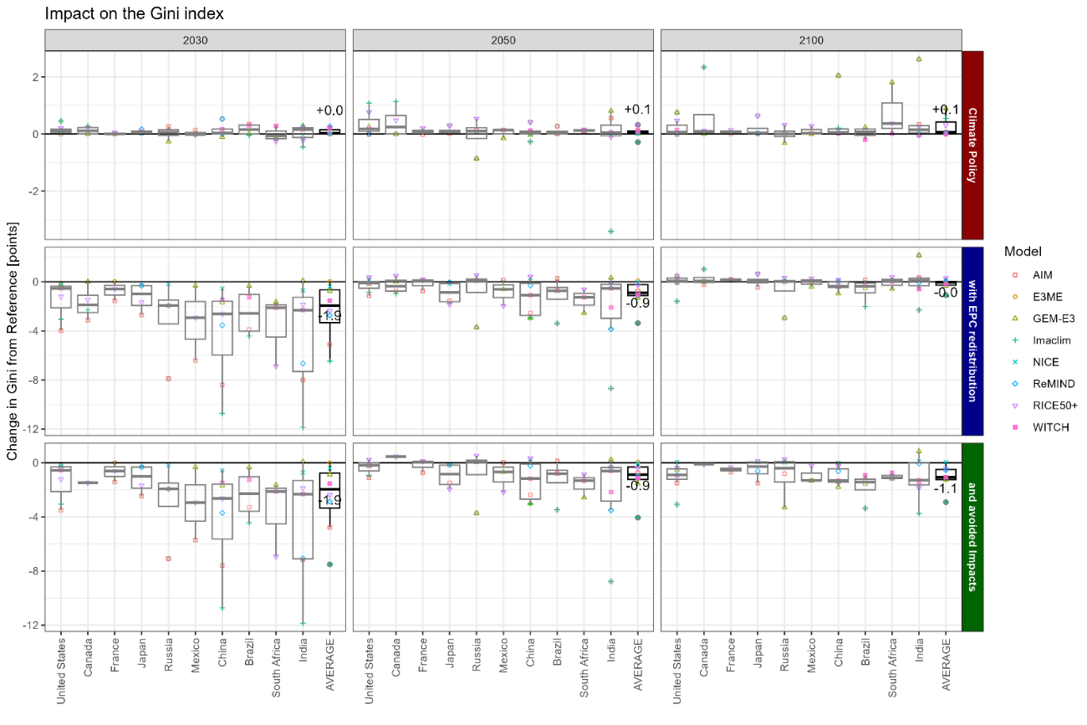
Figure 10: Country-specific change in the Gini index from the reference scenario (in points), in the Paris scenario. Top row shows the impact of climate policy with neutral redistribution, middle row includes equal per capita redistribution, bottom row includes avoided climate impacts.

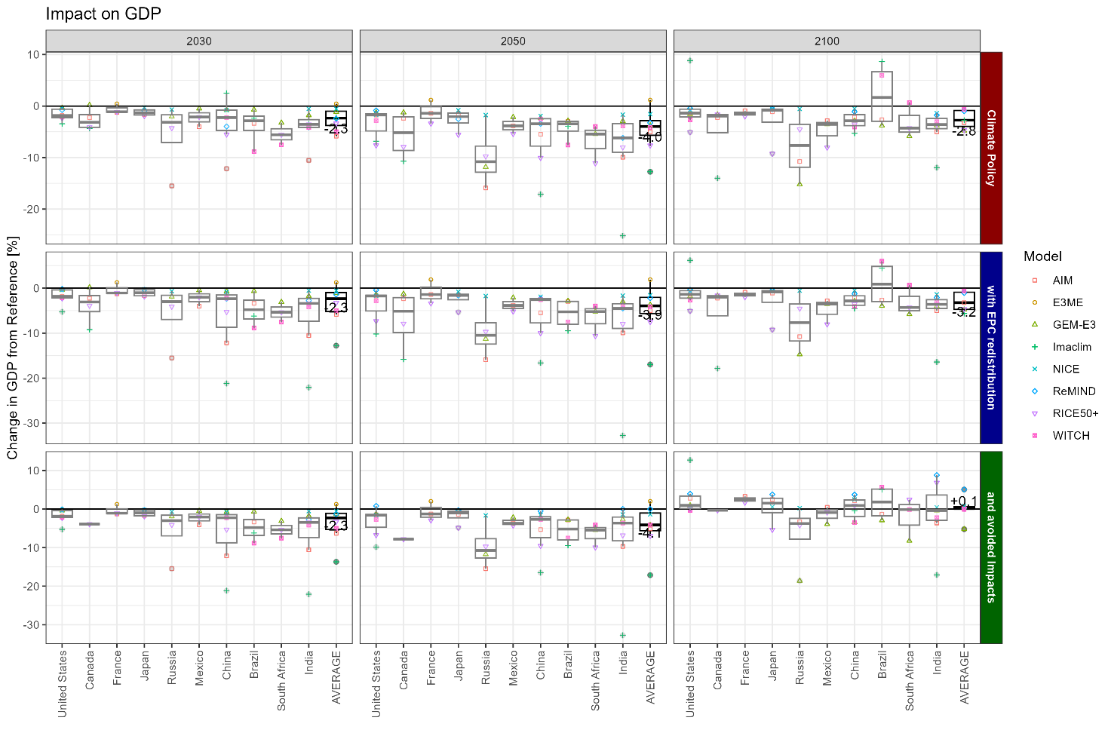
Figure 11: Country-specific Policy Cost in terms of GDP loss from the reference scenario (in %), in the Paris scenario. The top row shows climate policy with neutral redistribution, the middle row includes equal per capita redistribution, the bottom row includes avoided climate impacts.

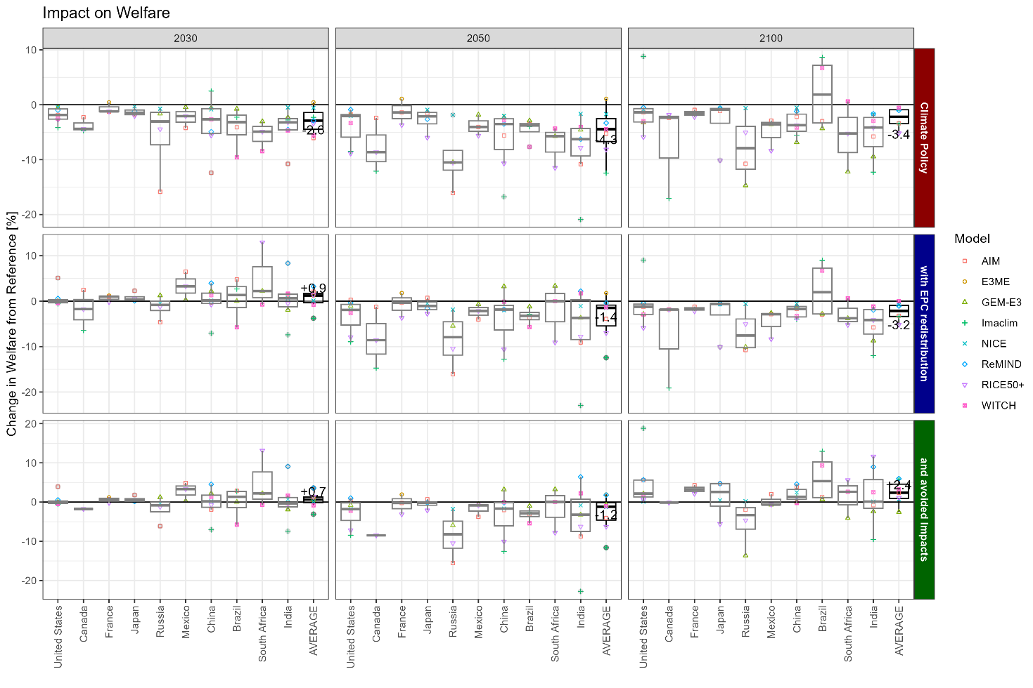
Figure 12: Country-specific welfare impact based on the Sen welfare function (in %), in the Paris scenario. The top row shows climate policy with neutral redistribution, the middle row includes equal per capita redistribution, the bottom row includes avoided climate impacts.

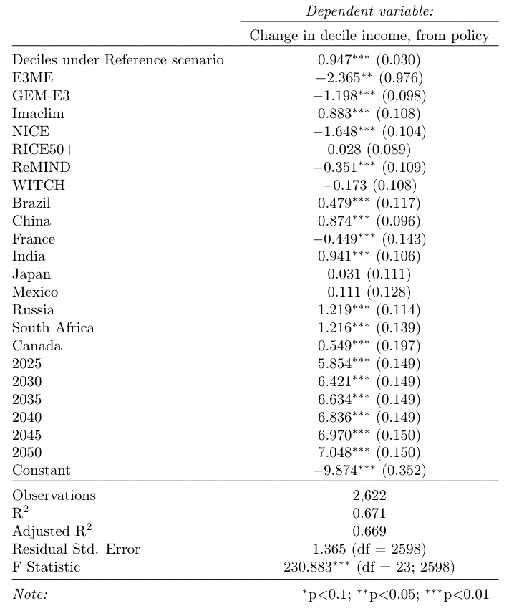
Table 2: Regressions of the pooled sample to estimate the income elasticity of climate policy incidence. The reference category is the United States, the AIM model, and the year 2020.

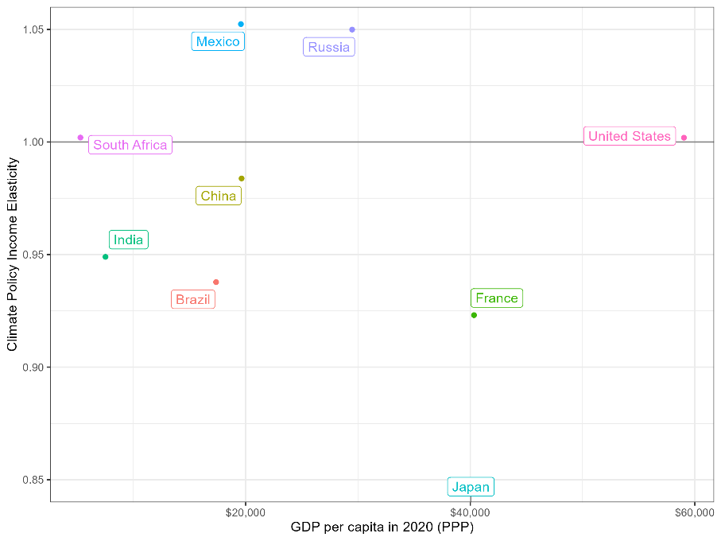
Figure 13: Estimated income elasticity of climate policy incidence per country, the x-axis shows the GDP per capita in 2020.
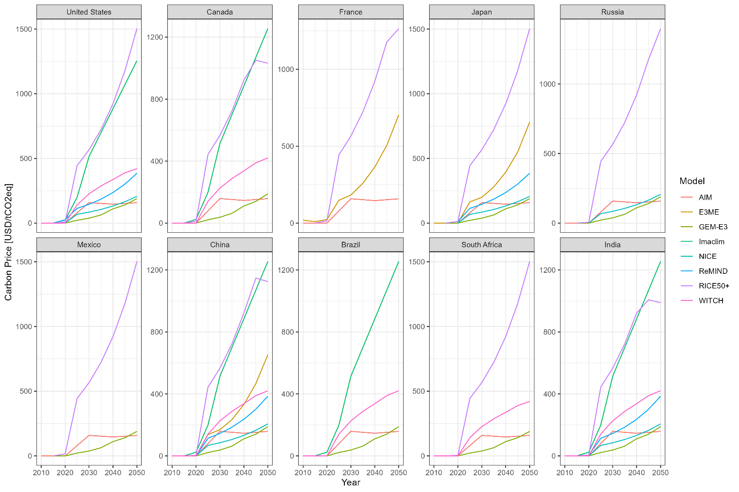
Figure 14: Carbon prices in the Paris scenario over time
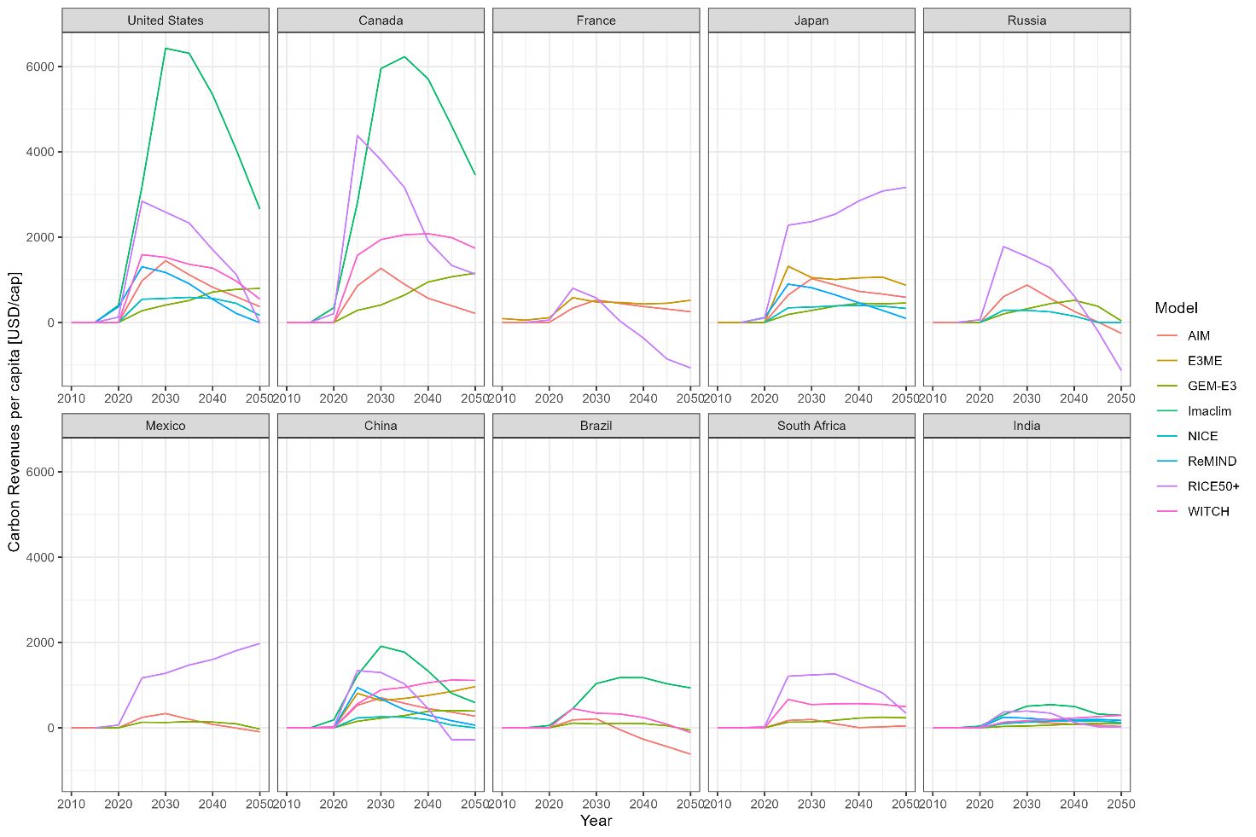
Figure 15: Carbon revenues in the Paris scenario over time (per capita)
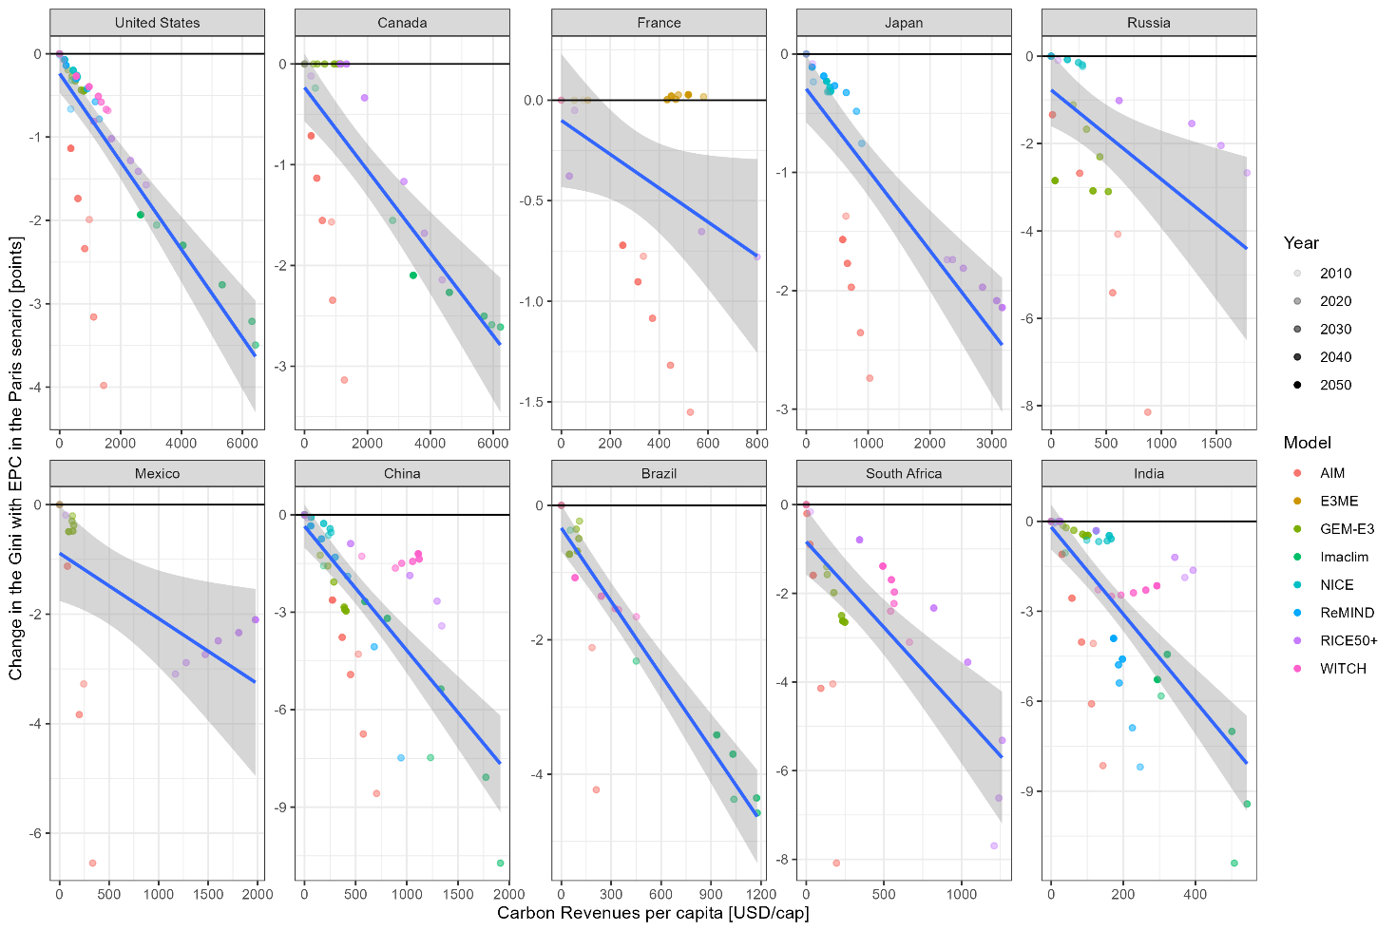
Figure 16: Carbon revenues and the impact on the Gini index (Paris scenario). blue lines indicate country-specific linear regression line.

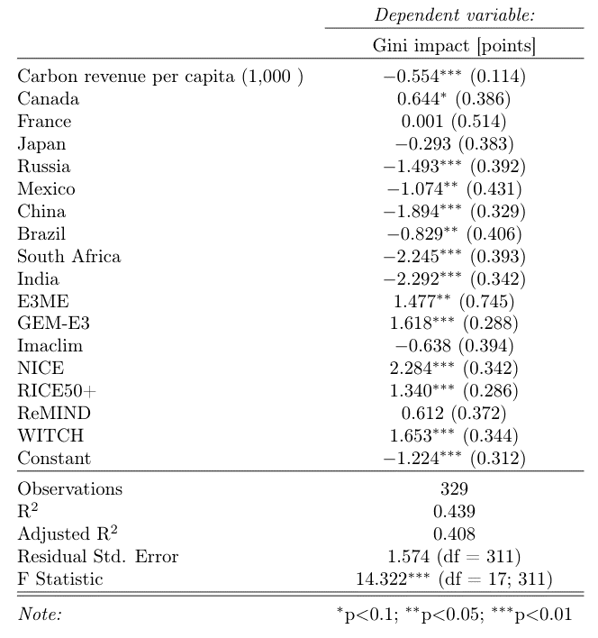
Table 3: Regression of the Gini impact of equal per capita redistribution on carbon revenue per capita, model and region (Paris to Paris with equal per capita redistribution scenario). The reference category is the AIM model.

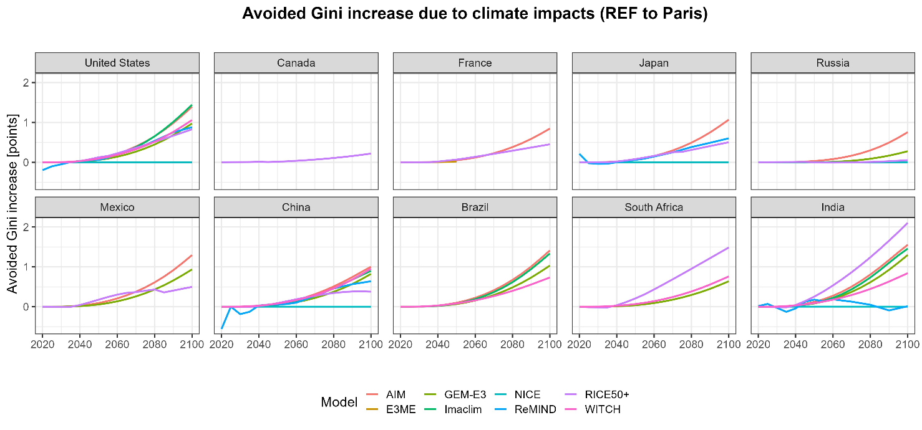
Figure 17: Gini index change [points] due to climate impacts between the Paris and REF scenarios

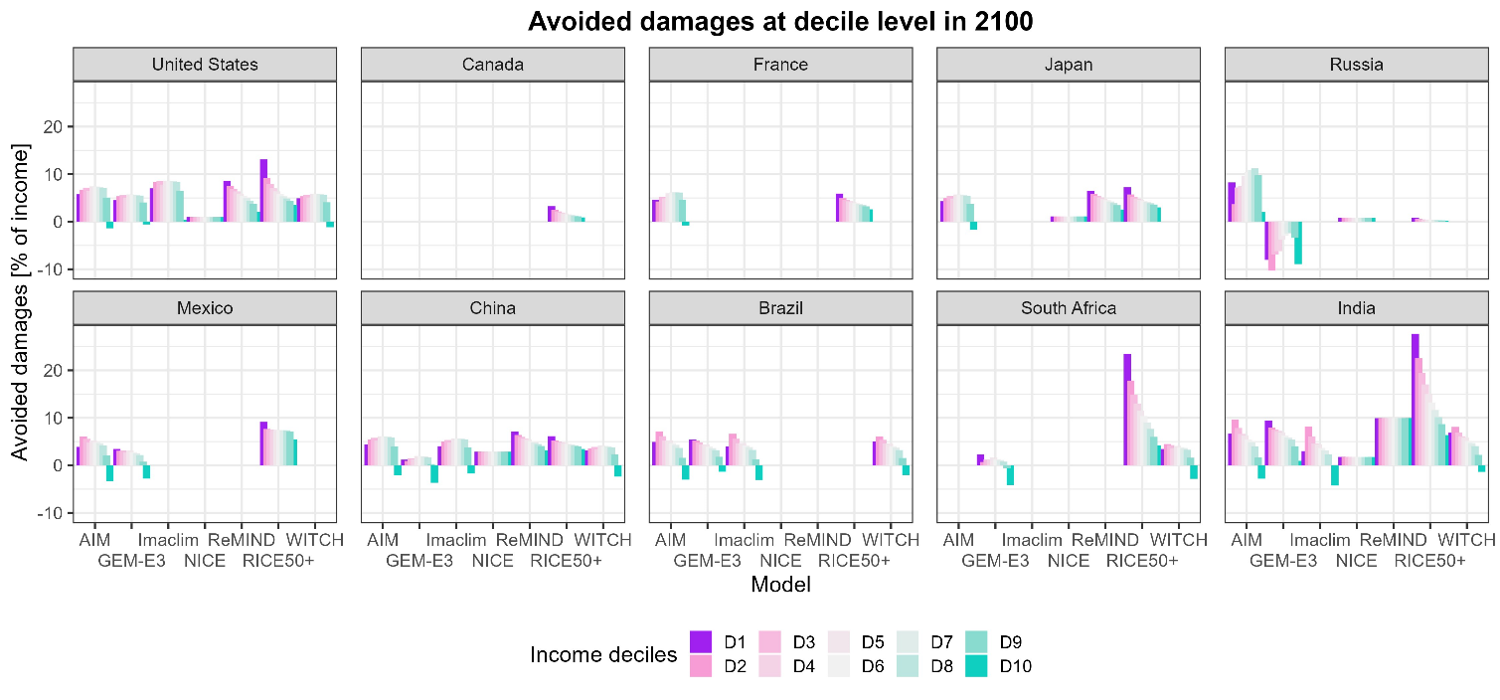
Figure 18: Avoided impacts at the decile income level in 2100

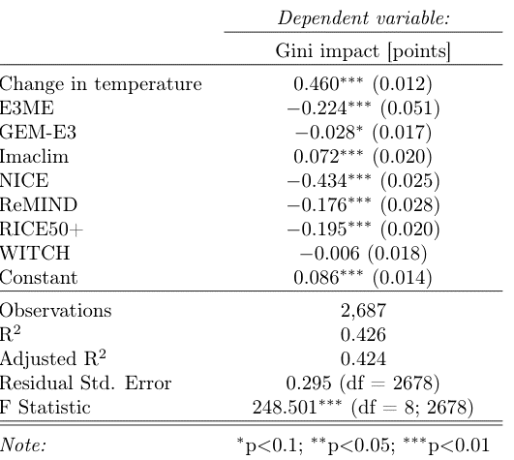
Table 4: Regression of the Gini impact of climate impacts on the change in country-level temperature and model (ref to ref with impacts). The reference category is the AIM model.

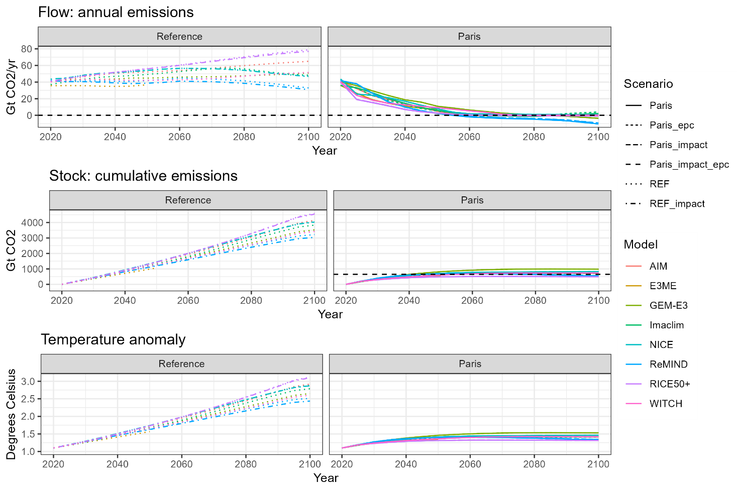
Figure 19: Global emissions and temperature change

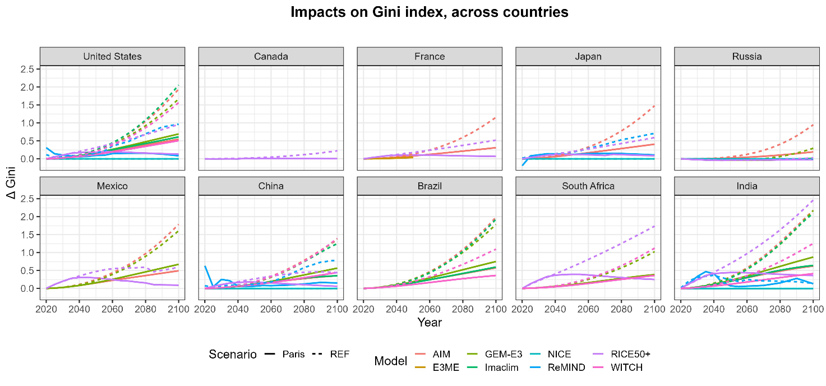
Figure 20: Aggregated impacts on the Gini index based on decile-based damage functions

