Supplementary Material Figure 1: Flowchart
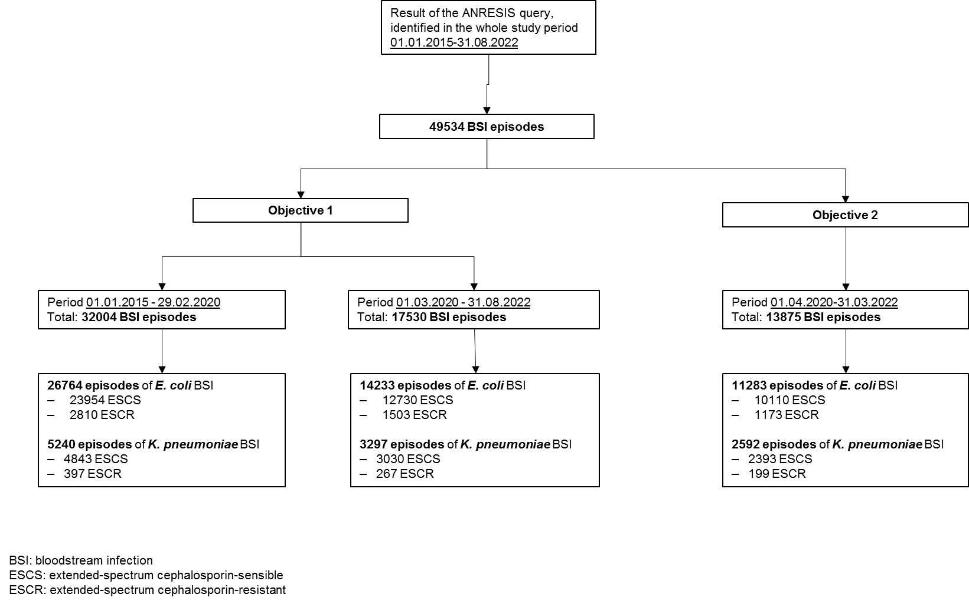

Supplementary Material Table 1: Baseline characteristics of the included patients (pandemic period only, 01.04.2020-31.03.2022)
Baseline characteristics | E.coli ESCR  N = 1,173 | E.coli ESCS  N = 10,110 | K. pneumoniae ESCR  N = 199 | K. pneumoniae ESCS  N = 2,393
Female gender | 541 (46%) | 5,319 (53%) | 70 (35%) | 837 (35%)
Age (median, IQR) | 75 (60, 80) | 75 (60, 80) | 65 (55, 75) | 70 (60, 80)
Latin Region | 423 (36%) | 3,153 (31%) | 79 (40%) | 761 (32%)
Departement
ICU | 51 (4.3%) | 327 (3.2%) | 27 (14%) | 153 (6.4%)
interdisciplinary | 245 (21%) | 2,355 (23%) | 21 (11%) | 492 (21%)
medicine | 164 (14%) | 1,439 (14%) | 49 (25%) | 399 (17%)
other | 65 (5.5%) | 410 (4.1%) | 9 (4.5%) | 99 (4.1%)
outpatient | 530 (45%) | 4,926 (49%) | 61 (31%) | 1,039 (43%)
surgery | 118 (10%) | 653 (6.5%) | 32 (16%) | 211 (8.8%)

Legend. ICU: intensive care unit. IQR: Interquartile range. ESCR: extended-spectrum cephalosporin-resistant. ESCS Extended-spectrum cephalosporin-sensitive

Supplementary Material Table 2: ESCR-KP and ESCR-EC BSI incidence rates in the German and Latin Regions: exploratory model
 |  |  | Estimate | 95% CI |  | P-value
Escherichia coli ESCR
COVID-19-region-interaction¹ |  | Region Latin | 0.52 | 0.45 | 0.60 | 0.001
 |  | COVID-19 | -0.14 | -0.27 | -0.02 | 0.001
 |  | Interaction | -0.24 | -0.38 | -0.10 | 0.001
Time² |  |  | 0.00 | 0.00 | 0.01 | 0.001
Klebsiella pneumoniae ESCR
COVID-19-month-interaction³ | COVID-19 |  | -0.50 | -0.86 | -0.16 | 0.003
COVID-19-month-interaction³ | Time |  | 0.01 | 0.01 | 0.02 | 0.003
COVID-19-month-interaction³ | Interaction |  | 0.03 | 0.01 | 0.04 | 0.003
Month-region-interaction⁴ | Region Latin |  | 0.62 | 0.44 | 0.79 | 0.03
Month-region-interaction⁴ | Interaction |  | -0.01 | -0.01 | 0.00 | 0.03

Legend
¹ The COVID-19-region-interaction was fitted to detect region specific levels during the COVID-19 pandemic.
² The study month was included as a numeric predictor.
³ COVID-19-month-interaction was fitted to detect a change in the slope during the COVID-19 pandemic.
⁴ The month-region-interaction was fitted to detect a region-specific increase/decrease over time

Supplementary Material Table 3: Association between ESCR-EC level and hospital occupancy with COVID-19 patients (pandemic period only, 01.04.2020-31.03.2022)
 |  | Estimate | 95% CI |  | P-value
Model A hypothesis testing
COVID-19 occupancy¹ |  | -0.01 | -0.02 | 0.01 | 0.28
Time² |  | 0.01 | 0.00 | 0.02 | 0.05
Latin Region³ |  | 0.33 | 0.21 | 0.44 | <0.001
Model B: exploratory model
Latin Region³ |  | 0.31 | 0.20 | 0.42 | <0.001
Seasonality⁴ | Term 1 | -0.10 | -0.17 | -0.02 | 0.02
Seasonality⁴ | Term 2 | 0.06 | -0.01 | 0.14 | 0.02

Legend:
¹ Hospital occupancy due to COVID-19 patients
² The study month was included as a numeric predictor.
³ Compared to the reference level German region
⁴ Seasonality: Amplitudes of a sine (Term 1) and a cosine (Term 2) component were estimated. The wavelength was set to 12 months.

Residual deviance and degrees of freedom for each model:
Model A, Residual deviance 42.0, on 44 degrees of freedom
Model B, Residual deviance, 42.9 on 44 degrees of freedom

Supplementary Material Table 4: Predictors of ESCR-EC, logistic regression model (pandemic period only, 01.04.2020-31.03.2022)
 | Estimate | 95% CI |  | P-value
Model A: hypothesis testing
COVID-19 occupancy¹ | 0.00 | -0.01 | 0.01 | 0.38
Time² | 0.01 | 0.00 | 0.02 | 0.02
Male gender | 0.25 | 0.13 | 0.37 | <0.001
Age groups³ |  |  |  | 0.54
0-2 | -0.02 | -0.58 | 0.48 | 0.54
2-14 | 0.76 | -0.35 | 1.68 | 0.54
15-44 | 0.06 | -0.20 | 0.31 | 0.54
45-64 | 0.08 | -0.07 | 0.24 | 0.54
University hospital | 0.36 | 0.22 | 0.50 | <0.001
ICU (vs. Non ICU) | -0.24 | -0.54 | 0.07 | 0.12
Latin Region⁴ | 0.16 | 0.03 | 0.29 | 0.02
Model B: exploratory model
Time¹ | 0.01 | 0.00 | 0.02 | 0.01
Male gender | 0.26 | 0.14 | 0.38 | <0.001
University hospital | 0.37 | 0.23 | 0.50 | <0.001
Latin Region⁴ | 0.17 | 0.04 | 0.29 | 0.01
Legend:
¹ Hospital occupancy due to COVID-19 patients
²The study month was included as a numeric predictor.
³ patients Compared to the reference level 65+ years
⁴ Compared to the reference level German region

Residual deviance and degrees of freedom for each model:
Model A, Residual deviance 7441, on 11242 degrees of freedom
Model B, Residual deviance 7455, on 11262 degrees of freedom

Supplementary Material Table 5: Association between ESCR-KP level and hospital occupancy with COVID-19 patients (pandemic period only, 01.04.2020-31.03.2022)
 | Estimate | 95% CI |  | P-value
Model A: hypothesis testing
COVID-19 occupancy¹ | -0.02 | -0.06 | 0.02 | 0.44
Time² | 0.03 | 0.01 | 0.06 | 0.01
Latin Region³ | 0.50 | 0.18 | 0.81 | 0.01
Model B: exploratory model
Time² | 0.03 | 0.01 | 0.05 | 0.01
Latin Region³ | 0.46 | 0.16 | 0.76 | 0.01

Legend:
¹ Hospital occupancy due to COVID-19 patients
² The study month was included as a numeric predictor.
³ Compared to the reference level German region

Residual deviance and degrees of freedom for each model:
Model A, Residual deviance 65.7 on 44 degrees of freedom
Model B, Residual deviance 66.6 on 45 degrees of freedom

 | Estimate | 95% CI |  | P-value
Model A : hypothesis testing
COVID-19 occupancy¹ | -0.01 | -0.04 | 0.01 | 0.39
Time² | 0.03 | 0.01 | 0.05 | 0.02
Male gender | -0.04 | -0.34 | 0.28 | 0.82
Age groups³ |  |  |  | 0.03
0-2 | -1.29 | -4.18 | 0.30 | 0.03
2-14 | 0.80 | -1.10 | 2.20 | 0.03
15-44 | 0.76 | 0.23 | 1.25 | 0.03
45-64 | 0.11 | -0.25 | 0.45 | 0.03
University hospital | 0.76 | 0.45 | 1.07 | <0.001
ICU (vs. Non ICU) | -0.81 | -1.25 | -0.34 | <0.001
Latin Region⁴ | 0.24 | -0.07 | 0.55 | 0.13
Model B: exploratory model
Time¹ | 0.03 | 0.00 | 0.05 | 0.02
Age groups |  |  |  | 0.03
0-2 | -1.28 | -4.17 | 0.30 | 0.03
2-14 | 0.76 | 0.23 | 1.25 | 0.03
15-44 | 0.75 | -1.16 | 2.14 | 0.03
45-64 | 0.09 | -0.27 | 0.44 | 0.03
University hospital | 0.80 | 0.50 | 1.10 | <0.001
ICU (vs. Non ICU) | -0.79 | -1.23 | -0.32 | 0.001
Supplementary Material Table 6: Predictors of ESCR-KP, logistic regression model (pandemic period only, 01.04.2020-31.03.2022)

Legend:
¹ Hospital occupancy due to COVID-19 patients
²The study month was included as a numeric predictor.
³ patients Compared to the reference level 65+ years
⁴ Compared to the reference level German region

Residual deviance and degrees of freedom for each model:
Model A Residual deviance 1330 on 2578 degrees of freedom
Model B Residual deviance 1333 on 2581 degrees of freedom

