Transcriptome analysis reveals multiple targets of erythritol-related transcription factor EUF1 in unconventional yeast Yarrowia lipolytica
Rzechonek DA^{a1}, Szczepańczyk Mª, Borodina I^{b}, Neuvéglise C^{c}, Mirończuk AM^{a*}
- Wrocław University of Environmental and Life Sciences, Institute of Environmental Biology, Laboratory for Biosustainability, Wrocław, Poland
- The Novo Nordisk Foundation Center for Biosustainability, Technical University of Denmark, Kgs. Lyngby, Denmark.
- INRAE, Institut Agro, SPO, University Montpellier, Montpellier, France
- Present address: Department of Life Sciences (LIFE), Chalmers University of Technology, Gothenburg, Sweden, dorota.rzechonek@chalmers.se
*Corresponding author: aleksandra.mironczuk@upwr.edu.pl

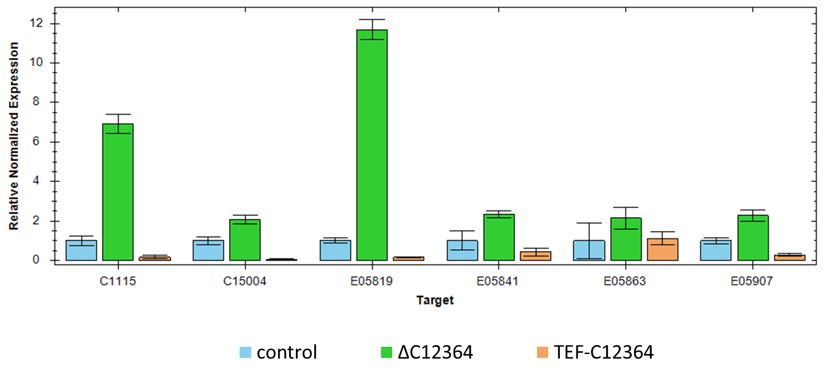
Fig S1. Results of qPCR targeting genes YALI0C11165g, YALIC15004g, YALI0E05819g, YALI0E05841g, YALIE05863g and YALI0E05907g performed on three Y. lipolytica strains AMM+ (control), AMM C12364∆ (deletion of YALI0C12364g) and AMM TEF-C12364 (overexpression of YALI0C12364g).
YALI0C115g, YALIC15004g, YALI0E05819g, YALI0E05841g, YALIE05863g and YALI0E05907g were all down-reguleted in RNA-seq comparison between strains MK1 and K1. We suspected that the downregulation might be connected with transcriptional repressor encoded by YALI0C12364g. The repressor had higher expression in strain MK1, which might lead to downregulation of its targeted genes.
To test this possibility we prepared strains with deletion (AMM C12364∆) and overexpression (AMM TEF-C12364) of YALI0C12364g. All AMM strains are derivatives of MK1. Their detailed description will be presented in a publication that is currently under preparation.
Strains were grown in shake-flasks on YNB medium with 10% glycerol. Samples for RNA isolation were taken after 24h. The q-PCR results are presented as Relative Normalized Expression in comparison to AMM+ control strain (where YALI0C12364g was not modified) . Deletion of C12364g repressor resulted in higher expression of the tested genes, while the overexpression of C12364g leads to lower expression. It supports the assumption that the downregulation of these genes in MK1 strain is a result of upregulation of YALI0C12364g by Euf1.

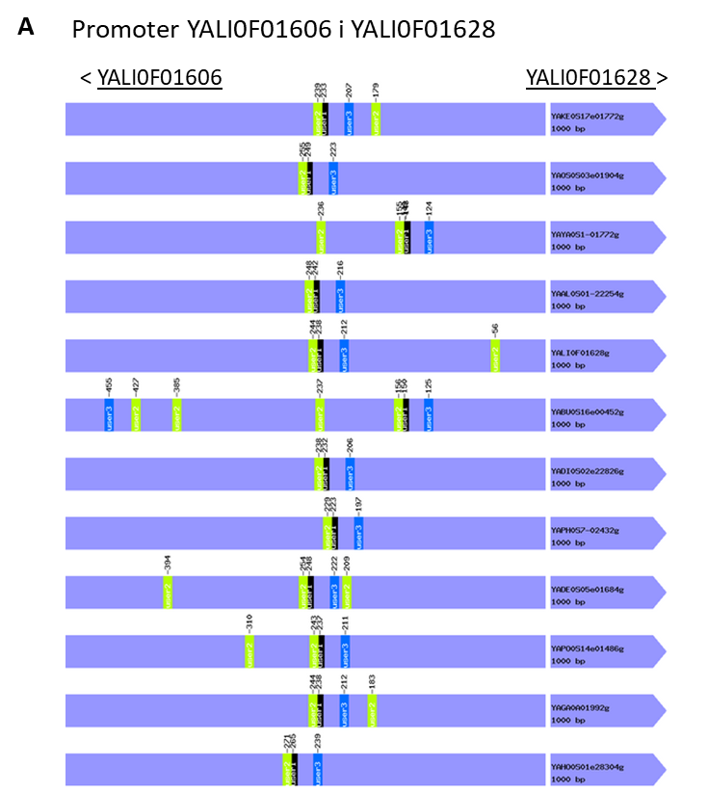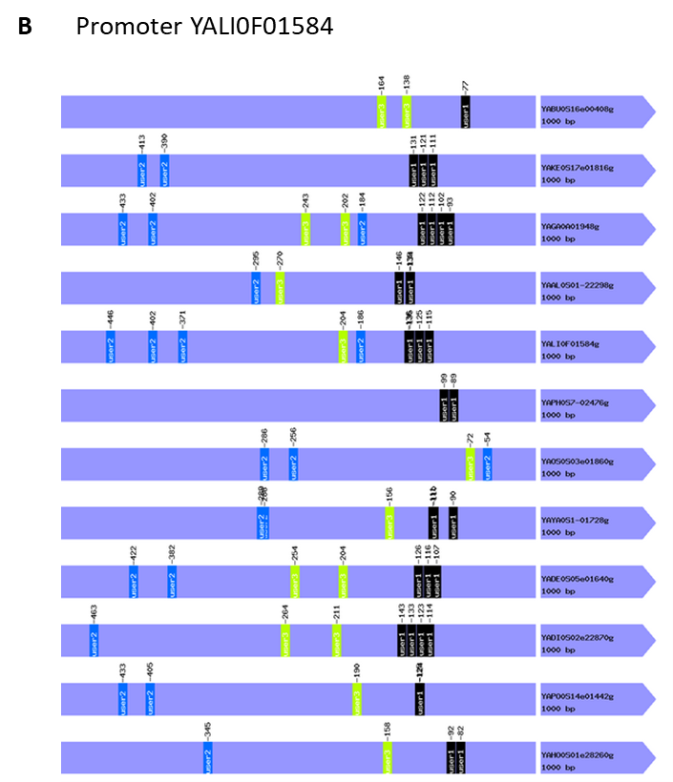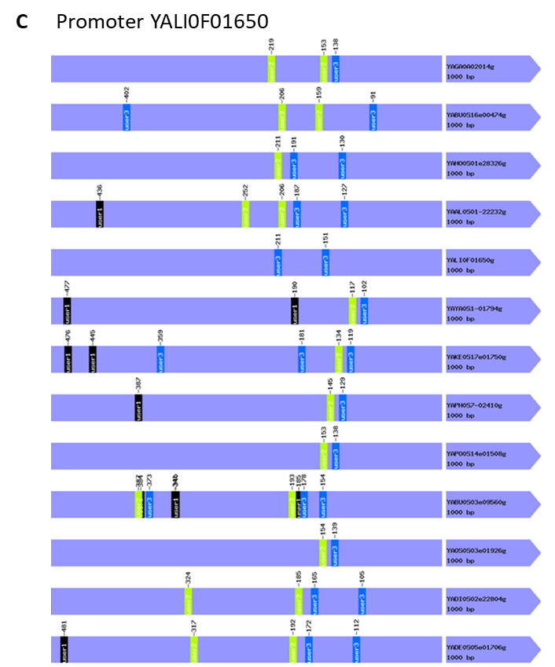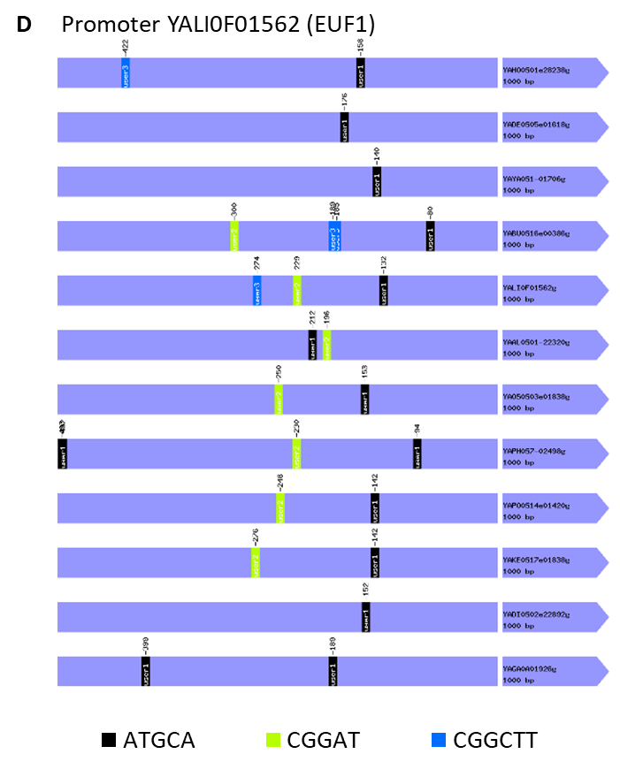
Figure S2. Promoter regions of genes from erythritol utilization cluster with the localizations of repeated motifs found by YEASTRACK+.

