Supplementary Information
Figure S1 Genome re-sequencing reads from xiaomi alleles
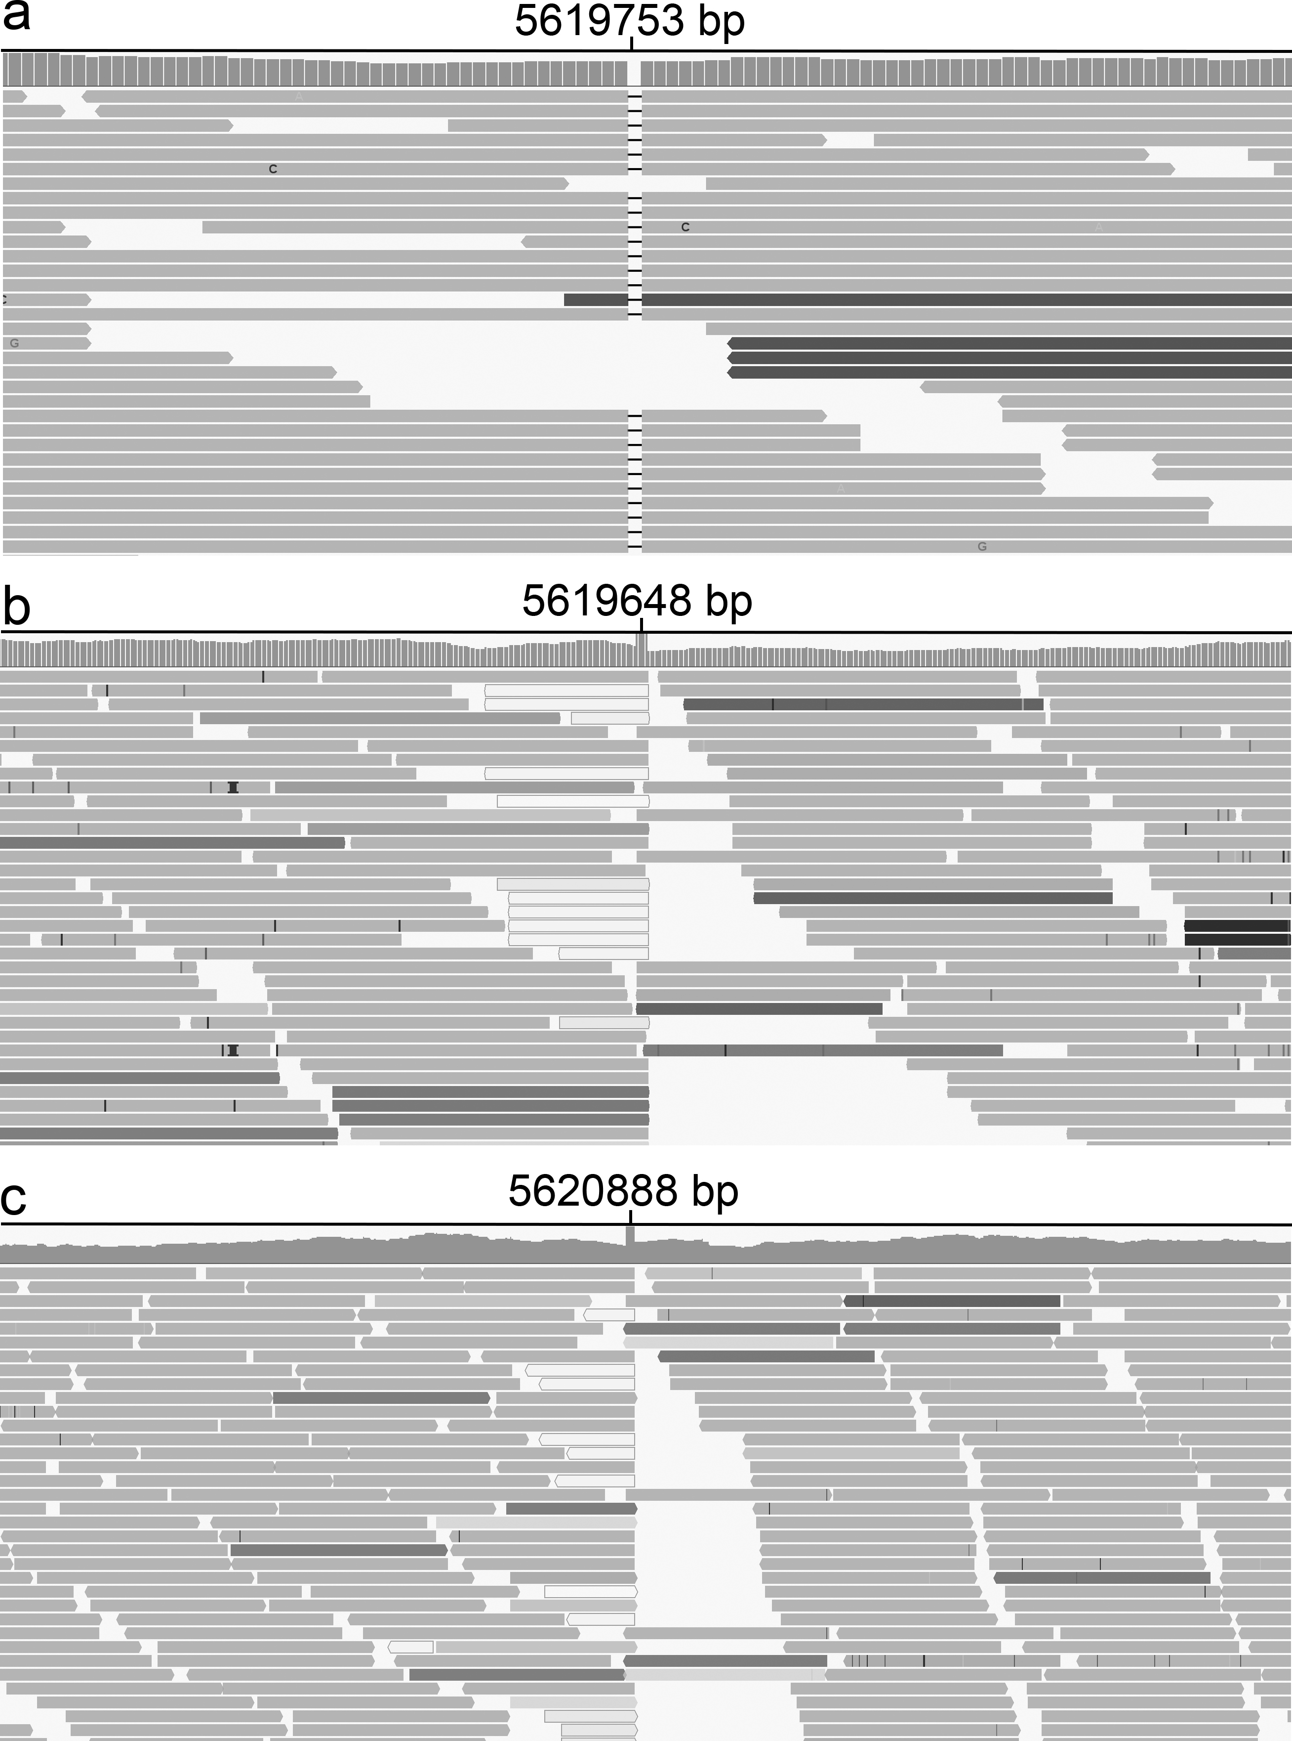
Genome re-sequencing reads from xiaomi alleles displayed using IGV. a xiaomi3; b xiaomi5; c xiaomi6. The numbers above the reads indicate the mutation sites.

Table S1 Primers used in this study.
Primer | Sequences (5'-3') | Experiments
M3200F | CCTAGACTCTCGATCTTTTGCTG | Bulked segregant analysis
M3200R | CACTCGGCGAACTTCCTGTTTC | Bulked segregant analysis
M8621F | GTATGCTGCGAGAAAATAACC | Bulked segregant analysis
M8621R | CAAGCAGAAGTATGATGGCTC | Bulked segregant analysis
xiaomi3F | GTCGCTTGTGATGTCAGTAAC | Deletion site confirmation of xiaomi3
Xiaomi3R | TCTCATCAGTAACTGTCCTTAG | Deletion site confirmation of xiaomi3
xiaomi4F | TGGGAGGATGTTGAAATGGAC | Insertion site confirmation of xiaomi4
xiaomi4R | AAATGATTTGGACAGTCTGGCAC | Insertion site confirmation of xiaomi4
xiaomi4TF | GGAACAACTCCAACACCTGTA | Insertion site confirmation of xiaomi4
xiaomi4TR | CATACGCCGTTCGTTCATAACA | Insertion site confirmation of xiaomi4
xiaomi5F | ACGCCACATCGCTTTCCACTC | Insertion site confirmation of xiaomi5
xiaomi5R | CACCTCACGGACAAGGACATC | Insertion site confirmation of xiaomi5
xiaomi5TF | TACGCCGTTCGTTCCTAACAC | Insertion site confirmation of xiaomi5
xiaomi5TR | GAGTGAATTTGGAACAACTCC | Insertion site confirmation of xiaomi5
xiaomi6F | GGGAAGCCCTTCTACGCCATT | Insertion site confirmation of xiaomi6
xiaomi6R | CCCTGTATCTTCTTCGTATCC | Insertion site confirmation of xiaomi6
xiaomi6TF | CATACGCCGTTCGTTCCTAAC | Insertion site confirmation of xiaomi6
xiaomi6TR | GAGTGAATTTGGAACAACTCC | Insertion site confirmation of xiaomi6
P1F | AGGAGCAAAATCTGGAAATCAGG | PHYC RT-PCR
P1R | CTCTGTTCCTCTGTCAACTCGG | PHYC RT-PCR
SiHIS3F | ATGGCCCGTACCAAGCAAACT | Internal reference gene for RT- and qRT-PCR
SiHIS3R | GGATCTCACGGAGGGCAACAGT | Internal reference gene for RT- and qRT-PCR
Si1G24310F | CCAGGGATGGTAGAGCACAGCA | RT-qPCR
Si1G24310R | CAGCATGGCATTGGGGATAAAC | RT-qPCR
Si2G43940F | TTGATTCTTCCTTCGCTGGTTC | RT-qPCR
Si2G43940R | GTAGGGGATTGATTGATAGGAG | RT-qPCR
Si2G38170F | CTTGAGCGTTATCAGCGTTACTC | RT-qPCR
Si2G38170R | AACAGTTGCCTTTGACTCTTCTG | RT-qPCR
Si5G32220F | CATGGTGTTTGTGCTGTTCCGAC | RT-qPCR
Si5G32220R | CCTTTGGCAGTTGAAATATGTGG | RT-qPCR
Si5g46430F | CGCCGACAAATAACACAATCTC | RT-qPCR
Si5g46430R | TTGACTTGACTCTCCAGCAGG | RT-qPCR
Si9G09160F | GCTCGTGGAGAAGCAGAAAGG | RT-qPCR
Si9G09160R | GACAGGGTAGCTGCTGATATTTG | RT-qPCR

