Supplemental Material to

‘Detection and attribution for land surface air temperature Warming in China based on a perfect model selection analysis of optimal fingerprint strategy’

Ziyou Guo^{1,2, #}, Chao Li^{3*}, Qingxiang Li^{1,4 #*}
- School of Atmospheric Sciences, Sun Yat-sen University, and Key Laboratory of Tropical Atmosphere-Ocean System, Ministry of Education, Zhuhai, China
- Shaoguan Meteorological Bureau, Shaoguan, China
- School of Geographic Sciences, East China Normal University, Shanghai, China
- Research Center for Ecology and Environment of Central Asia, Chinese Academy of Sciences; Urumqi 830011, China
# Southern Laboratory of Ocean Science and Engineering (Guangdong Zhuhai), Zhuhai 519082, China
*Correspondence to: Qingxiang Li: liqingx5@mail.sysu.edu.cn; Chao Li: cli@geo.ecnu.edu.cn

This Supplementary Information document includes:
Figures S1 to S2
Table S1

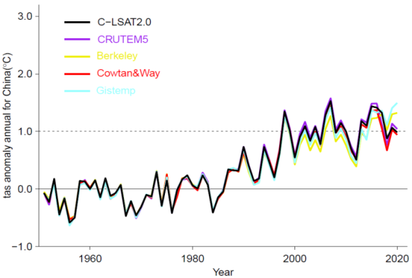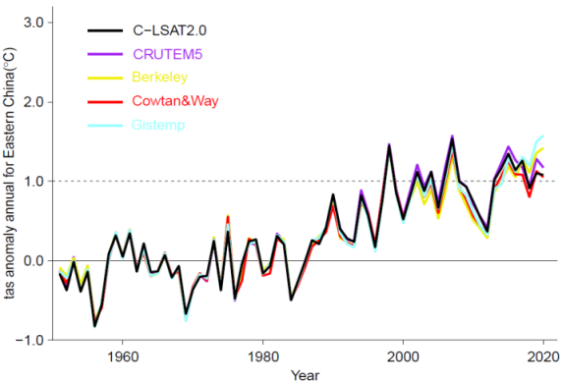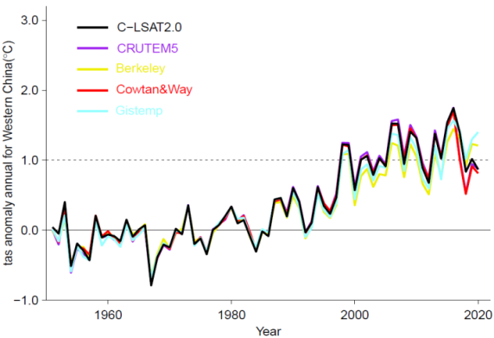
Supplementary Fig. 1 Time series of regional mean near-surface temperature anomalies in mainland China from 1951 to 2020 in C-LSAT2.0, CRUTEM5, Berkeley, Cowton&Way and Gistemp datasets (a); Same as (a), but in eastern China (b); Same as (a), but in western China (c)

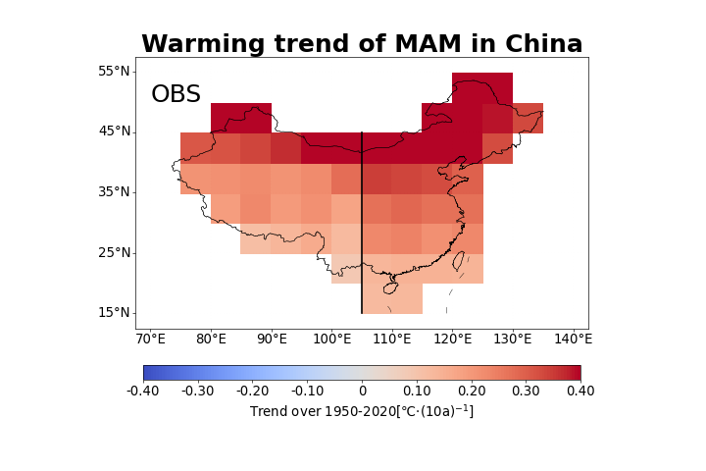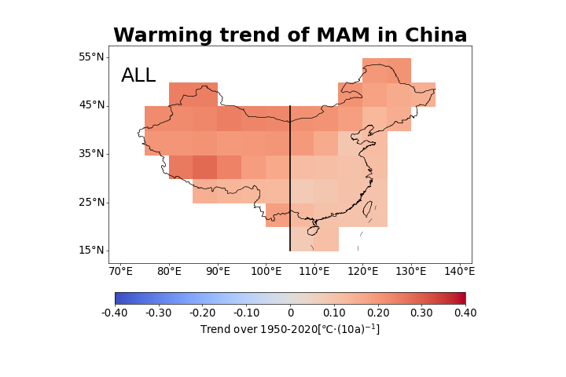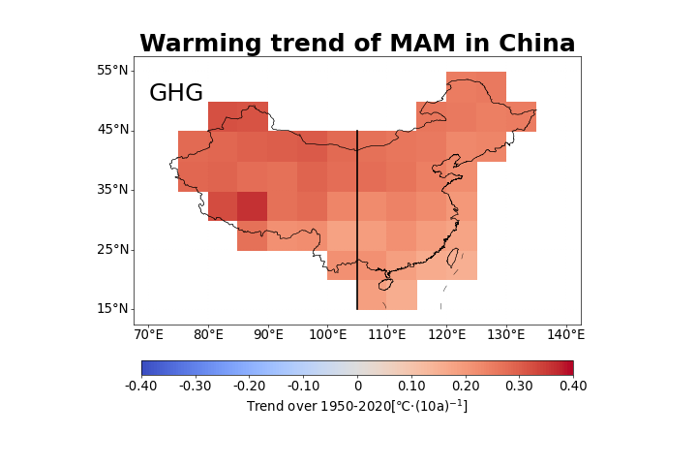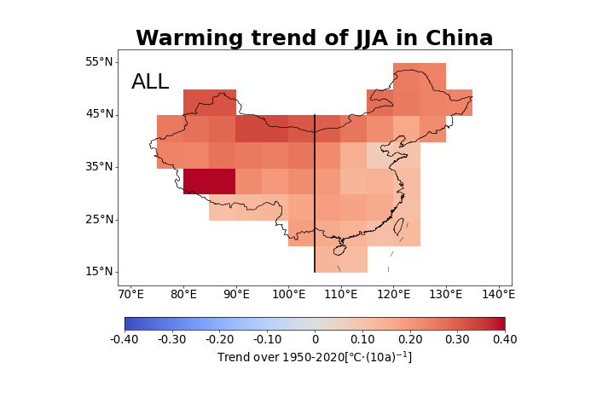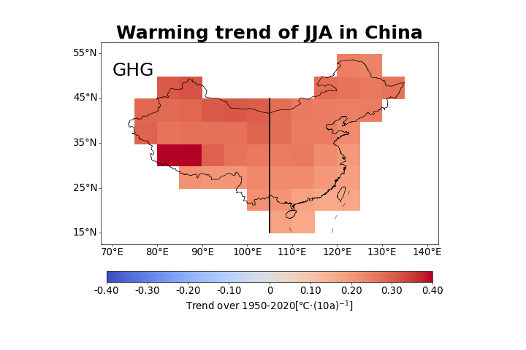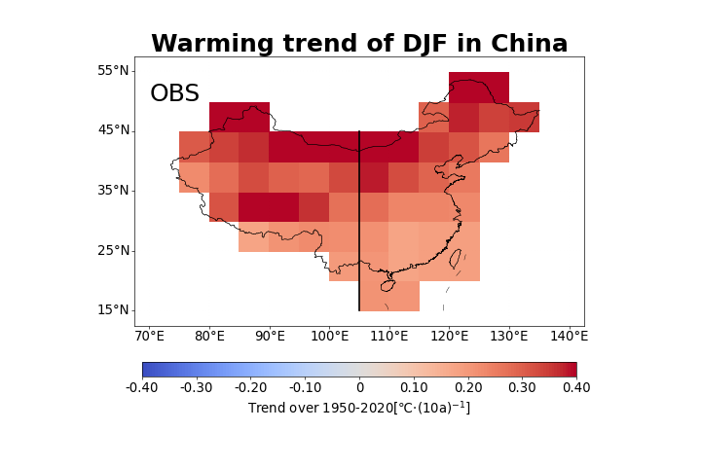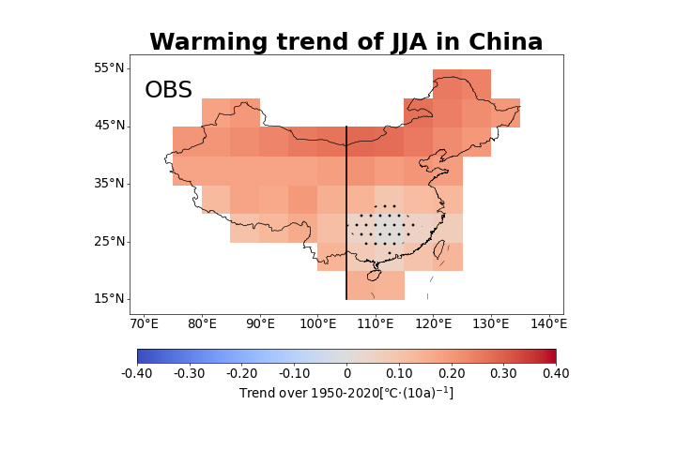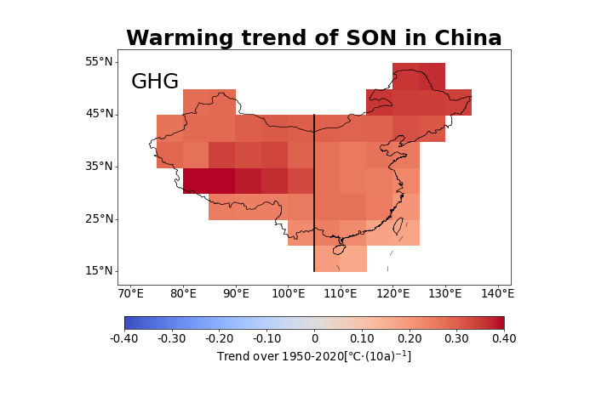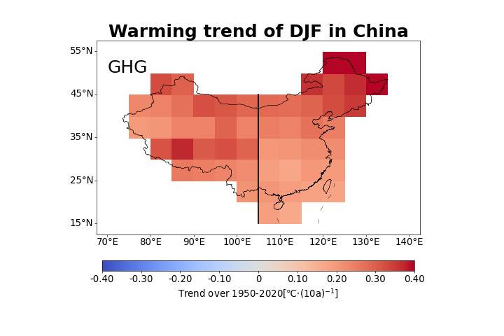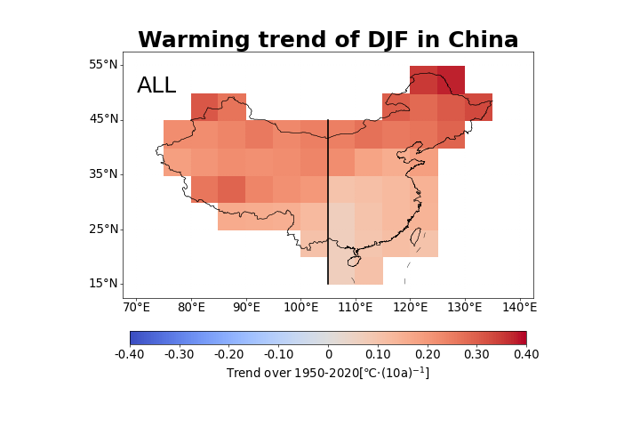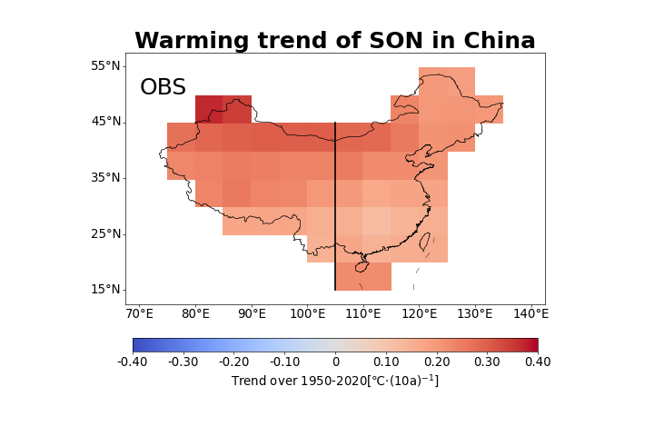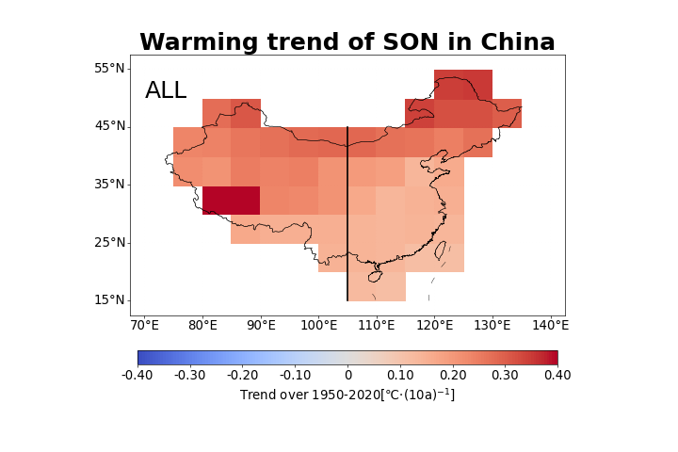
Supplementary Fig. 2 Spatial distribution trend of SAT anomalies in mainland China from 1951 to 2020: the left, middle and right columns are observation, CMIP6 multi-model ensemble mean of ALL and GHG respectively; the average C-LSAT anomalies of winter (DJF), spring (MAM), summer (JJA) and autumn (son) are shown from top to bottom (the black vertical line is the boundary between the eastern and western China, and the black dot is the regions passing through 5-95% significance)

Supplementary Table 1 Forcing names and numbers of Model’s simulations Used in CMIP6
ID | Model | historical | hist-GHG | hist-aer | hist-nat | historical-ssp5-8.5 | picontrol
1 | ACCESS-CM2 | 5 | 3 | 3 | 3 | 5 | 2
2 | ACCESS-ESM1-5 | 40 | 3 | 3 | 3 | 40 | 2
3 | AWI-CM-1-1-MR | 5 |  |  |  | 1 | 2
4 | AWI-ESM-1-1-LR | 1
5 | BCC-CSM2-MR | 3 | 3 | 3 | 3 | 1 | 3
6 | BCC-ESM1 | 3 |  |  |  |  | 2
7 | CAMS-CSM1-0 | 3 |  |  |  | 2 | 2
8 | CanESM5 | 65 | 50 | 30 | 50 | 50 | 11
9 | CanESM5-CanOE | 3 |  |  |  | 3 | 2
10 | CAS-ESM2-0 | 4 |  |  |  |  | 2
11 | CESM2 | 11 | 3 | 2 | 3 | 3 | 5
12 | CESM2-FV2 | 3 |  |  |  |  | 2
13 | CESM2-WACCM | 3 |  |  |  | 3 | 2
14 | CESM2-WACCM-FV2 | 3
15 | CIESM | 3 |  |  |  | 1 | 2
16 | CMCC-CM2-HR4 | 1
17 | CMCC-CM2-SR5 | 3 |  |  |  | 1 | 2
18 | CMCC-ESM2 | 1 |  |  |  | 1
19 | CNRM-CM6-1 | 30 | 10 | 10 | 10 | 6 | 2
20 | CNRM-CM6-1-HR | 1
21 | CNRM-ESM2-1 | 10 |  |  |  | 5 | 2
22 | E3SM-1-0 | 5 |  |  |  |  | 2
23 | E3SM-1-1 | 1 |  |  |  | 1
24 | E3SM-1-1-ECA | 1
25 | EC-Earth3 | 18 |  |  |  | 3 | 3
26 | EC-Earth3-AerChem | 1 |  |  |  |  | 1
27 | EC-Earth3-LR |  |  |  |  |  | 1
28 | EC-Earth3-CC | 1 |  |  |  | 1
29 | EC-Earth3-Veg | 9 |  |  |  | 8 | 2
30 | EC-Earth3-Veg-LR | 3 |  |  |  | 3 | 1
31 | FGOALS-f3-L | 3 |  |  |  | 1 | 3
32 | FGOALS-g3 | 6 | 3 | 3 | 3 | 4 | 4
33 | FIO-ESM-2-0 | 3 |  |  |  | 3 | 3
34 | GFDL-CM4 | 1 |  |  | 3 | 1
35 | GFDL-ESM4 | 3 | 1 | 1 | 3 | 1
36 | GISS-E2-1-G | 47 | 10 | 15 | 20 | 11 | 12
37 | GISS-E2-1-H | 25 |  |  |  | 5 | 6
38 | GISS-E2-2-H | 5
39 | HadGEM3-GC31-LL | 5 | 5 | 5 | 10 | 4 | 2
40 | HadGEM3-GC31-MM | 4 |  |  |  | 4
41 | ICON-ESM-LR
42 | IITM-ESM
43 | INM-CM4-8 | 1 |  |  |  | 1 | 3
44 | INM-CM5-0 | 10 |  |  |  | 1 | 5
45 | IPSL-CM5A2-INCA | 1
46 | IPSL-CM6A-LR | 32 | 10 | 10 | 10 | 6 | 9
47 | IPSL-CM6A-LR-INCA | 1
48 | KACE-1-0-G | 3 |  |  |  | 3
49 | KIOST-ESM | 1 |  |  |  | 1 | 2
50 | MCM-UA-1-0 | 2 |  |  |  | 1
51 | MIROC6 | 50 | 3 | 10 | 50 | 50 | 4
52 | MIROC-ES2L | 31 |  |  |  | 10 | 2
53 | MPI-ESM-1-2-HAM | 3 |  |  |  |  | 4
54 | MPI-ESM1-2-HR | 10 |  |  |  | 2 | 2
55 | MPI-ESM1-2-LR | 10 |  |  |  | 10 | 5
56 | MRI-ESM2-0 | 12 | 5 | 5 | 5 | 6 | 1
57 | NESM3 | 5 |  |  |  | 2 | 2
58 | NorCPM1 | 30 |  |  |  |  | 8
59 | NorESM2-LM | 3 | 3 | 3 | 3 | 1 | 2
60 | NorESM2-MM | 3 |  |  |  | 1 | 2
61 | SAM0-UNICON | 1
62 | TaiESM1 | 2 |  |  |  | 1 | 2
63 | UKESM1-0-LL | 18 |  |  |  | 5 | 10

