Supplemental Figures

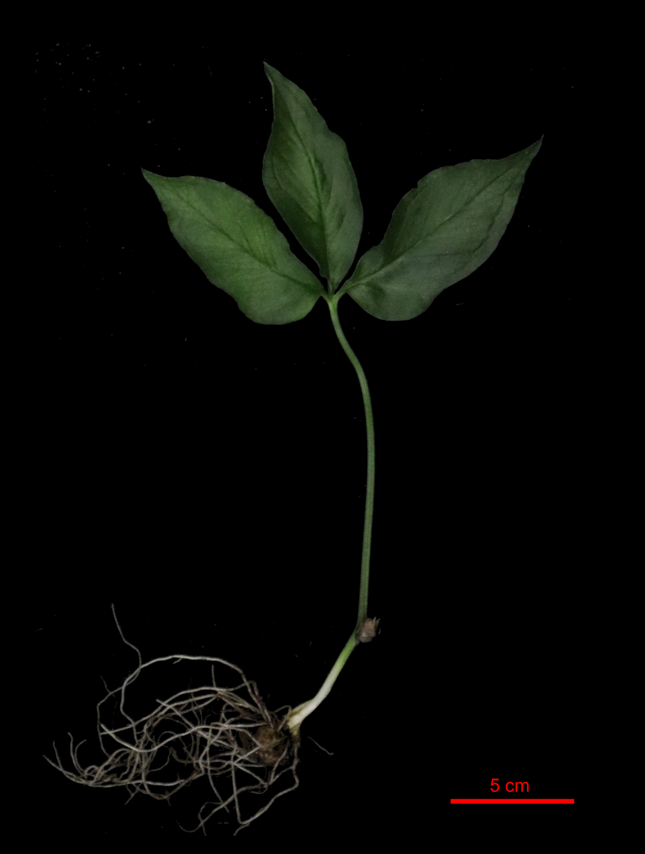
Fig. S1 Photo of the whole plant Pinellia ternata. The plants consists of the tuber and root system in the underground part and above-ground part of the petiole, bulbil and leaf (Scale Bar= 5cm).

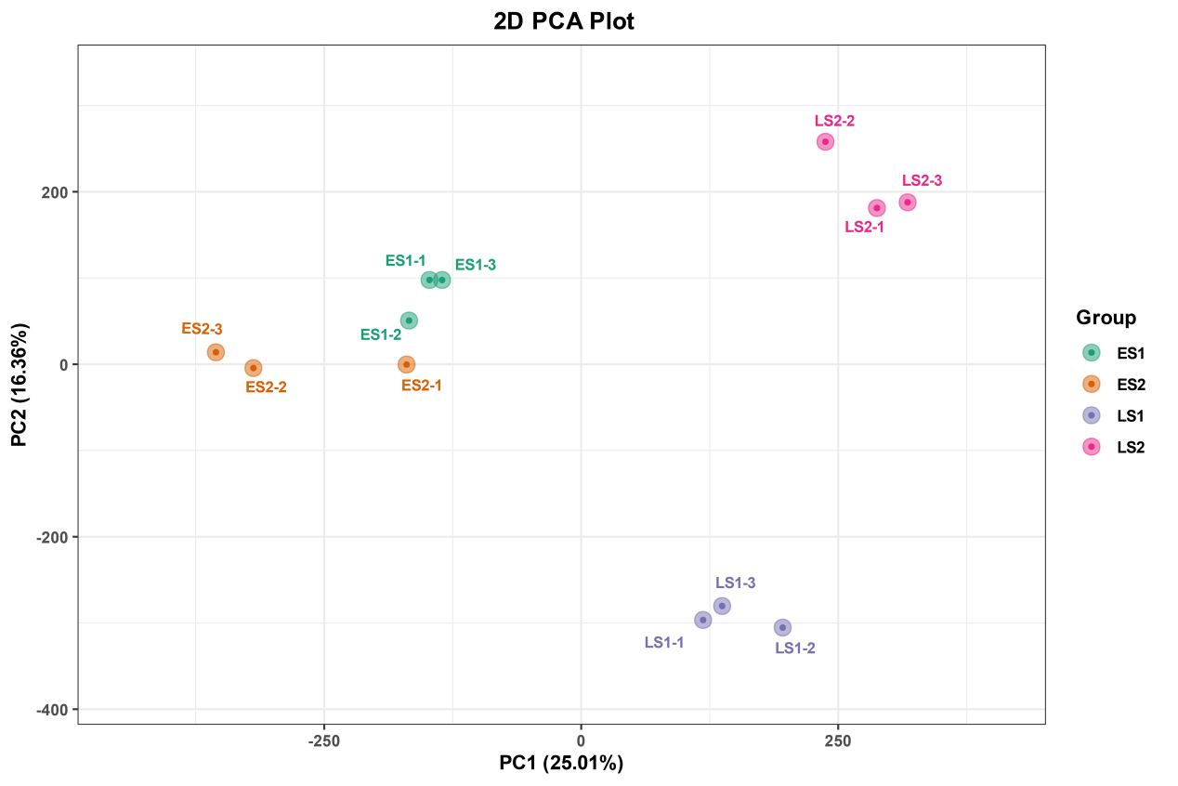

Fig. S2 PCA analysis of the transcriptomics. Principal component analysis (PCA) of the gene expression in four experimental samples (ES1, ES2, LS1, and LS2).
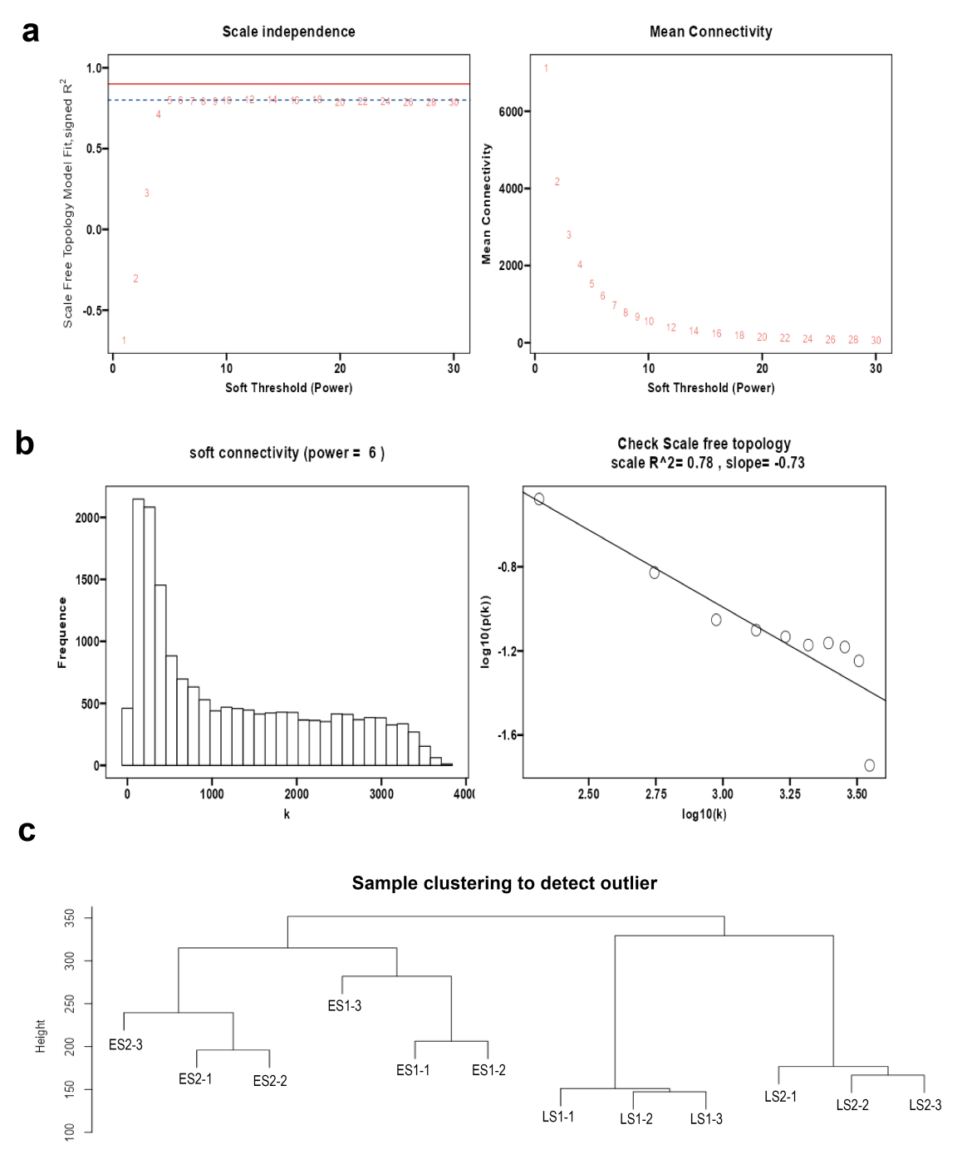

Fig. S3 Clustering of samples and determination of soft-thresholding power.
- Analysis of the scale-free fit index for various soft-thresholding powers.
- Analysis of the mean connectivity for various soft-thresholding powers. In all, 6 was the most fit power value.
- Clustering tree plot between samples, at a soft threshold of 6, individual samples with a good clustering.

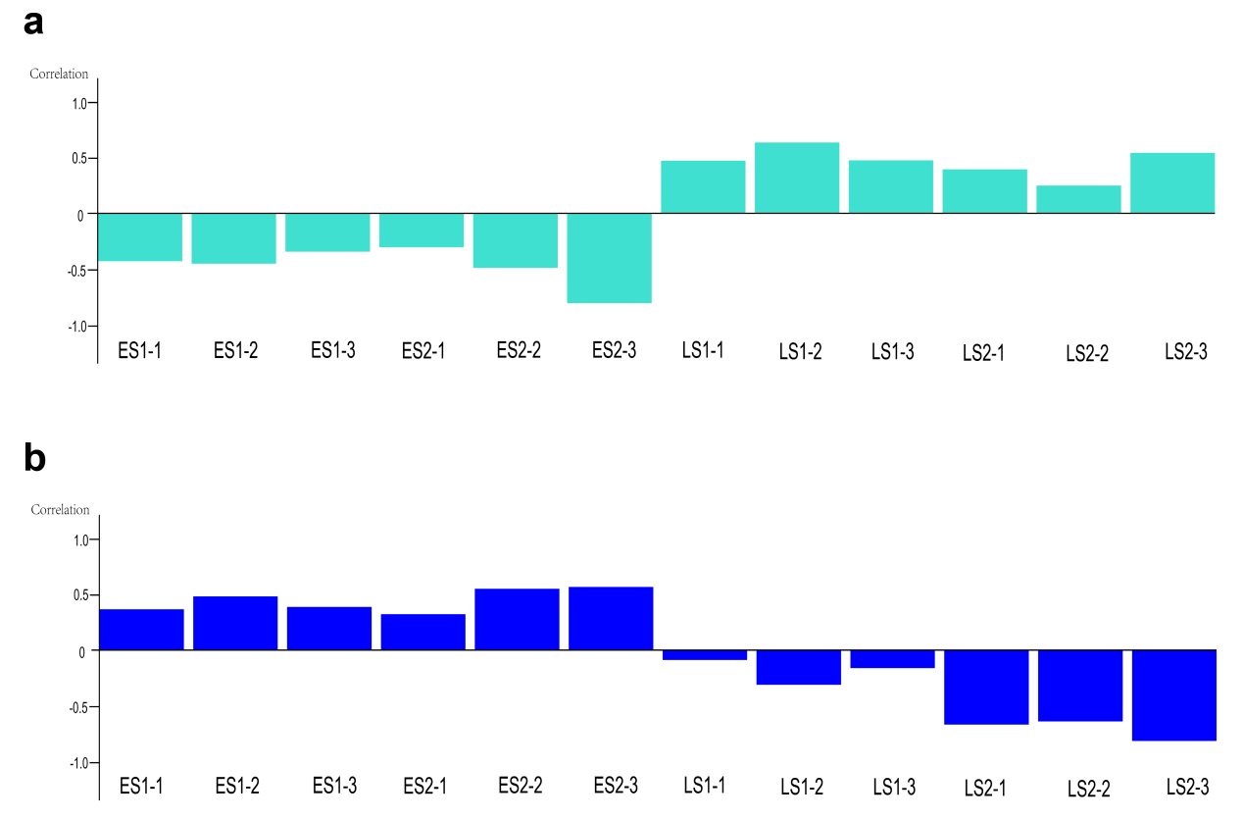
Fig. S4 Module-traits relationship in turquoise and blue modules.
- Module-traits relationship in turquoise module. The top half is a heatmap of the correlation of the genes in each repetition with that module, and the bottom color bar is the correlation of this repetition with the color module.
- Module-traits relationship in blue module. The top half is a heatmap of the correlation of the genes in each repetition with that module, and the bottom color bar is the correlation of this repetition with the color module.

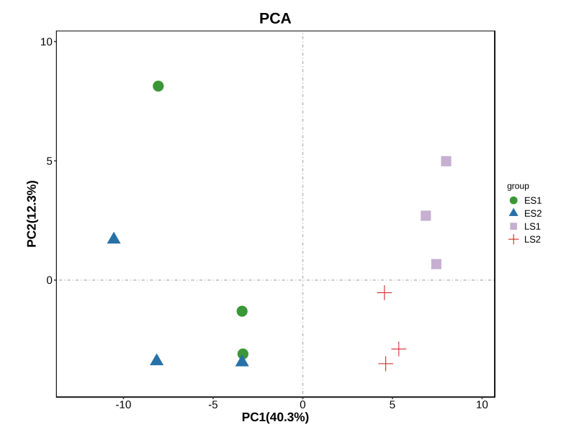

Fig. S5 PCA analysis of the metabolomics. Principal component analysis (PCA) of the identified metabolites in four experimental samples (ES1, ES2, LS1, and LS2).

