Supplementary Materials

Suicidal risk is associated with hyper-connections between frontal-parietal and limbic networks in patients with depression

Table S1 Participants’ demographic and clinical information
Figure S1 Flowchart for identifying functional connectivity associated with suicide risk
Figure S2 Suicide and depression symptoms significantly decreased after ECT treatment
Figure S3 Pre vs. Post comparison in the connection between FPN and other networks

Table S1 Participants’ demographic and clinical information
 | NSS  (n = 35) | SI  (n = 31) | SA  (n = 30) | NSS vs. SI | NSS vs. SA | SI vs. SA
Demographic characteristics
Gender(female/male) | 11/24 | 9/22 | 4/26 | 0.833 | 0.031 | 0.054
Age | 26.46±9.01 (16~44) | 27.23±7.79  (16~45) | 23.77±8.22  (16~43) | 0.714 | 0.216 | 0.097
Education | 14.49±2.25 (11~18) | 14.74±2.22 (11~19) | 14.07±2.05 (11~16) | 0.644 | 0.439 | 0.223
Clinical evaluations
BSSI | 0 | 38.61±13.04 (15.15~72.73) | 68.08±15.43 (33.33~93.94) | - | - | 4.23E-11
HAMD  (exclude item3) | 21.03±4.08 (11~29) | 23.55 ±4.03  (16~32) | 26.45±3.60  (19~33) | 0.017 | 6.96E-7 | 0.005
Duration of illness(years) | 3.67±4.42 (0.08~20) | 3.96±5.02 (0.08~20) | 4.11±4.65 (0.08~21) | 0.805 | 0.699 | 0.905
Medical characteristics
Psychiatric medication (No/Yes) | 16/19 | 14/17 | 8/22 | 0.964 | 0.113 | 0.133
Depression medication (No/Yes) | 11/24 | 6/25 | 11/19 | 0.263 | 0.656 | 0.132
Mood stabilizers (No/Yes) | 19/16 | 16/15 | 7/23 | 0.828 | 0.011 | 0.023
Head motion | 0.081±0.035 (0.033~0.174) | 0.094±0.046 (0.028~0.238) | 0.082±0.045 (0.041~0.215) | 0.193 | 0.910 | 0.310
NSS, no suicide symptom; SI, suicide ideation; SA: suicide attempt; BSSI, Beck Scale for suicide ideation; HAMD, Hamilton depression rating scale; the p values of age, education, BSSI, HAMD, and duration of illness were obtained by two-sample t-test, and p values of gender and medical characteristics were obtained by Chi-squared test.

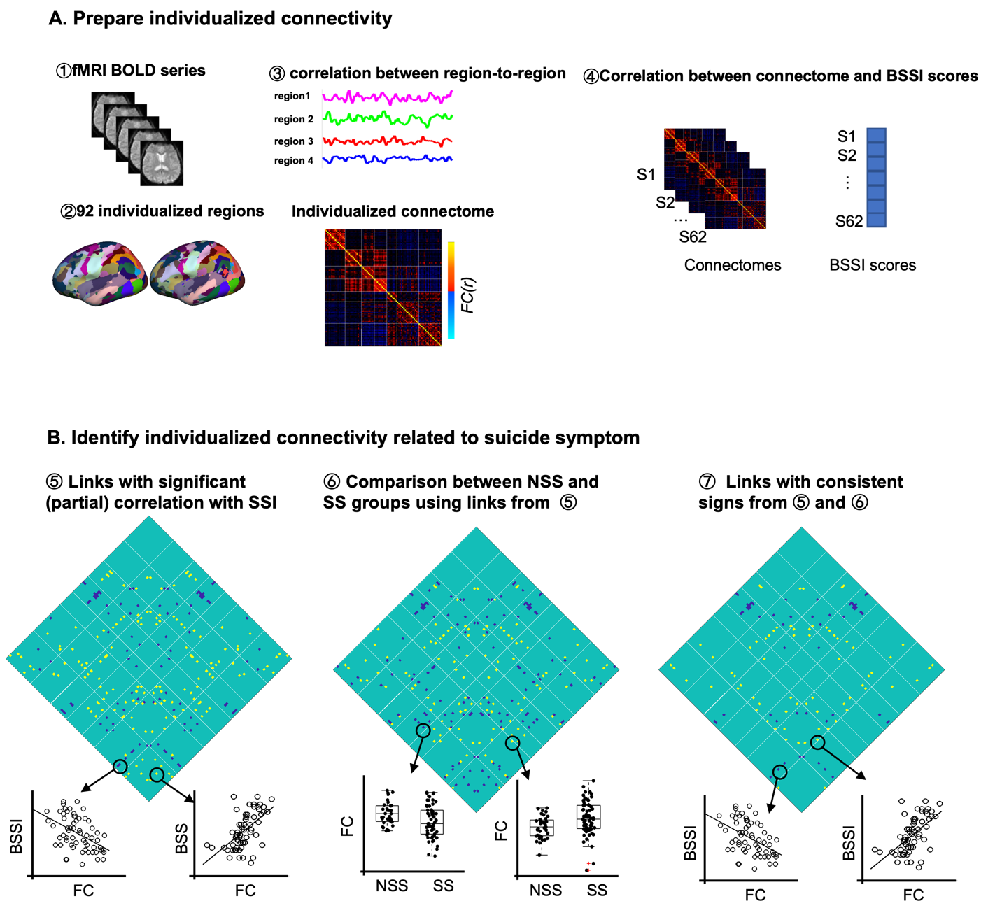

Figure S1 Flowchart for identifying functional connectivity associated with suicide risk

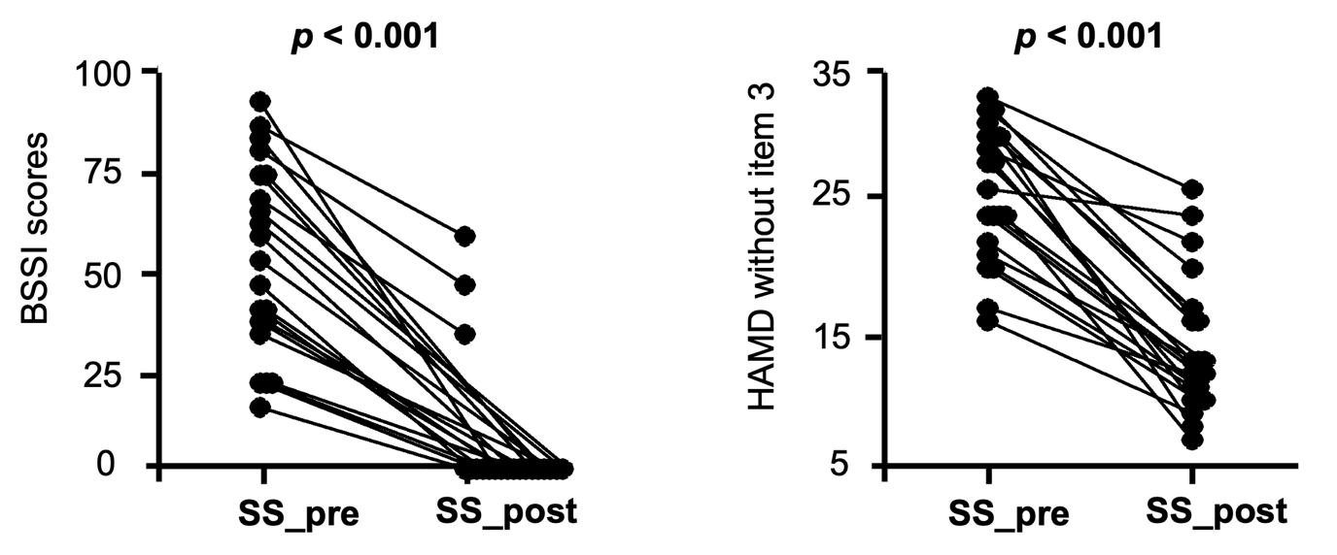
Figure S2 Suicide and depression symptoms significantly decreased after ECT treatment
Paired t-tests were performed on depressed patients with suicide symptoms, and the BSSI and HAMD (excluding the third item) both were significantly decreased after treatment. BSSI, Beck Scale for suicide ideation; HAMD, Hamilton depression rating scale; Pre, pre-treatment; post, post-treatment.

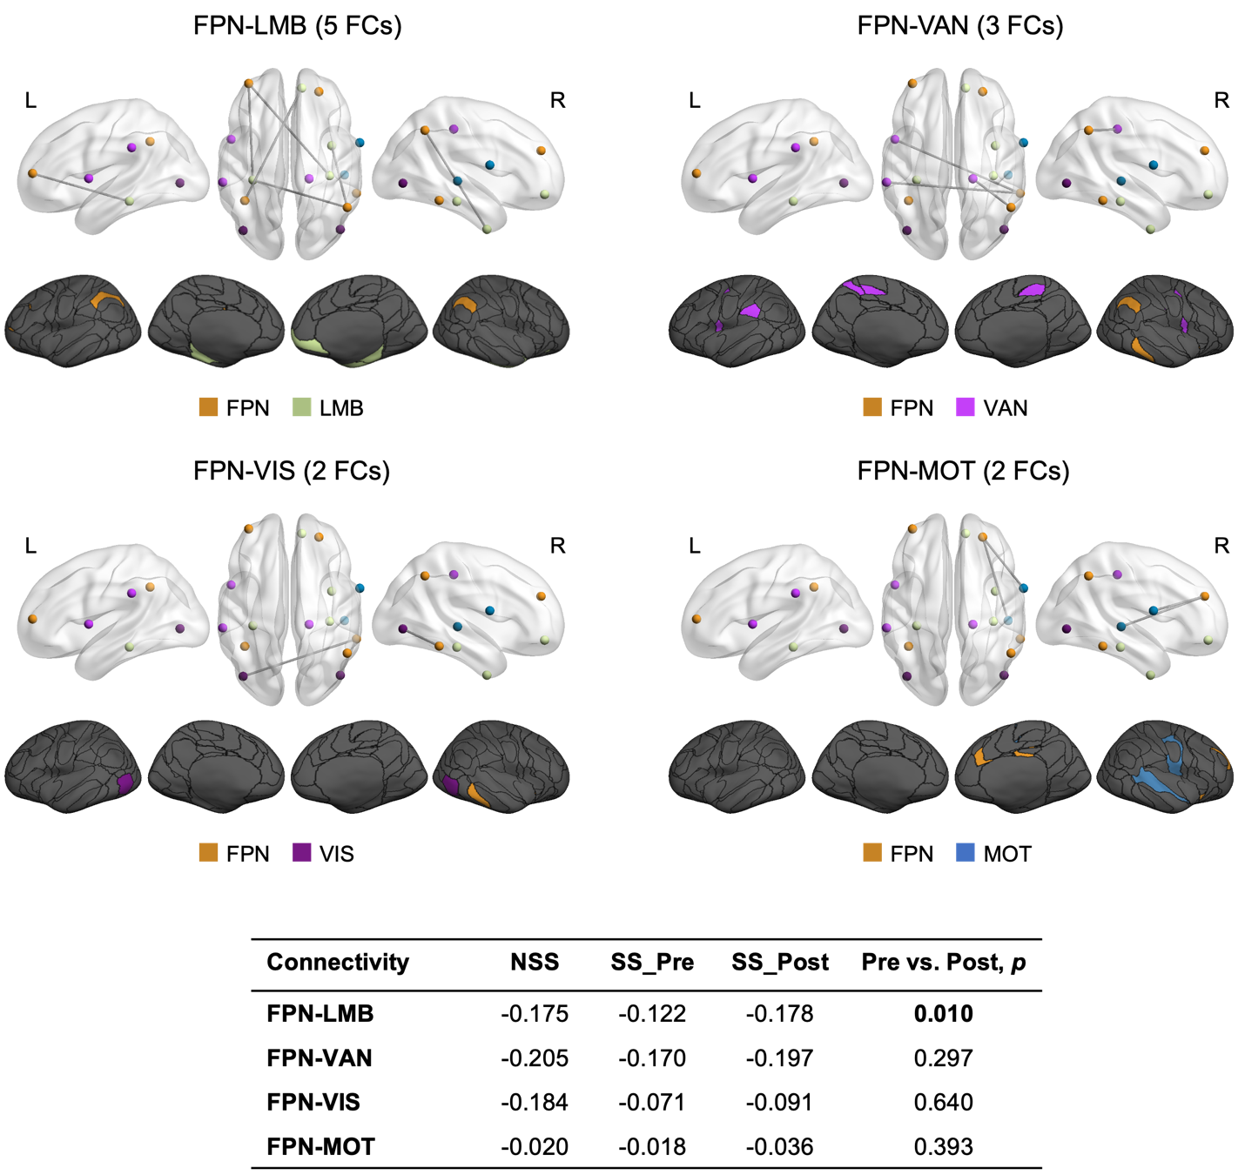

Figure S3 Pre vs. Post comparison in the connection between FPN and other networks
Average values of negative connections between the FPN and other networks were presented in the table and compared between SS_Pre and SS_Post groups using paired t-tests. To check whether the connections changed from pre to post were normalized and closer to that of patients without suicide symptoms, mean values of these connections in the NSS group were presented. NSS, no suicide symptom; VIS, visual network; MOT, sensorimotor network; VAN, ventral attention network; LMB, limbic network; FPN, frontoparietal network.

