SUPPLEMENTARY INFORMATION

Catalytic specificity and crystal structure of cystathionine γ-lyase from Pseudomonas aeruginosa

Marco Pedretti^{1, #}, Carmen Fernández-Rodríguez^{2, #}, Carolina Conter¹, Iker Oyenarte², Filippo Favretto¹, Adele di Matteo³, Paola Dominici¹, Maria Luz Martinez-Chantar^{2,5}, Maria Petrosino⁴, Maria Luz Martinez-Chantar^{2,5}, Tomas Majtan⁴, Alessandra Astegno^{1,} * and Luis Alfonso Martínez-Cruz^{2,} *

¹Department of Biotechnology, University of Verona, Strada Le Grazie 15, 37134 Verona, Italy.

²Center for Cooperative Research in Biosciences (CIC bioGUNE), Basque Research and Technology Alliance (BRTA), Bizkaia Technology Park, Building 801A, 48160 Derio, Spain

³ CNR Institute of Molecular Biology and Pathology, P.le Aldo Moro 5, 00185 Rome, Italy

⁴University of Fribourg, Department of Pharmacology, Faculty of Science and Medicine, Chemin du Musee 18, Bldg. PER17, CH-1700 Fribourg, FR, Switzerland.

⁵Centro de Investigación Biomédica en Red de Enfermedades Hepáticas y Digestivas (CIBERehd)

# These authors contributed equally to this work.

*Corresponding authors. Address: Luis Alfonso Martínez-Cruz: email: amartinez@cicbiogune.es; Tel: +34 944061318, fax: +34 944-061-301. Alessandra Astegno: email: alessandra.astegno@univr.it; Tel: +39 045-8027955, fax: +39 045-8027929

Table S1. List of mutagenic primers used to generate PaCGL variants. PF = Primer Forward, PR = Primer Reverse.
Mutation | Type of primer | Primer sequence
F114A | PF | CTACGGCGGTACCGCCCGCCTGTTCGAGCG
F114A | PR | CGCTCGAACAGGCGGGCGGTACCGCCGTAG
F114N | PF | CTACGGCGGTACCAACCGCCTGTTCGAGCG
F114N | PR | CGCTCGAACAGGCGGTTGGTACCGCCGTAG

Table S2 Statistics for data collection and refinement

PDB code | 7BA4
Space group | P3₁21
Unit cell (Å) (a, b, c) | 79.30 79.30 446.67
Resolution (Å)(a, b, c) | 54.45 – 1.99 (2.03 - 1.99)
CC ½ (%) | 99.50 (77.50)
Redundancy | 18.30 (10.60)
Completeness (%) | 99.90 (98.80)
I/σ (I) | 13.90 (2.90)
Wilson B-factor (Å²) | 30.70
R_{merge}ª | 0.158 (0.780)
R_{meas}^{b} | 0.162 (0.820)
R_{pim}^{c} | 0.037 (0.247)
Refinement  Total reflections  Unique reflections  Rwork^{d}/Rfree^{e} | 2060939 (58513)  112386 (5512)  0.160/0.205
N° of non-hydrogen atoms  Macromolecules  Ligand (PLP) | 12573  15
Average B-factor (Å²)  Macromolecules  Ligands | 40.00  37.19
Ramachandran plot statistics (%)  Res. in most favored regions  In additional allowed regions  In disallowed regions | 98.07  1.72  0.21
RMSDs  Bonds length (Å)/ angle (°) | 0.010/0.99
Rotamers outliers (%) | 0.00
Clashcore | 4.32
MolProbity score ^{f} | 1.21

One crystal was used for each data set. Values in parentheses are for highest-resolution shell. Rmerge a = Σhkl Σi |Ii (hkl) − <I(hkl)>I/Σhkl Σi Ii(hkl) (all I+ and I-); ^{b}Rmeas = Σhkl Σi |Ii (hkl) − <I(hkl)>I/Σhkl Σi Ii(hkl) (all I+ and I-); ^{c} Rpim= Σhkl Σi |Ii (hkl) − <I(hkl)>I/Σhkl Σi Ii(hkl) (all I+ and I-); ^{d}Rwork = Σ |Fo – Fc | / ΣFo; ^{e} Rfree = Σ |Fo – Fc | / ΣFo, calculated using a random 5 % of reflections that were not included throughout refinement. ^{f} MolProbity score: 0.426 *ln(1+clashscore) + 0.33 *ln(1+max(0, rota_out|-1)) + 0.25 *ln(1+max(0, rama_iffy|-2)) + 0.5

Figure S1. Properties of recombinant PaCGL. (A) 12% SDS-PAGE analysis of purified recombinant PaCGL. Lane M, protein marker. (B) Size exclusion chromatography of PaCGL using Sephacryl S-200 16/60 high resolution column in 20 mM sodium phosphate pH 8.0, 150 mM NaCl, 0.1 mM DTT. (Inset) Calibration curve of molecular weight logarithm versus elution volumes. (C) UV-visible absorption spectrum of 15 μM purified PaCGL in 20 mM sodium phosphate buffer pH 8.0. (D) Emission spectra of 1 μM apo-PaCGL before and after reconstitution with PLP in 20 mM sodium phosphate buffer pH 8. Inset, representative fluorescence titration of apo-PaCGL (1 μM) with PLP (0.01– 4 μΜ) monitoring the quenching of intrinsic fluorescence emission at 333 nm upon excitation of the apo- PaCGL at 295 nm. The K_{d} value is determined by fitting the fraction of bound PLP (fb) to a hyperbolic equation and represents a mean value ± SEM of three independent measurements. (E) Thermal denaturation profile of 0.2 mg/mL apo- (black) and holo-PaCGL (red) recorded following the ellipticity signal at 222 nm in 20 mM sodium phosphate buffer pH 8.0.

Figure S2. Effect of pH and temperature on PaCGL γ-elimination of L-Cth. (A) pH-dependent activity profile for PaCGL performed at constant saturating L-Cth concentration in the pH range of 6-10 at 37°C. (B) PaCGL enzyme activity over temperature range of 15-65°C at constant saturating L-Cth concentrations at pH 8.0. Data points correspond to average values of four independent measurements, while error bars represent SEMs.

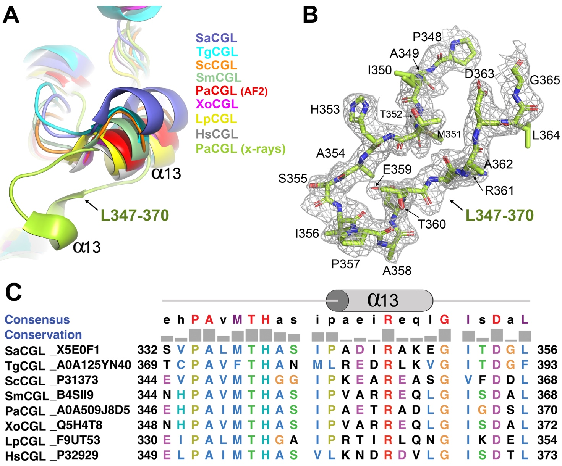

Figure S3. Conformation of the loop 347-370 in PaCGL and homologs. (A) Zoomed view of the loop L347-370 in PaCGL and homolog enzymes from various species. SaCGL, Staphylococcus aureus (PDB ID 7MCB); TgCGL, Toxoplasma gondii (PDB ID 7NL1); ScCGL, Saccharomyces cerevisiae (PDB ID 1N8P); SmCGL, Stenotrophomonas maltophila (PDB ID 6K1L); XoCGL, Xanthomonas oryzae (PDB ID 4IYO); LpCGL, Lactobacillus plantarum (PDB ID 6LDO); HsCGL, Homo sapiens (PDB ID 2NMP); PaCGL, Pseudomonas aeruginosa-crystal structure (PDB ID 7BA4); PaCGL-AF2 (Pseudomonas aeruginosa, predicted with AF2). (B) Detailed view of the loop L347-370 of PaCGL observed in the crystals and 2FoFc σ-weighted electron density map, contoured at 1 σ. (C) Alignment of the amino acid sequence from loop 347-370 of PaCGL with the homologous region of the organisms depicted in panel A. The numbering of the corresponding amino acids and the UniProt code of each protein are indicated in the figure. The upper part displays the consensus sequence and the level of conservation resulting from the alignment using Clustal Omega (https://www.ebi.ac.uk/Tools/msa/clustalo/). Residues included in the commonly observed two-turn helix α13 are indicated with a cylinder.

Figure S4. Structural and kinetic properties of PaCGL variants. (A) Size exclusion chromatography of PaCGL variants at 2 mg/mL using Sephacryl S-200 16/60 high resolution column. (B) UV-visible absorption spectra of 15 μM PaCGL variants recorded in 20 mM sodium phosphate buffer pH 8.0. (C) Far-UV CD spectra of 0.2 mg/mL PaCGL variants in 20 mM sodium phosphate buffer pH 8.0. (D) Representative kinetics of H₂S generation (Fig. 1B main text, reactions 3 + 4) by PaCGL variants in the presence of L-Cys.

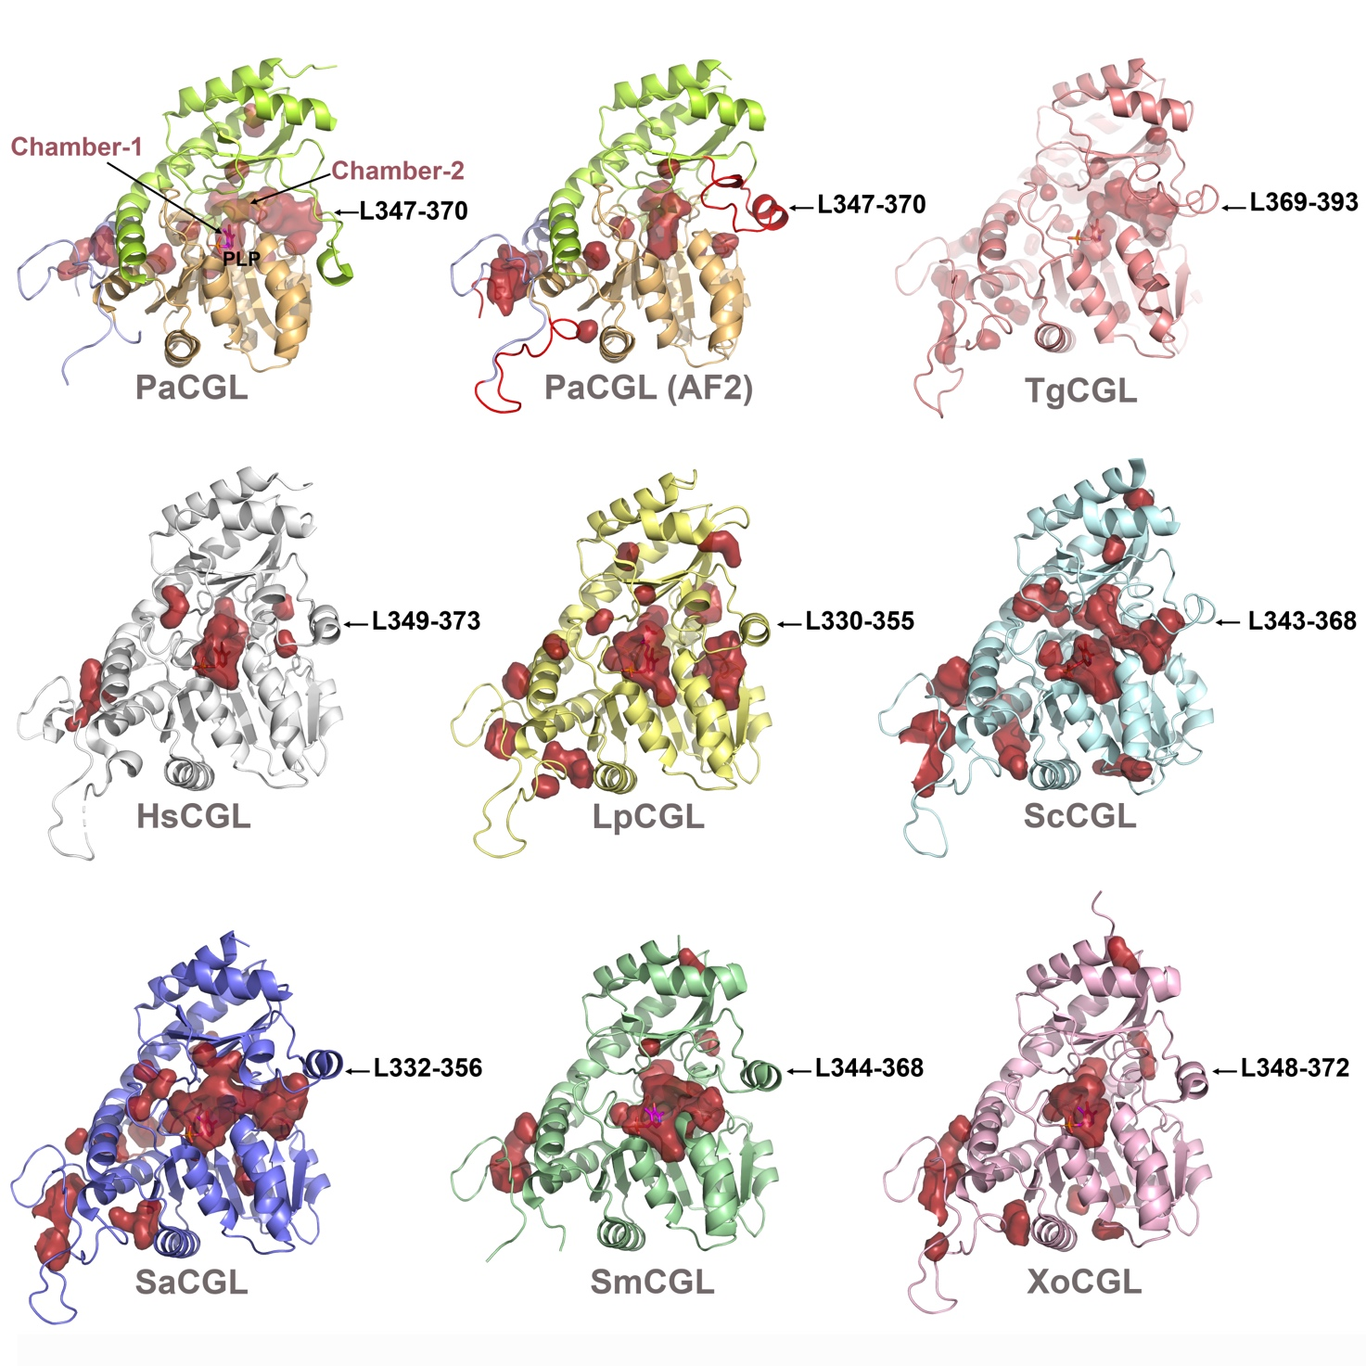
Figure S5. Main cavities found in CGLs. Surface representation of main interior cavities found in all CGLs whose crystal structures are available at present. Chamber-1 corresponds to the catalytic cavity containing the PLP cofactor (in sticks). Chamber-2 is known to host NL1, NL2 and NL3 inhibitors in SaCGL [3]. Interestingly, the size of chamber-1 is essentially conserved in all CGL enzymes. In contrast, chamber-2 varies significantly among species, being smallest in HsCGL, XoCGL or LpCGL. PaCGL-AF2 corresponds to the 3D-model predicted by AF2, where the chamber-2 is significantly smaller and less accessible compared to the chamber-2 identified in our PaCGL crystal structure. Abbreviations: PaCGL, Pseudomonas aeruginosa-crystal structure (PDB ID 7BA4); PaCGL-AF2 (Pseudomonas aeruginosa, predicted with AF2); TgCGL, Toxoplasma gondii (PDB ID 7NL1); HsCGL, Homo sapiens (PDB ID 2NMP); LpCGL, Lactobacillus plantarum (PDB ID 6LDO); ScCGL, Saccharomyces cerevisiae (PDB ID 1N8P); SaCGL, Staphylococcus aureus (PDB ID 7MCB); SmCGL, Stenotrophomonas maltophila (PDB ID 6K1L); XoCGL, Xanthomonas oryzae (PDB ID 4IYO);

Supplementary Movie S1. Conformational change of loop L347-370. Movie showing the potential conformational change suffered by loop L347-370 from the extended state found in the crystals to the helical arrangement predicted by Alphafold2 for this loop. The increased helicity of loop L347-370 in the model predicted by Alphafold2 would correspond to a closed conformation of chamber-2. In this state, this cavity significantly restricts its accessibility and internal volume. On the contrary, chamber-2 is more accessible and ready to host small molecules when the loop adopts the extended conformation found in the crystals.

