Supplementary Materials
Figure 1SM: Deprivation in England and Wales LSOAs, 1971 to 2021
- 1971 Deprivation | - 1981 Deprivation | - 1991 Deprivation
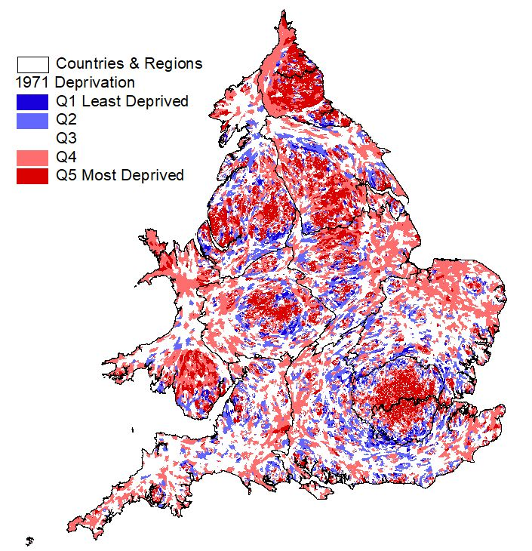 | 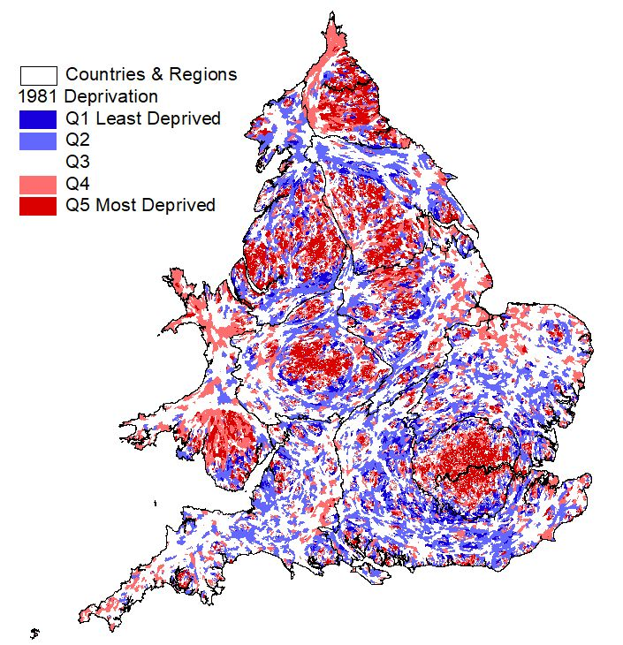 | 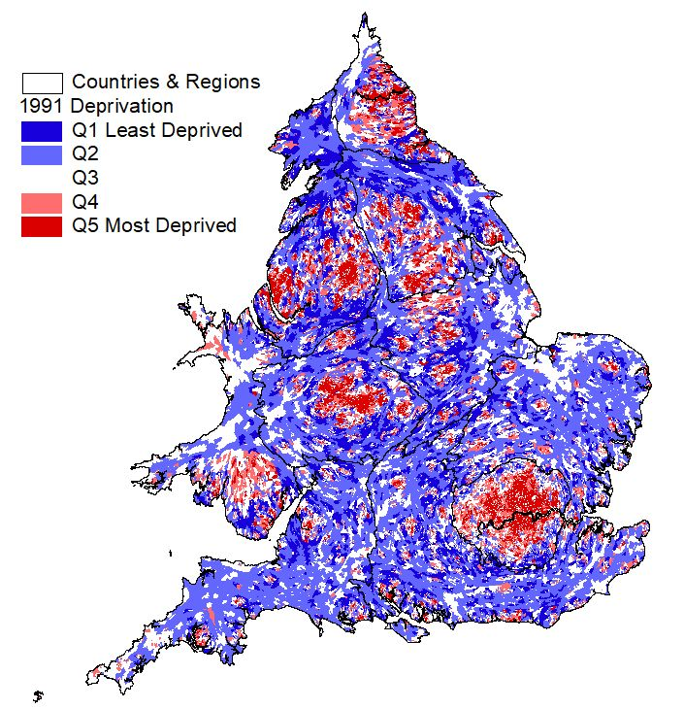
- 2001 Deprivation | - 2011 Deprivation | - 2021 Deprivation
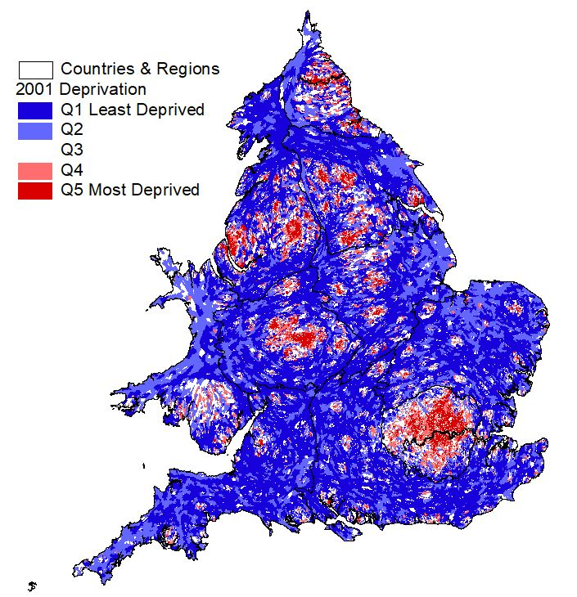 | 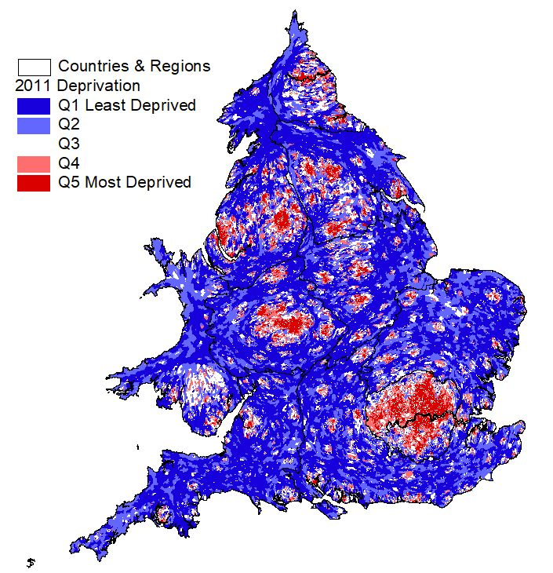 | 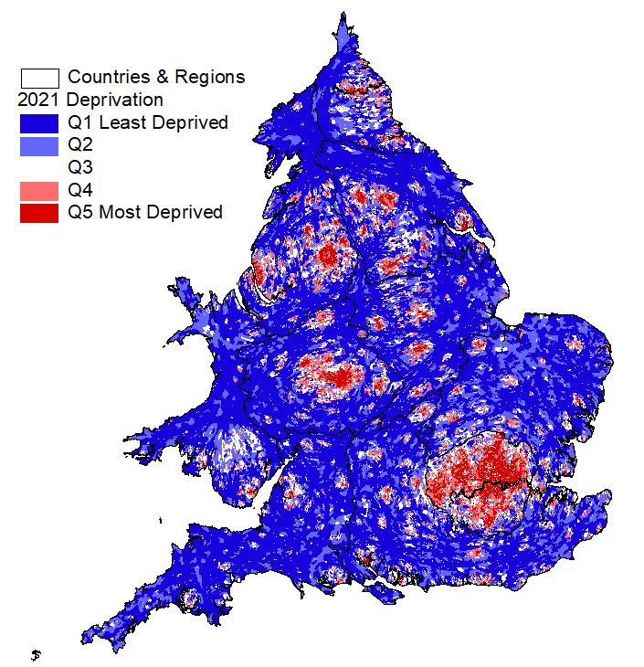

Figure 2SM: ONS Supergroups Classification of Local Authorities, 2001
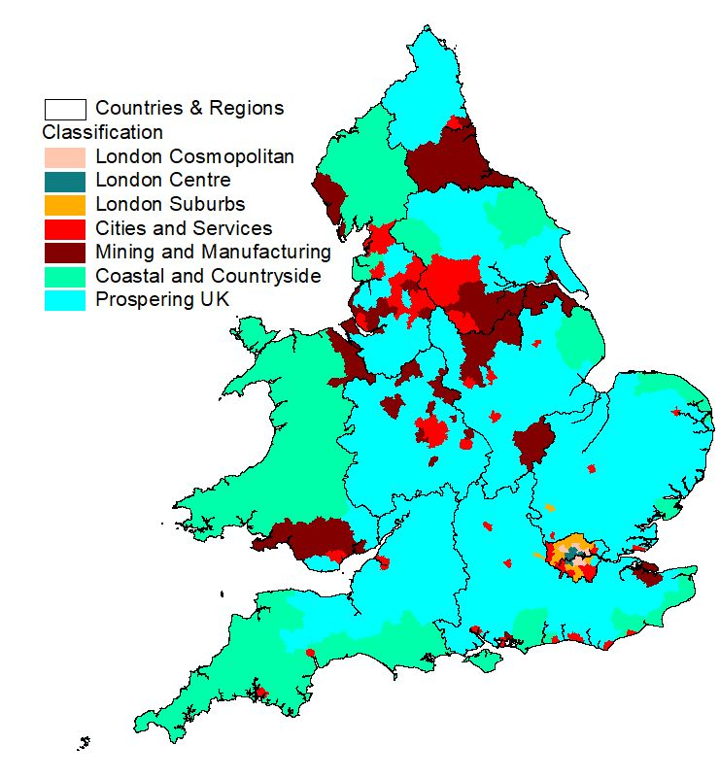

Table 1SM: Distribution of Deprivation Trajectories within each Supergroup
 |  | Deprivation Trajectory
 | Counts | Persistently Deprived | Worsening Deprivation | Moderately Deprived | Less Deprived | Persistently Not Deprived | Total
Supergroups | London Centre | 635 | 23 | 236 | 28 | 1 | 923
Supergroups | London Cosmopolitan | 688 | 315 | 99 | 42 | 7 | 1,151
Supergroups | London Suburbs | 204 | 873 | 139 | 446 | 232 | 1,894
Supergroups | Cities and Services | 1,652 | 795 | 1,765 | 2,087 | 1,598 | 7,897
Supergroups | Mining and Manufacturing | 777 | 87 | 1,916 | 1,904 | 1,630 | 6,314
Supergroups | Coastal and Countryside | 93 | 10 | 506 | 1,356 | 1,223 | 3,188
Supergroups | Prospering UK | 253 | 216 | 1,815 | 4,190 | 6,984 | 13,458
 | Total | 4,302 | 2,319 | 6,476 | 10,053 | 11,675 | 34,825

 |  | Deprivation Trajectory
 | Percentages | Persistently Deprived | Worsening Deprivation | Moderately Deprived | Less Deprived | Persistently Not Deprived | Total
SuperGroups100 | London Centre | 68.8 | 2.5 | 25.6 | 3.0 | 0.1 | 100
SuperGroups100 | London Cosmopolitan | 59.8 | 27.4 | 8.6 | 3.6 | 0.6 | 100
SuperGroups100 | London Suburbs | 10.8 | 46.1 | 7.3 | 23.5 | 12.2 | 100
SuperGroups100 | Cities and Services | 20.9 | 10.1 | 22.4 | 26.4 | 20.2 | 100
SuperGroups100 | Mining and Manufacturing | 12.3 | 1.4 | 30.3 | 30.2 | 25.8 | 100
SuperGroups100 | Coastal and Countryside | 2.9 | 0.3 | 15.9 | 42.5 | 38.4 | 100
SuperGroups100 | Prospering UK | 1.9 | 1.6 | 13.5 | 31.1 | 51.9 | 100
 | Total | 12.4 | 6.7 | 18.6 | 28.9 | 33.5 | 100

