CuO/PANI nanocomposites: An efficient catalyst for degradation and reduction of pollutants
Ammara ¹, Sadia Noreen ¹, Sarmed Ali², Saba Jamil¹, Shamsa Bibi¹, Muhammad Jamshed Latif¹,Touseef Jafar¹, , Arslan Bashir¹, Shanza Rauf Khan¹
(SUPPLEMENTARY INFORMATION)
- Synthesis of copper oxide nanoparticles
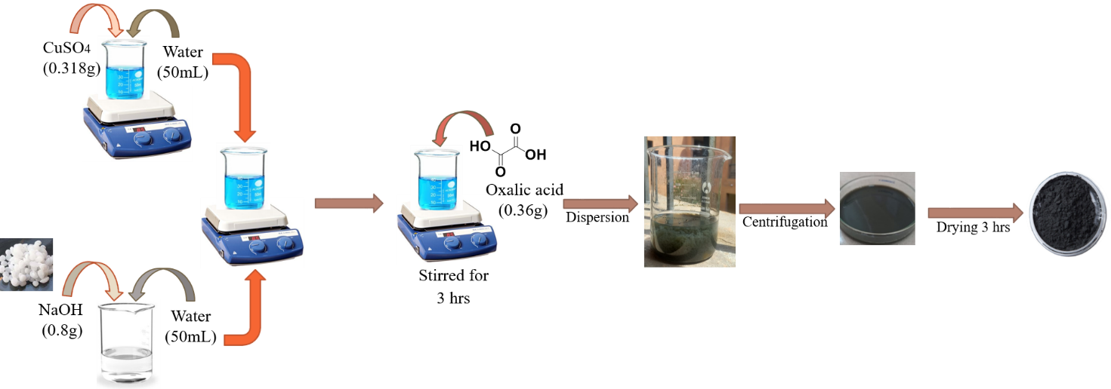

Fig S1. Schematic diagram of CuO nanoparticle
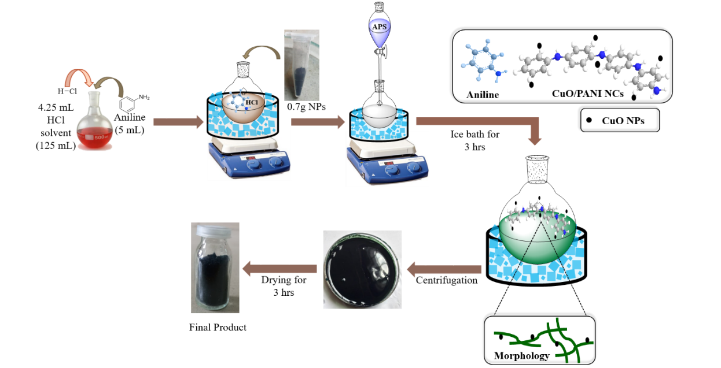
- Synthesis of copper oxide/polyaniline nanocomposites
Fig S2. Schematic diagram of CuO/PANI nanocomposite

- XRD


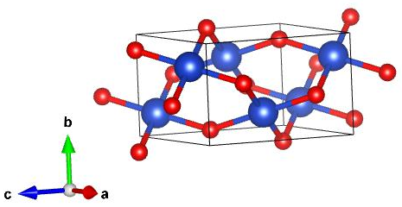
(a)
O-atom
Cu-atom
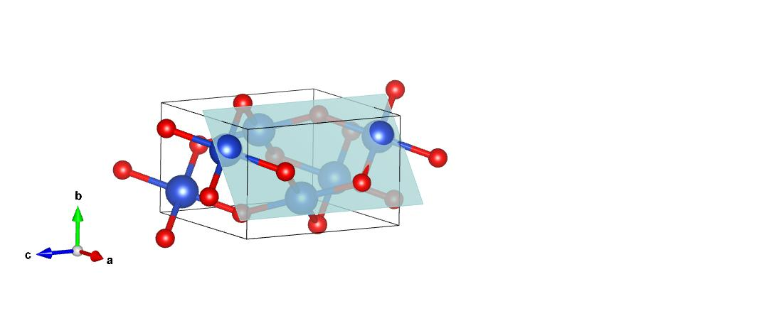
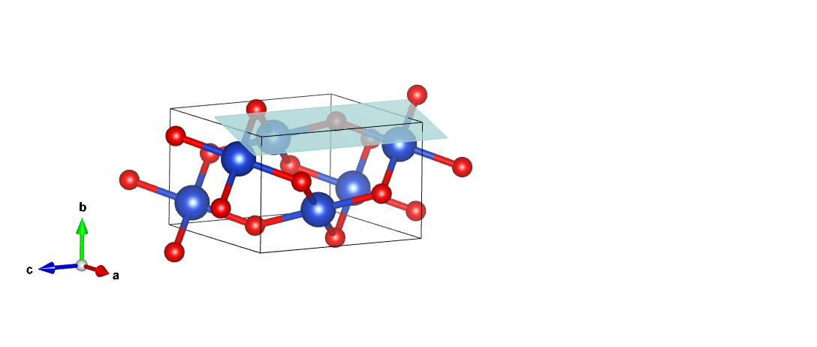
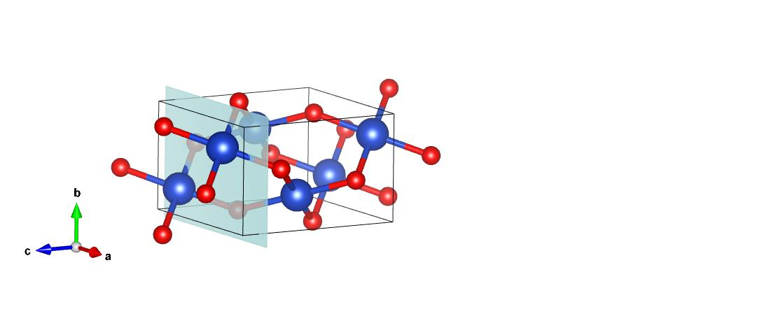
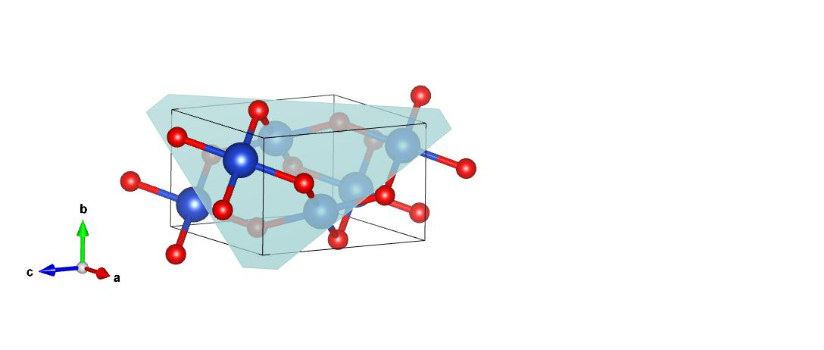
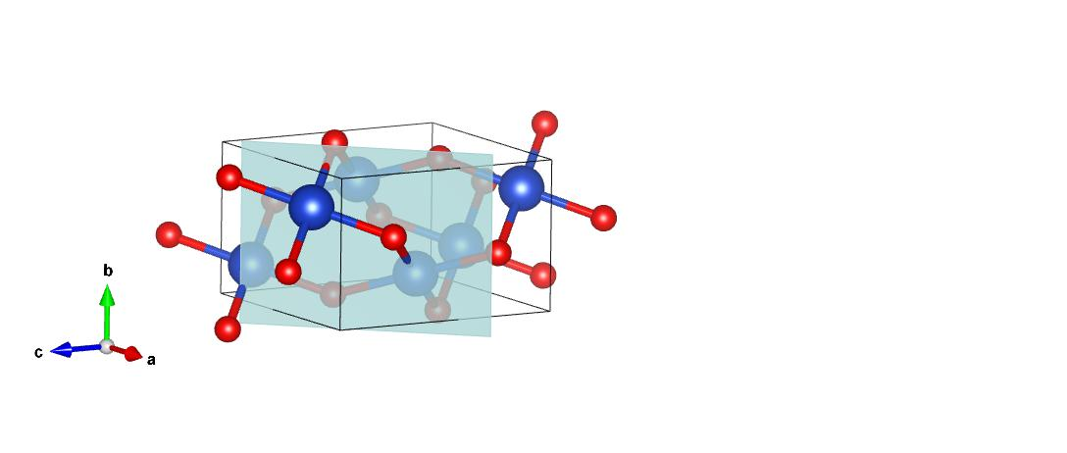
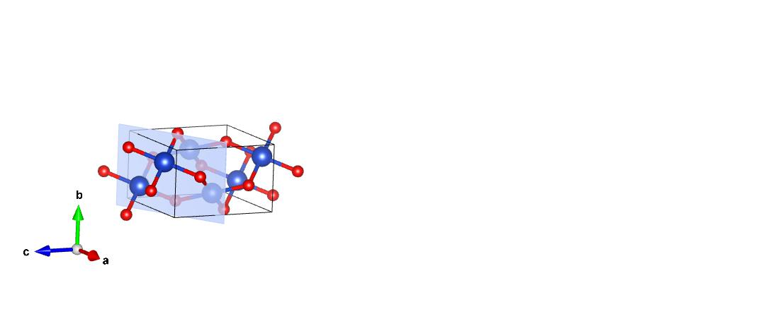
(102)
(210)
(121)
(002)
(111)
(202)

Fig 3. Monoclinic crystal system of CuO (a). Unit cell with different bonding arrangements of atoms with miller indices.
Table 1. Summary of structural parameters of CuO nanoparticles
Parameters | Details
Name of compound | Copper oxide NPs
Crystal system | Monoclinic
Space group | C 2/c (1 5)
Type | Primitive
Cell parameters:  a, b and c (Å)  β (º) | 4.6530, 3.4100, 5.1080  99.480
x, y and z coordinates for Cu atom | 0.2500, 0.2500 and 0.2500
x, y and z coordinates for O atom | 0.000, 0.000 and 0.000
d-spacing, 2 theta (º) and miller indices (hkl) | 7.5747, 16.76 and (101)  5.3922, 24.00 and (210)  4.3709, 32.51 and (110)  4.1917, 34.06 and (121)  3.3680, 35.64 and (002)  3.3316, 38.69 and (111)  2.8621, 52.02 and (112)  2.096, 53.44 and (020)  2.074, 57.87 and (021)  2.024, 61.59 and (202)
I/Ic | 4.92
Density (g/cm³) | 6.608

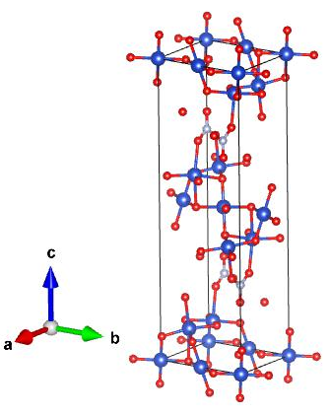
(b)





O-atom
Cu-atom
N-atom
C-atom
H-atom

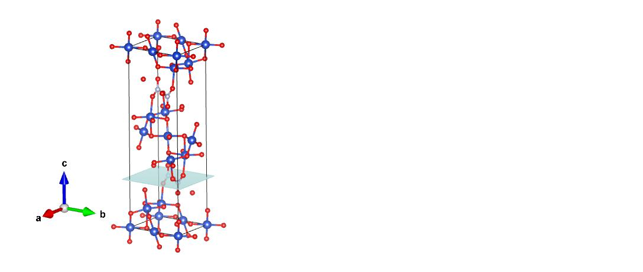
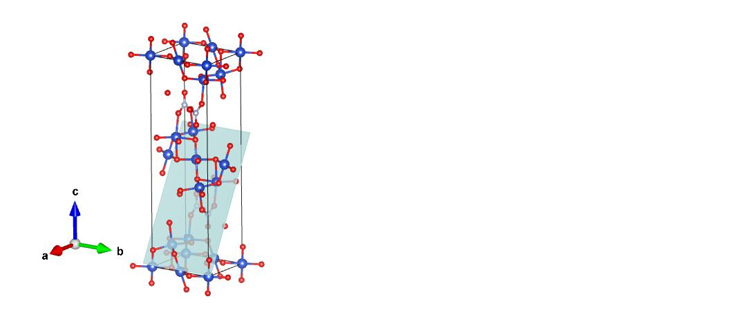
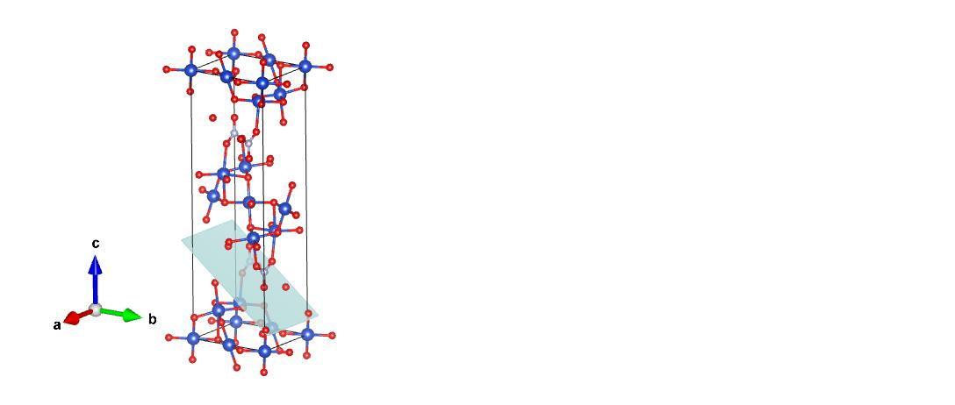
(004)
(102)
(014)

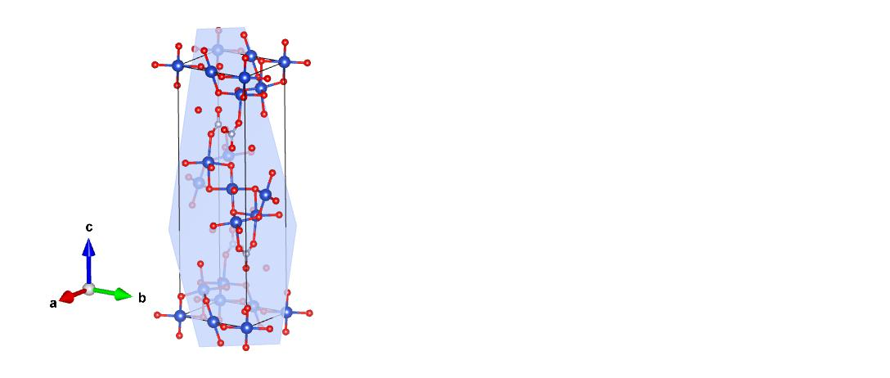
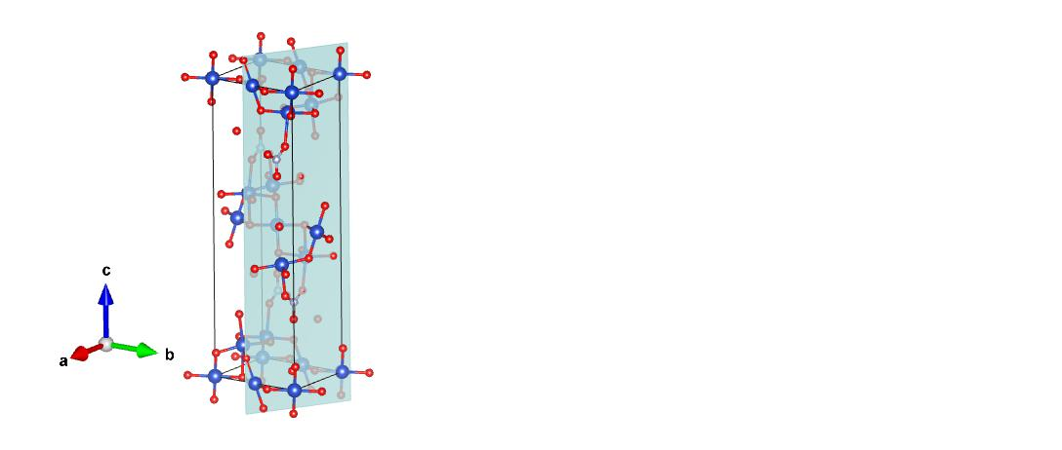
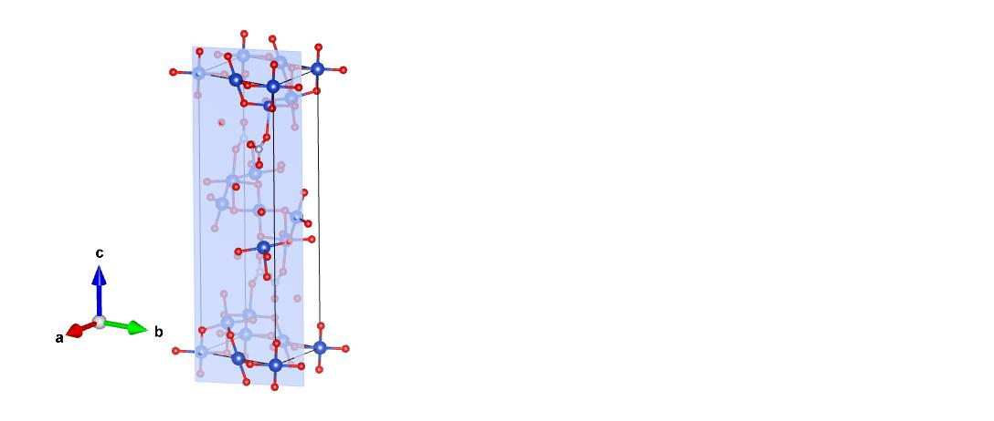
(111)
(210)
(120)

Fig 4. Orthorhombic crystal system of CuO/PANI nanocomposite (b). Unit cells with miller indices.

Table 2: Summary of structural parameters of CuO/PANI nanocomposites

Parameters | Details
Name of compound | CuO/PANI NCs
Crystal system | Orthorhombic
Space group | P c m n (6 2)
Type | Primitive
Cell parameters:  a, b and c (Å)  α, β and γ (º) | 5.8300, 6.7750 and 21.7110  111.9790, 96.8790 and 106.6780
x, y and z coordinates for Cu atom | 0.16819, 0.39624 and 0.29210
x, y and z coordinates for O atom | 0.24510, 0.50330 and 0.49580
x, y and z coordinates for N atom | 0.14420, 0.72260 and 0.30980
x, y and z coordinates for Nʹ atom | 0.11890, 0.59480 and 0.29720
x, y and z coordinates for C atom | 0.11890, 0.59480 and 0.29720
d-spacing, 2 theta (º) and miller indices (hkl) | 3.6387, 10.56 and (002)  2.6930, 16.27 and (004)  2.5211, 17.25 and (102)  2.2075, 21.19 and (014)  1.8692, 25.38 and (105)  1.6960, 39.79 and (206)  1.4868, 56.51 and (229)  1.4530, 65.23 and (404)
I/Ic | 3.64
Density (g/cm³) | 2.895

- SEM
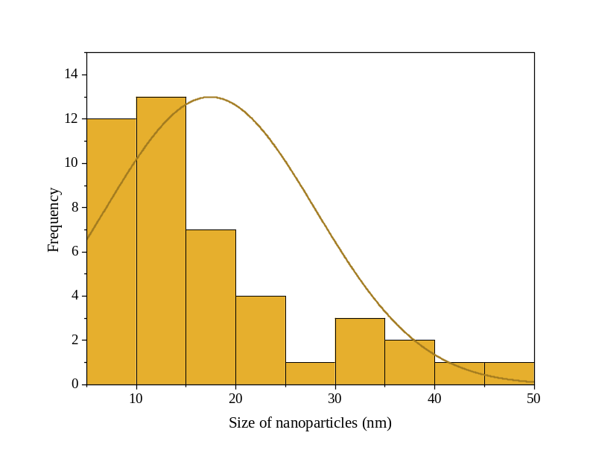

Fig 5. Histogram size distribution graph of the synthesized needle-like CuO nanoparticles

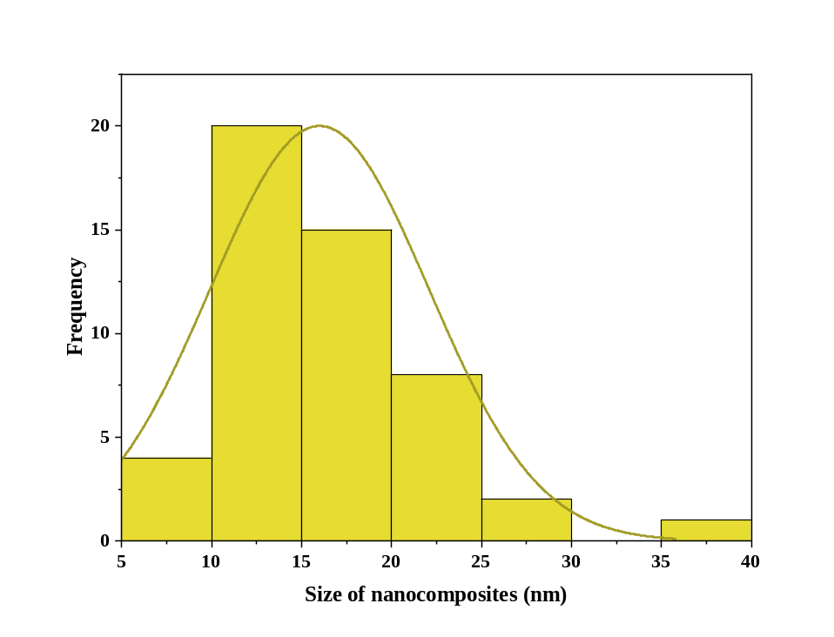
Fig 6. Histogram size distribution graph of the synthesized CuO/PANI nanocomposites
- EDX
Table 3. Showing the atomic and weight percentage of the elements present in (a) CuO nanoparticles (b) CuO/PANI nanocomposite.
Spectrum (a)
Element | Weight % | Atomic %
C K
O K | 62.92 | 24.94
Cu K | 37.08 | 70.06
Total | 100.00

Spectrum (b)
Element | Weight% | Atomic%
C K | 70.79 | 78.11
O K | 23.94 | 19.83
S K | 3.38 | 1.40
Cl K | 1.58 | 0.59
Cu K | 0.31 | 0.07
Totals | 100.00

- FTIR
Table 4 Summary of all the characteristic bands observed along with their functional groups, vibrations and wavenumber
Functional Group | Vibrations | Wavenumber (cm⁻¹)
Carbonyl group  (C=O) | Stretching | 1735, 1638
Carboxylic acid  (C-O) | Stretching | 1319, 849
Hydroxyl compounds  (O-H) | Stretching | 3349
Ketone  (C-H) | Stretching | 765
Allenes  (C=C=C) | Stretching | 1994
Primary Amines  (N-H) | Stretching | 3317
Aliphatic amines  (C-N) | Stretching | 1209
Alkenes  (C=C) | Stretching | 1388, 1528
Cu-O | Bending | 652
PANI matrix | Stretching | 700, 765

Corresponding author: shanzaraufkhan@gmail.com

