Original image for checking
Stem cells ameliorate neurotrauma-induced visual disturbances and retinopathy via broad normalization of the β-catenin-related signaling pathway
Suan Hwang¹, Chia-Yi Lee¹, Chung-Hsin Tseng², Ting-Feng Wu³, Pi-Yu Chao², Wen-Pin Liu², Anthony Lu², Chao-Hung Yeh^{2,4}, Ching-Ping Chang², Chung-Ching Chio⁵, Shu-Chun Kuo^{1,4}

¹Department of Ophthalmology, Chi Mei Medical Center, Tainan, Taiwan
²Department of Medical Research, Chi Mei Medical Center, Tainan 710, Taiwan
³Department of Biotechnology and Food Technology, Southern Taiwan University of Science and Technology, Tainan 710, Taiwan
⁴Department of Optometry, Chung Hwa University of Medical Technology, Tainan, Taiwan
⁵Division of Neurosurgery, Department of Surgery, Chi Mei Medical Center, Tainan 717, Taiwan

Correspondence to:
Ching-Ping Chang, Ph.D., Department of Medical Research, Chi Mei Medical Center. Address: No. 901, Zhonghua Rd, Yongkang District, Tainan City 710, Taiwan. Phone: +886-6-2812811 ext 52657; fax: +886-6-2832639; e-mail: jessica.cpchang@gmail.com or a50831@mail.chimei.org.tw
Chung-Ching Chio, M.D., Division of Neurosurgery, Department of Surgery, Chi Mei Medical Center. Address: No. 901, Zhonghua Rd, Yongkang District, Tainan City 710, Taiwan. Phone: +886-6-2812811 ext 52000; fax: +886-6-2832639; e-mail: chiocc@ms28.hinet.net
Shu-Chun Kuo, M.D., Department of Ophthalmology, Chi Mei Medical Center. Address: No. 901, Zhonghua Rd, Yongkang District, Tainan City 710, Taiwan. Phone: +886-6-2812811 ext 52000; fax: +886-6-2832639; e-mail: ophkuo@gmail.com

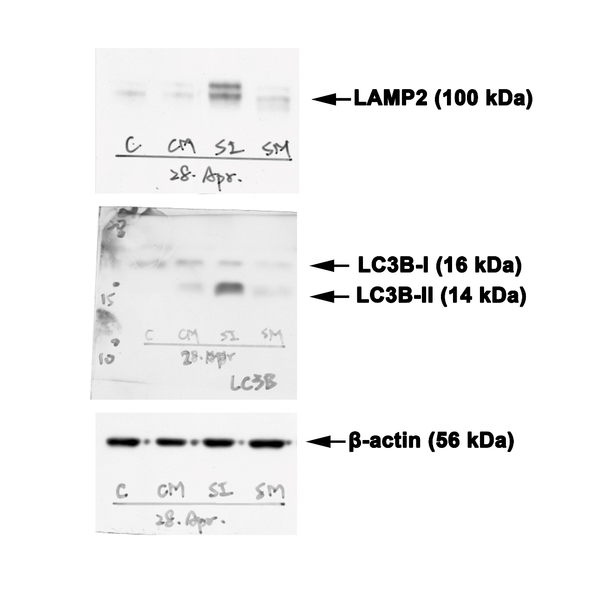

Supplementary Figure S1: Original Western blots for Figure 7 (A). Labels on the right of each x-film scan indicate the antibody used for detection. Dashed red boxes show the regions that were cropped for the figures.

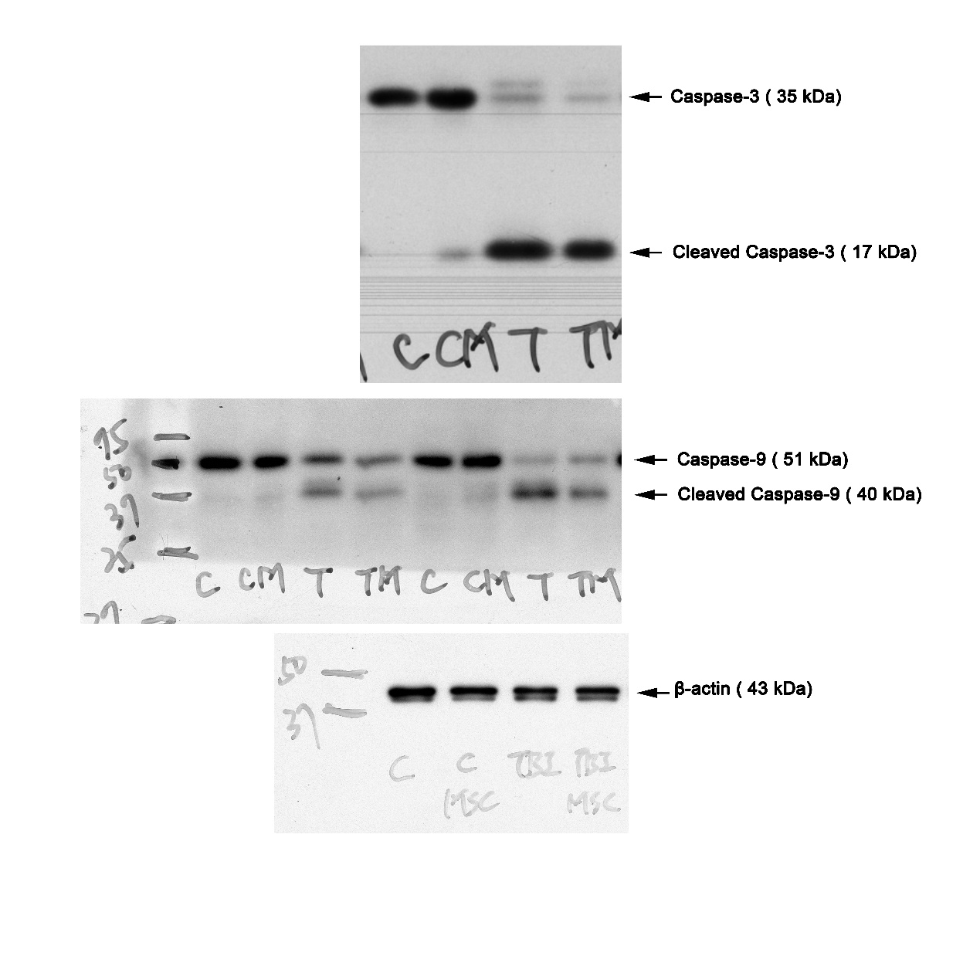
Supplementary Figure S2: Original Western blots for Figure 8 (C). Labels on the right of each x-film scan indicate the antibody used for detection. Dashed red boxes show the regions that were cropped for the figures.
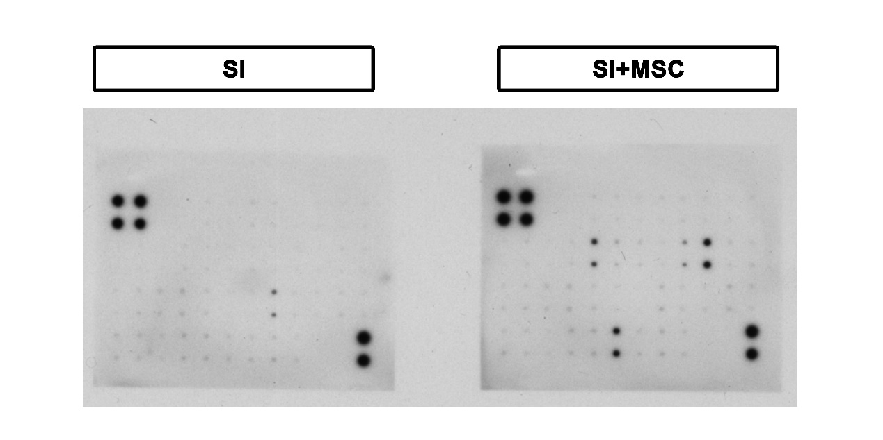
Supplementary Figure S3: Original Western blots for Figure 9 (A). Labels on the right of each x-film scan indicate the antibody used for detection. Dashed red boxes show the regions that were cropped for the figures.
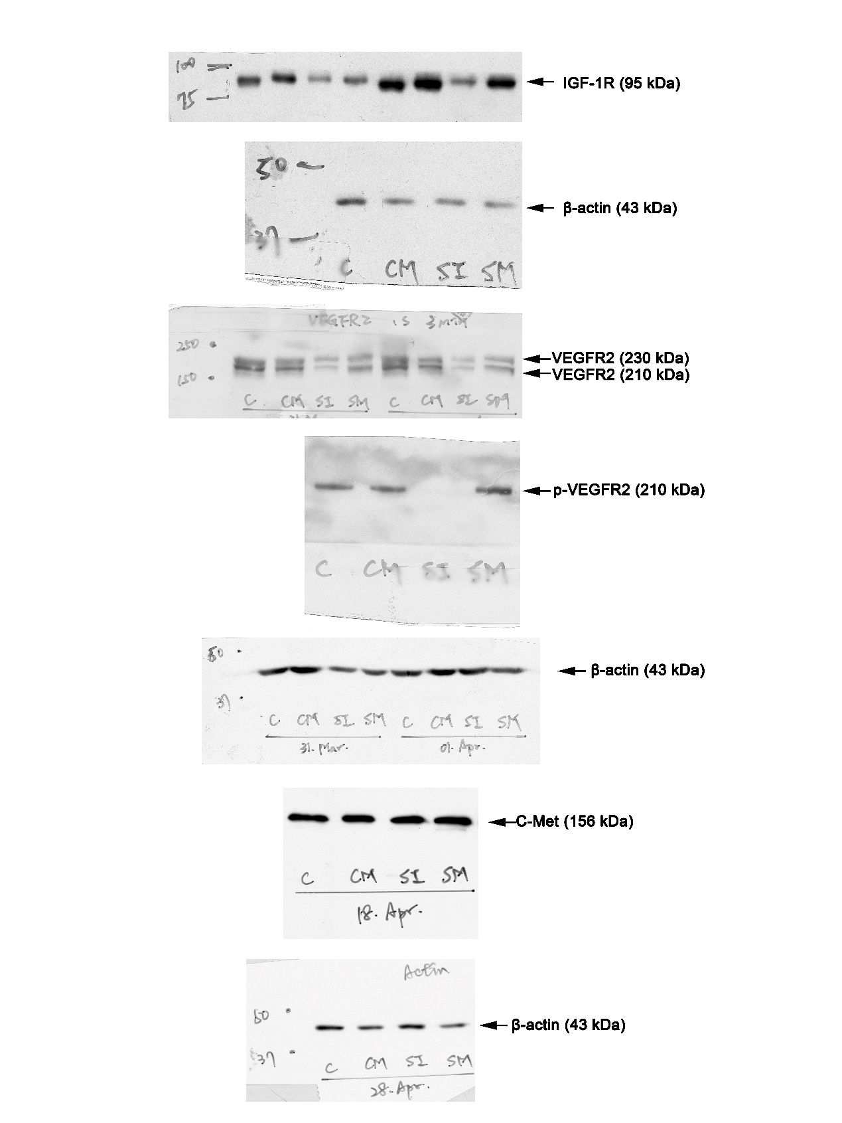
Supplementary Figure S4: Original Western blots for Figure 9 (B). Labels on the right of each x-film scan indicate the antibody used for detection. Dashed red boxes show the regions that were cropped for the figures.
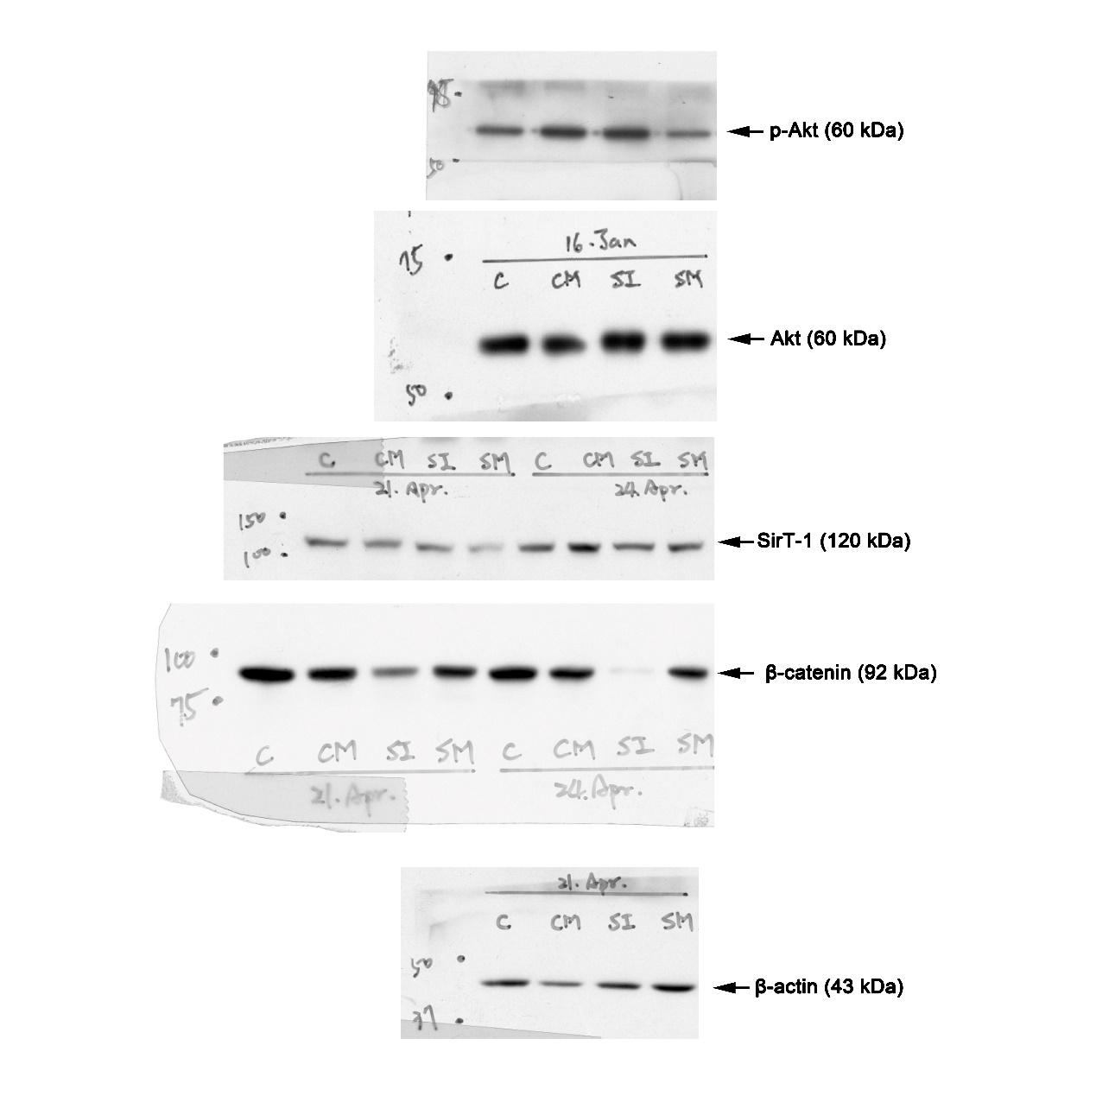
Supplementary Figure S5: Original Western blots for Figure 9 (C). Labels on the right of each x-film scan indicate the antibody used for detection. Dashed red boxes show the regions that were cropped for the figures.

