Extended data - Methods:
Elicitation of Indigenous Knowledge
A range of collaborative research methods were employed throughout this study and where possible Indigenous-led methods were the foundations, to ensure mutual benefits are achieved for all participants engaged. The study was grounded in the four key principles that empower Indigenous peoples to drive positive outcomes for biodiversity and people on Country²⁶; to benefit the Indigenous community; to be undertaken for and with the community, in line with their aspirations, needs and interests; to promote their cultural values; and to be emancipatory²⁶.

To guide our workshops we used a structured decision-making framework^{27,28}, using Indigenous-led approaches and tools to identify Bundjalung-led management actions (Extended data Figure 1), demonstrating a place-based and scale-based approach to the genuine collaborative management of CSE. Structured decision-making is effective when collaborating with Indigenous groups and for setting management objectives and actions ^{29,30} because it supports participatory and transparent decision-making processes, and works to clearly identify what is in and out of scope.

The complete structured decision-making process we undertook resulted in three outputs; 1) Indigenous-led development of bio-cultural objectives and related measures for identification of CSE and assessment of collaborative management actions of CSE ⁴; 2) the identification and prioritization of Bundjalung-led Cultural Significant Entities, exemplifying a place-based and scale-based approach to the designation of CSE, and; 3) the identification of Bundjalung-led CSE management actions to be implemented under a collaborative approach.

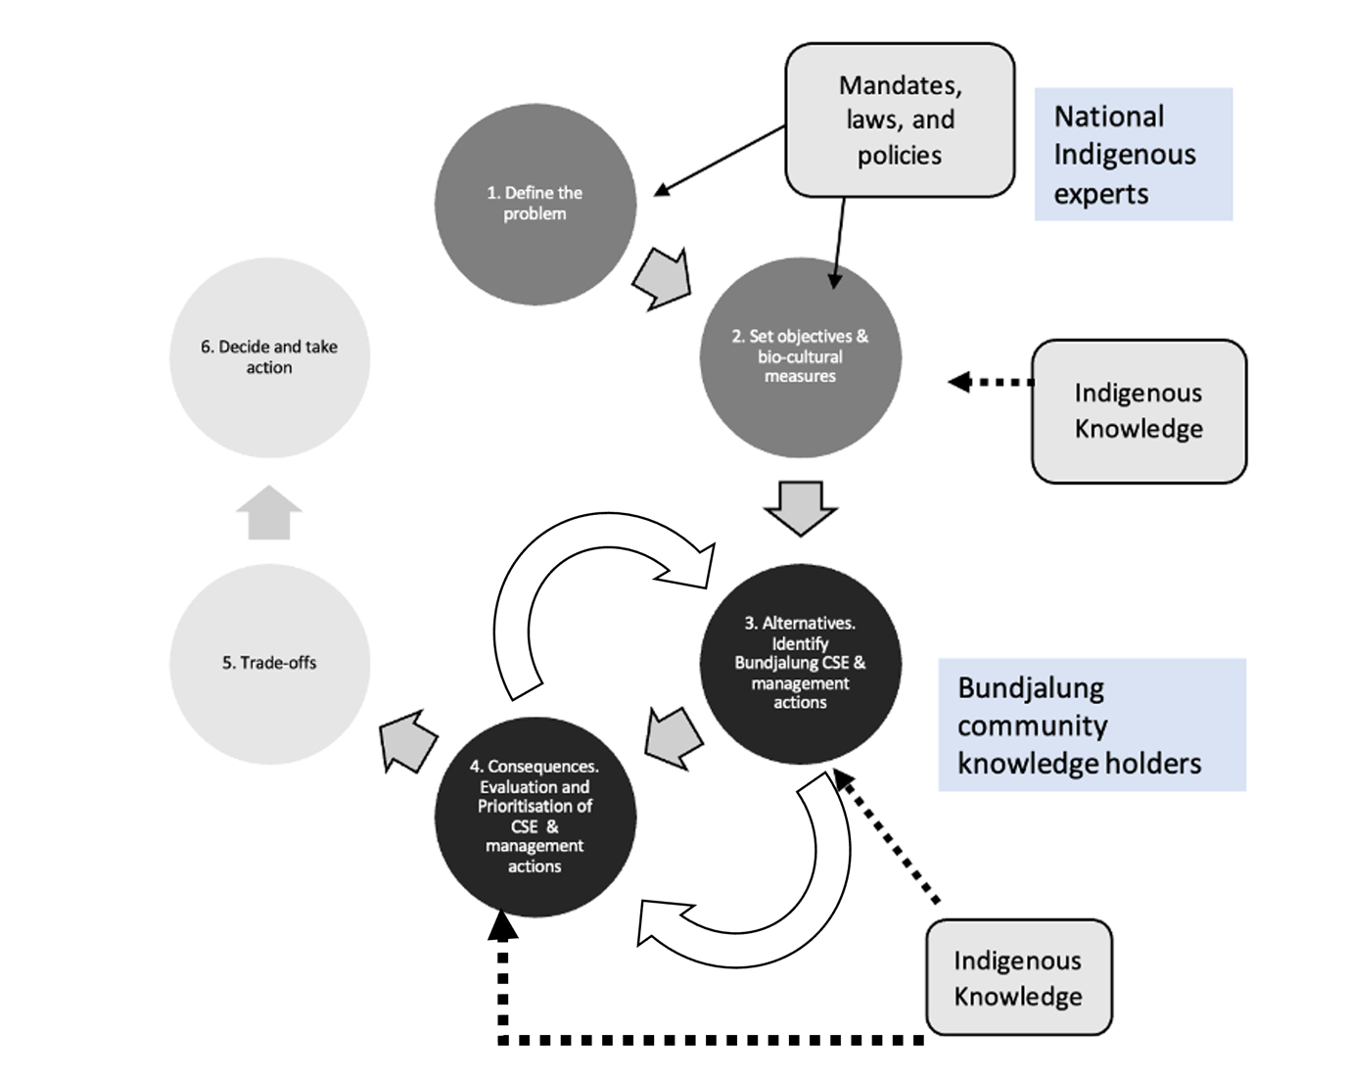

Extended data Figure 1: Structured decision-making framework employed in the identification and prioritization of Bundjalung-led Cultural Significant Entities adapted from ^{30,31}. The steps are iterative, with feedback between each step to the community. The iterative steps three and four are the focus of this study.

We developed a formal partnership through the Bundjalung-led Jagun Alliance Aboriginal Corporation (JAAC), which was crucial in ensuring the study was conducted in a culturally secure manner and grounded in the empowered Indigenous-lens²⁶. Ethics and methods were co-authored with JAAC. The study was carried out with approvals from JAAC and the University of Melbourne Human Research Ethics (approval number 24293). A data sharing agreement was central to the partnership with all data stored and owned by JAAC and the Bundjalung community. JAAC were able to leverage existing relationships and reputation in community to engage Bundjalung leaders and experts in CSE and traditional management approaches. Indigenous co-authors were renumerated for their expertise and Bundjalung Community participants were provided with travel allowances.

Cultural landscape
Bundjalung Country (Extended data Figure 2) comprises of about ten clan groups, covering an area from Logan River in the north, to the Clarence River in the South, and from the coast to the Warwick in the west. In recent years, Bundjalung Country has been severely impacted by natural disasters. Including the 2022 floods and the 2019-2020 bush fire season ¹⁹. In the bioregion, there are currently 349 entities listed under the NSW Threatened Species Conservation Act plus 21 species listed on the EPBC Act. The region is also subject to 36 key threatening processes ¹². For decades, Bundjalung have been advocating to decision makers to draw on the wealth of their knowledge system to manage Country ³², emphasizing that the Bundjalung community want to see their Country healthy and plentiful.
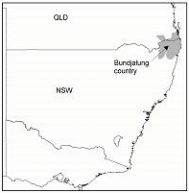
Extended data Figure 2: Location of Bundjalung Country in North-Eastern New South Wales, Australia.

Structured Decision-Making framework
Step one: Developing an Australian-centric definition for CSE and its alignment to laws and mandates.
The first step in decision-making is determining what is the context for the decision. We convened a roundtable of Indigenous experts (N = 5), who have extensive experience in Indigenous-led work of national and international matters relating to biodiversity. The expert group emphasized the connections with international mandates, laws, and policies. As an output of these discussions the group proposed a suite of reform options and policy recommendations for the Australian government to consider in its review of the EPBC Act ⁴.
Step two: Setting objectives and biocultural measures.
The expert group co-authored the foundational objectives and biocultural measures for CSE which recognize the environmental, social, spiritual wellbeing, economic and cultural values of the Indigenous Estate. In structured decision making, it is important that all foundational (or fundamental) objectives are defined and measurable, to enable evaluation of the performance of policy and management strategies ²⁷. In this case, the CSE developed would be evaluated in relation to the objectives and biocultural measures. Using a collaborative online document (google docs) the group of experts refined the objectives and biocultural measures over a six-month period. The group then used these objectives to develop the structured decision-making rapid prototyping template (Supplementary Data Table 1) used in Bundjalung community workshops ^{27,31,33,34}.

A group of Bundjalung knowledge holders (N=20) gathered on a culturally significant site which overlooked Bundjalung Country. The aim of the gathering was the reaffirm Bundjalung aspirations to identify CSE for collaborative management. The objectives and biocultural measures were then evaluated with Bundjalung knowledge holders to test the relevance for a place-based approach ³¹. Culturally, security was key to the workshops, and this was supported by Aboriginal facilitators (male and female), who led the discussions. Facilitators enabled everyone to be heard in both formal and informal free-flowing discussions and employed active listening. They were able to get endorsement from the group on the objectives and performance measures, with some nuances to the wording. The workshop concluded with a cultural practice, traversing the cultural site, and sharing knowledge and a cultural burning, this was vital to as participants actively added to each other’s comments and common themes and aspirations became clear.
Step three(a): Identifying alternatives for Bundjalung designation CSE.
The options generation step in structured decision-making was used to list all the species under consideration. In this context, a subset of Bundjalung knowledge holders (N=10) gathered on Minyumai IPA. The workshop commenced with a cultural practice and Welcome to Country, the group was able to spend some time celebrating the successes to the IPA and participating in a knowledge exchange. Using the rapid prototyping template (Supplementary Data Table 1) the group brainstormed and identified CSE against objectives (Table 1) and measures ²⁸. Participants shared their cultural connections and practices associated with the identified entities; however, this information was intentionally not recorded to ensure culturally sensitive information was not indirectly or unintentionally captured and control of cultural IP was lost.
Table 1: Indigenous-led objectives for the identification and collaborative management of CSE under the domains of CSE identification⁵.
Domain | Objectives
Country | Improve cultural land/seascape health and protection
Country | Improve cultural and spiritual connection, health, and wellbeing
Culture | Increase cultural knowledge transfer in a culturally secure manner
Culture | Promote Indigenous Knowledge as the first science
Kin | Empowering Indigenous-led governance structures
Kin | Emphasize cultural responsibility and autonomy to Country

Step four (a): Evaluating Culturally Significant Entities.
The consequences step in structured decision making is undertaken by experts to determine how effective management actions are in addressing objectives. Indigenous knowledge holders are the experts on CSE, and workshop participants were happy to identify CSE but felt it wasn’t culturally appropriate to prioritize the CSE for collaborative management approaches. As such, they requested a survey distributed to the wider Bundjalung community as a more transparent decision-making process for prioritization. The Bundjalung-led survey was co-authored with JAAC and circulated throughout community networks via social media and email. The survey questions consisted of ranking and open-end questions and based on the findings from workshops (Supplementary Data survey questions). The survey was open for 12 weeks and a chance to win gift vouchers for a local Bundjalung owned business were used as an incentive to complete the survey. Using a continuum of importance to determine prioritization, Bundjalung CSE were mapped to demonstrate the culturally significant species most preferred for collaborative management approaches ².

Once the survey results were analyzed, the prioritized Bundjalung-led CSE were evaluated by JAAC practitioners’ (N=7) who used their expert knowledge of traditional management to predict the likelihood of achieving the objectives via a consequence table. JAAC Knowledge holders were asked if the priority CSE were removed from Country, whether there would be a notable impact on the objectives. The group developed a consensus binary score (No= 0, Yes= 1) ^{1,30,33,35}.

Step three (b): Identifying alternatives for Bundjalung CSE traditional management actions under a collaborative approach.
A group of Bundjalung knowledge holders (N=30) participated in two separate workshops grounded in cultural practice, traversing the cultural sites, and sharing knowledge. We fast tracked discussions with Bundjalung participants to focus on management at the place-based scale ^{27,31,33}, as objectives (Table 1), measures and Bundjalung-led designated CSE were established in earlier working groups (Step 3a). These were informed using the structured decision-making rapid-prototyping template²⁸ (Supplementary Data Table 1). Rapid prototyping entails moving through the steps of structured decision-making rapidly, to see whether a decision can be made, and if not, to highlight the key sticking points in the process.

Bundjalung aspirations were reaffirmed through identification of Bundjalung-led management actions to be implemented for the CSE (Koala, Goanna, Platypus, Echidna, Wedge-tailed Eagle, Coastal Emu, Pipis and Long-necked Turtle). Common threats for these species were also identified as part of the discussions, using a continuum of importance Bundjalung mapped key common threats for CSE.
Step four (b): Estimating consequences.
Indigenous experts determined management action effectiveness in meeting each objective²⁷. In this context, the individual Jagun (N=7) practitioners employed their knowledge of implementing traditional management practices under a collaborative management approach, to assess the nominated Bundjalung-led management actions identified and described in the previous step. Jagun Knowledge holders were asked if the Bundjalung-led CSE management actions were implemented across the Bundjalung landscape, whether there would be a notable impact on the identified objectives (Table 1). The group developed a categorical ranking score to measure the impact of management actions on each objective (2 highly likely, 1 likely, 0 unlikely) ^{1,30,31,34}.

Step five: Evaluating trade-offs.
As all identified CSE were prioritized by the survey participants and all four Bundjalung-led management actions were accepted by the participants, decisions about trade-offs were not required.

Step six: Implementation, monitoring and communication of findings
Local Bundjalung leadership and governments will lead ongoing implementation, monitoring and reporting of outcomes. We investigated how the Bundjalung-led management actions could be integrated with national recovery plans for threatened species, using the Koala as a case study, which is a Bundjalung designated CSE. Bundjalung participants discussed the potential opportunities and barriers to implementation of actions under a collaborative management approach.

At the request of the Bundjalung community, JAAC hosted a gathering with workshop participants and the wider community (N=55) to share findings of the CSE evaluation. A closed meeting ensured that culturally sensitive information was protected. Equally important, the gathering provided an opportunity for the community to heal over a shared vision for their Country.

