Processing of onion samples
Firstly, the onion root tissue was cut into 1cm and the bulb into 1×1cm2 pieces, then it was cleaned by the following methods: sterile water immersion for 2 min; alcohol immersion for 2 min; NaClO immersion for 2 min; alcohol immersion for 1 min; 2 sterile water immersions for 30s, and the sterile water from the last wash was collected to coat the plates, no bacterial growth was found. Finally, the cleaned onion samples were lyophilised, and milled into a powder in and aseptic environment.

Methods for analysing macrogenomic data
The comprehensive profiles of antibiotic resistome were determined by an ARG analysis pipeline (ARGs-OAP, v2.0) based on the generated clean sequences (ARGs-OAP: online analysis pipeline for antibiotic resistance genes detection from metagenomic data using an integrated structured ARG-database). Briefly, the prescreened ARG-like reads via UBLAST were identified against the Structured Antibiotic Resistance Genes database (SARG, v2.2) using BLASTX with the default parameters (e-value ≤ 10-7, sequence identity ≥ 80 %, and alignment length ≥ 25 amino acids). ARG types and subtypes were assigned by a package of customized perl scripts(https://github.com/biofuture/Ublastx_stageone).To compare ARG abundance among samples, we normalized it using 16S rRNA gene data. A previous study has thoroughly described the calculation method(ARGs-OAP: online analysis pipeline for antibiotic resistance genes detection from metagenomic data using an integrated structured ARG-database). Soil microbial community analysis based on metagenomic data reads was conducted using Kraken2 for species annotation. Methods of analysis in supplementary materials

16S rRNA gene sequencing
The PCR primers were 799F (AACMGGATTAGATACCCKG) and reverse primer 1193 R (ACGTCATCCCCACCTTCC). After that, UPARSE.28 was used in a quality control process on the raw data. Quantitative Insights Into Microbial Ecology (QIIME) software was used to process and evaluate the obtained high-quality sequences, and the UPARSE pipeline examined the sequences.With default options and the UPARSE pipeline, we assigned a taxonomy with 97% similarity to RDP for Illumina processing in QIIME.

Isolation and screening of ARBs from onion bulbs
Wash onion bulbs in the same manner as for the DNA pre-treatment of onion samples. The cleaned onion bulbs were ground into a homogenate under liquid nitrogen and diluted 10-fold with PBS buffer. 100 μL of the dilution was evenly spread on R2A medium supplemented with three antibiotics, Ampicillin (15 μg/mL), Roxithromycin (48 μg/mL), and Gentamicin (15 μg/mL), and incubated for 3 days. Single bacteria were selected for isolation culture and purified three times.

Chromatographic conditions
Mobile phase A was 1% acetic acid solution by volume, and mobile phase B was acetonitrile solution containing 1% acetic acid by volume. Elution procedure: 0-5 min, 5%-8% B; 5-7 min, 8%-12% B; 7-12 min, 12%-18% B; 12.00-17.00 min, 18%-22% B; 17-19 min, 22%-35% B; 19-21 min, 35%-100% B; 21-25 min, 100% B; 25-27 min, 100%-5% B. Flow rate: 1.0 mL/sec. 27 min, 100%-5% B. Flow rate: 1.0 mL/min; column temperature: 25 ℃; detection wavelength: 280 nm; wavelength scanning range: 200-900 nm; injection volume: 2 μL. ESI parameter settings: anion mode, nebuliser pressure of 35 psi; desiccant flow rate of 10 L/min; desiccant temperature 325 ℃; collision-induced dissociation (collision-induced dissociation, CID) MS/MS induced collision voltage was 1.00 V; the ion scanning range was 100-1 500 m/z.

Table S1 The basic physicochemical characteristics of the soil (dry matter content) and the organic fertilizer
 | Soil | Pig manure organic fertilizer | Sheep manure organic fertilizer
pH | 8.14±0.34 | 7.63±0.37 | 7.94±0.23
Organic Matter | 16.92±1.80 g/kg | 381.38±48.36 g/kg | 412.29±47.33g/kg
Available Phosphorus | 10.08±1.29 mg/kg | 2.09±0.23 g/kg | 1.78±0.38 g/kg
Available potassium | 168.52±24.71 mg/kg | 8.21±1.73 g/kg | 6.55±1.01 g/kg
Total Nitrogen | 0.83±0.22 g/kg | 19.86±0.65 g/kg | 20.30±0.48 g/kg
Values are presented as mean ± SD (n = 5).

Table. S2. The peak area of 29 phenolic root exudates
 | CK1 | CK2 | CK3 | P1 | P2 | P3 | S1 | S2 | S3
Gallic Acid | 41890000 | 11580000 | 10930000 | 16960000 | 4883000 | 14320000 | 17856000 | 12920200 | 7988000
Catechin | 322900 | 261800 | 182500 | 120600 | 198200 | 820800 | 293800 | 490100 | 1490100
Ferulic Acid | 113400 | 2670000 | 48670 | 296100 | 117100 | 207000 | 47450 | 48510 | 468200
Rutin | 973600 | 773600 | 1239000 | 449000 | 656700 | 633400 | 890000 | 918700 | 963600
Phloridzin | 531600 | 1268000 | 1305000 | 1203000 | 1435000 | 1152000 | 1008000 | 1597000 | 948400
Caffeic Acid | 2740000 | 7801000 | 15030000 | 18150000 | 3680000 | 18740000 | 9110000 | 6403000 | 7040000
Proanthocyanidin | 67620 | 113200 | 48310 | 52090 | 55820 | 100500 | 174600 | 102600 | 27210
Quercetin | 82000 | 84530 | 143500 | 554600 | 399400 | 361800 | 589100 | 357700 | 335600
Syringic acid | 1364600 | 1354700 | 1691000 | 2774000 | 7290000 | 3145000 | 7831000 | 235400 | 5108000
Protocatechuic acid | 1313000 | 1668000 | 1759000 | 3239000 | 2837000 | 4548000 | 1653100 | 1737200 | 2022000
Coumalic acid | 3012000 | 5998000 | 13860000 | 2976500 | 3794000 | 2562000 | 6454100 | 6145000 | 7980000
Luteolin | 90680 | 474300 | 126600 | 139500 | 216600 | 118500 | 61650 | 79190 | 54410
Paeoniflorin | 96520 | 93310 | 2656000 | 210300 | 614900 | 27120 | 2640000 | 2716000 | 1213000
Apigenin | 594600 | 893000 | 198000 | 2604000 | 3974000 | 3136300 | 257200 | 983000 | 574400
Hyperoside | 1758000 | 870100 | 1402000 | 2576000 | 1242000 | 1642000 | 2416000 | 862900 | 1995000
Benzoic acid | 11720000 | 4181000 | 440600 | 15380000 | 17410000 | 478200 | 449800 | 5488000 | 12980000
Resveratrol | 456600 | 183800 | 157200 | 378400 | 250400 | 142200 | 1877800 | 125800 | 188600
Salicylic Acid | 52913000 | 73830000 | 58520000 | 80730000 | 35270000 | 36900000 | 36310000 | 21505000 | 22520000
Isorhamnetin | 977900 | 1140000 | 975900 | 707900 | 415800 | 720500 | 700400 | 861300 | 855700
Naringin | 752200 | 808900 | 750200 | 980400 | 757000 | 114000 | 647100 | 244600 | 724900
Prunin | 304500 | 626700 | 138100 | 609700 | 331800 | 603000 | 1528000 | 943400 | 506300
Chlorogenic acid | 782000 | 1145000 | 1611400 | 2415000 | 1314200 | 1645000 | 4332000 | 4272000 | 3420000
Rutin | 59510 | 18610 | 9310 | 27930 | 27930 | 37250 | 9016 | 9310 | 9304
Kaempferol | 130500 | 601600 | 738700 | 573900 | 198700 | 406100 | 865100 | 898400 | 1007000
P-coumaric acid | 1575500 | 3570000 | 2307000 | 6859000 | 5315000 | 5905000 | 16390000 | 14126400 | 19120000
Cinnamic acid | 15220000 | 15880000 | 16600000 | 12960000 | 13116000 | 15650000 | 15760000 | 16920000 | 17010000
Gentisic acid | 162800 | 110300 | 113400 | 287700 | 206200 | 282300 | 374000 | 246200 | 484600
Isoflavone | 57740 | 49980 | 272400 | 540100 | 74600 | 17970 | 222900 | 169220 | 434300
Epicatechin | 108700 | 439200 | 86010 | 373000 | 108700 | 778800 | 2555000 | 1171000 | 2793000

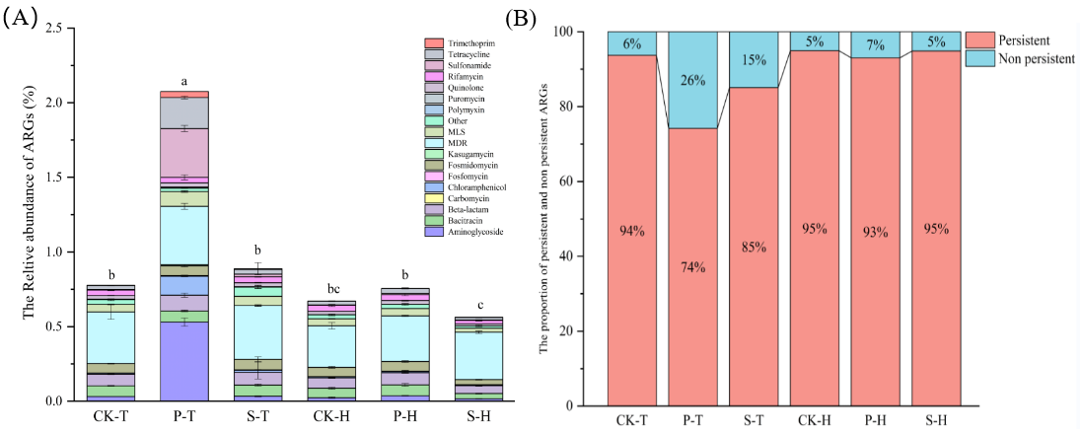
Fig.S1. The relative abundance of ARG in rhizosphere soil (A). The proportion of inherent and additional ARGs in soil(B). Different colors on the bar chart represent different types of ARGs. CK, P, and S respectively represent the treatments of no organic fertilizer application, pig manure organic fertilizer application, and sheep manure organic fertilizer application; T and H represent the onion planting and harvesting periods, respectively. The value is the mean ± standard deviation (n=5). Different lowercase letters represent significant differences (p<0.05).

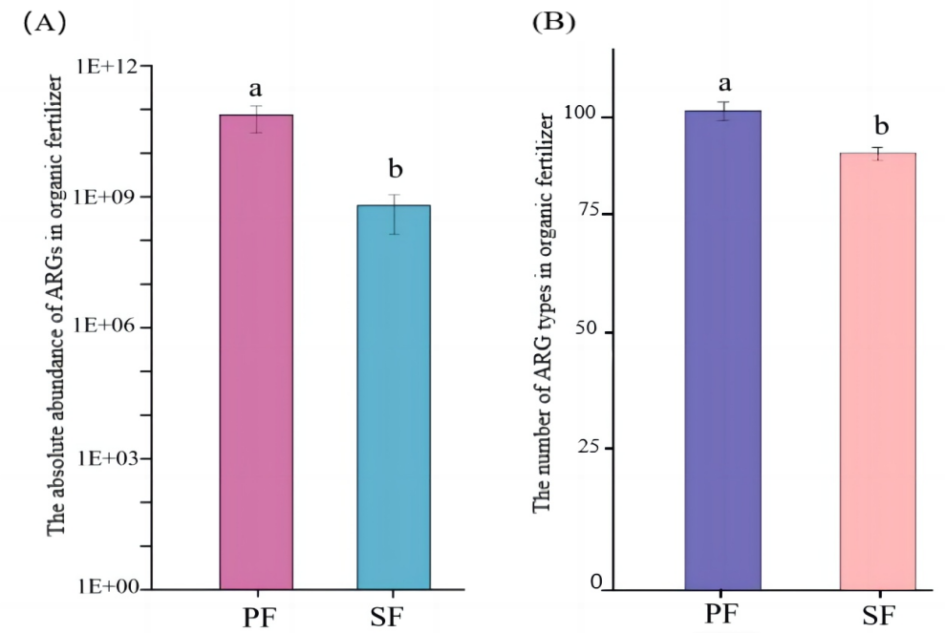
Fig.S2. The absolute abundance of ARGs in organic fertilizer (A). The number of ARG types in organic fertilizer (B). PF and SF represent pig manure organic fertilizer and sheep manure organic fertilizer, respectively. The value is the mean ± standard deviation (n=5). Different lowercase letters represent significant differences (p<0.05).

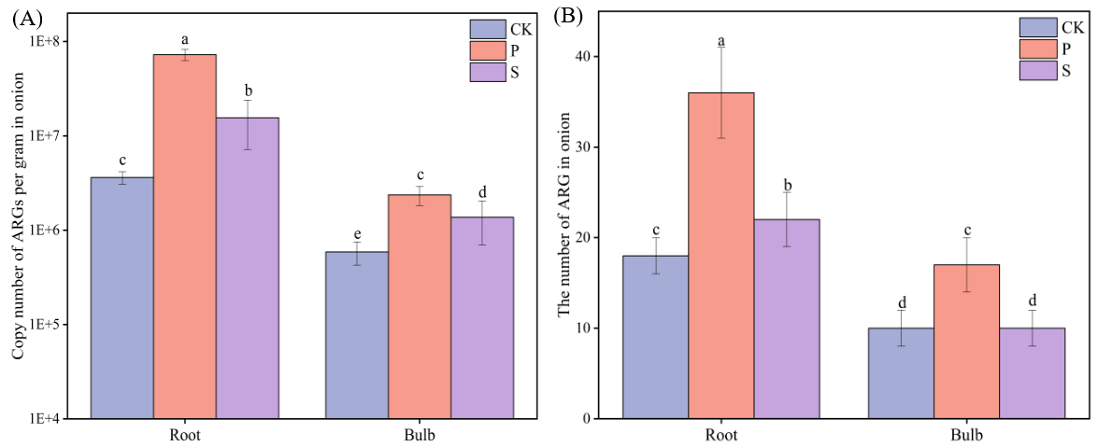
Fig. S3. Copy number of ARGs per gram in onion (A). The number of ARG in onion (B). The value is the mean ± standard deviation (n=5). Different lowercase letters represent significant differences (p<0.05).
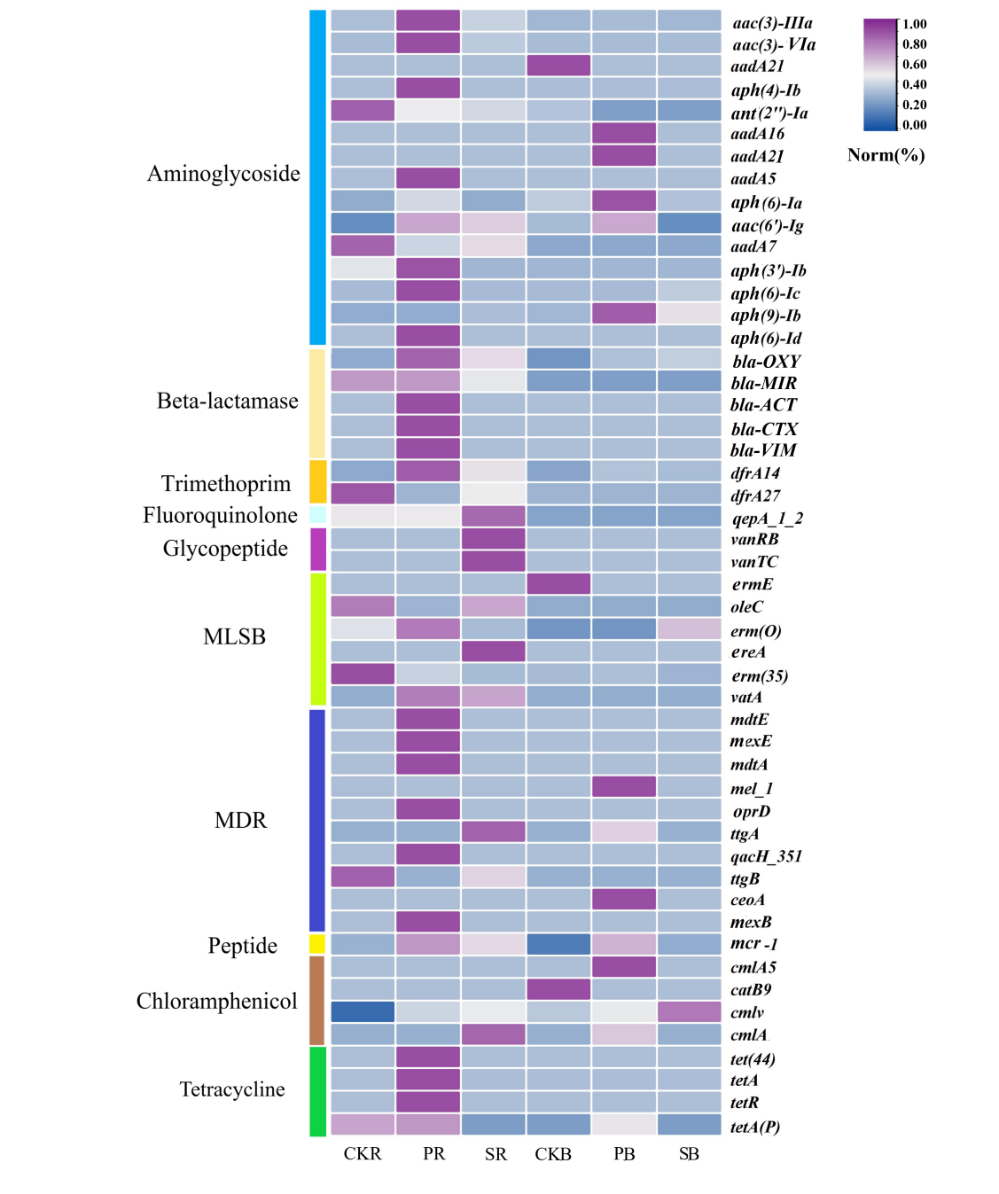
Fig. S4. The relative abundance of ARG in onions. CK, P, and S represent treatments without organic fertilizer, with pig manure organic fertilizer, and with sheep manure organic fertilizer, respectively; R and B represent the root and bulb tissues of onions, respectively. Normalize each row

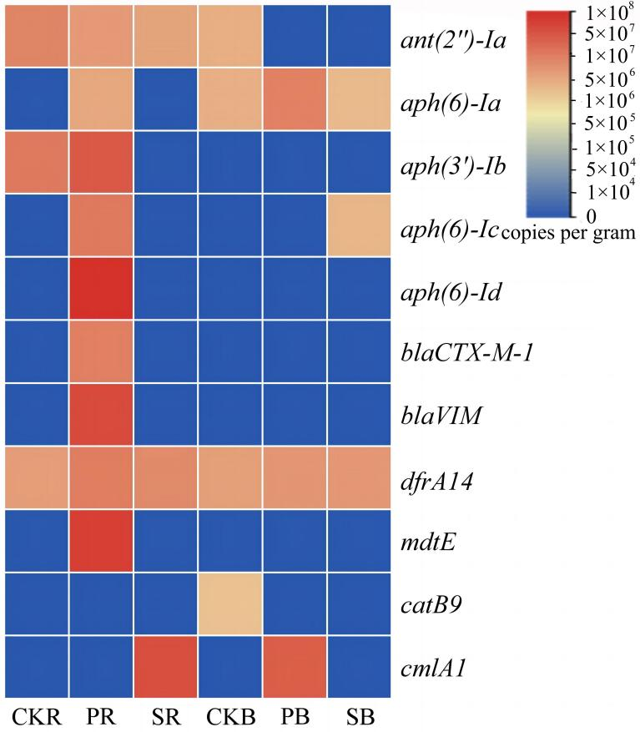
Fig. S5. Absolute abundance of high-risk ARGs detected in onion roots and bulb tissues. CK, P, and S represent treatments without organic fertilizer, with pig manure organic fertilizer, and with sheep manure organic fertilizer, respectively; R and B represent the root and bulb tissues of onion, respectively.

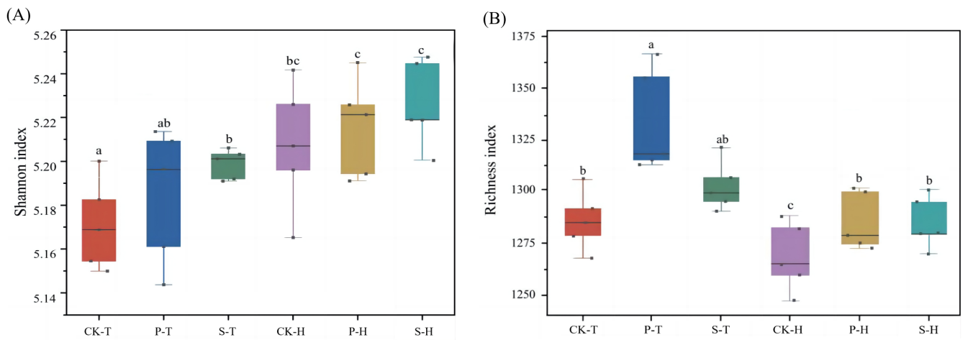
Fig. S6. Analysis of α diversity of rhizosphere soil microbial communities. Different lowercase letters represent significant differences (p<0.05). Sample code is the same as in Fig. S1.

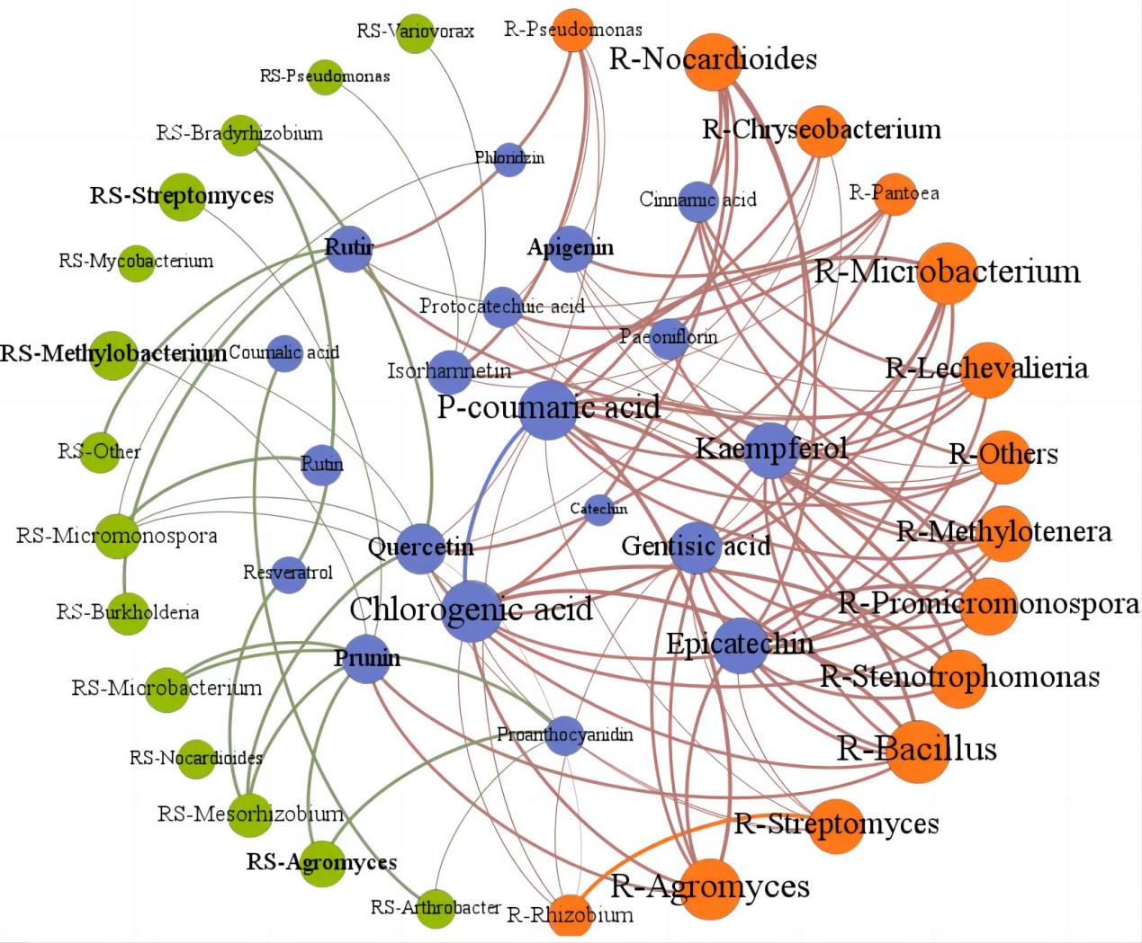
Fig. S7. Network of the Spearman's correlations between root exudates、potential hosts of ARGs and rhizosphere soil(E). Among them, R represents onion endophytic bacteria, and RS represents rhizosphere soil microorganisms
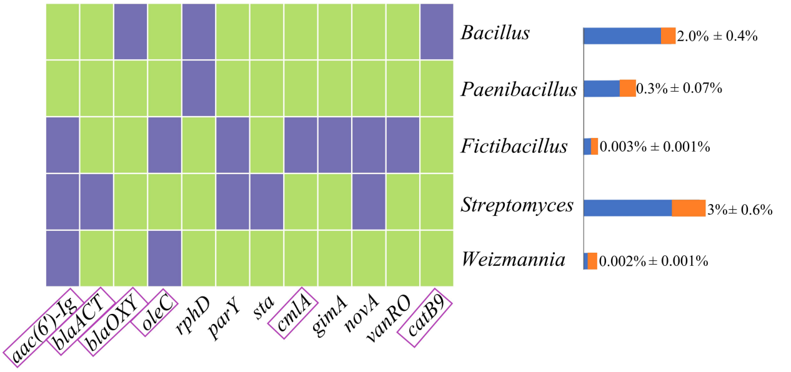
Fig. S8. Heatmap of 5 bacteria carrying ARGs, green is uncarried and purple represents carried. Genes that have been detected by high-throughput Qpcr are within the purple circles. The right bar graph shows the relative abundance of the five bacteria in the onion bulb microbial community, mean ± SD (n=3).

