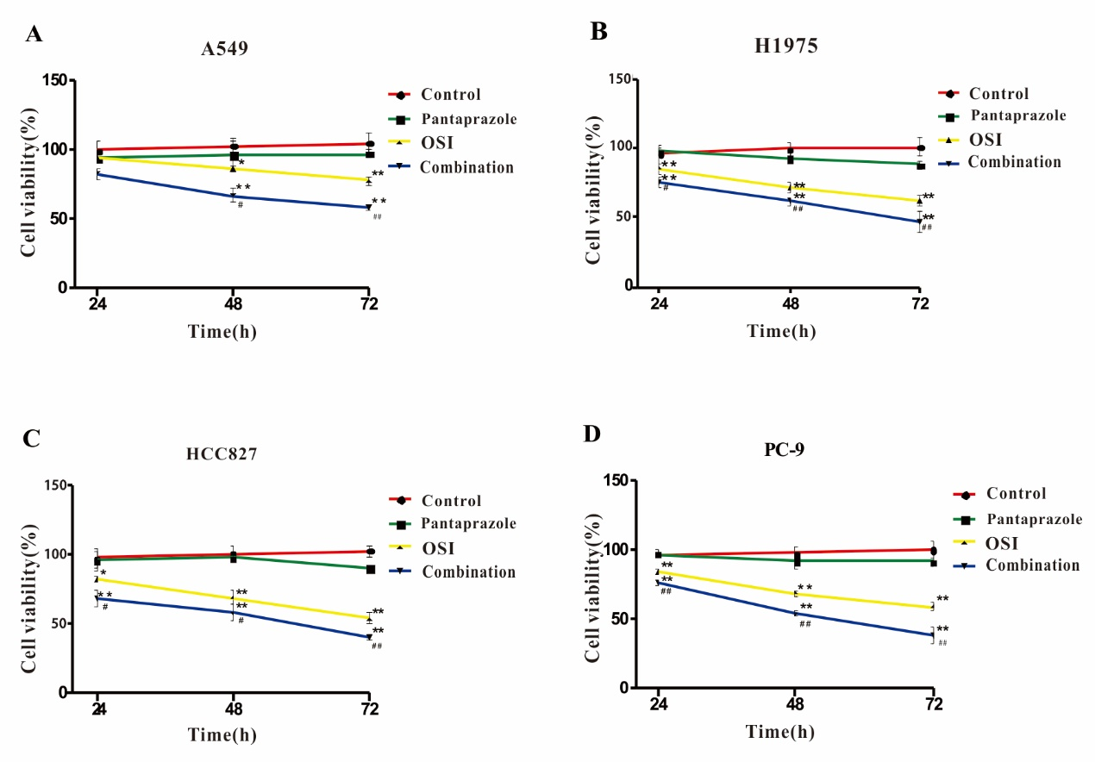 Supplemental Figure 1. Effect of pantoprazole and OSI on cell viability of four different cell lines as evaluated by the CCK-8 assay. The data were quantified and are represented as the mean and SD from 3 independent experiments. * vs pantoprazole group, p <0.05, ** vs pantoprazole group, p <0.01; # vs OSI group, p <0.05, ## vs OSI group, p <0.01.

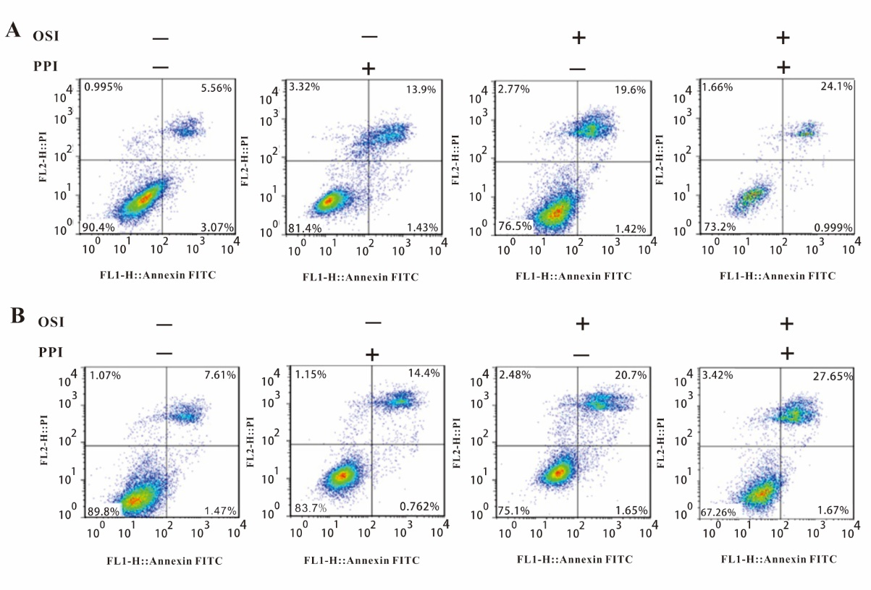
Supplemental Figure 2. Effect of pantoprazole and OSI on cell apoptosis of NSCLC cell lines was evaluated through annexin V/propidium iodide (PI) staining assay and the distribution of apoptotic cells was measured by flow cytometric analysis. A. A549 cells. B. H1975 cells.

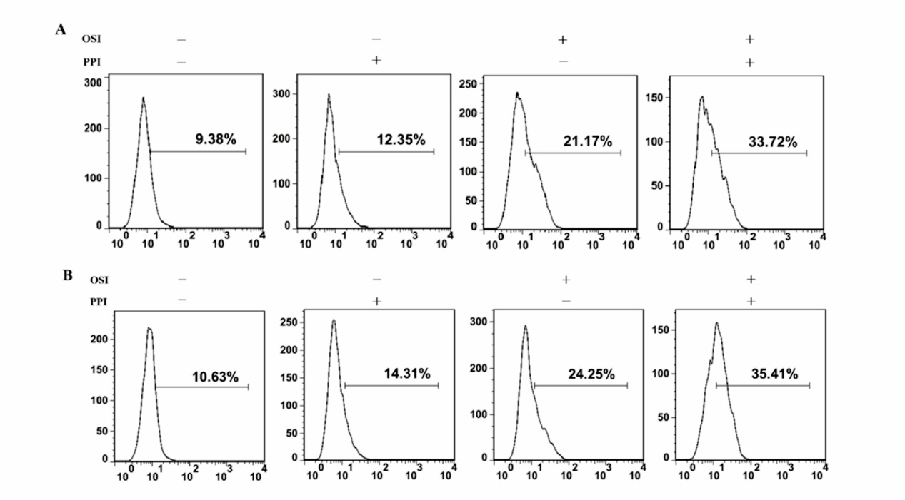
Supplemental Figure 3. Effect of pantoprazole and OSI on the generation of ROS in NSCLC cell lines. The intracellular ROS was measured by flow cytometric analysis using oxidation-sensitive fluorescent probe. A. A549 cells. B. H1975 cells.

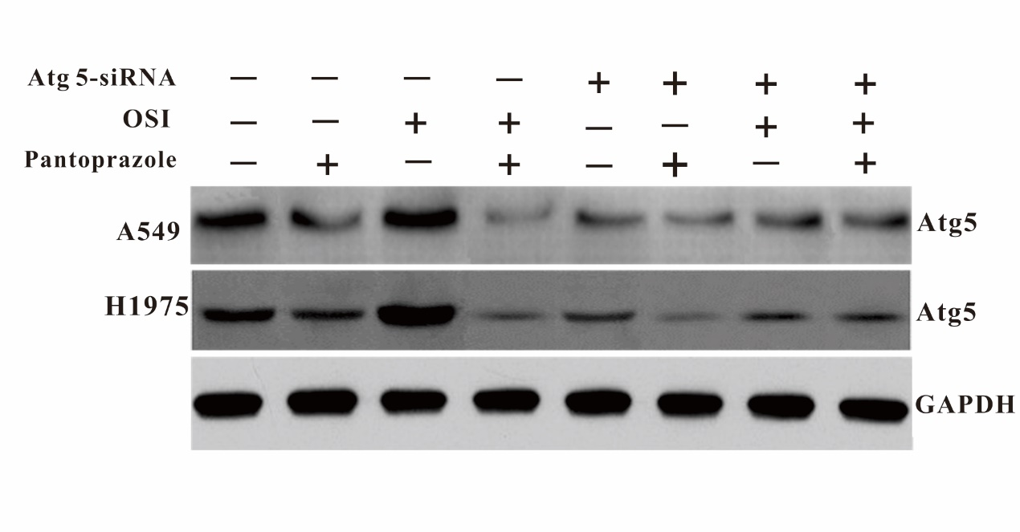
Supplemental Figure 4. Effect of pantoprazole and OSI on normal or Atg5-knockdown NSCLC cell lines cell lines. The expression of Atg5 was evaluated through western blotting.

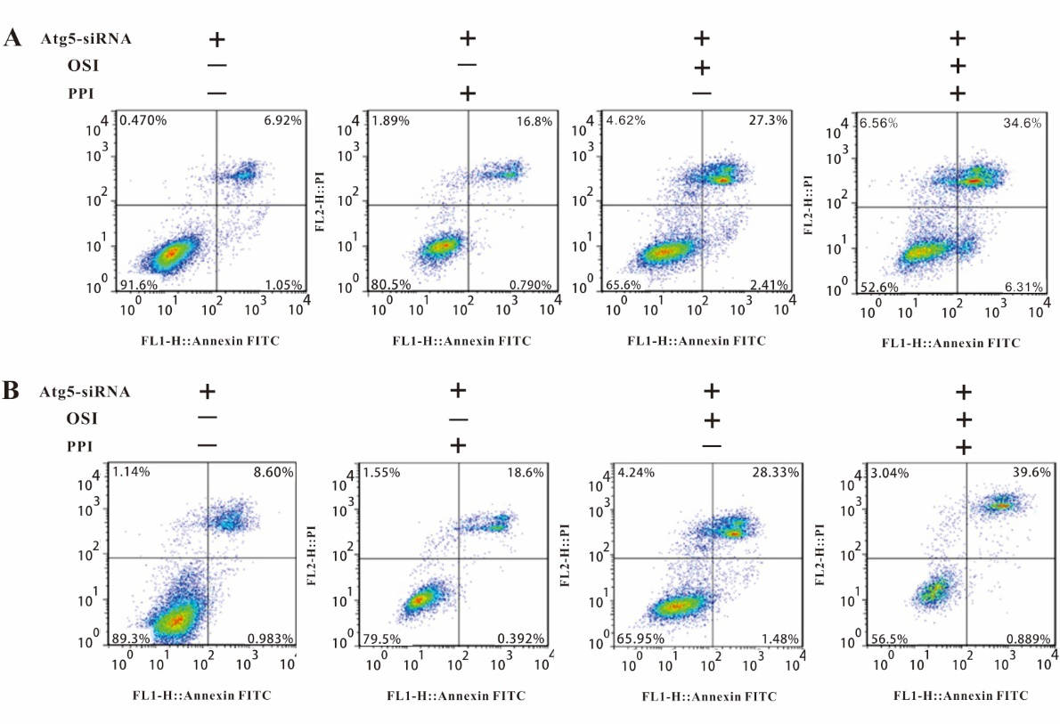
Supplemental Figure 5. Effect of pantoprazole and OSI on cell apoptosis of Atg5-knockdown NSCLC cell lines was evaluated through annexin V/propidium iodide (PI) staining assay and the distribution of apoptotic cells was measured by flow cytometric analysis. A. A549 cells. B. H1975 cells.

