Extended Data
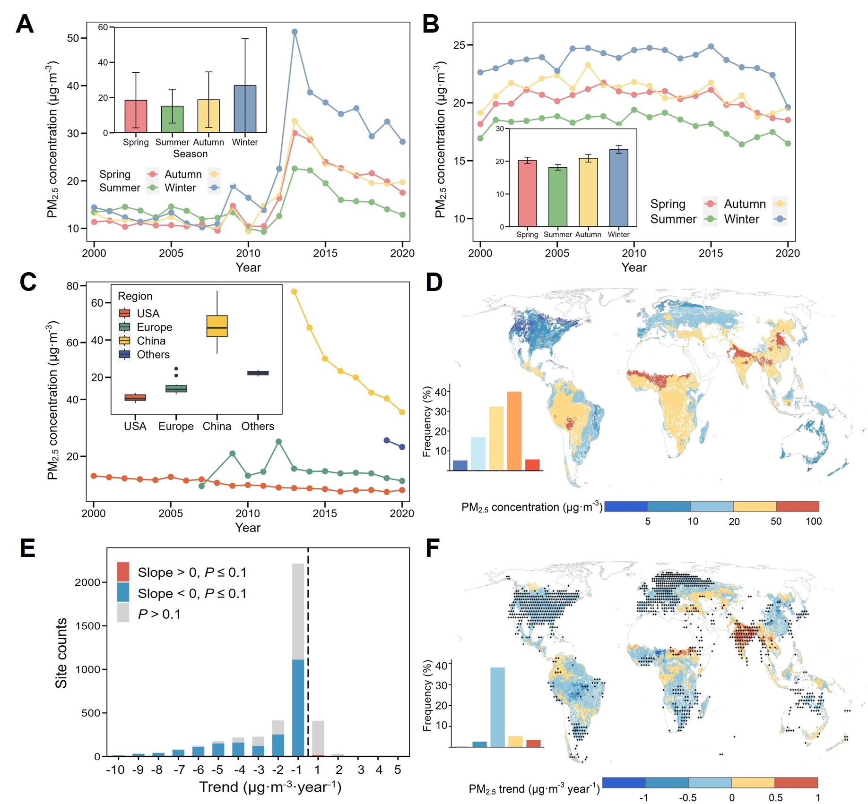
Fig. 1 | Patterns of PM_{2.5} air pollution for site measurements and satellite observation. A, B, The temporal variations of PM_{2.5} concentrations across four seasons, as determined by site measurements and satellite observations. The bar plots depicted in both figures represent the average PM_{2.5} concentrations for various seasons, with the accompanying error bars indicating the standard deviations. C, Temporal span of PM_{2.5} measurement data from sites in the USA, Europe, China, and other regions. The box plots indicate the distribution of PM_{2.5} concentrations in spring obtained from site measurements. D, Global distribution of springtime PM_{2.5} concentrations as derived from satellite observations. E, Trends in site-measured PM_{2.5} concentrations in spring. The blue and red indicates a declining and an increasing trend of PM_{2.5} concentrations, with varying opacities reflecting the significance of these trends. F, Spatial distribution of springtime PM_{2.5} concentration trends for satellite observations, where black cross symbols represent significant changes in trends (P < 0.1).

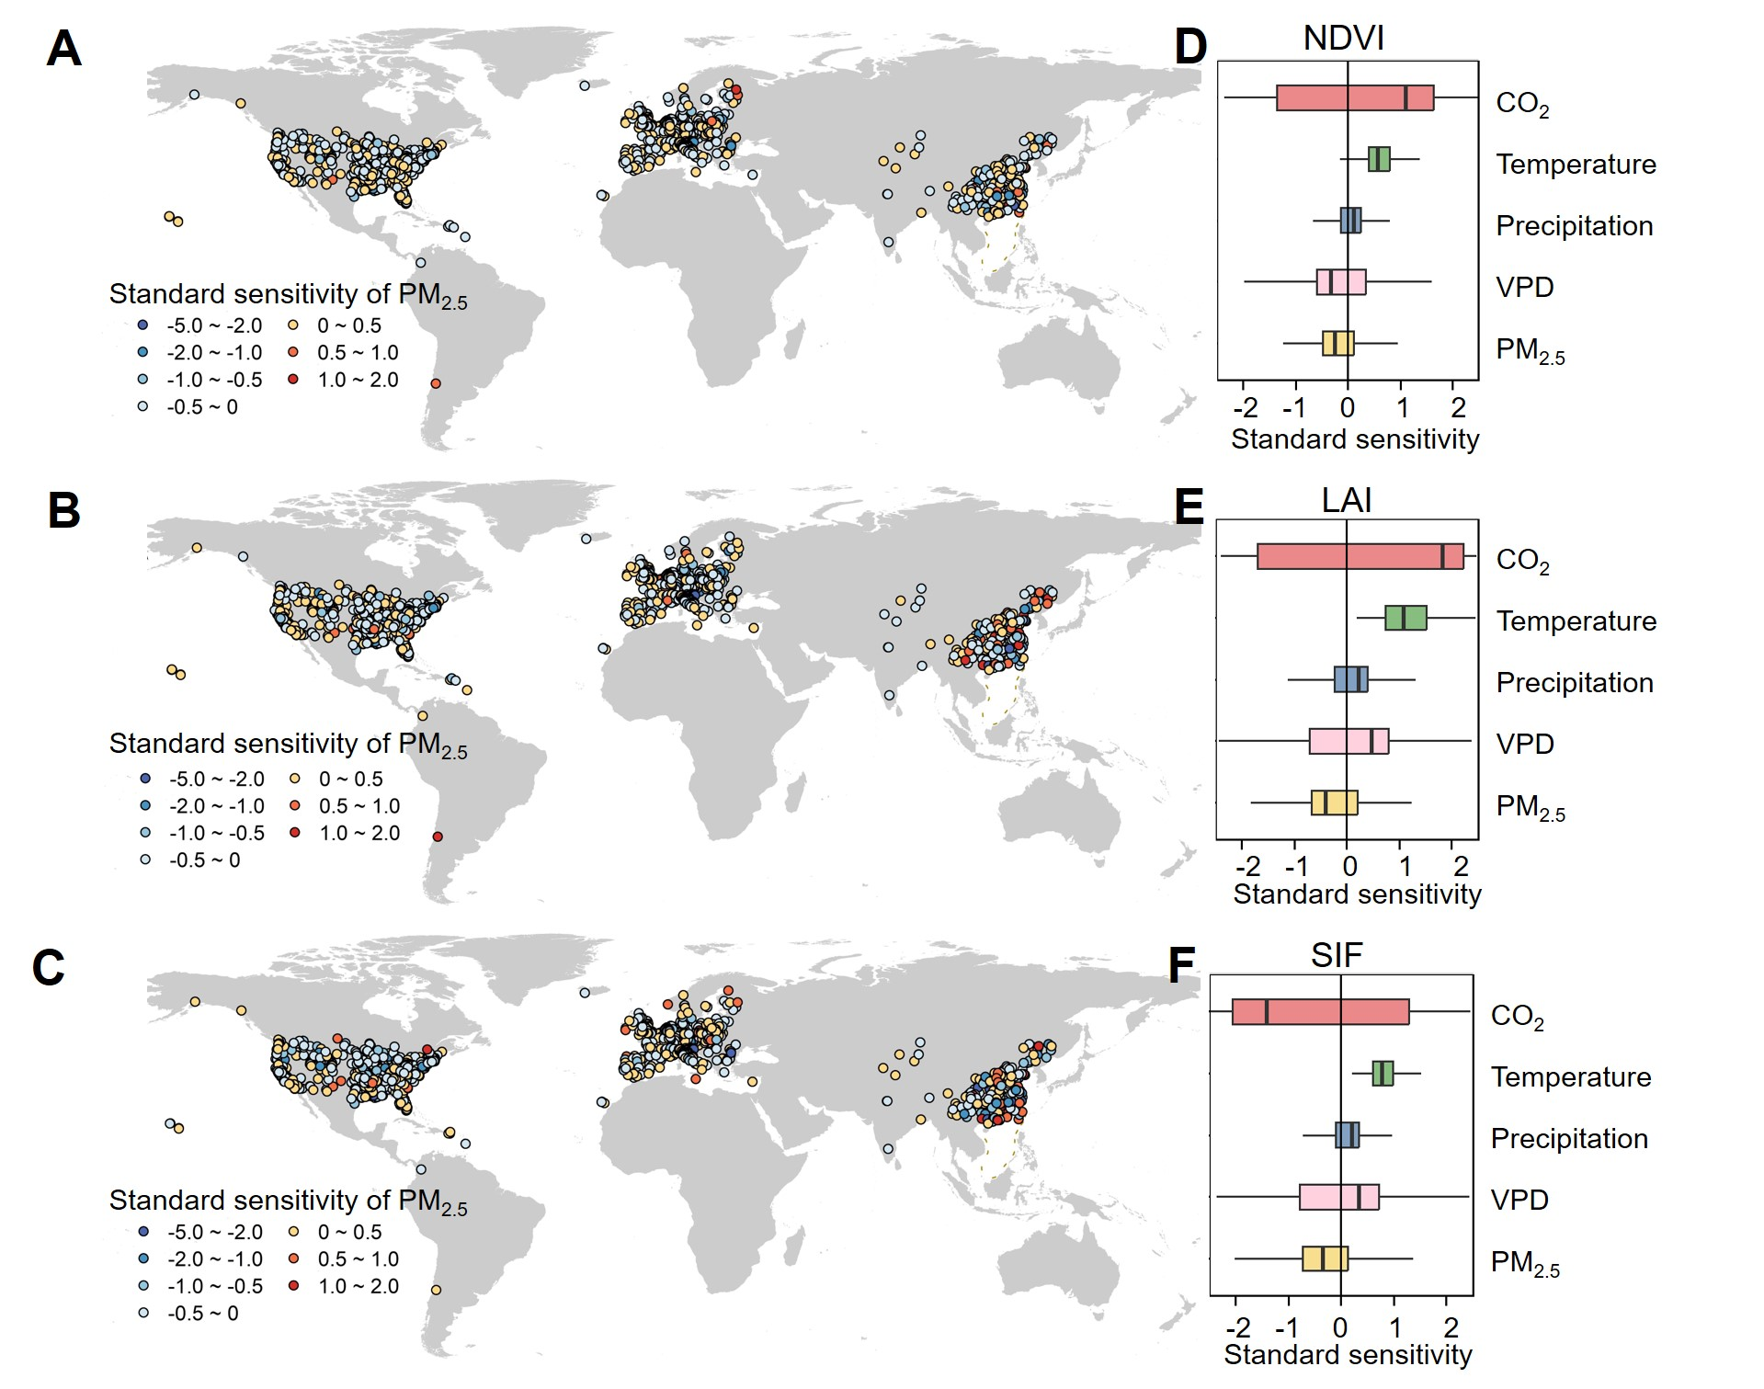
Fig. 2 | Impacts of PM_{2.5} and climate change on spring greening at site scale. A-C, Sensitivities of NDVI (A), LAI (B), and SIF (C) to PM_{2.5} pollution determined by stepwise linear regression analyses. D-F, Sensitivity of NDVI (D), LAI (E), and SIF (F) to PM_{2.5} and climatic factors (i.e., CO₂, temperature, precipitation, and VPD) involved in the stepwise linear regression analyses.
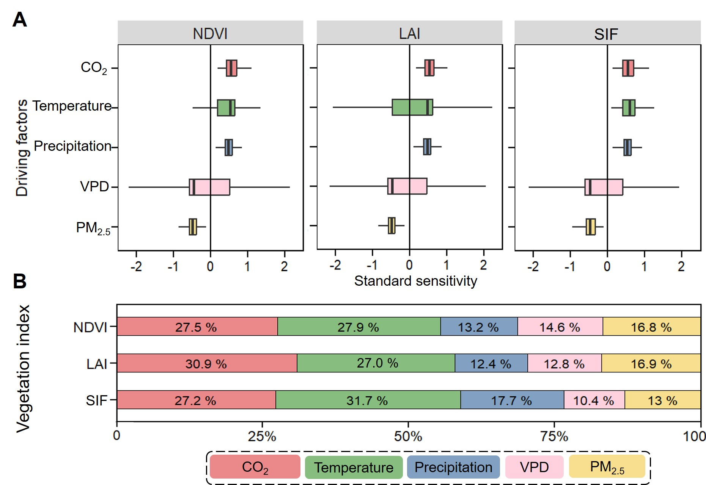
Fig. 3 | Impacts of PM_{2.5} and climate change on spring greening at global scale. A, Sensitivity of NDVI, LAI, and SIF to PM_{2.5} and climatic factors (i.e., CO₂, temperature, precipitation, and VPD) involved in the stepwise linear regression analyses. B, Relative frequency of the entry of five variables into the model when constructing stepwise regression models with different vegetation indices (i.e., NDVI, LAI, and SIF) as the dependent variables.
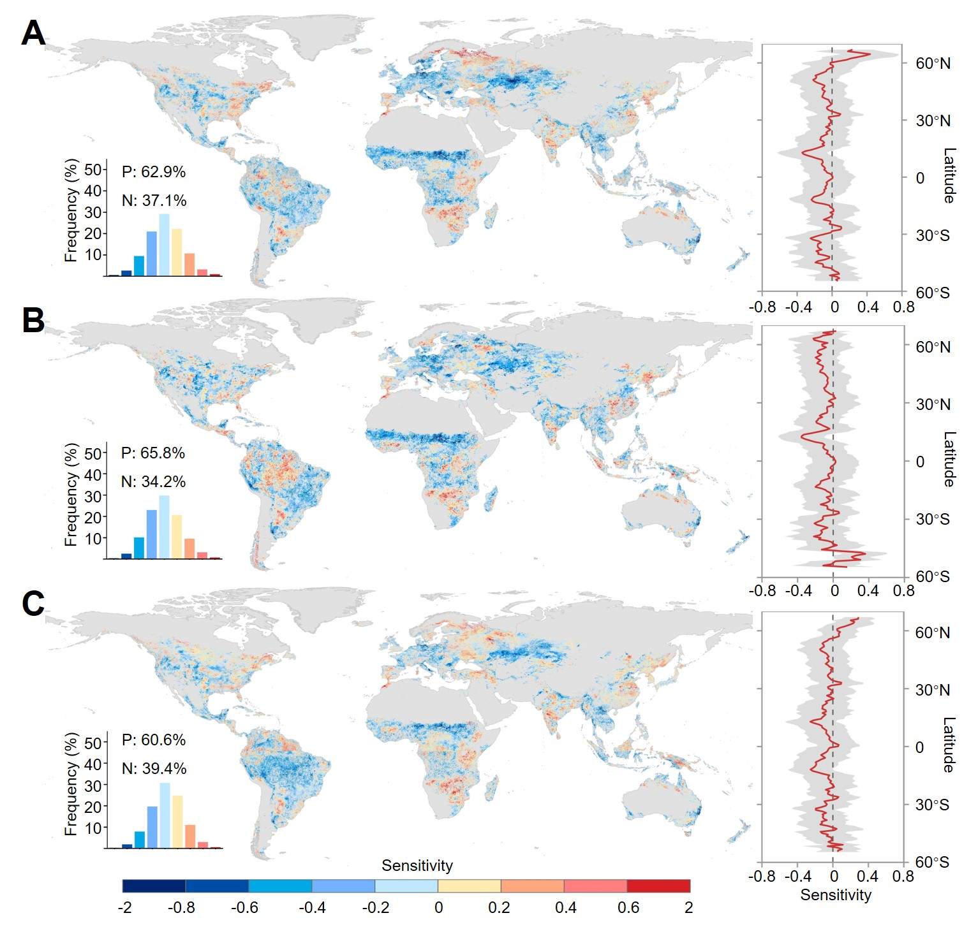
Fig. 4 | Sensitivity of spring greening indicators (i.e., NDVI, LAI, and SIF) to PM_{2.5} concentrations as analyzed through ridge regression. The greening indicators that used as dependent variables in the ridge regression include NDVI, LAI, and SIF. Apart from PM_{2.5} concentration, the analysis includes CO₂, temperature, precipitation, and VPD as additional independent variables influencing these greening indicators.
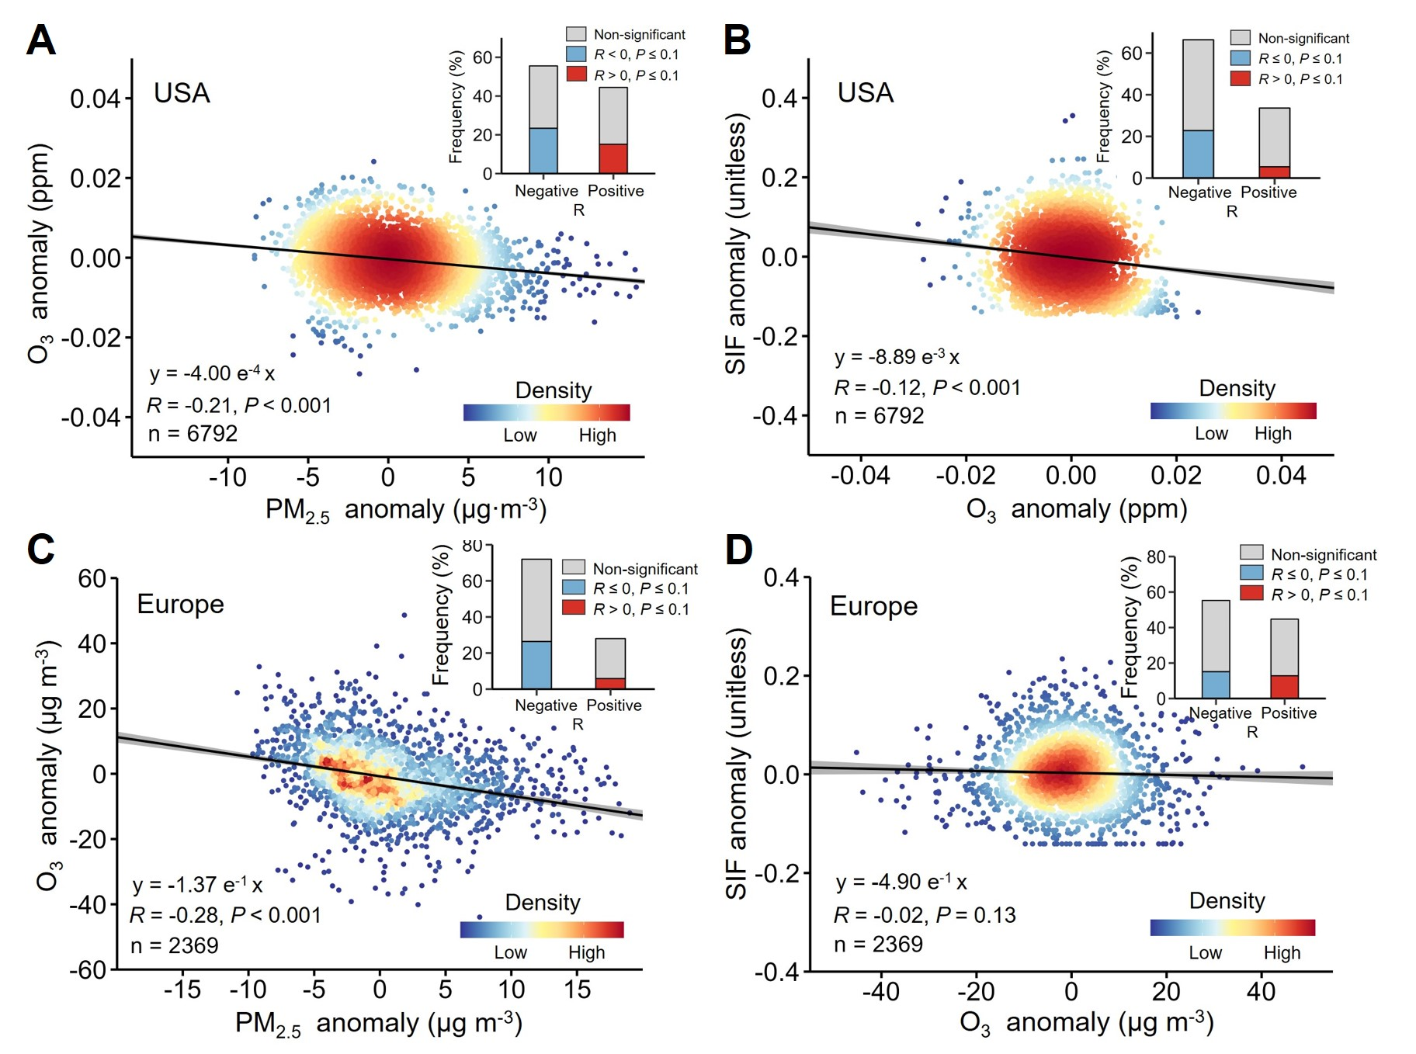
Fig. 5 | PM_{2.5}-driven ozone (O₃) shift and impacts on vegetation photosynthesis. A, C, The relationship between near-surface PM_{2.5} and O₃ in spring for ground observations in the USA (A) and Europe (C). B, D, The relationship between O₃ and SIF in spring for the USA (B) and Europe (D). The density scatter plots represent the relationships between anomalies of PM_{2.5} and anomalies of O₃ (A, C) and between anomalies of O₃ and anomalies of SIF (B, D). The bars in the corner represent the site-level distribution of positive and negative correlations.

