Air pollution weakens global spring greening
Chaoyang Wu*†, Hao Hua, Jian Wang†, Lingwen Dong†, Constantin M. Zohner, Josep Peñuelas, Yunqi Wang, Yuyu Zhou, Shushi Peng, Zaichun Zhu, Jing Wei, Wenping Yuan, Xiuzhi Chen, Lei Chen, Yongshuo H. Fu, Jialing Li, Weimin Ju, Yanlian Zhou, Dan Liang, Pierre Friedlingstein, Sitch Stephen, Yuming Guo*, Quansheng Ge¹*

*Corresponding authors: C Wu (wucy@igsnrr.ac.cn), Y Guo (yuming.guo@monash.edu), Q Ge (geqs@igsnrr.ac.cn).
† These authors contributed equally to this work.

The PDF file includes:
Materials and Methods
Supplementary Figures 1 to 17
Supplementary Tables 1 to 6

Materials and Methods
1. Multi-source PM_{2.5} data
1.1 Site monitoring of PM_{2.5} data
Daily PM_{2.5} concentrations measurements from 2000 to 2020 were collected at 3552 ground-based monitoring sites around the world (Supplementary Fig.1 and Table.1). Sources of data include Open AQ, the China National Environmental Monitoring Centre, the US Environmental Protection Agency, the European Air Quality e-Reporting, the Canadian National Air Pollution Surveillance Program, and other national networks (e.g., South Africa, New Zealand, and Brazil). Quality control procedures were applied to the raw PM_{2.5} data by eliminating anomalies, which include values that are negative or excessively high (surpassing the 99.9th percentile). The distribution of vegetation types in the areas where ground-level PM_{2.5} monitoring sites are located, as well as the site-year distribution of measurement data provided by various regions/agencies, are illustrated in Supplementary Fig. 1.

1.2 Satellite-based PM_{2.5} data and evaluation
The generation of satellite-based PM_{2.5} data involves integrating satellite-derived aerosol optical depth (AOD) products with ground-based air quality measurements and meteorological data. Based on our recent studies on satellite-based PM_{2.5} simulation^{36,37}, we used machine learning models, particularly ensemble tree-based methods such as Random Forest and Gradient Boosting Machines, for effective data integration and handling the spatio-temporal variability. The validation of these models is achieved through sample-based cross-validation methods, including ten-fold cross-validation, ensuring accurate and reliable predictions of PM_{2.5} concentrations across different locations and times. This methodology offers a comprehensive approach to monitor and assess air quality on a global scale. The details of satellite-based PM_{2.5} data production can be seen in ref.36 and ref.37. It should be noted that seasonal data conditions of satellite-observed AOD could bring large uncertainty of PM_{2.5} simulation. We found frequent missing of satellite-observed AOD in spring over the northern permafrost regions. The lack of ground monitoring of PM_{2.5} pollution in permafrost regions could further harm the reliability of simulated PM_{2.5}. To exclude these factors, here we removed all permafrost regions in our data production to ensure the quality of satellite-based PM_{2.5} data. We evaluated the satellite-based spring PM_{2.5} concentrations using all collected site monitoring data, with a high Pearson correlation coefficient (R) of 0.95 and a low root mean square error (RMSE) of 5.39 μg m⁻³ (Supplementary Fig. 13). High accuracy of satellite-based PM_{2.5} data allows us to examine the response of spring greening to PM_{2.5} pollution at the global scale.

2. Indicators of spring greening
2.1. Satellite-based vegetation indices
To quantify spring vegetation greenness, we used three independent satellite-observed vegetation indices (VIs) from 2000 to 2020 in spring, i.e., March to May for the northern hemisphere and September to November for the southern hemisphere. The VIs include the normalized difference vegetation index (NDVI), leaf area index (LAI), and solar-induced chlorophyll fluorescence (SIF), which are widely used as the proxies of vegetation greenness^{1,2,14}. Here we used the spring average VIs to represent observational spring vegetation greenness. The daily NDVI data and 8-day composite LAI data with a resolution of 500m×500m were obtained from the Moderate Resolution Imaging Spectroradiometer (MODIS) products version 6.1 (NDVI: MOD13C2, LAI: MOD15A2H). The 4-day composite SIF data at 0.05° resolution (nearly 5km×5km) were obtained from a global spatially contiguous SIF (CSIF) product using neutral networks³⁸ (Supplementary Table 1). The CSIF product provides well-validated clear sky estimations of SIF. For NDVI and LAI, we removed abnormal values that possibly affected by observational conditions and cloud screening.

To check whether PM_{2.5} pollution influence the observational signals, we examined the contaminating impacts of PM_{2.5} pollution on satellite-observed vegetation greenness (Supplementary Figs. 2 and 3). We assumed that 1) vegetation greenness in spring showed overall increasing trends and 2) a sudden increase in PM_{2.5} concentrations could contaminate satellite observations with a sudden decrease in greenness. To test this assumption, we used site-monitored PM_{2.5} data, derived from the China PM_{2.5} Monitoring Network that initiated since 2013 when China was facing the most severe PM_{2.5} pollution, and satellite-observed greenness for each site. We first calculated the changes in vegetation greenness with a short-term (i.e., 4-day) temporal gap. During this temporal gap, VIs could be relatively stable with minor increases and sudden decreases in VIs could be attributed to PM_{2.5} pollution-induced signal attenuation. We found that the LAI and SIF overall showed consistent increases within the temporal gap, i.e., the differences in LAI and SIF for same site after and before the temporal gap were overall positive, under all scenarios of PM_{2.5} shift (Supplementary Fig. 2A and C). We then calculated the monthly changes in LAI and SIF considering the magnitude of PM_{2.5} shift. We also observed overall consistent increases in LAI and SIF, suggesting that changes in PM_{2.5} concentration rarely affect the natural variations of LAI and SIF (Supplementary Fig. 2B and D). However, the sudden increases in PM_{2.5}, especially when the PM_{2.5} increase is higher than 30 μg m⁻³, could obviously reduce the NDVI signal with a lower NDVI value (Supplementary Fig. 3A). Here we applied the Savitzky-Golay (SG) filter with different window sizes to remove abnormal NDVI data and reconstructed the time series of NDVI in spring (Supplementary Fig. 3C-H)³⁹. We found that SG-filtered NDVI can well exhibit the natural increases in vegetation greenness with a window size of 7 days. We then applied the 7-day SG filter to minimize the influence of PM_{2.5} pollution-caused contamination of NDVI signal.

We used other two satellite-based VIs to examine the PM_{2.5}-greening relationship, strengthening the main conclusion of our study. First, we used another LAI product from the Global Land Surface Satellite (GLASS) Product suite that was developed using the bidirectional long short-term memory (Bi-LSTM) model (Supplementary Table 1)⁴⁰. We found that the sensitivities of climatic factors and PM_{2.5} pollution were similar between MODIS LAI and GLASS LAI, with a spatial consistency of PM_{2.5} effect (i.e., consistently positive or negative) for 66.8% of studied areas (Supplementary Fig. 14). Second, we calculated relative SIF that refers to SIF normalized by the continuum-level NIR-reflected radiance to check the response of SIF to PM_{2.5} pollution. We found similar climatic and PM_{2.5} sensitivities of SIF and that of relative SIF, with a spatial consistency of PM_{2.5} effect for 87.1% of studied areas (Supplementary Fig. 15). These results indicated that the widespread decreases in spring LAI and SIF under PM_{2.5} pollution are primarily attributed to the biogeochemical and biogeophysical effects of PM_{2.5} pollution, rather than being influenced by the contamination and attenuation of observational signal⁴¹.

2.2. Process-based model projections
We also used model-simulated gross primary productivity (GPP) as the proxy of vegetation greenness. We investigated the impacts of PM_{2.5} pollution on model-simulated GPP in spring using 16 terrestrial biosphere models outputs from the TRENDY project (Supplementary Table 3)^{42,43}. TRENDY is an ensemble of models that estimates ecosystem carbon dynamics from initial forcing. We used outputs from simulation scenario S3, which allows for changes in land use, climate, and CO₂ concentration through time. Selecting this scenario allows us to comprehend the interconnected effects of human activities and climate change on the greening of land surfaces. Model-simulated GPPs are produced at monthly time steps with different spatial resolutions. We calculated spring accumulated GPP from each model and re-gridded them to 0.5°×0.5° prior to analysis.

3. Climatic and ancillary data
We obtained monthly meteorological data with a 1/24° (nearly 4km×4km) spatial resolution for the period of 2000-2020 from the TerraClimate⁴⁴, including monthly mean temperature and VPD, and total precipitation. Global averaged marine surface CO₂ was obtained from the Global Monitoring Laboratory (GML) of the National Oceanic and Atmospheric Administration (NOAA). Details of data can be seen in Supplementary Table 1.

To eliminate the influence of land cover change, our study only focused on sites or pixels where the land use type remains constant during 2000 to 2020 identified by the MODIS land cover product (MCD12C1 v6.1). Additionally, we removed areas featuring sparse vegetation by excluding pixels with mean spring NDVI lower than 0.1, reducing the noises from non-vegetation areas. We also excluded the permafrost region with limited site monitoring of PM_{2.5} and low-quality satellite-observed AOD. To identify the permafrost region, we utilized the Circum-Arctic Map of Permafrost and Ground-Ice Conditions from the National Snow and Ice Data Centre⁴⁵.

4. Analyses
4.1 Site- and grid-scale analyses
We used site monitoring of PM_{2.5} data and satellite-based gridded PM_{2.5} data with site- and grid-scale variables to perform independent analyses. For grid-scale analyses, we resampled climatic factors and satellite-based PM_{2.5} data to match the resolution of VIs. For the site-scale analyses, we first extracted VIs and climatic factors from gridded files for each site and calculated the spring mean (i.e., VIs, CO₂, temperature, and VPD) and sum (i.e., precipitation). Since the site-level PM_{2.5} were limited in the time series except for USA (Supplementary Fig. 1B), we then merged site variables into city level based on the PM_{2.5} site information. We calculated the site-based anomalies of all variables by subtracting the multi-year mean of variables from the all-year variable values. We then merged all anomalies from the same city to create city-based and site-scale datasets. We removed all cities with fewer than 15 site-year records from the analyses. This approach allowed us to eliminate the effects of spatial variations in the background PM_{2.5} and climate, while preserving the effects of their interannual variations on greenness shift.

4.2 Spatial and temporal patterns of PM_{2.5} and greening indicators
We determined the spatial pattern of PM_{2.5} pollution and vegetation greenness (i.e., NDVI, LAI, and SIF) in spring by calculating multi-year mean of corresponding variables (Extended data Fig. 1D and Supplementary Fig. 16). We classified PM_{2.5} pollution into four levels based on the Air Quality Index (AQI), i.e., AQI level 1: 0-12 μg m⁻³; AQI level 2: 12-35.4 μg m⁻³; AQI level 3: 35.4-55.4 μg m⁻³; and AQI level 4: 55.4-150.4 μg m⁻³. For temporal trend analysis, we applied the Theil–Sen slope estimator, a non-parametric and median-based slope estimator, to analyse the temporal trends of vegetation greenness (Supplementary Fig. 16) and PM_{2.5} concentration (Extended data Fig. 1E and F). The trends were evaluated using the Mann–Kendall trend test at a significance level of 0.1.

4.3 Impacts of PM_{2.5} pollution and climate change on spring greening
We used multiple statistical methods to rigorously examine the impacts of PM_{2.5} pollution and climate change on spring greening at site and global scales. First, we applied linear regression to determine the sensitivity of vegetation greenness (i.e., NDVI, LAI, and SIF) to driving factors, including climatic factors (i.e., CO₂, temperature, precipitation, and VPD)¹⁻² and PM_{2.5} pollution (Eq. 1) (Fig. 1). Then we determined the standard sensitivity by incorporating the standard deviation of dependent variable and independent variable for each driving factor (Eq. 2). By doing so, the sensitivity of each driving factor can be comparable with each other.
${\text{VI}}_{\text{anl}} \text{= }{\text{β}}_{\text{1}} \text{×} {{\text{CO}}_{\text{2}}}_{\text{anl}} \text{+ }{\text{β}}_{\text{2}} \text{×} {\text{TMN}}_{\text{anl}} \text{+ }{\text{β}}_{\text{3}} \text{×} {\text{PPT}}_{\text{anl}} \text{+ }{\text{β}}_{\text{4}} \text{×} {\text{VPD}}_{\text{anl}} \text{+ }{\text{β}}_{\text{5}} \text{×} {{\text{PM}}_{\text{2.5}}}_{\text{anl}} \text{+} \text{res}$ (1)
${{\text{β}}_{\text{i}}}_{\text{STD}} \text{= }\frac{\text{SD(}{\text{VAR}}_{\text{i}}\text{)}}{\text{SD(}{\text{VI}}_{\text{i}}\text{)}}$ (2)
where VI indicates the value of VIs (i.e., NDVI, LAI, and SIF). The subscript ‘anl’ represents the anomaly for corresponding variable. TMN, PPT, and VPD represents spring mean temperature, total precipitation, and mean vapor pressure deficit, respectively. β₁₋₅ represent regression coefficients of each driving factor. res is the residual. β_{iSTD} represents the standard sensitivity of variable i. SD here represents the function of calculating the standard deviation of corresponding variable.

Second, we utilized stepwise regression to quantify the effects of driving factors (i.e., CO₂, temperature, precipitation, VPD, and PM_{2.5}) on spring greenness (i.e., NDVI, LAI, and SIF) at site and global scales (Extended data Figs. 2 and 3). Stepwise regression refers to the gradual, iterative development of a regression model in relation to the response variable, taking into account all possible explanatory variables. During this process, variables are either incorporated or excluded from the group of explanatory variables based on the results of statistical hypothesis tests. The standardized coefficients of the explanatory variables were used to quantify the effects of individual factors.

Third, to avoid potential multicollinearity between climatic factors and PM_{2.5} concentration, we used ridge regression that adds a penalty parameter to reduce the variance of the regression coefficient to determine the sensitivities of PM_{2.5} pollution and climatic factors (Extended data Fig. 4). Spring vegetation greenness (i.e., NDVI, LAI, and SIF) were used as response variables. Driving factors (i.e., CO₂, temperature, precipitation, VPD, and PM_{2.5}) were used as the predictors. We used the normalized anomalies of driving factors and spring greenness as regression inputs, and regression coefficients were determined the sensitivities.

Last, we used partial correlation analysis to investigate the impact of PM_{2.5} pollution on spring greening at site and global scales. We excluded the impacts of climate change when we conducted the partial correlation analysis for PM_{2.5} pollution-greening relationships (Supplementary Fig. 4). Overall, linear regression-, stepwise regression-, ridge regression-, and partial correlation-based analyses generated similar results that PM_{2.5} pollution could undermine spring greening from site to global scales.

5. Mechanism of PM_{2.5} effects on spring greening
5.1 PM_{2.5} exposure experiments
We conducted an PM_{2.5} exposure experiment in 2014 to investigate the effects of PM_{2.5} pollution on leaf characteristics in 15 common tree species (Supplementary Table 2) in Beijing (39.54°N, 116.23°E) and Chongqing (29.59°N, 106.54°E), China, where PM_{2.5} pollution was frequently happened in spring (highest daily PM_{2.5} record of Beijing and Chongqing in 2014 was 486.3 and 274.2 μg m⁻³, respectively). For each species, we collected samples of first-year twigs from four trees. Samples were collected from four directions at three different heights (low, middle, and high canopy layers), with a total of 12 twigs collected from each tree, weighting between 300 and 500 grams. The twigs were then washed with deionized water in the laboratory and dried in an incubator at 60 °C for 30 minutes.

Leaf observations were carried out in leaf chambers with a controlled temperature of 27 °C and a CO₂ concentration of 750 μmol mol⁻¹. Submicron (diameter < 1 μm) and ultrafine (< 0.1 μm) particles were generated using a sodium chloride (NaCl) solution (0.1 mol L⁻¹)⁴⁶ in air mixing chambers to simulate the natural condition of the PM_{2.5} pollutions (Supplementary Fig. 17). In real-world scenarios, the composition of PM_{2.5} particles is indeed complex. However, the primary focus of this experiment is on the physical impact of PM_{2.5} on the blockage of leaf stomata. Therefore, NaCl was chosen as a representative particulate component for this study. The PM_{2.5} concentration downstream of the vacuum pump was measured every 5 minutes using a DustMate instrument (Turnkey Instruments, UK). The tests lasted approximately 30 minutes, during which time the PM_{2.5} concentrations remained stable, with an average concentration of 550 μg m⁻³. In laboratory environments, it is common for aerosol generators to produce concentrations ranging from tens to thousands of micrograms per cubic meter (μg m⁻³). For our experiment, we selected a higher concentration within this feasible range to precisely control the experimental conditions and to ensure the observability of the PM_{2.5} effects on plant physiology. This controlled, heightened concentration allows for a more detailed examination of the physiological responses to PM_{2.5}, which might be less discernible at lower concentrations. The use of such concentrations, while higher than typical ambient levels, is in line with the technical capabilities and common practices in controlled experimental studies⁴⁷. This approach aids in establishing a clear understanding of the potential impacts under varied environmental conditions and serves as a foundation for further research that could explore a broader range of concentrations, including those more reflective of typical ambient levels.

5.2 Meta-analysis on gas exchange and photosynthesis
We aimed to examine the physical and physiological response of plants to PM_{2.5} pollution by collecting data from both controlled experiments and ambient samples^{48,49}. We searched for relevant peer-reviewed publications using Google Scholar (https://scholar.google.com), Web of Science (https://www.webofscience.com/) and China National Knowledge Infrastructure Databases (https://www.cnki.net), using the combinations of keywords related to PM_{2.5} (‘PM_{2.5}’ and ‘particulate matter’) and plant physiology (‘leaf physiology’, ‘stomatal conductance’, and ‘photosynthetic traits’). Articles were included in this study if the following criteria were met: 1) For experimental studies, we ensured that PM experiments were carried out on both control and treatment groups with the same temporal and spatial scales. Furthermore, leaf samples from both control and treatment groups were taken at the same time, and the physiological indices of the sample leaves were measured. 2) For observational studies, leaf samples were simultaneously collected from undisturbed sites with similar ecological conditions and contrasting air quality (e.g., leaf samples from trees next to highly polluted motorways versus clean city parks). The studies reported the concentrations of particulate matter and leaf physiological indicators at both the polluted and unpolluted sites. We considered the stations with higher air pollution levels as the treatment group. 3) For both experimental and observational studies, the names of plant species and the number of leaf replicates were recorded.

We extracted the original data from the figures and tables in the publications and constructed a database consisting of 233 entries, each containing data source, study type (experiment or observation), type of particulate matter (all PM or only PM_{2.5}), species, PM concentrations (both control and treatment groups), exposure time, number of samples (or replications), and eight variables related to gas exchange and photosynthesis (Supplementary Table 3). For each of the 8 variables, the means and standard errors of the control and treatment groups were directly calculated or extracted from the original publications. The means in the treatment ($\overline{{\text{X}}_{\text{t}}}$) and control group ($\overline{{\text{X}}_{\text{c}}}$) were used to compute a response ratio by:
$\text{RR} \text{= }\text{ln}{\text{(}\frac{\overline{{\text{X}}_{\text{t}}}}{\overline{{\text{X}}_{\text{c}}}}\text{)} }\text{= }\text{ln}{\text{(}\overline{{\text{X}}_{\text{t}}}\text{)}} \text{- }\text{ln}{\text{(}\overline{{\text{X}}_{\text{c}}}\text{)}}$ (3)
We used the natural logarithm for the purpose of statistical testing. Most meta-analyses give more weight to effect sizes when estimates have higher precision (lower variance)⁵⁰. However, only ~75% of the studies reported the variance estimate (s.e.m., s.d. or 95% CI), and the variance-based weighting function can potentially assign extreme weights to individual studies, so that the final effect size might primarily be driven by a few studies⁵¹. As an alternative to variance-based testing, we used replication in the weighting function^{52,53} to calculate the weight associated with each response ratio.
${\text{W}}_{\text{i}} \text{= }\frac{{\text{N}}_{\text{i}}}{\sum{{\text{N}}_{\text{i}}}}$ (4)
${\text{N}}_{\text{i}} \text{= }\frac{{\text{N}}_{\text{c}}\text{ × }{\text{N}}_{\text{t}}}{{\text{N}}_{\text{c}} \text{+ }{\text{N}}_{\text{t}}}$ (5)
where ${\text{N}}_{\text{c}}$and ${\text{N}}_{\text{t}}$ are the number of replications for control and treatment, respectively. We performed three meta-analyses to assess the robustness of our results: 1) a weighted meta-analysis for the experimental studies that only included PM_{2.5} treatment (109 data points), 2) a weighted meta-analysis for the observational studies (120 data points) and 3) a weighted meta-analysis for all collected data records (233 data points).

We applied meta-analytic mixed-effects models to evaluate the effects of particulate matter on the response ratios of 8 variables. Data points from the same study were given a common study ID. For the full models on all collected data (both experimental and observational), we used a three-level model with study type as the first grouping variable and study ID as the second grouping variable. We assumed that these grouping variables were nested and that these nested effects acted as random intercept effects, allowing us to account for the non-independence of individual effect sizes calculated from the same study and the same study type. For the experimental-only or observational-only model, only study ID was included as random effect. We obtained the confidence intervals for the effect size of each of the eight variables. If the bias-corrected 95% CI value of the effect size does not overlap with zero, the response of the corresponding variable to PM treatment is statistically significant. The models were constructed using the “metafor” package in R⁵⁴.

5.3 PM_{2.5} effects on canopy stomatal conductance
To assess the impact of PM_{2.5} pollution on canopy-level stomatal conductance (G_{S}) through meta-analysis, we used EC-based flux data from FLUXNET2015 dataset (Supplementary Table 4). These were chosen for their detailed variables essential for calculating G_{S}, ensuring reliability and accuracy. The site-specific measurements from these datasets also offer consistent and comparable insights into stomatal responses under diverse environmental and geographical conditions. We collected half-hourly observed meteorological data and water fluxes as input for G_{S} calculations. To minimize uncertainty, we excluded days with rainfall in the current day and previous two days as well as days without measured data around noon⁵⁵. Flux tower-based G_{S} was derived from observed evapotranspiration (ET) using the Penman-Monteith equation^{56,57}. We aggregated the half-hour meteorological and flux data during daylight hours to daily values. Daylight hours were determined using incoming shortwave radiation (> 5 W m⁻²)⁵⁸. Daily G_{S} can be calculated as follows:
${\text{G}}_{\text{S}} \text{= }\frac{\text{γ} \text{λ ET }{\text{G}}_{\text{a}}}{\text{Δ}{ \text{(R}}_{\text{n}}\text{-} \text{G)} \text{+ ρ}{ \text{C}}_{\text{ρ} }\text{D} {\text{G}}_{\text{a}} \text{- λ} \text{(Δ} \text{+ γ)} \text{ET}}$ (6)
${\text{G}}_{\text{a}}\text{ = }\frac{{\text{k}}^{\text{2}}\text{ U}}{\text{ln}\left(\frac{\text{Z-d}}{{\text{Z}}_{\text{o}}}\right)\text{ × }\text{ln}{\text{(}\frac{\text{Z-d}}{{\text{Z}}_{\text{oh}}}\text{)}}}$ (7)
where ET represents the transpiration of the canopy (when ET is assumed to be small, it can be estimated as $\text{1/λ}$ times the latent heat flux), $\text{γ}$ is the humidity constant (0.066 kPa °C⁻¹)， $\text{λ}$ is the amount of energy required to evaporate one kilogram of water (2454000 J Kg⁻¹), $\text{Δ}$ (kPa °C⁻¹) is the slope of the saturated water vapor pressure as temperature changes; ${\text{R}}_{\text{n}}$ (W m⁻²) is the net radiation, G (W m⁻²) is the soil heat flux; D (hPa) is the vapor pressure deficit; $\text{ρ}$ (kg m⁻³) is the air density, and C is the specific heat capacity of air at 1000 J °C⁻¹Kg⁻¹. G_{a} is the aerodynamic conductance (m s⁻¹), k is the von Karman constant (0.41); U (m s⁻¹) is the wind speed; Z (m) is the wind measurement height, H (m) is the canopy height; d (0.667H, m) is the zero-plane displacement, Z_{o} (0.123H, m) is the aerodynamic roughness of the wind speed profile, and Z_{oh} (0.0123H, m) is the temperature curve. As Z and H were unknown for most of sites, we established different scenarios (Supplementary Table 6) for different vegetation types. We calculated monthly average G_{S} and removed all sites with less than two continuous year observations (24-month records). Finally, we collected 9844 site-month G_{S} globally at 166 sites. To examine the effect of PM_{2.5} variations on G_{S} changes, we then calculated the anomalies of monthly PM_{2.5} and G_{S} for each site, removing the effect of site-specific background environmental and climatic conditions. We further linked G_{S} with GPP using similar correlation analysis.
We also derived gridded G_{S} for global scale analysis. The gridded G_{S} was roughly calculated based on the assumption of identical leaf and atmosphere temperatures, disregarding aerodynamic resistance within the boundary layer, and substituting plant transpiration with ET. The gridded G_{S} was expressed as:
${\text{G}}_{\text{S}} \text{= }\frac{\text{ET × }{\text{P}}_{\text{a}}}{\text{1.6 × VPD}}$ (8)
where P_{a} is the atmospheric pressure (kPa); VPD (kPa) is the atmospheric vapor pressure deficit; factor 1.6 represents the greater diffusion rate of H₂O molecules relative to CO₂.
We determined the relationships between satellite-based PM_{2.5} concentration and gridded G_{S} using simple and partial correlations. To link the relationship between PM_{2.5} and SIF, we further calculated the correlation coefficients for G_{S} and SIF. When we conducted partial correlation analyses, the effects of CO₂, temperature, precipitation, and VPD were removed (Supplementary Fig. 9).

5.4 Potential biogeophysical and biogeochemical PM_{2.5} effects
We considered multiple potential processes underlying PM_{2.5} effects on spring greening. We first determined the areas with positive and negative PM_{2.5} effects based on the sign of SIF-based sensitivities of PM_{2.5} (Fig. 1D). Then we collected gridded variables including VC_{max}⁵⁹, LAI, PAR, PAR_{diff}⁶⁰, and N_{deposition}⁶¹ (Supplementary Table 1) to determine the effects of PM2.5 on photosynthetic activities and environmental conditions using the simple correlation analyses (Fig. 3A, B). To explain PM_{2.5}-greenning relationship, we also explored the PM_{2.5}-driven changes in near-surface ozone (O₃), PAR, PAR_{diff}, and air temperature using site monitoring and EC-based flux measurements. We collected all monitoring sites with records of PM_{2.5} and O₃, which were mainly distributed in the USA and Europe, and extracted the SIF data from satellite observations for each site. We determined the PM_{2.5}-O₃ and O₃-SIF relationships using the site-based anomaly for each variable (Extended data Fig. 5). We collected all available sites with records of PAR and PAR_{diff} from the FLUXNET and extracted PM_{2.5} concentrations from satellite-based gridded data for each site. We determined the correlations between PAR and PM_{2.5} using both simple correlation and partial correlation analysis (excluding the effect of incoming shortwave radiation) (Supplementary Fig. 10A). Similarly, we examined the effects of PM_{2.5} on PAR_{diff} and removed the impact of PAR when conducted partial correlation analysis (Supplementary Fig. 10B). Lastly, we used flux measurement of air temperature and extracted PM_{2.5} to explore the PM_{2.5}-driven regulation of temperature (Supplementary Fig. 11). We calculated the overall correlation coefficient using the site-merged anomaly of PM_{2.5} and temperature, and site-based correlation coefficients.

We applied Structural Equation Models (SEM) to investigate the biogeophysical and biogeochemical effects of PM_{2.5} pollution on spring greening (Fig. 3C-H). The SEM allows us to quantify both direct and indirect causal relationships among multiple driving factors. Utilizing multiple gridded variables, our SEM aims to elucidate the mechanisms of distinct positive and negative influences of PM_{2.5} pollution on spring greening. We also employed standard sensitivity of SIF to PM_{2.5} pollution to differentiate the regions where vegetation greenness was positively and negatively affected by PM_{2.5} pollution (Fig. 1D). Subsequently, we explored the links between PM_{2.5} pollution and SIF mediated by factors including VC_{max}, PAR, PAR_{diff}/PAR, N_{deposition} and LAI under different AQI-based levels of PM_{2.5} pollution. All variables were standardized before analyses and maximum-likelihood estimation was used to calculate the path coefficients. We used the standard criteria to assess the validity of our SEM, including the χ2 test (P > 0.05), the comparative fit index (CFI > 0.9), the Standardized Root Mean Square Residual (SRMR < 0.08), the goodness of fit index (GFI > 0.95), and the Root Mean Square Error of Approximation (RMSEA < 0.08). The SEM was considered valid if at least three out of five criteria were met⁶². Structural equation models were constructed using the “lavaan” package in R⁶³.

Supplementary Figures
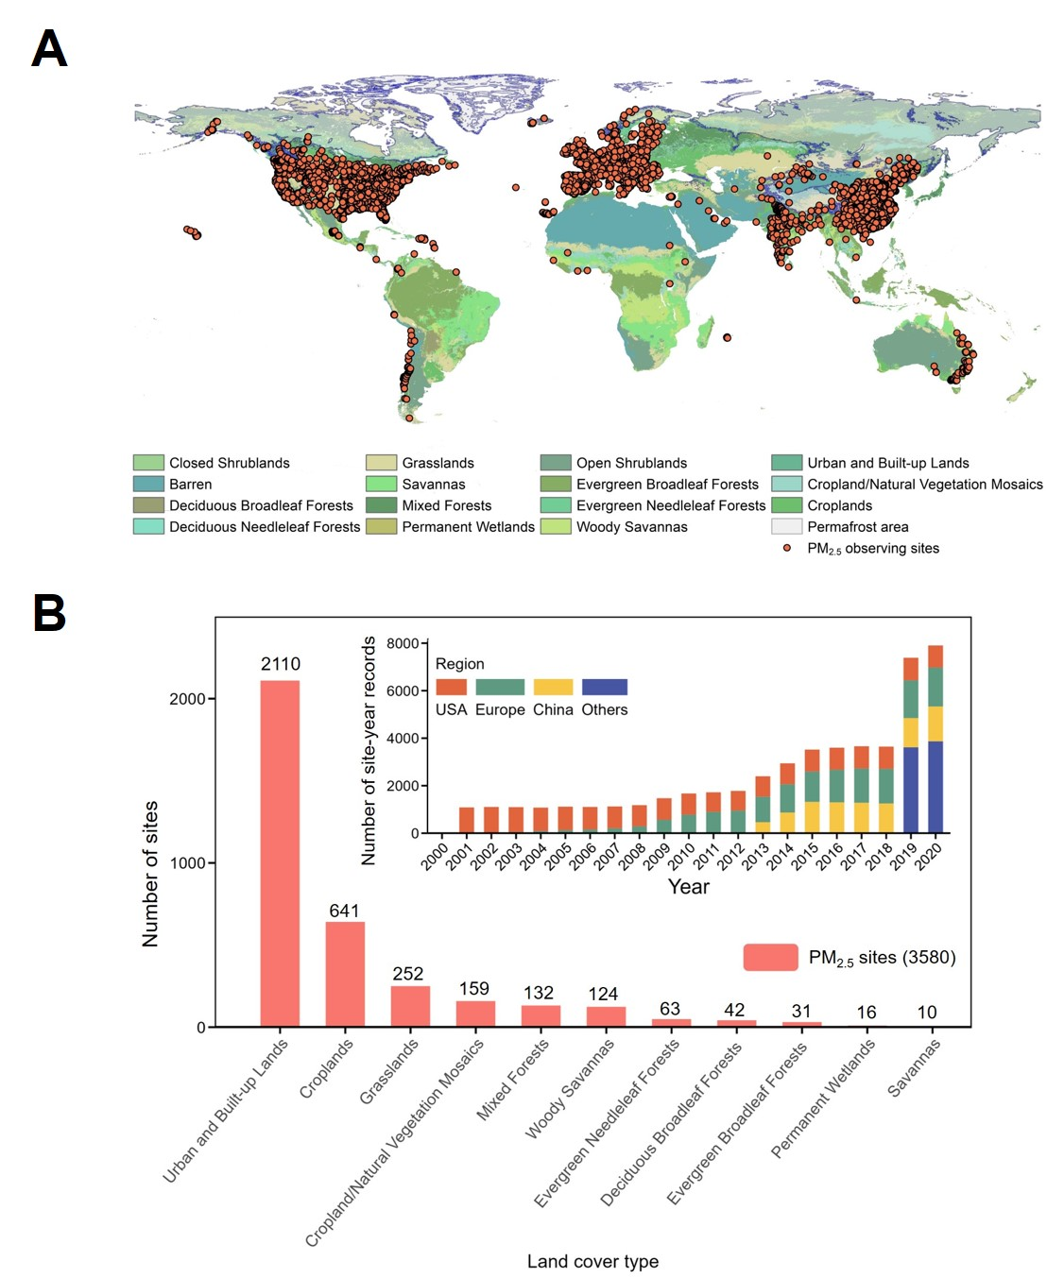
Fig. 1 | Distribution of global PM_{2.5} monitoring sites. The map shows the location and land cover type of PM_{2.5} sites (A). The bars represent the number of PM_{2.5} sites classified by land cover type and temporal variations of regional site-year records (B).
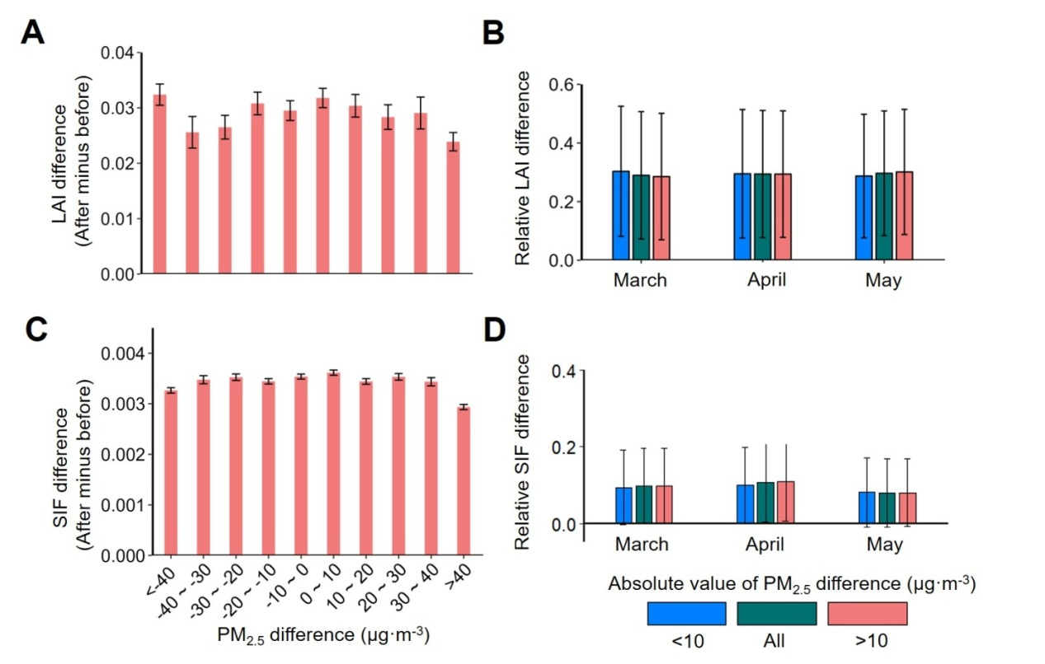
Fig. 2 | Contaminating effects of PM_{2.5} on satellite-observed LAI and SIF signal. A, C, The distribution of changes in LAI (A) and SIF (C) (after minus before) along with changes in PM_{2.5} during the temporal gap (Supplementary Materials and Methods). B, D, Monthly patterns of relative changes in LAI (B) and SIF (D) along with changes in PM_{2.5} during the temporal gap.
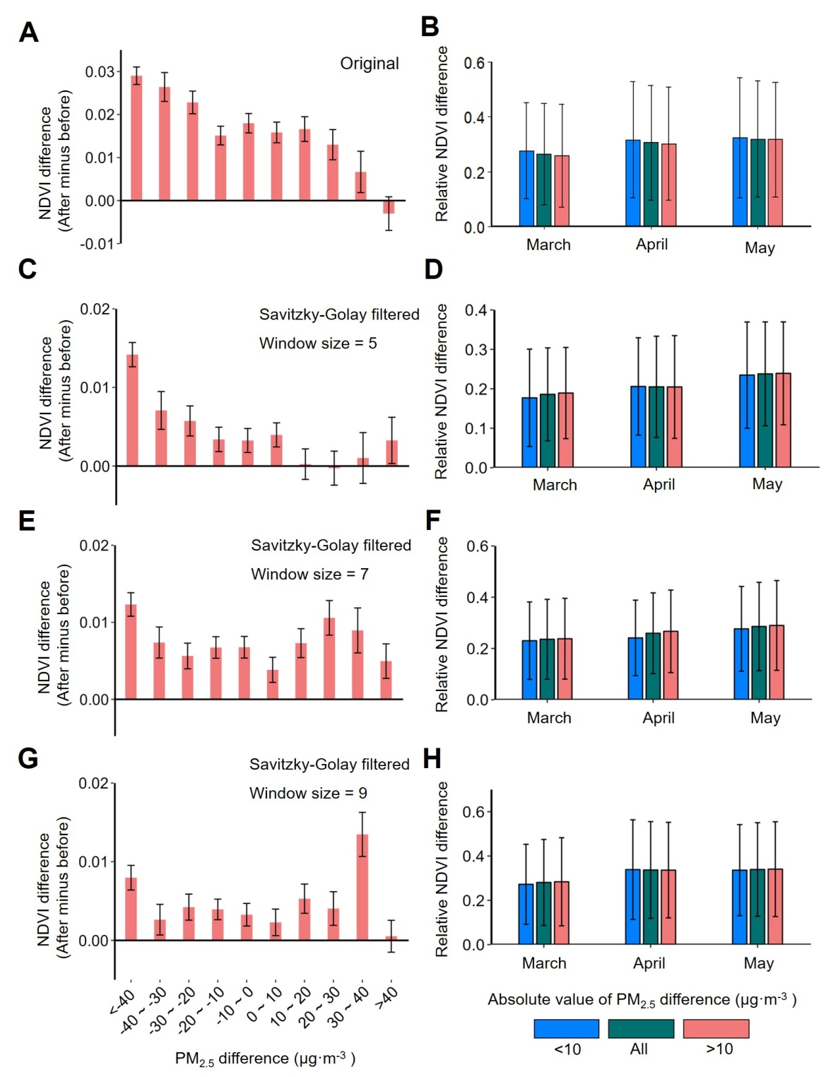
Fig. 3 | Contaminating effect of PM_{2.5} on satellite-observed NDVI signal. A, C, E, G, The distribution of changes in NDVI (after minus before) along with changes in PM_{2.5} during the temporal gap (Supplementary Materials and Methods) for original NDVI (A) and Savitzky-Golay filtered NDVI with window sizes of 5 (C), 7 (E), and 9 (G) days. B, D, F, H, Monthly patterns of relative changes in NDVI along with changes in PM_{2.5} during the temporal gap for original NDVI (B), and Savitzky-Golay filtered NDVI with window sizes of 5 (D), 7 (F), and 9 (H) days.
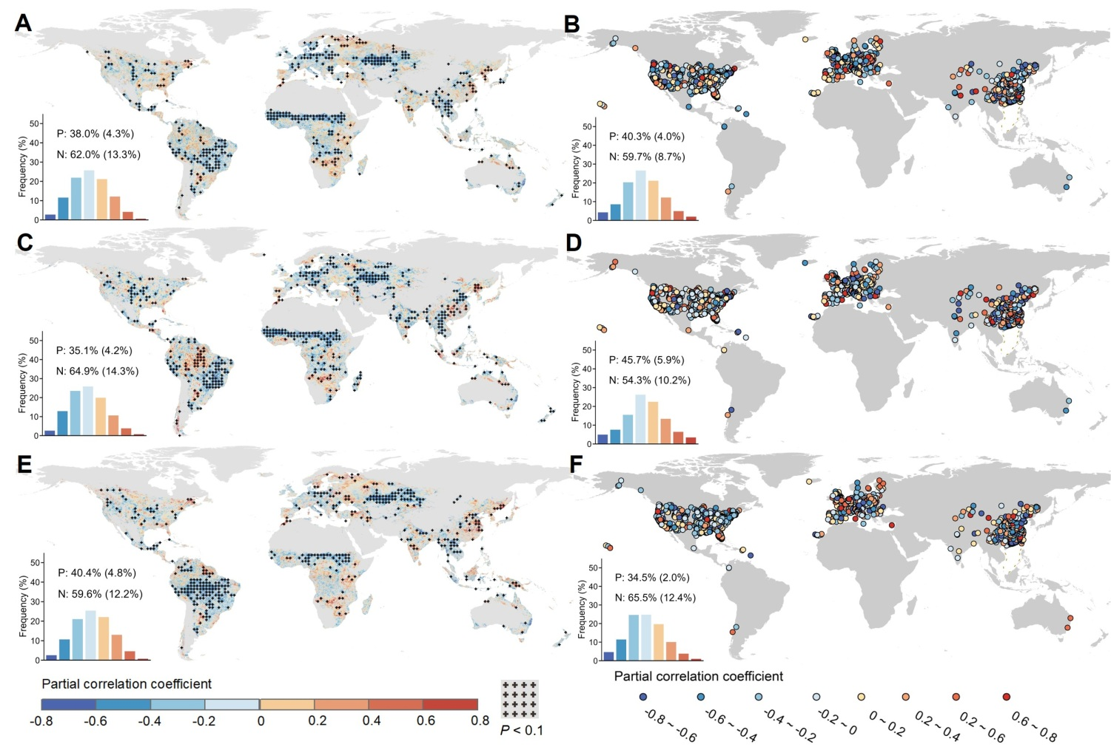
Fig. 4 | The distribution of partial correlation coefficients between PM_{2.5} pollution and spring greenness at global (A, C, E) and site (B, D, F) scales. The greenness was represented by satellite-observed NDVI (A, B), LAI (C, D), and SIF (E, F). The bars in the corner show the distribution of partial correlation coefficients. P and N indicates the positive and negative correlations, respectively. The values in the columns represent the frequency of pixels or sites with significant correlations (P < 0.1).
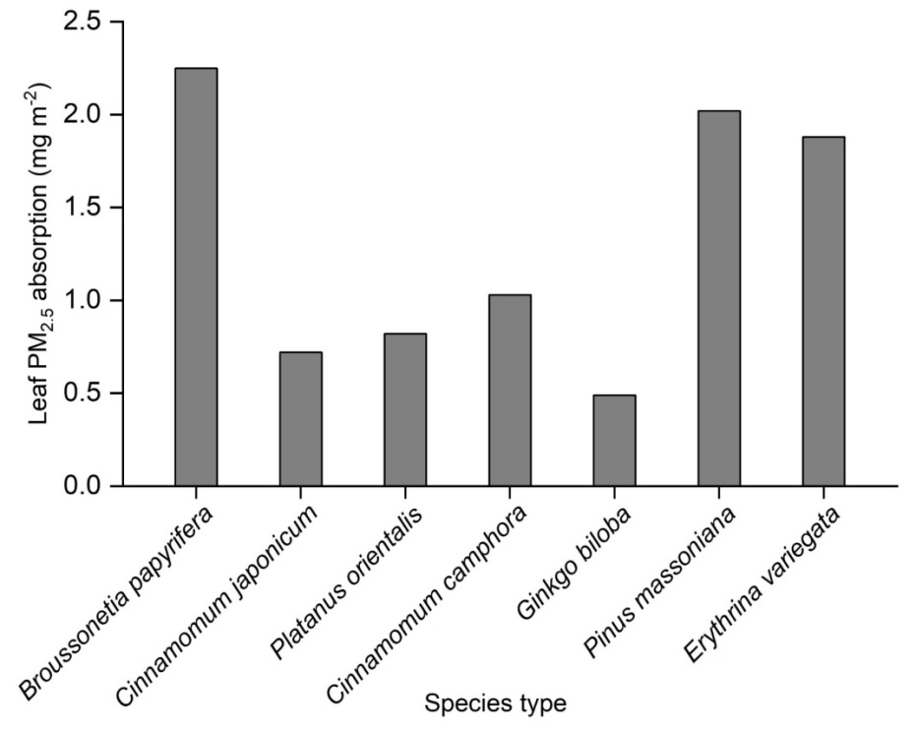
Fig. 5 | Leaf PM_{2.5} absorption under the PM_{2.5} treatment for seven species (Supplementary Table 2). The leaf PM_{2.5} absorption was measured when PM_{2.5} concentrations remained stable with an average concentration of 550 μg m⁻³ (Supplementary Materials and Methods).
Fig. 6 | Effects of particulate matter on plant physiological indicators derived from experimental and observational datasets. “Exp” and “Obs” represent model results derived from experimental studies and observational studies respectively. Amax is the maximum rate of carbon assimilation. Fv/Fm is the maximum quantum efficiency of Photosystem. Values in brackets represent the mean effect size (left) and number of species (right) in each estimate. P-values are shown when the effect size of a variable was significant (P < 0.05). The dashed vertical lines indicate the effect size at zero.
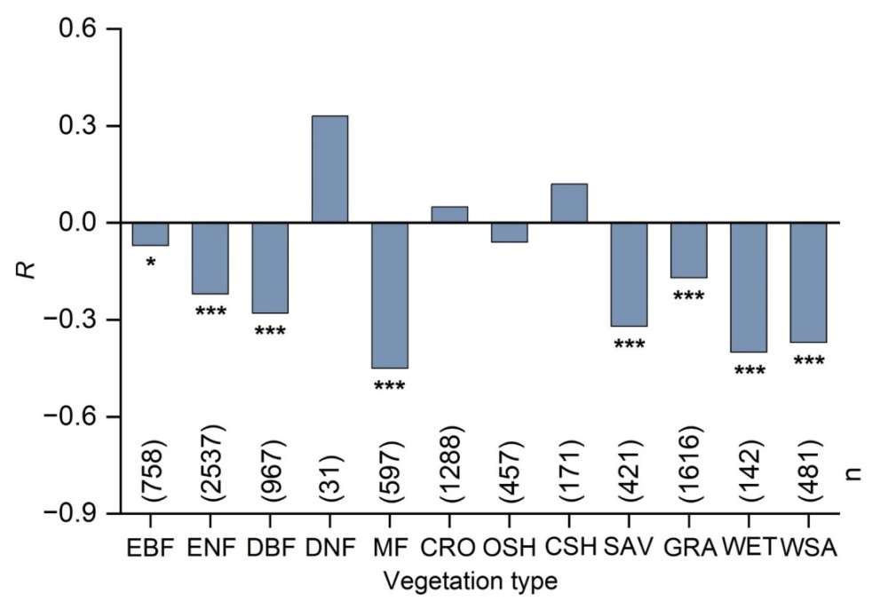
Fig. 7 | Relationship between PM_{2.5} pollution and canopy stomatal conductance for different vegetation types. R represents the correlation coefficient between monthly anomaly of PM_{2.5} and canopy stomatal conductance. The symbol * and *** indicates P < 0.01 and P < 0.001, respectively.
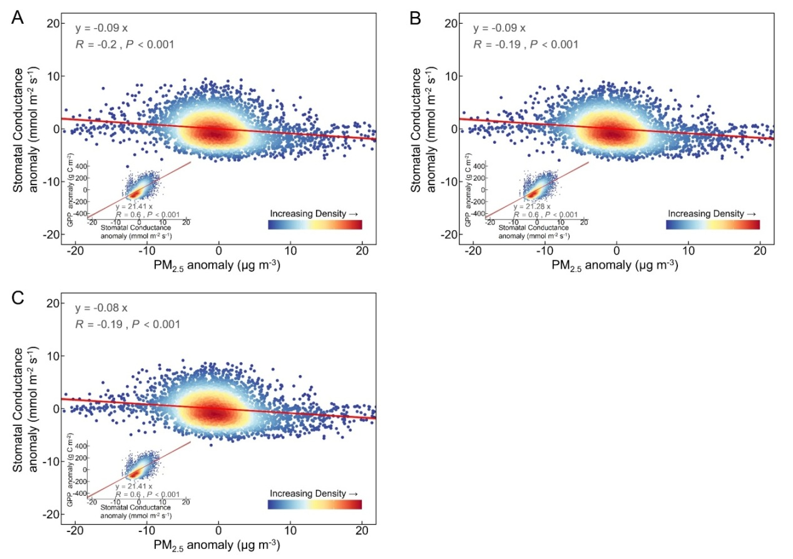
Fig. 8 | Effect of PM_{2.5} pollution on canopy stomatal conductance for forests based on different scenarios of canopy height (H, m) and wind measurement height (Z, m) (Supplementary Table 6). (A-C) indicate the relationship between the monthly anomaly of PM_{2.5} and stomatal conductance derived from global flux measurements (density plot) for forests under three scenarios, The subplot shows the relationship between anomalies of stomatal conductance and GPP (A) H=10, Z=15; (B) H=15, Z= 20; (C) H=20, Z=30 (Supplementary Table 6).
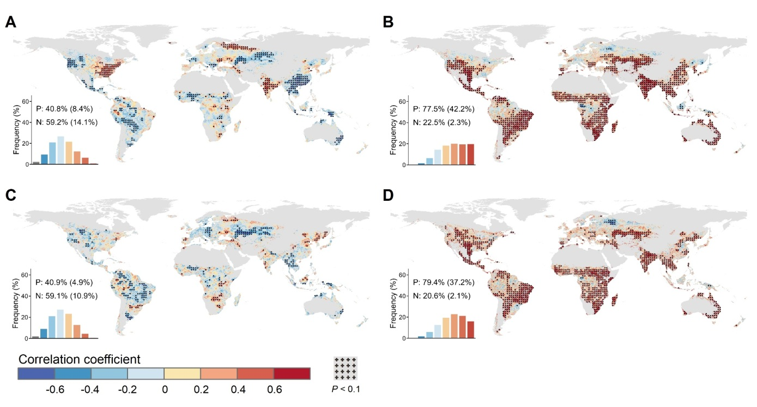
Fig. 9 | Effects of PM_{2.5} pollution on canopy stomatal conductance and SIF in spring. A, C, The relationship between PM_{2.5} concentration and canopy stomatal conductance (A, simple correlation, C, partial correlation). B, D, The relationship between canopy stomatal conductance and SIF (B, simple correlation, D, partial correlation). For partial correlation analyses, the effects of CO₂, temperature, precipitation, and VPD were removed.
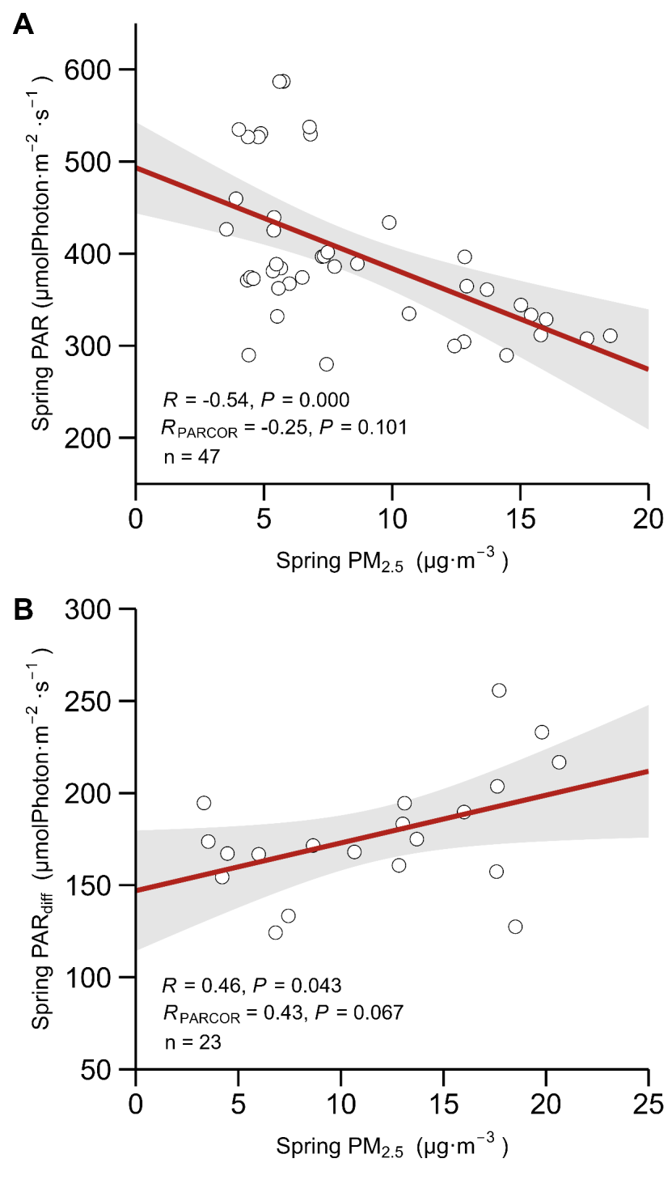
Fig. 10 | Effects of PM_{2.5} pollution on PAR and PAR_{diff} in spring using flux measurements. A, The relationship between PM_{2.5} concentration and PAR. For partial correlation analysis, the effect of incoming shortwave radiation was excluded. B, The relationship between PM_{2.5} concentration and PAR_{diff}. For partial correlation analysis, the effect of PAR was excluded.
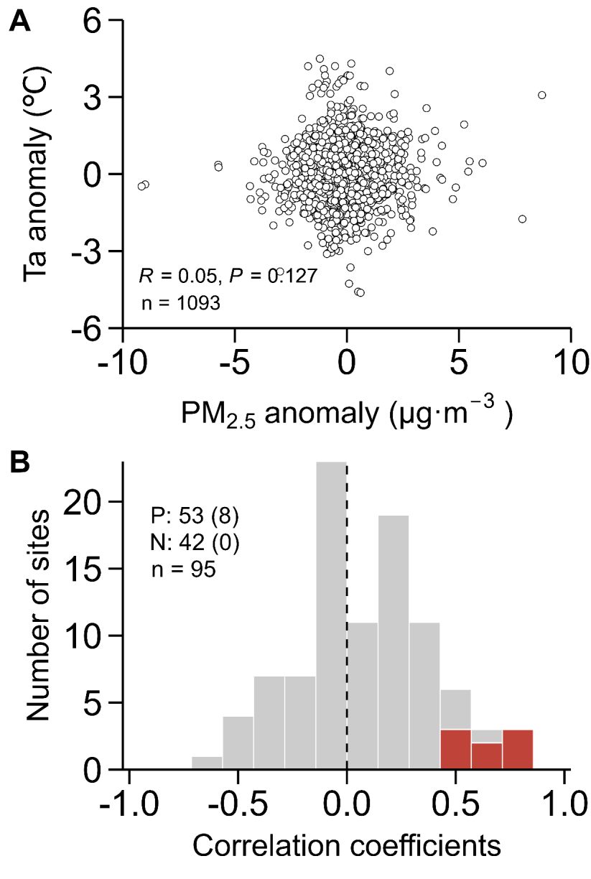
Fig. 11 | Effect of PM_{2.5} pollution on air temperature (Ta) using flux measurements. A, The relationship between the anomaly of PM_{2.5} concentration and the anomaly of Ta. B, The distribution of PM_{2.5}-Ta relationship. P and N indicates positive and negative correlation, respectively. The values in the columns or the red bars indicate the number of sites of significant correlations (P < 0.1).
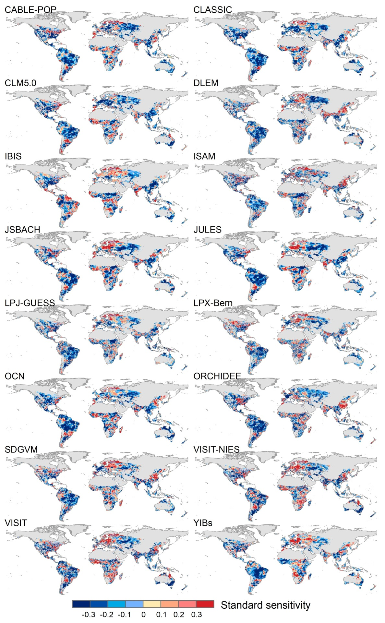
Fig. 12 | Standard sensitivities of simulated GPP from 16 process-based models to PM_{2.5} pollution. The figure shows the spatial pattern of standard sensitivity of PM_{2.5} for each model.
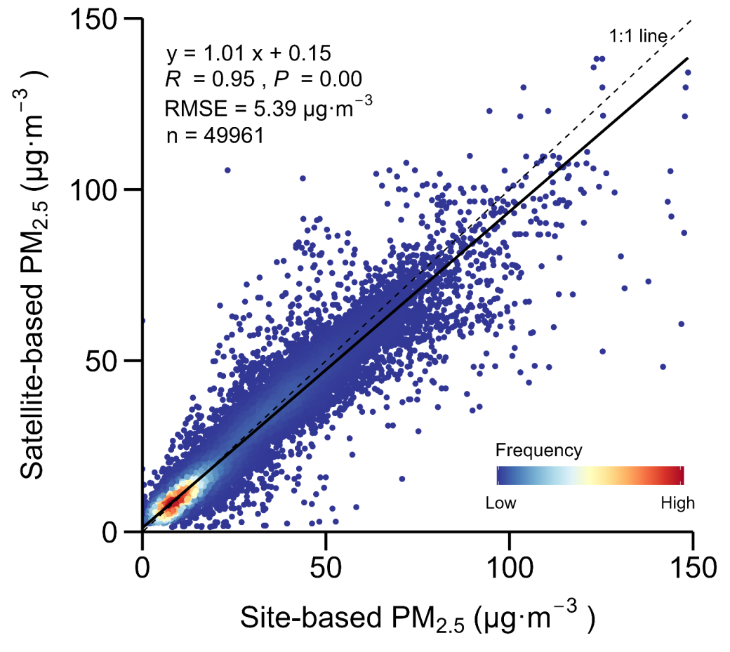
Fig. 13 | Evaluation of satellite-based PM_{2.5} data using site monitoring of PM_{2.5} concentrations. The density scatter plot shows the relationship between site- and satellite-based PM_{2.5}.
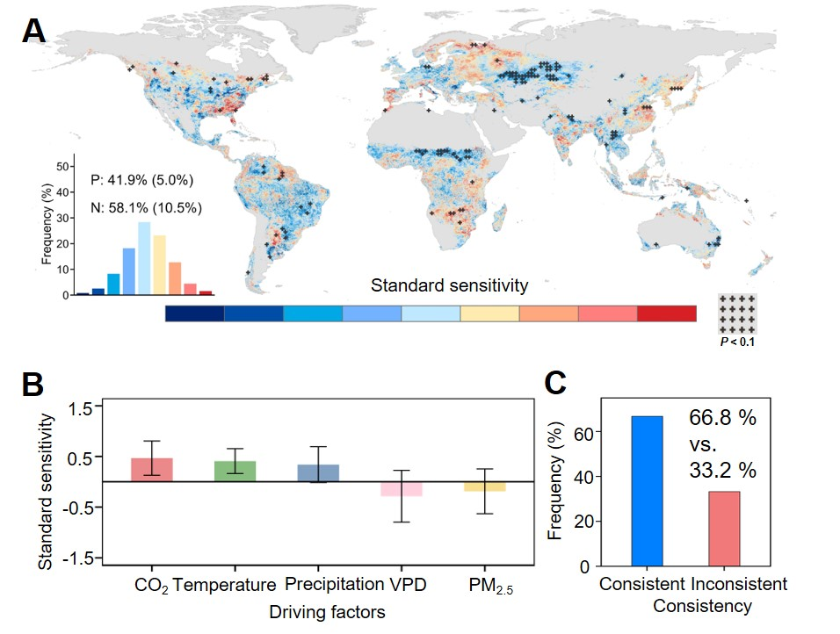
Fig. 14 | Impact of spring PM_{2.5} pollution on LAI derived from the GLASS product suite. A, The spatial pattern of standard sensitivity of GLASS LAI to PM_{2.5} pollution. B, The pattern of standard sensitivities of climatic factors (i.e., CO₂, temperature, precipitation, and VPD) and PM_{2.5} pollution. C, The comparison of PM_{2.5} effects for MODIS LAI and GLASS LAI. Consistent and inconsistent indicates the same and contrasting direction of PM_{2.5} effect on MODIS LAI and GLASS LAI, respectively.
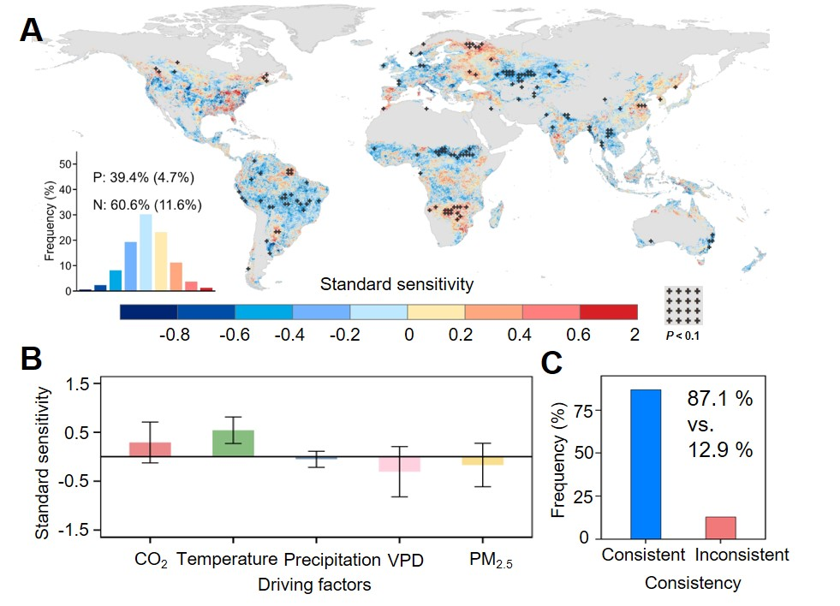
Fig. 15 | Impact of spring PM_{2.5} pollution on relative SIF. A, The spatial pattern of standard sensitivity of relative SIF to PM_{2.5} concentration. B, The pattern of standard sensitivities of climatic factors (i.e., CO₂, temperature, precipitation, and VPD) and PM_{2.5} pollution. C, The comparison of PM_{2.5} effects for SIF and relative SIF. Consistent and inconsistent indicates the same and contrasting direction of PM_{2.5} effect on SIF and relative SIF, respectively.
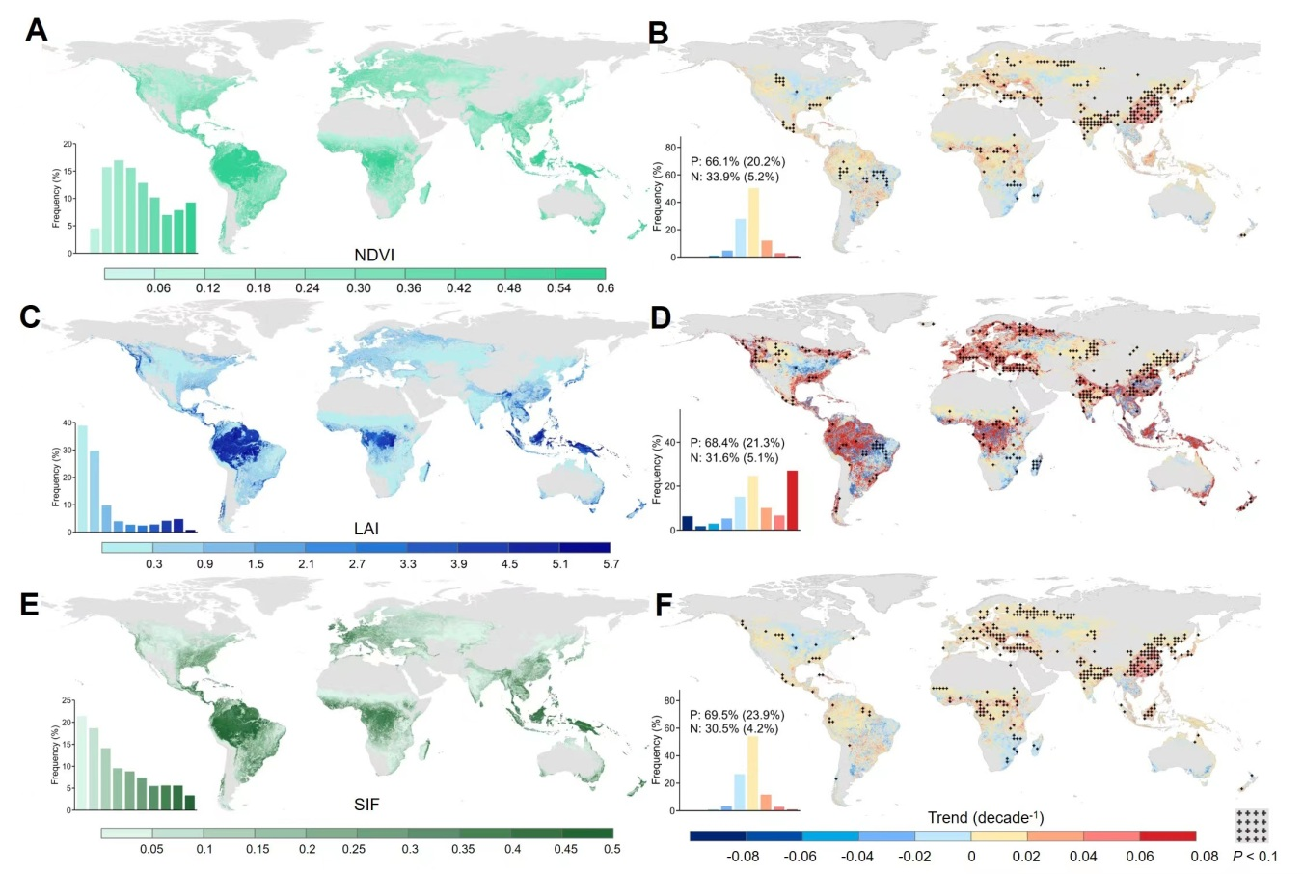
Fig. 16 | Spatial and temporal patterns of spring vegetation greenness from 2000 to 2020. A, C, E, The spatial patterns of multi-year averaged spring greenness (A: NDVI, C: LAI, and E: SIF). B, D, F, The spatial patterns of temporal trends of spring greenness (B: NDVI, D: LAI, and F: SIF). P and N above the bars indicates the positive and negative trend, respectively. The values in the columns represent the percentage of areas with significant temporal trends (P < 0.1).
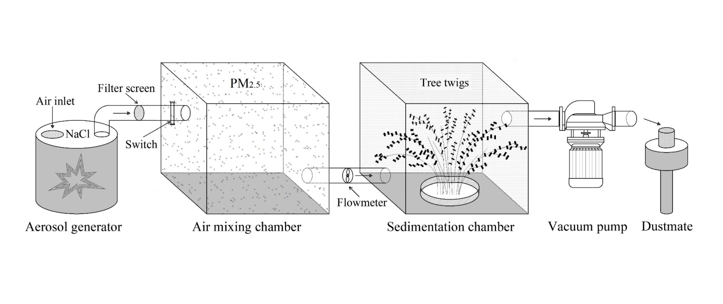
Fig. 17 | Diagram of PM_{2.5} exposure experiment. Details of experiment can be seen in the Supplementary Materials and Methods.

Supplementary Tables
Table 1 Summary of data used in this study.
Data | Indicator | Spatial resolution | Temporal resolution | Time duration | Source
Site monitoring of air pollution data | PM_{2.5} | - | daily | 2000-2020 | Ref¹⁻⁵
Site monitoring of air pollution data | O₃
Satellite-based PM_{2.5} pollution | PM_{2.5} | 0.01° | daily | 2000-2020 | Ref⁶
Satellite-based vegetation indices | NDVI | 500m | daily | 2000-2020 | MOD13C2⁷
Satellite-based vegetation indices | LAI | 500m | 8-day | 2000-2020 | MOD15A2H⁷
Satellite-based vegetation indices | SIF | 0.05° | 4-day | 2000-2020 | CSIF⁸
TerraClimate | Temperature | 1/24° | monthly | 2000-2020 | Climatology Lab⁹
TerraClimate | Precipitation
TerraClimate | VPD  Vapor pressure
Global monthly mean CO₂ | CO₂ | - | monthly | 2000-2020 | NOAA¹⁰
Land cover | IGBP | 0.05° | yearly | 2000-2020 | MCD12C1⁷
Land cover | Permafrost type | - | - | - | NSIDC¹¹
BESS_Rad | PAR | 5km | 4-day | 2000-2020 | BESS¹²
BESS_Rad | diffuse PAR
Biogeochemical variables | VC_{max} | 500m | 8-day | 2000-2019 | NESDC¹³
Biogeochemical variables | N deposition  ET | 0.072727°  0.25° | yearly  monthly | 2000-2019  2000-2020 | Ref¹⁴  GLEAM¹⁵

¹Open AQ (https://openaq.org/)
²The China National Environmental Monitoring Centre (http://www.cnemc.cn/)
³The US Environmental Protection Agency (https://www.epa.gov/)
⁴The European Air Quality e-Reporting (https://www.eea.europa.eu/data-and-maps/data/external/air-quality-e-reporting-aq)
⁵The Canadian National Air Pollution Surveillance Program (https://www.canada.ca/en/environment-climate-change/services/air-pollution/monitoring-networks-data/national-air-pollution-program.html)
⁶10.1038/s41467-023-43862-3
⁷https://lpdaac.usgs.gov/
⁸https://figshare.com/articles/dataset/CSIF/6387494
⁹https://www.climatologylab.org/terraclimate.html
¹⁰https://gml.noaa.gov/ccgg/trends/global.html
¹¹https://nsidc.org/data/ggd318/versions/2
¹²https://www.environment.snu.ac.kr/bess-rad
¹³http://www.nesdc.org.cn/sdo/detail?id=612f42ee7e28172cbed3d80f1410.1038/s41467-019-12257-8
¹⁴https://doi.org/10.1038/s41467-019-12257-8
¹⁵https://www.gleam.eu/

Table 2. Description of Scan Electron Microscopy observations in Fig. 2.
ID | Species name | Scan area | Leaf Status | PM_{2.5} absorption measurement
A1 | Gordonia acuminata | Leaf stomata | Stomata closed; massive particulates accumulate. | No
A2 | Lindera kwangtungensis | Leaf stomata | 50% of stomata closed; massive particulates accumulate. | No
A3 | Rhamnus esquirolii | Leaf stomata | Stomata open, massive particulates accumulate. | No
A4 | Euonymus japonicus Thunb | Leaf stomata | Stomata open, adherent particulates block stomata. | No
A5 | Buxus sinica var. parvifolia | Leaf stomata | Stomata damaged; adherent particulates blocked stomata. | No
A6 | Lagerstroemia indica | Leaf stomata | 90% of stomata closed; particulates adhere to leaf surface. | No
A7 | Prunus triloba | Leaf surface | Particulates adhere to leaf surface. | No
A8 | Parthenocissus quinquefolia | Leaf (back) surface | Massive particulates adhere to leaf surface. | No
A9 | Broussonetia papyrifera | Leaf trichomes | Particulates adhere to leaf hair. | Yes
A10 | Cinnamomum japonicum | Leaf surface | Leaf surface damaged, massive particulates accumulated. | Yes
A11 | Platanus orientalis | Leaf stomata | Stomata closed; particulates adhere to leaf surface. | Yes
A12 | Cinnamomum camphora | Leaf (back) surface | Particulates adhere to leaf surface. | Yes
A13 | Ginkgo biloba | Leaf surface | Massive particulates accumulated. | Yes
A14 | Pinus massoniana | Leaf surface | Particulates adhere to leaf surface. | Yes
A15 | Erythrina variegata | Leaf vein | Particulates adhere to leaf vein. | Yes

Table 3. Description of meta-analysis materials.
Study ID | Author | Year | Study type | Species | DOI
1 | Borka et al. | 1980 | Experimental | Helianthus annuus | 10.1016/0143-1471(80)90084-7
2 | Thompson et al. | 1984 | Experimental | Viburnum tinus | 10.1016/0143-1471(84)90056-4
3 | Hirano et al. | 1995 | Experimental | Cucumis sativusL | 10.1016/0269-7491(94)00075-O
4 | Lu et al. | 1999 | Observational | Osmanthus fragrans Lour., Rhododendron x pulchrum, Photinia x fraseri Dress | 10.1016/j.gecco.2019.e00783
5 | Prusty et al. | 2005 | Observational | Pongamia pinnata, Tabernaemontana divaricata, Ipomoea carnea, Ficus religiosa, Ficus benghalensis, Quisqualis indica | 10.1016/j.ecoenv.2003.12.013
6 | Nanos et al. | 2007 | Experimental | Olea europaea | 10.1065/espr2006.08.327
7 | Morina et al, | 2013 | Observational | Phyllostachys bissetii | 10.3390/atmos10040224
8 | González et al. | 2014 | Experimental | Tabebuia chrysotricha, Fragaria chiloensis, Ricinus communis, Rapanea laetevirens, Saccharum officinarum, Hibiscus rosa-sinensis, Alocasia macrorrhiza, Rosa rubiginosa, Mespilus germanica, Bauhinia candicans, Psychotria carthagenensis, Coccoloba cordata, Justicia oranensis, Eugenia uniflora, Lonchocarpus lilloi, Myrcianthes pseudomato | 10.2134/jeq2013.08.0308
9 | Przybysz et al. | 2014 | Observational | Acer platanoides L., Acer pseudoplatanus L., Parthenocissus tricuspidata (S. Et Z.) Planch., Parthenocissus quinquefolia L., Sorbaria sorbifolia L. | doi:10.1080/01448765.2013.849208
10 | Yamaguchi et al. | 2014 | Experimental | Fagus crenata, Castanopsis sieboldii, Cryptomeria japonica, Larix kaempferi | 10.1016/j.atmosenv.2014.01.023
11 | Yu et al. | 2015 | Experimental | Neolitsea aurata, Polyspora speciosa, Lindera kwangtungensis, Rhamnus esquirolii, Cunninghamia lanceolata, Pinus massoniana, Phyllostachys edulis, Symplocos setchuensis Brand, Castanopsis sclerophylla | 10.1007/s11356-018-2128-6
12 | Chen et al. | 2015 | Observational | Koelreuteria bipinnata, Elaeocarpus sylvestris (Lour.) Poir., Platanus acerifolia Willd., Magnolia grandiflora, Ligustrum lucidum, Prunus cerasifera Ehrh. cv. Atropurpurea, Morus alba L., Osmanthus fragrans Lour., Parthenocissus tricuspidata (S. Et Z.) Planch., Viburnum odoratissinum, Pyracantha fortuneana (Maxim.) Li, Mahonia fortune (Lindl.) Fedde, Loropetalum chinense (R. Br.) Oliver var. rubrum Yieh, Trachycarpus fortunei (Hook.) H. Wendl., Pittosporum tobira (Thunb.) Ait., Reineckia carnea (Andr.) Kunth, Ginkgo biloba L., Eriobotrya japonica (Thunb.) Lindl., Jasminum mesnyi Hance, Rhododendron simsii Planch., Nerium indicum Mill., Photinia serrulata Lindl., Sophora japonica Linn. var. pendula Loud., Iris tectorum | 10.2298/ABS150325102C
13 | Shi et al. | 2015 | Observational | Populus tomentosa | 10.5846/stxb201403190487
14 | Zhang et al. | 2017 | Experimental | Populus deltoides × P. nigra | 10.13332/j.1000-1522.20160376
15 | Yang et al. | 2018 | Experimental | Populus × euramericana | 10.1016/j.envexpbot.2018.06.009
16 | Yang et al. | 2018 | Observational | Buxus megistophylla H. Lév., Agave sisalana Perr. ex Engelm., Ligustrum lucidum, Buxus sinica var. parvifolia M. Cheng | 10.19640/j.cnki.jtau.2018.01.007
17 | Popek et al. | 2018 | Observational | Physocarpus opulifolius, Sorbaria sorbifolia | 10.15244/pjoes/78626
18 | Qiu et al. | 2018 | Observational | Magnolia grandiflora, Cinnamomum camphora, Viburnum odoratissinum, Castanopsis sclerophylla, Schima superba, Koelreuteria bipinnata | 10.11833/j.issn.2095-0756.2018.01.011
19 | Xu et al. | 2018 | Experimental | Microcystis aeruginosa | 10.1007/s11356-017-0955-5
20 | Li et al. | 2019 | Experimental | Neolitsea aurata, Gordonia acuminata, Lindera kwangtungensis, Rhamnus esquirolii | 10.1007/s12374-018-0254-9
21 | Kiyomizu et al. | 2019 | Observational | Rhododendron × pulchrum, Ginkgo biloba L. | 10.1007/s00468-018-1759-z
22 | Haynes et al. | 2019 | Observational | Pittosporum undulatum Vent., hepaticae | 10.3390/atmos10040224
23 | Sadia et al. | 2019 | Observational | Polyalthia longifolia, Swietenia mahagoni, Artocarpus heterophyllus | 10.1007/s42452-019-1421-4
24 | Yang et al. | 2019 | Experimental | Chlorella vulgaris | 10.1016/j.envpol.2019.04.017
25 | Wang et al. | 2020 | Observational | Populus × canadensis Moench | 10.1111/1365-2745.13633
26 | Ma et al. | 2020 | Experimental | Populus tomentosa | 10.11707/j.1001-7488.20200820
27 | Li et al. | 2021 | Experimental | Nerium oleander L. | 10.1016/j.chemosphere.2021.130682
28 | Zhu et al, | 2021 | Observational | Euonymus japonicus | 10.1186/s12870-021-03207-y
29 | Kong et al. | 2021 | Experimental | Brassica campestris L. | 10.32604/phyton.2021.014190
30 | Treesubsuntorn et al. | 2021 | Experimental | Wrightia religiosa | 10.1016/j.scitotenv.2021.148779
31 | Sharma et al. | 2021 | Experimental | Triticum aestivum L. | 10.5572/ajae.2020.080
32 | Kwon et al. | 2021 | Experimental | Iris sanguinea, Pteris multifida, Vitis coigenetiae, Viburnum odoratissinum | 10.11628/ksppe.2021.24.5.461
33 | Gao et al. | 2022 | Experimental | Brassica rapa spp. Pekinensis | 10.1016/j.envpol.2021.118585
34 | Matsumoto et al. | 2022 | Observational | Rhododendron × pulchrum, Rhaphiolepis indica (L.), Prunus × yedoensis (Matsum.), Ginkgo biloba L. | 10.1007/s11252-022-01212-z
35 | Goswami et al. | 2022 | Observational | Azadirachta indica, Toona ciliate, Callistemon citrinus, Psidium guajava | 10.1007/s10661-022-10384-2
36 | Huang et al. | 2023 | Experimental | Euonymus Japonicus var.aurea-marginatus | 10.1016/j.envpol.2022.120593

Table 4. Description of the 187 sites of EC-based flux measurement used in this study.
NO. | Site | Lat | Lon | IGBP | Year | NO. | Site | Lat | Lon | IGBP | Year
1 | AR-Slu | −33.5 | −66.5 | MF | 2009-2011 | 95 | IT-BCi | 40.50 | 15.00 | CRO | 2004-2014
2 | AT-Neu | 47.10 | 11.30 | GRA | 2002-2012 | 96 | IT-CA1 | 42.40 | 12.00 | DBF | 2011-2014
3 | AU-Ade | −13.1 | 131.10 | WSA | 2007-2009 | 97 | IT-CA2 | 42.40 | 12.00 | CRO | 2011-2014
4 | AU-ASM | −22.3 | 133.20 | ENF | 2010-2014 | 98 | IT-CA3 | 42.30 | 12.00 | DBF | 2011-2014
5 | AU-Cpr | −34 | 140.60 | SAV | 2010-2014 | 99 | IT-Col | 41.80 | 13.60 | DBF | 1996-2014
6 | AU-Cum | −33.6 | 150.70 | EBF | 2012-2014 | 100 | IT-Cp2 | 41.70 | 12.40 | EBF | 2012-2014
7 | AU-DaP | −14.1 | 131.30 | GRA | 2007-2013 | 101 | IT-Cpz | 41.70 | 12.40 | EBF | 1997-2009
8 | AU-DaS | −14.2 | 131.40 | SAV | 2008-2014 | 102 | IT-Isp | 45.80 | 8.60 | DBF | 2013-2014
9 | AU-Dry | −15.3 | 132.40 | SAV | 2008-2014 | 103 | IT-Lav | 46.00 | 11.30 | ENF | 2003-2014
10 | AU-Emr | −23.9 | 148.50 | GRA | 2011-2013 | 104 | IT-MBo | 46.00 | 11.00 | GRA | 2003-2013
11 | AU-Fog | −12.5 | 131.30 | WET | 2006-2008 | 105 | IT-Noe | 40.60 | 8.20 | CSH | 2004-2014
12 | AU-Gin | −31.4 | 115.70 | WSA | 2011-2014 | 106 | IT-PT1 | 45.20 | 9.10 | DBF | 2002-2004
13 | AU-GWW | −30.2 | 120.70 | SAV | 2013-2014 | 107 | IT-Ren | 46.60 | 11.40 | ENF | 1998-2013
14 | AU-How | −12.5 | 131.20 | WSA | 2001-2014 | 108 | IT-Ro2 | 42.40 | 11.90 | DBF | 2002-2012
15 | AU-Lox | −34.5 | 140.70 | DBF | 2008-2009 | 109 | IT-SR2 | 43.70 | 10.30 | ENF | 2013-2014
16 | AU-RDF | −14.6 | 132.50 | WSA | 2011-2013 | 110 | IT-SRo | 43.70 | 10.30 | ENF | 1999-2012
17 | AU-Rig | −36.6 | 145.60 | GRA | 2011-2014 | 111 | IT-Tor | 45.80 | 7.60 | GRA | 2008-2014
18 | AU-Rob | −17.1 | 145.60 | EBF | 2014-2014 | 112 | MY-PSO | 3.00 | 102.30 | EBF | 2003-2009
19 | AU-Stp | −17.2 | 133.40 | GRA | 2008-2014 | 113 | NL-Hor | 52.20 | 5.10 | GRA | 2004-2011
20 | AU-TTE | −22.3 | 133.60 | OSH | 2012-2014 | 114 | NL-Loo | 52.20 | 5.70 | ENF | 1996-2014
21 | AU-Tum | −35.7 | 148.20 | EBF | 2001-2014 | 115 | RU-Che | 68.60 | 161.30 | WET | 2002-2005
22 | AU-Wac | −37.4 | 145.20 | EBF | 2005-2008 | 116 | RU-Cok | 70.80 | 147.50 | OSH | 2003-2014
23 | AU-Whr | −36.7 | 145.00 | EBF | 2011-2014 | 117 | RU-Fyo | 56.50 | 32.90 | ENF | 1998-2014
24 | AU-Wom | −37.4 | 144.10 | EBF | 2010-2014 | 118 | RU-Ha1 | 54.70 | 90.00 | GRA | 2002-2004
25 | AU-Ync | −35 | 146.30 | GRA | 2012-2014 | 119 | RU-SkP | 62.30 | 129.20 | DNF | 2012-2014
26 | BE-Bra | 51.30 | 4.50 | MF | 1996-2014 | 120 | RU-Tks | 71.60 | 128.90 | GRA | 2010-2014
27 | BE-Lon | 50.60 | 4.70 | CRO | 2004-2014 | 121 | RU-Vrk | 67.10 | 62.90 | CSH | 2008-2008
28 | BE-Vie | 50.30 | 6.00 | MF | 1996-2014 | 122 | SD-Dem | 13.30 | 30.50 | SAV | 2005-2009
29 | BR-Sa3 | −3 | −55 | EBF | 2000-2004 | 123 | SN-Dhr | 15.40 | −15.4 | SAV | 2010-2013
30 | CA-Cbo | 44.32 | -79.93 | DBF | 1994-2020 | 124 | US-AR1 | 36.40 | −99.4 | GRA | 2009-2012
31 | CA-Gro | 48.20 | −82.2 | MF | 2003-2014 | 125 | US-AR2 | 36.60 | −99.6 | GRA | 2009-2012
32 | CA-Oas | 53.63 | -106.2 | DBF | 1996-2010 | 126 | US-ARc | 35.50 | −98 | GRA | 2005-2006
33 | CA-Obs | 54.00 | −105.1 | ENF | 1997-2010 | 127 | US-ARM | 36.60 | −97.5 | CRO | 2003-2012
34 | CA-Qfo | 49.70 | −74.3 | ENF | 2003-2010 | 128 | US-Atq | 70.50 | −157.4 | WET | 2003-2008
35 | CA-SF1 | 54.50 | −105.8 | ENF | 2003-2006 | 129 | US-Bi2 | 38.1091 | -121.535 | CRO | 2017-2021
36 | CA-SF2 | 54.30 | −105.9 | ENF | 2001-2005 | 130 | US-Blo | 38.90 | −120.6 | ENF | 1997-2007
37 | CA-SF3 | 54.10 | −106 | OSH | 2001-2006 | 131 | US-Cop | 38.10 | −109.4 | GRA | 2001-2007
38 | CA-TP1 | 42.70 | −80.6 | ENF | 2002-2014 | 132 | US-CRT | 41.60 | −83.3 | CRO | 2011-2013
39 | CA-TP2 | 42.80 | −80.5 | ENF | 2002-2007 | 133 | US-GBT | 41.40 | −106.2 | ENF | 1999-2006
40 | CA-TP3 | 42.70 | −80.3 | ENF | 2002-2014 | 134 | US-GLE | 41.40 | −106.2 | ENF | 2004-2014
41 | CA-TP4 | 42.70 | −80.4 | ENF | 2002-2014 | 135 | US-Goo | 34.30 | −89.9 | GRA | 2002-2006
42 | CA-TPD | 42.60 | −80.6 | DBF | 2012-2014 | 136 | US-Ha1 | 42.5378 | -72.1715 | DBF | 1991-2020
43 | CG-Tch | -4.29 | 11.656 | SAV | 2006-2009 | 137 | US-Ho2 | 45.2091 | -68.747 | ENF | 1999-2020
44 | CH-Cha | 47.20 | 8.40 | GRA | 2005-2014 | 138 | US-IB2 | 41.80 | −88.2 | GRA | 2004-2011
45 | CH-Dav | 46.80 | 9.90 | ENF | 1997-2014 | 139 | US-Ivo | 68.50 | −155.8 | WET | 2004-2007
46 | CH-Fru | 47.10 | 8.50 | GRA | 2005-2014 | 140 | US-KS1 | 28.50 | −80.7 | ENF | 2002-2002
47 | CH-Lae | 47.48 | 8.3644 | MF | 2004-2014 | 141 | US-KS2 | 28.60 | −80.7 | CSH | 2003-2006
48 | CH-Oe2 | 47.29 | 7.7337 | CRO | 2004-2014 | 142 | US-Lin | 36.40 | −119.8 | CRO | 2009-2010
49 | CH-Oe2 | 47.29 | 7.7337 | CRO | 2004-2014 | 143 | US-Los | 46.10 | −90 | WET | 2000-2014
50 | CN-CBS | 42.40 | 128.10 | MF | 2003-2010 | 144 | US-LWW | 35.00 | −98 | GRA | 1997-1998
51 | CN-Cng | 44.60 | 123.50 | GRA | 2007-2010 | 145 | US-Me1 | 44.60 | −121.5 | ENF | 2004-2005
52 | CN-DHS | 23.20 | 112.50 | EBF | 2003-2010 | 146 | US-Me2 | 44.50 | −121.6 | ENF | 2002-2014
53 | CN-Du2 | 42.00 | 116.30 | GRA | 2006-2008 | 147 | US-Me4 | 44.50 | −121.6 | ENF | 1996-2000
54 | CN-Du3 | 42.10 | 116.30 | GRA | 2009-2010 | 148 | US-Me5 | 44.40 | −121.6 | ENF | 2000-2002
55 | CN-HaM | 37.40 | 101.20 | GRA | 2002-2004 | 149 | US-Me6 | 44.30 | −121.6 | ENF | 2010-2014
56 | CN-HBGC | 37.70 | 101.30 | GRA | 2004-2010 | 150 | US-MMS | 39.30 | −86.4 | DBF | 1999-2014
57 | CN-LBJ | 29.00 | 107.20 | EBF | 2020-2021 | 151 | US-MOz | 38.7441 | -92.2 | DBF | 2004-2019
58 | CN-LSDX | 30.40 | 91.10 | GRA | 2004-2010 | 152 | US-Mpj | 34.4385 | -106.238 | WSA | 2008-2020
59 | CN-QYZ | 26.70 | 115.10 | ENF | 2003-2010 | 153 | US-Myb | 38.0499 | -121.765 | WET | 2010-2021
60 | CN-XLGL | 44.10 | 116.30 | GRA | 2003-2010 | 154 | US-Ne1 | 41.20 | −96.5 | CRO | 2001-2013
61 | CN-XSBN | 22.00 | 101.20 | EBF | 2003-2010 | 155 | US-Ne2 | 41.20 | −96.5 | CRO | 2001-2013
62 | CN-YC | 36.80 | 116.60 | CRO | 2003-2010 | 156 | US-Ne3 | 41.20 | −96.4 | CRO | 2001-2013
63 | CZ-wet | 49.00 | 14.80 | WET | 2006-2014 | 157 | US-NR1 | 40.00 | −105.5 | ENF | 1998-2014
64 | DE-Geb | 51.10 | 10.90 | CRO | 2001-2014 | 158 | US-Oho | 41.60 | −83.8 | DBF | 2004-2013
65 | DE-Gri | 51.00 | 13.50 | GRA | 2004-2014 | 159 | US-PFa | 45.9459 | -90.2723 | MF | 1995-2014
66 | DE-Hai | 51.10 | 10.50 | DBF | 2000-2012 | 160 | US-Prr | 65.10 | −147.5 | ENF | 2010-2014
67 | DE-Kli | 50.90 | 13.50 | CRO | 2004-2014 | 161 | US-Seg | 34.3623 | -106.702 | GRA | 2007-2021
68 | DE-Lkb | 49.10 | 13.30 | ENF | 2009-2013 | 162 | US-Ses | 34.3349 | -106.744 | OSH | 2007-2021
69 | DE-Lnf | 51.30 | 10.40 | DBF | 2002-2012 | 163 | US-SRC | 31.90 | −110.8 | OSH | 2008-2014
70 | DE-Obe | 50.80 | 13.70 | ENF | 2008-2014 | 164 | US-SRG | 31.80 | −110.8 | GRA | 2008-2014
71 | DE-RuR | 50.60 | 6.30 | GRA | 2011-2014 | 165 | US-SRM | 31.80 | −110.9 | WSA | 2004-2014
72 | DE-RuS | 50.90 | 6.40 | CRO | 2011-2014 | 166 | US-Syv | 46.20 | −89.3 | MF | 2001-2014
73 | DE-Seh | 50.90 | 6.40 | CRO | 2007-2010 | 167 | US-Ton | 38.40 | −121 | WSA | 2001-2014
74 | DE-SfN | 47.80 | 11.30 | WET | 2012-2014 | 168 | US-Tw2 | 38.10 | −121.6 | CRO | 2012-2013
75 | DE-Tha | 51.00 | 13.60 | ENF | 1996-2014 | 169 | US-Tw3 | 38.10 | −121.6 | CRO | 2013-2014
76 | DE-Zrk | 53.90 | 12.90 | WET | 2013-2014 | 170 | US-Tw4 | 38.10 | −121.6 | WET | 2013-2014
77 | DK-Eng | 55.70 | 12.20 | GRA | 2005-2008 | 171 | US-Twt | 38.10 | −121.7 | CRO | 2009-2014
78 | DK-Fou | 56.50 | 9.60 | CRO | 2005-2005 | 172 | US-UMB | 45.5598 | -84.7138 | DBF | 2000-2014
79 | DK-Sor | 55.50 | 11.60 | DBF | 1996-2014 | 173 | US-UMd | 45.5625 | -84.6975 | DBF | 2007-2021
80 | ES-Amo | 36.80 | −2.3 | OSH | 2007-2012 | 174 | US-Var | 38.40 | −121 | GRA | 2000-2014
81 | ES-LgS | 37.10 | −3 | OSH | 2007-2009 | 175 | US-WCr | 45.80 | −90.1 | DBF | 1999-2014
82 | ES-LJu | 36.90 | −2.8 | OSH | 2004-2013 | 176 | US-Whs | 31.70 | −110.1 | OSH | 2007-2014
83 | FI-Hyy | 61.80 | 24.30 | ENF | 1996-2014 | 177 | US-Wi0 | 46.60 | −91.1 | ENF | 2002-2002
84 | FI-Jok | 60.90 | 23.50 | CRO | 2000-2003 | 178 | US-Wi1 | 46.70 | −91.2 | DBF | 2003-2003
85 | FI-Let | 60.60 | 24.00 | ENF | 2009-2012 | 179 | US-Wi2 | 46.70 | −91.2 | ENF | 2003-2003
86 | FI-Lom | 68.00 | 24.20 | WET | 2007-2009 | 180 | US-Wi3 | 46.60 | −91.1 | DBF | 2002-2004
87 | FI-Sod | 67.40 | 26.60 | ENF | 2001-2014 | 181 | US-Wi4 | 46.70 | −91.2 | ENF | 2002-2005
88 | FR-Fon | 48.48 | 2.7801 | DBF | 2005-2014 | 182 | US-Wi6 | 46.60 | −91.3 | OSH | 2002-2003
89 | FR-Gri | 48.80 | 2.00 | CRO | 2004-2014 | 183 | US-Wi8 | 46.70 | −91.3 | DBF | 2002-2002
90 | FR-LBr | 44.70 | −0.8 | ENF | 1996-2008 | 184 | US-Wjs | 34.4255 | -105.862 | SAV | 2007-2021
91 | FR-Pue | 43.70 | 3.60 | EBF | 2000-2014 | 185 | US-Wkg | 31.70 | −109.9 | GRA | 2004-2014
92 | GF-Guy | 5.279 | -52.92 | EBF | 2004-2014 | 186 | ZA-Kru | −25 | 31.50 | SAV | 2000-2013
93 | GH-Ank | 5.30 | −2.7 | EBF | 2011-2014 | 187 | ZM-Mon | −15.4 | 23.30 | DBF | 2000-2009
94 | GL-ZaH | 74.47 | -20.55 | GRA | 2000-2014

Table 5. Description of TRENDY model output used in this study.
TBM | Spatial resolution | Year Sequence | Reference | DOI
CABLE-POP | 1°x1° | 1700-2021 | Haverd et al., 2018 | 10.5194/gmd-11-2995-2018
CLASSIC | 1°x1° | 1701-2021 | Asaadi et al., 2018 | 10.5194/bg-15-6885-2018
CLM5.0 | 1.25°x0.9375° | 1701-2021 | Lawrence et al., 2019 | 10.1029/2018MS001583
DLEM | 0.5°x0.5° | 1700-2021 | Tian et al., 2011, 2015 | 10.1029/2010JG001393
IBIS | 1°x1° | 1700-2021 | Yuan et al., 2014 | 10.1002/2014JG002608
ISAM | 0.5°x0.5° | 1700-2021 | Jain et al., 2013 | 10.1111/gcb.12207
JSBACH | 1.875°x1.864° | 1701-2021 | Mauritsen et al., 2019 | 10.1029/2018MS001400
JULES | 1.875°x1.25° | 1700-2021 | Burton et al., 2019 | 10.5194/gmd-12-179-2019
LPJ-GUESS | 0.5°x0.5° | 1700-2021 | Smith et al., 2014 | 10.5194/bg-11-2027-2014
LPX-Bern | 0.5°x0.5° | 1700-2021 | Lienert & Joos, 2018 | 10.5194/bg-15-2909-2018
OCN | 1°x1° | 1700-2021 | Zaehle et al., 2011 | 10.1038/ngeo1207
ORCHIDEE | 0.5°x0.5° | 1700-2021 | Krinner et al., 2005 | 10.1029/2003GB002199
SDGVM | 1°x1° | 1900-2021 | Walker et al., 2017 | 10.1111/nph.14623
VISIT | 0.5°x0.5° | 1860-2021 | Ito & Inatomi, 2012 | 10.5194/bg-9-759-2012
VISIT-NIES | 0.5°x0.5° | 1700-2021 | Ito & Inatomi, 2012 | 10.5194/bg-9-759-2012
YIBs | 1°x1° | 1700-2021 | Yue & Unger, 2015 | 10.5194/gmd-8-2399-2015

Table 6. The scenarios of wind measurement height and canopy height for canopy stomatal conductance estimation.
IGBP | Scenarios | Canopy height (H, m) | Wind measurement height (Z, m)
Forests  (ENF, EBF, DNF, DBF, MF) | S-F1 | 10 | 15
Forests  (ENF, EBF, DNF, DBF, MF) | S-F2 | 15 | 20
Forests  (ENF, EBF, DNF, DBF, MF) | S-F3  S-F4 | 20  20 | 25  30
Shrublands  (CRO, OSH, SHB, CSH) | S-S1 | 1 | 2
Others  (GRA, SAV, WET, WSA) | S-O1 | 0.5 | 2

