Supporting Information

Biomimetic Polydopamine Loaded with Janus Kinase Inhibitor for Synergistic Vitiligo Therapy via Hydrogel Microneedles

Chunying Li^{1†}, Wenwen Wang^{1†}, Sen Zhou¹, Junyi Shao¹, Xiaolin Ji¹, Youxia Xi¹, Qiuyang Xu¹, Yuhan Huang¹, Jingle Wang³, Yilin Wan^{2*} and Zhiming Li^{1*}

1. Department of Dermatology and Venereology, the First Affiliated Hospital of Wenzhou Medical University, Wenzhou, Zhejiang, 325000, China
2. Institute of Nano Biomedicine and Engineering, Shanghai Engineering Research Center for Intelligent Diagnosis and Treatment Instrument, School of Sensing Science and Engineering, School of Electronic Information and Electrical Engineering, Shanghai Jiao Tong University, 800 Dongchuan Road, Shanghai 200240, China
3. Department of Medical Oncology, the Third Affiliated Hospital of Shanghai University, Wenzhou 325000, China

*Corresponding authors. E-mails:zhi-mingli@163.com; yilin.wan@sjtu.edu.cn;
Contributing authors: lichunying1995@163.com; wmu_www@163.com;
†These authors contributed equally to this work.

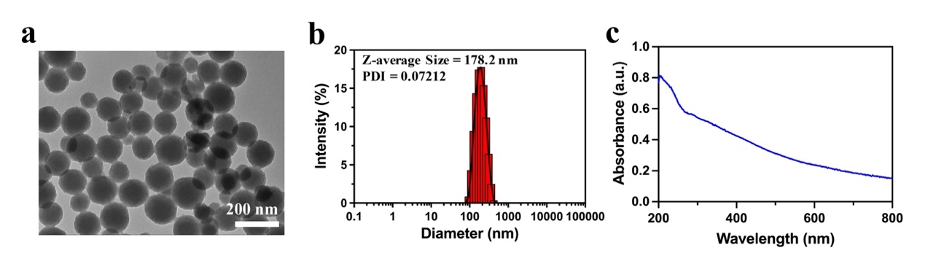
Figure S1. (a) Representative TEM image of PDA. (b) Hydrodynamic size distribution of PDA. (c) UV/Vis absorbance of PDA.

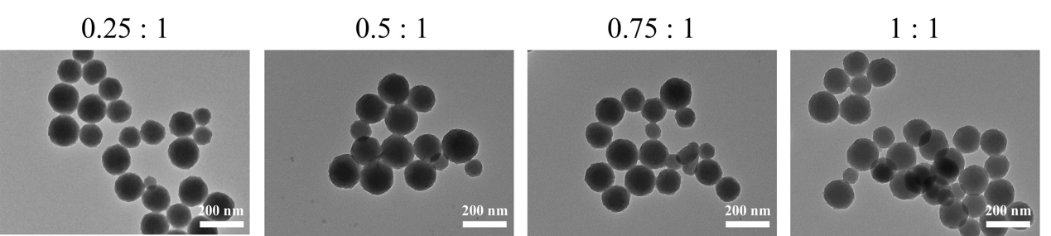
Figure S2. Representative TEM images of PDA-JAKi loaded with different contents of JAKi.

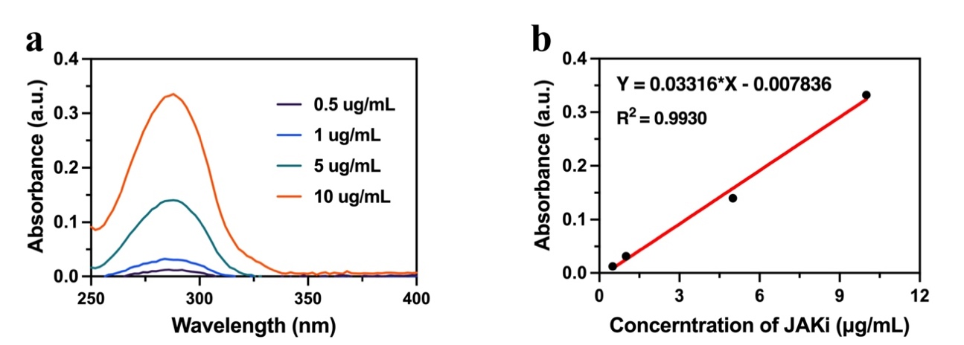
Figure S3. (a) UV/Vis absorbance curve of indicated concentration of JAKi. (b) The standard curve of UV/Vis absorbance of JAKi aqueous solution at 290 nm.

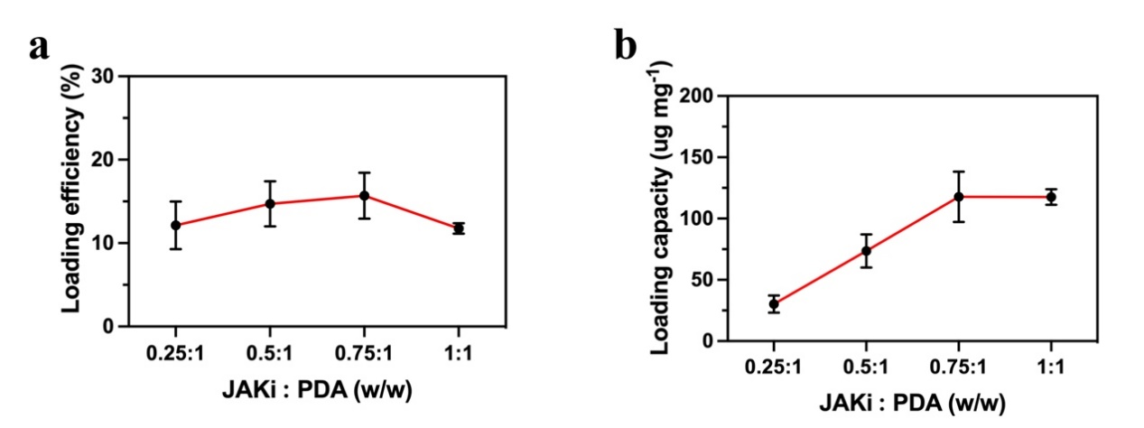
Figure S4. (a) JAKi loading efficiency and (b) loading capacity at different JAKi : PDA weight ratio.

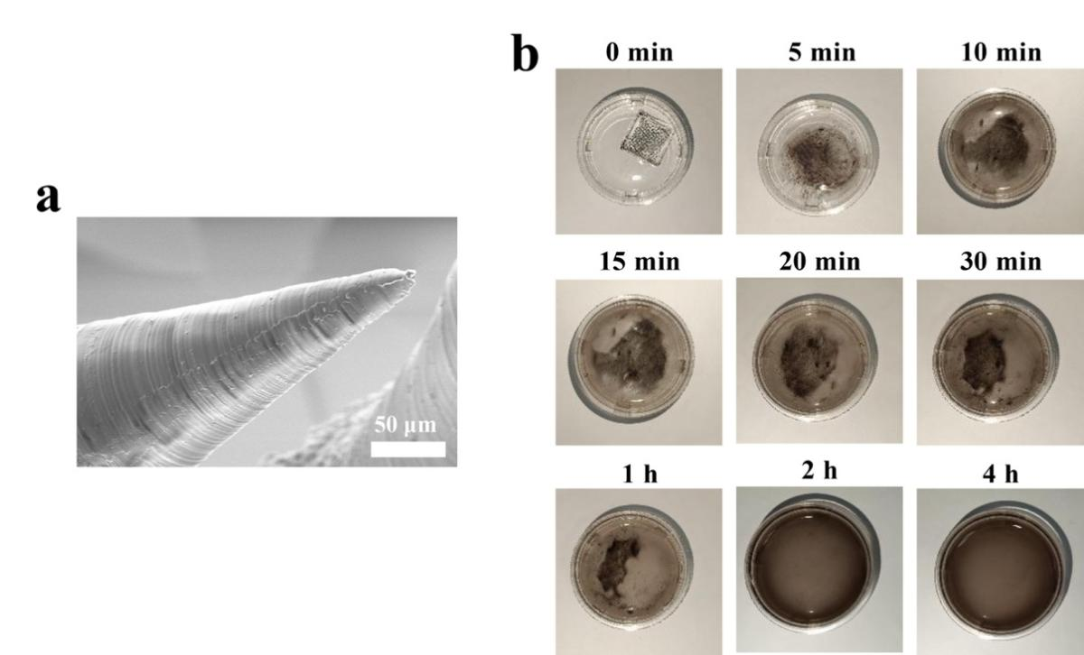
Figure S5. (a) Representative SEM image of The microneedle tip at high magnification. (b) The process of microneedle dissolution in PBS (pH 7.4) solution at indicated time.

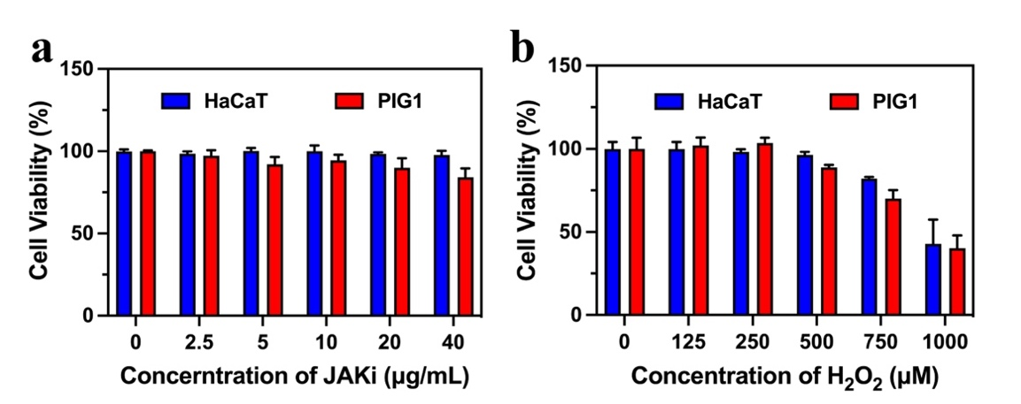
Figure S6. Coculture of HaCaT cells and PIG1 cells with varying concentrations of (a) JAKi and (b) H₂O₂ for 24 h.

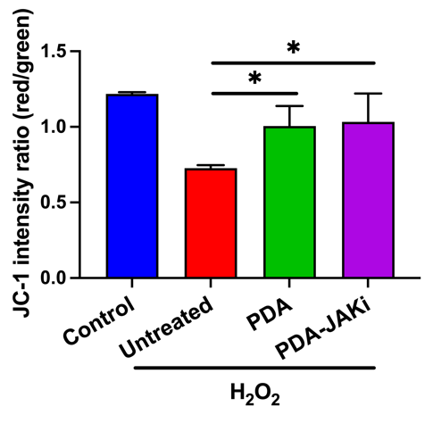
Figure S7. FL intensity ratio of JC-1 in HaCaT cells after different treatments. Mean ± SD, n = 3. *P < 0.05.

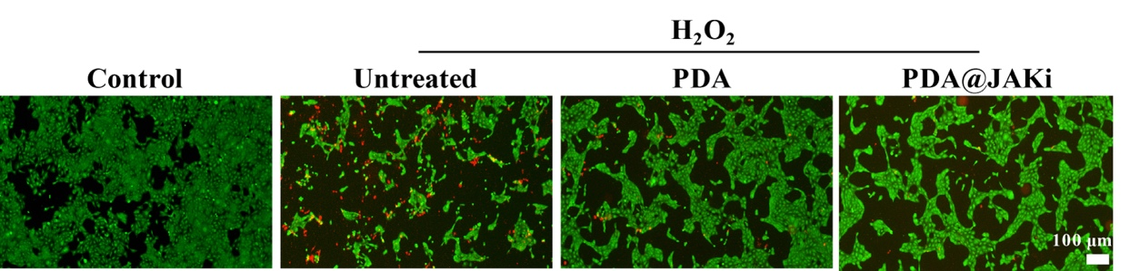
Figure S8. Fluorescence images of Calcein AM (green fluorescence, stained the live cells) and PI (red fluorescence, stained the dead cells) co-stained HaCaT cells after indicated treatments.

Figure S9. Representative photos of vitiligo mice after various treatments.

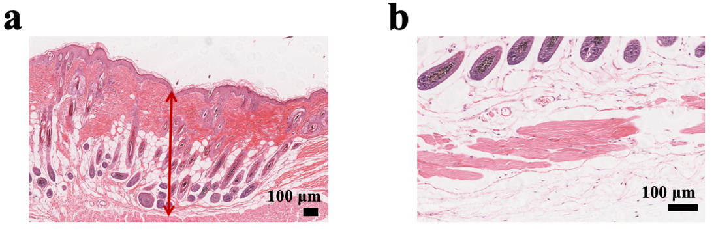
Figure S10. (a) Dermal thickness in the dissected mice skin of control group. (b) The infiltration of inflammatory cells of control group.

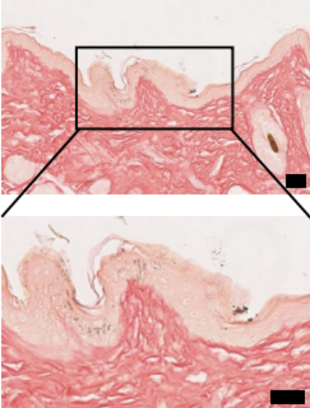
Figure S11. Representative Masson-Fontana staining image of control group. Scale bar: 20 μm.

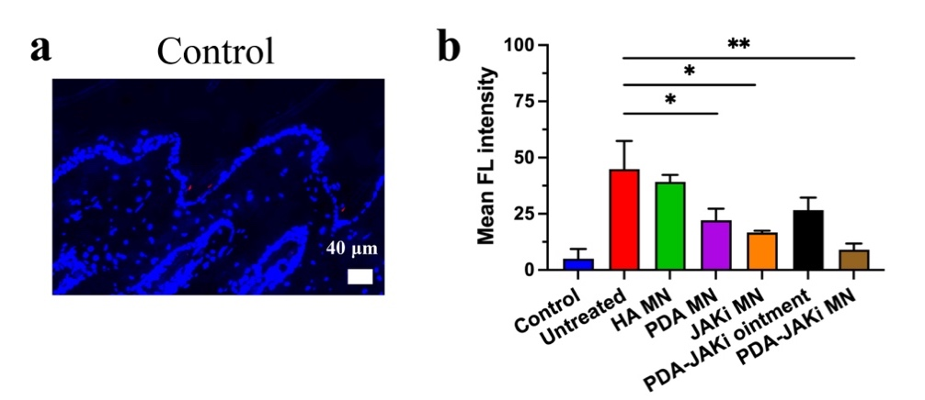
Figure S12. Representative immunofluorescence staining images of CD8⁺ T cells of control group. Scale bar: 20 μm. Mean ± SD, n = 3. *P < 0.05, **P < 0.05.

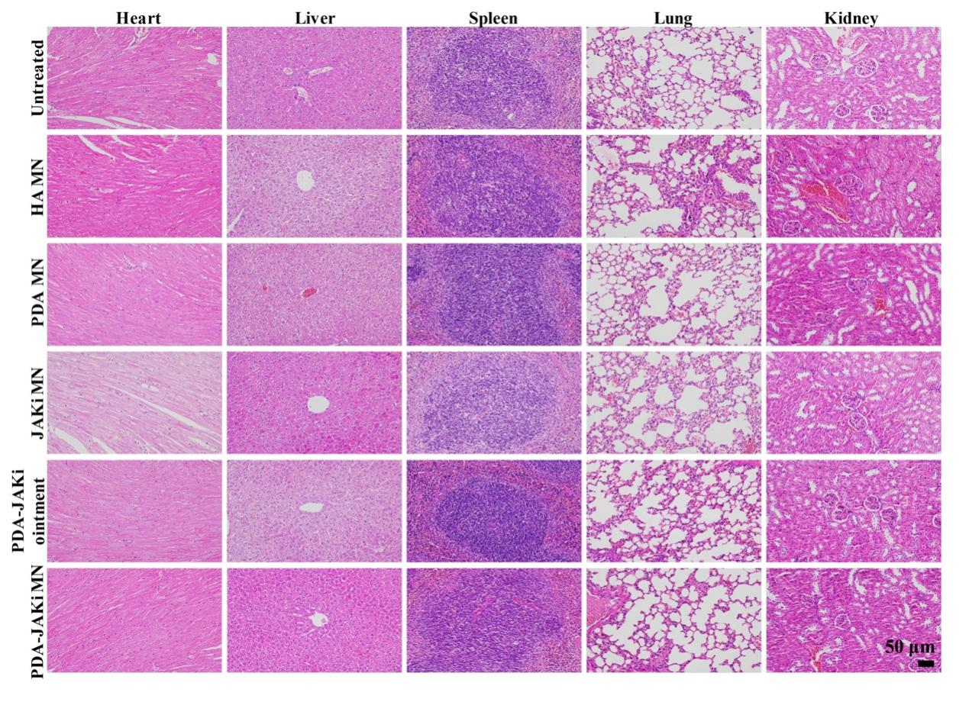
Figure S13. Representative H&E staining images of dissected major organs (heart, liver, spleen, lung, kidney) of vitiligo mice at the end of the whole treatments.

