Supplementary materials
Microbial degradation of DOC released by the mixed culture of Crassostrea gigas and Undaria pinnatifida
Tian Hu^{1,2,#}, Jie Su^{1,4,#}, Kuishuang Shao¹, Yuyang Xie^{1,3}, Yawen Wei¹, Hongxia Ming¹, Tingting Shi¹, Ge Guo¹, Jingfeng Fan^{1,*}
¹State Environmental Protection Key Laboratory of Coastal Ecosystem, National Marine Environmental Monitoring Center, Dalian 116023, China
²College of Marine Technology and Environment, Dalian Ocean University, Dalian 116023, China
³College of Marine Ecology and Environment, Shanghai Ocean University, Shanghai 201306, China
⁴State Environmental Protection Key Laboratory on Biodiversity and Biosafety
# These authors contributed equally to this work
* Corresponding author: Jingfeng Fan, State Environmental Protection Key Laboratory of Coastal Ecosystem, National Marine Environmental Monitoring Center, Dalian 116023, China
Email: jffan@nmemc.org.cn

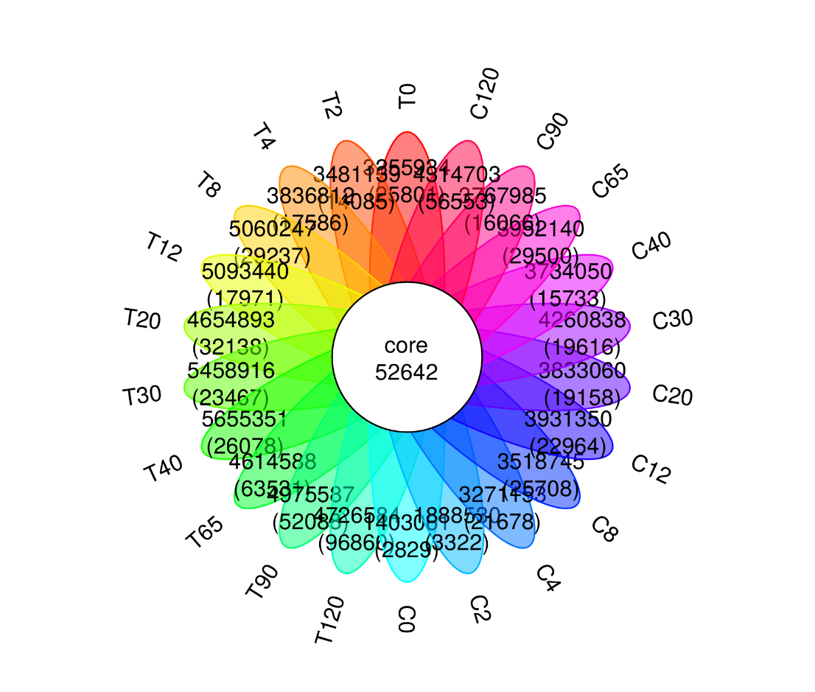
Figure. S1. Petal plot of the number of genes in different samples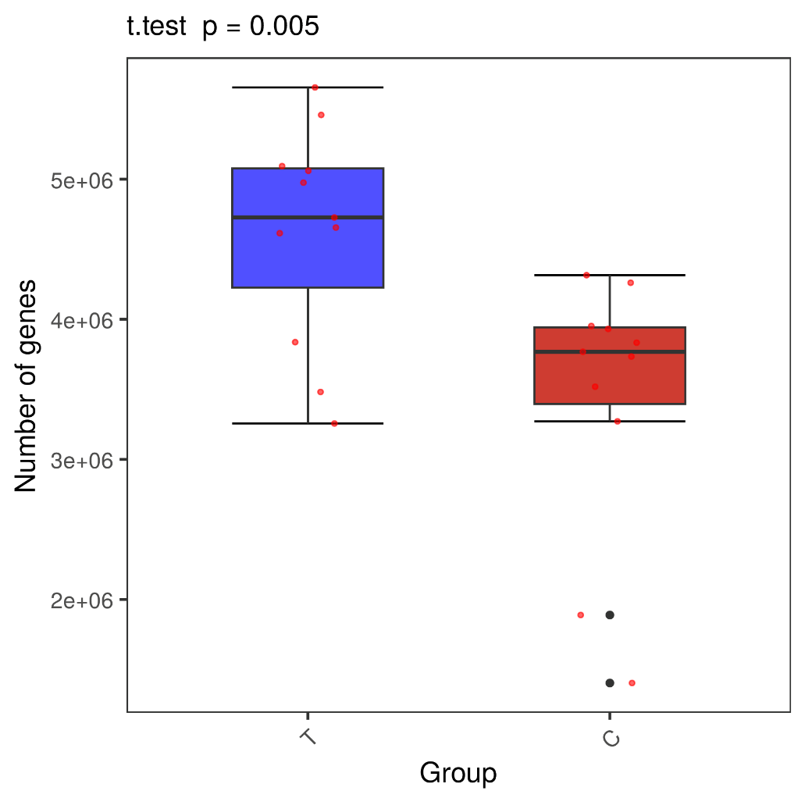
Figure. S2. Box plot of differences in gene numbers between treatment and control groups
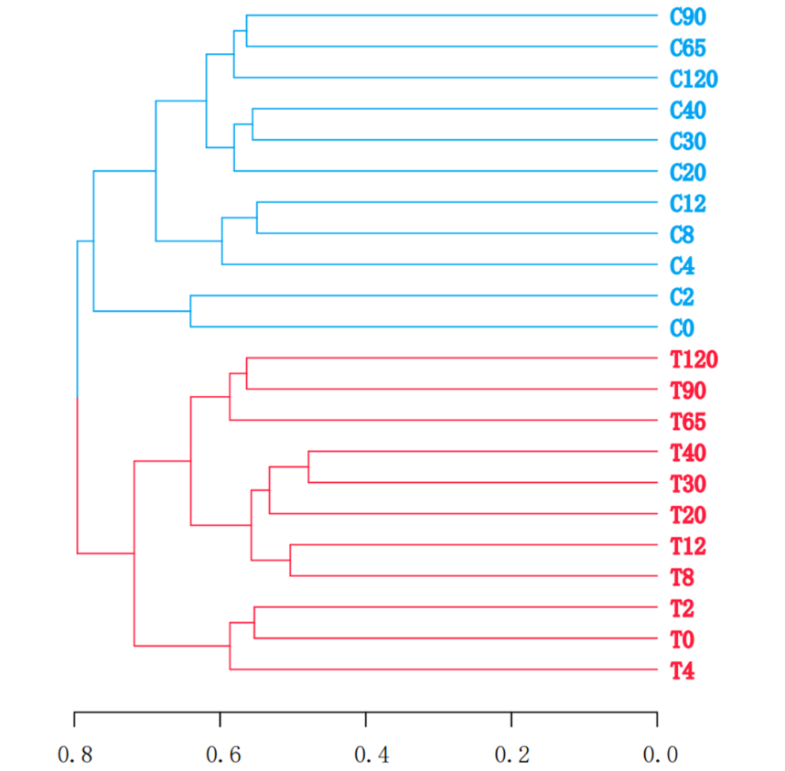
Figure. S3. Hierarchical cluster analysis of the bacterial communities sampled at different time points
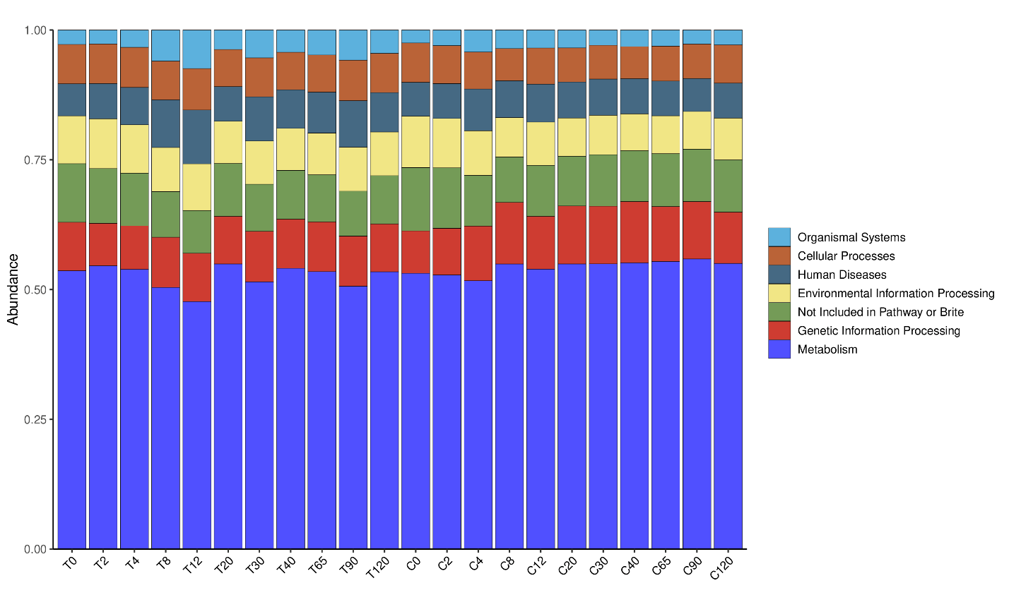
Figure. S4. The abundance of KEGG level 1 metabolic pathways in different groups
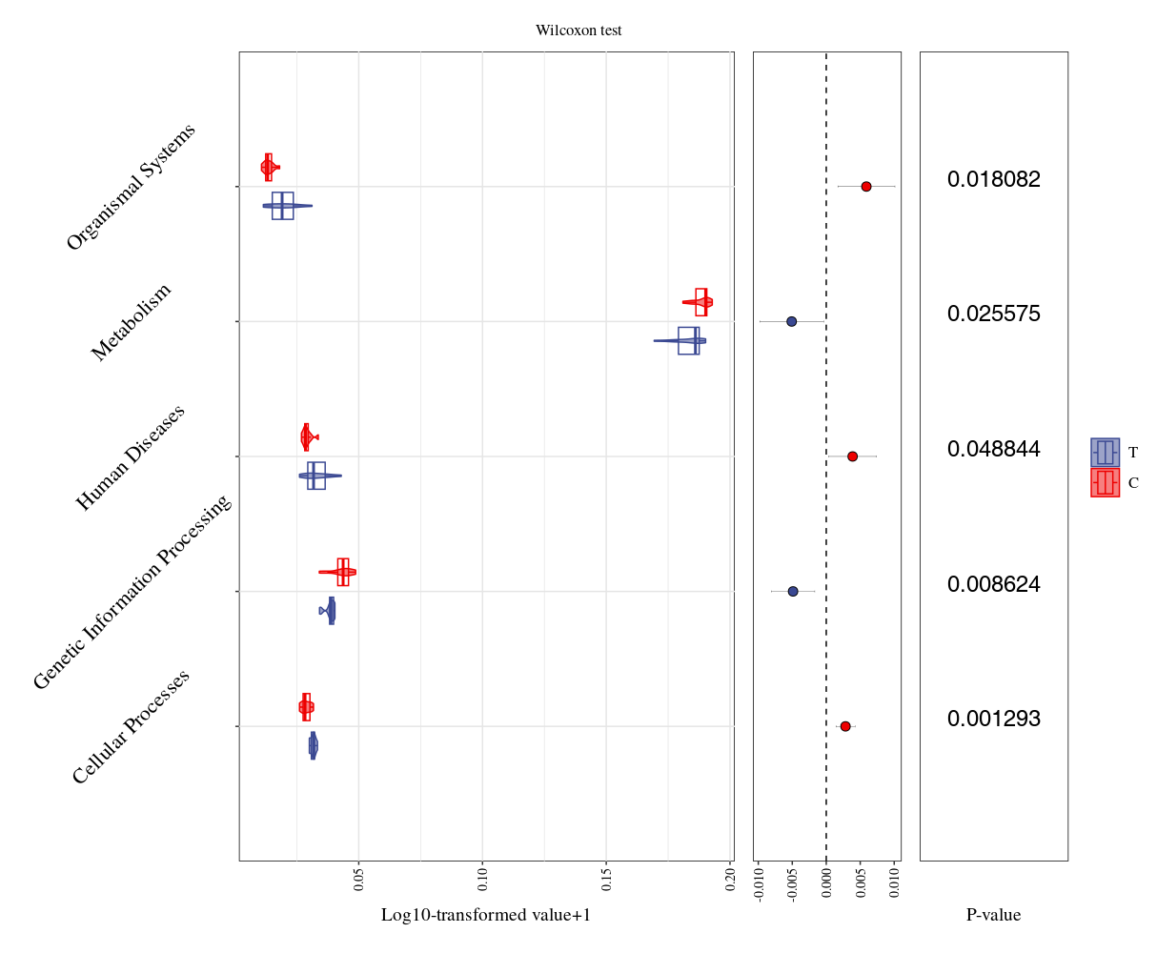
Figure. S5. Differential test plot of KEGG level 2 metabolic pathways functional annotation in different groups 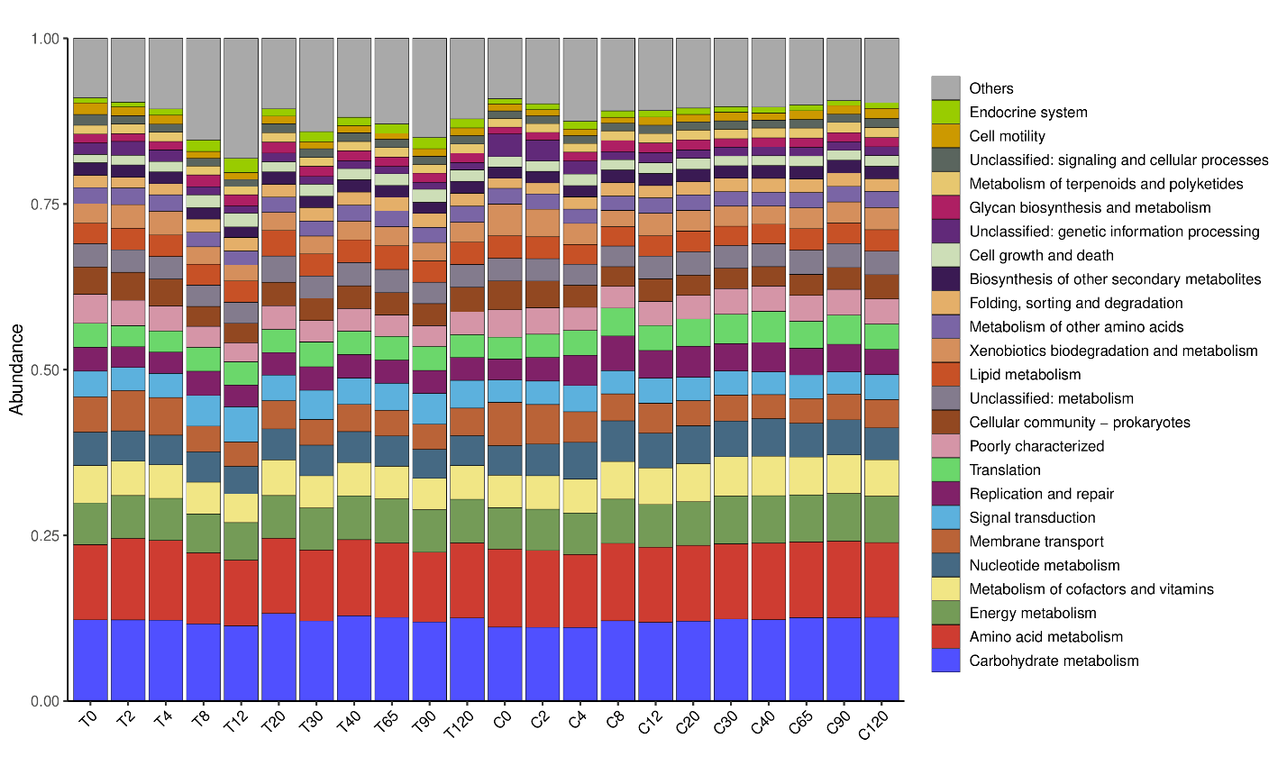
Figure. S6. The abundance of KEGG level 3 metabolic pathways was composed in different groups
Figure. S7. The abundance of KEGG level 3 metabolic pathways was composed in different groups

