Microbial degradation of DOC released by the mixed culture of Crassostrea gigas and Undaria pinnatifida
All the uncropped gels and blots image(s) in this article are shown below：
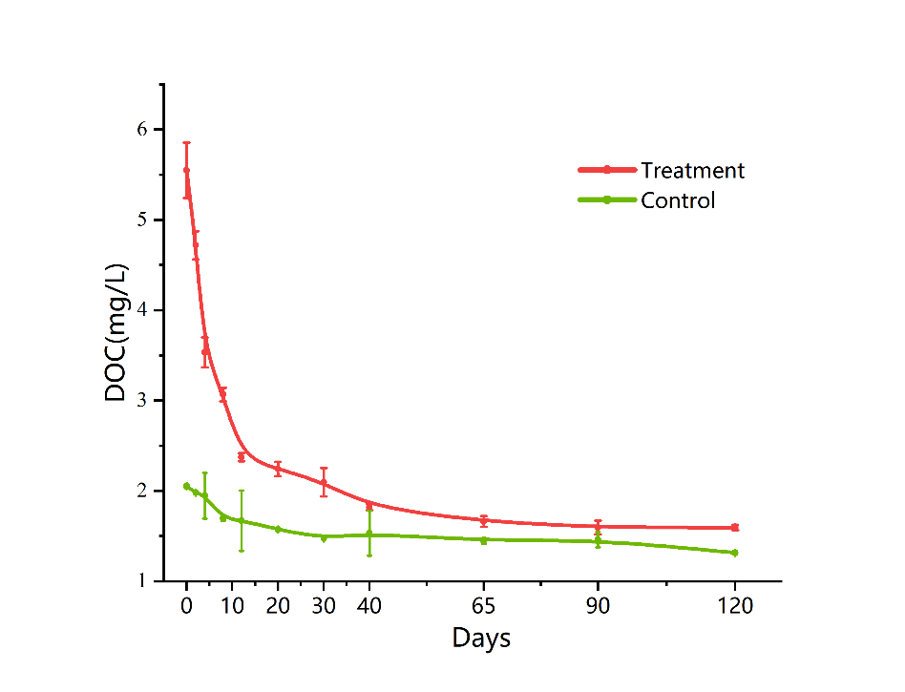
Fig. 1 Variations in the concentration of DOC released from the mixed culture of C. gigas and U. pinnatifida during the 120-day degradation experiment.

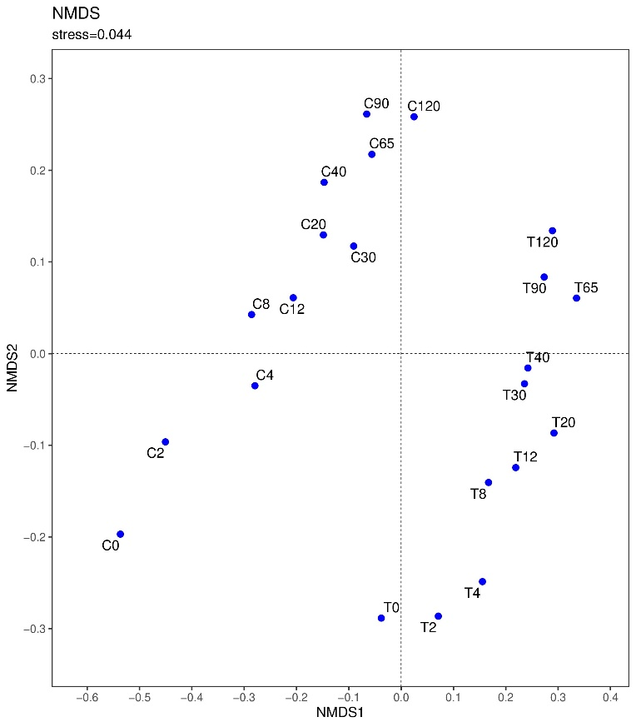
Fig. 3 Non-metric multidimensional scaling ordination of the bacterial communities in the samples collected at different time points during the 120-day DOC degradation process.
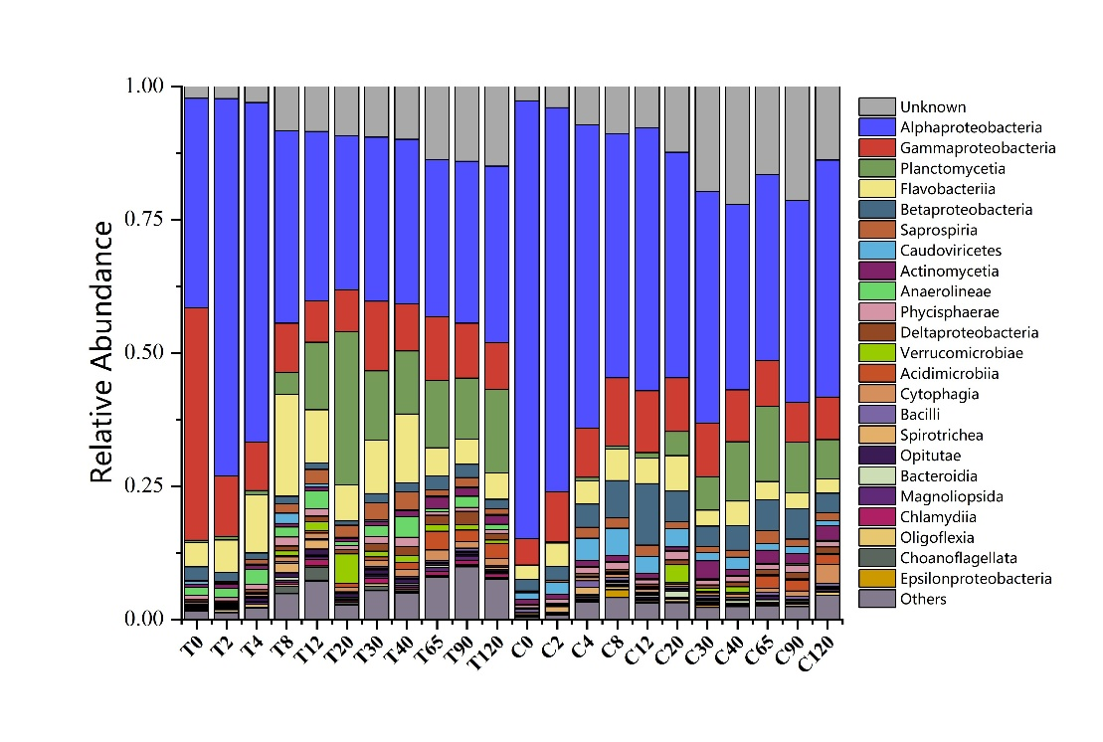
Fig. 4 Community structure of the microorganisms at the (top) class level and (under) genus level during the DOC degradation process (Top 25 depicted).
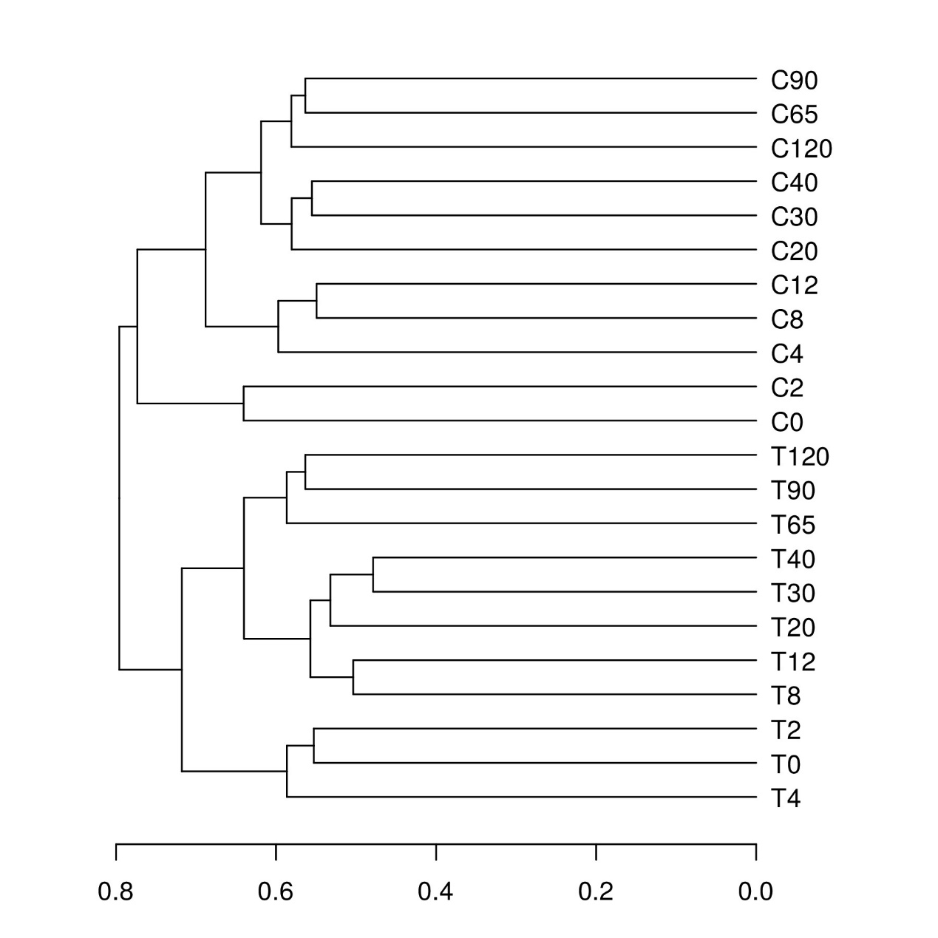
Figure. S3. Hierarchical cluster analysis of the bacterial communities sampled at different time points

