Supplementary Figures

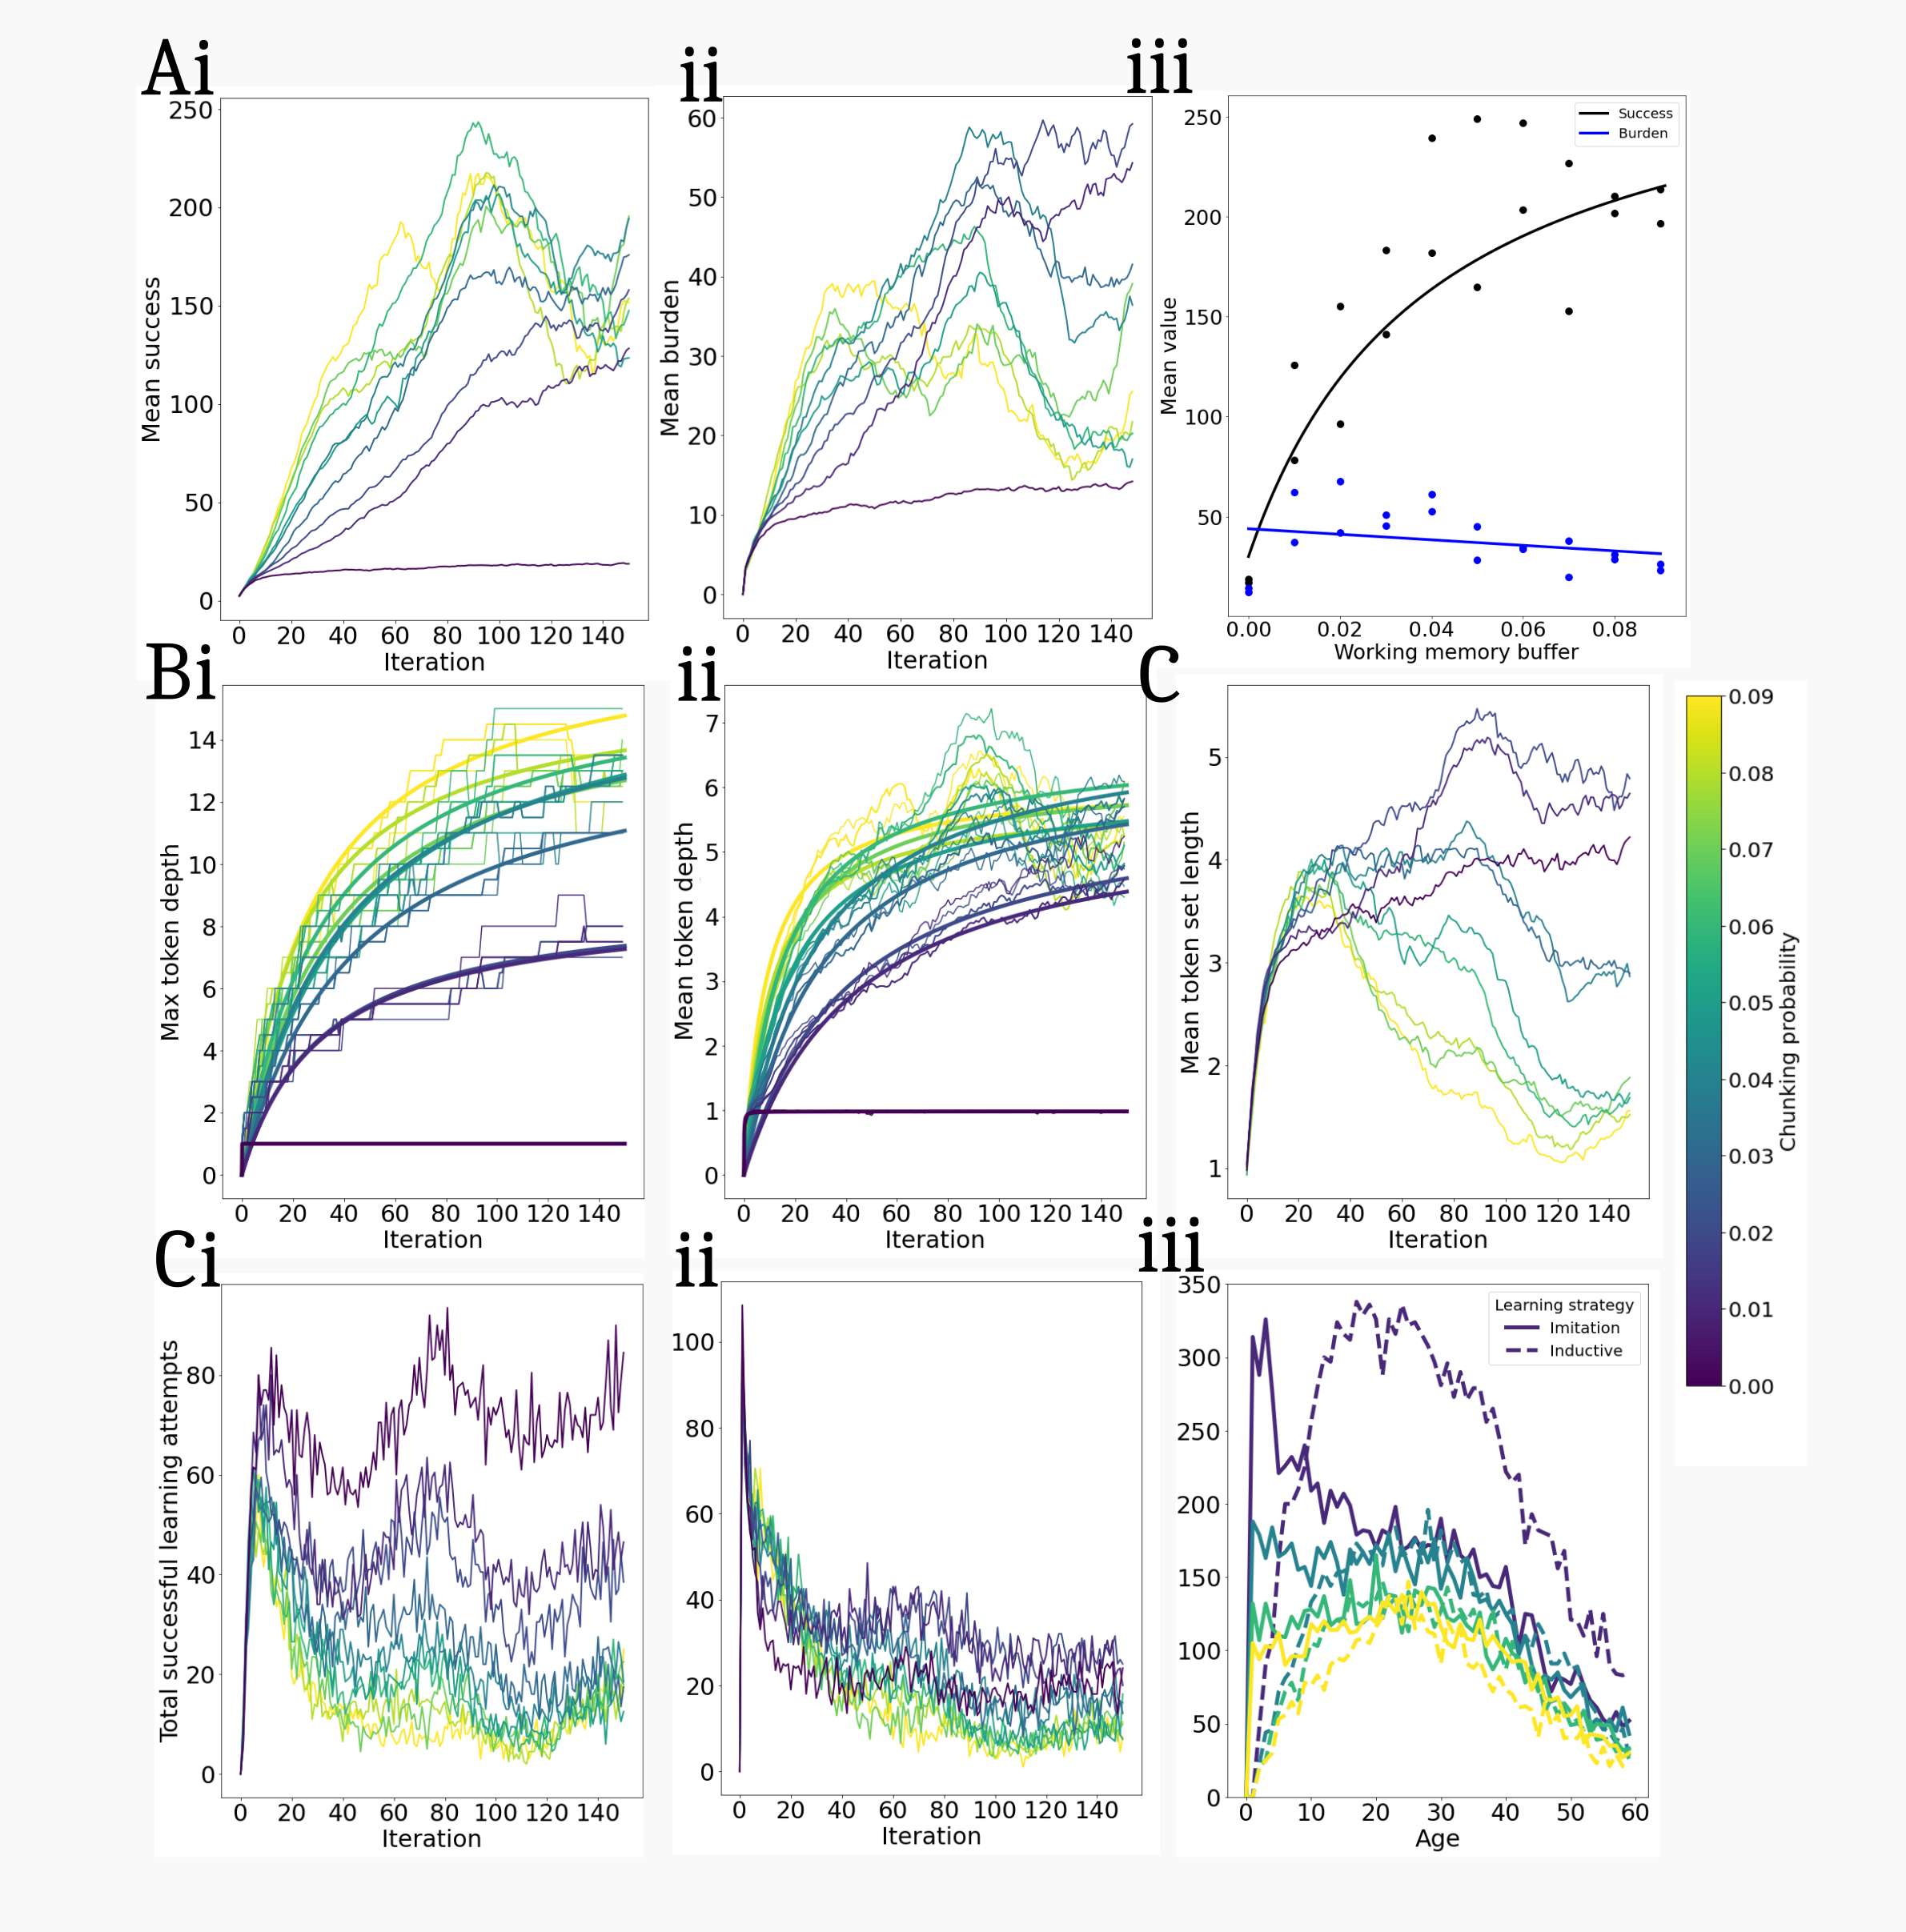
Supplementary Figure 1: Chunking probability shapes the learning and cultural dynamics of the population. Increasing P(chunk) affects the mean success (Ai) and burden (Aii) within the population, such that increasing P(chunk) leads to falling burden. (Bi-ii) P(chunk) increases the mean and maximum token depth, though remains constrained by working memory, suggesting an upper limit to token depth (Bi-ii). (Aiii) Success plateaus with increasing P(chunk) while the burden decreases. (C) token set length initially increases but then decreases earlier at higher chunk rates as tokens are aggregated into larger and fewer chunks. Successful (Di) inductive and (Dii) imitative learning attempts over time, suggesting that increasing P(chunk) decreases the number of successful inductive events as the average token complexity increases. (Diii) the number of successful inductive (dotted) and imitative (straight) learning attempts, showing a higher imitative-to-inductive learning ratio between 0 and ~10 years and fewer successful attempts for both learning strategies at higher P(chunk).
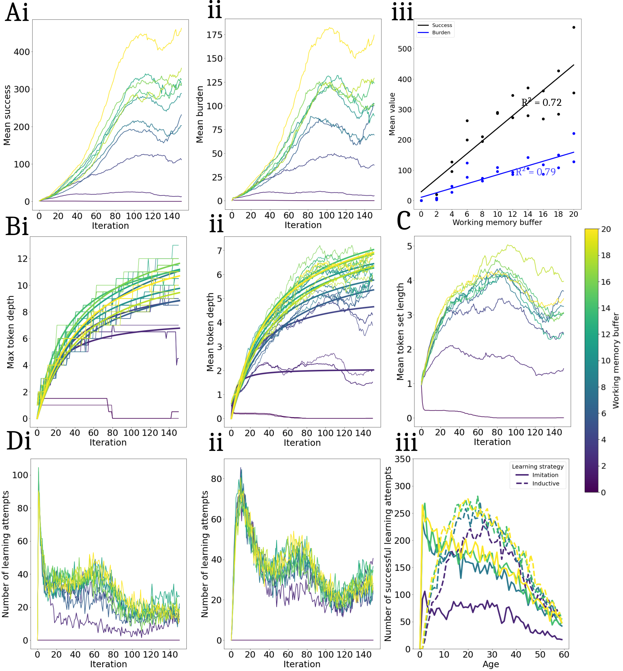
Supplementary Figure 2. Working memory shapes the learning and cultural dynamics of the population. (Ai,ii) Mean success and burden of the population (P = 100). (Aiii) shows the increasing success:burden ratio at higher m levels. Increasing m contributes to heightened token complexity, wit attainable maximum token depths even at lower m. (C) the change in mean token set length and m, reflecting the enhanced social learning capacity of agents and resulting increase in agent cultural repertoires. (Di,ii) illustrate the temporal evolution of inductive and imitative learning, suggesting higher m values facilitate more successful imitative and learning. Notably, at i = 0, all learning attempts are imitative. (Diii) number of successful learning attempts across the agent lifespan for inductive (dotted lines) and imitative (straight lines) learning. The graph reveals a higher imitative-to-inductive learning ratio within the initial ~10 years and shifting towards increased inductive learning attempts throughout an agent's lifespan. Peaking at a = 20 years before declining, this pattern reflects the learning rate dictated by the Gumbel distribution. Higher m values result in an overall increase in the total number of learning attempts, although the imitative-to-inductive ratio around 20 years diminishes as a function of m.
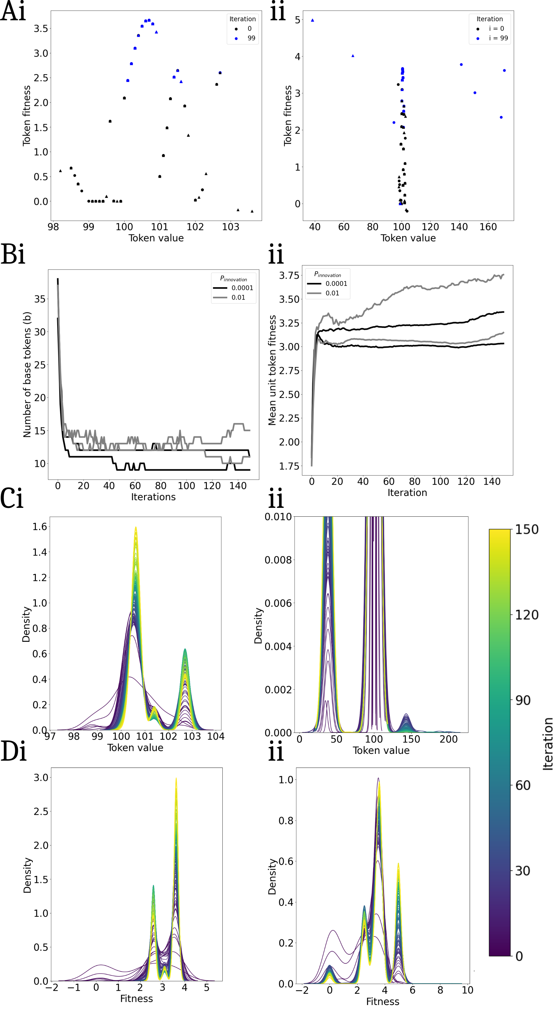
Supplementary Figure 3: Innovation increases the number of base tokens retained in the population and influences the emergence of cultural attractor values. (Ai-ii) Unit tokens in the uppermost quartile of fitness are retained in the population while neutral and low-fitness tokens are lost beyond the first iterations (black, iteration: 0, black, iteration: 99). The innovation rate increases the discovery of novel base tokens outside the sigma of initialisation (1σ) (Aii) and drives an increase in the number and fitness of base tokens present in the population (Bi-ii). (Ci-ii) Convergence upon certain unit tokens leads to increased density at certain unit token values while others are lost. Changes in density in attractors is biased towards their respective fitnesses (Di-ii). At high innovation (P(innovation) = 0.01), a cultural attractor outside the sigma of initialisation is present at t = 48)

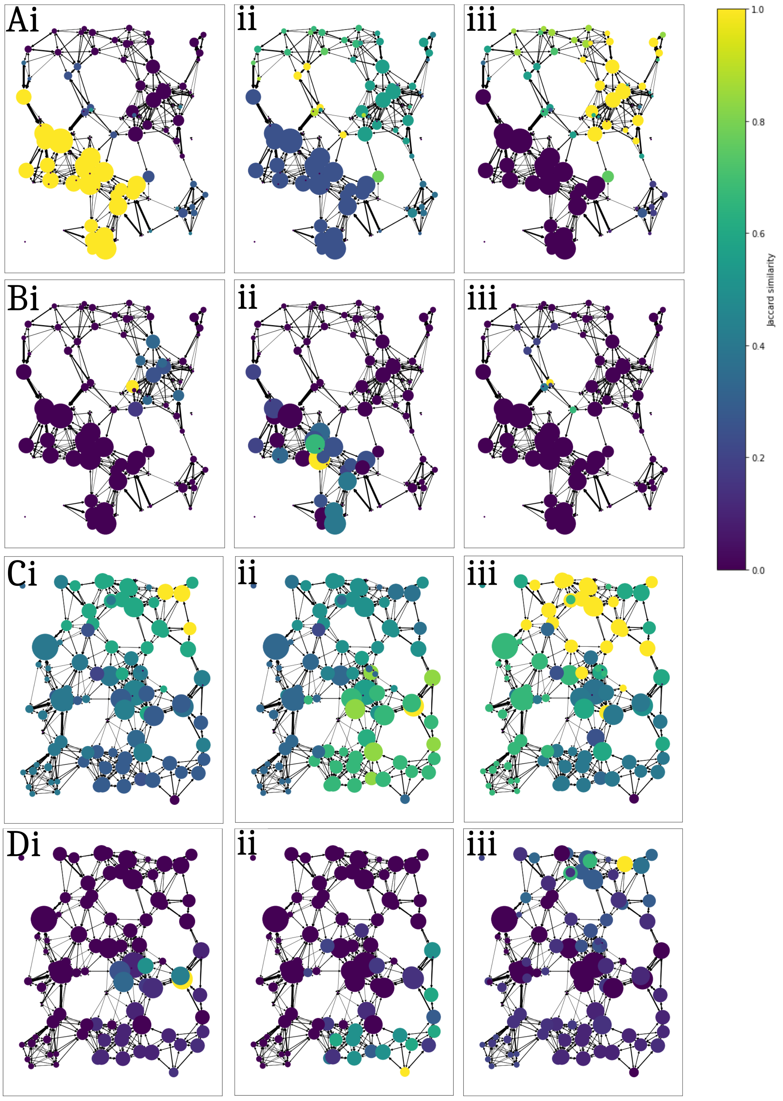

Supplementary Figure 4: Agent-agent similarity is correlated with the distance between agents, leading to modular effects in peer similarity. Model agents were randomly selected and the similarity between the model and all other agents compared (0 – no similarity, 1 – complete identity). (Ai-iii,Bi-iii) Exemplar communities at r = 60, m = 7. As agents die and are born randomly, changes in network structure may lead to loss and reintegration of edges between neighbouring groups of agents, leading to modularity effects within the groups. Putative communities with limited connections among them have different mean successes (proportional to node radius), with the highest mean success in the bottom left community (Ai,Bi). This modularity is also observed in C and D, m = 8. (Bi-iii,Di-iii) All agents comprise a unique set of complex tokens, some of which are held by agents within the vicinity.

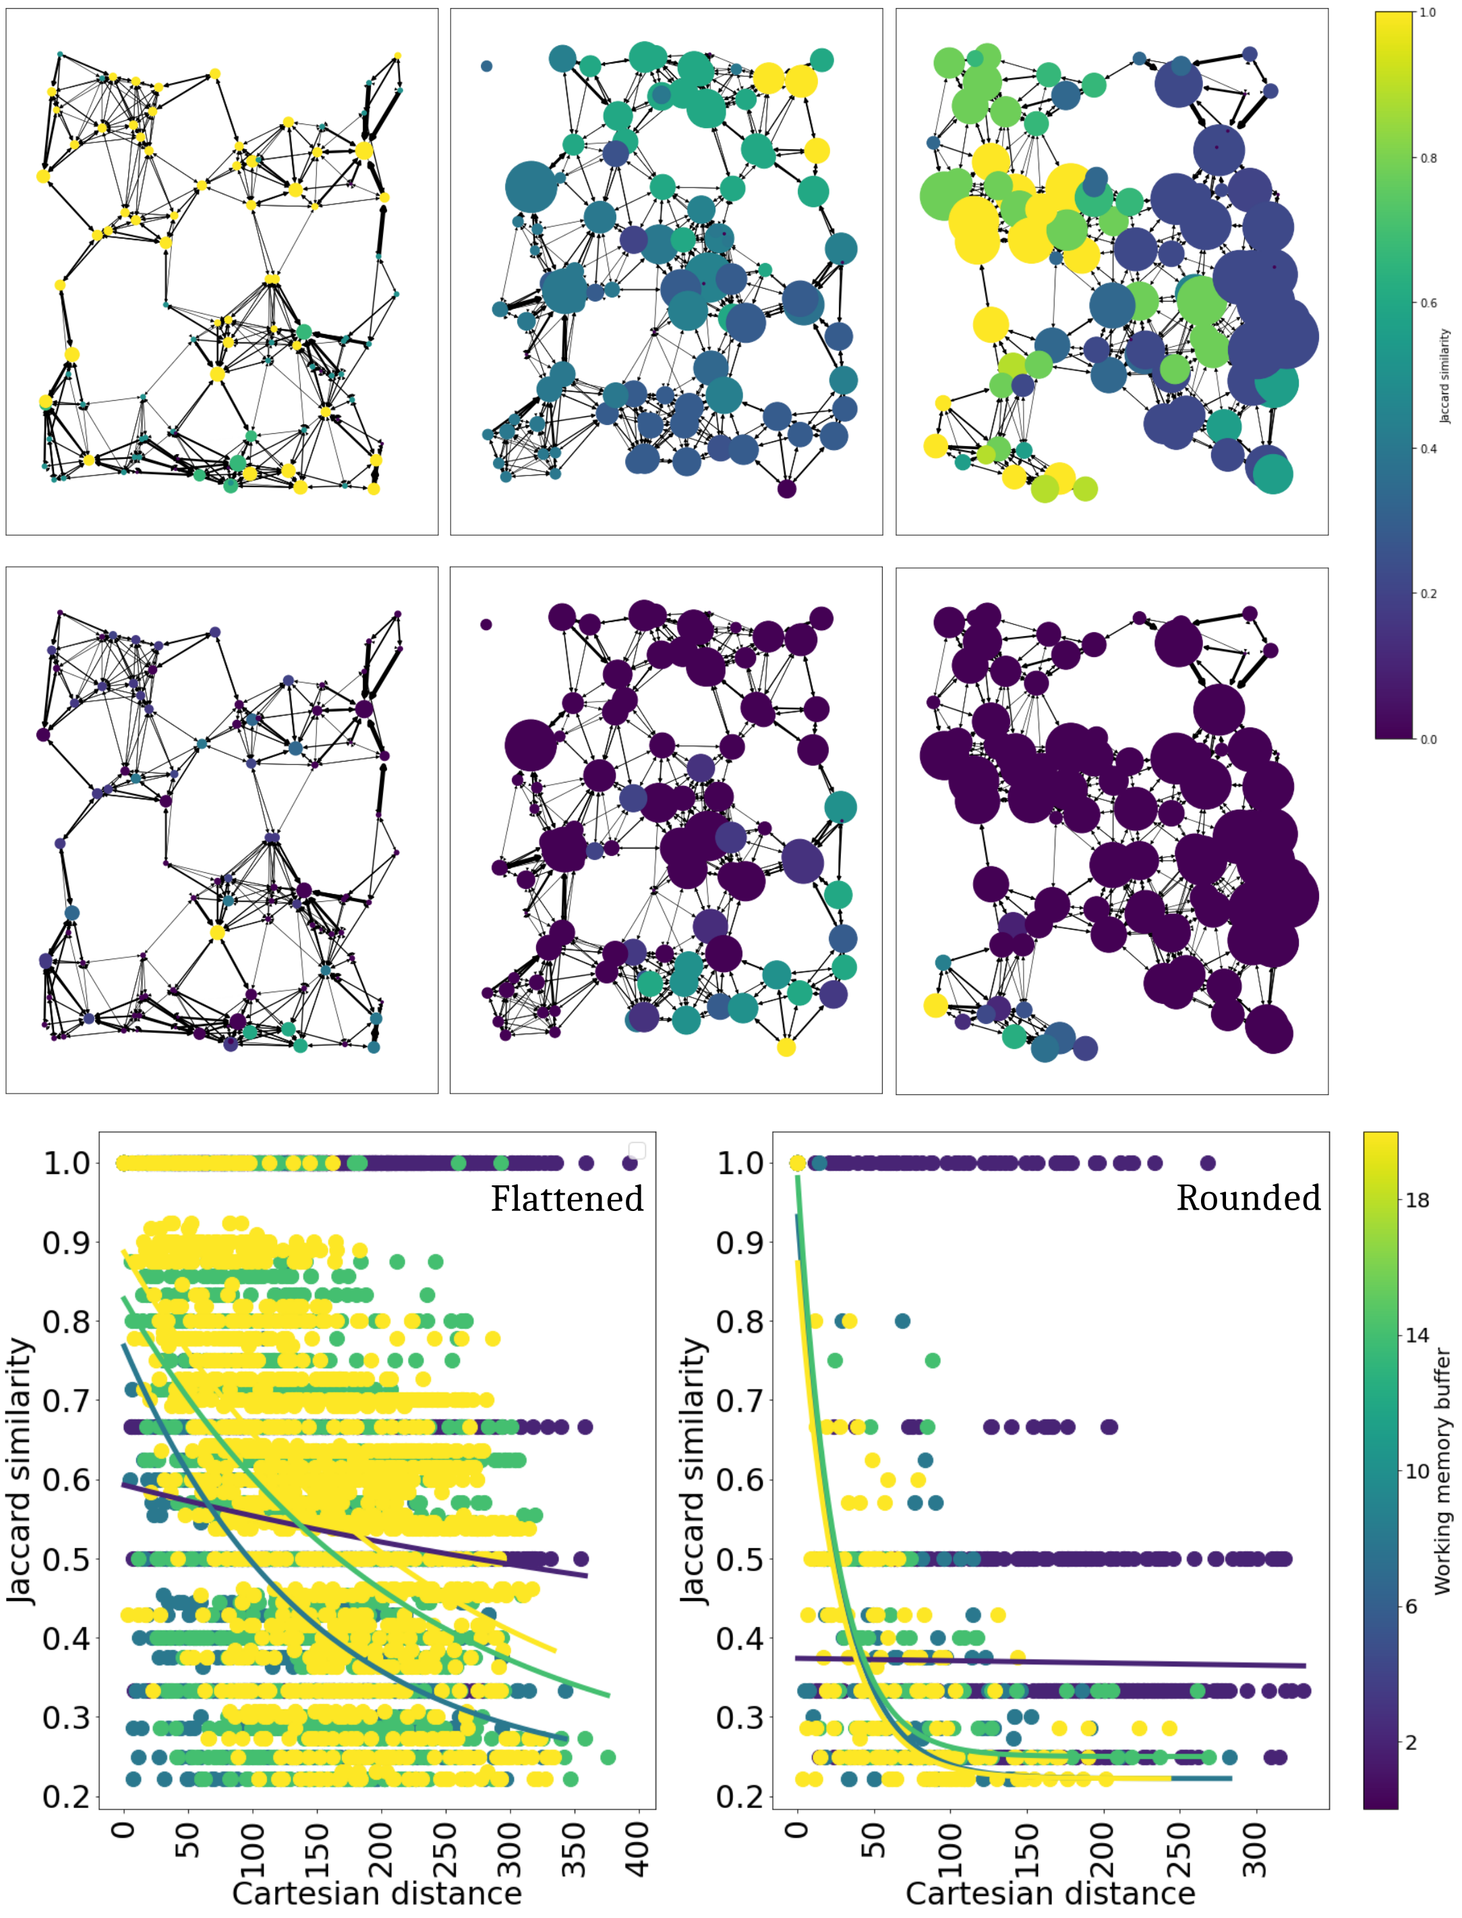

Supplementary Figure 5: m influences the distribution of unit tokens throughout the population. (Ai-iii,Biii) Jaccard similarity index between the unit tokens (A) and rounded complex tokens (B) of a randomly chosen agent (yellow, similarity = 1) and all other agents in the population for m = 2 (Ai, Bi), m = 8 (Aii, Bii) and m = 14 (Aiii, Biii). (Ci,ii) The similarity of unit and rounded complex tokens among agents decreases with distance, though unit tokens are more similar across a larger spatial extent than rounded tokens. At higher m, more successful learning attempts of complex tokens and imitation of novel unit tokens occurs (Supplementary Fig 1), leading to local differences in unit token distributions. As m increases, more successful learning may enable further diffusion of tokens, leading to greater similarity over a larger spatial extent. (Cii) The diffusion of complex tokens is more restricted to the learning radius.

