Near surface oxidation of elemental mercury explains high mercury levels in the Arctic Ocean biota

Seung Hyeon Lim¹, Younggwang Kim¹, Laura C. Motta², Eun Jin Yang³, Tae Siek Rhee³, Jong Kuk Hong³, Seunghee Han⁴, Sae Yun Kwon^{1*}

¹Division of Environmental Science and Engineering, Pohang University of Science and Technology, 77 Cheongam-Ro, Nam-Gu, Pohang 37673, Republic of Korea
²Marine Chemistry & Geochemistry, Woods Hole Oceanographic Institution, MA 02543, United States of America
³Korea Polar Research Institute, Incheon 21990, Republic of Korea
⁴School of Earth Sciences and Environmental Engineering, Gwangju Institute of Science and Technology (GIST), Gwangju 61005, Republic of Korea

*Corresponding author: Sae Yun Kwon (saeyunk@postech.ac.kr)
Phone: +82-54-279-2290
Fax: +82-54-279-8299

Supplementary information
- Isotope fractionation calculation
$${}^{202}Hg= \{[{{(\text{202}Hg/\text{198}Hg)}_{sample}}/{{(\text{202}Hg/\text{198}Hg)}_{NIST3133}}]-1\}×1000$$
$${}^{xxx}Hg= {}^{xxx}Hg-\left({}^{202}Hg×β\right)$$
xxx of Δ^{xxx}Hg and δ^{xxx}Hg represents either 199, 200, 201, 204, and β represents mass proportionality constant (0.2520, 0.5024, 0.7520, and 1.493, respectively). Analytical uncertainty of 2SD is determined by measuring NIST RM 8610 (UM-Almaden; n = 34), NRC-TORT-3 (n =7) and NIST-2711A (Montana II soil; n = 4). NIST RM8610 showed δ²⁰²Hg of -0.54±0.08‰, Δ¹⁹⁹Hg of -0.03±0.04‰, Δ²⁰⁰Hg of 0.01±0.05‰, Δ²⁰¹Hg of -0.03±0.08‰, and Δ²⁰⁴Hg of -0.01±0.08‰. NRC-TORT-3 exhibited δ²⁰²Hg of 0.03±0.07‰, Δ¹⁹⁹Hg of 0.63±0.06‰, Δ²⁰⁰Hg of 0.06±0.03‰, Δ²⁰¹Hg of 0.52±0.10‰, and Δ²⁰⁴Hg of -0.08±0.05‰. NIST-2711A depicted δ²⁰²Hg of 0.01±0.09‰, Δ¹⁹⁹Hg of -0.19±0.01‰, Δ²⁰⁰Hg of -0.01±0.02‰, Δ²⁰¹Hg of -0.17±0.05‰, and Δ²⁰⁴Hg of -0.01±0.04‰. Procedural blanks of liquid sample analysis of NIST RM 8610 (UM-Almaden; n = 4) depicted δ²⁰²Hg of -0.56±0.13‰, Δ¹⁹⁹Hg of -0.01±0.02‰, Δ²⁰⁰Hg of 0.00±0.02‰, Δ²⁰¹Hg of 0.00±0.05‰, and Δ²⁰⁴Hg of 0.02±0.06‰. To establish analytical uncertainties, maximum 2SD values were adopted from reference material NIST RM8610 (2SD; δ²⁰²Hg: 0.08, Δ¹⁹⁹Hg: 0.04, Δ²⁰⁰Hg: 0.05, Δ²⁰¹Hg: 0.08, Δ²⁰⁴Hg: 0.08).

- Hg Isotopic corrections and calculations on biota from Masbou et al 2018
Due to the measurable in vivo mass-dependent fractionation (MDF), marine mammals typically have tissue-specific δ²⁰²Hg values. Among different tissues, livers of the Arctic biota (beluga whale, ringed seal, polar bear) were investigated by Masbou et al 2018. To remove the effect of in vivo MDF, we estimated the δ²⁰²Hg of prey item consumed by beluga whale, ringed seal, and polar bear. For beluga whale, δ²⁰²Hg correction factor of 0.97‰ (liver to prey), derived from Li et al 2020¹, was applied based on the observations of pilot whale liver and its prey (fish, squid) as depicted in Fig. 4c. For ringed seal and polar bear, we used the δ²⁰²Hg correction factor of 1.47‰ from Perrot et al 2012, 2016^{2,3} which investigated the internal Hg isotope fractionation in Baikalian seal (Phoca sibirica). The Baikalian seal displayed 1.47‰ higher δ²⁰²Hg in its prey (pelagic fish) relative to the liver due to hepatic demethylation. Fig. 4b depicts the corrected δ²⁰²Hg, reflecting the prey item of ringed seals and polar bear from Bering Strait and Chukchi Sea.

Supplementary Tables
Supplementary Table 1. Total mercury concentration (THg) and % methylmercury content in zooplankton, fish (Arctic Cod, Boreogadus saida) and other environmental matrices. L indicates >5 mm size, M for 1-5 mm size, S for 0.2-1 mm size fraction. All zooplankton were sampled from the surface to the listed depth. Table is attached to the excel file ‘Supplementary Table 1’.

Supplementary Table 2. Endmembers used to calculate % contributions of each Hg source to the Arctic Ocean zooplankton. Particulate Bounded Mercury (PBM) is calculated from our measured TGM and δ²⁰²Hg and Δ¹⁹⁹Hg difference estimated between TGM and PBM by Zheng et al. 2021⁵. River particulate Hg (river pHg) are from the Mackenzie River measured by Campeau et al. 2022⁶. Wet precipitation is the compiled by Jiskra et al. 2021⁷. The reported Hg isotope ratios represent mean and 1S.D. for PBM and river pHg, and median and quartile for wet precipitation.
 | δ²⁰²Hg (‰) | Δ²⁰⁰Hg (‰) | Δ¹⁹⁹Hg (‰)
PBM | 0.04±0.13 | -0.04±0.00 | -0.53±0.13
River pHg | -1.46±0.42 | 0.02±0.07 | -0.11±0.15
Wet precipitation | -0.30 (-0.63−0.03) | 0.17 (0.11−0.22) | 0.40 (0.21−0.51)

Supplementary Table 3. Seawater parameters from Section C (the Beaufort Sea).
Casting depth, salinity, dissolved oxygen, chlorophyll A, and temperature measured using CTD/rosette equipped with acid-cleaned 10L Niskin bottles with SBE9plus CTD profiler at Section C (C.01-C.04, C.07).

 | Casting depth  (m) | Salinity (psu) | Oxygen (umol kg⁻¹) | Chlorophyll A  (mg m⁻³) | Temperature (℃)
C.01 | 5 | 23.63 | 370.99 | 0.00 | 1.44
C.01 | 50 | 31.19 | 355.17 | 0.47 | -0.41
C.02 | 5 | 26.03 | 376.26 | 0.10 | 1.61
C.02 | 40 | 30.51 | 373.52 | 0.35 | -1.12
C.03 | 5 | 22.48 | 331.92 | 0.38 | 4.26
C.03 | 40 | 31.11 | 354.39 | 0.37 | -0.89
C.04 | 5 | 22.25 | 356.04 | 0.49 | 4.06
C.07 | 2 | 20.25 | 345.38 | 0.70 | 5.50
C.07 | 45 | 31.40 | 291.15 | 0.08 | -1.03

Supplementary Table 4. Hg isotope ratios of standard reference materials from this study and other studies. (*: standard error)
SRM | Sample Type | n | δ²⁰²Hg | 2SD | Δ²⁰⁴Hg | 2SD | Δ²⁰¹Hg | 2SD | Δ²⁰⁰Hg | 2SD | Δ¹⁹⁹Hg | 2SD | Reference
 |  |  | ‰ |  | ‰ |  | ‰ |  | ‰ |  | ‰
NIST RM 8610 | Standard Solution | 34 | -0.54 | 0.08 | -0.01 | 0.08 | -0.03 | 0.08 | 0.01 | 0.05 | -0.03 | 0.04 | This study
NIST RM 8610 | Standard Solution | 403 | -0.57 | <0.01* | -0.01 | <0.01* | -0.04 | <0.01* | 0.01 | <0.01* | -0.02 | <0.01* | Blum and Johnson⁸
NIST RM 8610 | Standard Solution | 88 | -0.53 | 0.05 | -0.01 | 0.06 | -0.04 | 0.03 | 0.01 | 0.03 | -0.02 | 0.05 | Lepak et al⁹
NIST RM 8610 | Standard Solution | 11 | -0.56 | 0.07 | 0 | 0.04 | -0.04 | 0.05 | 0.01 | 0.03 | -0.02 | 0.05 | Motta et al¹⁰
NIST RM 8610 | Standard Solution | 46 | -0.53 | 0.1 | - | - | -0.04 | 0.06 | 0.01 | 0.05 | -0.03 | 0.05 | Masbou et al¹¹
NIST RM 8610 | Procedure Standard | 4 | -0.56 | 0.13 | 0.02 | 0.06 | 0.00 | 0.05 | 0.00 | 0.02 | -0.01 | 0.02 | This study
NRC TORT-3 | Lobster | 7 | 0.03 | 0.07 | -0.08 | 0.05 | 0.52 | 0.10 | 0.06 | 0.03 | 0.63 | 0.06 | This study
NRC TORT-3 | Lobster | 4 | 0.07 | 0.04* | -0.08 | 0.08* | 0.55 | 0.08* | 0.06 | 0.06* | 0.67 | 0.05* | Blum and Johnson⁸
NRC TORT-3 | Lobster | 10 | 0.06 | 0.06 |  |  | 0.59 | 0.11 | 0.07 | 0.06 | 0.72 | 0.07 | Enrico et al¹²
NRC TORT-3 | Lobster | 3 | -0.02 | 0.18 |  |  | 0.5 | 0.18 | 0.04 | 0.14 | 0.66 | 0.02 | Besnard et al¹³
NRC TORT-3 | Lobster | 10 | 0 | 0.07 | -0.09 | 0.04 | 0.49 | 0.04 | 0.07 | 0.02 | 0.67 | 0.06 | Kim et al¹⁴
NIST SRM2711a | Soil | 4 | 0.01 | 0.09 | -0.01 | 0.04 | -0.17 | 0.05 | -0.01 | 0.02 | -0.19 | 0.01 | This study
NIST SRM2711a | Soil | 3 | -0.11 | 0.11 | 0.02 | 0.08 | -0.18 | 0.06 | -0.03 | 0.09 | -0.25 | 0.04 | Grigg et al¹⁵
NIST SRM2711a | Soil | 6 | -0.23 | 0.06 | -0.18 | 0.26 | -0.19 | 0.05 | 0 | 0.09 | -0.2 | 0.05 | Liu et al¹⁶
NIST SRM2711a | Soil | 8 | -0.1 | 0.06 | - | - | -0.18 | 0.04 | -0.02 | 0.04 | -0.22 | 0.04 | Geng et al¹⁷
NIST SRM2711a | Soil | 10 | -0.1 | 0.08 | 0.02 | 0.02 | -0.19 | 0.05 | -0.01 | 0.03 | -0.23 | 0.03 | Kim et al¹⁴

Supplementary Figures

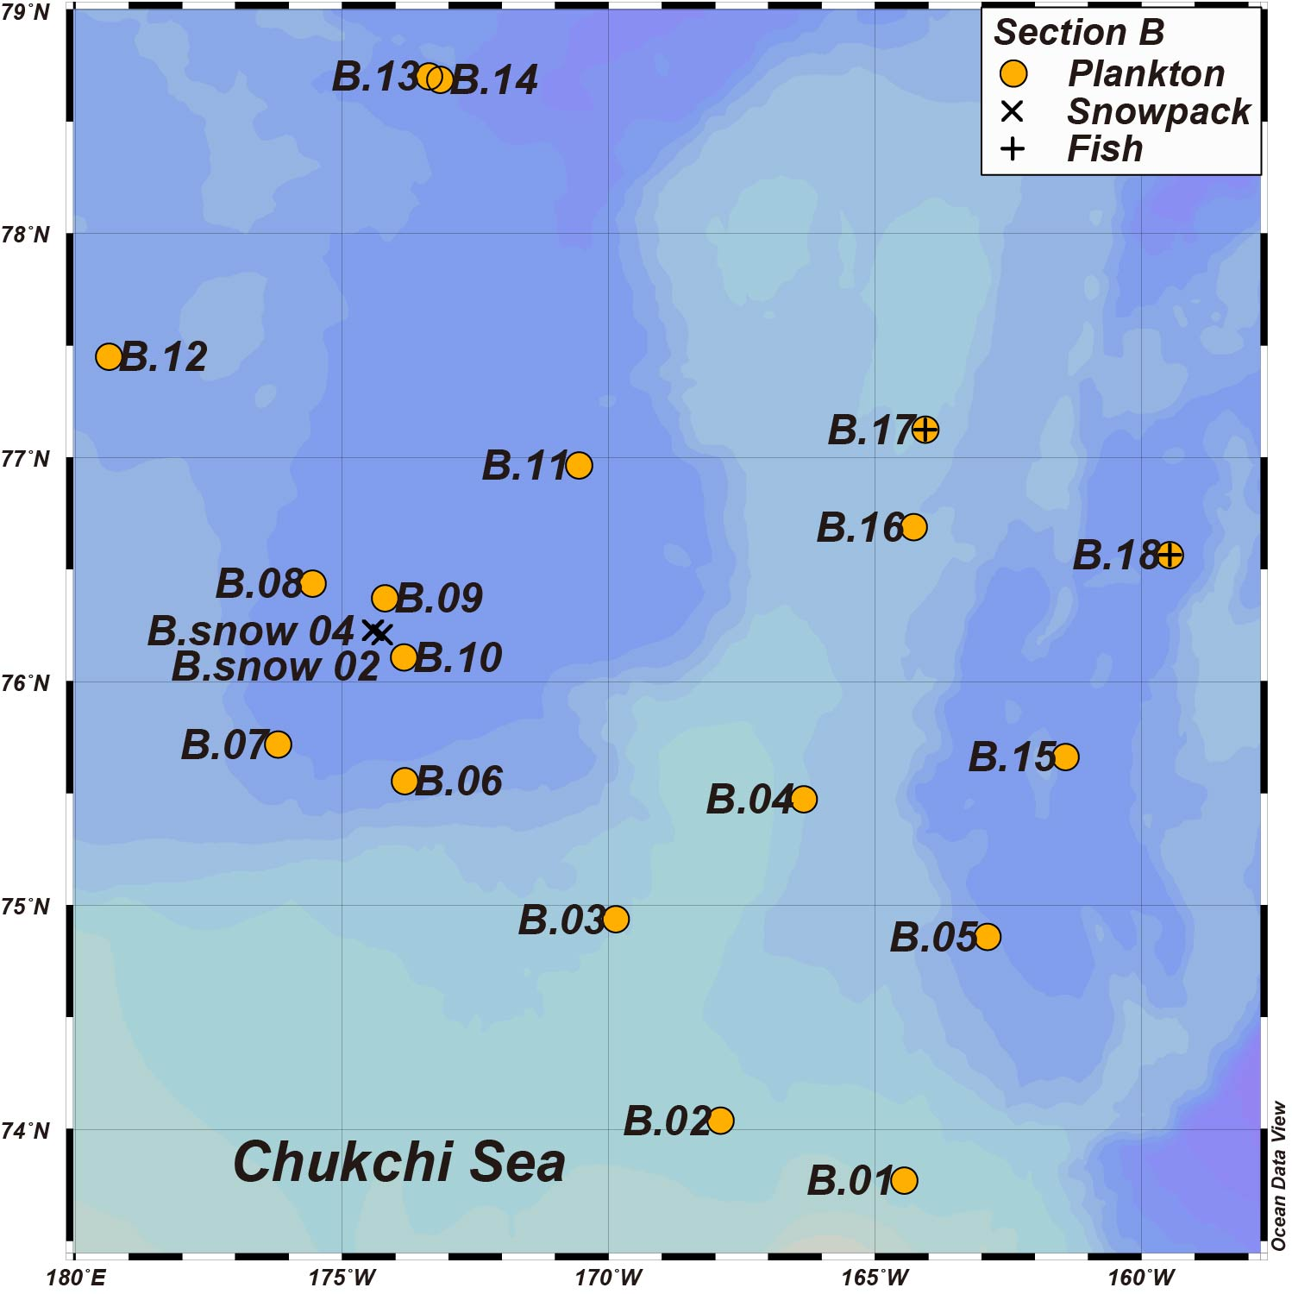
Supplementary Fig. 1 Map of sampling locations at Section B (Chukchi Sea). The figure was drawn using Ocean Data View¹⁸

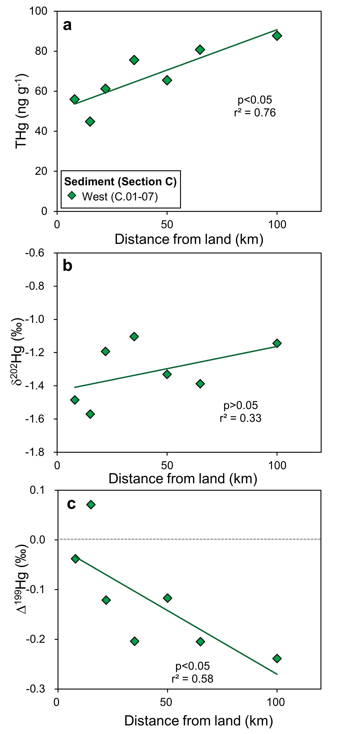
Supplementary Fig. 2 Total Hg (THg) concentration, δ²⁰²Hg, and Δ¹⁹⁹Hg of sediment sampled at Section C (Beaufort Sea) in relation to their distances away from land. From a to c, the P-values for the regression are 0.01, 0.18, 0.05.

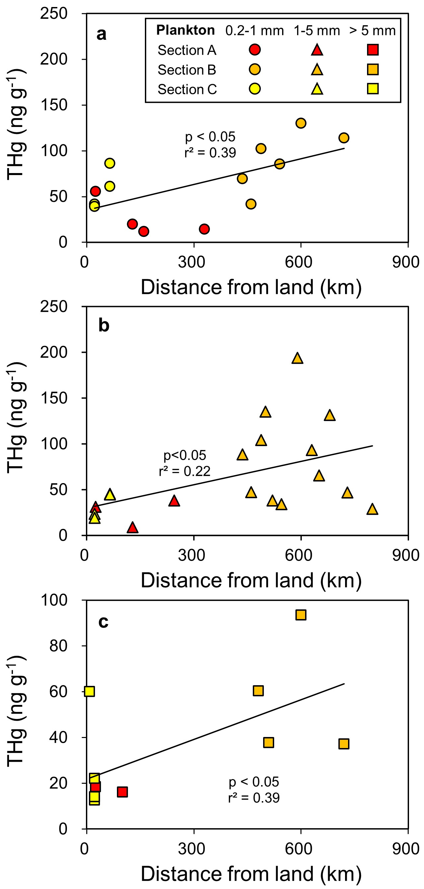
Supplementary Fig. 3 Zooplankton total Hg (THg) concentration with increasing distances away from land. From a to c, the P-values for the regression are 0.04, 0.04, 0.02.
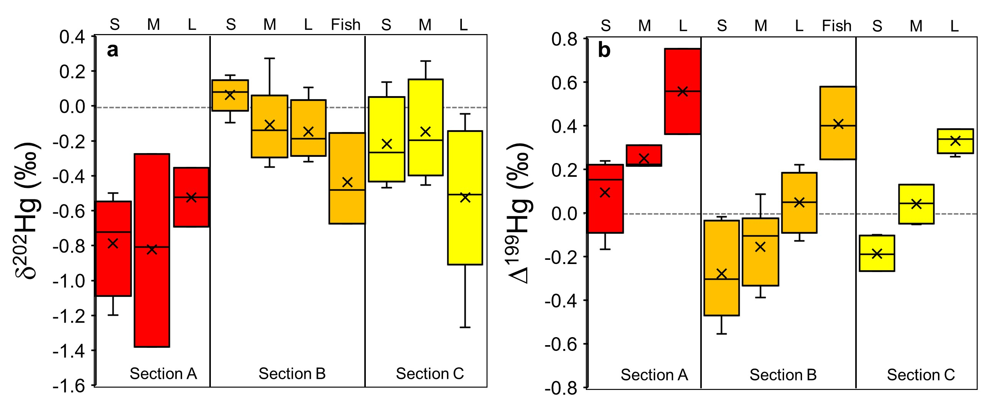
Supplementary Fig. 4 δ²⁰²Hg and Δ¹⁹⁹Hg of zooplankton and Artic cod. S (0.2-1 mm), M (1-5 mm), L (>5 mm) refer to zooplankton sizes, and fish refers to the Arctic Cod sampled exclusively at Section B. The bar graphs represent the mean, minimum, and maximum values.
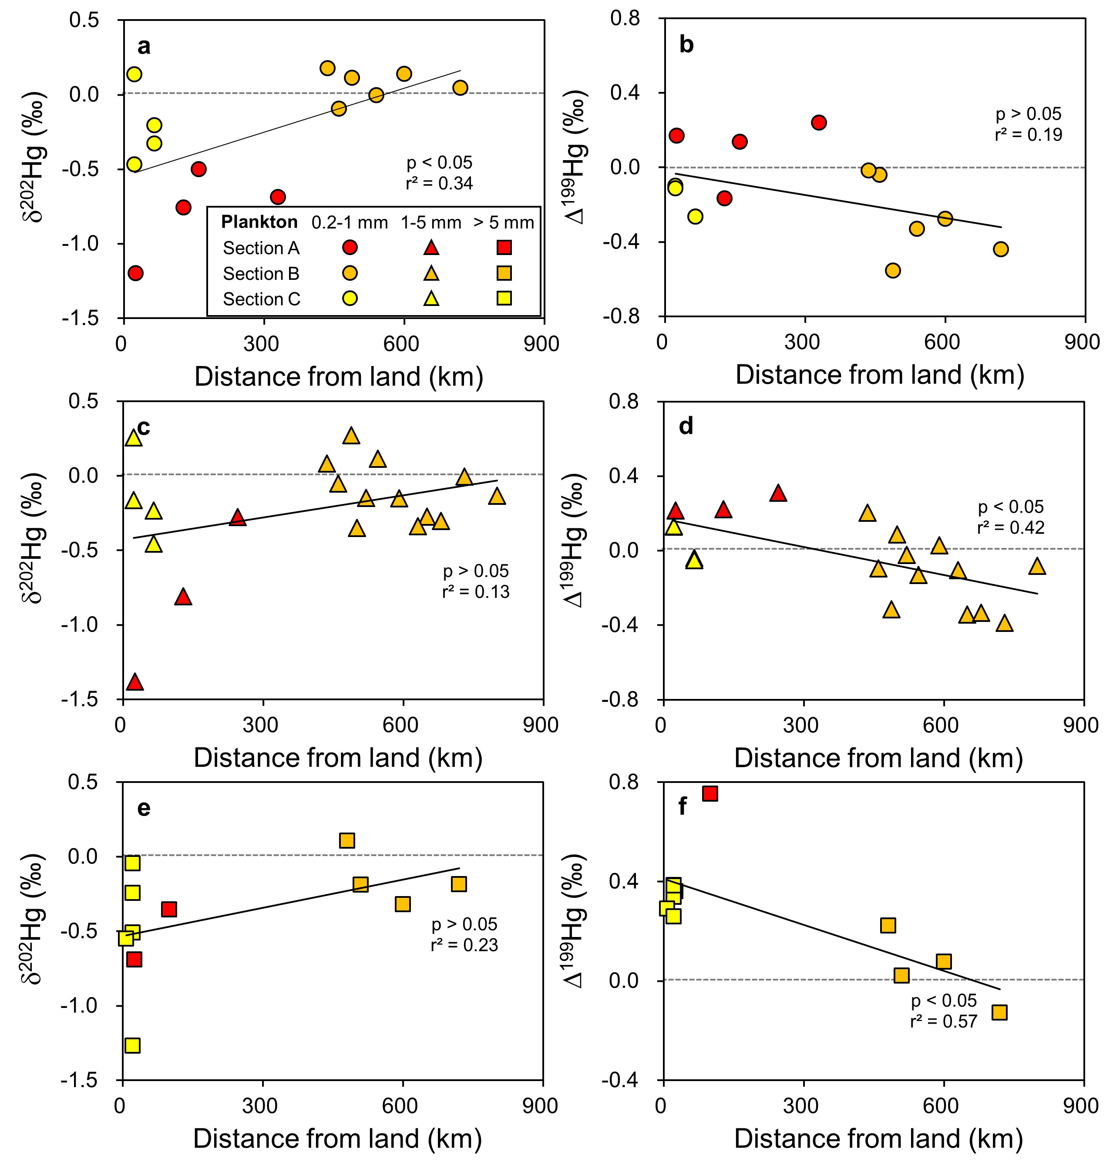
Supplementary Fig. 5 δ²⁰²Hg (a, c, e) and Δ¹⁹⁹Hg (b, d, f) of zooplankton in relation to distances away from land. From a to f, the P-values for the regression are 0.03, 0.11, 0.13, 0.00, 0.13, 0.01.

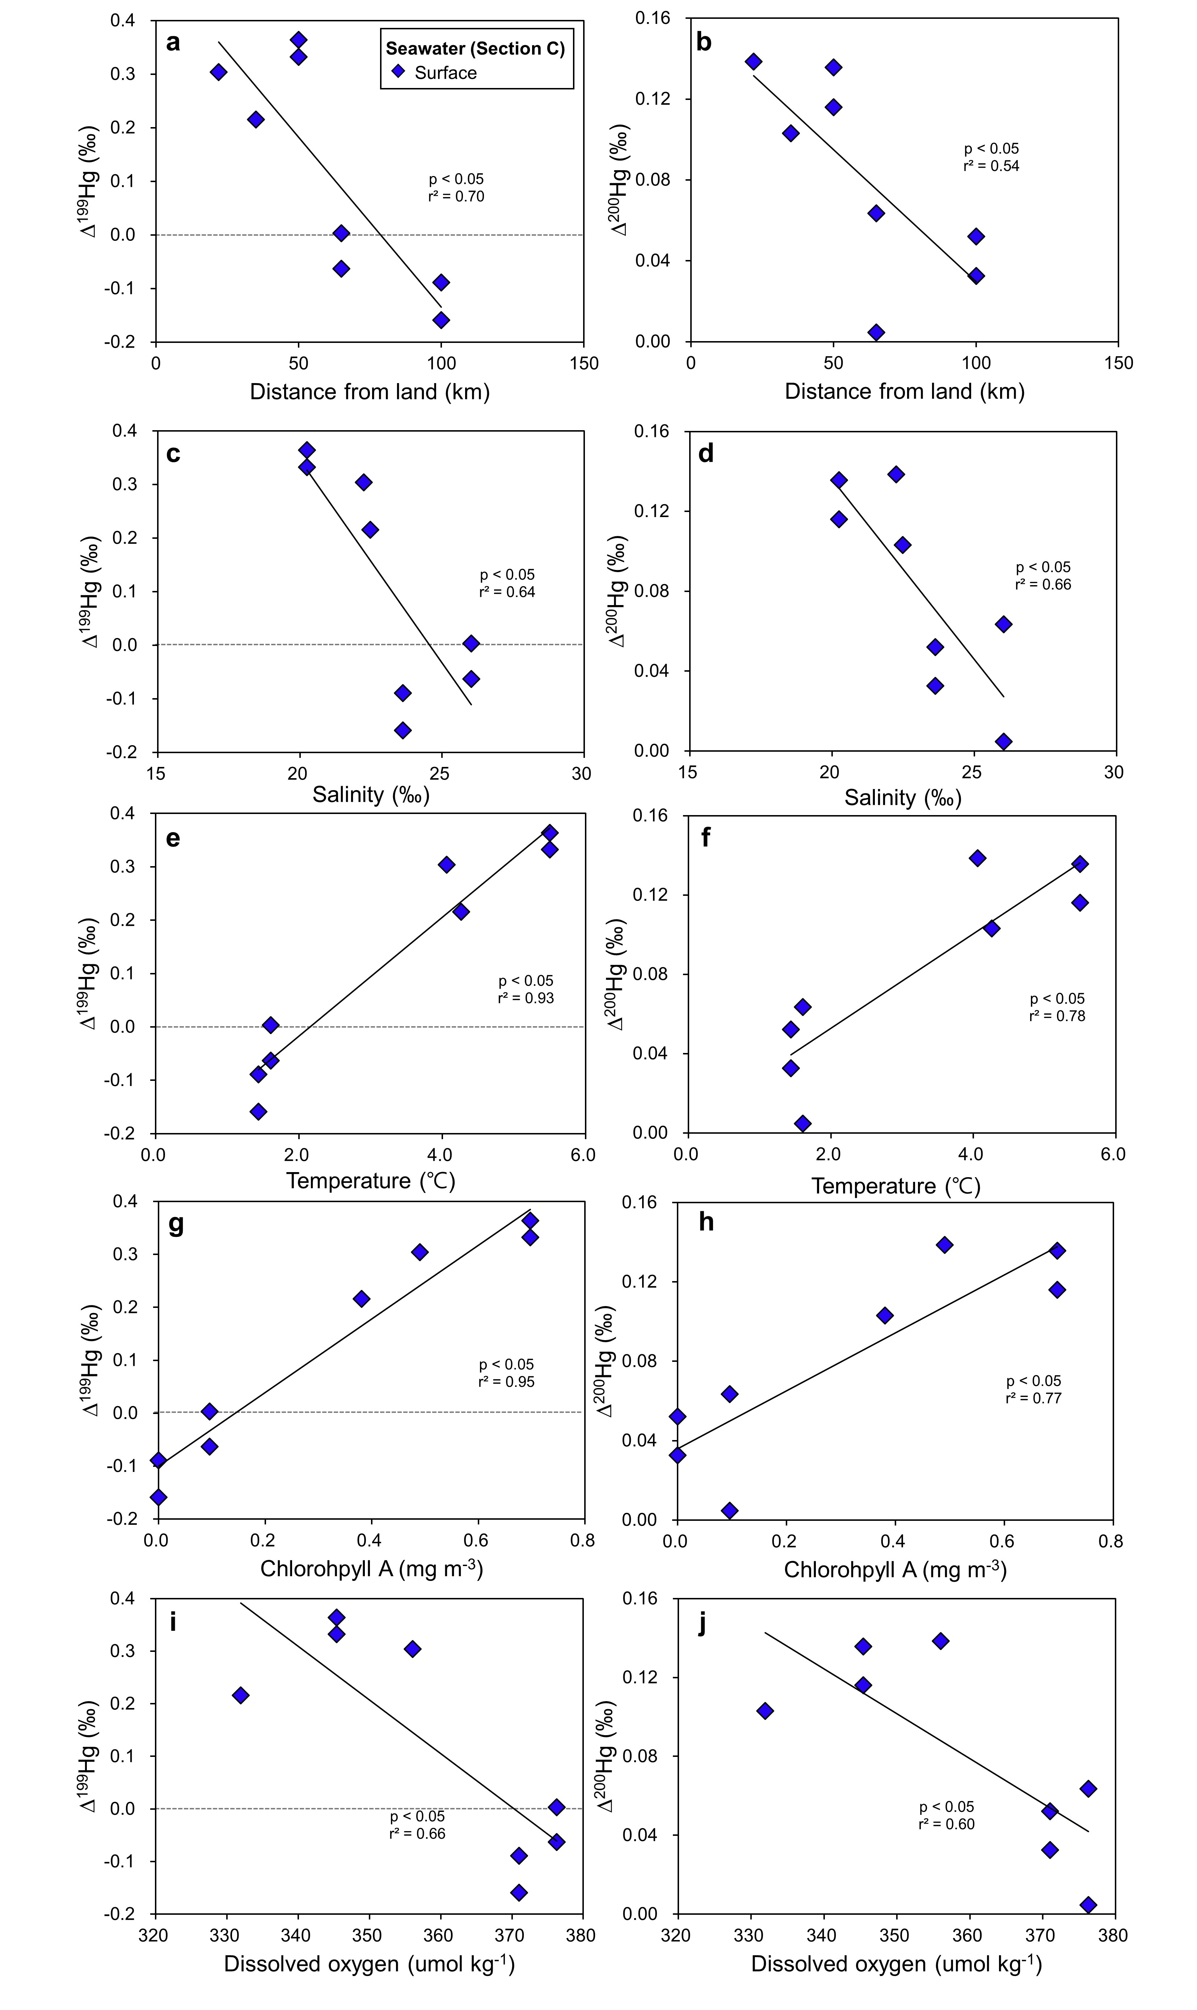
Supplementary Fig. 6 Δ¹⁹⁹Hg (a, c, e, g, i) and Δ²⁰⁰Hg (b, d, f, h, j) of surface seawater with respect to varying measured parameters. Each variable is measured using CTD at Section C at the water depth of 2−5 m. From a to j, the P-values for the regression are 0.01, 0.04, 0.02, 0.01, 0.00, 0.00, 0.00, 0.01, 0.01, and 0.02.

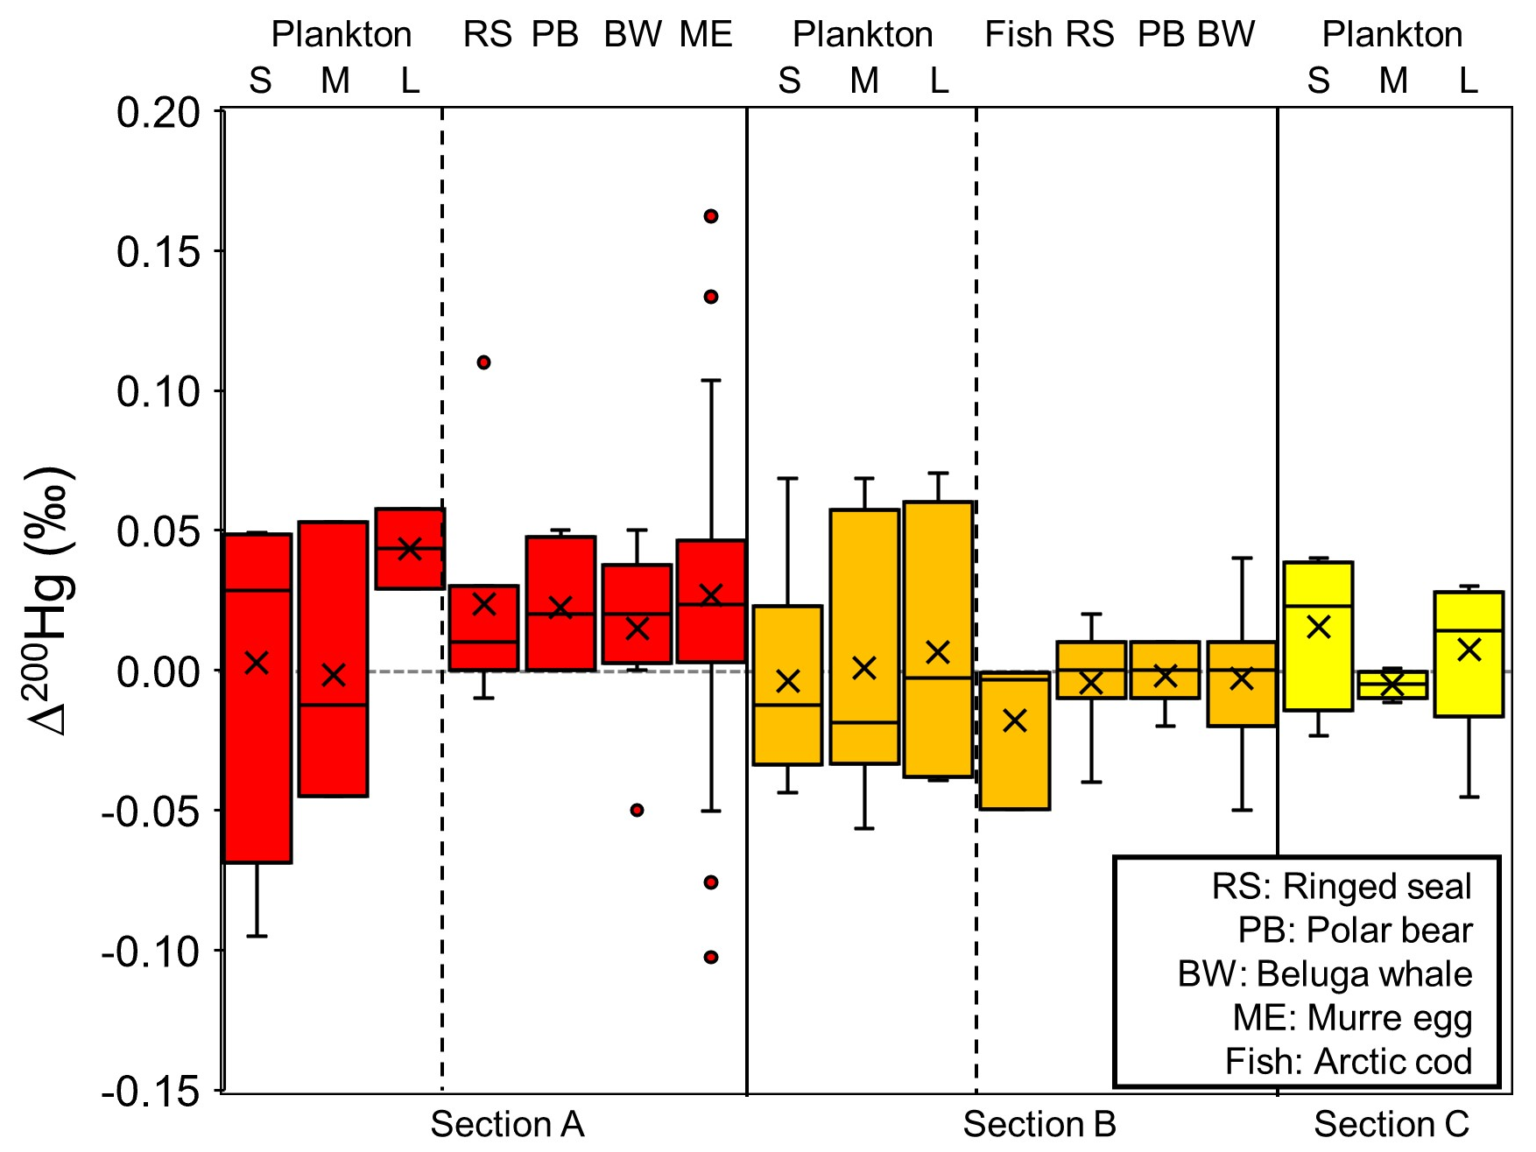
Supplementary Fig. 7 Δ²⁰⁰Hg of the Arctic biota from all this study and prior literature. Ringed seal, polar bear, and beluga whale from Masbou et al 2018¹¹, murre eggs are from Point et al 2011¹⁹ and Day et al 2012²⁰. The bar graphs represent mean, minimum and maximum values.

References
1. Li, M. et al. Selenium and stable mercury isotopes provide new insights into mercury toxicokinetics in pilot whales. Science of The Total Environment 710, 136325 (2020).
2. Perrot, V. et al. Higher Mass-Independent Isotope Fractionation of Methylmercury in the Pelagic Food Web of Lake Baikal (Russia). Environ. Sci. Technol. 46, 5902–5911 (2012).
3. Perrot, V. et al. Natural Hg isotopic composition of different Hg compounds in mammal tissues as a proxy for in vivo breakdown of toxic methylmercury. Metallomics 8, 170–178 (2016).
4. Brookens, T., Harvey, J. & Ohara, T. Trace element concentrations in the Pacific harbor seal (Phoca vitulina richardii) in central and northern California. Science of The Total Environment 372, 676–692 (2007).
5. Zheng, W. et al. Mercury stable isotopes reveal the sources and transformations of atmospheric Hg in the high Arctic. Applied Geochemistry 131, 105002 (2021).
6. Campeau, A. et al. Sources of riverine mercury across the Mackenzie River Basin; inferences from a combined Hg C isotopes and optical properties approach. Science of The Total Environment 806, 150808 (2022).
7. Jiskra, M. et al. Mercury stable isotopes constrain atmospheric sources to the ocean. Nature 597, 678–682 (2021).
8. Blum, J. D. & Johnson, M. W. Recent Developments in Mercury Stable Isotope Analysis. Reviews in Mineralogy and Geochemistry 82, 733–757 (2017).
9. Lepak, R. F. et al. Resolving Atmospheric Mercury Loading and Source Trends from Isotopic Records of Remote North American Lake Sediments. Environ. Sci. Technol. 54, 9325–9333 (2020).
10. Motta, L. C. et al. Mercury Cycling in the North Pacific Subtropical Gyre as Revealed by Mercury Stable Isotope Ratios. Global Biogeochem. Cycles 33, 777–794 (2019).
11. Masbou, J. et al. Hg-Stable Isotope Variations in Marine Top Predators of the Western Arctic Ocean. ACS Earth Space Chem. 2, 479–490 (2018).
12. Enrico, M., Balcom, P., Johnston, D. T., Foriel, J. & Sunderland, E. M. Simultaneous combustion preparation for mercury isotope analysis and detection of total mercury using a direct mercury analyzer. Analytica Chimica Acta 1154, 338327 (2021).
13. Besnard, L. et al. Foraging depth depicts resource partitioning and contamination level in a pelagic shark assemblage: Insights from mercury stable isotopes. Environmental Pollution 283, 117066 (2021).
14. Kim, Y. G. et al. Reconsidering mercury sources and exposure pathways to bivalves: Insights from mercury stable isotopes. Water Research 248, 120843 (2024).
15. Grigg, A. R. C., Kretzschmar, R., Gilli, R. S. & Wiederhold, J. G. Mercury isotope signatures of digests and sequential extracts from industrially contaminated soils and sediments. Science of The Total Environment 636, 1344–1354 (2018).
16. Liu, C. et al. Sources and Transformation Mechanisms of Atmospheric Particulate Bound Mercury Revealed by Mercury Stable Isotopes. Environ. Sci. Technol. 56, 5224–5233 (2022).
17. Geng, H., Yin, R. & Li, X. An optimized protocol for high precision measurement of Hg isotopic compositions in samples with low concentrations of Hg using MC-ICP-MS. J. Anal. At. Spectrom. 33, 1932–1940 (2018).
18. Schlitzer, Reiner, Ocean Data View, odv.awi.de, 2023
19. Point, D. et al. Methylmercury photodegradation influenced by sea-ice cover in Arctic marine ecosystems. Nature Geosci 4, 188–194 (2011).
20. Day, R. D. et al. Mercury Stable Isotopes in Seabird Eggs Reflect a Gradient from Terrestrial Geogenic to Oceanic Mercury Reservoirs. Environ. Sci. Technol. 46, 5327–5335 (2012).

