ELECTRONIC SUPPLEMENTARY MATERIAL - ONLINE RESOURCES
Online Resource 1. Study sites; PNN Tatamá indicated with a shape (study site included only the buffer zone of park) and greenhouse at Guarne (Antioquia) indicated with a dot.
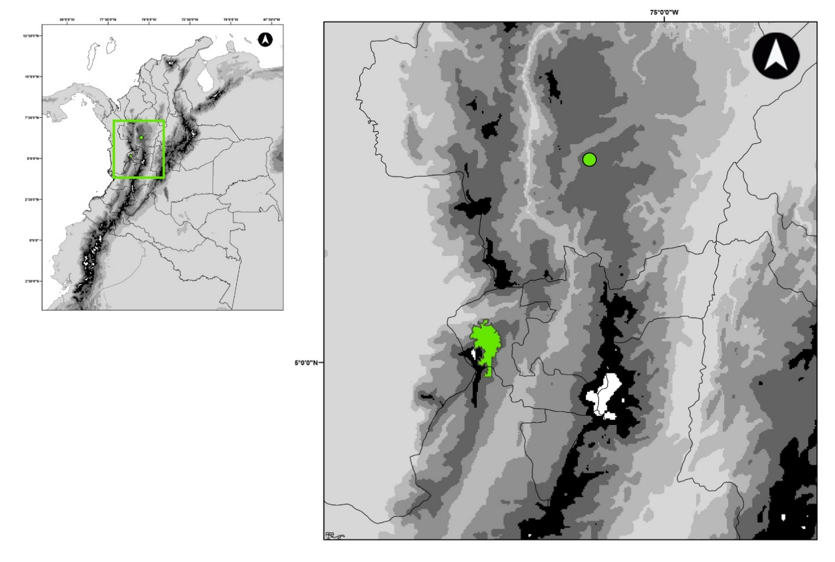
Online Resource 2. This video depicts the way in which the pollination fly, Drosophilidae sp. 1 [AO], escapes with the pollinarium and succeded in detaching the pollinarium anther cap by moving its legs and wings, being able to take off thereafter.

