Supplementary Table 1. Patient characteristics before applying multiple imputation method and the numbers (percentages) of missing values for each variable.
Variables | EEN  (n = 19,573) | LEN  (n = 7,988)
Body mass index, median (IQR) | 22.5 (20.0–25.1) | 22.2 (19.5–25.0)
Missing, n (%) | 1,173 (6.0) | 749 (9.4)
Smoking status, n (%)
Current/ex-smoker | 6,399 (38.2) | 2,351 (36.8)
Never smoker | 10,362 (52.9) | 4,029 (50.4)
Missing, n (%) | 2,812 (14.4) | 1,608 (20.1)
Ambulance use, n (%) | 14,163 (72.7) | 6,599 (83.3)
Missing, n (%) | 85 (0.4) | 66 (0.8)
Laboratory data
Platelet count, median (IQR), 10⁹/L | 180 (136–228) | 168 (118–219)
Missing, n (%) | 2,232 (11.4) | 871 (10.9)
Lymphocyte count, median (IQR), 10⁹/L | 1,080 (700–1,620) | 920 (550–1,430)
Missing, n (%) | 9,421 (48.1) | 4,218 (52.8)
Total bilirubin, median (IQR), mg/dL | 0.63 (0.47–0.90) | 0.63 (0.45–0.90)
Missing, n (%) | 2,768 (14.1) | 1,027 (12.9)
Creatinine, median (IQR), mg/dL | 0.82 (0.63–1.15) | 0.83 (0.63–1.20)
Missing, n (%) | 2,209 (11.3) | 863 (10.8)
Albumin, median (IQR), g/dL | 3.40 (2.90–3.90) | 3.20 (2.70–3.70)
Missing, n (%) | 3,184 (16.3) | 1,166 (14.6)
C-reactive protein, median (IQR), mg/dL | 0.51 (0.12–3.58) | 0.66 (0.13–4.43)
Missing, n (%) | 3,854 (19.7) | 1,338 (16.8)
Only variables with missing values were displayed.
Abbreviations; EEN, early enteral nutrition; LEN, late enteral nutrition; IQR, interquartile range.

Supplementary Table 2. Maximum absolute standardized mean differences of covariates in the matched cohorts created from 20 imputed datasets.
Category | Max ASD | Dataset number
Age, years old
< 50 | 0.010 | 16
≥ 50, < 60 | 0.025 | 6
≥ 60, < 70 | 0.019 | 5
≥ 70, < 80 | 0.024 | 7
≥ 80 | 0.030 | 9
Sex | 0.035 | 13
Body mass index
< 18.5 | 0.053 | 5
≥ 18.5, < 25.0 | 0.024 | 5
≥ 25.0, < 30.0 | 0.029 | 13
> 30.0 | 0.017 | 15
Current/ex-smoker | 0.031 | 6
Charlson Comorbidity Index
0–1 | 0.014 | 5
2–3 | 0.019 | 3
≥ 4 | 0.015 | 17
Ambulance use | 0.057 | 11
Emergent admission | 0.050 | 13
Emergent surgery | 0.036 | 7
Elective surgery | 0.026 | 1
Diagnosis for ICU admission
Sepsis | 0 | 1
Cardiovascular | 0 | 1
Pulmonary | 0 | 1
Metabolic | 0 | 1
Neurology | 0 | 1
Trauma | 0 | 1
Digestive | 0 | 1
Others | 0 | 1
Total SOFA score | 0.104 | 17
SOFA, respiratory | 0.085 | 15
SOFA, coagulation | 0.044 | 17
SOFA, liver | 0.024 | 19
SOFA, renal | 0.020 | 8
SOFA, conscious | 0.096 | 2
SOFA, circulation | 0.048 | 18
Catecholamine index | 0.030 | 18
Mechanical ventilation | 0.069 | 1
Extracorporeal membrane oxygenation | 0.009 | 10
Renal replacement therapy
Continuous | 0.022 | 8
Intermittent | 0.031 | 2
Systemic steroid | 0.023 | 8
Laboratory data
Lymphocyte count | 0.027 | 15
Albumin | 0.059 | 16
C-reactive protein | 0.026 | 3
Abbreviations; ASD, absolute standardized mean difference; ICU, intensive care unit; SOFA, sequential organ failure assessment.

Supplementary Figure 1.
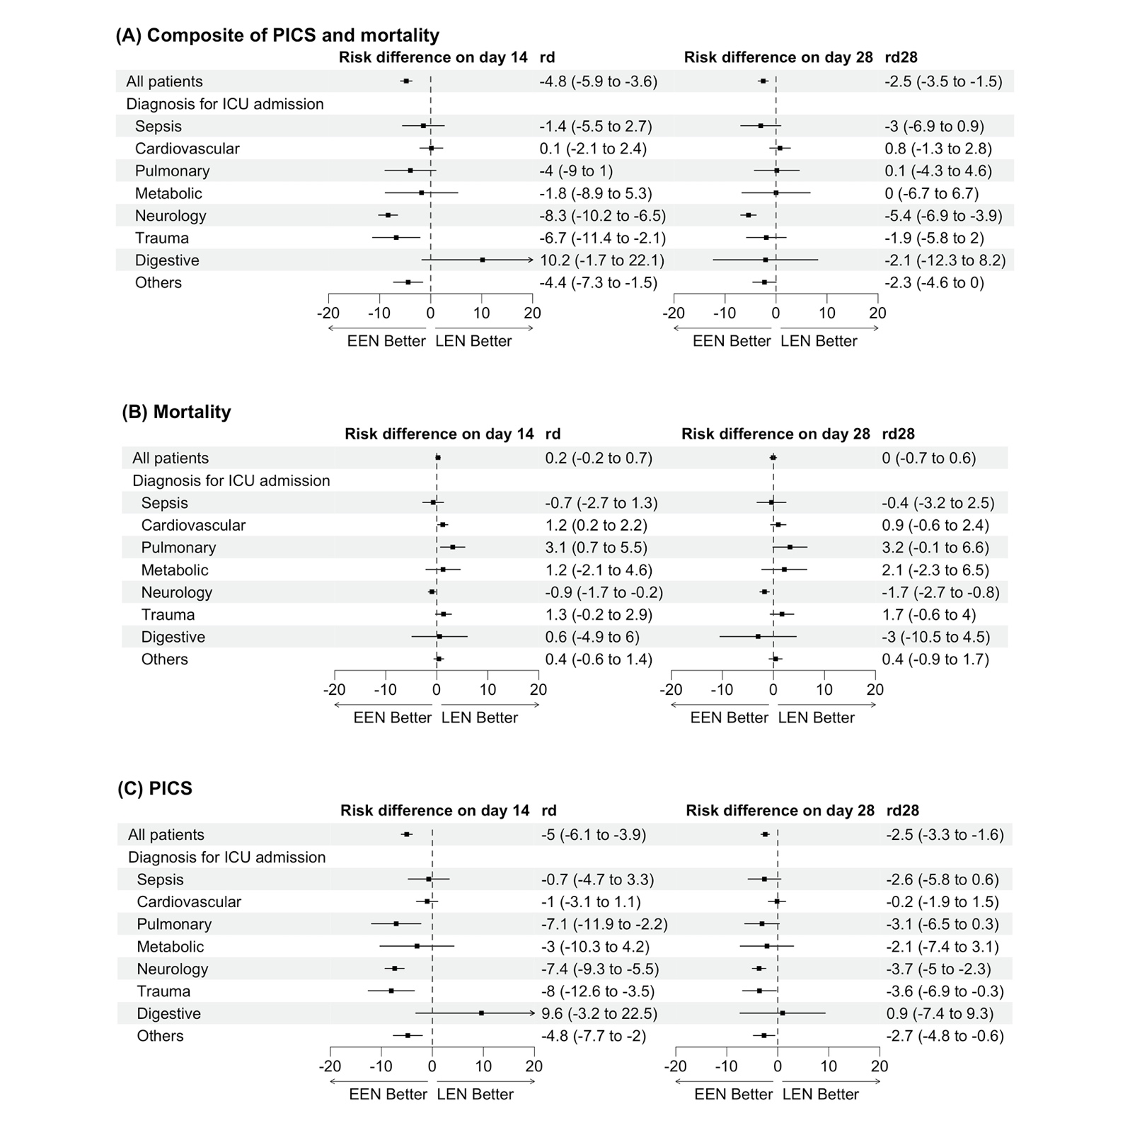
Sensitivity analysis using overlap weighting method for overall patients and subgroup analyses stratified by the diagnoses for intensive care unit admission: A, the composite of PICS and mortality; B, mortality; C, PICS. Risk differences were the combination of estimates from 20 imputed datasets according to the Rubin's rule and displayed with 95% confidence interval.
PICS, persistent inflammation, immunosuppression, and catabolism syndrome; EEN, early enteral nutrition; LEN, late enteral nutrition; ICU, intensive care unit.

