Supplementary figures and tables for:

Inducible prophages modulate symbiotic phenotypes in Sargassum-associated bacteria

Alexandra K. Stiffler¹, Poppy Hesketh-Best², Natascha S. Varona¹, Ashley Zagame¹, Brian LaPointe³, Cynthia Silveira^{1,4*}

¹Department of Biology, University of Miami, Coral Gables, FL 33146, USA
²Department of Veterinary Population Medicine, University of Minnesota, Saint Paul, MN, 55108, USA
³Harbor Branch Oceanographic Institute, Florida Atlantic University, Fort Pierce, FL 34946, USA
⁴Department of Marine Biology and Ecology, Rosenstiel School of Marine, Atmospheric, and Earth Science, University of Miami, Miami, FL 33149, USA

Keywords: Bacteriophage, biofilm formation, induction, primary producer, metagenomics, metagenome-assembled genome

*Correspondence: cynthiasilveira@miami.edu

Supplementary Figures

Sup. Fig. 1 | Bacterial order abundances. Mean abundance of Sargassum and seawater bacteria at the order level.

Sup. Fig. 2 | Sargassum and seawater bMAG completeness. Boxplot comparison of bMAG completeness for both sample types (Two-sample t-test, p-value = 0.343).

Sup. Fig. 3 | Auxiliary metabolic gene pathway comparison between Sargassum, seawater cellular, and seawater viral communities. Fractional abundances indicate the sum of all viruses encoding a gene in the specified pathway. The heatmap was normalized by pathway using a z-score function.

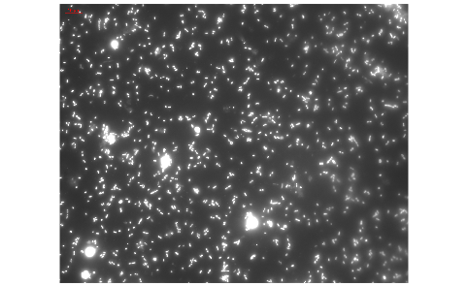

Sup. Fig. 4 | Microscopy for initial Sargassum bacteria enrichment. Fluorescence microscopy image for the initial Sargassum bacterial enrichment depleted of extracellular viruses. Bacteria and viruses were stained with SYBR Gold and visualized at 6300X magnitude.

Sup. Fig. 5 | Representative fluorescence microscopy for mitomycin C and no treatment groups during biofilm induction assay. Representative fluorescence microscopy images for mitomycin c treated (bottom) and not treated (top) Sargassum bacterial enrichment communities 12 hours post-induction. Bacteria and viruses were stained with SYBR Gold and visualized at 6300X magnitude.

Sup. Fig. 6 | Vibrio sp. abundances (log-transformed percentages) in Sargassum and seawater cellular fractions. Median abundance of Vibrio sp. of log percent read abundance per sample type (Sargassum n = 5, Seawater n = 5).

Supplemental Table
Sup. Table 1 | Viral community ecology statistics. From left to right, Shannon diversity index, Simpson diversity index, richness, and evenness.
 | Shannon Index | Simpson Index | Richness | Evenness
Sargassum | 5.682 | 0.985 | 2176 | 0.741
Seawater cellular | 5.825 | 0.9914 | 1906 | 0.772
Seawater viral | 7.464 | 0.999 | 3591 | 0.912

