Supplementary Figures
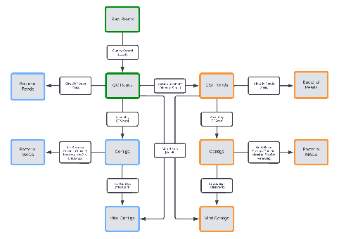
Figure S1 | Bioinformatic workflow. Simplified bioinformatic pipeline for the recovery of viruses and bacteria in the comparison of methods, blue boxes represent the bacterial and viral recovery from quality-controlled (QC) reads, orange boxes represent bacterial and viral recovery from coral-filtered (CSF) reads, and where green boxes represent steps shared by both.

