APPENDIX

Figure A 1. Minimal sufficient covariate adjustment set for the saturated model. This DAG shows how this adjustment set blocks all the back-door (i.e., spurious) paths between X and Y₁.
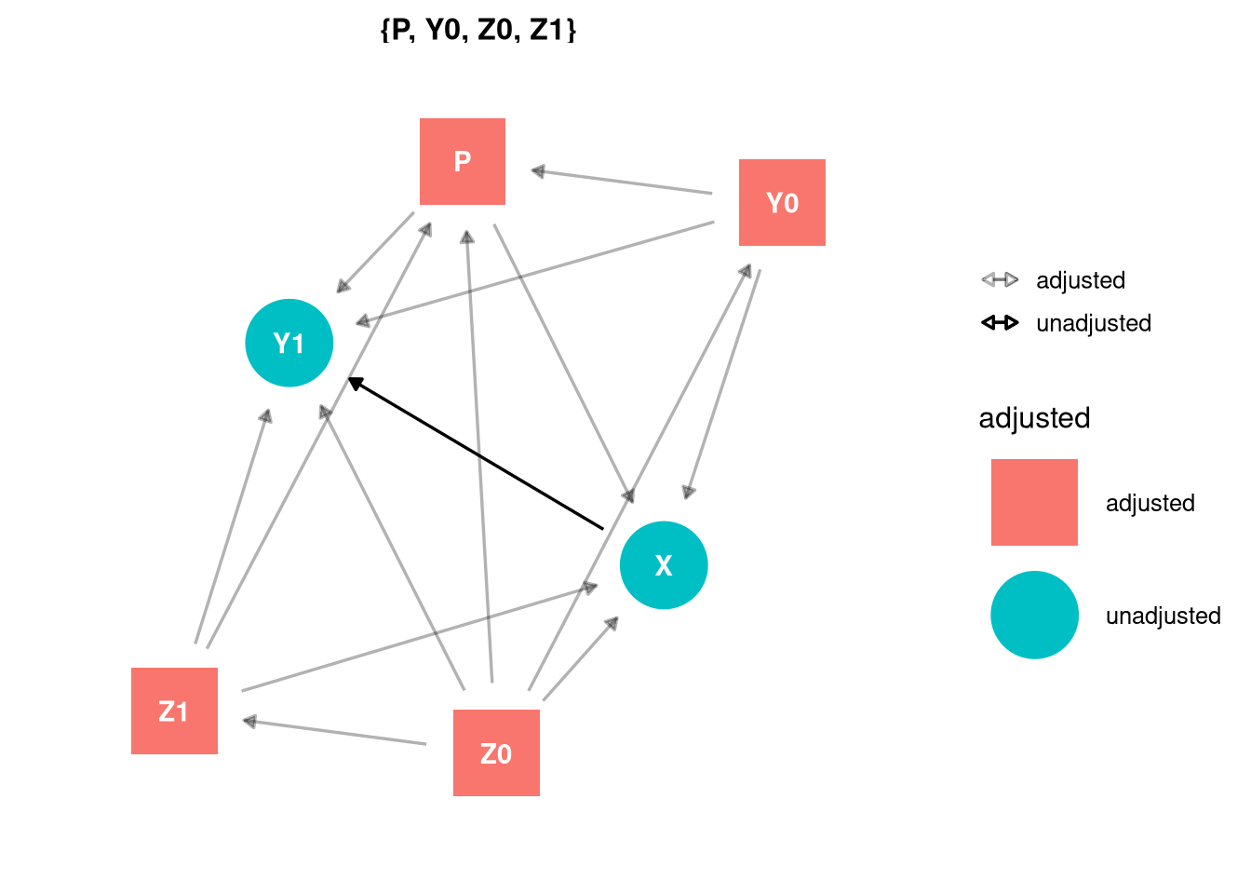

Figure A 2. Minimal sufficient covariate adjustment set for the myopic voter model. This DAG shows how this adjustment set blocks all the back-door (i.e., spurious) paths between X and Y₁.
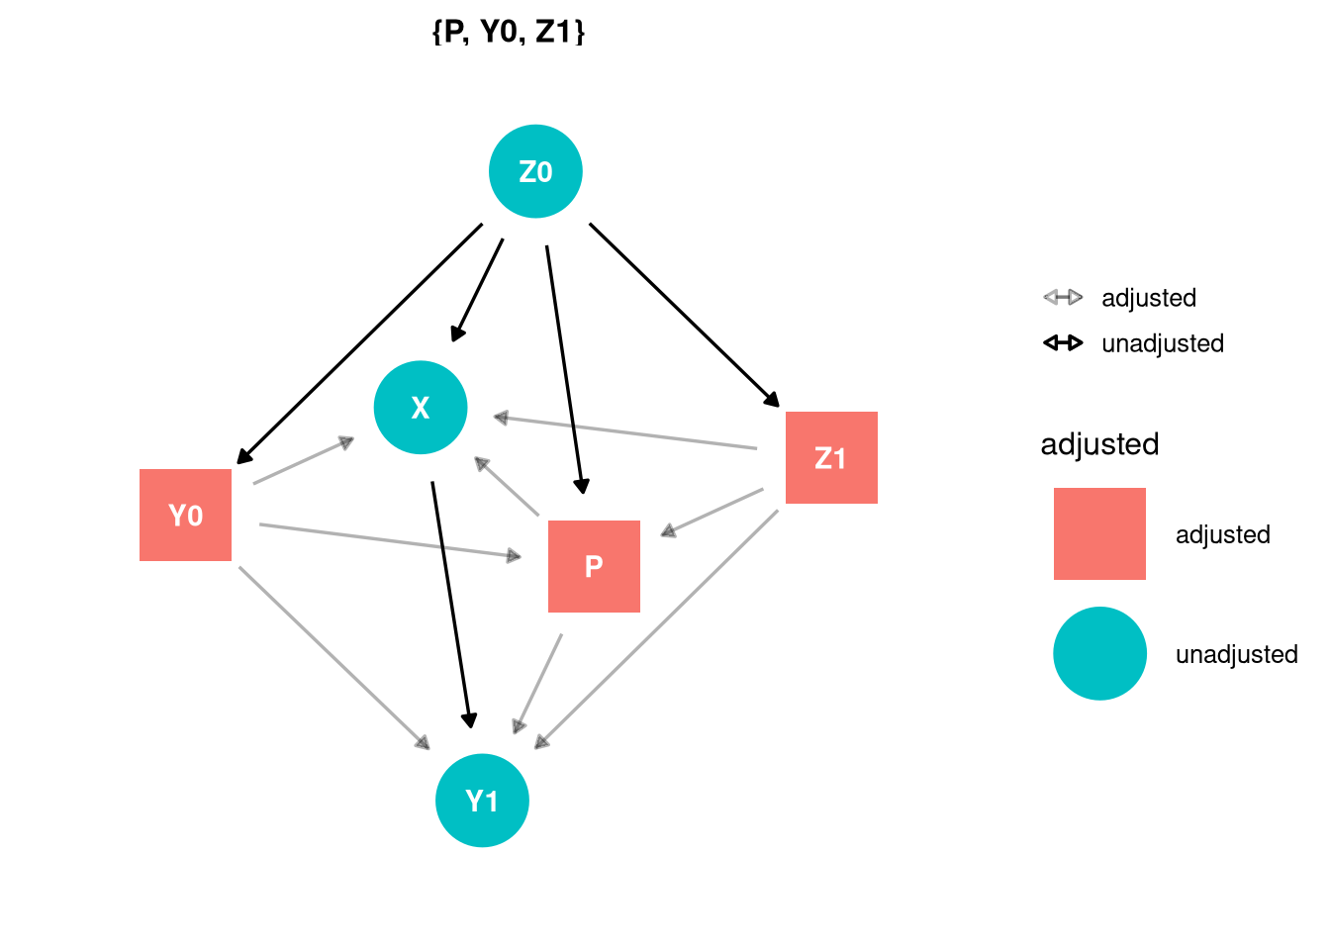

Figure A 3. Minimal sufficient covariate adjustment set for the polling failure model. This DAG shows how this adjustment set blocks all the back-door (i.e., spurious) paths between X and Y₁.
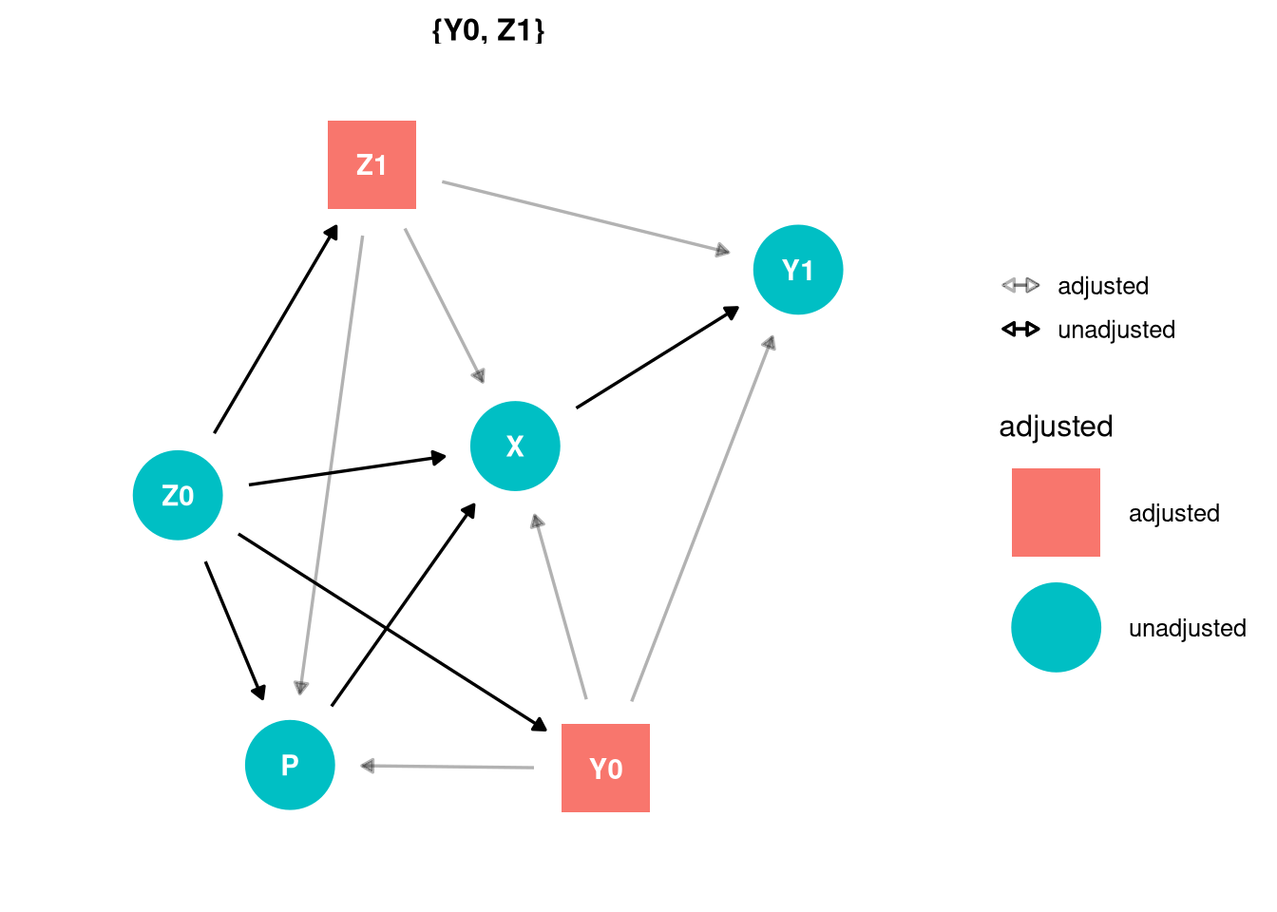
Figure A 4. Estimated median effect of Trump's campaign visit on the propensity of increased Republican vote between the 2012 and 2016 presidential elections (odds ratio). Results are obtained from sensitivity test that include Z₁, Z₀, and additional Z₁ and Z₀.
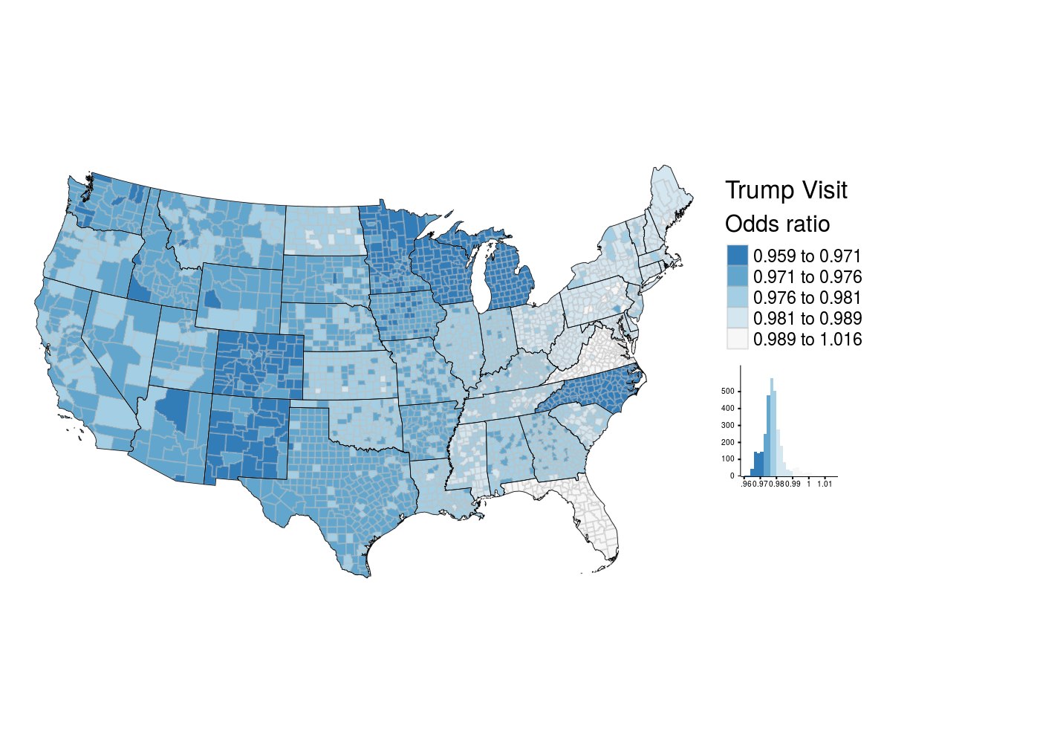

Figure A 5. Estimated median effect of Clinton's campaign visit on the propensity of increased Republican vote between the 2012 and 2016 presidential elections (odds ratio). Results are obtained from sensitivity test that include Z₁, Z₀, and additional Z₁ and Z₀.
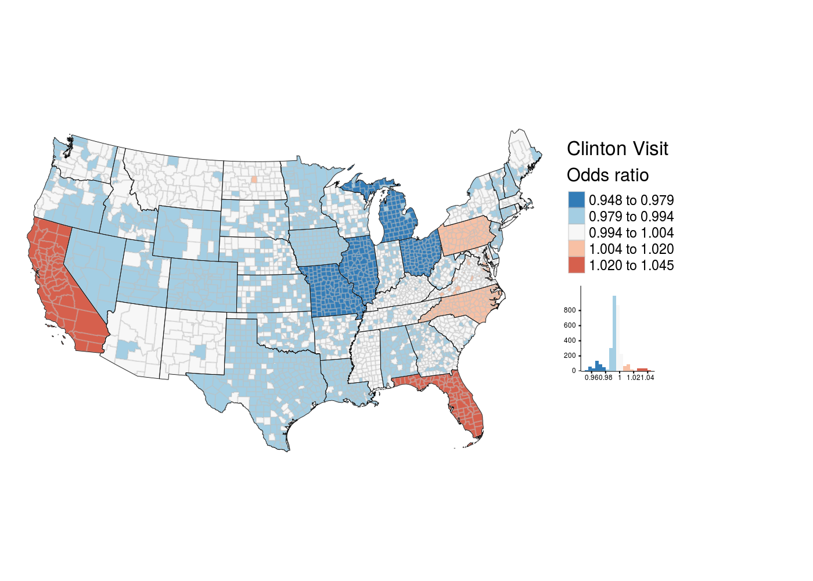

Figure A 6. Estimated median effect of campaign visit by both Trump and Clinton on the propensity of increased Republican vote between the 2012 and 2016 presidential elections (odds ratio). Results are obtained from sensitivity test that include Z₁, Z₀, and additional Z₁ and Z₀.
