Submission SRS: TABLES

TABLE 1. Available Data Points and Relative Passing Rate When Benchmarks are Calculated 3 Different Ways
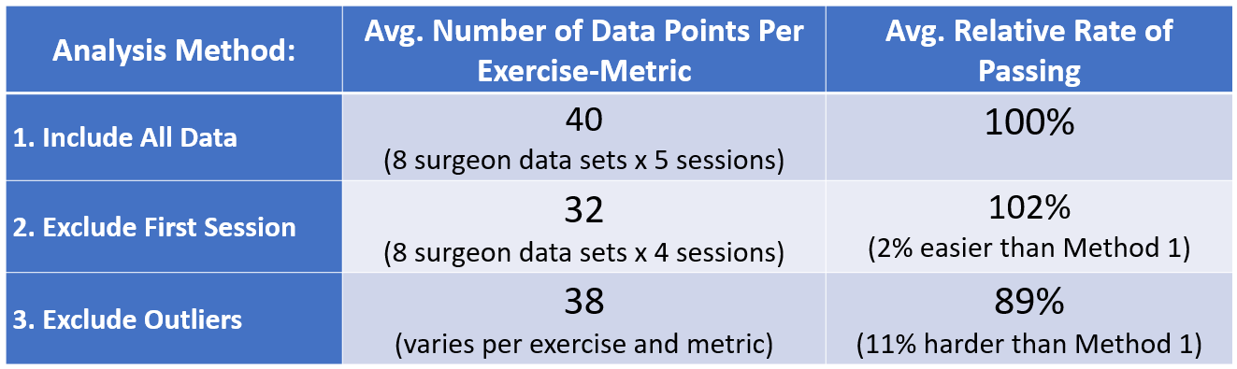

TABLE 2. The Number of Passed and Failed Metrics for all Sessions per Metric
Metric | Type | Passed | Failed | Grand Total | Percentage “Failed”
Economy of Motion | Efficiency | 1466 | 368 | 1834 | 20.07%
Time to Complete Exercise | Efficiency | 1443 | 391 | 1834 | 21.32%
Master Workspace Range | Efficiency | 1330 | 189 | 1519 | 12.44%
Instruments Out of View | Safety | 1525 | 309 | 1834 | 16.85%
Excessive Instrument Force | Safety | 1391 | 203 | 1594 | 12.74%

TABLE 3. Comparison of Pass/Fail scores with CLASSIC & ABSOLUTE Methods of Scoring for One Surgeon’s Attempt at one Exercise
Individual Metrics | ABSOLUTE Method | CLASSIC Method
Economy of Motion | Pass | 92%
Excessive Instrument Force | Fail | 70%
Instrument Collisions | Fail | 75%
Instruments Out Of View | Pass | 80%
Master Workspace Range | Pass | 88%
Time to Complete Exercise | Pass | 107%
OVERALL EXERCISE RESULT: | Fail | 85% (Pass)

