Supplemental Figures
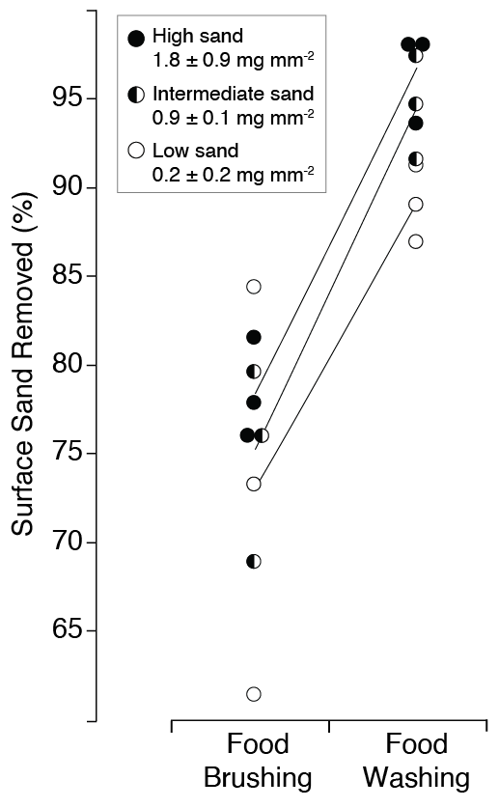
Fig. S1. Comparison of cleaning effectiveness. We simulated the brushing and washing behaviours of our study animals using the same three treatments of cucumber slices in our experiment. Brushing was less efficient than washing across all treatments, eliminating an average 76 ± 7% vs. 93 ± 4% of surface sands, respectively.
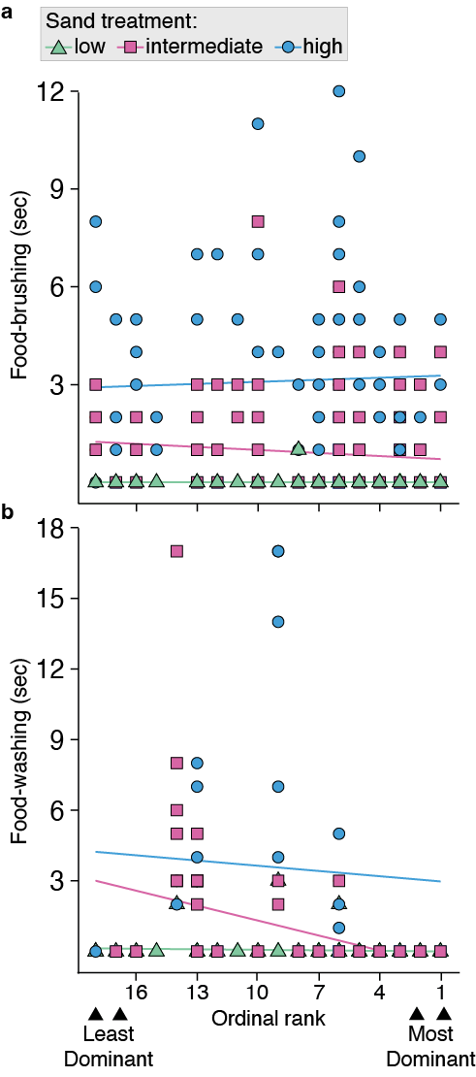
Fig. S2. Individual food-cleaning events. a, Monkeys put more time into brushing sandier treatments, 𝛸² (2, n = 575 food-brushing events) = 185.7, p < 0.0001) with no difference across dominance ranks (Table S3). b, Monkeys put more time into washing sandier treatments, 𝛸² (2, n = 362 food-washing events) = 50.5, p < 0.0001), but we detected an interaction effect with dominance rank, 𝛸² = 6.4, p = 0.04 (Table S4).
Supplemental Tables
Table S1 - delta AIC model results for brushing models - testing different model distributions and potential zero-inflation for brushing model (n = 575 observations)
Model | dAICc | Degrees of Freedom
Fit: Negative Binomial | 0.0 | 11
Fit: Poisson | 0.8 | 10
Fit: Zero-Inflated Poisson | 1.1 | 11
Fit: Zero-Inflated Negative Binomial | 1.7 | 12

Table S2 - delta AIC model results for washing models - testing different model distributions and potential zero inflation for washing models (n = 362 observations)
Model | dAICc | Degrees of Freedom
Fit: Negative Binomial | 0.0 | 11
Fit: Zero-Inflated Negative Binomial | 2.1 | 12
Fit: Poisson | 20.2 | 10
Fit: Zero-Inflated Poisson | 21.0 | 11

Table S3 – Fixed effects for food-brushing (n = 575 events by animals with known rank), analysis of deviance (Type II Wald Chi Square Tests)
Fixed Effect | 𝛸² | Degrees of Freedom | p (one sided)
Grit treatment | 185.74 | 2 | p< 0.0001
Ordinal rank * grit treatment | 2.57 | 2 | 0.2765
Ordinal rank | 0.01 | 1 | 0.3253
Sex | 0.09 | 1 | 0.7703
Sex * grit treatment | 0.13 | 2 | 0.9368

Table S4 – Fixed effects for food-washing (n = 362 events by animals with known rank), analysis of deviance (Type II Wald Chi Square Tests)
Fixed Effect | 𝛸² | Degrees of Freedom | p (one sided)
Grit treatment | 50.45 | 2 | p< 0.0001
Ordinal rank * grit treatment | 6.38 | 2 | 0.0411
Sex * grit treatment | 0.77 | 2 | 0.7762
Ordinal rank | 0.06 | 1 | 0.8082
Sex | 0.00 | 1 | 0.9760

