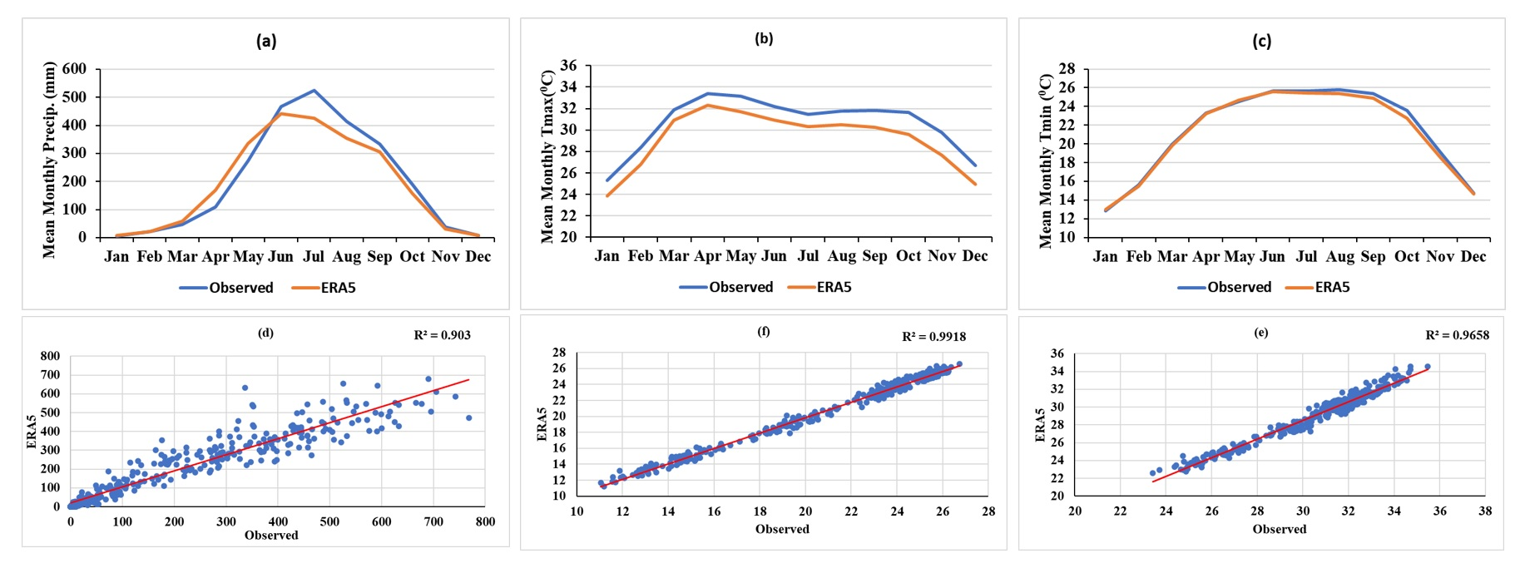
Figure S1. The annual cycle of monthly mean (a) precipitation, (b) maximum temperature (Tmax), and (c) minimum temperature (Tmin) over Bangladesh. The blue line represents observed data, while the yellow line depicts ERA5 reanalysis. Scatter plots in (d), (e), and (f) present the monthly mean precipitation, Tmax, and Tmin from 1985 to 2014, comparing observations versus ERA5.

