Figure 2D
SPC

β-actin

Figure 3C
E-cadherin

N-cadherin
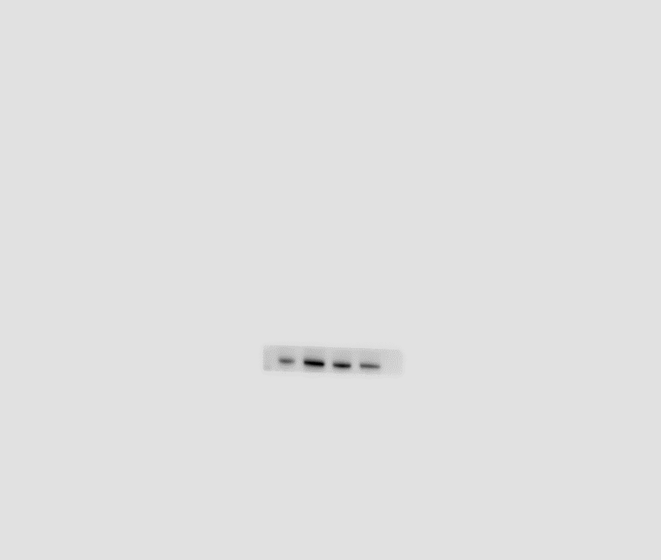

β-actin

Figure 7A
Smad3
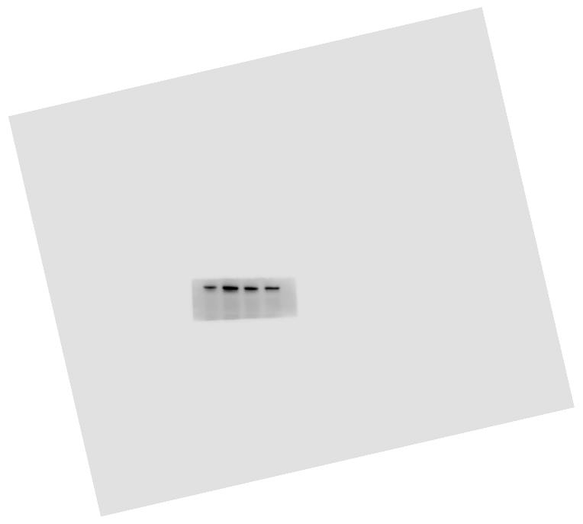

β-actin

Figure 7B
BAX

Bcl-2
C-caspase-9

C-caspase-3

β-actin

Figure S1A
α-SMA

Fibronectin

Collagen I

β-actin

