Climate change and terrigenous inputs decrease the efficiency of the future Arctic Ocean’s biological carbon pump

Laurent Oziel^{1*}, Özgur Gürses¹, Sinhué Torres-Valdés¹, Clara J.M. Hoppe¹, Björn Rost^{1,2}, Onur Karakus^{1,3}, Christopher Danek¹, Bennet Juhls⁴, Christoph Völker¹, Nikolay Koldunov¹, Qiang Wang¹, Morten Iversen^{1,5}, Boris P. Koch^{1,6}, Cara Nissen^{1,7}, Judith Hauck¹

¹Alfred-Wegener-Institut - Helmholtz-Zentrum für Polar- und Meeresforschung, Bremerhaven, Germany
²Faculty of Biology/Chemistry, University of Bremen, Bremen, Germany
³Physical Oceanography Department, Woods Hole Oceanographic Institution, Woods Hole, Massachusetts, USA
⁴Alfred Wegener Institute, Helmholtz Centre for Polar and Marine Research, Telegrafenberg A45, 14473 Potsdam, Germany
⁵MARUM and University of Bremen, Bremen, Germany
⁶Faculty 1, Bremerhaven University of Applied Sciences, An der Karlstadt 8, 27568 Bremerhaven, Germany
⁷Department of Atmospheric and Oceanic Sciences and Institute of Arctic and Alpine Research, University of Colorado Boulder, Boulder, CO, USA

*Correspondence: laurent.oziel@awi.de

SUPPLEMENTARY INFORMATION
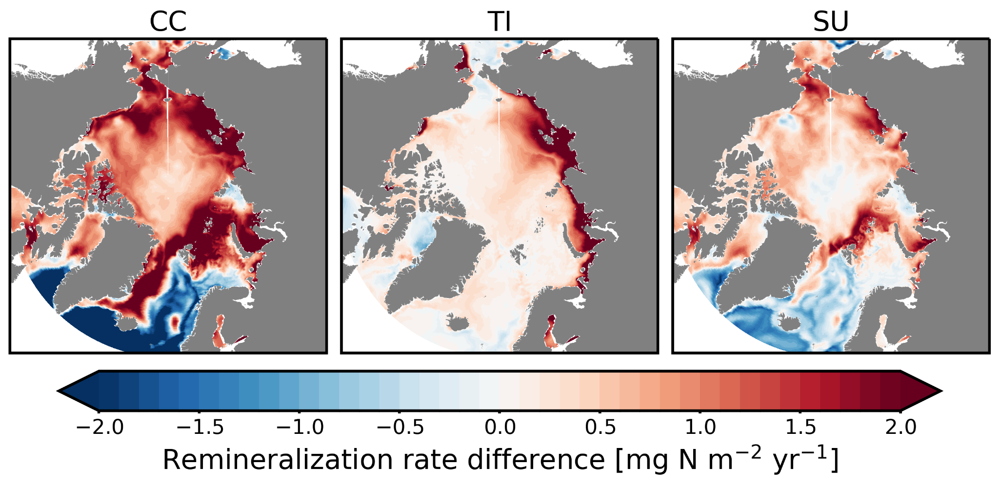
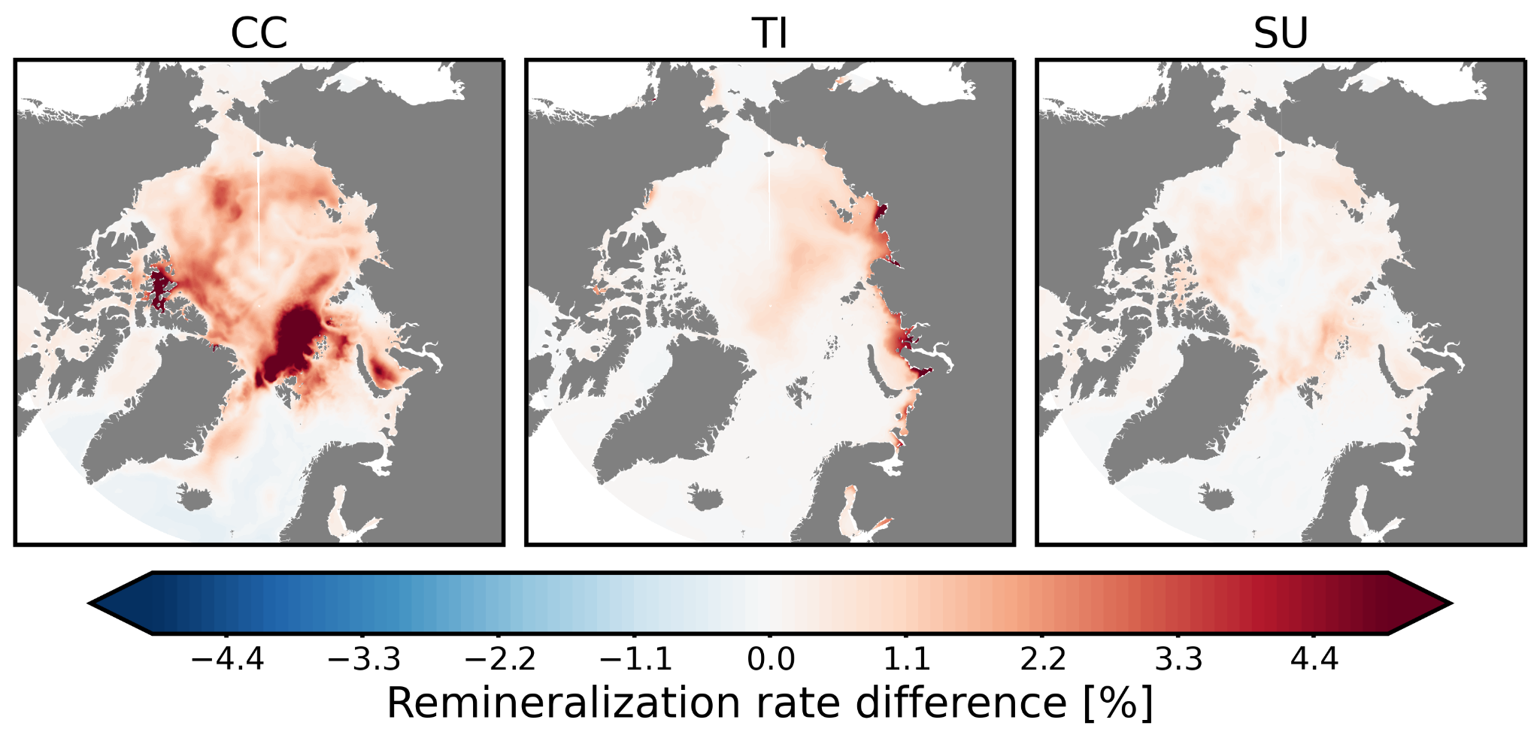
Fig. S1: Maps of remineralization absolute (top) and relative (bottom) differences due to climate change (CC, left), terrigenous inputs (TI, middle) and the avoidable contribution of climate change (SU, right) across the AO. In terms of relative increase, most climate change effects occur in the central AO. Terrigenous inputs affect mostly Siberian shelves and the transpolar drift. The avoidable contribution of climate change seems to occur where most of the future changes in sea ice are expected.

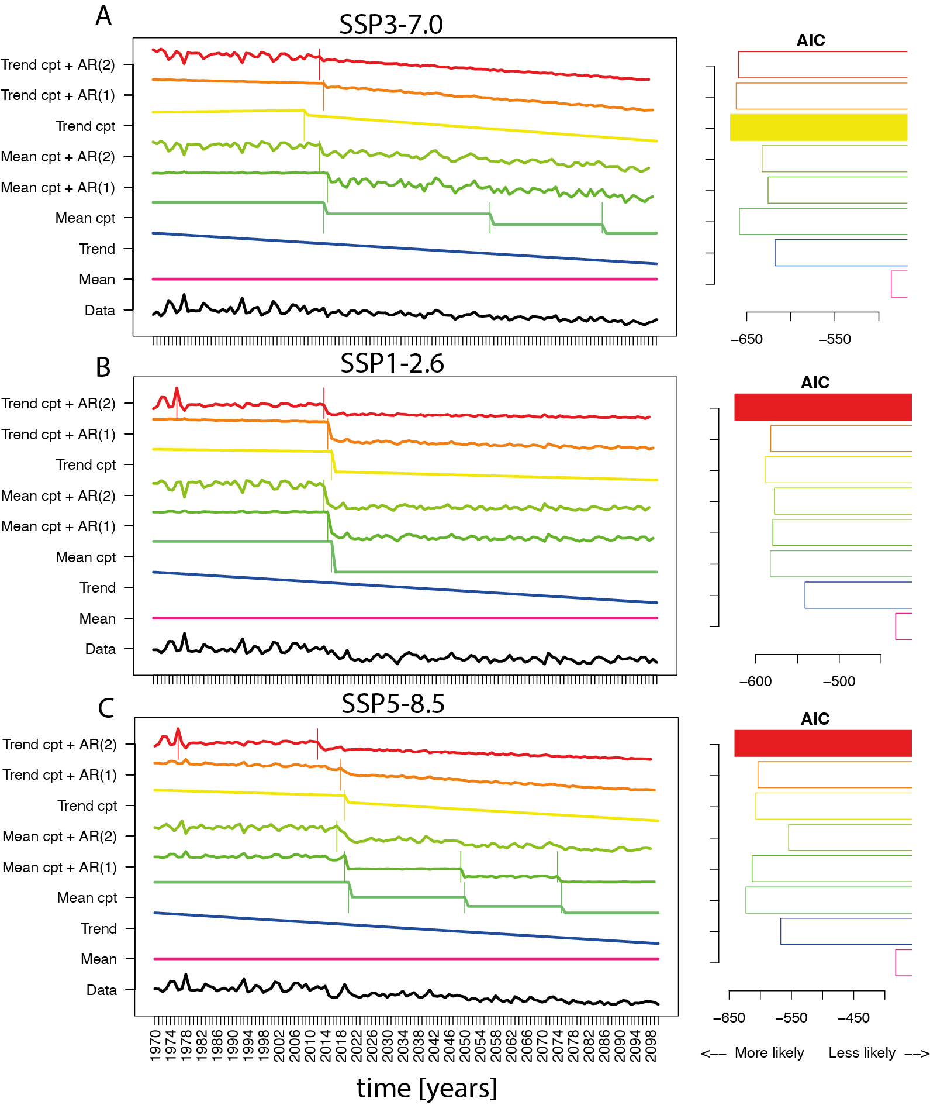Figure S2: Change point analysis showing the export flux time series describing the data and statistical models with vertical lines being the detected change-points (cpt). Panels on the right hand-side show the Akaike Information Criterion which allows us to estimate the best performing model (the lowest value corresponds to the best performance). Most change points are changes in the trend in the 2010s. We included 8 statistical models in our analysis (from bottom to top): a constant mean, a constant linear trend, a constant mean with first-order autocorrelation, a constant linear trend with first-order autocorrelation, multiple change points in the mean, multiple change points in the linear trend, multiple change points in the mean with first-order autocorrelation, and multiple change points in the linear trend with first-order autocorrelation.
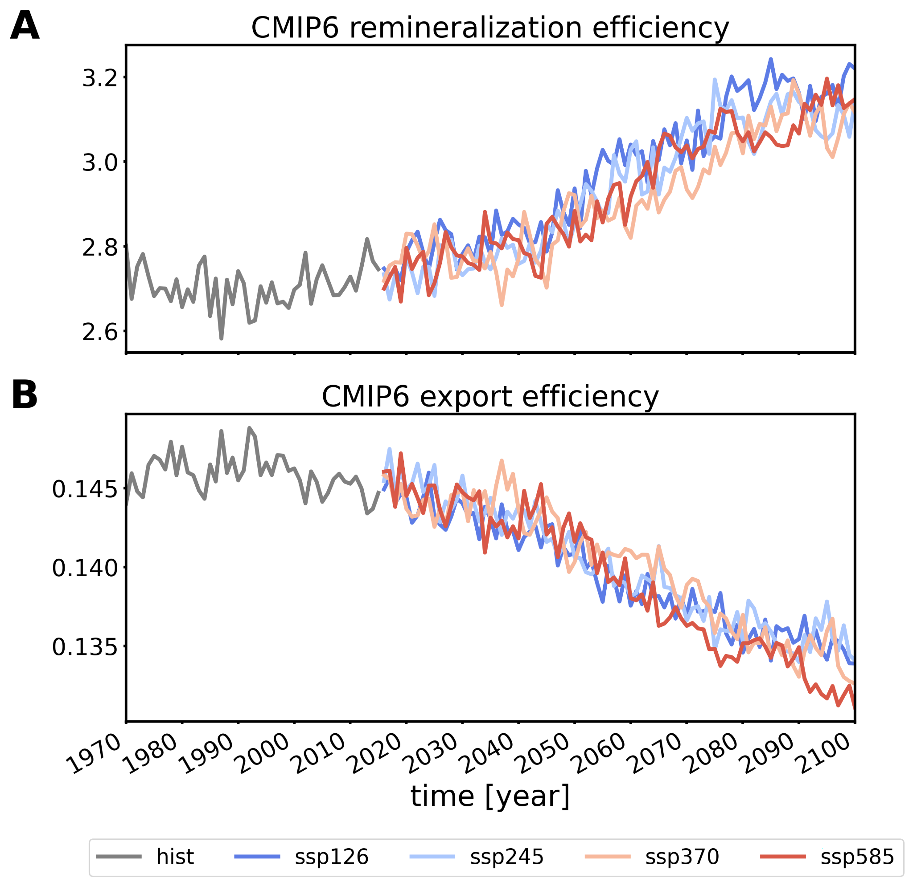
Figure S3: Comparison with CMIP6 (IPCC-like) Earth system models: Time series of the (carbon-based) A export and B remineralization efficiencies from the CMIP6 (Coupled Model Intercomparison Project) ensemble. Only 5 models from 3 different Earth System model providers delivered remineralization as an output. For consistency, we limited the analysis to those 5 models: CESM2, CESM2-WACCM, IPSL-CM6A-LR, MPI-ESM1-2-HR, MPI-ESM1-2-LR. The analysis shows that our results are consistent with those of CMIP6 models.

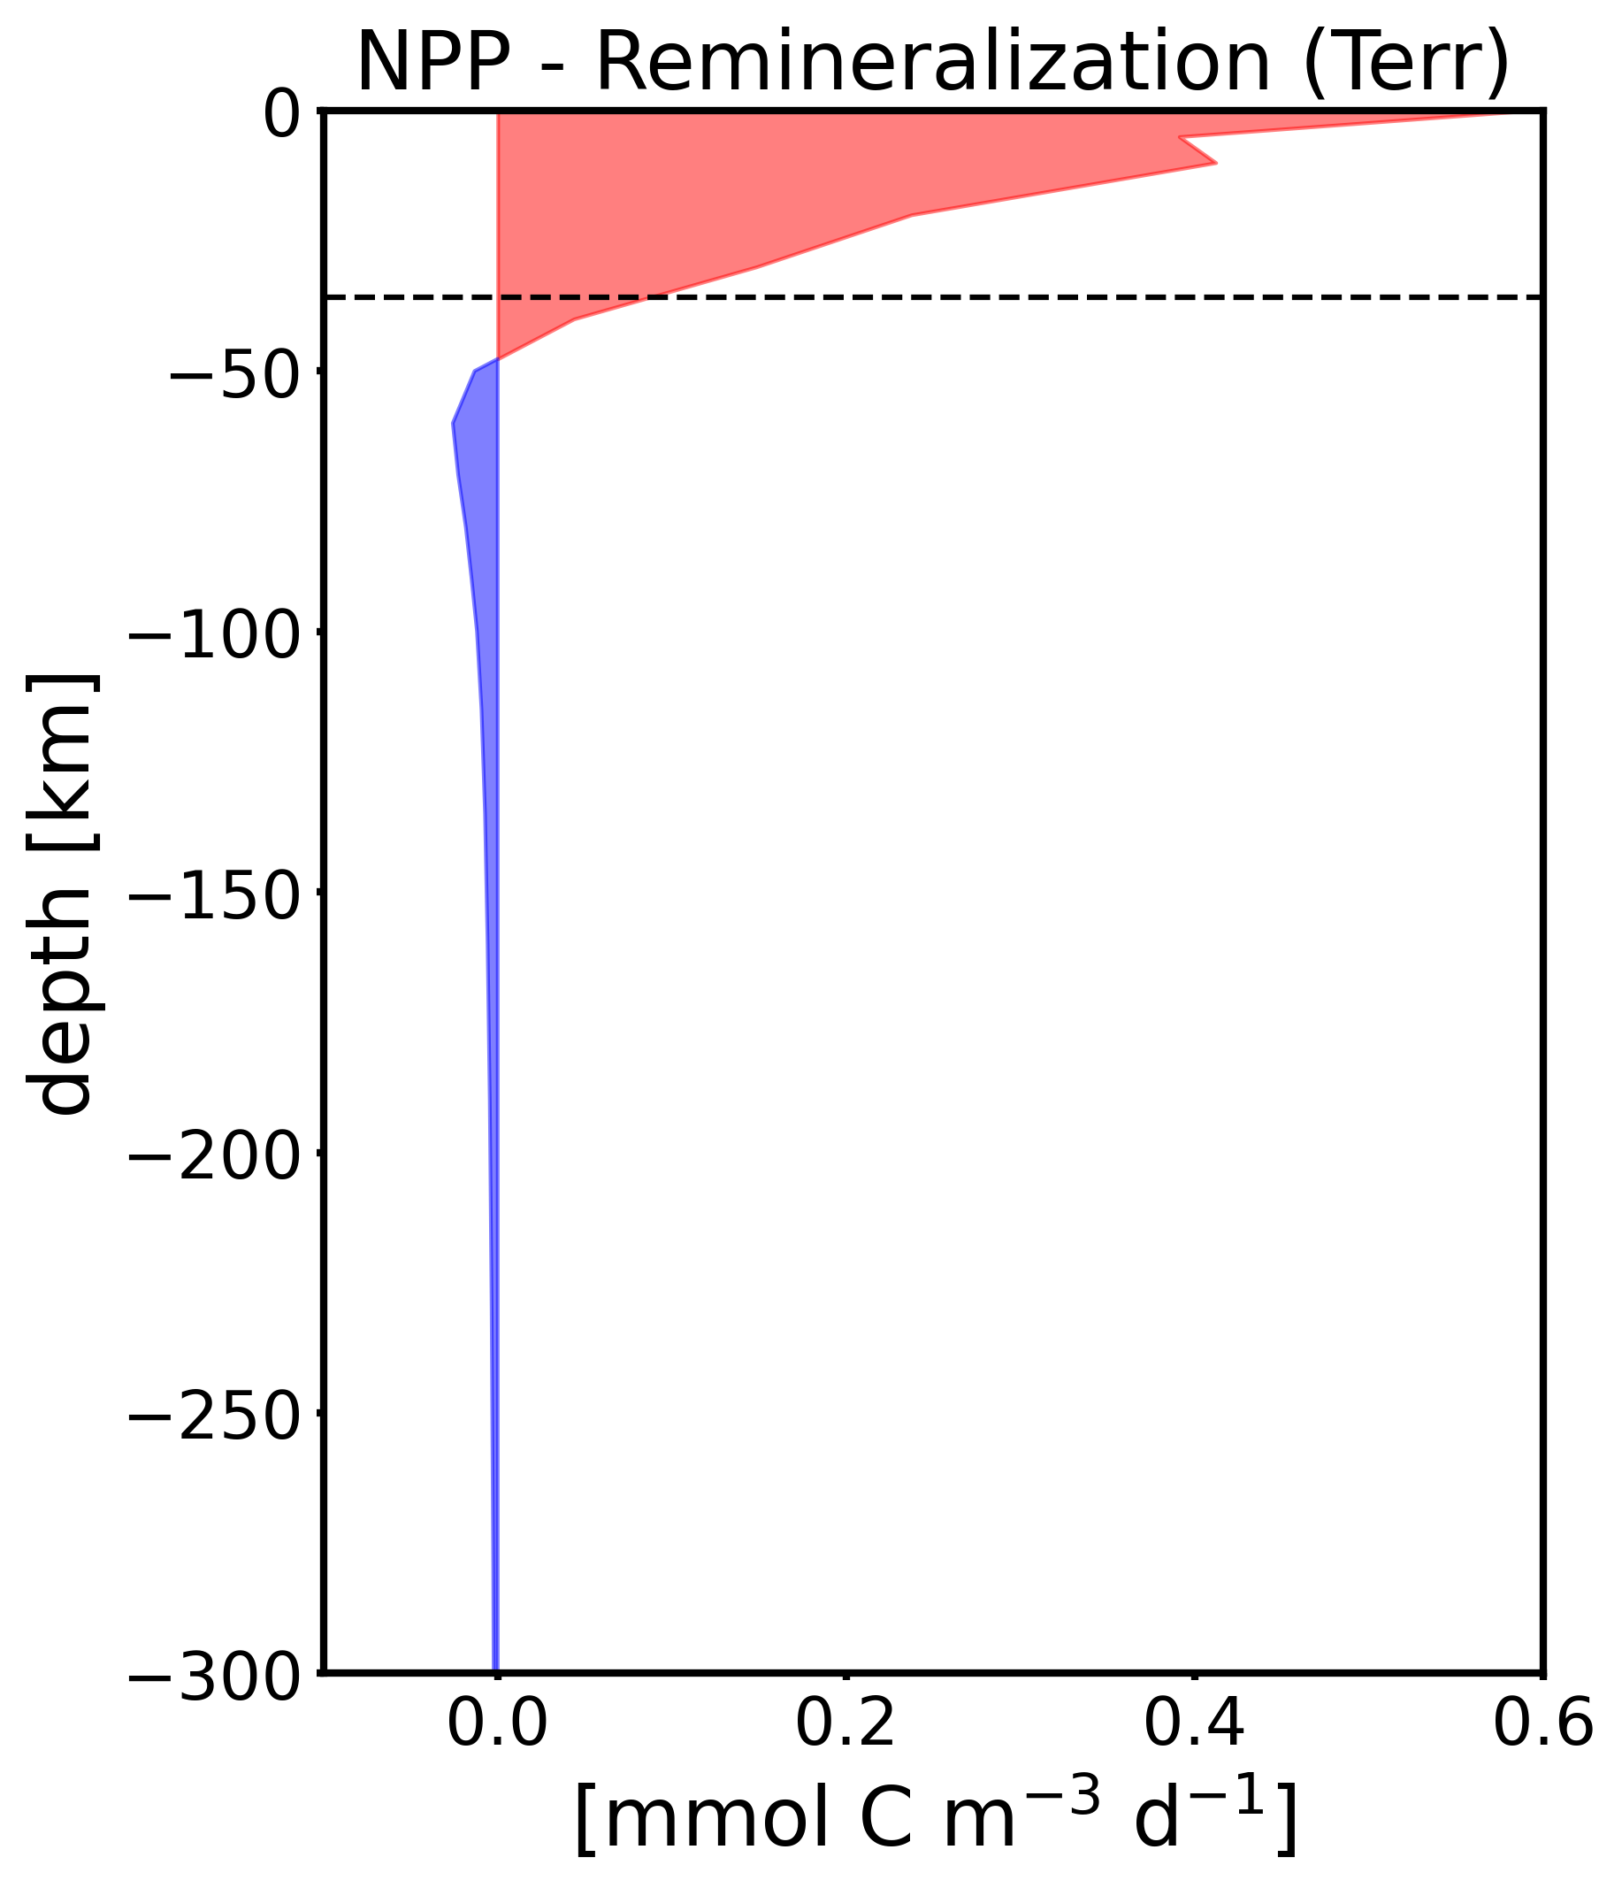
Figure S4: Anomaly profiles of NPP vs. remineralization rates [mmol C m⁻³ d⁻¹] (2090s, Terr). NPP already encompasses carbon losses through respiration (NPP = gross primary production – respiration). Blue areas = therefore represent depths where respiration and remineralization govern over photosynthetic processes. The horizontal dashed line is the mixed layer depth.

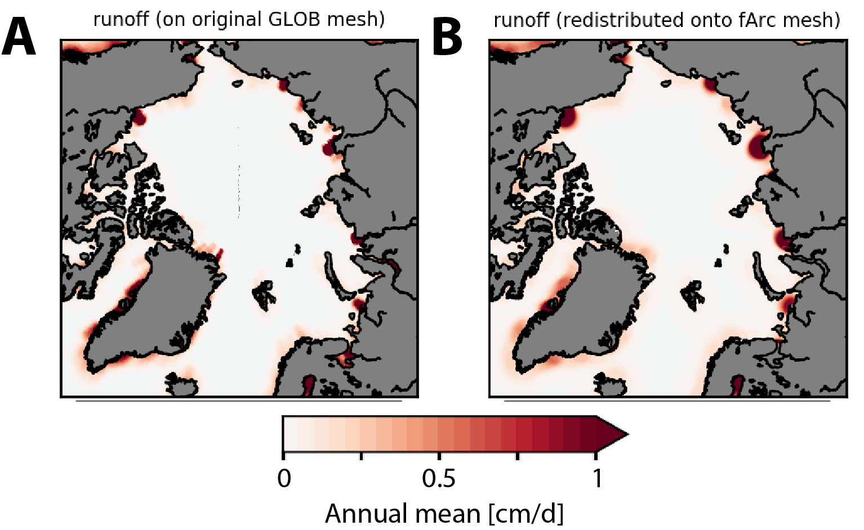
Figure S5: Physical runoff from the original AWI-ESM model and those reprojected for the ‘fArc’ mesh in this study.

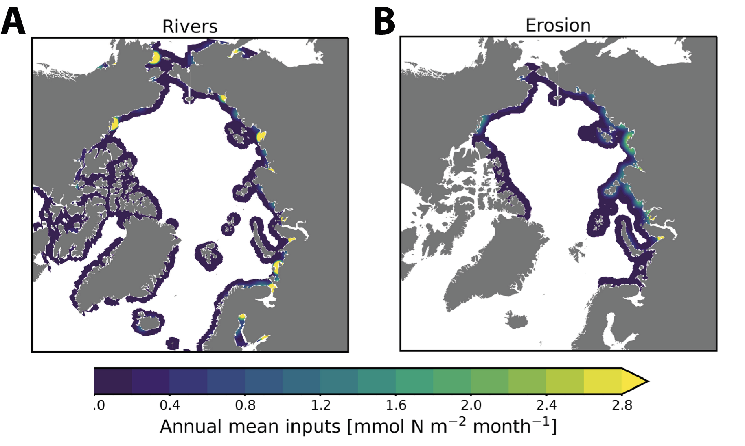
Figure S6: Maps of annual mean terrigenous inputs of nitrogen from A rivers and B coastal erosion.

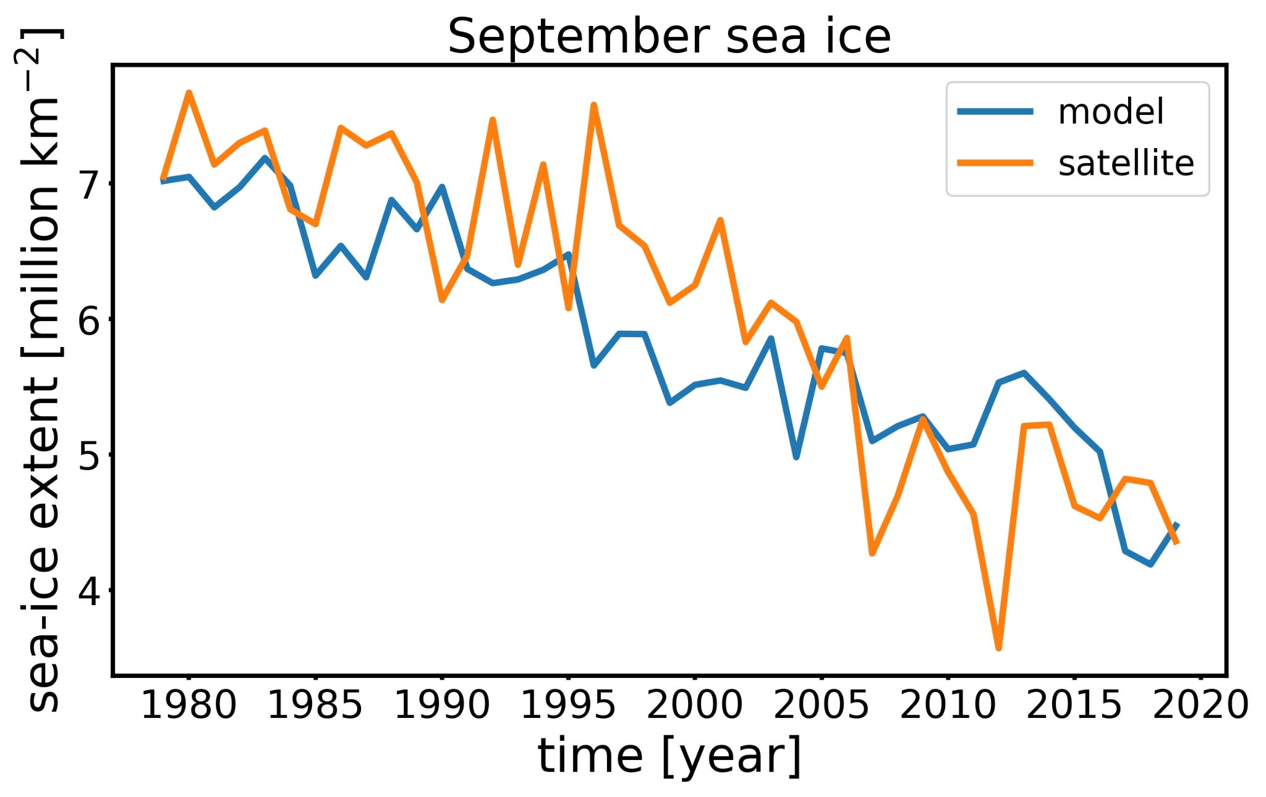
Figure S7: Comparison of modeled and observed (from satellite, see methods) Arctic Ocean summer (September) sea-ice extent expressed in million km².

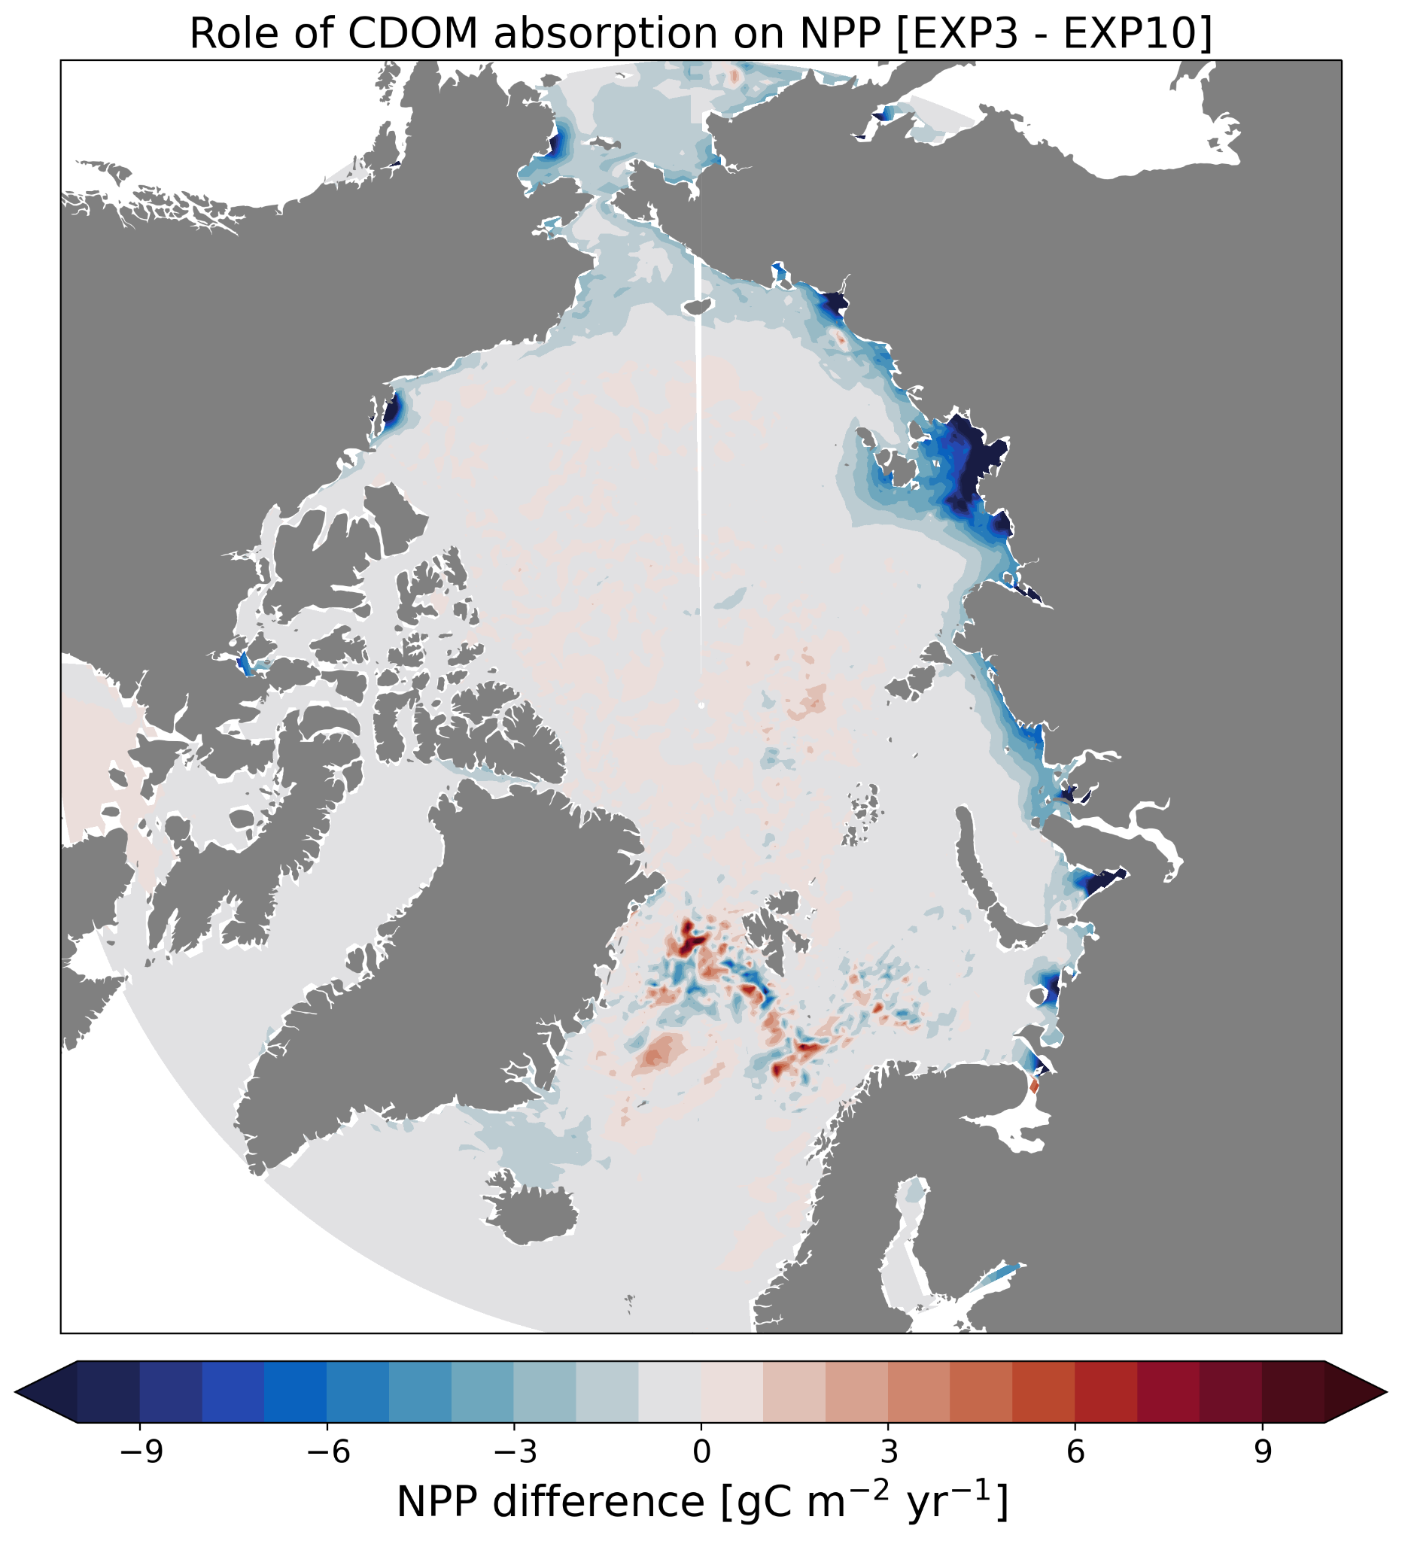
Figure S8: Influence of the CDOM light-absorption parametrization on the annual NPP [gC m⁻² year⁻¹]. The difference in annually integrated NPP is about -8.98 TgC (-1.78%) for the 2010-2014 period.

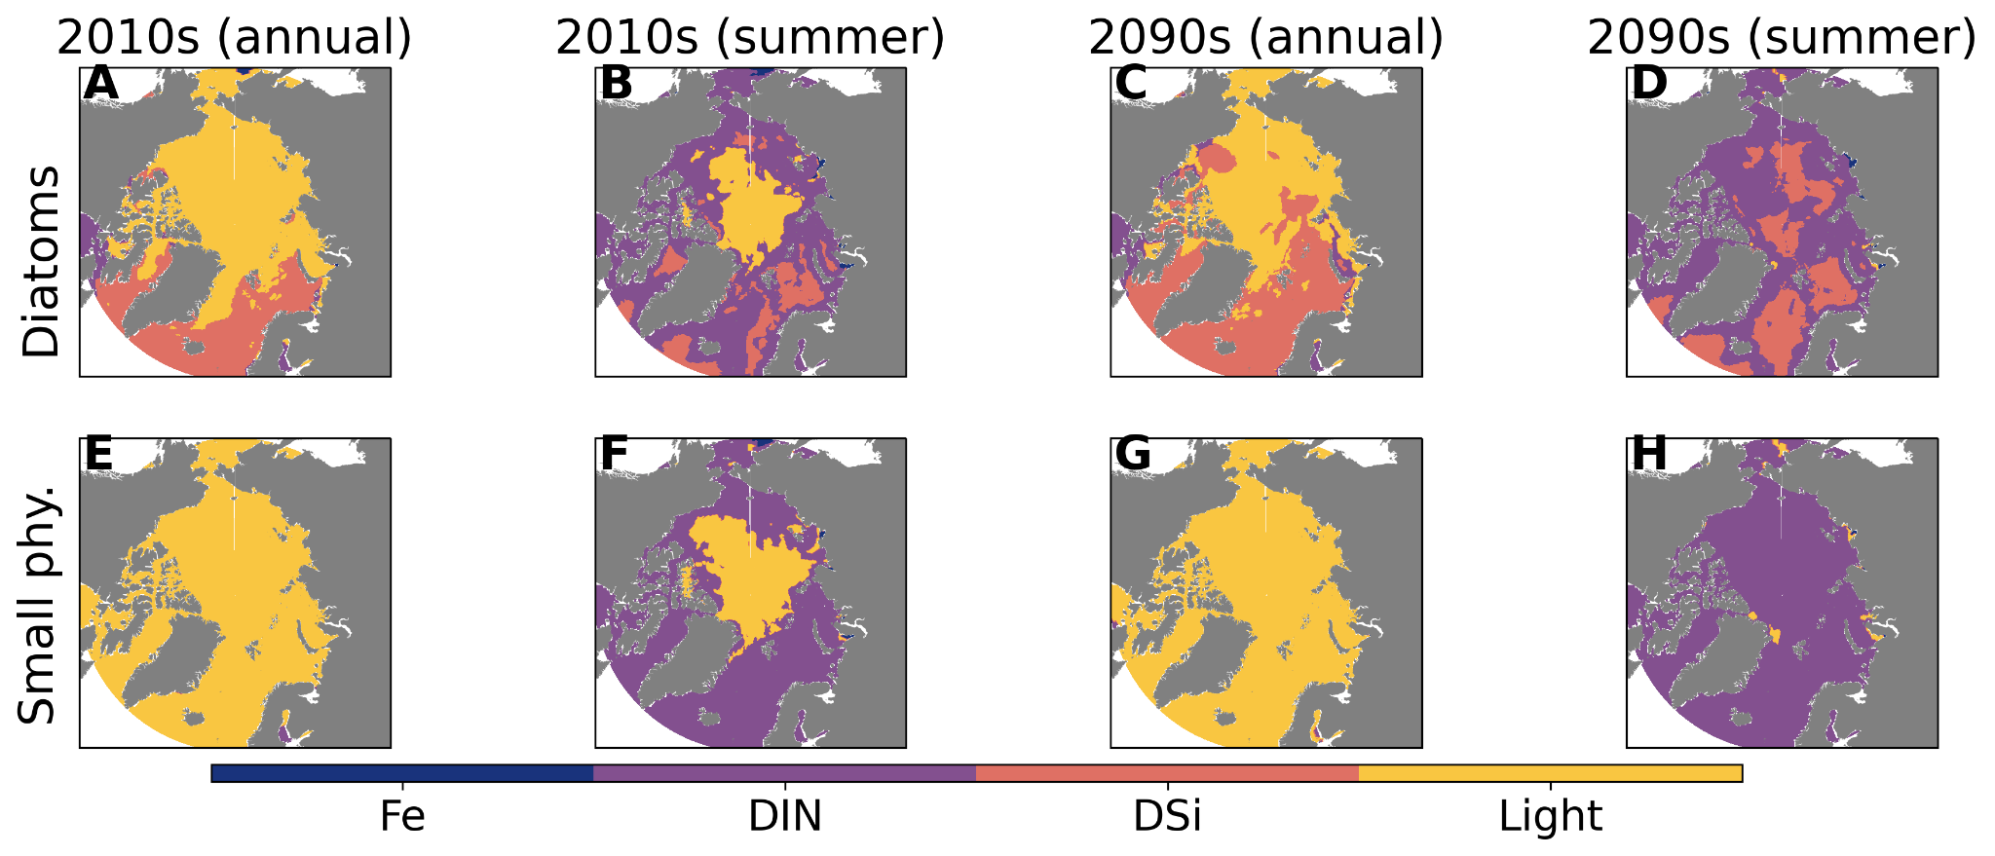
Figure S9: Maps of limiting factors showing the simulated (Terr) spatial distribution of the most limiting factor in the surface waters of the Arctic Ocean for A,B,C,D diatoms and E,F,G,H small phytoplankton. Results are shown for both A,C,E,G annual and B, D, F, H summer (June-July-August) means for the A,B,E,F 2010s and C,D,G,H 2090s periods. Note that Fe is for iron, DIN is for dissolved inorganic nitrogen, and DSi is for silicic acid. By the end of the century, the Arctic Ocean is mainly limited by nitrogen.

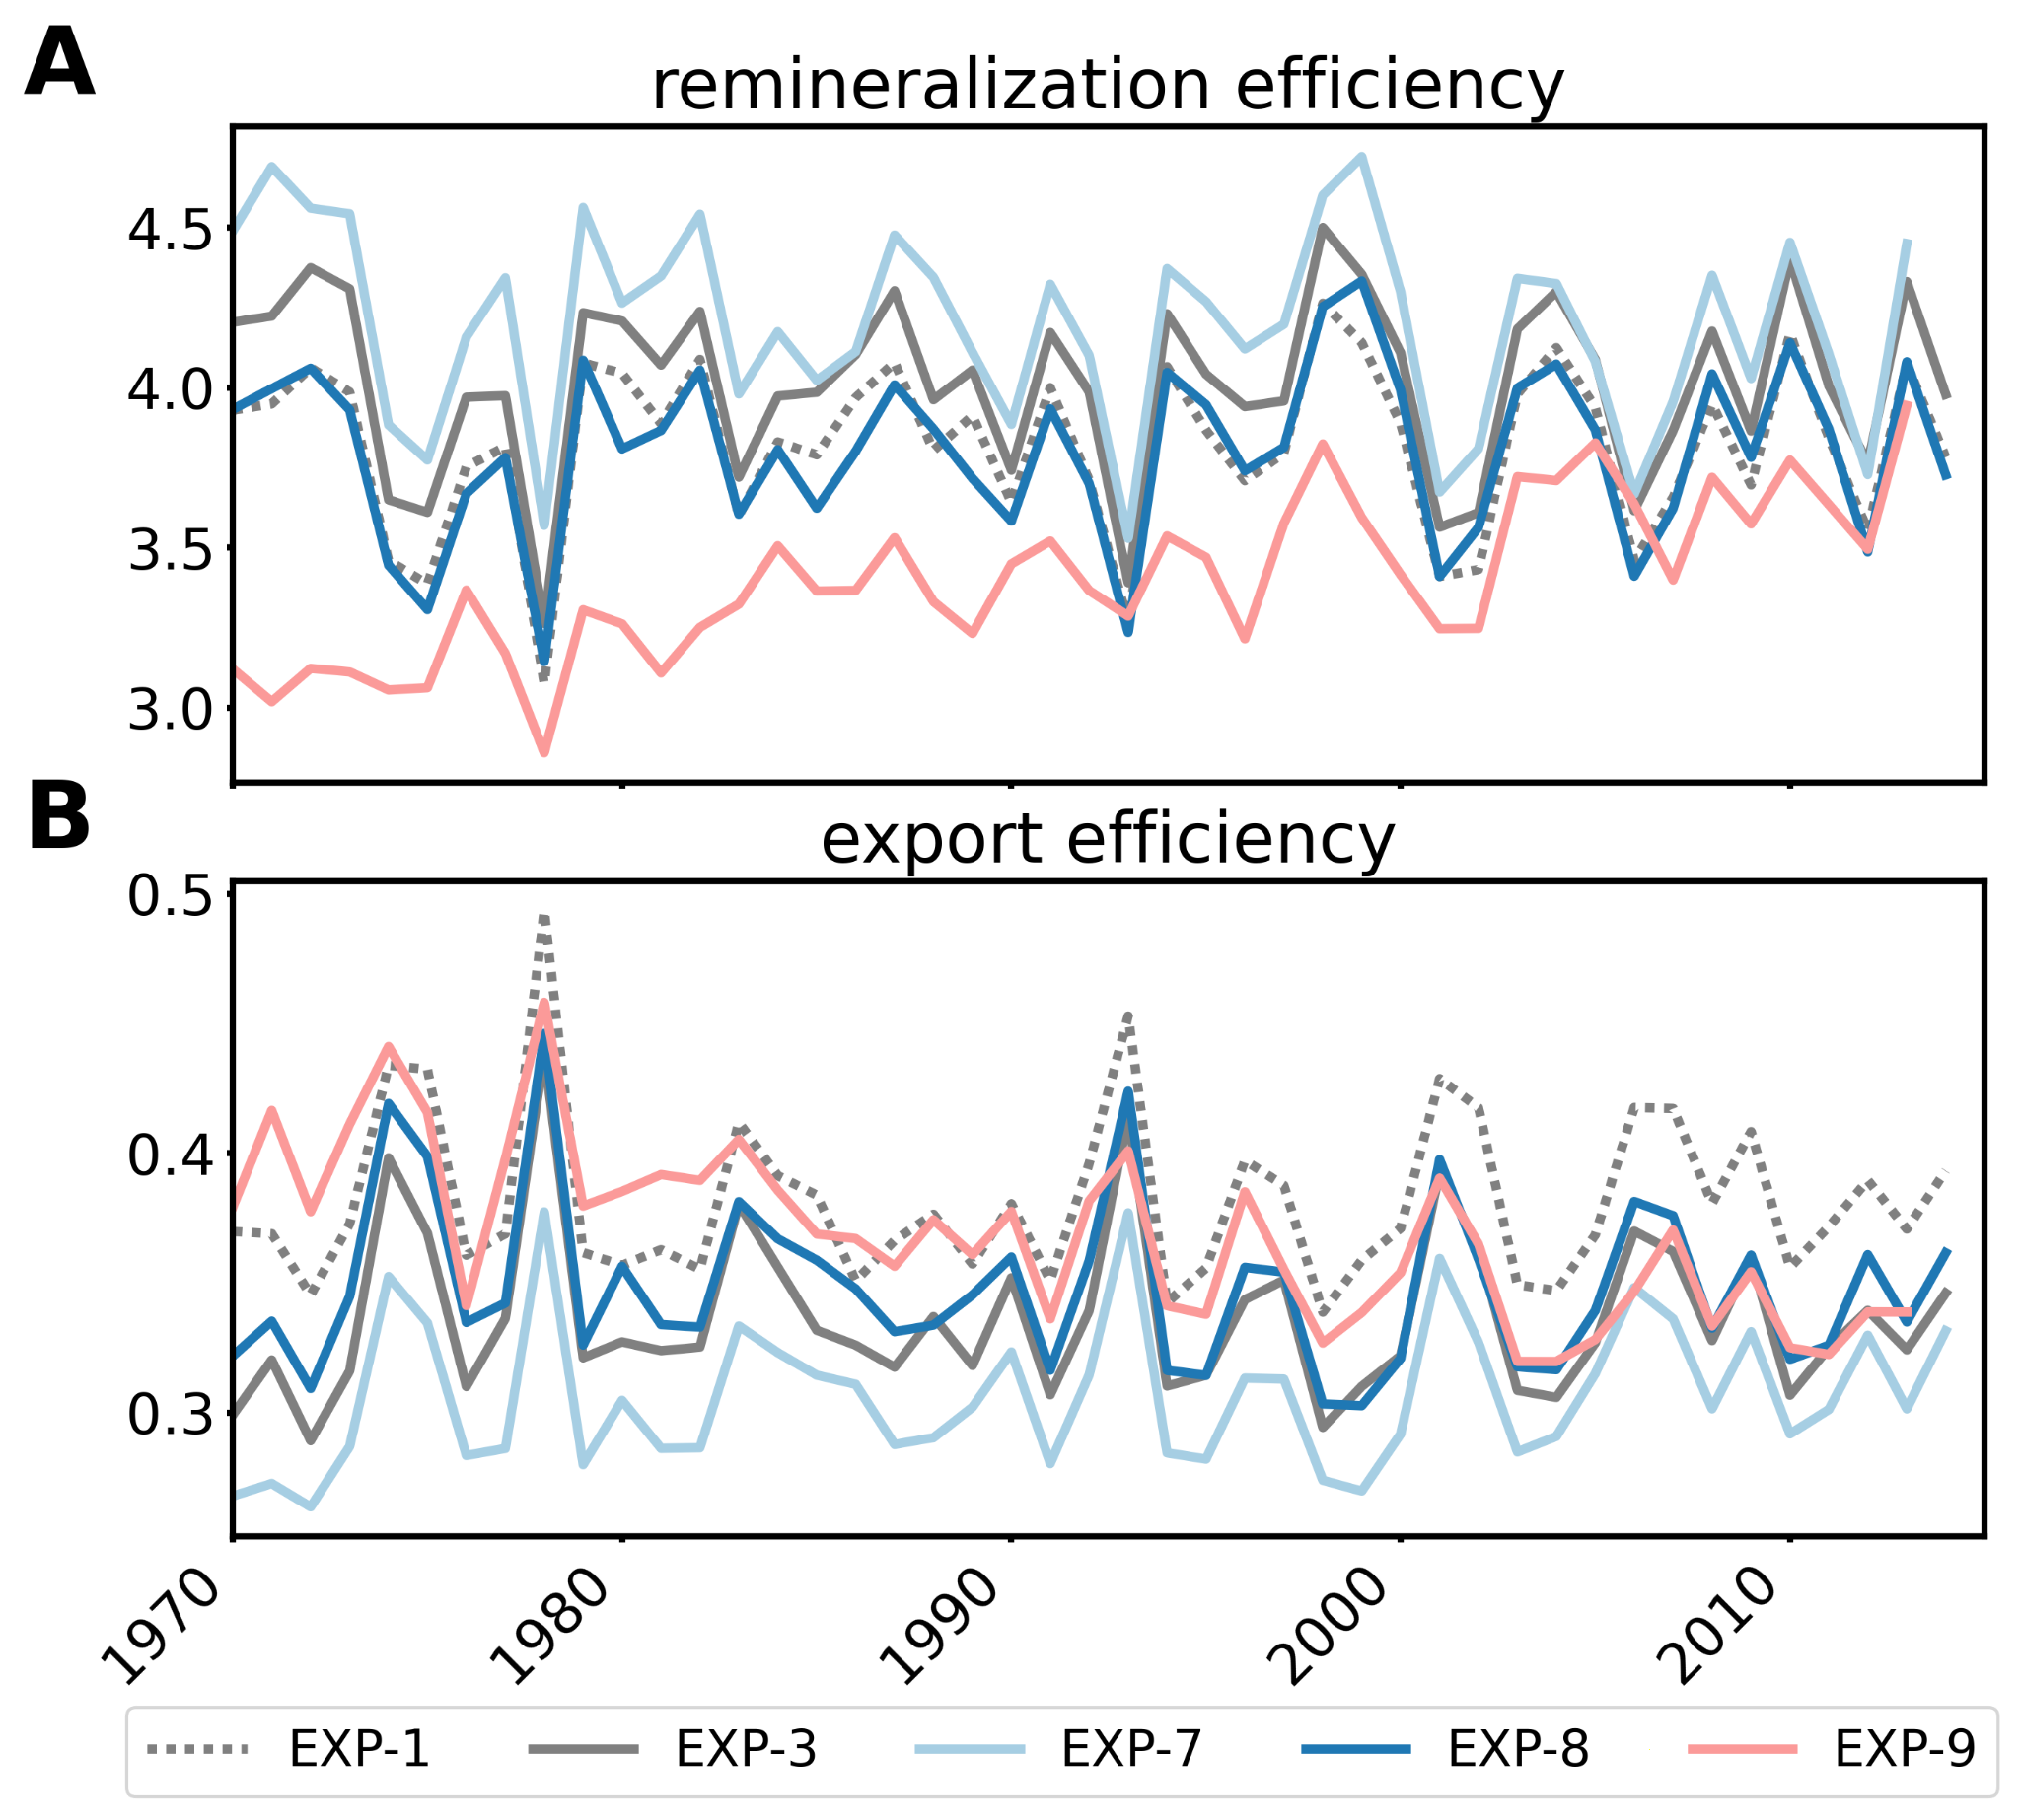
Figure S10: Remineralization and export efficiencies. Time-series of metrics illustrating the evolution of the biogeochemical fluxes in the nitrogen budget over the AO during the historical [1970-2014] periods with A remineralization efficiency (r-ratio = Remineralization / export flux), B export efficiency (e-ratio = export flux / NPP). Similar as Fig. 5 but for test runs EXP-7, 8 and 9.

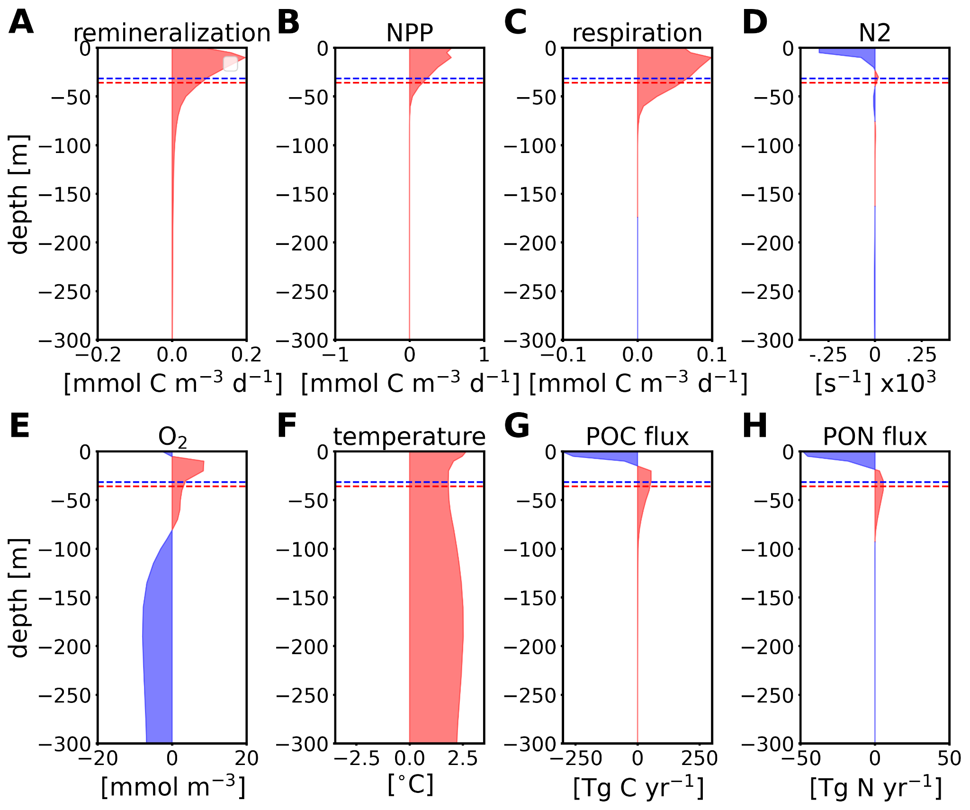
Figure S11: Temporal anomaly profiles (2090s minus 1970s) representing the effect of climate change for the baseline simulation (Terr) for A remineralization rate [mmol C m⁻³ d⁻¹], B net primary production (NPP) [mmol C m⁻³ d⁻¹], C respiration [mmol C m⁻³ d⁻¹], D brunt–Väisälä frequency [s⁻¹], E oxygen concentration (O2) [mmol m⁻³], F temperature [°C], vertical fluxes of particulate detritic organic matter of G carbon and H nitrogen. The mixed layer depth is indicated as a dashed blue (1970) or red (2090) line. The decline of oxygen below 100 m provides evidence that respiration processes, including remineralization, is happening, even at a very low rate, below the mixed layer depth. The subsurface export flux increase is compensated by a surface decrease.

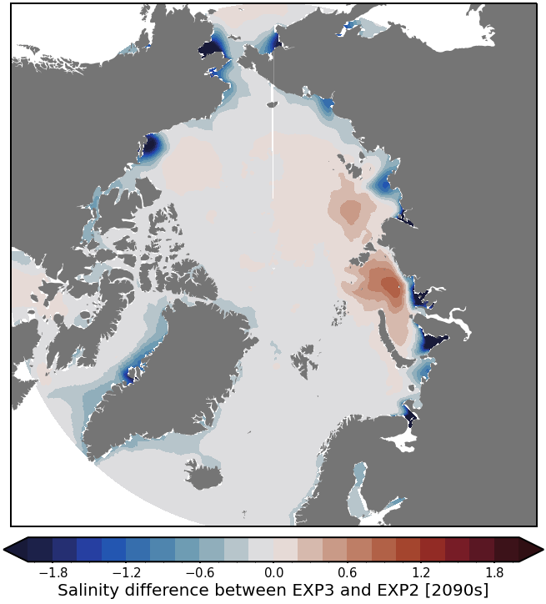

Figure S12: Influence of the monthly varying freshwater runoff compared to a climatology at the end of the century (2090s). EXP3 refers to Terr and EXP2 refers to the same run but with constant freshwater runoff and carbon and nutrient terrigenous input (see Extended Data Table 1). Important salinity biases can be found in coastal areas. The simulation with constant runoff underestimates freshwater fluxes from land, especially by the end of the century with a high emission scenario (SSP3-7.0), leading to a much lower stratification in the coastal areas.
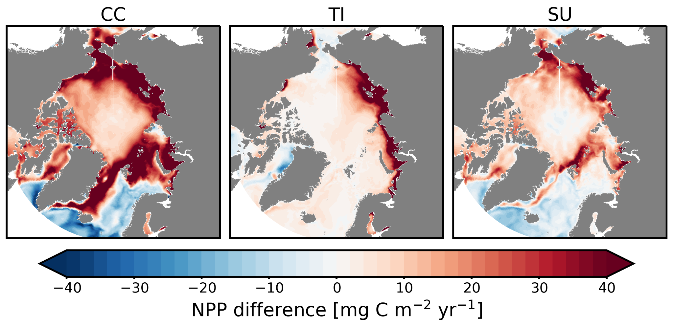
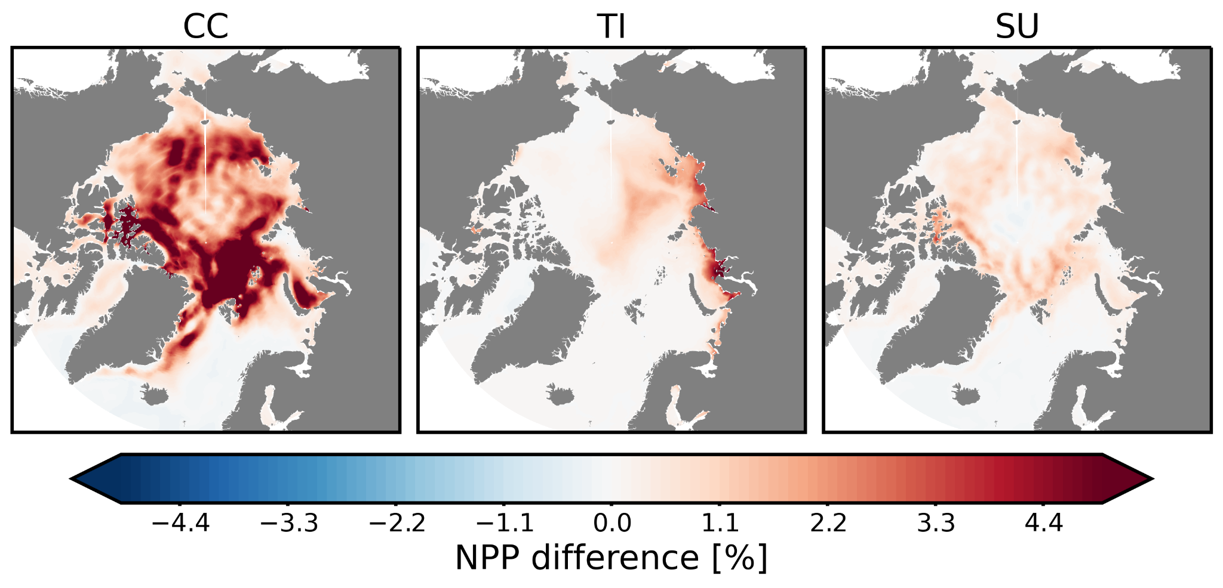
Fig. S13: Maps of NPP differences showing the spatial absolute (top) and relative (bottom) increase in NPP across the AO due to climate change (CC, left), terrigenous inputs (TI, middle) and the avoidable contribution of climate change (SU, right). Spatial changes are consistent with changes in remineralization.

Table S1: Sensitivity tests with constant runoffs and terrigenous input [EXP-2], with coastal erosion inputs directed toward the DOC [EXP-7] and the POC [EXP-8] pools, as well as the baseline simulation (Terr) but with Cram et al. 2018 parametrizations [EXP-9]. Results are shown as absolute [TgC year⁻¹] and relative [%] differences (within brackets) with baseline simulation Terr [EXP-3] for the period 2010-2014. A negative (positive) flux of CO₂ (CO2f) means uptake (outgassing) by the ocean; therefore, a negative anomaly means that there is more uptake than baseline simulation Terr. Re-routing the coastal erosion inputs towards the organic pools does not significantly affect the NPP but can increase the Export Flux (EF) by up to 20 %.
Experiments | NPP | EF | CO2f
EXP-2 | +2.6 TgC (+0.5%) | -0.2 TgC (-0.4%) | +24 TgC (+13%)
EXP-7 | +48 TgC (+9.4%) | + 11 TgC (+20%) | - 9 TgC (-5%)
EXP-8 | +23 TgC (+4.5%) | +5.5 TgC (+10%) | +20 TgC (+11%)
EXP-9 | -23 TgC (-4.5%) | + 22 TgC (+40%) | +96 TgC (+55%)

Table S2: Net Transport through the AO gateways. This table shows the modeled physical transport between the AO and the global ocean used to derive the carbon and the nitrogen budgets. We used the convention so that a positive net transport is directed toward the AO while a negative net transport is exiting the AO. The Arctic gateways are indicated in Extended Fig. 1 and correspond to Barents Sea Opening, Davis Strait, Fram Strait and Bering Strait. Observational budgets for the Arctic Ocean nitrogen budget are from Torres-Valdes et al. (2013 & 2016), inorganic carbon is from MacGilchrist et al. (2014) and organic carbon from Anderson and Amon (2015). The modeled transports are derived with baseline simulation (Terr) for the 2010-2014 period. Observations are majorly based on summer data while the model includes seasonality.
Total Arctic gateways | Modelled | Observations
Volume [+/- SD, Sv] | ﹣ 0.77 ± 2.50 | ﹣ 0.14 ± 0.0
DIN [+/- SD, kmol s⁻¹] | ﹣9.33 ± 17.3 | ﹣1.0 ± 3.2
DON [+/- SD, kmol s⁻¹] | ﹢0.61 ± 1.11 | ﹣4.66 ± 3.08
DIC [+/- SD, kmol s⁻¹] | ﹣1535 ± 1356 | ﹣595 ± 129
DOC [+/- SD, kmol s⁻¹] | ﹢9.52 ± 4.93 | ﹣9 ± 20

