EXTENDED FIGURES
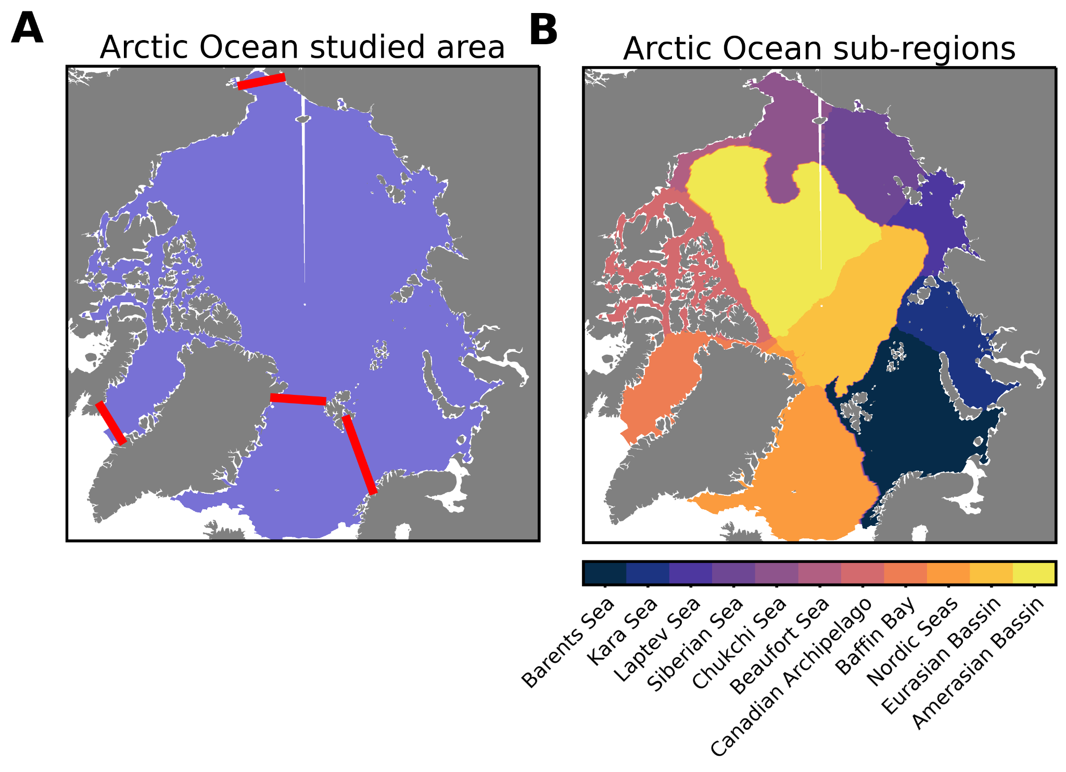
Extended Fig. 1: Studied area of the “AO” represented in A by the colored area. The studied area is subdivided in B 11 regions. Red lines are transects representing the boundary of the Arctic region used for volume and nutrient transport (Extended Data Table 3) in order to be consistent with observations. The regionalization is not used in the main manuscript but serves in the assessment of the modeled versus satellite-derived NPP.

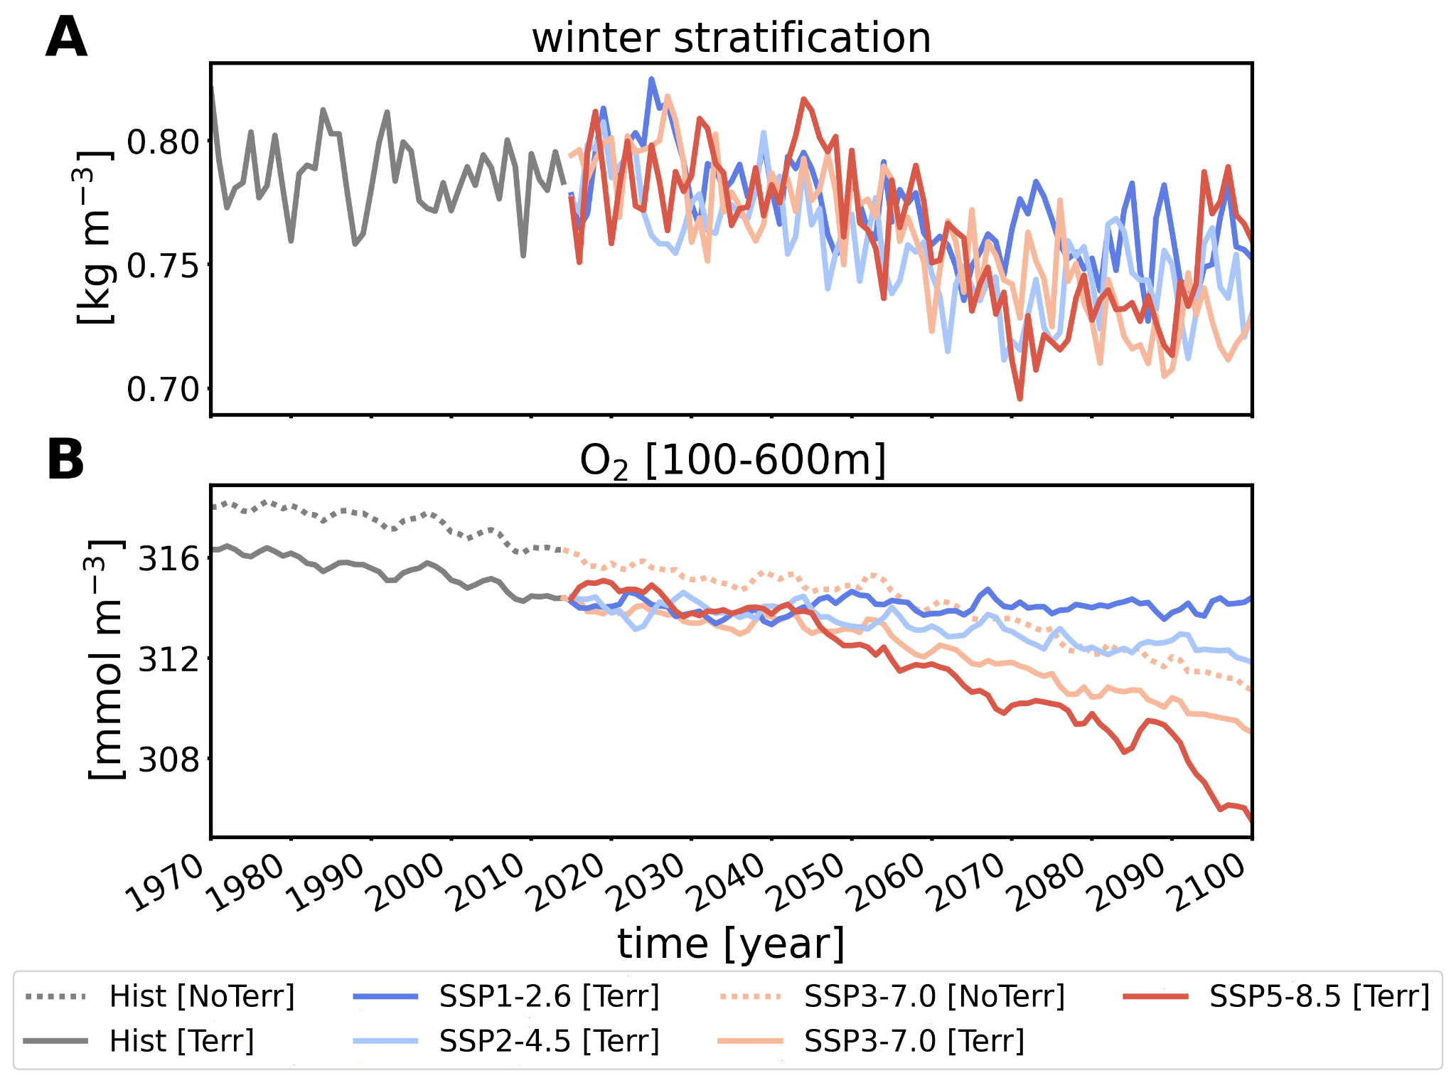
Extended Fig. 2: Characteristics of the ‘New Arctic’. Time-series of A winter Stratification [kg m⁻³] and B upper mesopelagic (100-600 m) oxygen concentration [mmol m⁻³].
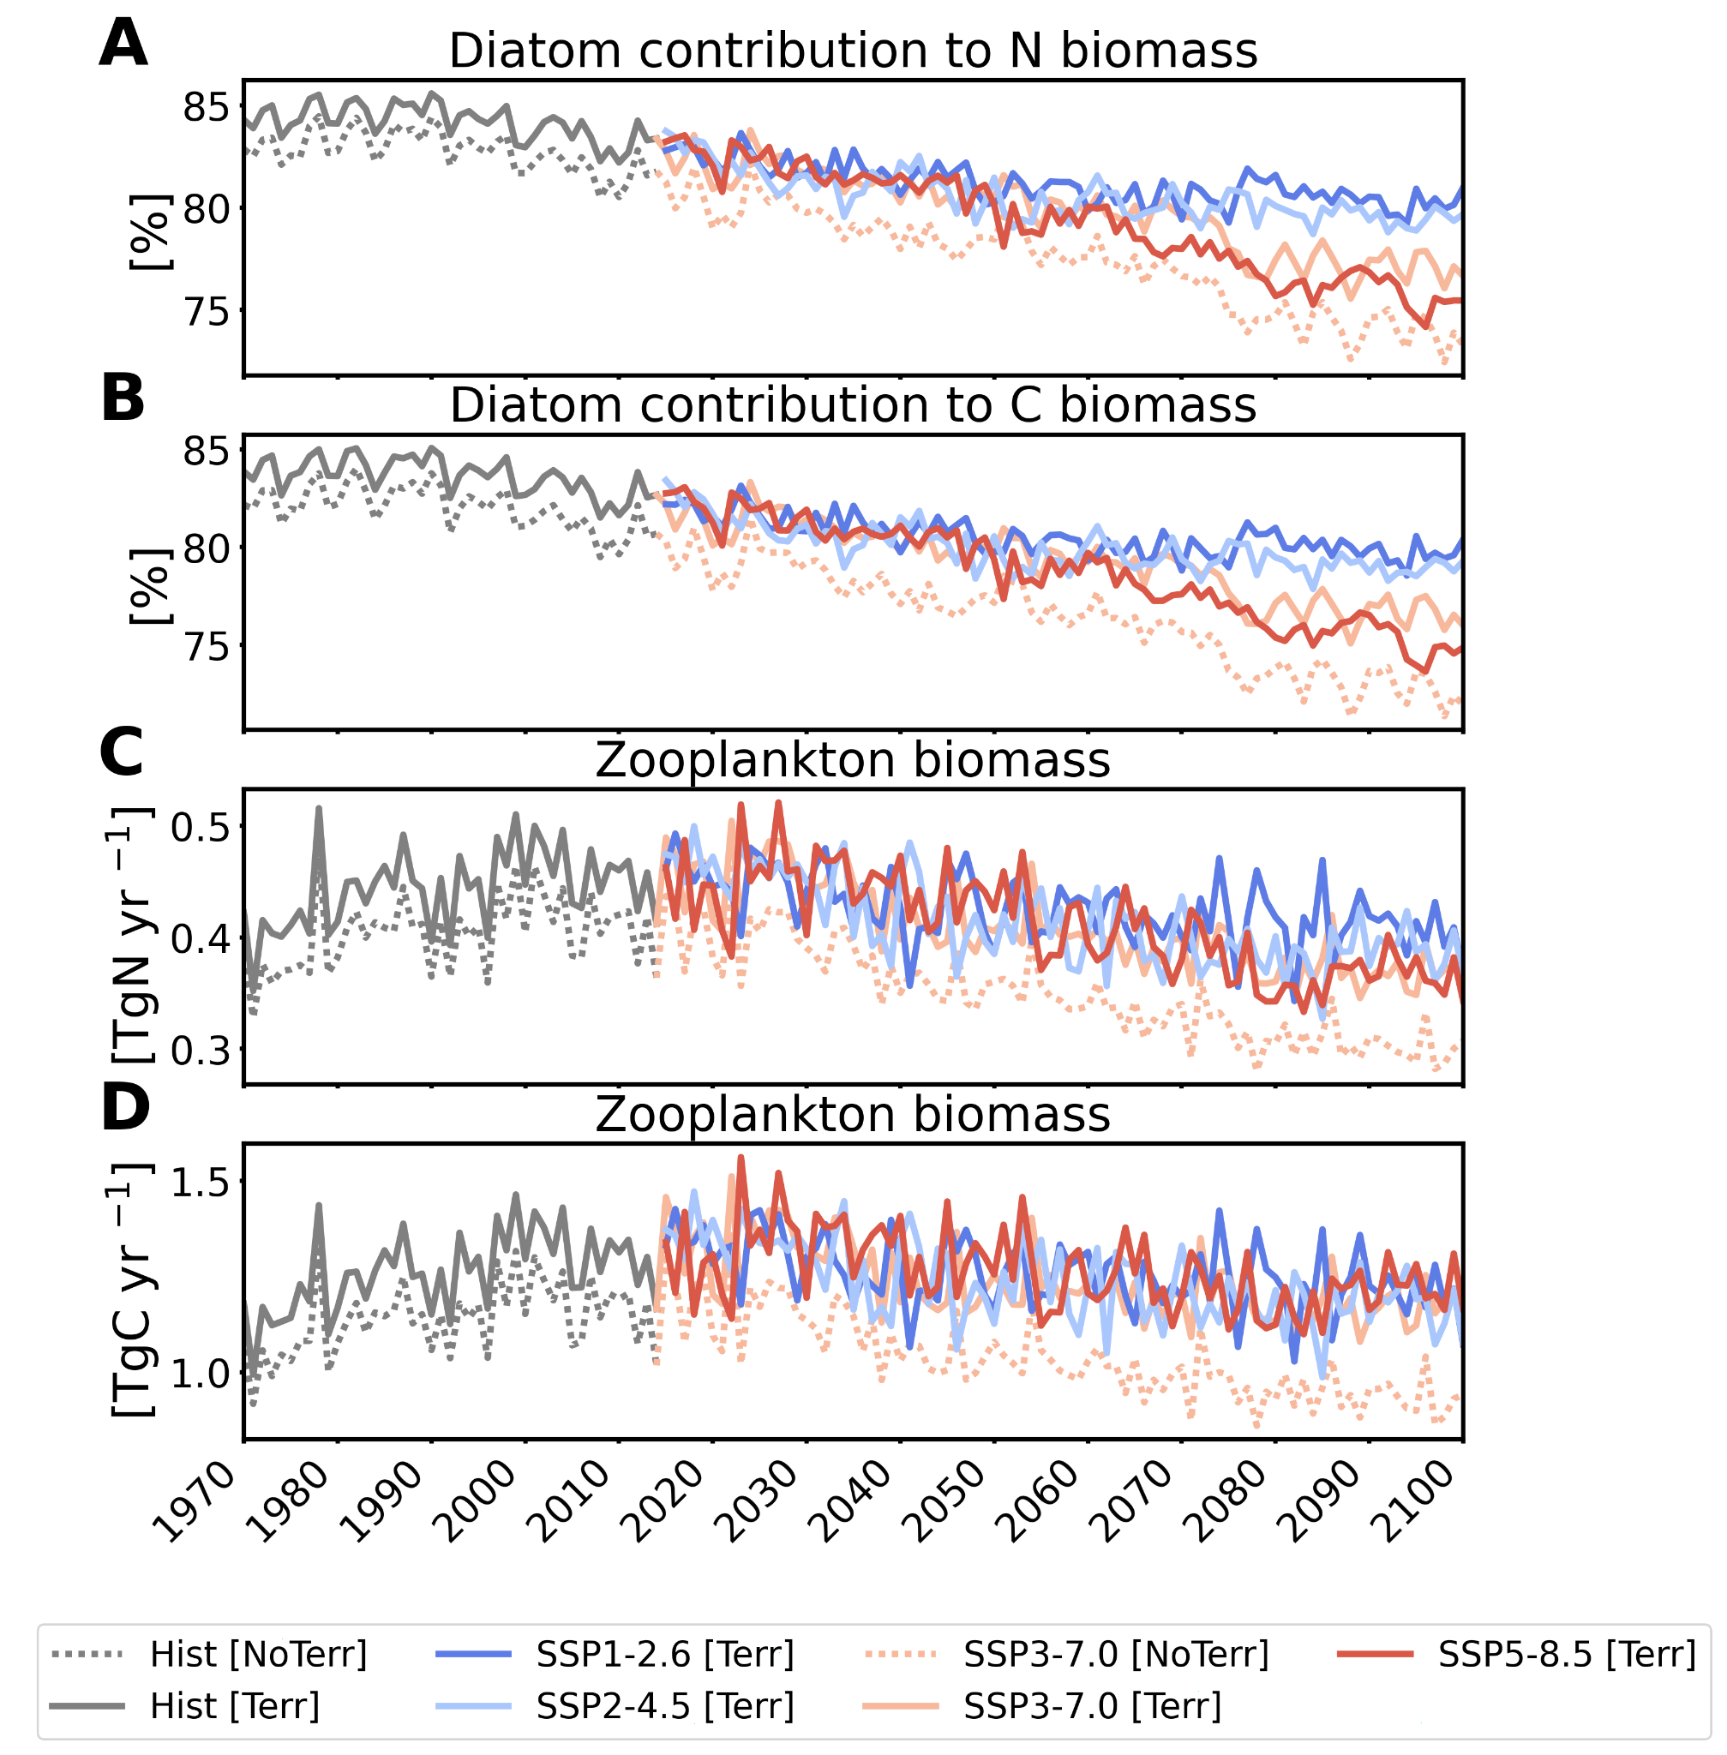Extended Fig. 3: Change in diatom relative contribution to the total phytoplankton A nitrogen and B carbon biomass [%] and zooplankton C nitrogen and D carbon biomass. The relative contribution of diatom to the total phytoplankton C-biomass decreased by 12% with climate change.
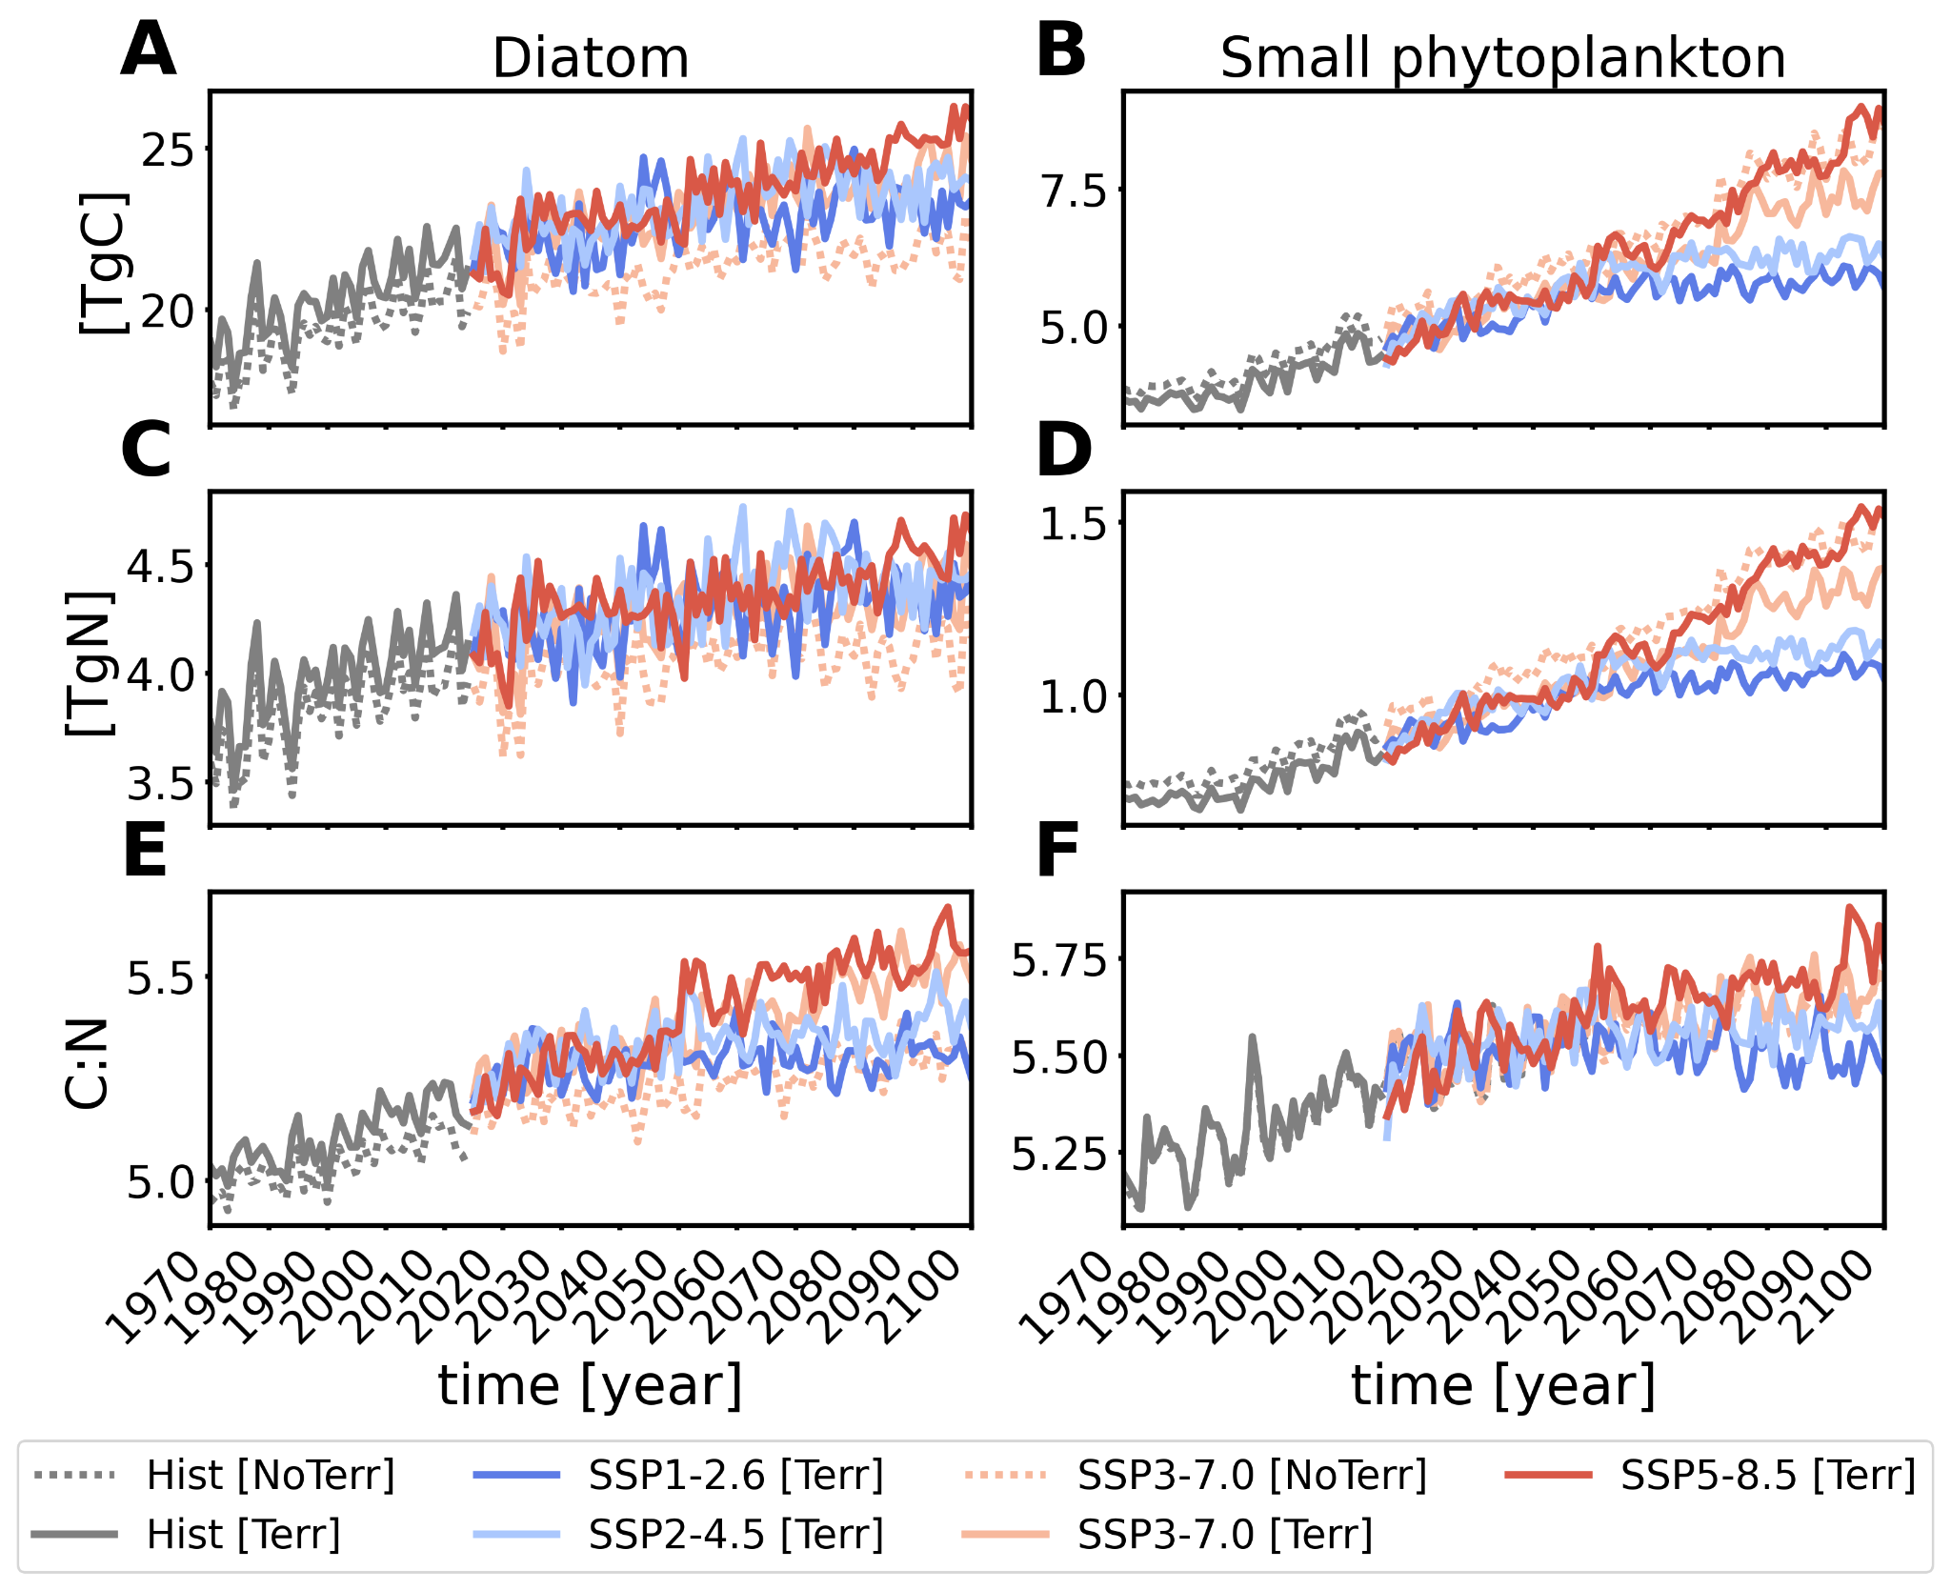
Extended Fig. 4: Time series of phytoplankton biomass and stoichiometry. The two functional types, diatoms on the left panels and small phytoplankton on the right panels, are represented in terms of A, B carbon; C, D nitrogen; E, F elemental C:N ratios. Note the different ‘y’ axis.

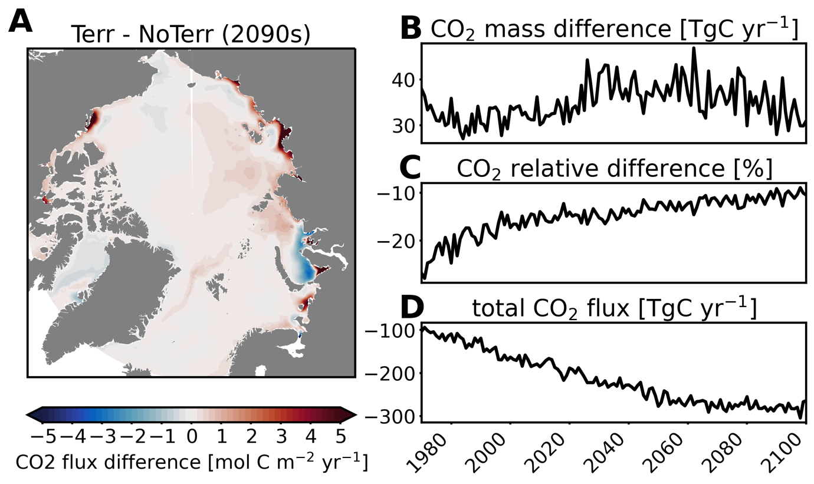
Extended Fig. 5: Spatio-temporal changes in air-sea CO₂ fluxes due to terrigenous inputs. A Map showing the contribution of terrigenous inputs on air-sea CO₂ fluxes [molC m⁻² yr⁻¹]. Positive anomalies (red colors) indicate regions where Terr is showing more outgassing than NoTerr. The associated time series on the right-hand side show the B absolute [TgC yr⁻¹], C relative [%] differences between Terr and NoTerr and D the total AO carbon sink of the baseline Terr simulation.
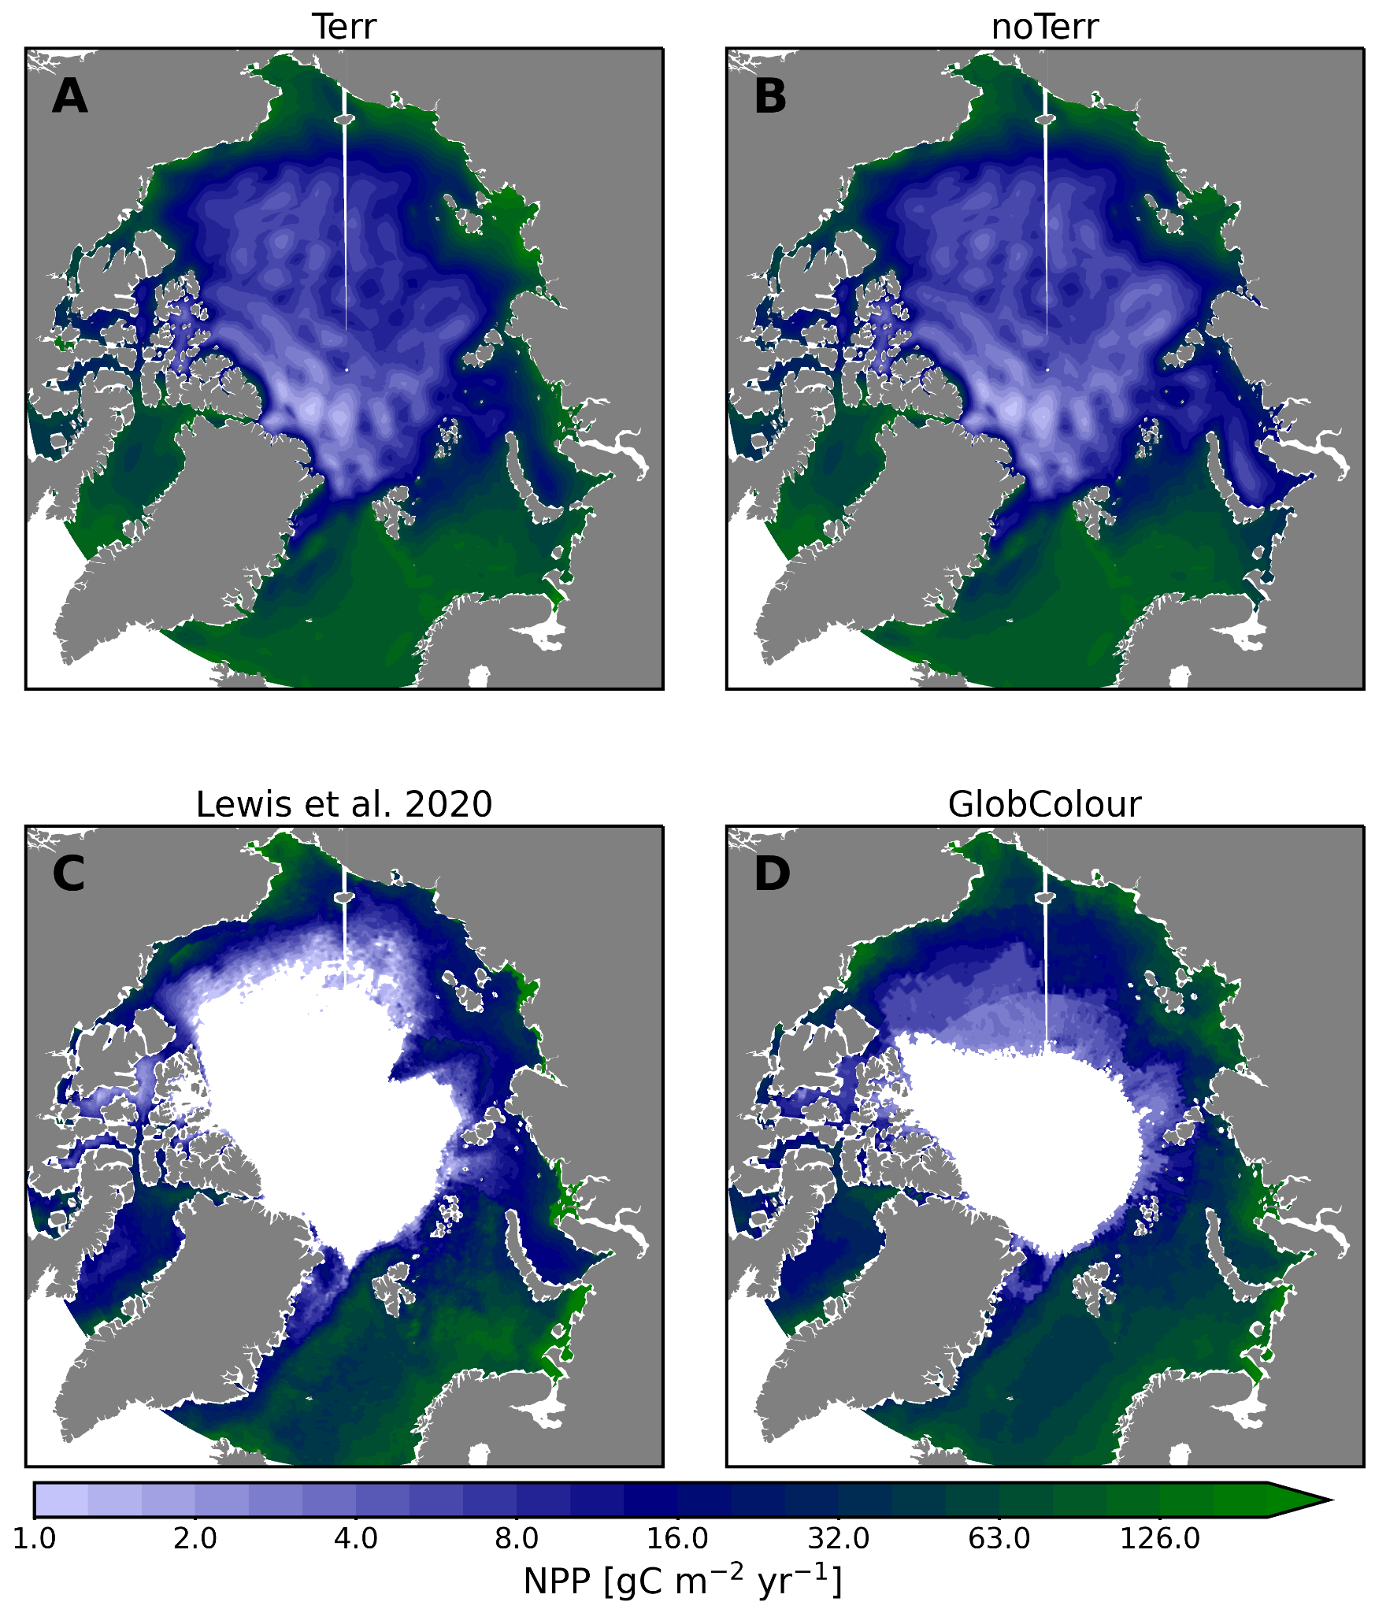
Extended Fig. 6: Maps of climatological (2003-2018) Net Primary Production [gC m⁻² yr⁻¹] with A simulations including terrigenous inputs; B simulations without terrigenous inputs, as well as C Satellite derived from Lewis et al. 2020 and D Satellite derived from Globcolour (Product ID: OCEANCOLOUR_GLO_BGC_L4_MY_009_104). The 2003-2018 period was chosen to fit the ocean color MODIS sensor. Note that the modeled NPP is depth integrated whereas satellite data is limited to the surface layer. White areas are either data outside the study domain (below 66°N) or areas where no data are obtained from satellites due to the presence of sea ice.
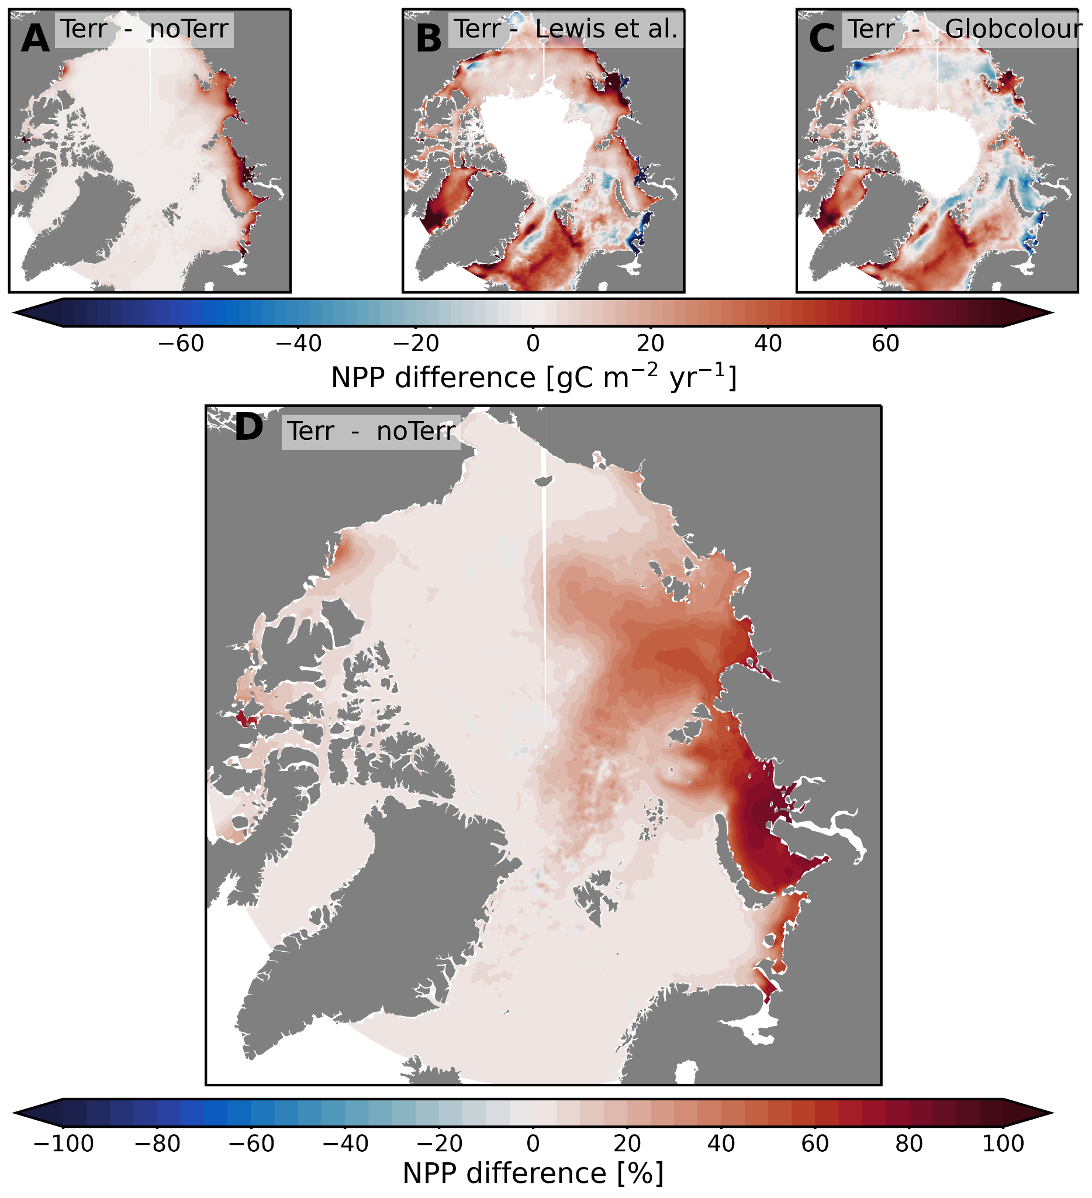
Extended Fig. 7: Maps of climatological (2003-2018) Net Primary Production differences between A modeled NPP with terrigenous inputs and without terrigenous inputs [gC m⁻² yr⁻¹]; B modeled NPP with terrigenous inputs and satellite derived NPP from Lewis et al. 2020 [gC m⁻² yr⁻¹]; C modeled NPP with terrigenous inputs and satellite derived NPP from GlobColour [gC m⁻² year⁻¹]; and D modeled NPP with terrigenous inputs and without terrigenous inputs [%]. The 2003-2018 period was chosen to fit the ocean color MODIS sensor. Note that the modeled NPP is depth integrated whereas satellite data is limited to the surface layer.

Extended Table 1: Full exhaustive experimental set-up with all simulations for sensitivity tests. The model was spun up for 50 years including four cycles of the 1950s decade, and one of the 1960s decade. Analysis started in 1970.
Simulations | forcing | Terrigenous inputs | Coastal erosion pools | freshwater runoff | year span
EXP-1 (NoTerr) | historical + SSP3-7.0 | No | DIN, DIC | constant | 1970-2100
EXP-2 | historical + SSP3-7.0 | constant | DIN, DIC | constant | 1970-2100
EXP-3  (Terr) | historical + SSP3-7.0 | varying | DIN, DIC | varying | 1970-2100
EXP-4 | historical + SSP5-8.5 | varying | DIN, DIC | varying | 2015-2100
EXP-5 | historical + SSP1-2.6 | varying | DIN, DIC | varying | 2015-2100
EXP-6 | historical + SSP2-4.5 | varying | DIN, DIC | varying | 2015-2100
EXP-7 | historical + SSP3-7.0 | varying | DON, DOC | varying | 1970-2014
EXP-8 | historical + SSP3-7.0 | varying | PON, POC | varying | 1970-2014
EXP-9 | historical (Cram et al. 2018) | varying | DIN, DIC | varying | 1970-2014
EXP-10 | historical (no CDOM absorption) | varying | DIN, DIC | varying | 2010-2014

Extended Table 2: Quantification of the absolute contribution of climate change, terrigenous inputs and scenario uncertainty on some biogeochemical processes expressed in Tg N yr⁻¹. Phytoplankton losses encompass excretion and aggregation. Zooplankton losses encompass mortality, excretion, sloppy feeding, and fecal loss.
Processes | climate change | Terrigenous inputs | Scenario Uncertainty | Baseline (Terr)
Phytoplankton assimilation | 9.3 | 7.9 | 4.7 | 31.7
Phytoplankton aggregation | 2.1 | 4.0 | 2.7 | 16.3
Phytoplankton Excretion | 9.2 | 3.0 | 4.15 | 28.8
Zooplankton Grazing | 1.1 | 1.9 | 1.9 | 9.4
Zooplankton losses | 1.26 | 2.0 | 1.9 | 9.6
Water Remineralization | 13.2 | 6.5 | 4.5 | 43.2
Dissolution | 1.4 | 1.2 | 0.52 | 9.4
Benthic Remineralization | 6.6 | 5.5 | 3.6 | 18.1
export flux | -0.04 | 0.5 | -0.4 | 7.7
Sedimentation | 2.9 | 1.5 | 1.5 | 6.7
Benthic dénitrification | 0.06 | 0.26 | 0.13 | 0.82

Extended Table 3: Simulated and remote-sensing-based annual primary production [Tg C year⁻¹] during the MODIS 2003–2018 period over the AO and per region.
 | Model [NoTerr] | Model [Terr] | Satellite [Lewis et al. 2020] | Satellite [Globcolour]
Barents | 104.0 | 112.9 | 104.0 | 96.0
Kara | 13.2 | 36.0 | 29.5 | 37.5
Laptev | 23.4 | 39.4 | 20.7 | 29.3
Siberian | 33.4 | 39.6 | 12.3 | 34.0
Chukchi | 34.9 | 35.2 | 29.3 | 29.7
Beaufort | 8.16 | 9.40 | 3.96 | 9.14
CAA | 30.1 | 33.0 | 9.83 | 12.9
Baffin | 52.1 | 48.4 | 17.1 | 23.3
Greenland | 128.3 | 131.8 | 73.6 | 81.2
EB | 7.35 | 10.1 | 3.84 | 4.53
AB | 18.1 | 19.6 | 5.54 | 11.5
Arctic | 453.2 | 515.4 | 309.7 | 369

