aSupporting Information

Mechanically Enhanced 3D Printable Photocurable Resin Composed of Epoxy Waste Cooking Oil and Triethylene Glycol Dimethacrylate
Meng-Yu Liu, Gui-Mei Li, Peng-Yu Wang, Wan-Ying Ying, Yang Yang, Chuan-Yang Tang, Ying-Ying Li and Shuo-Ping Chen*

College of Materials Science and Engineering, Guilin University of Technology, Guilin 541004, China
- Liu, 2120210291@glut.edu.cn, G. Li, 3243907527@qq.com, P. Wang, 2120220368@glut.edu.cn, W. Ying, 2120210327@glut.edu.cn, Y. Yang, 839840447@qq.com, C. Tang, 2281220100@qq.com, Y. Li, 461191750@qq.com
*Corresponding author: Shuo-Ping Chen. E-mail address: 2012014@glut.edu.cn.
Phone: +86-773-5896672. Fax: +86-773-5896671. https://orcid.org/0000-0001-5160-9869.

List
S1. Synthesis of E-WCO
S2. Characterization
Table S1. Fatty acid compositions (wt.%) of WCO. Three main types of fatty acids: saturated (C n:0), monounsaturated (C n:1), and polyunsaturated with two or three double bonds (C n:2/3).
Table S2. The Lovibond color codes of WCO and E-WCO.
Figure S1. Photograph of E-WCO (left) and WCO (right) showing the difference in their colors.
Figure S2. The aldehyde content of WCO and E-WCO.
Figure S3. DTG curves of E-WCO/TEGDMA resins and other control samples.
Figure S4. DSC curves of E-WCO/TEGDMA resins and other control samples: (a) A1; (b) A2; (c) A3; (d) A4; (e) pure TEGDMA; (f) ESO/TEGDMA resin.
Figure S5. Storage modulus curves of E-WCO/TEGDMA resins and other control samples.
Figure S6. Stress-strain curves of E-WCO/TEGDMA resins and other control samples.

S1. Synthesis of E-WCO
The epoxy waste cooking oil (E-WCO) could be produced following the epoxidation method in our previously reported.^{[49]} Initially, we carried out the epoxidation of WCO to produce E-WCO. To accomplish this, we prepared a mixture consisting of 1240 g of 30% H₂O₂, 320 g of glacial acetic acid, 8 g of sulfuric acid, and 8 g of urea in a lightproof container. This mixture was then placed in an oven at 40 ℃ for 12 hours to generate peracetic acid, which served as the epoxidation reagent. Subsequently, 1000 g of WCO was introduced into a glass-stirred reactor and heated to 40 ℃. The prepared epoxidation reagent was gradually added to the reactor over a 2-hour period. The reaction mixture was then heated to 70 ℃ and stirred for 3 hours. Upon completion of the reaction, the mixture was allowed to stand for 12 hours to allow for stratification. The upper oil layer was collected, subjected to a single wash with a 5% NaHCO₃ solution, followed by two washes with deionized water at 60 ℃. Finally, it underwent vacuum evaporation at 70 ℃, resulting in E-WCO with an epoxy value of 4.37. Following the epoxylation reaction, a significant improvement in color was observed in the resulting product, transitioning from a dark brown hue (Lovibond color scale: Y = 50.5 and R = 20) to a yellow shade (Y = 10 and R = 1) (Refer to Figure S1 and Table S2 in the ESI). Furthermore, the epoxylation process effectively eliminated over 70% of aldehyde compounds from the oil product, thus removing the unpleasant odor commonly associated with WCO (Refer to Figure S2 in the ESI).

S2. Characterization
The characterization of the resulting WCO-based photocurable resins and other related samples was carried out in accordance with the methods detailed in our prior publication.^{[49]} The iodine value of WCO was determined using the China Standard GB/T 5532-2008. The epoxy value of E-WCO was examined following China Standard GB/T 1677-2008. The Lovibond color of WCO and E-WCO was analyzed by a LABO-HUB WSL-2 Lovibond tintometer (Xinrui, Shanghai, China). The aldehyde contents of WCO and E-WCO were determined according to GB/T 14571.3-2008. The infrared (IR) spectrum of the resulting products was recorded as KBr pellets in the range of 400–4000 cm⁻¹ on a Nicolet 5700 FT-IR spectrometer (Thermofisher, Waltham, USA) with a spectral resolution of 4 cm⁻¹. The migration test of E-WCO as plasticizer was conducted through the following procedure: the E-WCO/TEGDMA composites, containing varying concentrations of E-WCO, were subjected to an isothermal temperature of 135 °C within an oven, and their weights were recorded at specified intervals. The migration rate of the plasticizer, described in terms of plasticizer weight loss (w_{s}, %), is quantitatively determined by employing Equation (1):
$w_{s}=\frac{m_{0}−m_{t}}{m_{0}}×100\%$ (1)
where m₀ represents the initial weight before migration, and m_{t} corresponds to the weight after migration at distinct time intervals.
The thermogravimetric analysis was carried out with a TG 209 F1 Libra thermal gravimetric analyzer (Netzsch, Selb, Germany) at a heating rate of 10 °C/min in the range of 30−650 °C under a nitrogen gas atmosphere. The tests of differential scanning calorimetry (DSC) were performed on a DSC 204/2920 differential scanning calorimeter (TA Instruments, New Castle, USA) equipped with a refrigerated cooling system. After equilibrating the samples at −60 °C for 5 min, the first heating trace started from −60 to 100 °C at 10 °C/min. The samples were equilibrated at 100 °C for 1 minute and cooled down at 3 °C/min. When the temperature reached −60 °C, the samples were equilibrated for 1 min and heated again to 100 °C at 10 °C/min. The first cooling and second heating traces were recorded to test the glass transition temperature (T_{g}) of resin. Dynamic thermomechanical analysis (DMA) was performed using a DMA861e dynamic thermomechanical analyzer (Mettler Toledo, Zurich, Switzerland) operating in the stretch mode under an air atmosphere, spanning the temperature range of 25 to 150 ◦C. The heating rate employed was 3 ℃/min, with a frequency of 1 Hz. Test samples were 3D printed in the form of rectangular strips (size: 25 mm × 5 mm × 0.6 mm).
The mechanical properties were examined by an AG-20Ⅰ electronic universal testing machine (Shimadzu, Tokyo, Japan) with a 5 mm/min stretching rate. The test sample was printed as 1BA dumbbell-shaped splines according to the China Standard GB/T 1040.2-2006 using a Photon X LCD 3D printer (Anycubic, Shenzhen, China). Impact strength was measured by a DR-802b cantilever beam impact testing machine (Sansi, Shenzhen, China) with an impact energy of 1J. The scanning electron microscope (SEM) images were obtained by using an S-4800 field emission scanning electron microscope (Hitachi, Chiyoda, Tokyo, Japan) with an accelerating voltage of 20 kV.

Table S1. Fatty acid compositions (wt.%) of WCO. Three main types of fatty acids: saturated (C n:0), monounsaturated (C n:1), and polyunsaturated with two or three double bonds (C n:2/3).
Fatty acid |  | The WCO used in this work
Caprylic | C 8:0 | 0.2
Lauric | C 12:0 | 0.1
Myristic | C 14:0 | 0.2
Palmitic | C 16:0 | 19.7
Palmitoleic | C 16:1 | 0.5
Stearic | C 18:0 | 6.8
Oleic | C 18:1 | 69.6
Linoleic | C 18:2 | 3.0
Linolenic | C 18:3 | 0.3
Arachidic | C 20:0 | 0.5
Gadoleic | C 20:1 | 0.1

Table S2. The Lovibond color codes of WCO and E-WCO.

Sample | Y (Yellow) | R (Red) | B (Blue) | Light field | Darkfield
WCO | 50.5 | 20 | 9 | 0 | 0
E-WCO | 10 | 1 | 0 | 0 | 0

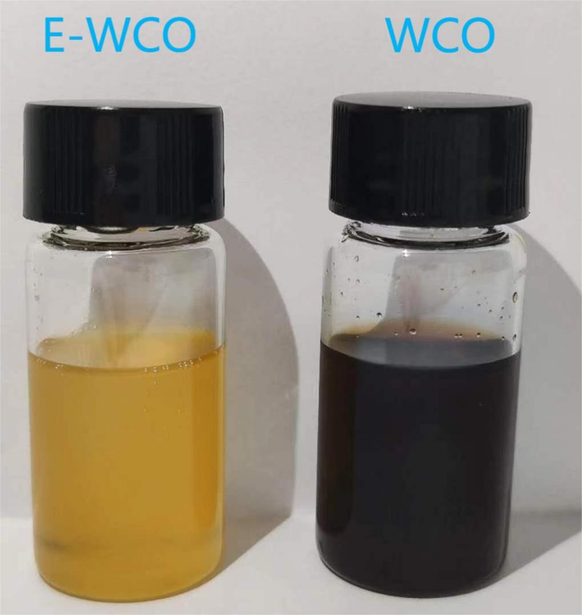
Figure S1. Photograph of E-WCO (left) and WCO (right) showing the difference in their colors.

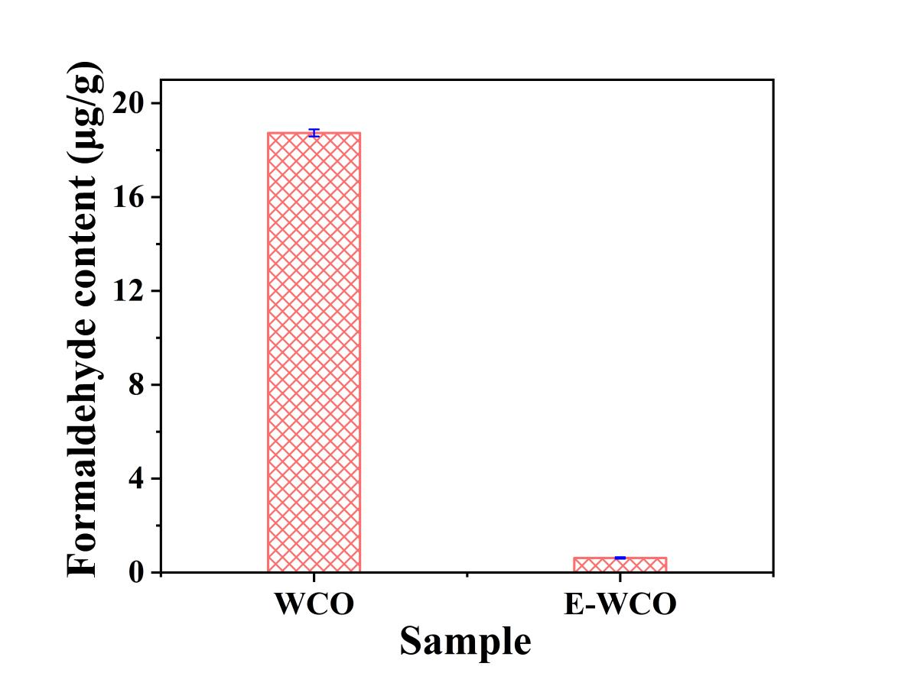
Figure S2. The aldehyde content of WCO and E-WCO.

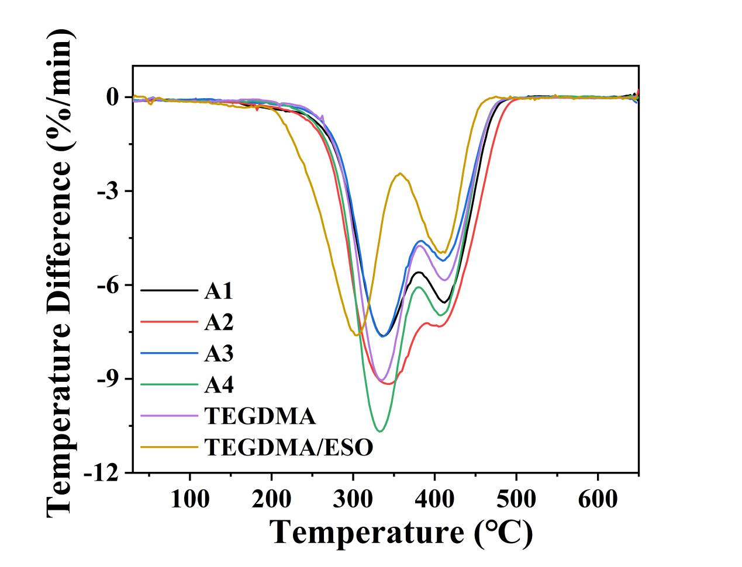
Figure S3. DTG curves of E-WCO/TEGDMA resins and other control samples.

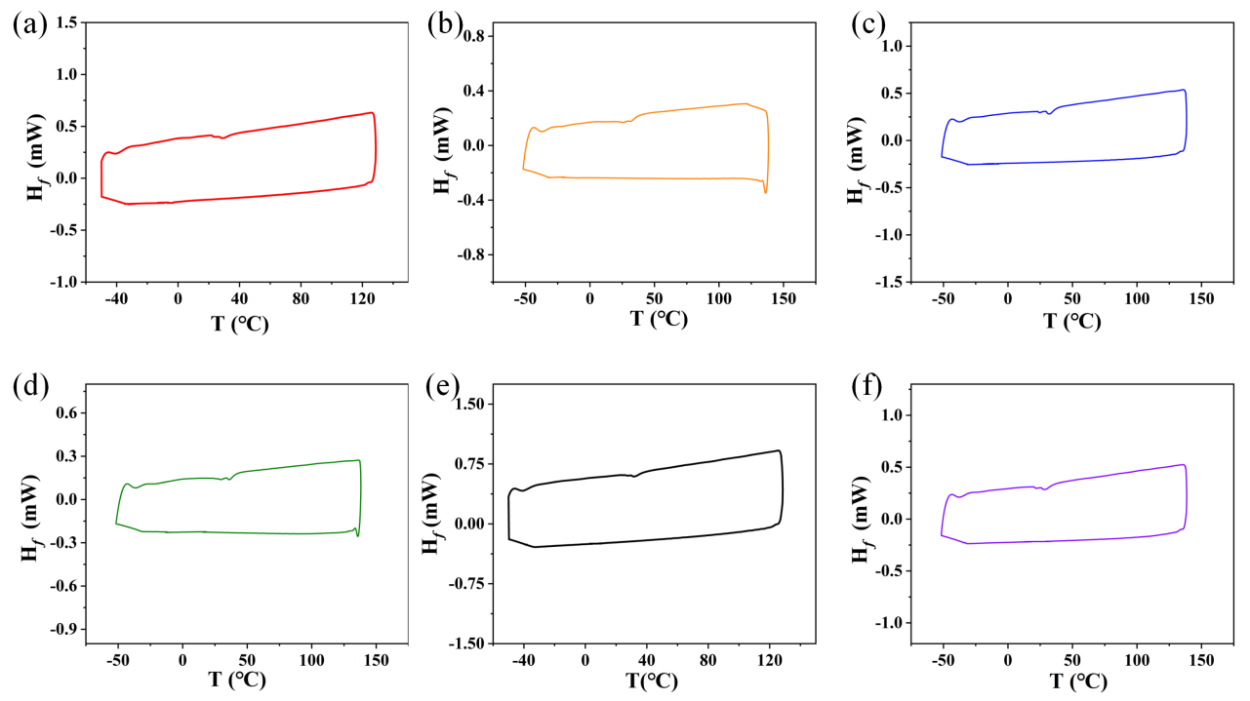
Figure S4. DSC curves of E-WCO/TEGDMA resins and other control samples: (a) A1; (b) A2; (c) A3; (d) A4; (e) pure TEGDMA; (f) ESO/TEGDMA resin.

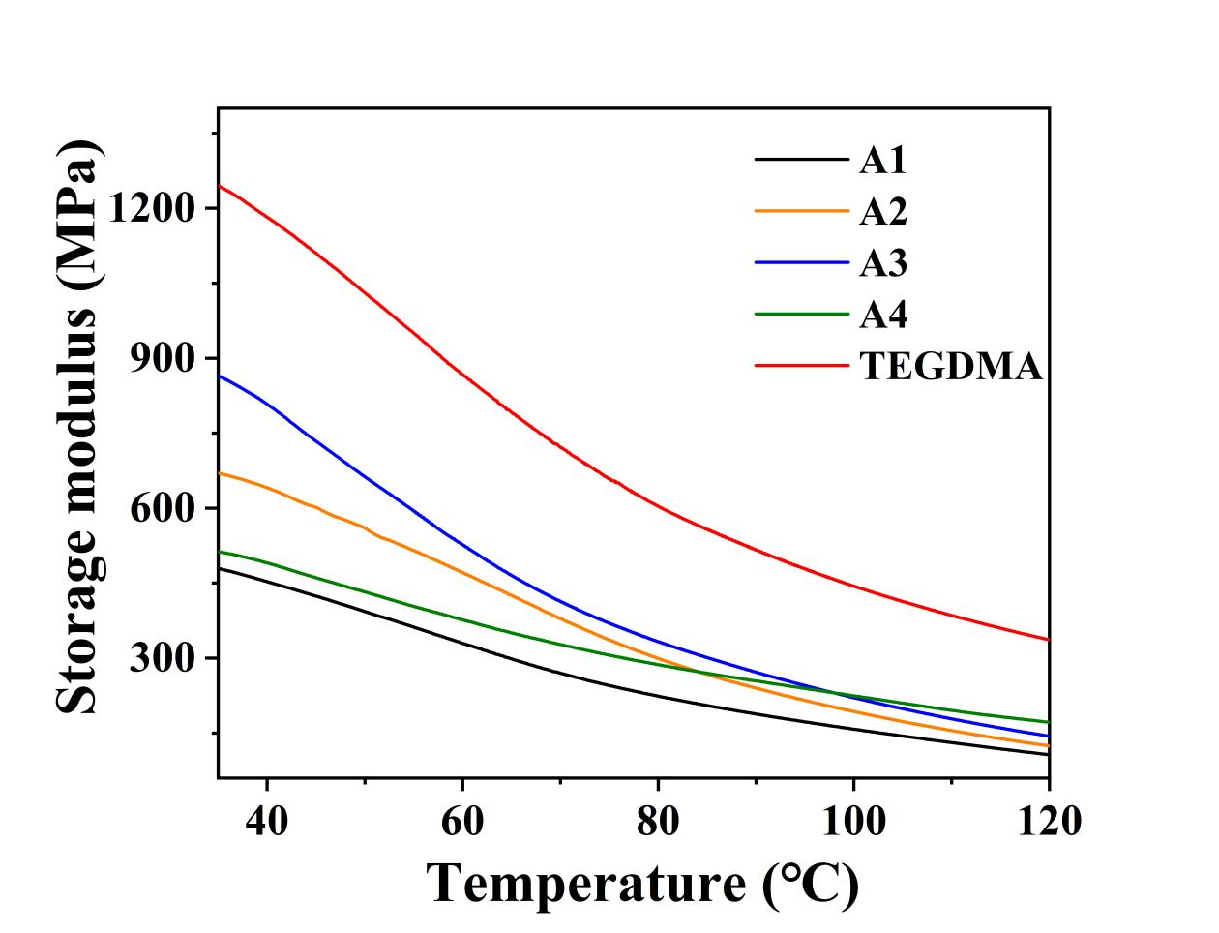
Figure S5. Storage modulus curves of E-WCO/TEGDMA resins and other control samples.

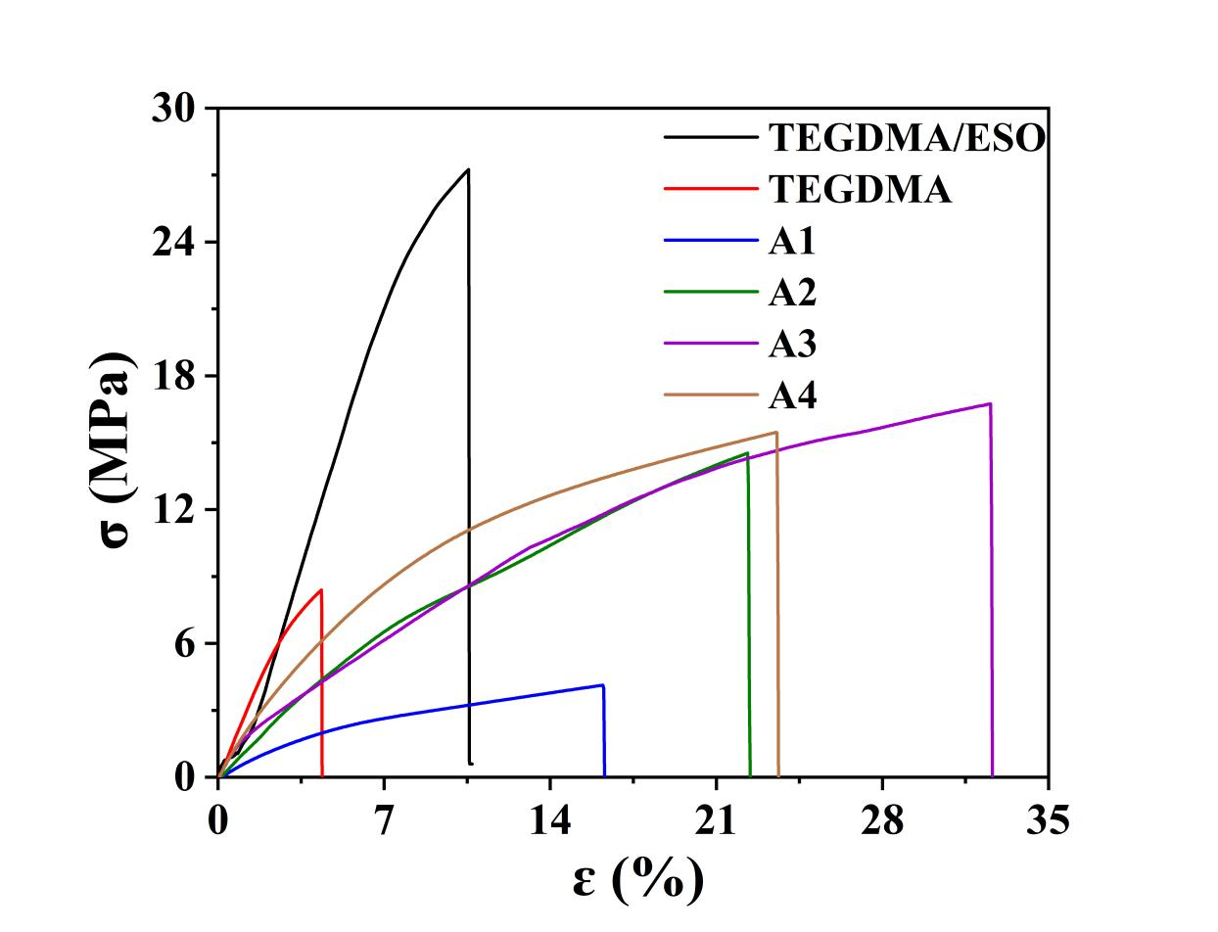
Figure S6. Stress-strain curves of E-WCO/TEGDMA resins and other control samples.

