Supplementary Information

Orally delivered biodegradable targeted inflammation resolving pectin-coated nanoparticles induce anastomotic healing post intestinal surgery

Jong Hyun Lee,^{1,2†} Stefan Reischl^{3,4†}, Robert Leon Walter³, Vincent Vieregge³, Marie-Christin Weber³, Runxin Xu,¹ Hao Chen,¹ Atsuko Kasajima⁵, Helmut Friess⁴, Philipp-Alexander Neumann*³ and Nazila Kamaly*¹

¹ Imperial College London, Department of Chemistry, Molecular Sciences Research Hub, United Kingdom
² Technical University of Denmark, Department of Health Technology, Kgs. Lyngby, Denmark
³ Technical University of Munich, School of Medicine, Department of Surgery, Germany
⁴ Technical University of Munich, Institute of Diagnostic and Interventional Radiology, Germany
⁵ Technical University of Munich, Institute of Pathology, Germany

†,*These authors contributed equally to this work

Correspondence: Email: nazila.kamaly@imperial.ac.uk and philipp-alexander.neumann@tum.de

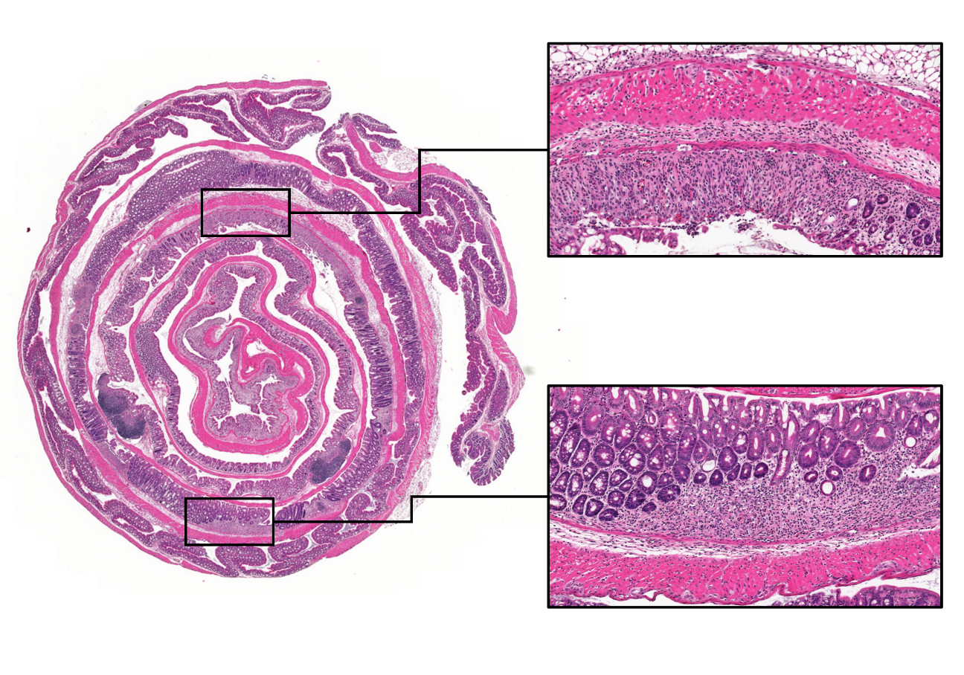
Supplemental Figure 1. Exemplary whole colon slice after 7 days of DSS administration. Colonic tissue was harvested, cut lengthwise, rolled, fixed and HE-stained to ensure presence of colitis. Characteristic features of DSS colitis are shown enlarged. DSS colitis is characterized by lymphocytic infiltrates, loss of crypt architecture and mucosal ulcerations.

