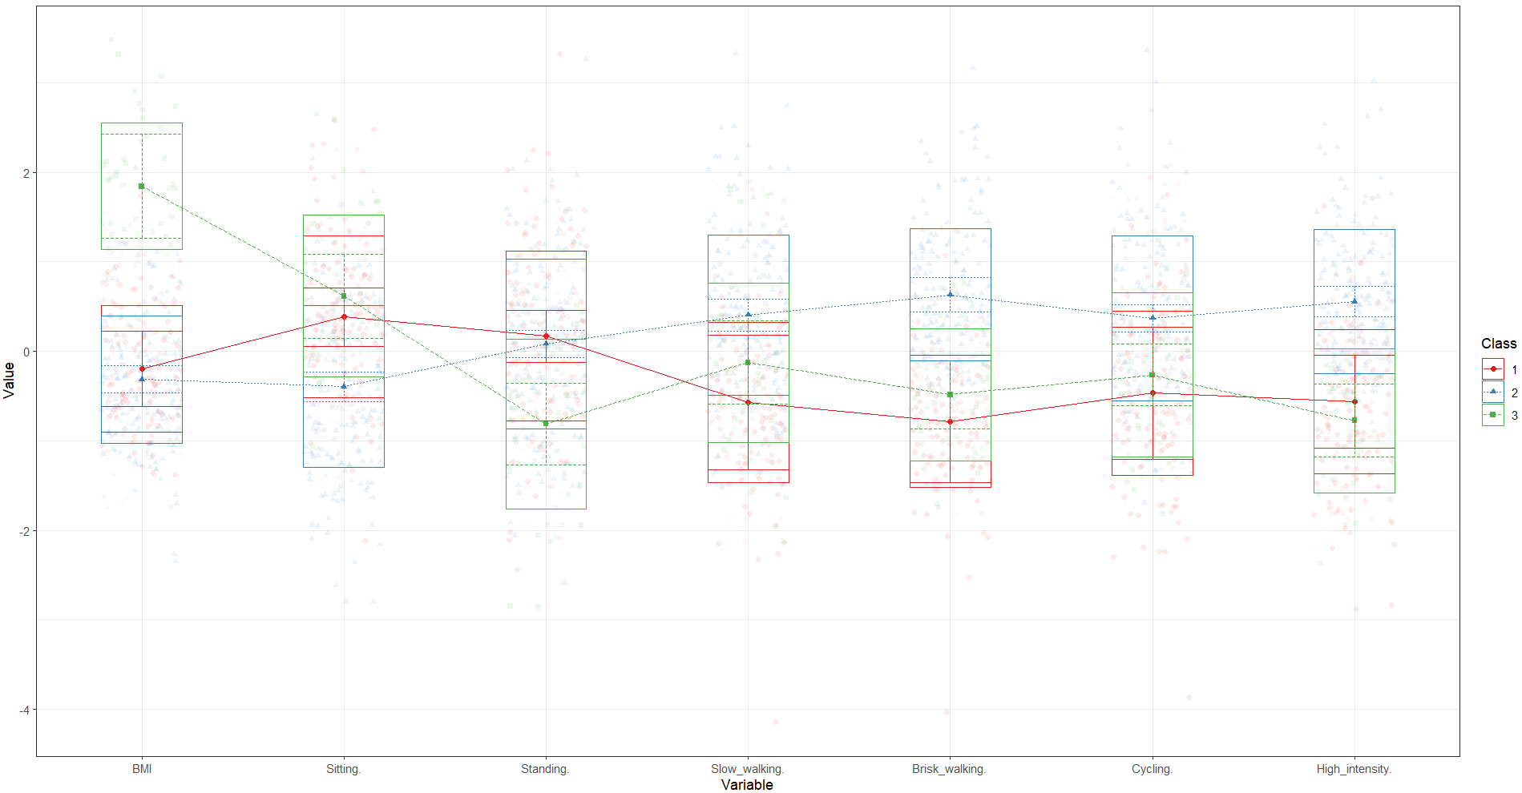
Figure 1. Standardized group averages on physical activity, sitting and BMI for three-profile solution.
[Class 1 = Normal BMI – high sitting – high standing – low slow-walking – low brisk-walking – low cycling – low high-intensity]; [Class 2 = Normal BMI – low sitting – high standing – high slow-walking – high brisk-walking – high cycling – high high-intensity]; [Class 3 = High BMI – high sitting – low standing – low slow-walking – low brisk-walking – low cycling – low high-intensity]

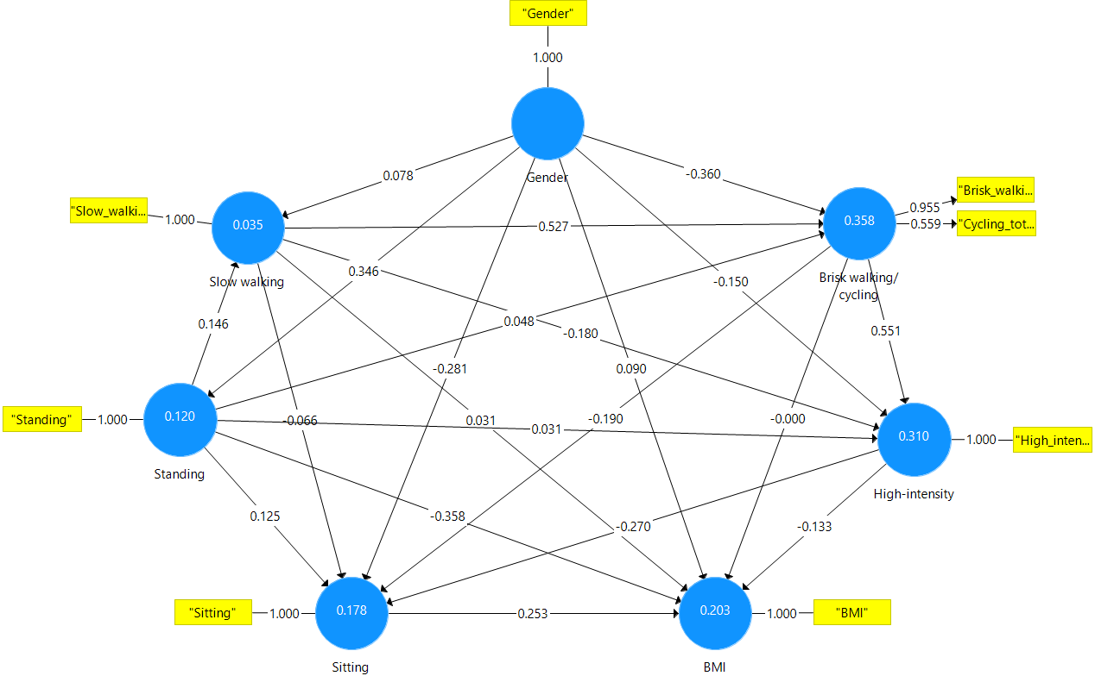
Figure 2. First construct of PLS-SEM predicting BMI in children after removing non-significant associations

Table 1. Total indirect effects among variables
 | Sample Mean | SD | T Statistics | Effect size | p
"High-intensity -> BMI" | -0.057 | 0.021 | 2.802 | 0.0032 | 0.005
"Brisk walking/cycling -> BMI" | -0.176 | 0.031 | 5.647 | 0.031 | <0.001
"Brisk walking/cycling -> Sitting" | -0.142 | 0.042 | 3.418 | 0.020 | 0.001
"Slow walking -> BMI" | -0.055 | 0.016 | 3.442 | 0.003 | 0.001
"Slow walking -> High-intensity" | 0.296 | 0.033 | 8.944 | 0.088 | <0.001
"Slow walking -> Sitting" | -0.155 | 0.033 | 4.716 | 0.024 | <0.001
"Standing -> Brisk walking/cycling " | 0.091 | 0.03 | 3.022 | 0.008 | 0.003
"Standing -> Sitting" | -0.026 | 0.01 | 2.662 | 0.0007 | 0.008

Table 2. Specific indirect effects among variables
 | Sample Mean | SD | T Statistics | P Values | Effect size
Brisk walking/Cycling -> High-intensity -> BMI | -0.09 | 0.03 | 3.44 | 0 | 0.0081
Slow walking -> Brisk walking/Cycling -> High-intensity -> BMI | -0.05 | 0.01 | 3.51 | 0 | 0.0025
Standing -> Slow walking -> Brisk walking/Cycling -> High-intensity -> BMI | -0.01 | 0 | 2.26 | 0.02 | 0.0001
Slow walking -> High-intensity -> BMI | 0.03 | 0.01 | 2.59 | 0.01 | 0.0009
Standing -> Slow walking -> High-intensity -> BMI | 0 | 0 | 2.07 | 0.04 | 0
Brisk walking/Cycling -> Sitting -> BMI | -0.05 | 0.02 | 2.62 | 0.01 | 0.0025
Slow walking -> Brisk walking/Cycling -> Sitting -> BMI | -0.03 | 0.01 | 2.58 | 0.01 | 0.0009
Standing -> Slow walking -> Brisk walking/Cycling -> Sitting -> BMI | 0 | 0 | 2.07 | 0.04 | 0
Brisk walking/Cycling -> High-intensity -> Sitting -> BMI | -0.03 | 0.01 | 2.53 | 0.01 | 0.0009
Slow walking -> Brisk walking/Cycling -> High-intensity -> Sitting -> BMI | -0.02 | 0.01 | 2.62 | 0.01 | 0.0004
Standing -> Slow walking -> Brisk walking/Cycling -> High-intensity -> Sitting -> BMI | 0 | 0 | 1.85 | 0.06 | 0
High-intensity -> Sitting -> BMI | -0.06 | 0.02 | 2.72 | 0.01 | 0.0036
Slow walking -> High-intensity -> Sitting -> BMI | 0.01 | 0.01 | 1.91 | 0.05 | 0.0001
Standing -> Slow walking -> High-intensity -> Sitting -> BMI | 0 | 0 | 1.56 | 0.12 | 0
Standing -> Sitting -> BMI | 0.03 | 0.01 | 1.82 | 0.05 | 0.0009
Standing -> Slow walking -> Brisk walking/Cycling | 0.09 | 0.03 | 2.93 | 0 | 0.0081
Slow walking -> Brisk walking/Cycling -> High-intensity | 0.3 | 0.03 | 9.07 | 0 | 0.9
Standing -> Slow walking -> Brisk walking/Cycling -> High-intensity | 0.05 | 0.02 | 2.82 | 0 | 0.0025
Standing -> Slow walking -> High-intensity | -0.03 | 0.01 | 2.19 | 0.03 | 0.0009
Slow walking -> Brisk walking/Cycling -> Sitting | -0.12 | 0.04 | 3.46 | 0 | 0.0144
Standing -> Slow walking -> Brisk walking/Cycling -> Sitting | -0.02 | 0.01 | 2.44 | 0.01 | 0.0004
Brisk walking/Cycling -> High-intensity -> Sitting | -0.14 | 0.04 | 3.36 | 0 | 0.0196
Slow walking -> Brisk walking/Cycling -> High-intensity -> Sitting | -0.08 | 0.02 | 3.42 | 0 | 0.0064
Standing -> Slow walking -> Brisk walking/Cycling -> High-intensity -> Sitting | -0.01 | 0.01 | 2.16 | 0.03 | 0.0001
Slow walking -> High-intensity -> Sitting | 0.05 | 0.02 | 2.23 | 0.03 | 0.0025
Standing-> Slow walking -> High-intensity -> Sitting | 0.01 | 0 | 1.77 | 0.08 | 0.0001
Note: the table show the specific indirect effects of PLS-SEM results when including all variables in each association (i.e., results when existing or removing each variable)

