Supporting Information
Effect of amino silane coupling agent on crystallization behavior of polyamide 612/glass fiber composites

Yu-Hsiang Yeh, Hsu-I Mao, Chin-Wen Chen* and Syang-Peng Rwei*

Department of Molecular Science and Engineering, Institute of Organic and Polymeric Materials, Research and Development Center of Smart Textile Technology, National Taipei University of Technology, No. 1, Sec. 3, Chung-Hsiao East Road., Taipei, 10608, Taiwan

Figure S1. Representative stress-strain curves of (a) pure PA612 and PA612/GF10wt%+Silane,
(b) pure PA612 and PA612/GF15%+Silane, (c) pure PA612 and PA612/GF20%+Silane, and
(d) pure PA612 and PA612/GF30%+Silane………………………………………………………….2
Figure S2. Half-crystallization time as a function of crystallization temperature: (a) PA612/GF10%Composite and (b) PA612/GF20% Composite samples at different coupling agent...2
Table S1. PA612 composite ratios and code names of the materials………………………………..3
Table S2. Parameters of the isothermal crystallization kinetics of the PA612/GF10 composites…...3
Table S3. Parameters of the isothermal crystallization kinetics of the PA612/GF20 composites…...4

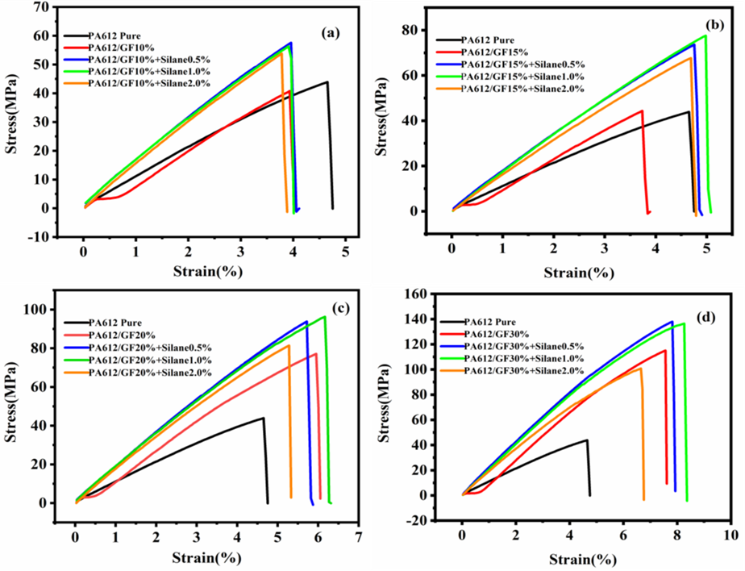
Figure S1. Representative stress-strain curves of (a) pure PA612 and PA612/GF10wt%+Silane,
(b) pure PA612 and PA612/GF15%+Silane, (c) pure PA612 and PA612/GF20%+Silane, and
(d) pure PA612 and PA612/GF30%+Silane.

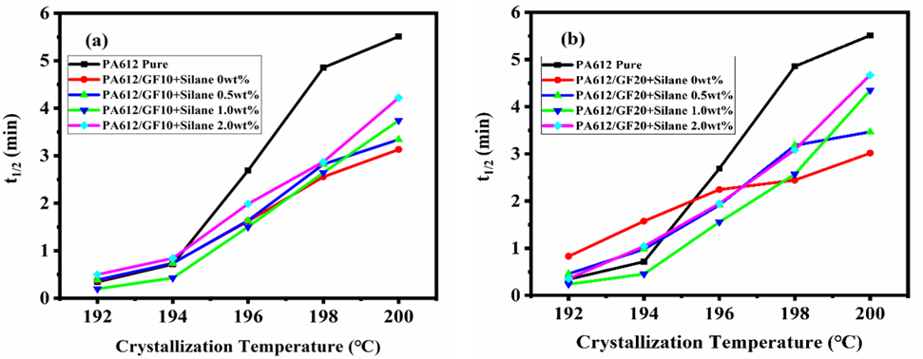
Figure S2. Half-crystallization time as a function of crystallization temperature: (a) PA612/GF10%Composite and (b) PA612/GF20% Composite samples at different coupling agent.

Table S1. PA612 composite ratios and code names of the materials
Materials | PA612 (wt %) | GF (wt %) | Silane (wt %)
PA612  PA/GF10% | 100  90 | 0  10 | 0  0
PA/GF10% + Silane 0.5 wt % | 89.5 | 10 | 0.5
PA/GF10% + Silane 1.0 wt % | 89 | 10 | 1.0
PA/GF10% + Silane 2.0 wt %  PA/GF20% | 88  80 | 10  20 | 2.0  0
PA/GF20% + Silane 0.5 wt % | 79 | 20 | 1.0
PA/GF20% + Silane 1.0 wt % | 78 | 20 | 2.0
PA/GF20% + Silane 2.0 wt %  PA/GF30% | 76  70 | 20  30 | 4.0  0
PA/GF30% + Silane 0.5 wt % | 68.5 | 30 | 1.5
PA/GF30% + Silane 1.0 wt % | 67 | 30 | 3.0
PA/GF30% + Silane 2.0 wt % | 64 | 30 | 6.0

Table S2. Parameters of the isothermal crystallization kinetics of the PA612/GF10 composites.
Samples | T_{iso} (℃) | K (min^{-n}) | n | t _{0.5} (min) | G_{0.5} (min⁻¹)
 | 192 | 0.345 | 1.701 | 1.507 | 0.664
 | 194 | 0.336 | 1.751 | 1.513 | 0.661
PA612 pure | 196 | 0.189 | 2.064 | 1.875 | 0.533
 | 198 | 0.176 | 2.141 | 1.897 | 0.527
 | 200 | 0.157 | 2.215 | 1.958 | 0.511
 | 192 | 0.346 | 1.857 | 1.454 | 0.688
 | 194 | 0.312 | 1.932 | 1.511 | 0.662
PA612/GF10 | 196 | 0.176 | 1.992 | 1.989 | 0.503
 | 198 | 0.169 | 2.071 | 1.977 | 0.506
 | 200 | 0.101 | 2.348 | 2.270 | 0.440
 | 192 | 0.425 | 1.805 | 1.311 | 0.763
 | 194 | 0.250 | 2.304 | 1.556 | 0.643
PA612/GF10+ | 196 | 0.143 | 2.079 | 2.137 | 0.468
Silane 0.5wt % | 198 | 0.117 | 2.241 | 2.213 | 0.452
 | 200 | 0.091 | 2.205 | 2.517 | 0.397
 | 192 | 0.288 | 1.861 | 1.602 | 0.624
 | 194 | 0.248 | 1.922 | 1.706 | 0.586
PA612/GF10+ | 196 | 0.167 | 1.920 | 2.096 | 0.477
Silane1.0wt % | 198 | 0.082 | 2.339 | 2.496 | 0.401
 | 200 | 0.108 | 2.109 | 2.418 | 0.414
 | 192 | 0.340 | 2.126 | 1.398 | 0.715
 | 194 | 0.192 | 2.268 | 1.760 | 0.568
PA612/GF10+ | 196 | 0.089 | 2.257 | 2.485 | 0.402
Silane 2.0wt % | 198 | 0.072 | 2.277 | 2.703 | 0.370
 | 200 | 0.081 | 2.228 | 2.617 | 0.382
Table S3. Parameters of the isothermal crystallization kinetics of the PA612/GF20 composites.
Samples | T_{iso} (℃) | K (min^{-n}) | n | t _{0.5} (min) | G_{0.5} (min⁻¹)
 | 192 | 0.345 | 1.701 | 1.507 | 0.664
 | 194 | 0.336 | 1.751 | 1.513 | 0.661
PA612 pure | 196 | 0.189 | 2.064 | 1.875 | 0.533
 | 198 | 0.176 | 2.141 | 1.897 | 0.527
 | 200 | 0.157 | 2.215 | 1.958 | 0.511
 | 192 | 0.384 | 1.842 | 1.379 | 0.726
 | 194 | 0.276 | 2.101 | 1.551 | 0.645
PA612/GF20 | 196 | 0.152 | 2.193 | 2.010 | 0.498
 | 198 | 0.169 | 1.984 | 2.038 | 0.491
 | 200 | 0.130 | 2.104 | 2.215 | 0.451
 | 192 | 0.304 | 1.969 | 1.519 | 0.658
 | 194 | 0.180 | 2.261 | 1.814 | 0.551
PA612/GF20+ | 196 | 0.078 | 2.327 | 2.560 | 0.391
Silane 0.5wt % | 198 | 0.031 | 2.890 | 2.918 | 0.343
 | 200 | 0.094 | 2.259 | 2.426 | 0.412
 | 192 | 0.271 | 2.021 | 1.592 | 0.628
 | 194 | 0.246 | 1.962 | 1.695 | 0.590
PA612/GF20+ | 196 | 0.116 | 1.938 | 2.521 | 0.397
Silane 1.0wt % | 198 | 0.060 | 2.207 | 3.038 | 0.329
 | 200 | 0.067 | 2.211 | 2.884 | 0.347
 | 192 | 0.099 | 2.209 | 2.414 | 0.414
 | 194 | 0.066 | 2.286 | 2.794 | 0.358
PA612/GF20+ | 196 | 0.051 | 2.152 | 3.350 | 0.299
Silane 2.0wt % | 198 | 0.025 | 2.468 | 3.823 | 0.262
 | 200 | 0.046 | 2.279 | 3.281 | 0.305

