Figure 4e
HCT8
PCBP1
HCT15
PCBP1
hnRNPK
HCT8
HCT15
GAPDH
HCT15
HCT8

Figure 4i
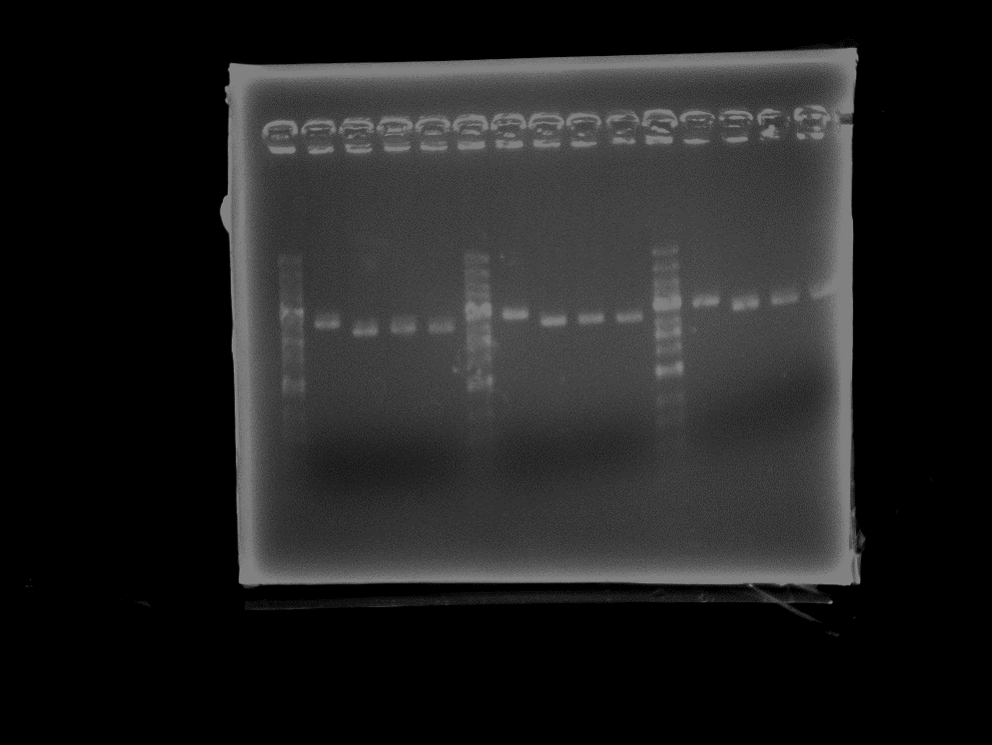

Figure 4j

Figure 5a
GAPDH
PCBP1

Figure 6e
HCT8
MCM3
HCT15MCM3

HCT8
Cyclin D1
HCT15
Cyclin D1

HCT8
CDK4
HCT15
CDK4
HCT8
GAPDH
HCT15
GAPDH
Figure 6g
HCT8
PCBP1
HCT15
PCBP1
HCT8
MCM3
HCT15
MCM3
HCT8
Cyclin D1
HCT15
Cyclin D1
HCT8
CDK4
HCT15
CDK4
HCT8
GAPDH
HCT15
GAPDH
Figure 7a
HCT8
PCBP1
HCT15
PCBP1
HCT8
GAPDH
HCT15
GAPDH
Figure 7d
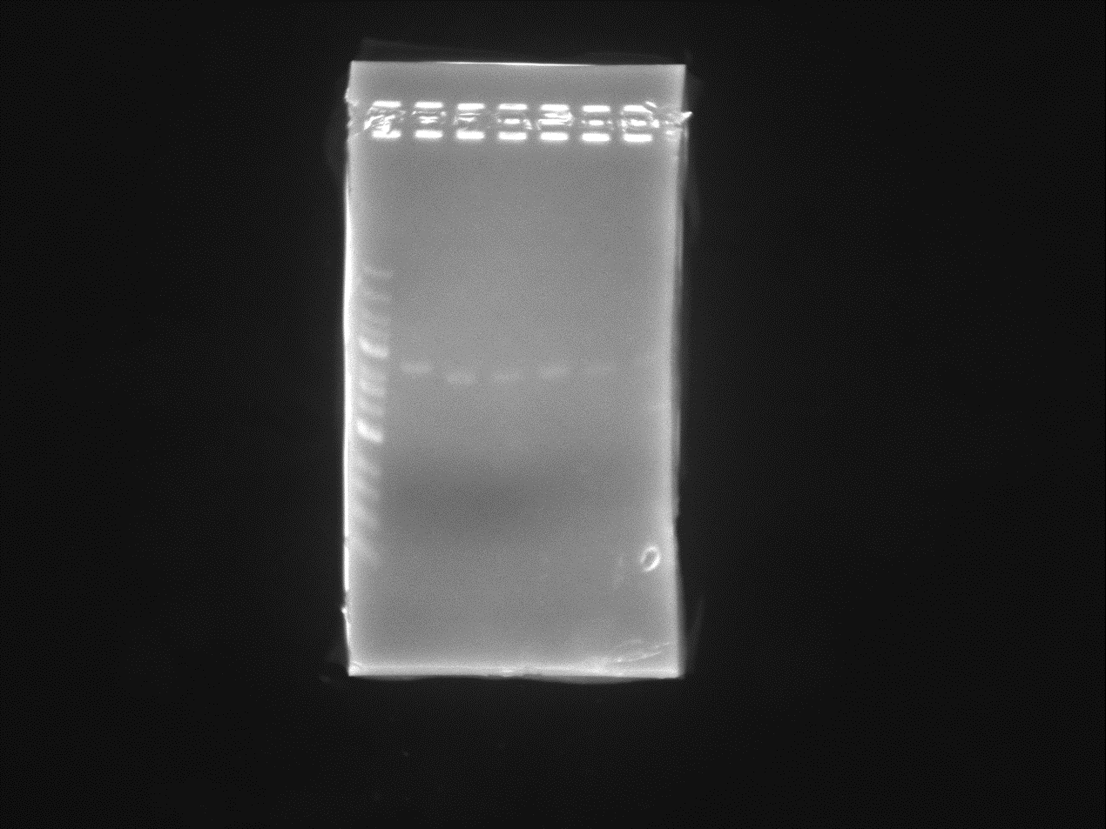
Figure 7e
Figure 7k
MCM3
PCBP1
HCT8
HCT8-Re
HCT15 HCT15-Re
Cyclin D1
Cyclin D1
GAPDH
CDK4
Figure S6a
GAPDH
MCM3

