Jiuzhuan Huangjing Pills alleviate fatigue by preventing mitochondria-mediated energy metabolism damage

Supplementary material

The accompanying document includes supplementary material and methods, and supplementary figures 1-6 along with their respective figure legends.

Supplementary material and methods
1. Chemicals, reagents, and materials
1.1. Quality control of JHP
Quantification of ferulic acid and diosgenin in JHP extract was performed using ultra performance liquid chromatography (UPLC) (Agilent, CA, USA). The chromatographic column used was a ACQUITY UPLC® HSS T3 (2.1×150 mm, 1.8 µm) column (Waters, MA, USA). The injection volume was 5 μL, the column temperature was set at 30℃, and the flow rate was 0.2 mL/min. Ferulic acid (purity > 98%) (DF081) was purchased from DeSite (Sichuan, China), and diosgenin (purity > 98%) (B21177) was purchased from Yuanye (Shanghai, China). For ferulic acid determination, acetonitrile/0.085% phosphoric acid (17:83 v/v) was used as the mobile phase with isocratic elution, and the detection wavelength was set at 280 nm. For diosgenin determination, acetonitrile/water (85:15 v/v) was used as the mobile phase with isocratic elution, and the detection wavelength was set at 203 nm.
1.2. Animal and cell experiments
A basic basal rodent diet was obtained from SPF Biotech (Beijing, China). High-purity deionized water was purified by a Milli-Q System (Millipore, MA, USA). Blood urea nitrogen (BUN) (C013-2-1), creatine kinase (CK) (A032-1-1), lactic acid (LA) (A019-2-1), lactate dehydrogenase (LDH) (A020-2-2), liver glycogen (LG) (A043-1-1), glutathione peroxidase (GSH-Px) (A005-1-2), superoxide dismutase (SOD) (A001-3-2), malondialdehyde (MDA) (A003-1-2), Adenosine triphosphatase (ATPase) assay kit (Ca²⁺-Mg²⁺ ATPase and Na⁺-K⁺ ATPase) (A016-1-1) were purchased from Nanjing Jiancheng Bioengineering Research Institute Co., Ltd (Jiangsu, China). Bicinchoninic acid (BCA) protein determination kits (P001-1), mouse cysteamine dioxygenase kit (MM-46007M1), mouse citrate synthase kit (MM-1083M1), mouse succinate dehydrogenase kit (MM-44136M1), mouse ATP kit (MM-43789M1), mitochondrial respiratory chain complex I kit (complex I) (MM-44745M1), and mitochondrial respiratory chain complex II kit (complex II) (MM-44757M1) were purchased from Meimian (Jiangsu, China). Mitochondrial complex I/nicotinamide adenine dinucleotide (NADH)-CoQ reductase activity assay kit (BC0515) was purchased from Solarbio (Beijing, China).
Panacis Quinquefolii Radix (PQR) (20191016) and ligustilide (purity > 98%) (JOT-10361) were purchased from Xianghui (Yunnan, China) and Pufeide (Sichuan, China), respectively. High performance liquid chromatography (HPLC)-grade methanol (1.06007.4008), formic acid (111670), acetonitrile (1.00030.4008) and linolenic acid (L2376), octadecenoic acid (01008), were purchased from Merck KGaA (Darmstadt, Germany). Ferulic acid (purity > 98%) (DF081), stearic acid (purity > 98%) (DY0221), linoleic acid (purity > 98%) (DY0211-0200), α-linolenic acid (purity > 98%) (DY0131), senkyunolide I (purity > 98%) (DY0009), Caffeine (purity > 98%) (DK0049-0020) were purchased from DeSite (Sichuan, China). Phthalic acid (purity > 98%) (P39303) and phthalide (purity > 99%) (P815690) were purchased from McKin (Shanghai, China). Disporopsin (purity > 97%) (BBP06753) and 3-butylidenephthalide (purity > 96%) (B138989) was purchased from BioBioPha (Yunnan, China) and Aladdin (Shanghai, China), respectively. Hydrogen peroxide (H₂O₂) (3%) (20230702) was purchased from TianGen (Yunnan, China).
Dulbecco’s modified Eagle medium (DMEM) (C11995500BT) was purchased from Thermo Fisher Scientific (MA, USA). Premium grade fetal bovine serum (164210-50) and premium equine serum (S9050) was purchased from Procell (Hubei, China) and Solarbio (Beijing, China), respectively. Phosphate-buffered saline (PBS) (BL302A) was obtained from Biosharp (Anhui, China). Penicillin-streptomycin solution (SV30010) and trypsin solution (0.25%) (SH30042.01) were purchased from Cytiva (MA, USA).
The calcein-acetoxymethyl ester (AM)/propidium iodide (PI) double staining kit (CA1630) was purchased from Solarbio (Beijing, China). The fluorescent probe 2′,7′-dichlorofluorescein diacetate (DCFH-DA) for reactive oxygen species (ROS) (S0033S) and mitochondria membrane potential assay kit with JC-1 (5,5′,6,6′-tetrachloro-1,1′,3,3′-tetraethyl-benzimi-dazolylcarbocyanine iodide) (C2006) were purchased from Beyotime (Shanghai, China).
2. Dosage setting for animal experiments
According to the record in the book “Taiping Huimin Heji Jufang”, the daily dosage of JHP for humans is 15 g. Based on the conversion of equivalent doses between humans and mice using body surface area ratio (Nair et al., 2018; Nair and Jacob, 2016), the estimated daily dose of JHP for mice is approximately 3.075 g/kg. Based on this calculated result, the animals were randomly divided into 5 different groups, each consisting of 6 mice: (1) normal control group (CON) receiving normal saline, (2) model group (MOD) undergoing swimming exercise and receiving saline, (3) PQR group administered with PQR at a dose of 0.6 g/kg, (4) low-dose JHP-treated group (JHP-L) given JHP at a dose of 1.8 g/kg, (5) high-dose JHP-treated group (JHP-H) administered JHP at a dose of 3.6 g/kg. The mice in each group were orally administered with their respective doses of JHP or PQR daily for a duration of 4 weeks.
3. Evaluation of fatigue-related indicators in mice
Blood samples were collected by removing the eyeballs, and allowed to clot at 4 ℃. The resulting serum samples were obtained by centrifuging at 3,500 rpm for 15 min. Subsequently, the mice were sacrificed through cervical dislocation, and the liver and hind leg SM were collected. All samples were stored at −80 ℃ until further use. For mitochondria isolation, SM samples weighing 0.1 g were placed in an ice-cold isolation buffer to remove blood, followed by mincing them into 1 mm³ pieces. The samples were then homogenized in the isolation buffer. After centrifugation at 1,000 g for 10 min, the supernatants were collected and further centrifuged at 10,000 g for 10 min. The resulting precipitates were resuspended in the isolation buffer and centrifuged again at 10,000 g for 10 min to isolate the mitochondria. All procedures were conducted on ice or at 4 ℃ in a cold room. Finally, the mitochondria were resuspended in normal saline.
The expression levels of LG, MDA, SOD, and GSH-Px in liver homogenates and supernatants, the expression levels of LA, LDH, BUN and CK in serum samples were measured, and the expression levels of ATPase, ATP, complex I and complex II in mitochondrial suspensions were determined by using the corresponding reagent kit described in 2.1.2. To quantify these indicators, the absorbance in each well was measured using the SpectraMax Plus 384 Microplate Reader (Molecular Devices, CA, USA) after determining the protein concentrations by BCA assay.
4. Detection of mitochondria function
4.1. Calcein-AM/PI double staining
The calcein-AM/PI double staining kit was used to assess membrane integrity. After co-incubation, cells were washed twice with DMEM solution, then loaded with calcein-AM and PI for 20-25 min at 37 ℃ in the absence of light. Following that, the cells were washed twice with staining buffer, and the fluorescence was measured using an inverted fluorescence microscope (Carl Zeiss, Oberkochen, Germany) for green (excitation 490 nm, emission 515 nm) and red (excitation 530 nm, emission 580 nm) channels. The live cells with yellow-green fluorescence and the dead cells with red fluorescence could be observed at 490 ± 10 nm. Image processing and analysis were performed using Image J software (version 1.8.0). The experiments were conducted on C2C12 cells from 3 different fields of view selected randomly.
4.2. Reactive oxygen species
C2C12 cells were seeded in 96-well black background plates at a density of 5,000 cells per well for flow cytometry analysis. Adherent cells were collected, washed twice with PBS, and then replenished with media containing the corresponding test samples for up to 18 h. Subsequently, H₂O₂ was added to stimulate the cells for 6 h. Following the incubation period, the cells were stained using the ROS assay kit and analyzed using a fluorescent microplate reader in accordance with the manufacturer's instructions.
4.3. Mitochondrial membrane potential
Mitochondrial membrane potential (ΔΨm) was measured by using the mitochondrial membrane potential assay kit with JC-1 according to the manufacturer’s instructions. JC-1 forms red-fluorescent J-aggregates (excitation 585 nm, emission 590 nm) at high membrane potential, while green-fluorescent monomers (excitation 514 nm, emission 529 nm) exist at low potential. The ratio of red to green fluorescence is used to quantitate changes in ΔΨm, which can be observed by fluorescence microscopy (Carl Zeiss). Mitochondrial depolarization is reflected in a decrease in the red-to-green fluorescence ratio. Image processing and analysis were performed using Image J software. The experiments were repeated with C2C12 cells from 3 different randomly selected fields of view.
4.4. Mitochondrial energy metabolism
Mitochondrial energy metabolism was measured using the complex I and complex II enzyme-linked immunoreaction assay kit according to the manufacturer’s instructions. The cell suspension was diluted with PBS at pH 7.2-7.4 until the cell density reached about 1 million cells/mL. The cells were then broken by ultrasound to release the intracellular components. The resulting mixture was centrifuged at 4 ℃, 2500 rpm for 20 min, and the supernatant was collected for subsequent testing.
5. Metabolome and data analysis
5.1. Sample preparation
The samples from serum, SM and skeletal muscle mitochondria (SMM) were collected. For the extraction of metabolites in the serum and SM samples, 80 μL of thawed serum samples and 80 mg of SM samples grinding in liquid nitrogen were mixed with 200 μL of pre-cooled water and 800 μL of pre-cooled methanol/acetonitrile (1:1, v/v), respectively. The mixed samples were subjected to sonication in an ice bath for 1 h, followed by incubation at −20 ℃ for 2 h. Subsequently, the samples were centrifuged at 16,000 g for 20 min at 4 ℃, and the resulting supernatant was collected (Yang et al., 2019). For the extraction of metabolites in the SMM samples, 0.1 g of the SMM samples were mix with 1.0 mL of mitochondrial extraction solution kit. The mixed samples were homogenized on ice, and then centrifuge at 600 g for 10 min at 4 ℃. The supernatants were further centrifuge at 11,000 g for 15 min at 4 ℃. The precipitations were mixed with 400 μL of extraction solution for ultrasonic crushing (20% power for 5 seconds, with an interval of 10 seconds, and repeated 15 times). Moreover, to ensure quality control, quality control samples were prepared by combining an equal amount of all the collected samples. All supernatants were quantification based on the overall protein content of each sample, and then subjected to evaporation and drying using the Vacuum Concentrator (Eppendorf, Hamburg, Germany). Finally, 100 μL of methanol-water solution (1:1, v/v) was added to reconstitute the dried samples. The reconstituted samples were then centrifuged at 20,000 g at 4 ℃ for 20 min, and the resulting supernatant was taken for ultra-performance liquid chromatography-Q Exactive Plus mass spectrometry (UPLC-QE/MS) analysis.
5.2. UPLC-QE/MS analysis
Metabolomics profiling in serum, SM and SMM were performed using an UPLC-QE/MS. The chromatographic column used was a ACQUITY UPLC® HSS T3 (2.1×150 mm, 1.8 µm) column (Waters, MA, USA). The injection volume was 6 μL, the column temperature was set at 40℃, and the flow rate was 0.3 mL/min. The chromatographic mobile phase consisted of water with 0.1% formic acid (solution A) and acetonitrile (solution B), with a gradient elution program as follows: 0-2 min, 0% B; 2-6 min, B linearly increased from 0% to 48%; 6-10 min, B linearly increased from 48% to 100%; 10-12 min, B maintained at 100%; 12-12.1 min, B linearly decreased from 100% to 0%; 12.1-15 min, B maintained at 0%.
5.3. Metabolome data analysis
The raw data was processed using MS-DIAL (version 4.48) (Tsugawa et al., 2015) to perform peak alignment, retention time correction, peak area extraction, compound identification and classification. Metabolites were identified through accuracy mass matching with a mass tolerance of < 0.01Da and by analyzing raw data with a mass tolerance of < 0.02 Da, using the human metabolome database (HMDB) (Wishart et al., 2022) and MassBank (Horai et al., 2010) databases as references. Only variables with more than 50% of nonzero measurement values in at least one group were retained. For filtered metabolites, any missing values were replaced with 1/5 of the minimum positive value for each variable. Finally, the abundances of metabolites were normalized based on quality control samples, log-transformed, and scaled using range scaling by R package MetaboAnalystR (version 3.2.0) (Pang et al., 2020).
To visualize group separation and identify significantly changed metabolites, orthogonal partial least squares-discriminant analysis (OPLS-DA) was conducted using MetaboAnalystR. Two-tailed Student’s t-test was performed for comparing the abundance differences of metabolites between the two groups. Metabolites with a significance level of P < 0.05 and a variable importance in projection (VIP) value > 1 were considered as statistically significant metabolites in abundance.
To identify the disrupted biological pathways, the metabolites with differential abundance underwent enrichment analysis based on the Kyoto encyclopedia of genes and genomes (KEGG) database (Kanehisa et al., 2017). Enriched KEGG pathways accessed by Fisher's exact test were considered statistically significant at a significance level of P < 0.05 adjusted using the Benjamini-Hochberg method.
5.4. Verification of key enzymes in metabolic pathways
The enzymes corresponding to the differentially abundant metabolites in the enriched KEGG pathways were selected as validation targets. The enzyme levels in each group were determined using the corresponding assay kits described in 2.1.2, following the protocols provided by the kits. After quantifying the protein concentrations using the BCA assay, the absorbance in each well was measured using the SpectraMax Plus 384 Microplate Reader.
6. Identification of JHP-derived ingredients in SM
The thawed SM samples weighing 0.1 g were homogenized on ice with 1 mL of physiological saline. Then, 1.5 mL of acetonitrile was added to the homogenized samples. After vortexing for 30 s, the mixtures were centrifuged at 12,000 rpm for 15 min at 4℃. The resulting supernatants were subjected to evaporation and drying using the Vacuum Concentrator. Next, the dried samples were re-dissolved in 100 μL of acetonitrile and subjected to ultrasound treatment. After ultrasound, the samples were centrifuged at 12,000 rpm for 15 min at 4℃. The supernatant was passed through a 0.22 μm membrane filter and used for ultra-performance liquid chromatography quadrupole-time of flight mass spectrometry (UPLC-Q-TOF/MS) analysis.
For UPLC-Q-TOF/MS analysis, the chromatographic column used was a shim-pack XR-ODS column (2.0 mm × 100 mm, 2.2 μm) (Shimadzu). The mobile phase consisted of acetonitrile (solution A) and water with 0.1% formic acid (solution B), with a gradient elution program as follows: 0 min, 5% A; 20 min, 10% A; 30 min, 20% A; 40 min, 30% A; 50 min, 40% A; 60 min, 50% A; 70 min, 60% A; 80 min, 70% A; 90 min, 85% A; 100 min, 95% A; 105 min, 100% A; 115 min, 5% A. The flow rate was 0.2 mL/min, and the column temperature was maintained at 30 ℃.
The MS raw data were analyzed using the MassHunter Qualitative Analysis B.06.00 to find out the JHP-derived ingredients in SM. In brief, the MS data of SM from JHP-treated mice were compared with the MS data of SM from normally cultured mice to eliminate interference from endogenous components in SM and obtain the MS data specifically related to the components introduced by JHP. Subsequently, the obtained data were compared with the previously reported MS information of the chemical constituents of PR and ASR (Hongming Ren et al., 2021; Huang et al., 2020; Jie li et al., 2019; Lu Wang et al., 2019; Wang et al., 2016) to identify the JHP-derived ingredients in SM.
References
Hongming Ren, Jinlian Zhang, Yaling Deng, Xianwen Ye, Lanting Xia, Wang, T., 2021. Analysis of Chemical Constitutions of Polygonatum cyrtonema Dried Rhizomes Before and After Processing with Wine Based on UPLC-Q-TOF-MS. Chin J Exp Traditi Med Formulae. 27(04), 110-121. https://doi.org/10.13422/j.cnki.syfjx.20202147.
Horai, H., Arita, M., Kanaya, S., Nihei, Y., Ikeda, T., Suwa, K., Ojima, Y., Tanaka, K., Tanaka, S., Aoshima, K., Oda, Y., Kakazu, Y., Kusano, M., Tohge, T., Matsuda, F., Sawada, Y., Hirai, M.Y., Nakanishi, H., Ikeda, K., Akimoto, N., Maoka, T., Takahashi, H., Ara, T., Sakurai, N., Suzuki, H., Shibata, D., Neumann, S., Iida, T., Tanaka, K., Funatsu, K., Matsuura, F., Soga, T., Taguchi, R., Saito, K., Nishioka, T., 2010. MassBank: a public repository for sharing mass spectral data for life sciences. J Mass spectrom. 45(7), 703-714. https://doi.org/10.1002/jms.1777.
Huang, Z.Z., Du, X., Ma, C.D., Zhang, R.R., Gong, W.L., Liu, F., 2020. Identification of Antitumor Active Constituents in Polygonatum sibiricum Flower by UPLC-Q-TOF-MS(E) and Network Pharmacology. ACS Omega. 5(46), 29755-29764. https://doi.org/10.1021/acsomega.0c03582.
Jie li, Yuqi Wang, Zihan Wang, Shuai Song, Tao Ma, Feng Lin, Zhang, J., 2019. Characterization of chemical constituents in aqueous extracts and fermentation broth from Polygonati Rhizoma by UHPLC-LTQ-Orbitrap MS combined with solid phase extraction. Chin. Tradit. Herb. Drugs. 50(13), 3029-3036+3043.
Kanehisa, M., Furumichi, M., Tanabe, M., Sato, Y., Morishima, K., 2017. KEGG: new perspectives on genomes, pathways, diseases and drugs. Nucleic acids Res. 45(D1), D353-d361. https://doi.org/10.1093/nar/gkw1092.
Lu Wang, Shanshan Fan, Feng Xu, Guangxue Liu, Mingying Shang, Cai, S., 2019. Analysis of polarityncomponents of Angelicae Sinensis Ｒadix and its metabolites in rats by HPLC-MSn. China J. Chin. Mater. Med. 44(22), 4924-4931. https://doi.org/10.19540/j.cnki.cjcmm.20190522.503.
Nair, A., Morsy, M.A., Jacob, S., 2018. Dose translation between laboratory animals and human in preclinical and clinical phases of drug development. Drug Dev Res. 79(8), 373-382. https://doi.org/10.1002/ddr.21461.
Nair, A.B., Jacob, S., 2016. A simple practice guide for dose conversion between animals and human. J Basic Clin Pharm. 7(2), 27-31. https://doi.org/10.4103/0976-0105.177703.
Pang, Z., Chong, J., Li, S., Xia, J., 2020. MetaboAnalystR 3.0: Toward an Optimized Workflow for Global Metabolomics. Metabolites. 10(5). https://doi.org/10.3390/metabo10050186.
Tsugawa, H., Cajka, T., Kind, T., Ma, Y., Higgins, B., Ikeda, K., Kanazawa, M., VanderGheynst, J., Fiehn, O., Arita, M., 2015. MS-DIAL: data-independent MS/MS deconvolution for comprehensive metabolome analysis. Nat Methods. 12(6), 523-526. https://doi.org/10.1038/nmeth.3393.
Wang, L., Huang, S., Chen, B., Zang, X.Y., Su, D., Liang, J., Xu, F., Liu, G.X., Shang, M.Y., Cai, S.Q., 2016. Characterization of the Anticoagulative Constituents of Angelicae Sinensis Radix and Their Metabolites in Rats by HPLC-DAD-ESI-IT-TOF-MSn. Planta Med. 82(4), 362-370. https://doi.org/10.1055/s-0035-1558309.
Wishart, D.S., Guo, A., Oler, E., Wang, F., Anjum, A., Peters, H., Dizon, R., Sayeeda, Z., Tian, S., Lee, B.L., Berjanskii, M., Mah, R., Yamamoto, M., Jovel, J., Torres-Calzada, C., Hiebert-Giesbrecht, M., Lui, V.W., Varshavi, D., Varshavi, D., Allen, D., Arndt, D., Khetarpal, N., Sivakumaran, A., Harford, K., Sanford, S., Yee, K., Cao, X., Budinski, Z., Liigand, J., Zhang, L., Zheng, J., Mandal, R., Karu, N., Dambrova, M., Schiöth, H.B., Greiner, R., Gautam, V., 2022. HMDB 5.0: the Human Metabolome Database for 2022. Nucleic acids Res. 50(D1), D622-d631. https://doi.org/10.1093/nar/gkab1062.
Yang, X.X., Wei, J.D., Mu, J.K., Liu, X., Li, F.J., Li, Y.Q., Gu, W., Li, J.P., Yu, J., 2019. Mitochondrial metabolomic profiling for elucidating the alleviating potential of Polygonatum kingianum against high-fat diet-induced nonalcoholic fatty liver disease. World J Gastroenterol. 25(43), 6404-6415. https://doi.org/10.3748/wjg.v25.i43.6404.

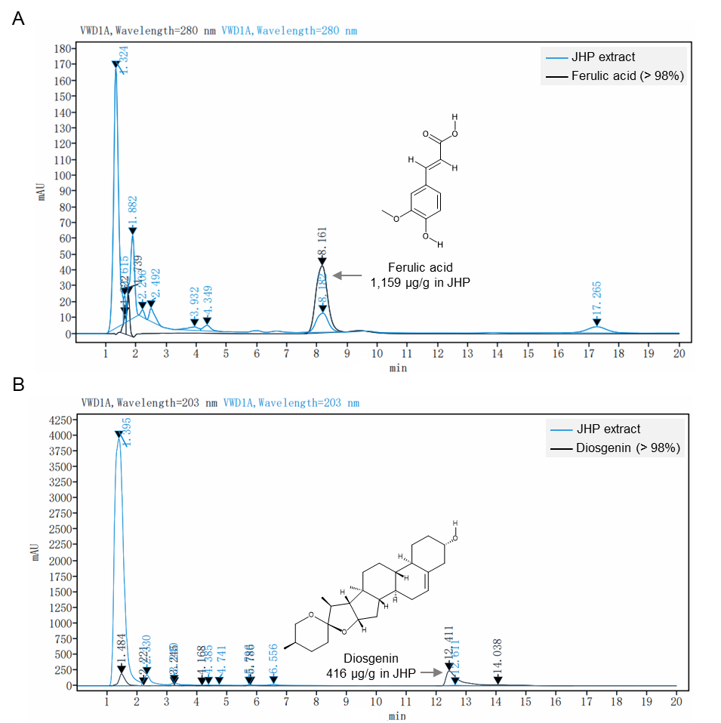
Fig. S1. Quantity control of JHP extract. (A) JHP extract and ferulic acid. (B) JHP extract and diosgenin. The blue line represented the JHP extract, while the black line represented the standard substances. The content of corresponding substances in the JHP extract was indicated by calculating based on the positions and peak areas of the standards. mAU, milli-absorbance units.

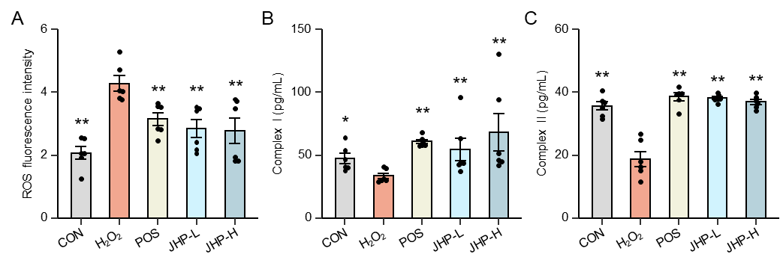
Fig. S2. The rescuing effects of JHP on oxidative stress and mitochondrial function in H₂O₂-stimulated C2C12 cells. Changes in ROS levels (A), mitochondrial complex I (B), and complex II (C) in the CON, H₂O₂, POS, JHP-L and JHP-H groups were shown. The significance of differences between each group and the H₂O₂ group was indicated above each group. *, P < 0.05; **, P < 0.01.

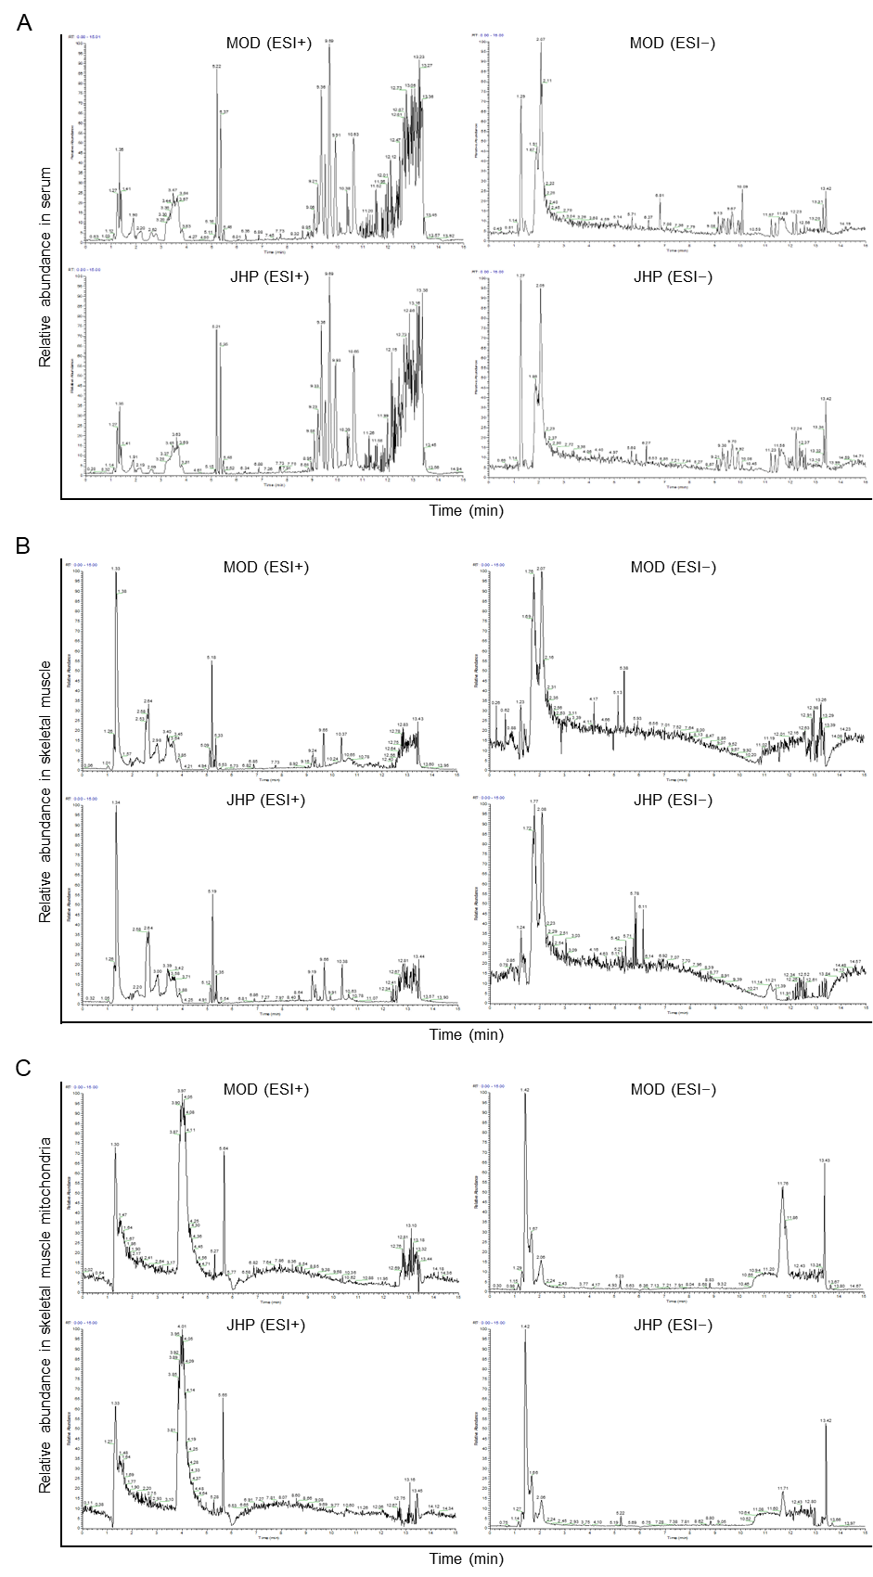
Fig. S3. Total ion chromatograms of metabolites in different tissues. Total ion chromatograms of metabolites in serum (A), skeletal muscle (B), and skeletal muscle mitochondria (C) in the MOD and JHP groups under ESI+ and ESI− modes.

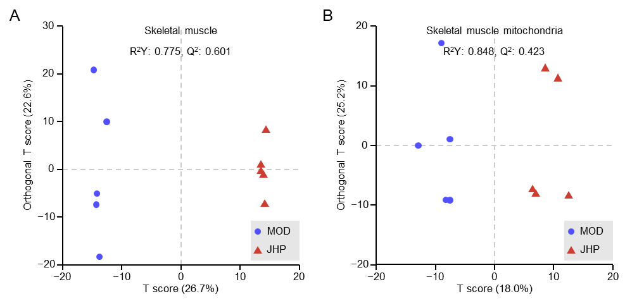
Fig. S4. Overall differences in metabolites between the MOD and JHP groups in skeletal muscle and skeletal muscle mitochondria. Metabolites in the MOD and JHP groups were visualized using OPLS-DA in skeletal muscle (A) and skeletal muscle mitochondria (B). The blue triangles represented the MOD group, and the red dots represented the JHP group. The parameters of the OPLS-DA model were indicated above the scatter plots.

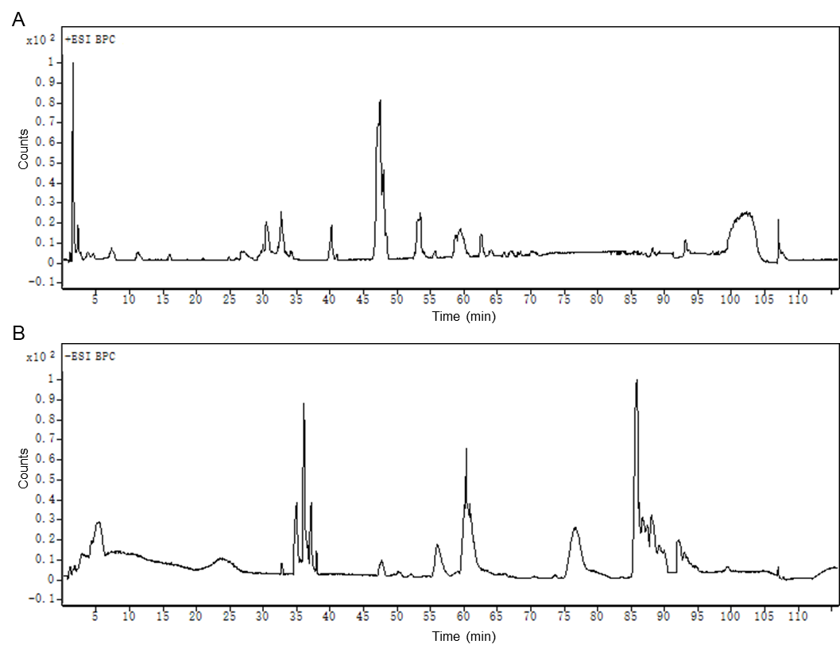
Fig. S5. Total ion chromatogram of JHP-derived ingredients in skeletal muscle. Total ion chromatograms were shown for both ESI+ (A) and ESI− (B) modes.

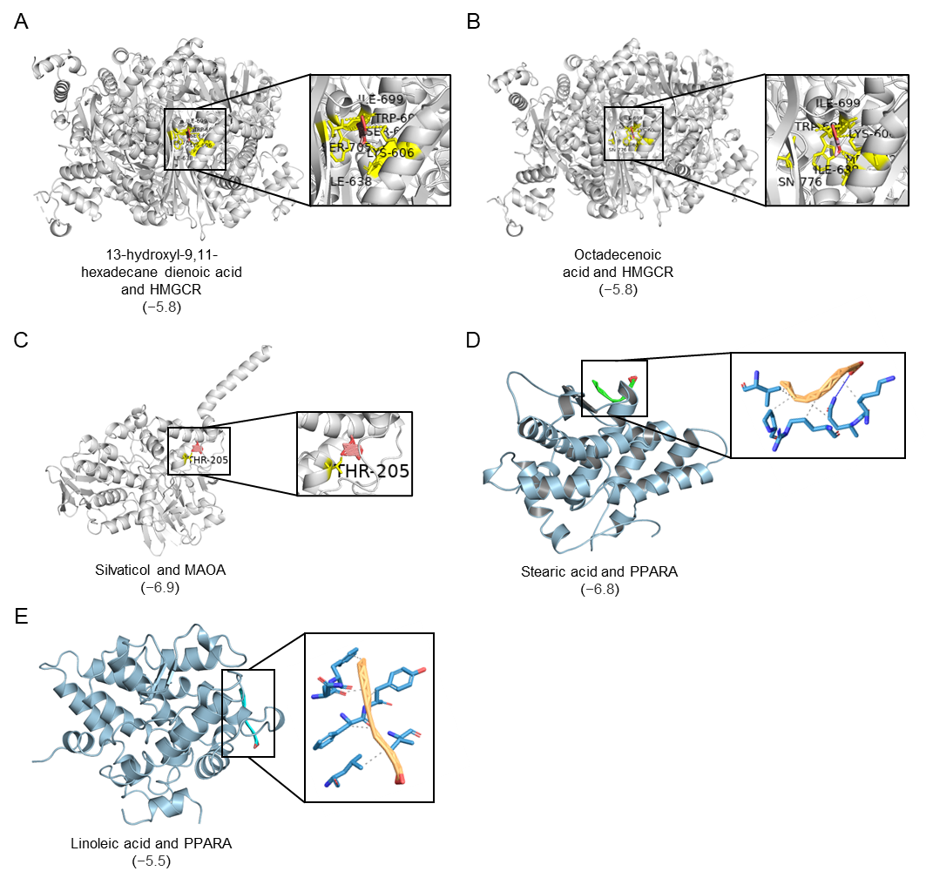
Fig. S6. Key target proteins potentially bound by candidate active components in JHP. The binding status of 13-hydroxyl-9,11-hexadecane dienoic acid (A) and octadecenoic acid (B) with HMGCR, silvaticol with MAOA (C), and stearic acid (D) and linoleic acid (E) with PPARA were shown. The numbers in parentheses represented the binding energy between the components and the proteins.

