Supplementary Tables
Supplementary Table 1: Example of terms used for Free-Text mining of GRO death notification records.
Example of terms used in free-text search of GRO 2000-2020 death file.
metastatic breast cancer  metastatic breast carcinoma  carcinomatosis  metastatic carcinoma of breast  metastatic breast carcinoma  metastatic cancer  metastatic lung cancer  metastatic liver disease  metastatic lung disease  liver metastases  lung metastases  brain metastases  cerebral metastases  bony metastases  mets  bone mets  bone metastasis  liver mets  liver metastasis  brain mets  brain metastasis  lung metastasis  lung mets  secondary carcinomatosis  secondary carcinoma  secondary breast  secondary lung  secondary brain  secondary liver  secondary bone  secondary breast  secondary breast cancer  secondaries  breast cancer with secondary spread  disseminated  disseminated carcinomatosis  widespread  breast cancer with metastases to liver and bone  breast cancer with metastases to bone and lung  carcinoma left breast with metastases in lung and liver | Examples of misspellings  metastatil breast carcinoma  metastic bone disease  metastic breast  metastic breast cancer  metastic carcinoma of breast  metastic disease of liver lungs  metastic liver disease  metaststic breast cancer  dessiminated breast carcinoma  breast cancer (desseminated)  metasatic breast carcinoma  metastaic breast carcinoma  secandary breast carcinoma  metastic disease left breast carcinoma  metasatic breast carcinoma  cerebral metestases liver and bonne  metastic carcinoma  breast cancer (desseminated)  matastatic breast carcinoma  cerebral metastatie cancer

Supplementary Table 2. BCDM estimates when including C77.3 cases and using PAS only notifications compared to when excluding C77.3 cases and using the validated NICR+PAS+GRO dataset.
 | Excluding C77.3 and using algorithm restricted rules. N=28,473 | Including C77.3* and using PAS Only notifications  n=30,461 | Difference
Total incidence of BCDM | 5,543 | 9,695 | 4,152 (+74.9%)
*PAS only notifications, unrestricted by validated BCDM algorithm

 | TP | TN | FN | FP | Sensitivity, %  (95% CI) | Specificity, %  (95% CI) | PPV, %  (95% CI) | NPV, %  (95% CI)
Test Dataset  n=1,024 | 182 | 648 | 2 | 192 | 98.9%  98.3%-99.6% | 77.14%  94.6%-79.7% | 48.7%  45.6%-51.7% | 99.7%  99.4%-100.0%
Supplementary Table 3. Performance results following validation of BCDM algorithm testing on BCDM (Test including C77.3 in definition of BCDM) dataset, against “known” 2009-2017 BCDM (Validation) dataset.

Abbreviations: TP-true positives; TN-true negatives; FN- false negatives; FP-false positives; PPV-positive predictive value, NPV-negative predictive value, CI- Confidence Interval.

Supplementary Figures
Supplementary Figure 1. Proportion of BCDM by notification type and period of diagnosis.
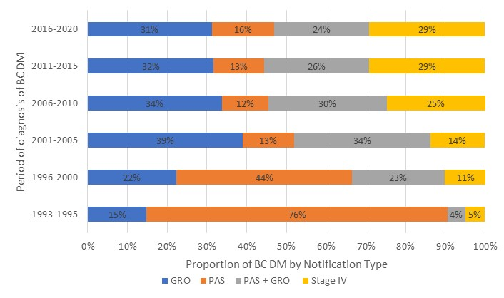
Supplementary Figure 2 Proportion of progressive BCDM patients by notification type and period of diagnosis.
