SUPPLEMENTAL MATERIAL

Genetically Determined Telomere Length and Risk for Haematologic Diseases: Results from Large Prospective Cohorts and Mendelian Randomization Analysis

Yang Li^{1,2*}, Jia Chen^{1,2*}, Ting Sun^{1,2*}, Rongfeng Fu^{1,2}, Xiaofan Liu^{1,2}, Feng Xue^{1,2}, Wei Liu^{1,2}, Yunfei Chen^{1,2}, Mankai Ju^{1,2}, Xinyue Dai^{1,2}, Huiyuan Li^{1,2}, Wentian Wang^{1,2}, Ying Chi^{1,2}, Lei Zhang^{1,2}

1.State Key Laboratory of Experimental Hematology, National Clinical Research Center for Blood Diseases, Haihe Laboratory of Cell Ecosystem, Institute of Hematology & Blood Diseases Hospital, Chinese Academy of Medical Sciences & Peking Union Medical College, Tianjin Key Laboratory of Gene Therapy for Blood Diseases, CAMS Key Laboratory of Gene Therapy for Blood Diseases, Tianjin 300020, China;
2. Tianjin Institutes of Health Science, Tianjin 301600, China;
3. School of Population Medicine and Public Health, Chinese Academy of Medical Sciences & Peking Union Medical College, Beijing 100730, China.
*Yang Li, Jia Chen and Ting Sun contributed equally to this study and should be regarded as co-first authors.
Correspondence:
Lei Zhang, State Key Laboratory of Experimental Hematology, National Clinical Research Center for Blood Diseases, Haihe Laboratory of Cell Ecosystem, Institute of Hematology & Blood Diseases Hospital, Chinese Academy of Medical Sciences & Peking Union Medical College, Tianjin Key Laboratory of Gene Therapy for Blood Diseases, CAMS Key Laboratory of Gene Therapy for Blood Diseases, Tianjin 300020, China; Tianjin Institutes of Health Science, Tianjin 301600, China. Email: zhanglei1@ihcams.ac.cn.

Supplementary Materials
Supplementary Table 1. Index instrumental SNPs for telomere length and the effects, standard errors on haematologic diseases in the discovery analysis.
Supplementary Table 2. Index instrumental SNPs for telomere length and the effects, standard errors on haematologic diseases in the validation analysis.
Supplementary Table 3. Index instrumental SNPs for DNA methylation GrimAge acceleration and the effects, standard errors on haematologic diseases in the discovery analysis.
Supplementary Table 4. Index instrumental SNPs for five epigenetic age acceleration and the effects, standard errors on haematologic diseases in the validation analysis.
Supplementary Table 5. Index instrumental SNPs for DNA methylation Hannum age acceleration and the effects, standard errors on haematologic diseases in the discovery analysis.
Supplementary Table 6. Index instrumental SNPs for Intrinsic epigenetic age acceleration and the effects, standard errors on haematologic diseases in the discovery analysis.
Supplementary Table 7. Index instrumental SNPs for DNA methylation-estimated plasminogen activator inhibitor-1 levels and the effects, standard errors on haematologic diseases in the discovery analysis.
Supplementary Table 8. Index instrumental SNPs for DNA methylation PhenoAge acceleration and the effects, standard errors on haematologic diseases in the discovery analysis.
Supplementary Table 9. Two-sample single-variable estimates of genetically predicted telomere length on each haematologic disease outcome using various Mendelian randomisation methods.
Supplementary Table 10. Two-sample single-variable estimates of genetically predicted five epigenetic age acceleration on each haematologic disease outcome using various Mendelian randomisation methods.
Supplementary Table 11. Index instrumental SNPs for exposures and outcomes in the multivariable Mendelian randomisation analysis in the discovery analysis.
Supplementary Table 12. Index instrumental SNPs for exposures and outcomes in the multivariable Mendelian randomisation analysis in the validation analysis.
Supplementary Table 13. Multivariable estimates of genetically predicted telomere length and five epigenetic age acceleration on each haematologic disease outcome using various Mendelian randomisation methods.
Supplementary Table 14. The ranking of models for haematologic diseases using all instrumental variables in the multivariable Mendelian randomisation analysis.
Supplementary Figure 1. A fishbone diagram to demonstrate which specific haematologic diseases constitute each of the 59 GWAS summary statistics in this study.
Supplementary Figure 2. Two-sample single-variable Mendelian randomisation results of telomere length and five epigenetic age acceleration on risk of multiple haematologic diseases in the discovery cohort. (a) The association between genetically increased telomere length and odds of haematologic diseases. (b) The association between genetically predicted DNA methylation GrimAge acceleration and odds of haematologic diseases. (c) The association between genetically predicted DNA methylation Hannum age acceleration and odds of haematologic diseases. (d) The association between genetically predicted Intrinsic epigenetic age acceleration and odds of haematologic diseases. (e) The association between genetically predicted DNAm PAI-1 levels and odds of haematologic diseases. (f) The association between genetically predicted DNA methylation PhenoAge acceleration and odds of haematologic diseases.
Supplementary Figure 3. Scatterplot of associations of genetic risk of telomere length on risk of 10 haematological malignancies.
Supplementary Figure 4. Two-sample single-variable Mendelian randomisation results of telomere length and five epigenetic age acceleration on risk of multiple haematologic diseases in the validation cohort.
Supplementary Figure 5. Multivariable Mendelian randomisation results of telomere length and five epigenetic age acceleration on risk of multiple haematologic diseases in the validation cohort.
Supplementary Figure 6. Model diagnostics in multivariable MR based on BMA.The predicted associations with haematologic diseases based on the model including telomere length (x-axis) are plotted against the observed associations with haematologic diseases (y-axis). These are the top models when keeping outliers and influential genetic variants in the analysis. (a) Cook's distance for the influential points; (b) the q-statistic for outliers. Any genetic variant with q value larger than threshold or Cook's distance larger than the median of the relevant F-distribution is marked by a label indicating the gene region.

Supplementary Table 1-13 displayed in Supplementary Table 1-13.xlsx

Supplementary Table 14. The ranking of models for haematologic diseases using all instrumental variables in the multivariable Mendelian randomisation analysis.
 | Model | PP | casual effect | Risk factor | MIP | Model-averaged causal effect | Empirical p-value | FDR
Discovery cohort
Lymphoid leukaemia (SNP=144)
1 | telomere length | 0.888 | 0.829 | GrimAge acceleration | 4.88E-02 | 0.007 | 0.99020098 | 0.99990001
2 | GrimAge acceleration, telomere length | 0.046 | 0.14,0.847 | Hannum age acceleration | 3.90E-02 | 0.004 | 0.98860114 | 0.99990001
3 | Hannum age acceleration, telomere length | 0.035 | 0.103,0.826 | Intrinsic epigenetic age acceleration | 1.39E-02 | 0 | 0.99940006 | 0.99990001
4 | PhenoAge acceleration, telomere length | 0.013 | 0.035,0.843 | DNAm PAI-1 | 3.50E-05 | 0 | 0.99990001 | 0.99990001
5 | Intrinsic epigenetic age acceleration, telomere length | 0.012 | -0.026,0.839 | PhenoAge acceleration | 1.49E-02 | 0 | 0.99990001 | 0.99990001
6 | GrimAge acceleration, Hannum age acceleration, telomere length | 0.001 | 0.085,0.072,0.837 | telomere length | 9.98E-01 | 0.828 | 0.00009999 | 0.00059994
7 | Hannum age acceleration, Intrinsic epigenetic age acceleration, telomere length | 0.001 | 0.158,-0.085,0.856
8 | Hannum age acceleration | 0.001 | 0.107
9 | GrimAge acceleration, Intrinsic epigenetic age acceleration, telomere length | 0.001 | 0.157,-0.043,0.865
10 | GrimAge acceleration | 0.001 | 0.113
Chronic lymphocytic leukaemia (SNP=144)
1 | telomere length | 0.543 | 0.752 | GrimAge acceleration | 8.95E-02 | 0.016 | 0.96670333 | 0.9939006
2 | Hannum age acceleration,telomere length | 0.112 | 0.248,0.747 | Hannum age acceleration | 2.44E-01 | 0.061 | 0.1539846 | 0.4619538
3 | Hannum age acceleration | 0.109 | 0.251 | Intrinsic epigenetic age acceleration | 3.28E-02 | -0.001 | 0.99390061 | 0.9939006
4 | PhenoAge acceleration,telomere length | 0.067 | 0.19,0.815 | DNAm PAI-1 | 7.90E-05 | 0 | 0.99130087 | 0.9939006
5 | GrimAge acceleration,telomere length | 0.041 | 0.215,0.775 | PhenoAge acceleration | 1.24E-01 | 0.022 | 0.5270473 | 0.9939006
6 | PhenoAge acceleration | 0.041 | 0.164 | telomere length | 7.92E-01 | 0.601 | 0.01249875 | 0.0749925
7 | GrimAge acceleration | 0.034 | 0.19
8 | Intrinsic epigenetic age acceleration | 0.011 | 0.03
9 | Intrinsic epigenetic age acceleration,telomere length | 0.01 | 0.011,0.749
10 | GrimAge acceleration,Hannum age acceleration,telomere length | 0.005 | 0.049,0.231,0.752
Myeloid leukaemia (SNP=144)
1 | telomere length | 0.42 | 0.244 | GrimAge acceleration | 0.208431885 | 0.014 | 0.5234477 | 0.5936406
2 | GrimAge acceleration | 0.177 | 0.061 | Hannum age acceleration | 0.164411245 | -0.012 | 0.3907609 | 0.5936406
3 | Hannum age acceleration | 0.138 | -0.068 | Intrinsic epigenetic age acceleration | 0.116602216 | 0.005 | 0.4969503 | 0.5936406
4 | PhenoAge acceleration | 0.098 | -0.019 | DNAm PAI-1 | 0.000587584 | 0 | 0.1846815 | 0.5717428
5 | Intrinsic epigenetic age acceleration | 0.098 | 0.039 | PhenoAge acceleration | 0.116695689 | -0.002 | 0.5936406 | 0.5936406
6 | GrimAge acceleration,telomere length | 0.015 | 0.069,0.251 | telomere length | 0.4638648 | 0.113 | 0.1905809 | 0.5717428
7 | Hannum age acceleration,telomere length | 0.011 | -0.069,0.246
8 | PhenoAge acceleration,telomere length | 0.008 | -0.012,0.24
9 | Intrinsic epigenetic age acceleration,telomere length | 0.008 | 0.033,0.234
10 | GrimAge acceleration,Hannum age acceleration | 0.007 | 0.148,-0.121
Chronic myeloid leukaemia (SNP=144)
1 | telomere length | 0.23 | 0.142 | GrimAge acceleration | 0.201249879 | 0.026 | 0.70242976 | 0.7147285
2 | PhenoAge acceleration | 0.208 | -0.197 | Hannum age acceleration | 0.263863346 | -0.057 | 0.15308469 | 0.3061694
3 | Hannum age acceleration | 0.203 | -0.21 | Intrinsic epigenetic age acceleration | 0.116575415 | -0.008 | 0.71472853 | 0.7147285
4 | GrimAge acceleration | 0.141 | 0.092 | DNAm PAI-1 | 0.001476633 | 0 | 0.07179282 | 0.3061694
5 | Intrinsic epigenetic age acceleration | 0.088 | -0.078 | PhenoAge acceleration | 0.264217474 | -0.052 | 0.11978802 | 0.3061694
6 | GrimAge acceleration,Hannum age acceleration | 0.02 | 0.284,-0.304 | telomere length | 0.290417999 | 0.041 | 0.71342866 | 0.7147285
7 | Hannum age acceleration,telomere length | 0.018 | -0.21,0.146
8 | PhenoAge acceleration,telomere length | 0.017 | -0.194,0.098
9 | GrimAge acceleration,PhenoAge acceleration | 0.016 | 0.224,-0.241
10 | GrimAge acceleration,telomere length | 0.012 | 0.096,0.149
Multiple myeloma and malignant plasma cell neoplasms (SNP=144)
1 | telomere length | 0.473 | 0.329 | GrimAge acceleration | 0.196592943 | 0.026 | 0.5282472 | 0.7923708
2 | GrimAge acceleration | 0.153 | 0.135 | Hannum age acceleration | 0.159089684 | 0.016 | 0.3612639 | 0.7225277
3 | Hannum age acceleration | 0.127 | 0.103 | Intrinsic epigenetic age acceleration | 0.130148145 | 0.01 | 0.3056694 | 0.7225277
4 | Intrinsic epigenetic age acceleration | 0.105 | 0.081 | DNAm PAI-1 | 0.000142816 | 0 | 0.8963104 | 0.9140086
5 | PhenoAge acceleration | 0.046 | 0.038 | PhenoAge acceleration | 0.06160903 | 0.002 | 0.9140086 | 0.9140086
6 | GrimAge acceleration,telomere length | 0.031 | 0.146,0.347 | telomere length | 0.551498479 | 0.182 | 0.1346865 | 0.7225277
7 | Hannum age acceleration,telomere length | 0.021 | 0.102,0.325
8 | Intrinsic epigenetic age acceleration,telomere length | 0.015 | 0.073,0.301
9 | PhenoAge acceleration,telomere length | 0.009 | 0.049,0.348
10 | GrimAge acceleration,Hannum age acceleration | 0.004 | 0.079,0.074
Acute lymphocytic leukaemia (SNP=142)
1 | telomere length | 0.616 | 0.589 | GrimAge acceleration | 0.089399298 | 0 | 0.97970203 | 0.97970203
2 | Intrinsic epigenetic age acceleration | 0.078 | -0.134 | Hannum age acceleration | 0.098818365 | -0.011 | 0.918708129 | 0.97970203
3 | Hannum age acceleration | 0.059 | -0.117 | Intrinsic epigenetic age acceleration | 0.141903499 | -0.02 | 0.358264174 | 0.97970203
4 | GrimAge acceleration | 0.052 | -0.012 | DNAm PAI-1 | 0.000165196 | 0 | 0.935606439 | 0.97970203
5 | Intrinsic epigenetic age acceleration,telomere length | 0.05 | -0.152,0.632 | PhenoAge acceleration | 0.07720873 | -0.007 | 0.935406459 | 0.97970203
6 | PhenoAge acceleration | 0.048 | -0.096 | telomere length | 0.747958317 | 0.443 | 0.01079892 | 0.064793521
7 | Hannum age acceleration,telomere length | 0.029 | -0.12,0.594
8 | GrimAge acceleration,telomere length | 0.025 | 0.004,0.59
9 | PhenoAge acceleration,telomere length | 0.02 | -0.078,0.568
10 | GrimAge acceleration,Intrinsic epigenetic age acceleration | 0.003 | 0.033,-0.137
Essential thrombocythaemia (SNP=144)
1 | telomere length | 0.67 | 0.703 | GrimAge acceleration | 0.068293967 | 0.008 | 0.9810019 | 0.98390161
2 | Intrinsic epigenetic age acceleration | 0.08 | 0.16 | Hannum age acceleration | 0.106685173 | 0.018 | 0.818418158 | 0.98390161
3 | Hannum age acceleration | 0.057 | 0.169 | Intrinsic epigenetic age acceleration | 0.132712693 | 0.02 | 0.318968103 | 0.95690431
4 | Intrinsic epigenetic age acceleration,telomere length | 0.042 | 0.143,0.654 | DNAm PAI-1 | 0.000115504 | 0 | 0.949705029 | 0.98390161
5 | Hannum age acceleration,telomere length | 0.041 | 0.167,0.699 | PhenoAge acceleration | 0.03848273 | 0.002 | 0.98390161 | 0.98390161
6 | GrimAge acceleration | 0.033 | 0.112 | telomere length | 0.802415141 | 0.563 | 0.01889811 | 0.113388661
7 | GrimAge acceleration,telomere length | 0.027 | 0.134,0.719
8 | PhenoAge acceleration | 0.017 | 0.051
9 | PhenoAge acceleration,telomere length | 0.015 | 0.075,0.731
10 | GrimAge acceleration,Intrinsic epigenetic age acceleration | 0.002 | 0.055,0.155
Malignant immunoproliferative diseases (SNP=144)
1 | telomere length | 0.483 | 0.488 | GrimAge acceleration | 0.180803753 | -0.022 | 0.804819518 | 0.900009999
2 | GrimAge acceleration | 0.133 | -0.118 | Hannum age acceleration | 0.118309797 | -0.003 | 0.900009999 | 0.900009999
3 | PhenoAge acceleration | 0.097 | 0.107 | Intrinsic epigenetic age acceleration | 0.116154802 | 0.01 | 0.709329067 | 0.900009999
4 | Intrinsic epigenetic age acceleration | 0.086 | 0.091 | DNAm PAI-1 | 0.000266574 | 0 | 0.832916708 | 0.900009999
5 | Hannum age acceleration | 0.084 | -0.021 | PhenoAge acceleration | 0.137984703 | 0.016 | 0.561543846 | 0.900009999
6 | GrimAge acceleration,telomere length | 0.026 | -0.105,0.48 | telomere length | 0.569870848 | 0.278 | 0.03269673 | 0.196180382
7 | PhenoAge acceleration,telomere length | 0.022 | 0.123,0.516
8 | Hannum age acceleration,telomere length | 0.017 | -0.022,0.488
9 | Intrinsic epigenetic age acceleration,telomere length | 0.016 | 0.079,0.471
10 | GrimAge acceleration,PhenoAge acceleration | 0.007 | -0.198,0.146
Hodgkin lymphoma (SNP=144)
1 | telomere length | 0.694 | 0.494 | GrimAge acceleration | 0.131960843 | 0.02 | 0.874812519 | 0.96350365
2 | GrimAge acceleration | 0.073 | 0.144 | Hannum age acceleration | 0.064047563 | 0.005 | 0.96350365 | 0.96350365
3 | GrimAge acceleration,telomere length | 0.05 | 0.159,0.512 | Intrinsic epigenetic age acceleration | 0.06132637 | 0.004 | 0.915108489 | 0.96350365
4 | Intrinsic epigenetic age acceleration | 0.038 | 0.075 | DNAm PAI-1 | 0.000220146 | 0 | 0.775422458 | 0.96350365
5 | Hannum age acceleration | 0.037 | 0.075 | PhenoAge acceleration | 0.061278696 | 0.004 | 0.939206079 | 0.96350365
6 | PhenoAge acceleration | 0.032 | 0.065 | telomere length | 0.810976886 | 0.402 | 0.01689831 | 0.101389861
7 | PhenoAge acceleration,telomere length | 0.024 | 0.082,0.523
8 | Hannum age acceleration,telomere length | 0.021 | 0.073,0.492
9 | Intrinsic epigenetic age acceleration,telomere length | 0.018 | 0.063,0.473
10 | GrimAge acceleration,Intrinsic epigenetic age acceleration | 0.002 | 0.121,0.063
Non-follicular lymphoma (SNP=144)
1 | telomere length | 0.893 | 0.345 | GrimAge acceleration | 0.044855477 | 0.002 | 0.9850015 | 0.99350065
2 | GrimAge acceleration | 0.023 | 0.042 | Hannum age acceleration | 0.025161583 | 0 | 0.99350065 | 0.99350065
3 | GrimAge acceleration,telomere length | 0.02 | 0.053,0.353 | Intrinsic epigenetic age acceleration | 0.019097371 | 0 | 0.9930007 | 0.99350065
4 | Hannum age acceleration | 0.014 | -0.01 | DNAm PAI-1 | 7.16E-05 | 0 | 0.96760324 | 0.99350065
5 | PhenoAge acceleration | 0.011 | -0.003 | PhenoAge acceleration | 0.02028864 | 0 | 0.99270073 | 0.99350065
6 | Intrinsic epigenetic age acceleration | 0.011 | 0.011 | telomere length | 0.940209687 | 0.325 | 0.00559944 | 0.03359664
7 | Hannum age acceleration,telomere length | 0.01 | -0.011,0.346
8 | PhenoAge acceleration,telomere length | 0.008 | 0.008,0.349
9 | Intrinsic epigenetic age acceleration,telomere length | 0.008 | 0.002,0.345
10 | GrimAge acceleration,Hannum age acceleration | 0 | 0.069,-0.035
Other and unspecified types of non-Hodgkin lymphoma (SNP=144)
1 | telomere length | 0.829 | 0.519 | GrimAge acceleration | 0.066263903 | -0.004 | 0.97890211 | 0.98710129
2 | GrimAge acceleration | 0.041 | -0.063 | Hannum age acceleration | 0.041619611 | 0 | 0.98690131 | 0.98710129
3 | Hannum age acceleration | 0.025 | -0.004 | Intrinsic epigenetic age acceleration | 0.033841508 | 0.001 | 0.98320168 | 0.98710129
4 | GrimAge acceleration,telomere length | 0.022 | -0.047,0.513 | DNAm PAI-1 | 9.50E-05 | 0 | 0.96490351 | 0.98710129
5 | Intrinsic epigenetic age acceleration | 0.021 | 0.027 | PhenoAge acceleration | 0.034761347 | 0 | 0.98710129 | 0.98710129
6 | PhenoAge acceleration | 0.02 | 0.003 | telomere length | 0.889904428 | 0.462 | 0.00779922 | 0.04679532
7 | Hannum age acceleration,telomere length | 0.014 | -0.006,0.519
8 | PhenoAge acceleration,telomere length | 0.012 | 0.02,0.527
9 | Intrinsic epigenetic age acceleration,telomere length | 0.011 | 0.013,0.514
10 | GrimAge acceleration,Hannum age acceleration | 0.001 | -0.083,0.026
Non-Hodgkin lymphoma (SNP=142)
1 | telomere length | 0.831 | 0.403 | GrimAge acceleration | 0.060600222 | -0.001 | 0.9750025 | 0.97770223
2 | GrimAge acceleration | 0.043 | -0.026 | Hannum age acceleration | 0.041774059 | 0 | 0.97770223 | 0.97770223
3 | Hannum age acceleration | 0.029 | -0.009 | Intrinsic epigenetic age acceleration | 0.034845972 | 0.001 | 0.96350365 | 0.97770223
4 | Intrinsic epigenetic age acceleration | 0.025 | 0.024 | DNAm PAI-1 | 0.000100987 | 0 | 0.946405359 | 0.97770223
5 | PhenoAge acceleration | 0.025 | -0.015 | PhenoAge acceleration | 0.035378092 | 0 | 0.9750025 | 0.97770223
6 | GrimAge acceleration,telomere length | 0.016 | -0.014,0.401 | telomere length | 0.876344013 | 0.353 | 0.01249875 | 0.074992501
7 | Hannum age acceleration,telomere length | 0.011 | -0.011,0.404
8 | PhenoAge acceleration,telomere length | 0.009 | -0.002,0.402
9 | Intrinsic epigenetic age acceleration,telomere length | 0.009 | 0.012,0.398
10 | GrimAge acceleration,Hannum age acceleration | 0.001 | -0.026,0.001
Other and unspecified iron deficiency (SNP=144)
1 | telomere length | 0.56 | 0.162 | GrimAge acceleration | 0.050260874 | 0.001 | 0.96460354 | 0.96460354
2 | PhenoAge acceleration | 0.3 | -0.05 | Hannum age acceleration | 0.038037389 | 0 | 0.96350365 | 0.96460354
3 | GrimAge acceleration | 0.039 | 0.005 | Intrinsic epigenetic age acceleration | 0.0278951 | 0 | 0.95580442 | 0.96460354
4 | Hannum age acceleration | 0.027 | 0.003 | DNAm PAI-1 | 6.97E-05 | 0 | 0.948705129 | 0.96460354
5 | PhenoAge acceleration,telomere length | 0.025 | -0.046,0.141 | PhenoAge acceleration | 0.342379906 | -0.017 | 0.04389561 | 0.263373663
6 | Intrinsic epigenetic age acceleration | 0.02 | -0.004 | telomere length | 0.59730683 | 0.096 | 0.131686831 | 0.395060494
7 | Hannum age acceleration,PhenoAge acceleration | 0.007 | 0.047,-0.07
8 | GrimAge acceleration,PhenoAge acceleration | 0.005 | 0.045,-0.06
9 | GrimAge acceleration,telomere length | 0.005 | 0.01,0.164
10 | Intrinsic epigenetic age acceleration,PhenoAge acceleration | 0.004 | 0.031,-0.069
Other disorders of white blood cells (SNP=144)
1 | telomere length | 0.557 | -0.238 | GrimAge acceleration | 0.142082259 | 0.005 | 0.804719528 | 0.835816418
2 | GrimAge acceleration | 0.121 | 0.038 | Hannum age acceleration | 0.138577344 | 0.008 | 0.514448555 | 0.835816418
3 | Hannum age acceleration | 0.115 | 0.055 | Intrinsic epigenetic age acceleration | 0.101223582 | -0.004 | 0.569043096 | 0.835816418
4 | Intrinsic epigenetic age acceleration | 0.083 | -0.039 | DNAm PAI-1 | 0.000211528 | 0 | 0.745725427 | 0.835816418
5 | PhenoAge acceleration | 0.065 | 0.012 | PhenoAge acceleration | 0.077324307 | 0.001 | 0.835816418 | 0.835816418
6 | GrimAge acceleration,telomere length | 0.013 | 0.031,-0.234 | telomere length | 0.600533535 | -0.143 | 0.098790121 | 0.592740726
7 | Hannum age acceleration,telomere length | 0.013 | 0.056,-0.24
8 | Intrinsic epigenetic age acceleration,telomere length | 0.009 | -0.033,-0.225
9 | PhenoAge acceleration,telomere length | 0.007 | 0.004,-0.236
10 | Hannum age acceleration,Intrinsic epigenetic age acceleration | 0.005 | 0.105,-0.078
Other and unspecified coagulation defects (SNP=144)
1 | telomere length | 0.532 | 0.354 | GrimAge acceleration | 0.100821859 | -0.001 | 0.924507549 | 0.930706929
2 | PhenoAge acceleration | 0.189 | -0.11 | Hannum age acceleration | 0.072453981 | 0.001 | 0.930706929 | 0.930706929
3 | GrimAge acceleration | 0.079 | -0.019 | Intrinsic epigenetic age acceleration | 0.086298649 | -0.005 | 0.723827617 | 0.930706929
4 | Intrinsic epigenetic age acceleration | 0.067 | -0.059 | DNAm PAI-1 | 0.000161278 | 0 | 0.865713429 | 0.930706929
5 | Hannum age acceleration | 0.054 | -0.001 | PhenoAge acceleration | 0.228735122 | -0.025 | 0.116088391 | 0.348265173
6 | PhenoAge acceleration,telomere length | 0.024 | -0.1,0.314 | telomere length | 0.593138861 | 0.209 | 0.102589741 | 0.348265173
7 | Intrinsic epigenetic age acceleration,telomere length | 0.013 | -0.069,0.38
8 | GrimAge acceleration,telomere length | 0.013 | -0.008,0.353
9 | Hannum age acceleration,telomere length | 0.009 | -0.002,0.354
10 | Hannum age acceleration,PhenoAge acceleration | 0.006 | 0.09,-0.147
Validation cohort
Leukaemia (SNP=148)
1 | telomere length | 0.994 | 0.003 | GrimAge acceleration | 7.33E-05 | 0 | 1 | 1
2 | Hannum age acceleration,telomere length | 0.006 | 0.001,0.003 | Hannum age acceleration | 0.006076573 | 0 | 0.99450055 | 1
3 | Hannum age acceleration | 0 | 0.001 | Intrinsic epigenetic age acceleration | 5.77E-05 | 0 | 0.99990001 | 1
4 | GrimAge acceleration,telomere length | 0 | 0,0.003 | DNAm PAI-1 | 7.12E-08 | 0 | 1 | 1
5 | Intrinsic epigenetic age acceleration,telomere length | 0 | 0,0.003 | PhenoAge acceleration | 4.21E-05 | 0 | 1 | 1
6 | PhenoAge acceleration,telomere length | 0 | 0,0.003 | telomere length | 0.99966854 | 0.003 | 1.00E-04 | 0.00059994
7 | Intrinsic epigenetic age acceleration | 0 | 0
8 | GrimAge acceleration | 0 | 0
9 | PhenoAge acceleration | 0 | 0
10 | DNAm PAI-1,telomere length | 0 | 0,0.003
Lymphoid leukaemia (SNP=142)
1 | telomere length | 0.999 | 0.002 | GrimAge acceleration | 5.43E-05 | 0 | 1 | 1
2 | Hannum age acceleration,telomere length | 0.001 | 0,0.002 | Hannum age acceleration | 0.000601037 | 0 | 0.99960004 | 1
3 | Intrinsic epigenetic age acceleration,telomere length | 0 | 0,0.002 | Intrinsic epigenetic age acceleration | 6.38E-05 | 0 | 0.99990001 | 1
4 | GrimAge acceleration,telomere length | 0 | 0,0.002 | DNAm PAI-1 | 1.03E-07 | 0 | 1 | 1
5 | PhenoAge acceleration,telomere length | 0 | 0,0.002 | PhenoAge acceleration | 2.73E-05 | 0 | 1 | 1
6 | Hannum age acceleration | 0 | 0 | telomere length | 0.999993242 | 0.002 | 1.00E-04 | 0.00059994
7 | Intrinsic epigenetic age acceleration | 0 | 0
8 | GrimAge acceleration | 0 | 0
9 | GrimAge acceleration,Hannum age acceleration,telomere length | 0 | -0.001,0.001,0.002
10 | PhenoAge acceleration | 0 | 0
Myeloid leukaemia (SNP=136)
1 | Hannum age acceleration | 0.396 | 0 | GrimAge acceleration | 0.244600518 | 0 | 0.212678732 | 0.638036196
2 | GrimAge acceleration | 0.245 | 0 | Hannum age acceleration | 0.396527757 | 0 | 0.04029597 | 0.241775822
3 | telomere length | 0.212 | 0 | Intrinsic epigenetic age acceleration | 0.08940226 | 0 | 0.461153885 | 0.885611439
4 | Intrinsic epigenetic age acceleration | 0.089 | 0 | DNAm PAI-1 | 0.000180293 | 0 | 0.727327267 | 0.885611439
5 | PhenoAge acceleration | 0.057 | 0 | PhenoAge acceleration | 0.057545961 | 0 | 0.817818218 | 0.885611439
6 | DNAm PAI-1 | 0 | 0 | telomere length | 0.211973011 | 0 | 0.885611439 | 0.885611439
7 | Hannum age acceleration,Intrinsic epigenetic age acceleration | 0 | 0,0
8 | Hannum age acceleration,telomere length | 0 | 0,0
9 | Hannum age acceleration,PhenoAge acceleration | 0 | 0,0
10 | GrimAge acceleration,telomere length | 0 | 0,0
Multiple myeloma (SNP=140)
1 | telomere length | 0.929 | 0.001 | GrimAge acceleration | 0.01714055 | 0 | 0.98760124 | 0.98760124
2 | Hannum age acceleration | 0.033 | 0 | Hannum age acceleration | 0.033561446 | 0 | 0.95380462 | 0.98760124
3 | GrimAge acceleration | 0.017 | 0 | Intrinsic epigenetic age acceleration | 0.008841664 | 0 | 0.98580142 | 0.98760124
4 | PhenoAge acceleration | 0.011 | 0 | DNAm PAI-1 | 4.21E-05 | 0 | 0.96950305 | 0.98760124
5 | Intrinsic epigenetic age acceleration | 0.009 | 0 | PhenoAge acceleration | 0.010938368 | 0 | 0.9860014 | 0.98760124
6 | Hannum age acceleration,telomere length | 0 | 0,0.001 | telomere length | 0.929631457 | 0.001 | 0.00919908 | 0.055194481
7 | DNAm PAI-1 | 0 | 0
8 | GrimAge acceleration,telomere length | 0 | 0,0.001
9 | PhenoAge acceleration,telomere length | 0 | 0,0.001
10 | Intrinsic epigenetic age acceleration,telomere length | 0 | 0,0.001
Lymphomas (SNP=148)
1 | telomere length | 0.609 | 0.001 | GrimAge acceleration | 0.178661438 | 0 | 0.505249475 | 0.903609639
2 | GrimAge acceleration | 0.178 | 0.001 | Hannum age acceleration | 0.124802125 | 0 | 0.486551345 | 0.903609639
3 | Hannum age acceleration | 0.125 | 0 | Intrinsic epigenetic age acceleration | 0.037083847 | 0 | 0.903609639 | 0.903609639
4 | PhenoAge acceleration | 0.05 | 0 | DNAm PAI-1 | 0.000122268 | 0 | 0.779222078 | 0.903609639
5 | Intrinsic epigenetic age acceleration | 0.037 | 0 | PhenoAge acceleration | 0.050356577 | 0 | 0.865713429 | 0.903609639
6 | GrimAge acceleration,telomere length | 0 | 0.001,0.002 | telomere length | 0.609418425 | 0.001 | 0.128887111 | 0.773322668
7 | DNAm PAI-1 | 0 | 0
8 | Hannum age acceleration,telomere length | 0 | 0,0.001
9 | PhenoAge acceleration,telomere length | 0 | 0,0.002
10 | Intrinsic epigenetic age acceleration,telomere length | 0 | 0,0.001
Top ten models (combination of risk factors) ranked by the model posterior probability and all risk factors ranked by the marginal inclusion probability based on all genetic variants. Causal effects are log odds ratios for haematologic diseases. Empirical P-values are computed using 200 permutations and adjustment for multiple testing via the Benjamini and Hochberg false discovery rate (FDR) procedure. SNP=single nucleotide polymorphism, PP=posterior probability, MIP =Marginal inclusion probability, DNAm PAI-1= DNA methylation-estimated plasminogen activator inhibitor-1.
Supplementary Figure 1. A fishbone diagram to demonstrate which specific haematologic diseases constitute each of the 59 GWAS summary statistics in this study.
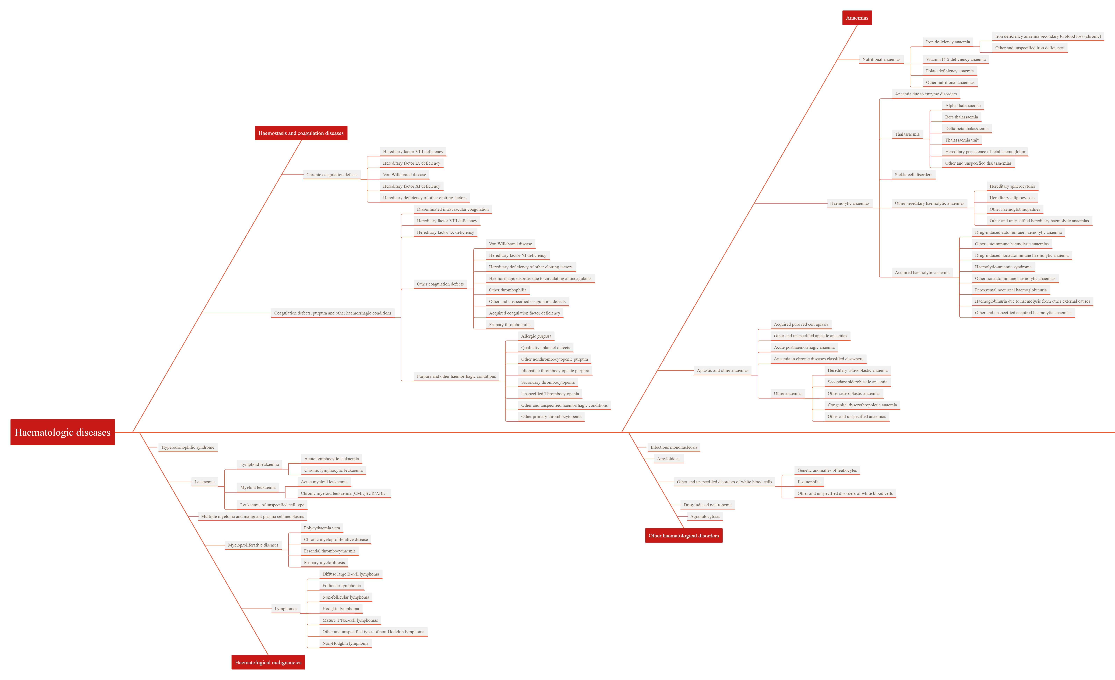
Note:
The term “malignant immunoproliferative disease” in FinnGen is defined as “A malignant (clonal) proliferation of B- lymphocytes or T- lymphocytes which involves the lymph nodes, bone marrow and/or extranodal sites”.
Supplementary Figure 2. Two-sample single-variable Mendelian randomisation results of telomere length and five epigenetic age acceleration on risk of multiple haematologic diseases in the discovery cohort. (a) The association between genetically increased telomere length and odds of haematologic diseases. (b) The association between genetically predicted DNA methylation GrimAge acceleration and odds of haematologic diseases. (c) The association between genetically predicted DNA methylation Hannum age acceleration and odds of haematologic diseases. (d) The association between genetically predicted Intrinsic epigenetic age acceleration and odds of haematologic diseases. (e) The association between genetically predicted DNAm PAI-1 levels and odds of haematologic diseases. (f) The association between genetically predicted DNA methylation PhenoAge acceleration and odds of haematologic diseases.DNAm PAI-1, DNA methylation-estimated plasminogen activator inhibitor-1; nSNP, number of single nucleotide polymorphism; OR, odds ratio; 95%CI, The 95% confidence intervals.

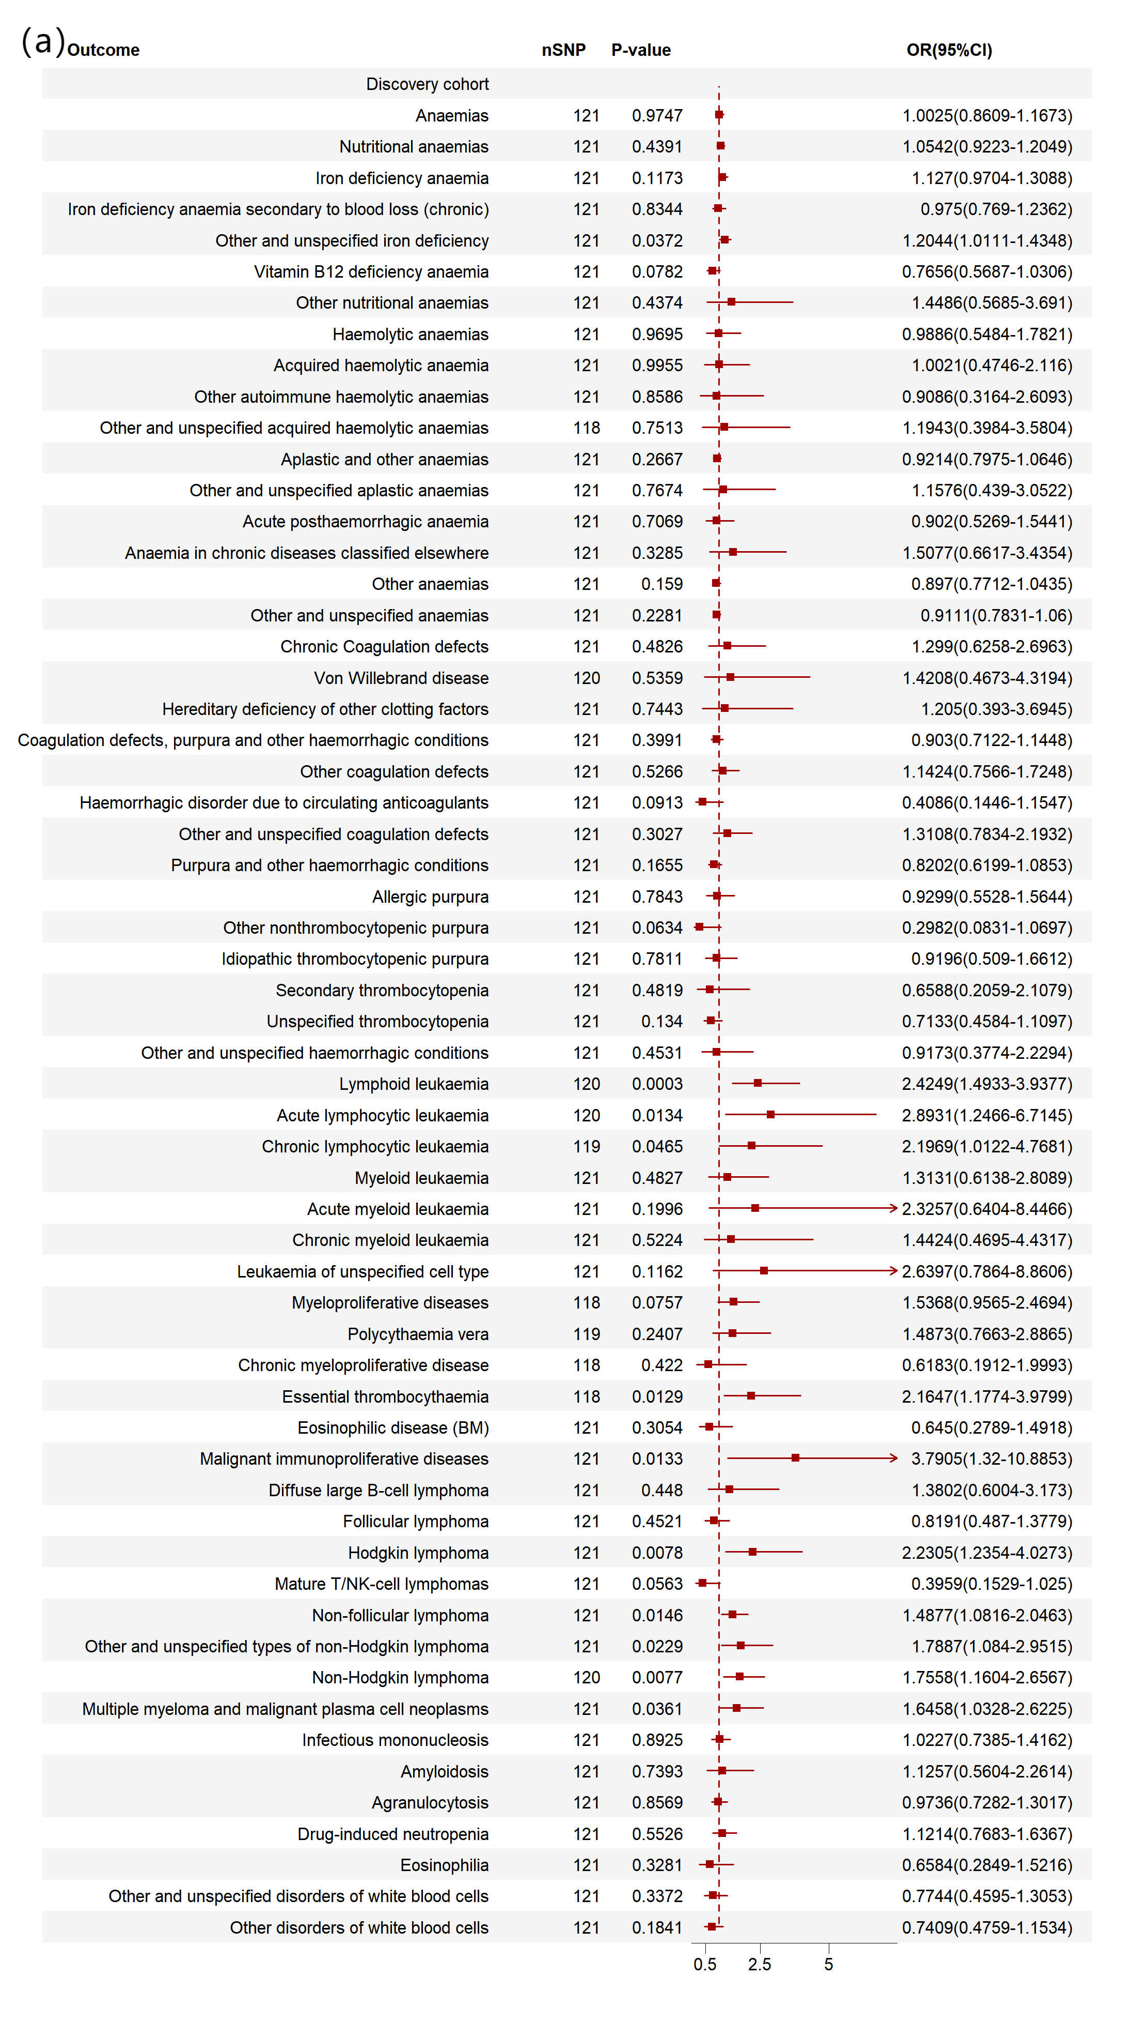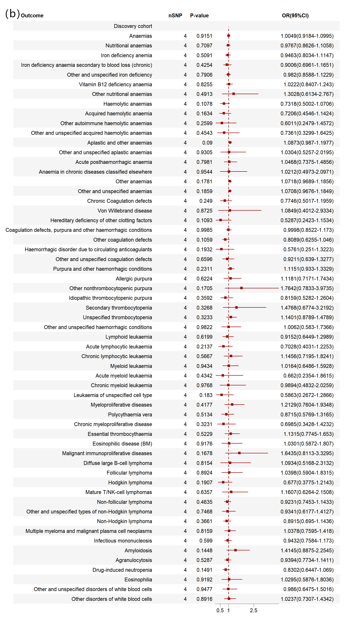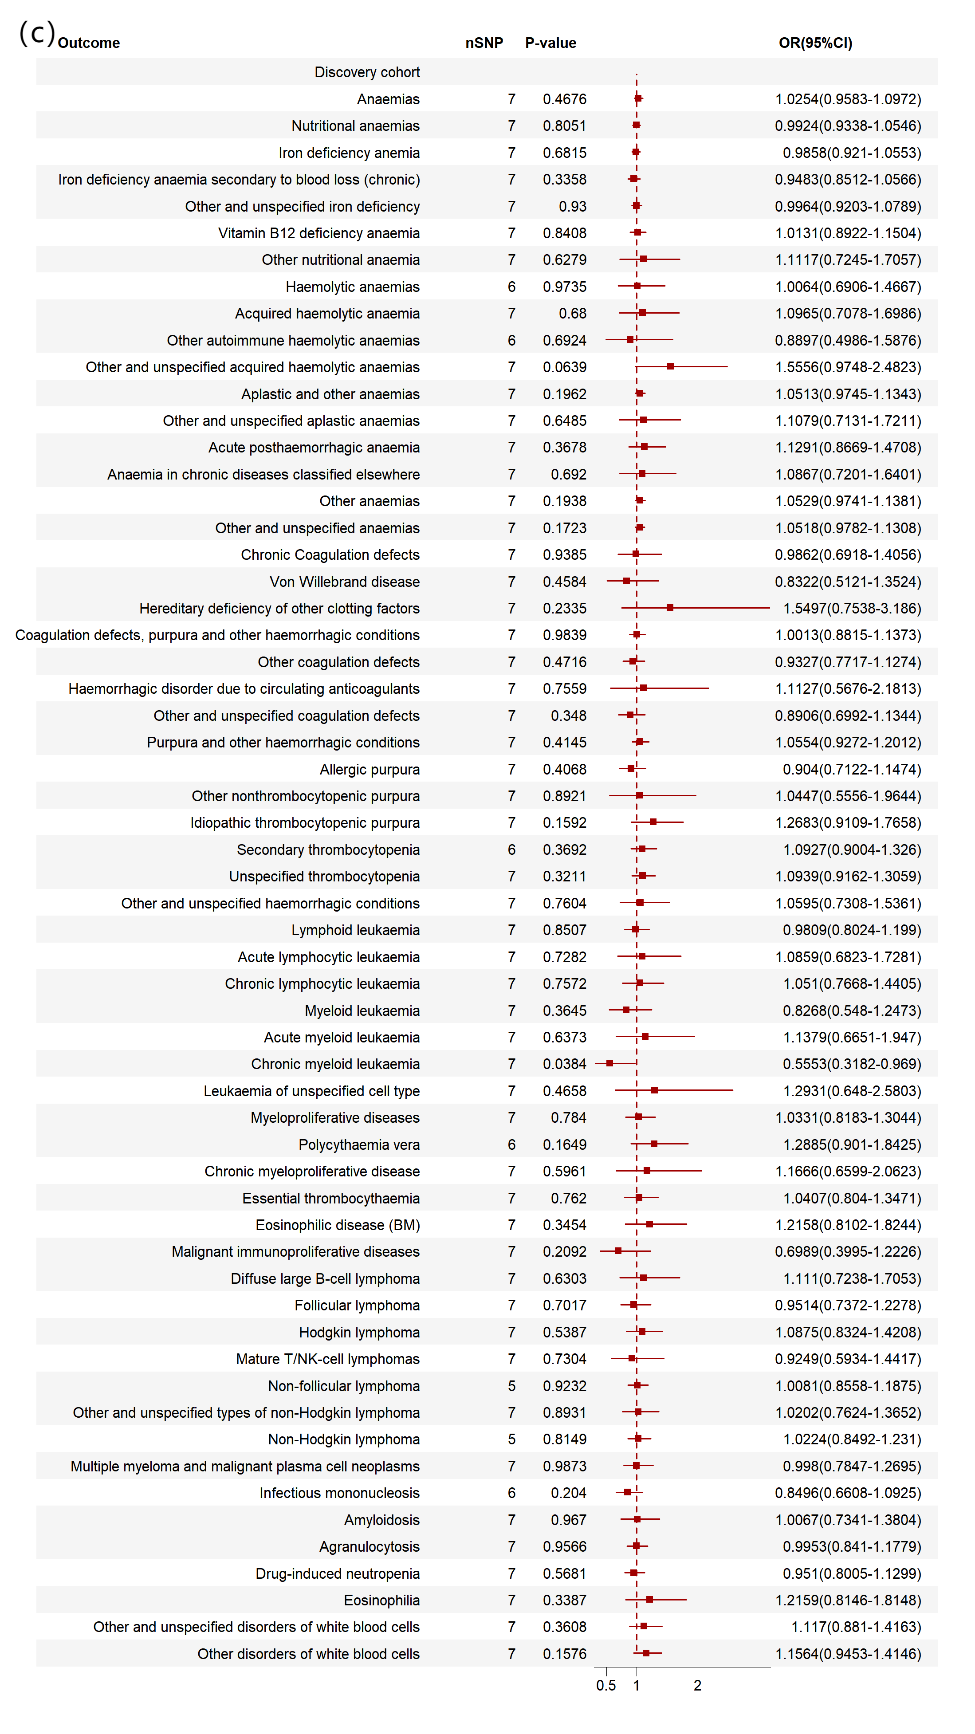
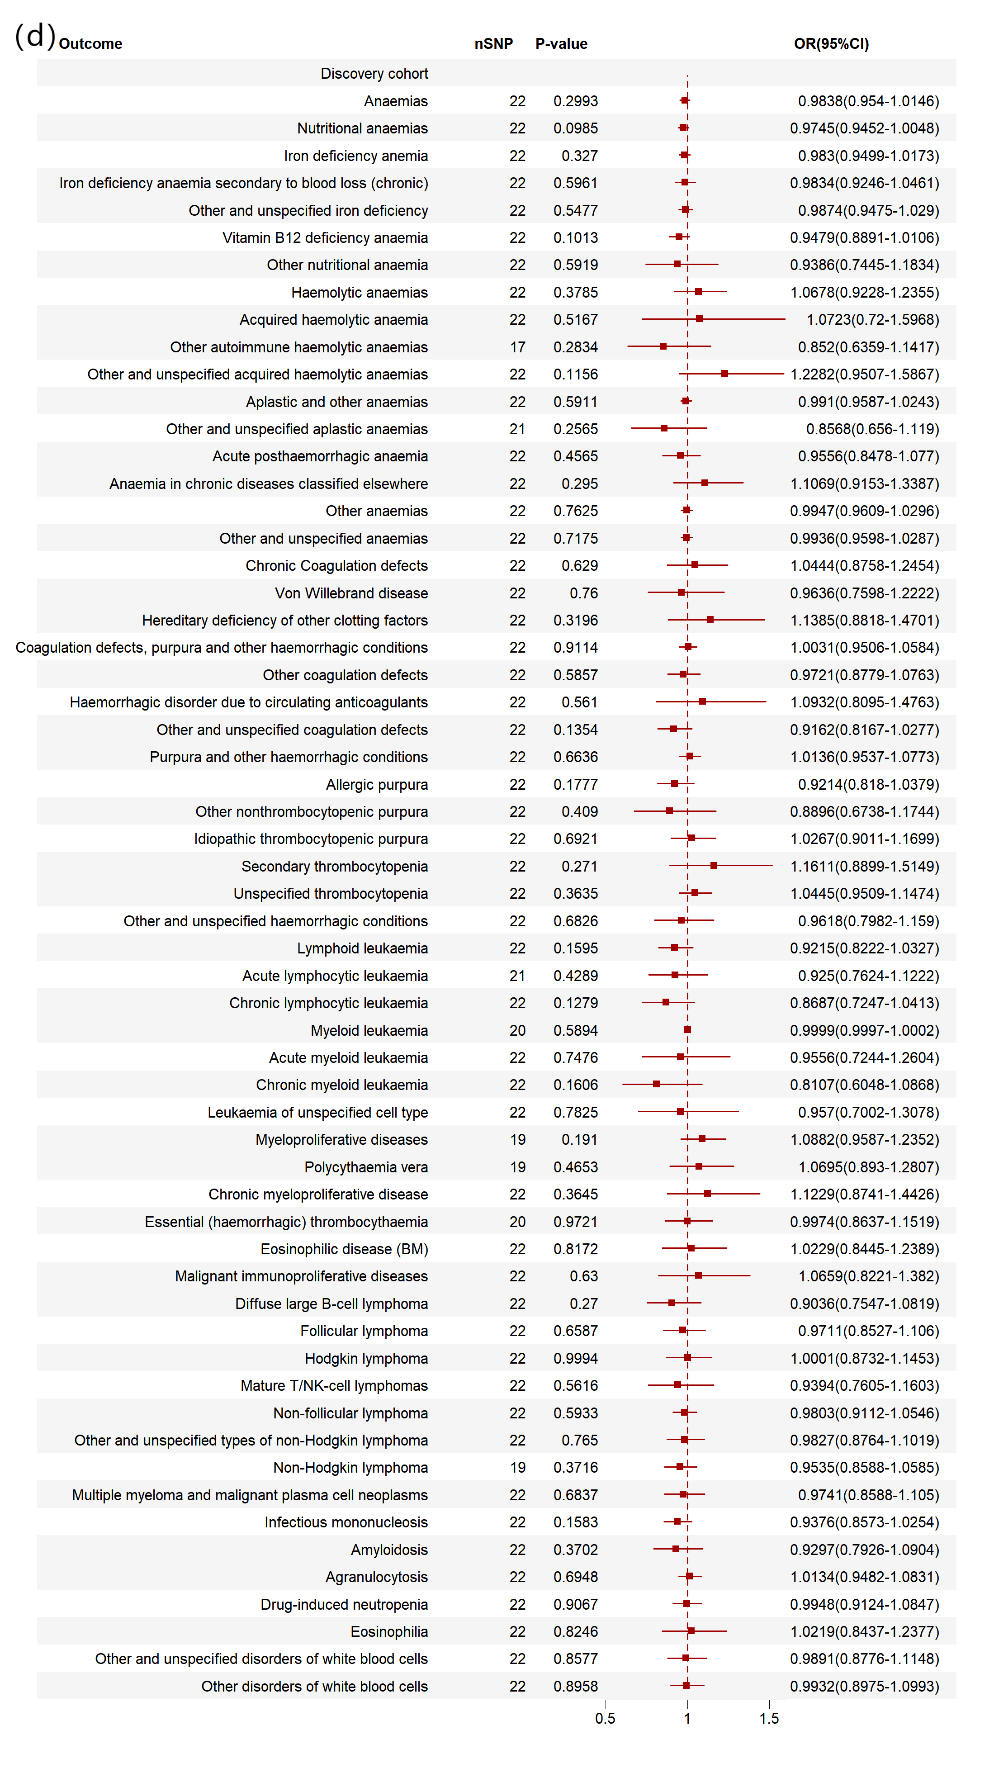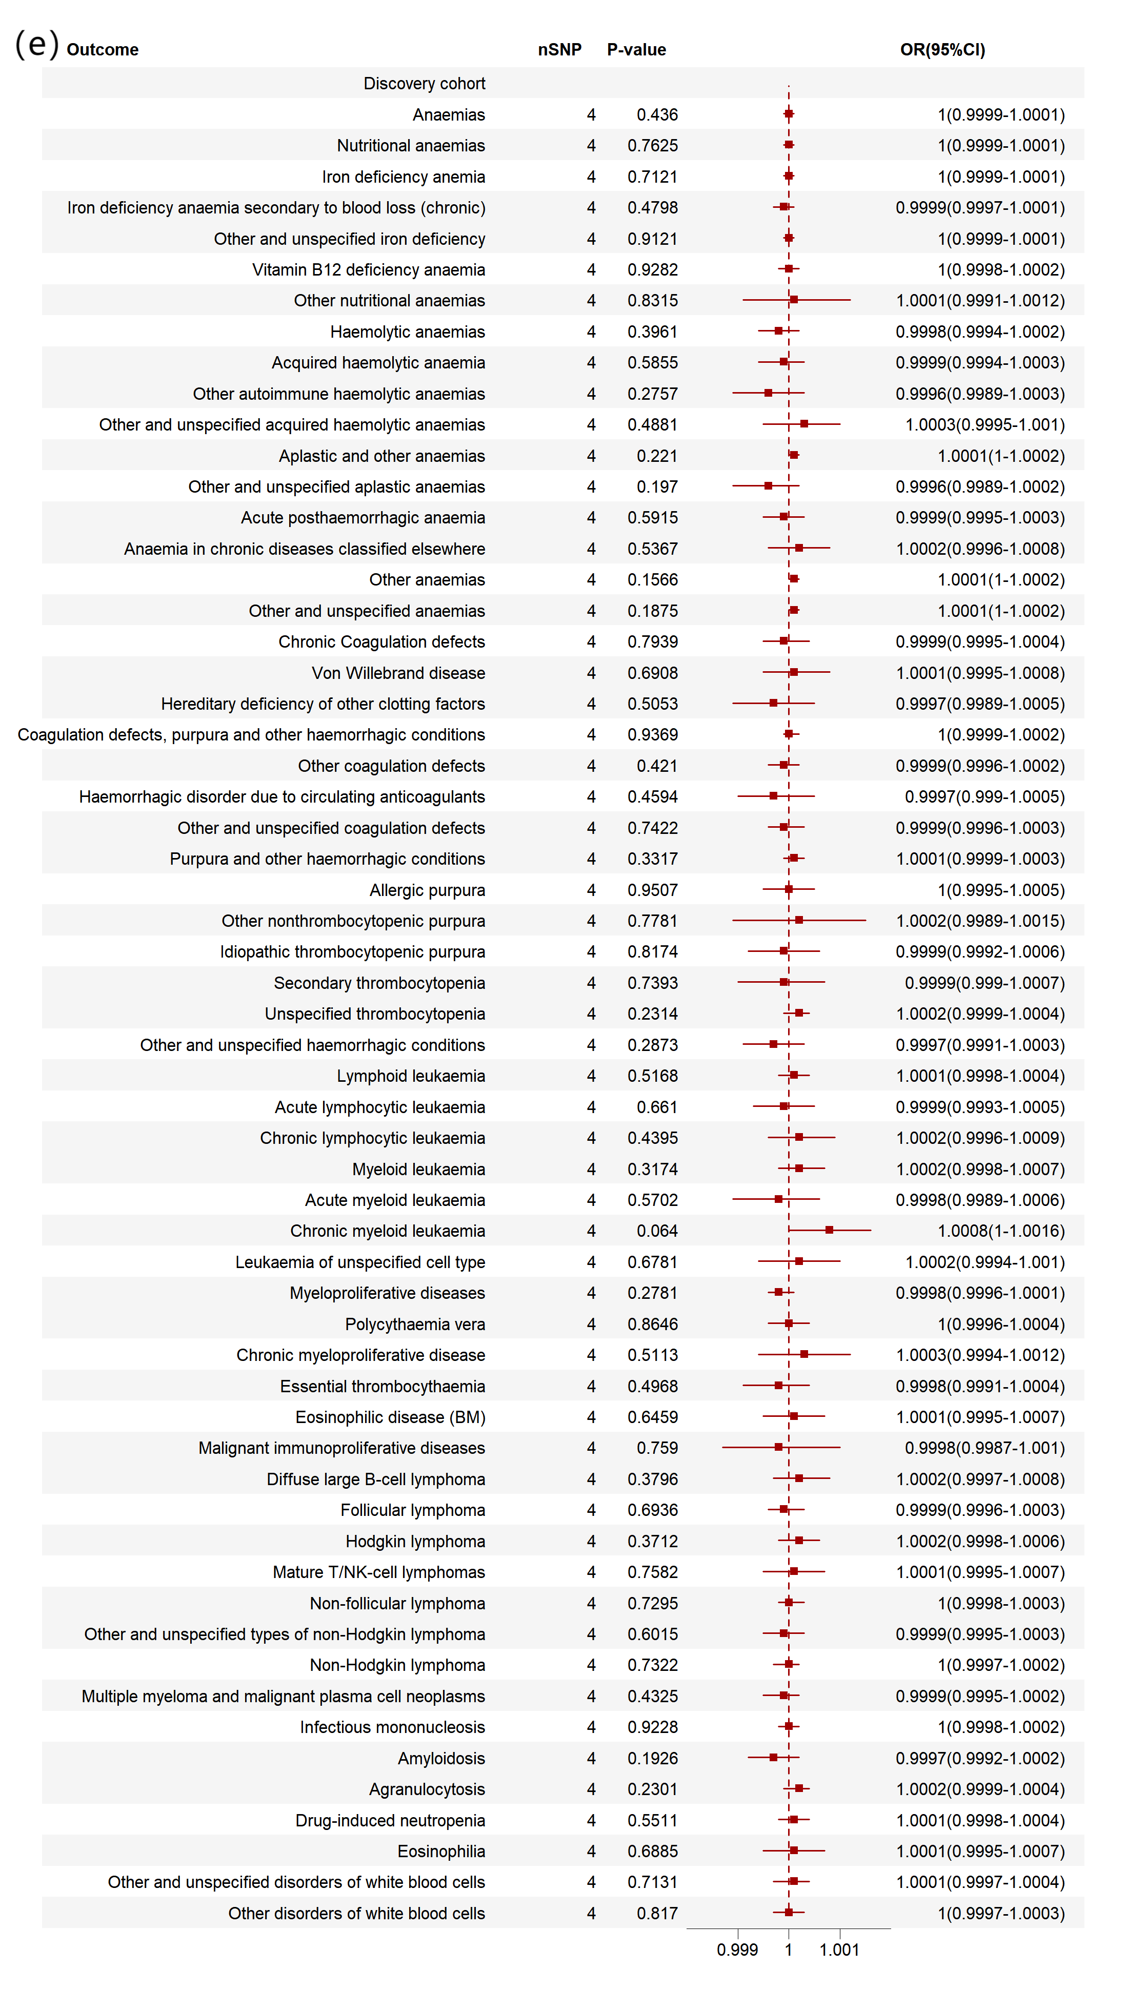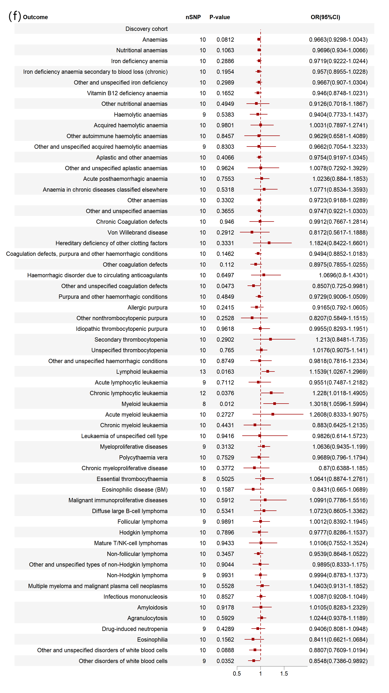
Supplementary Figure 3. Scatterplot of associations of genetic risk of telomere length on risk of 10 haematological malignancies.
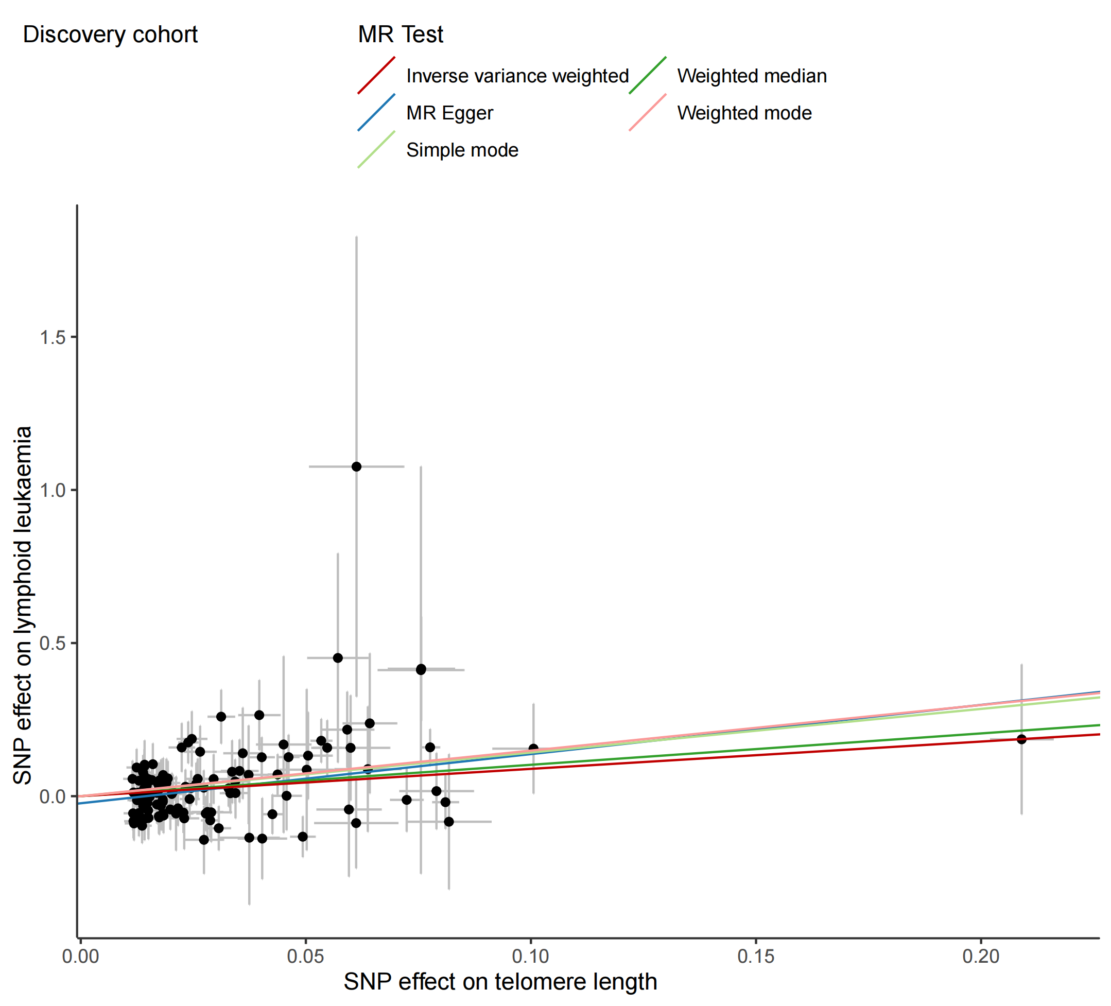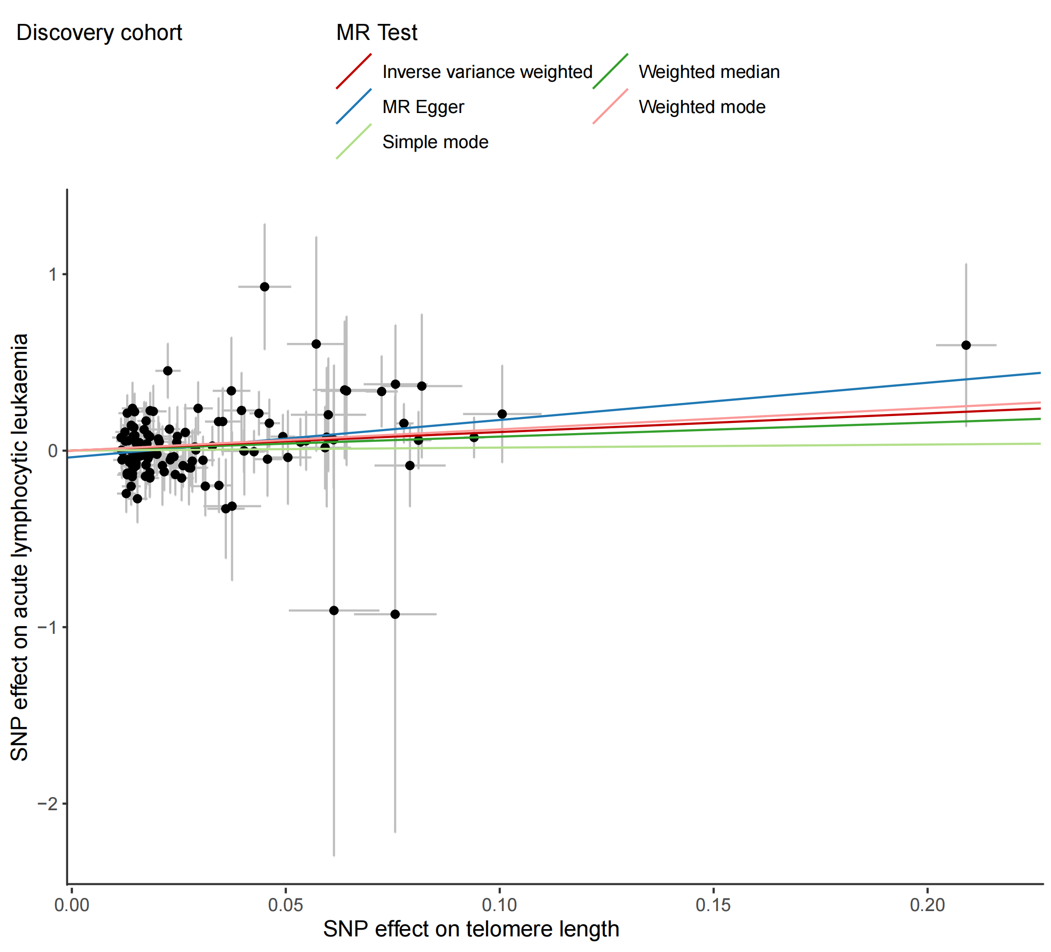

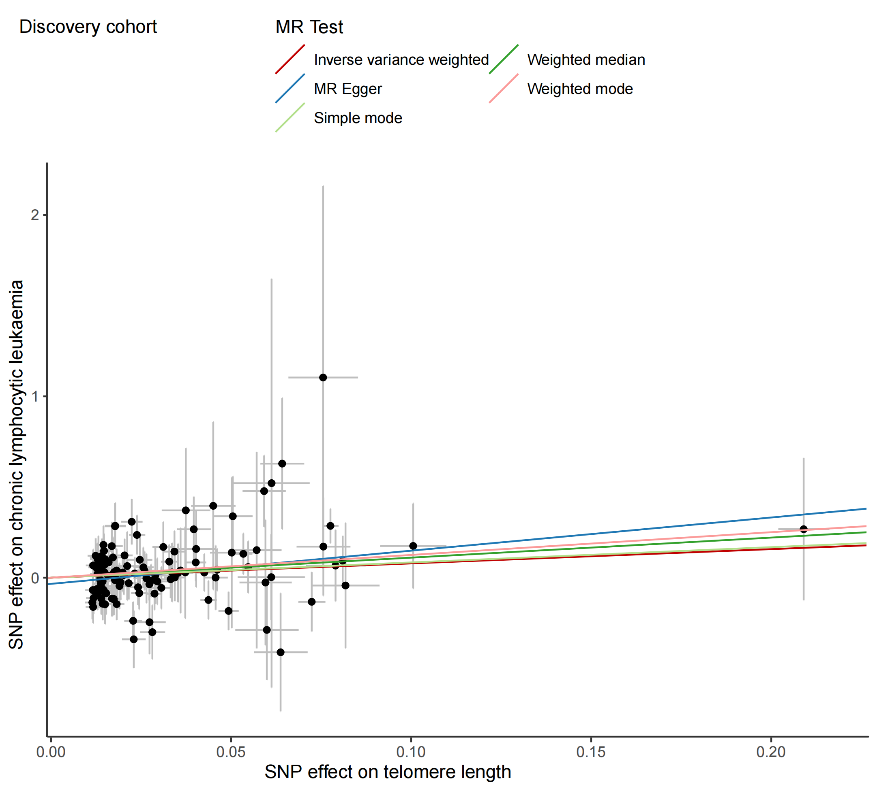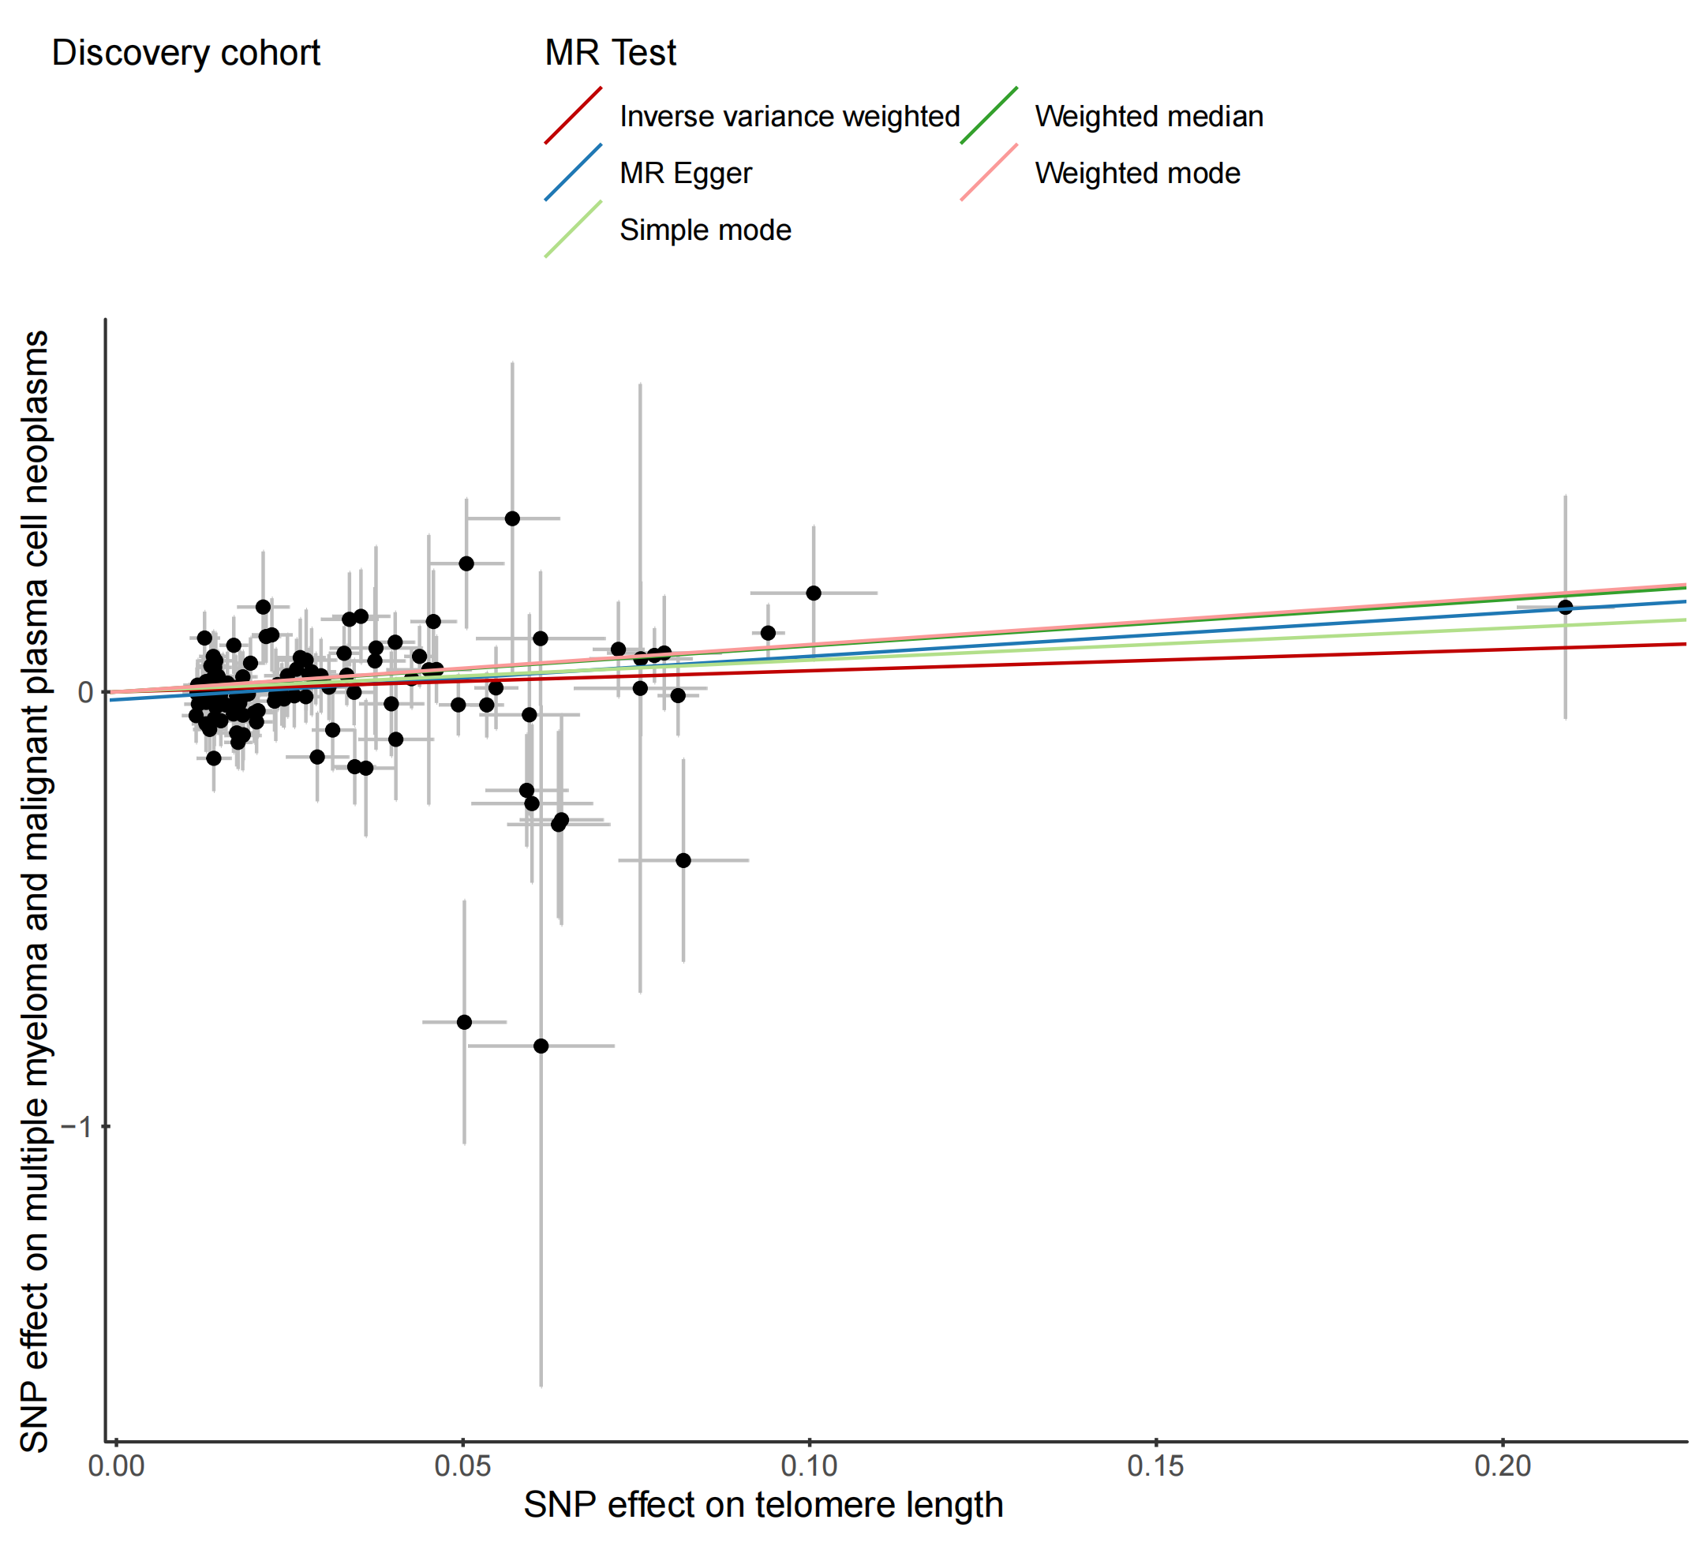

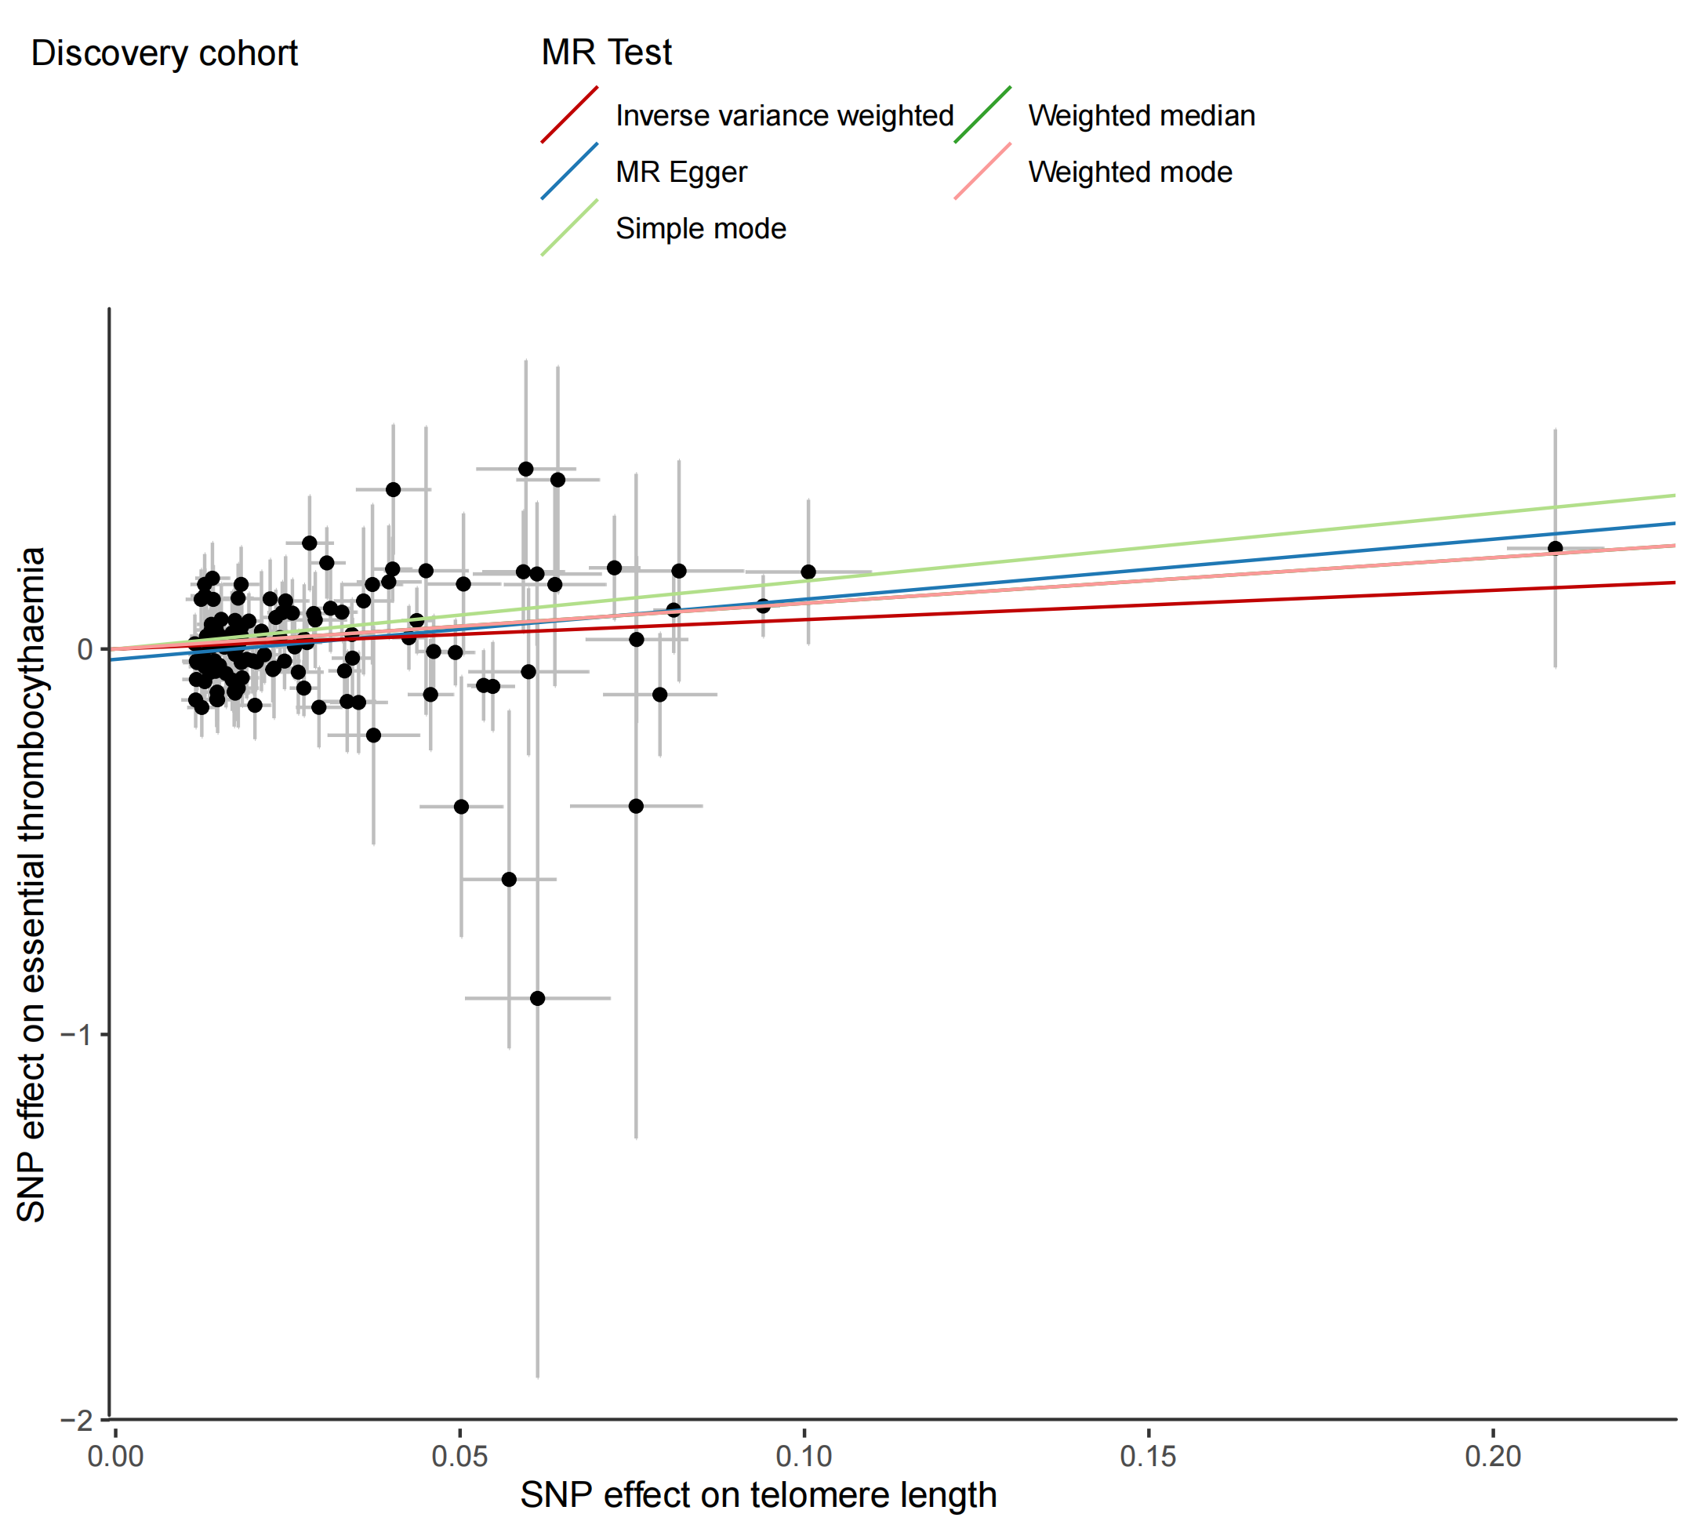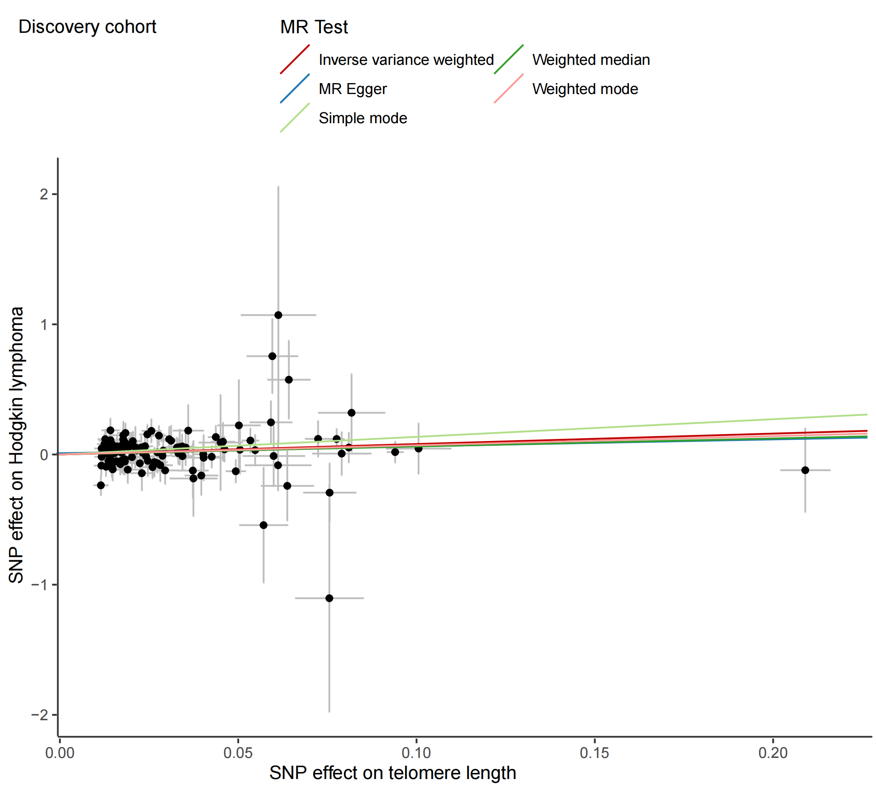

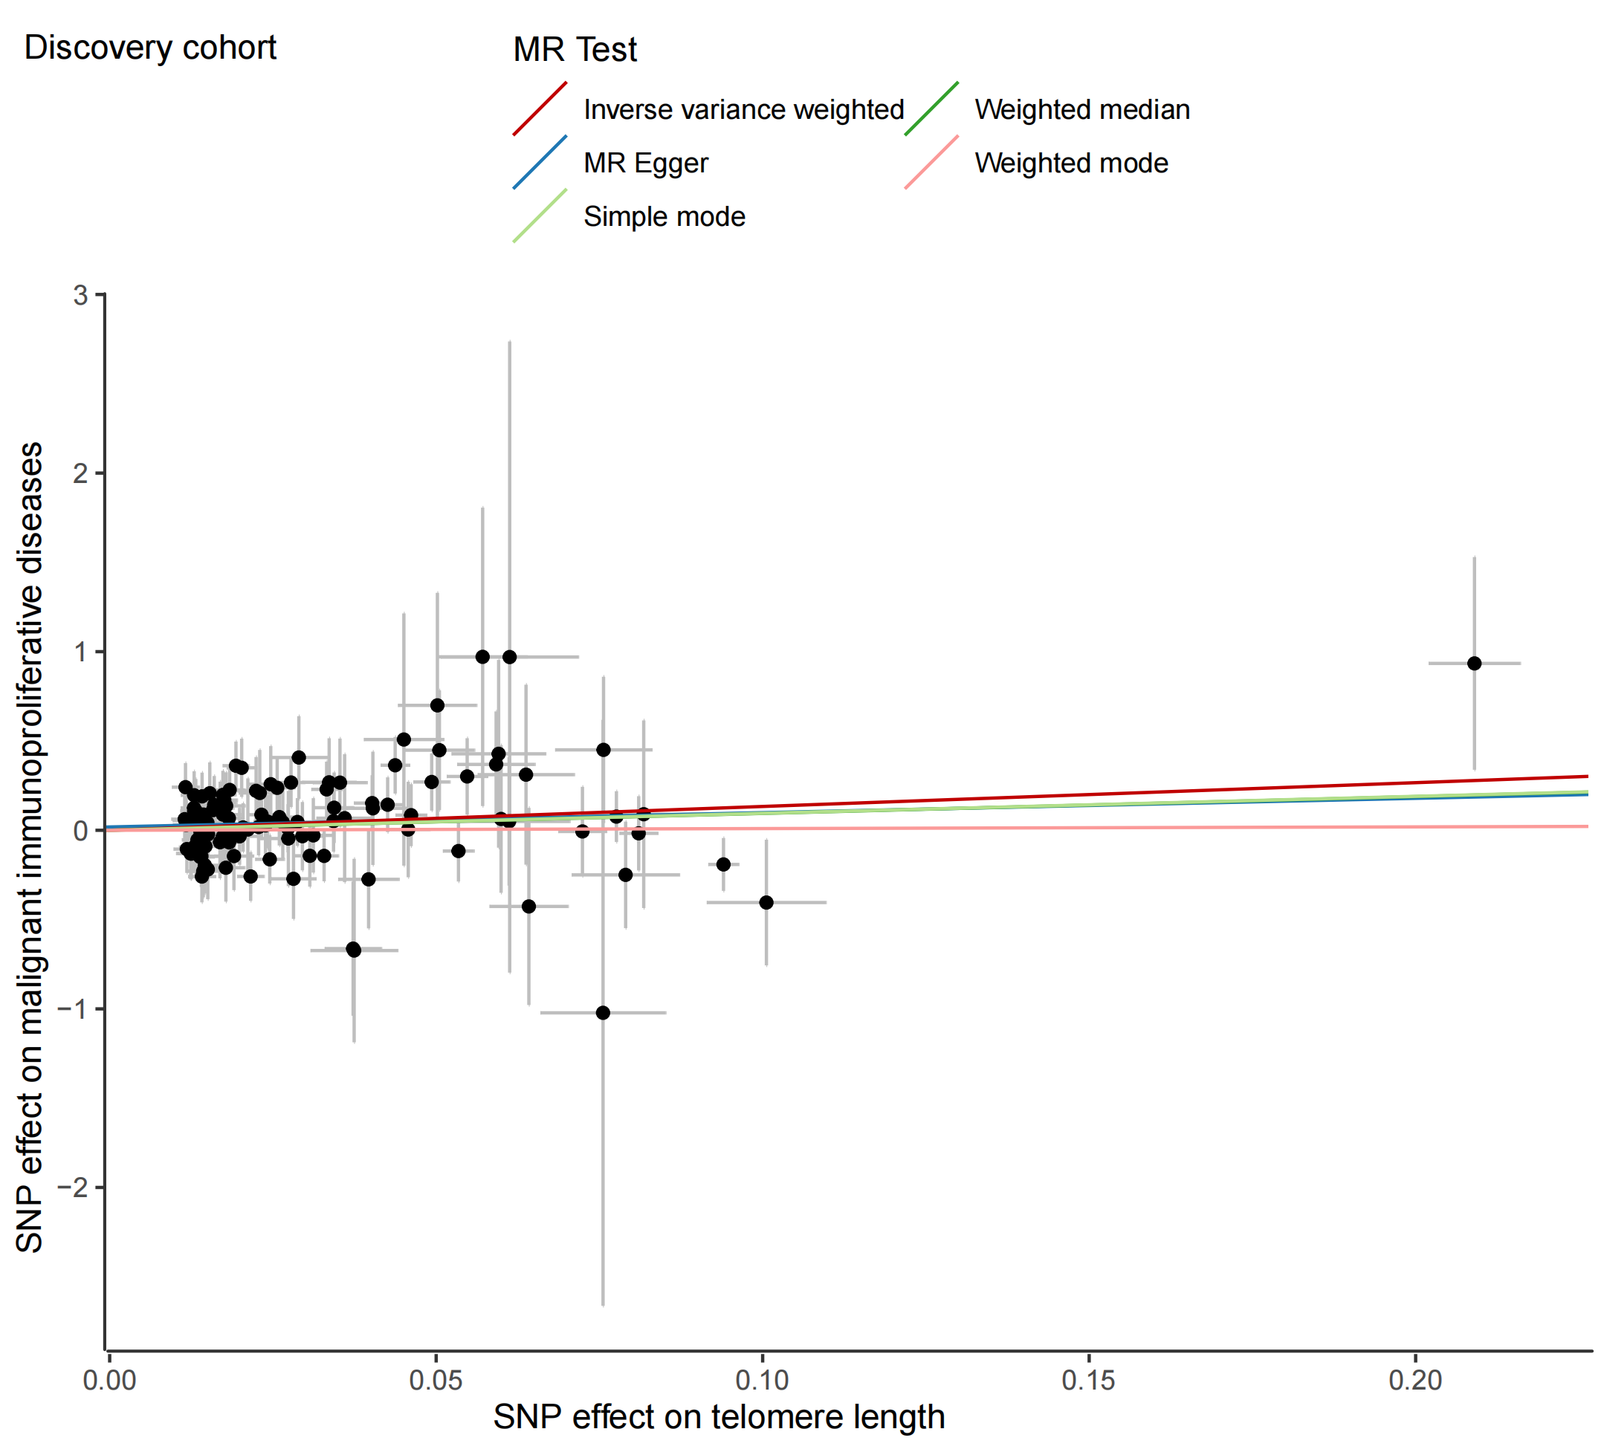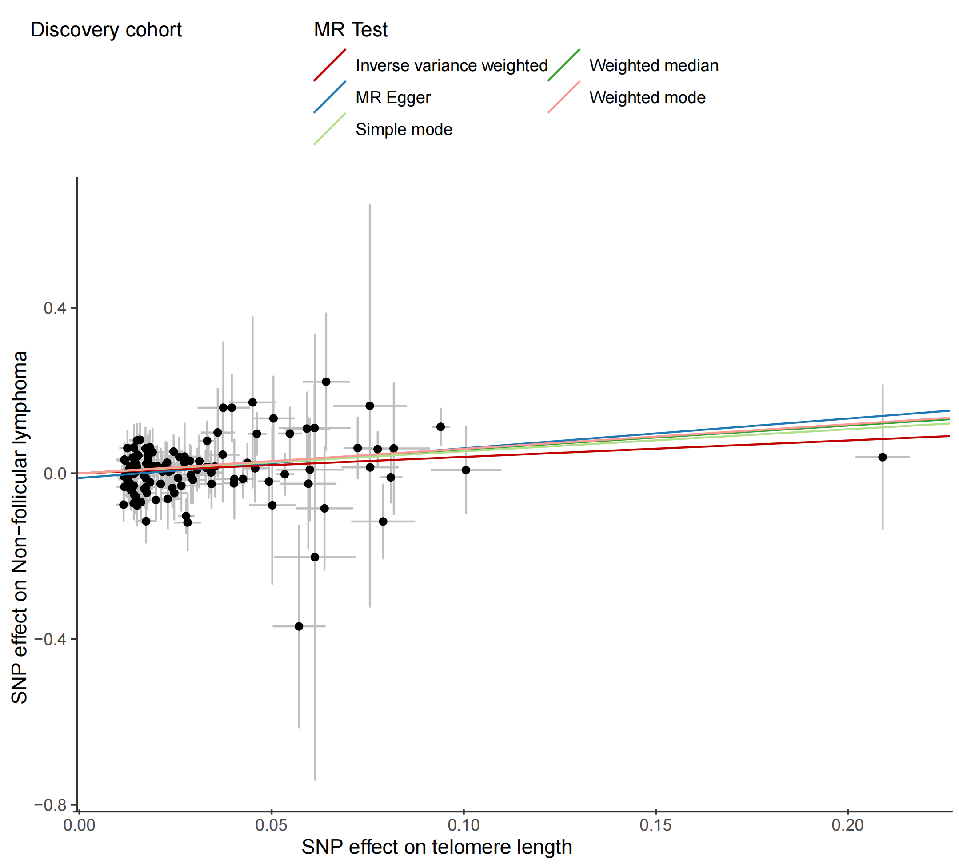

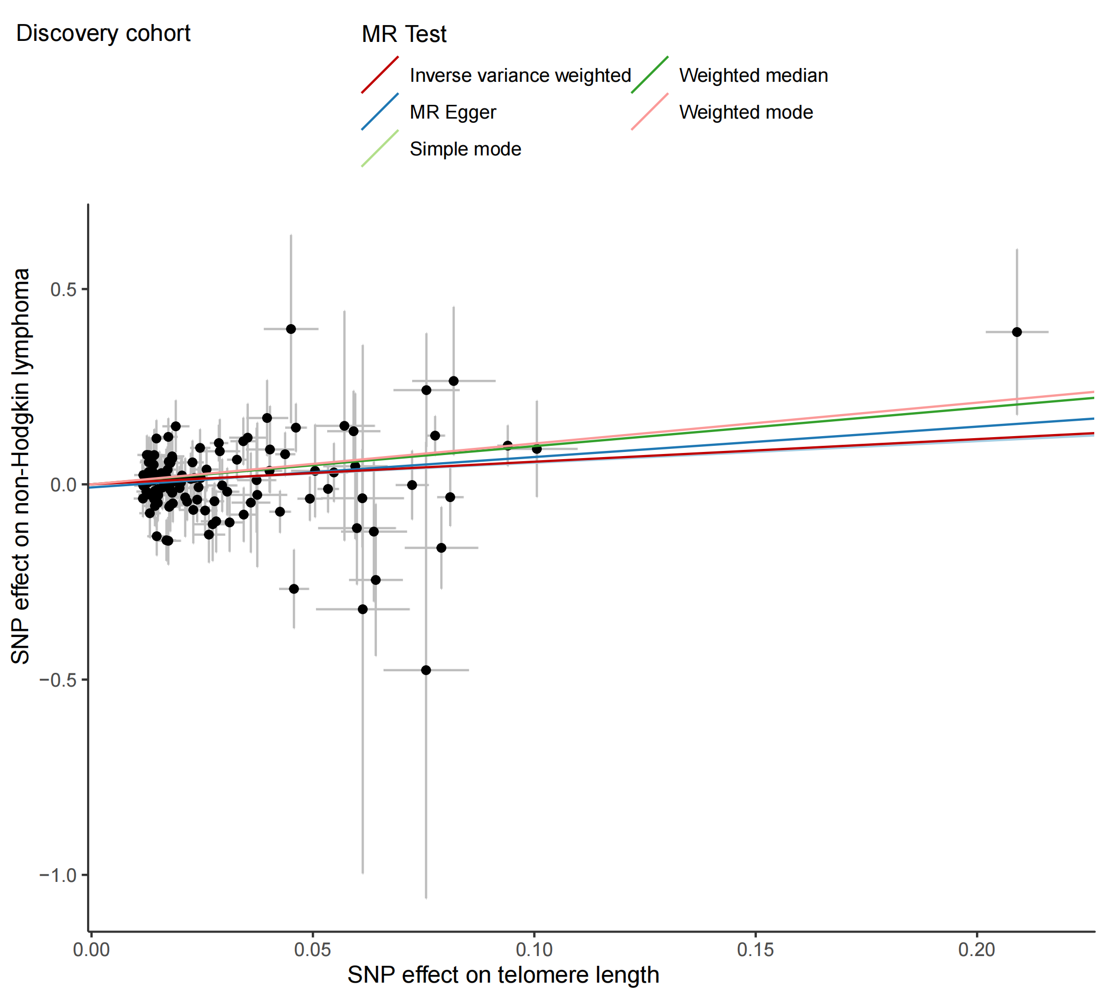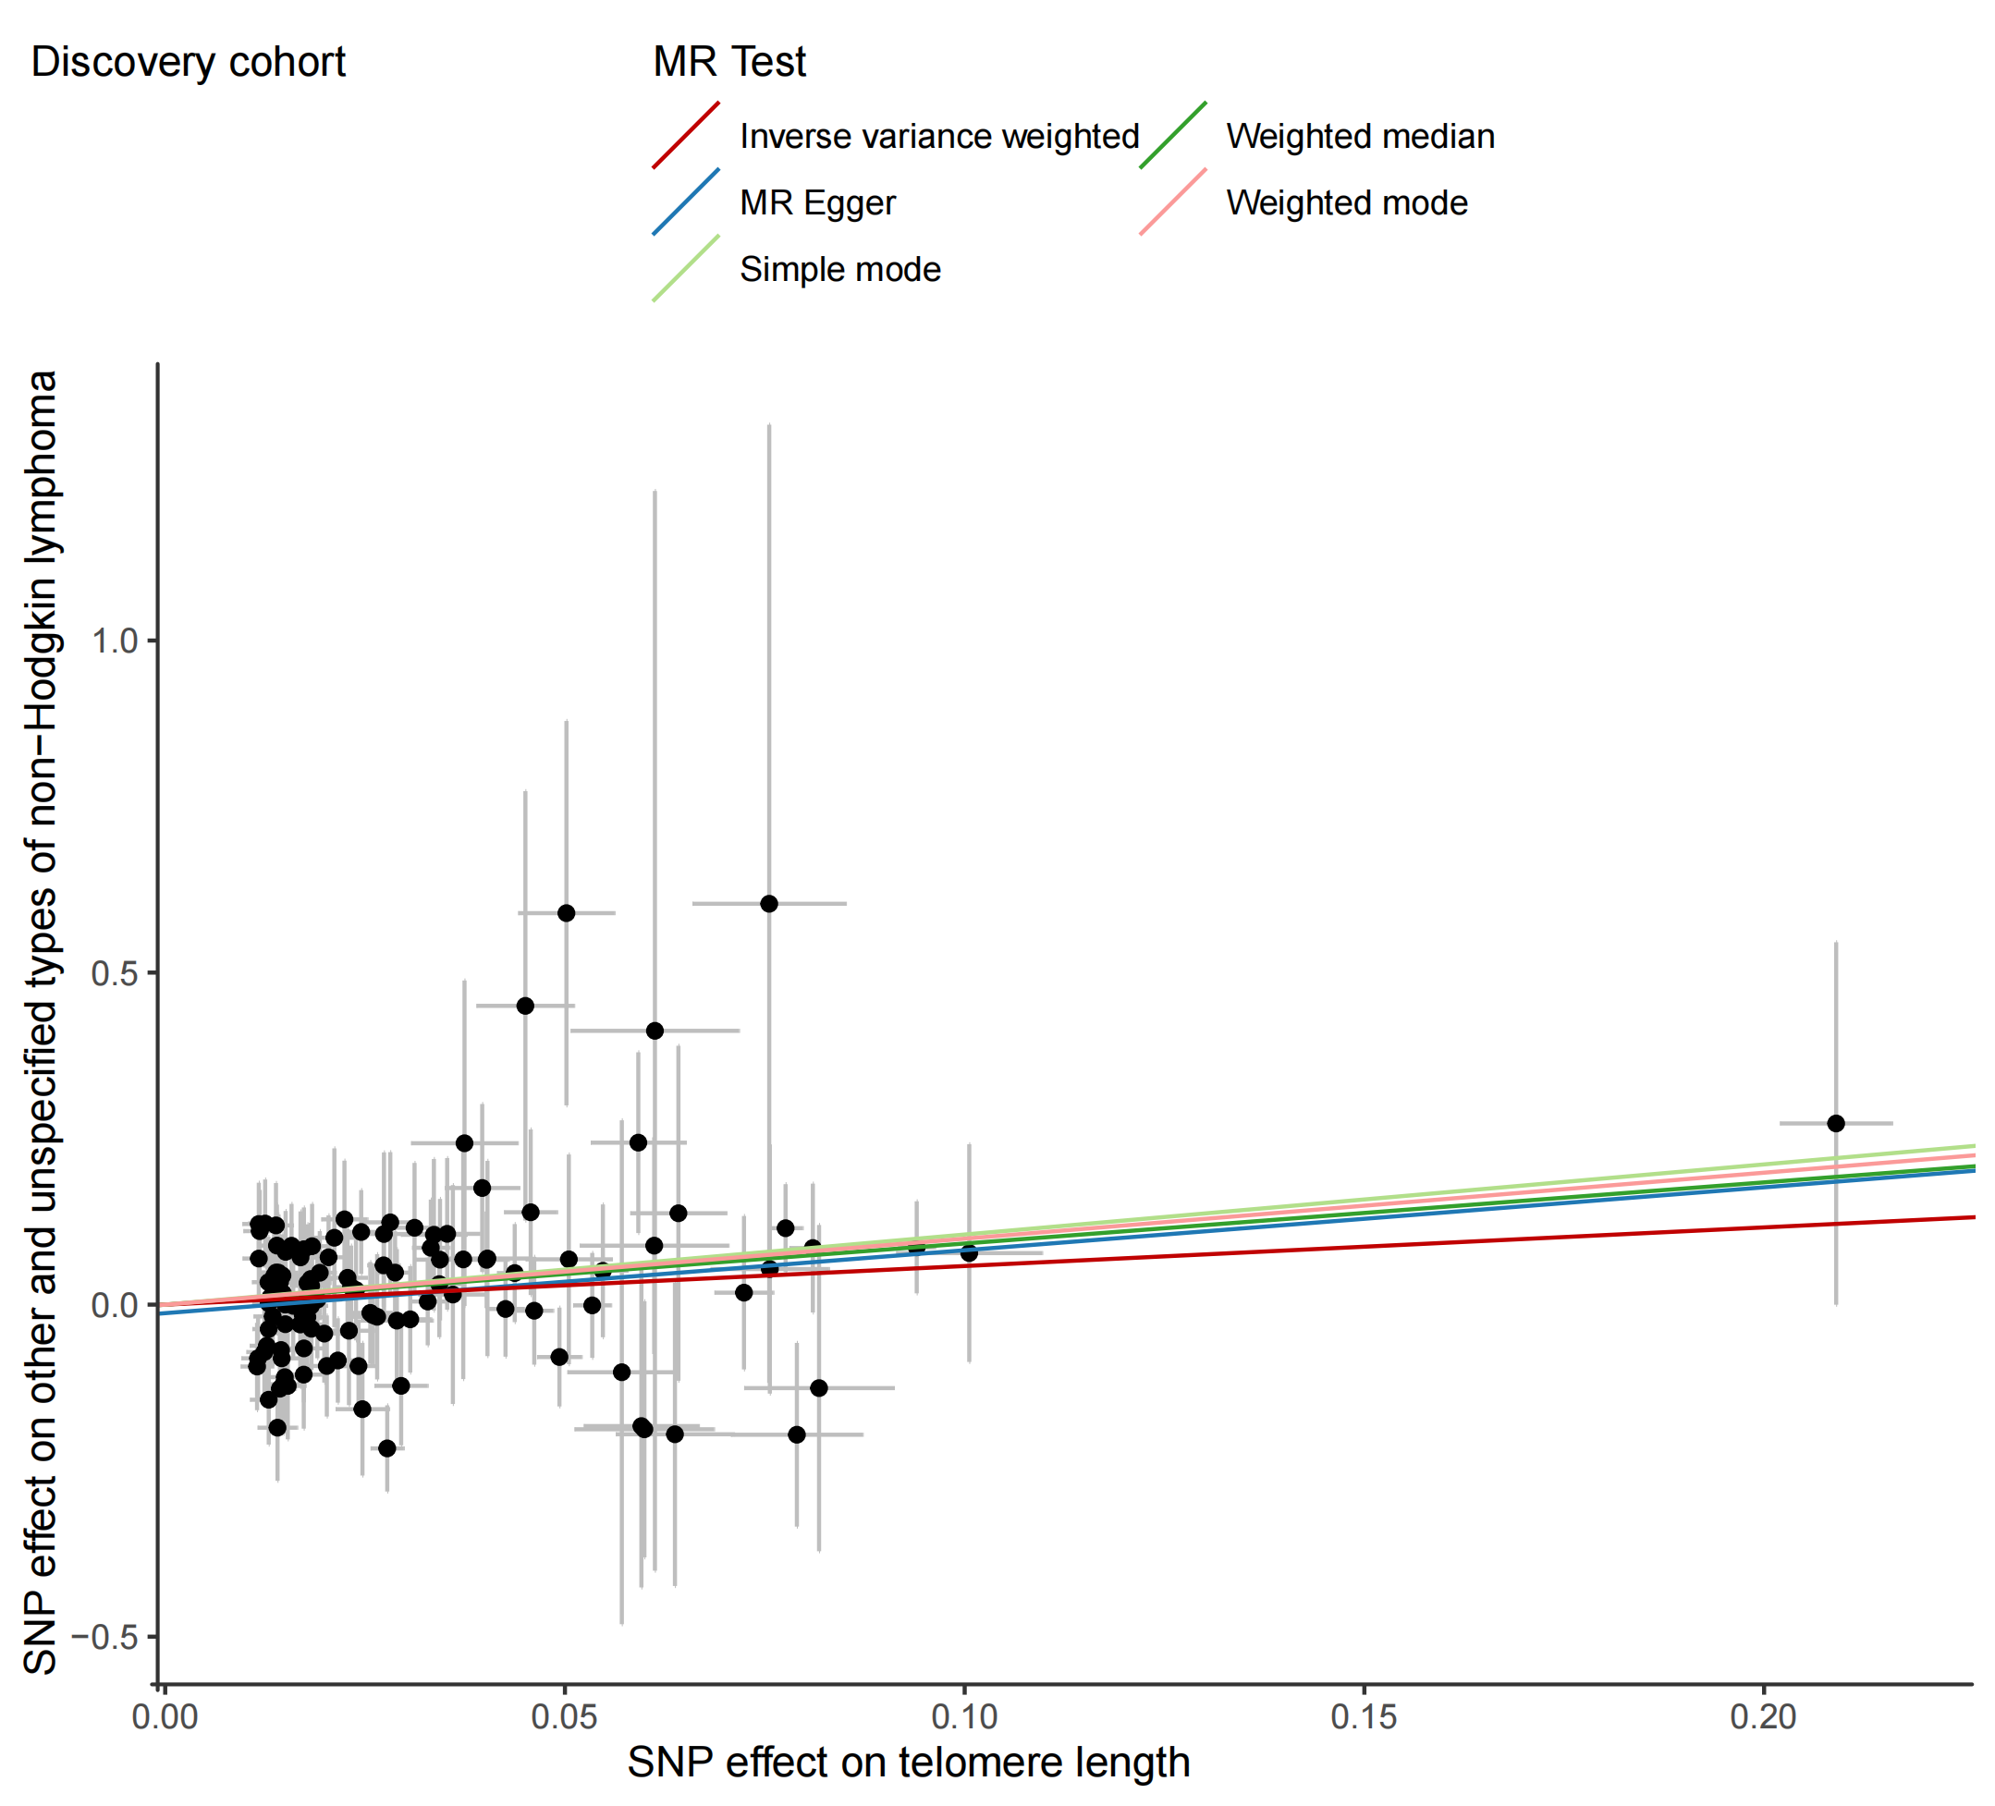

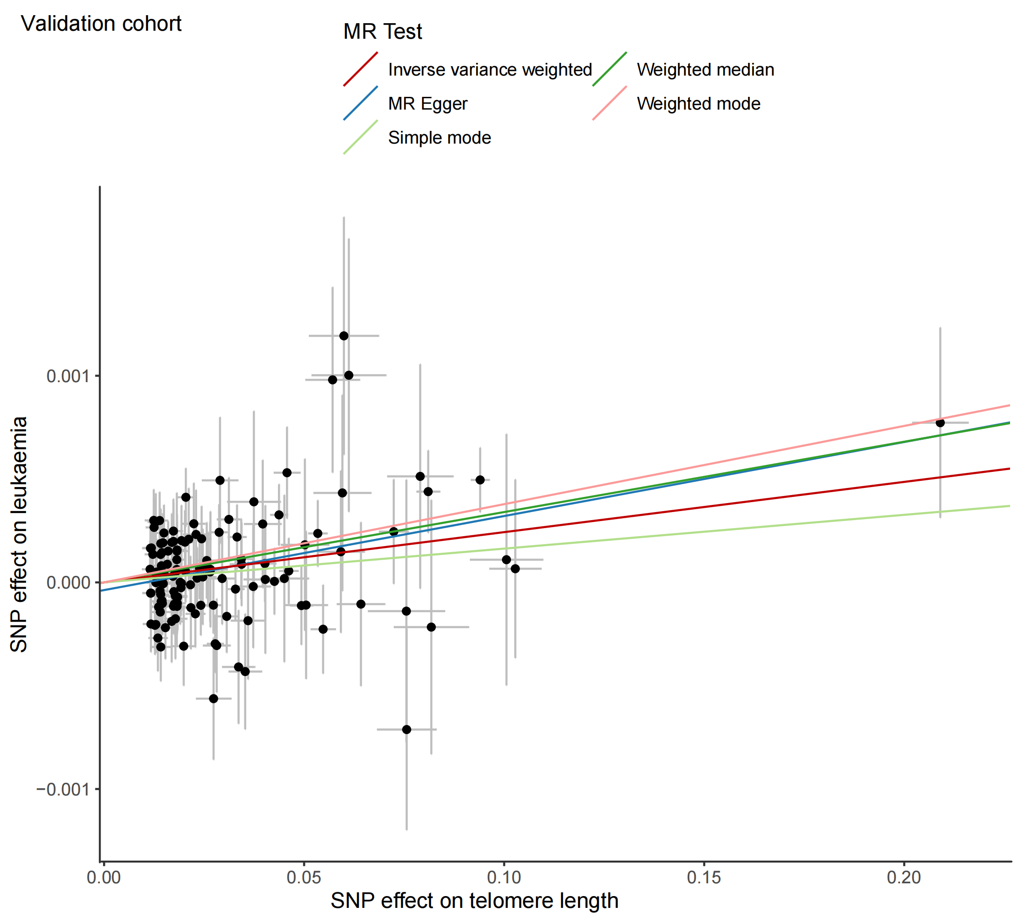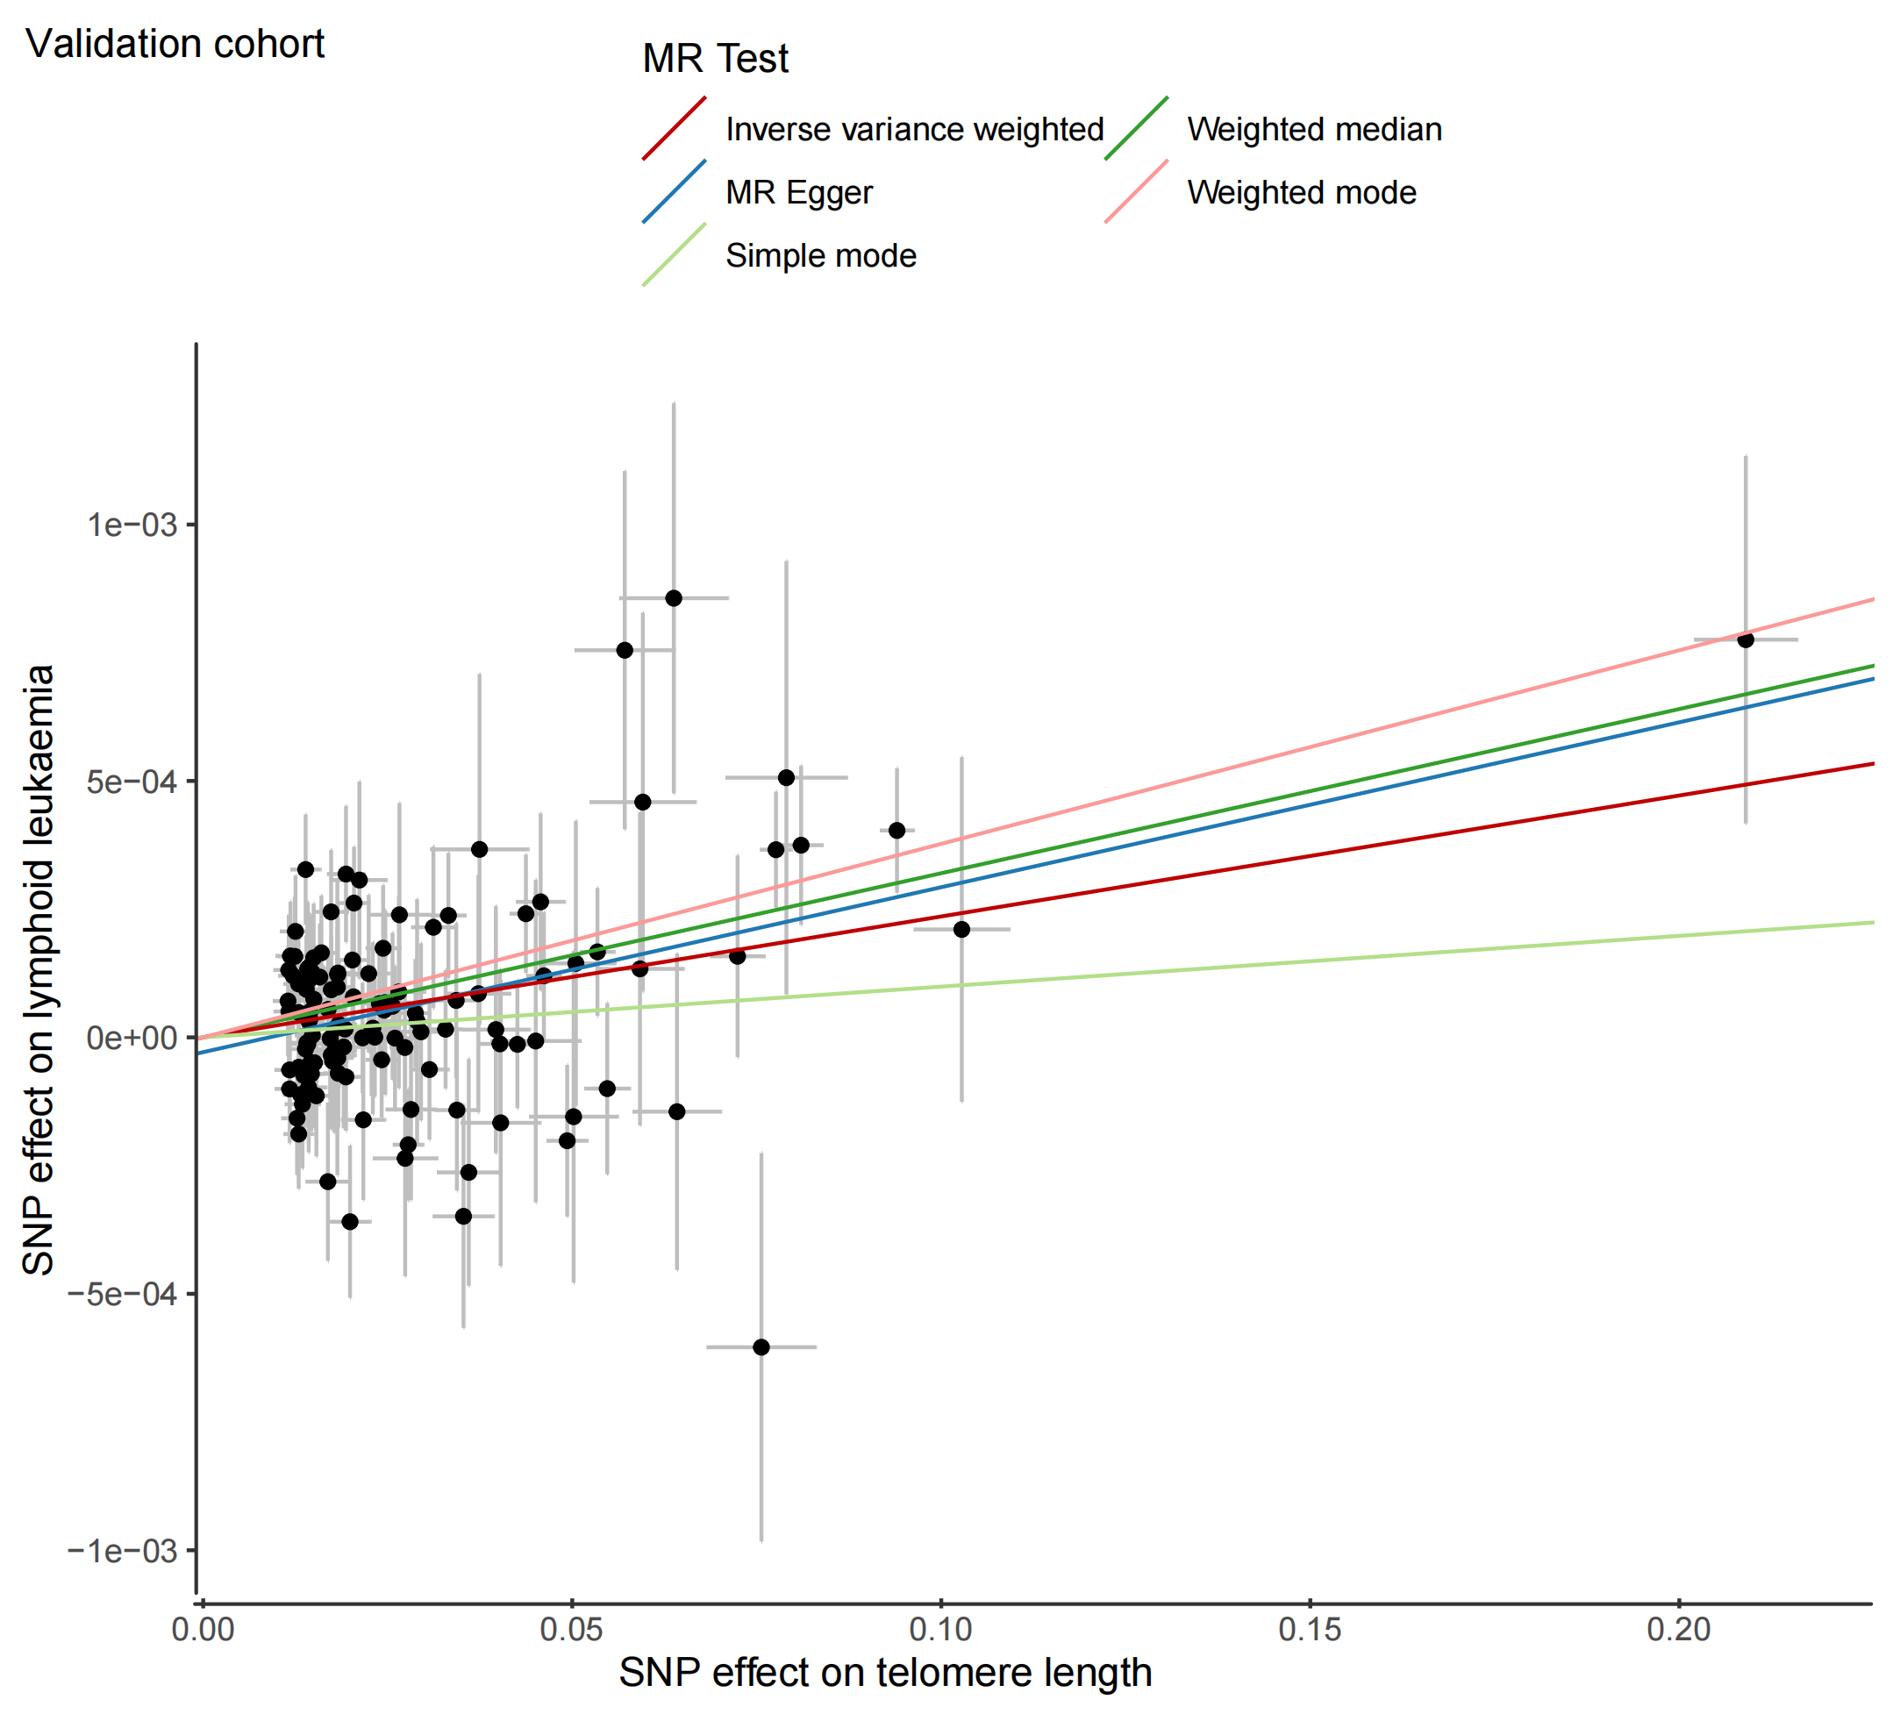

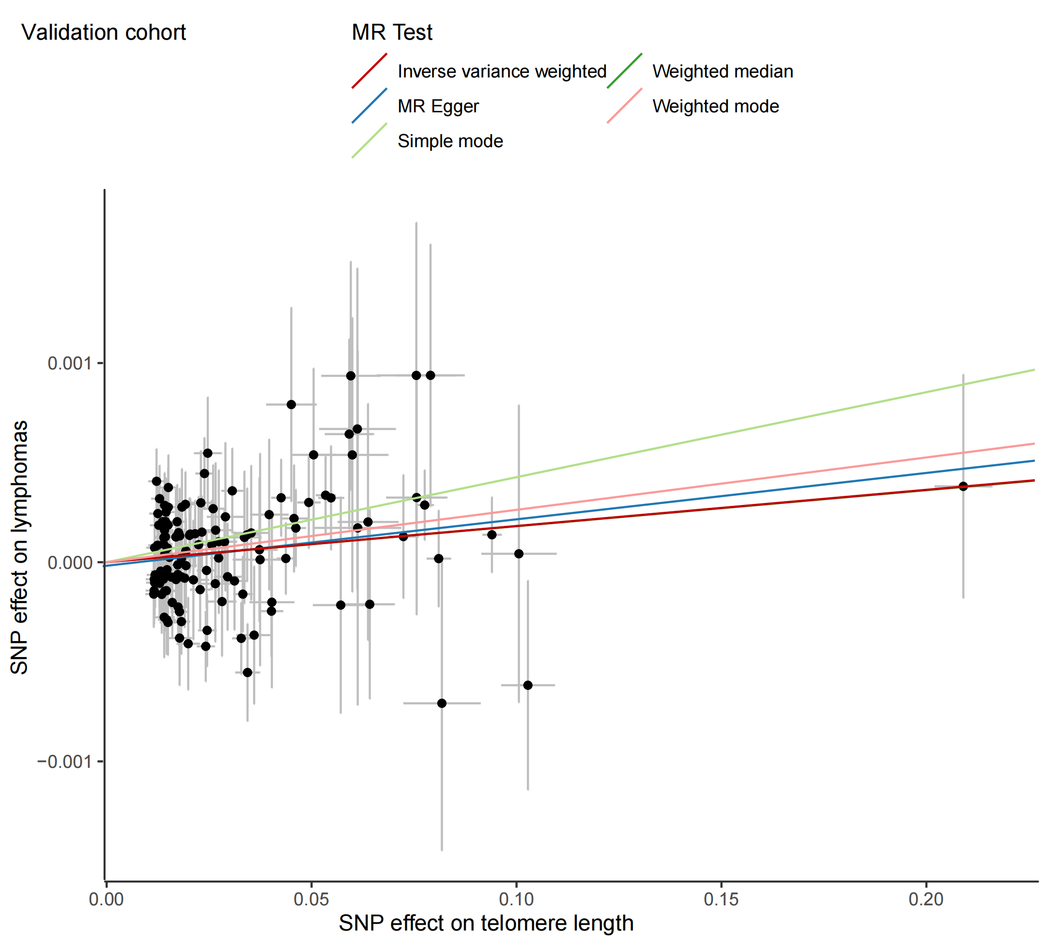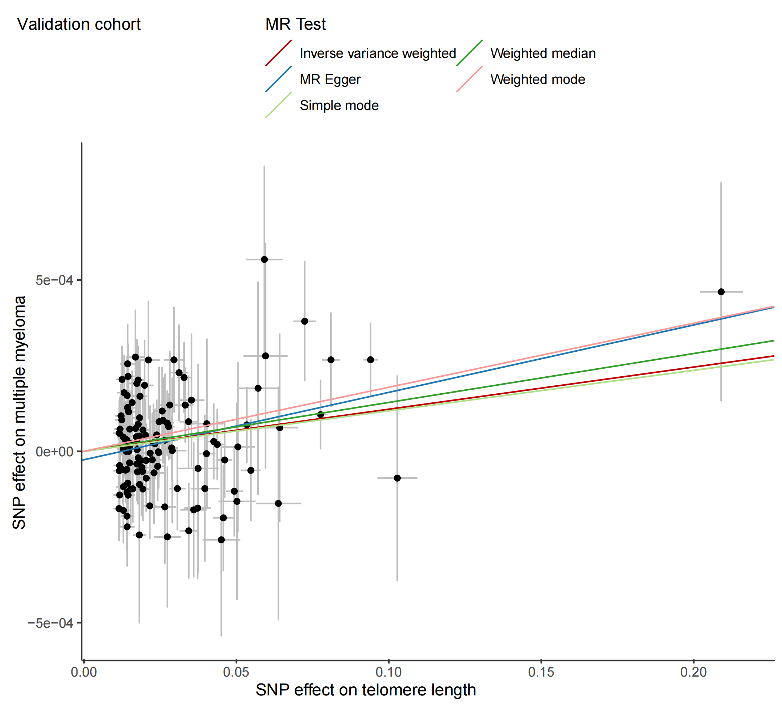

Supplementary Figure 4. Two-sample single-variable MR results of telomere length and five epigenetic age acceleration on risk of multiple haematologic diseases in the validation cohort.
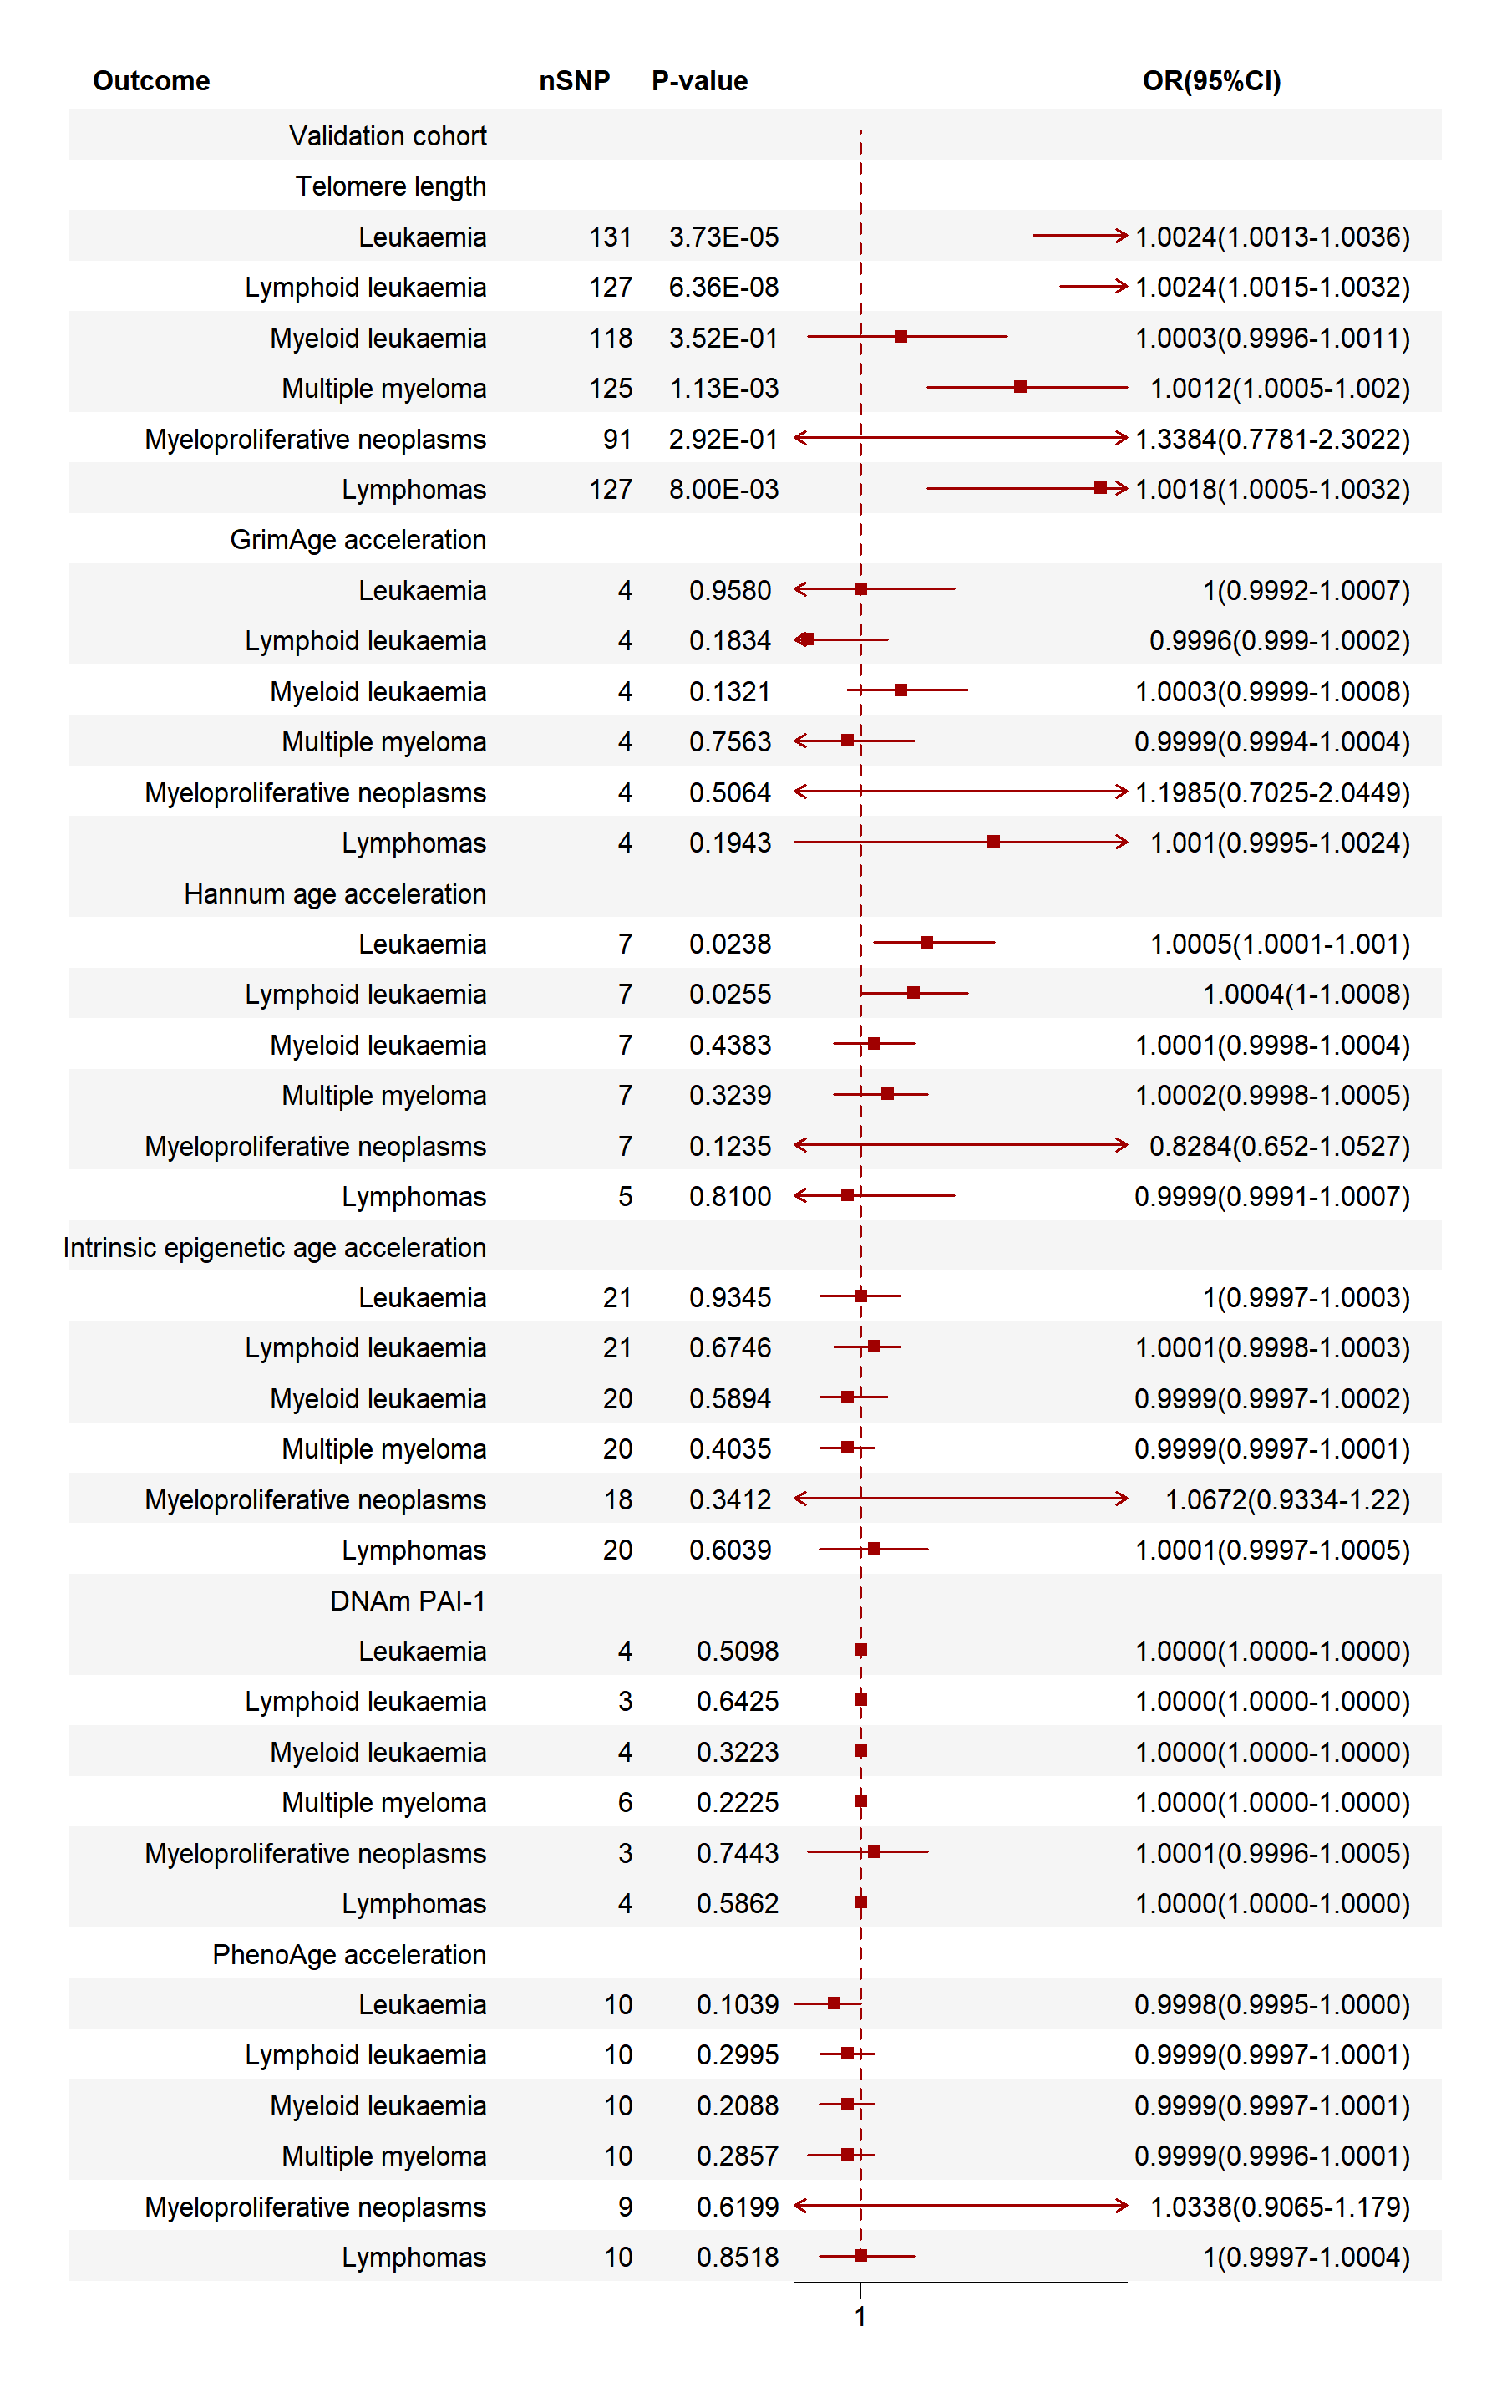
Supplementary Figure 5. Multivariable Mendelian randomisation results of telomere length and five epigenetic age acceleration on risk of multiple haematologic diseases in the validation cohort. DNAm PAI-1, DNA methylation-estimated plasminogen activator inhibitor-1; nSNP, number of single nucleotide polymorphism; OR, odds ratio; 95%CI, The 95% confidence intervals.
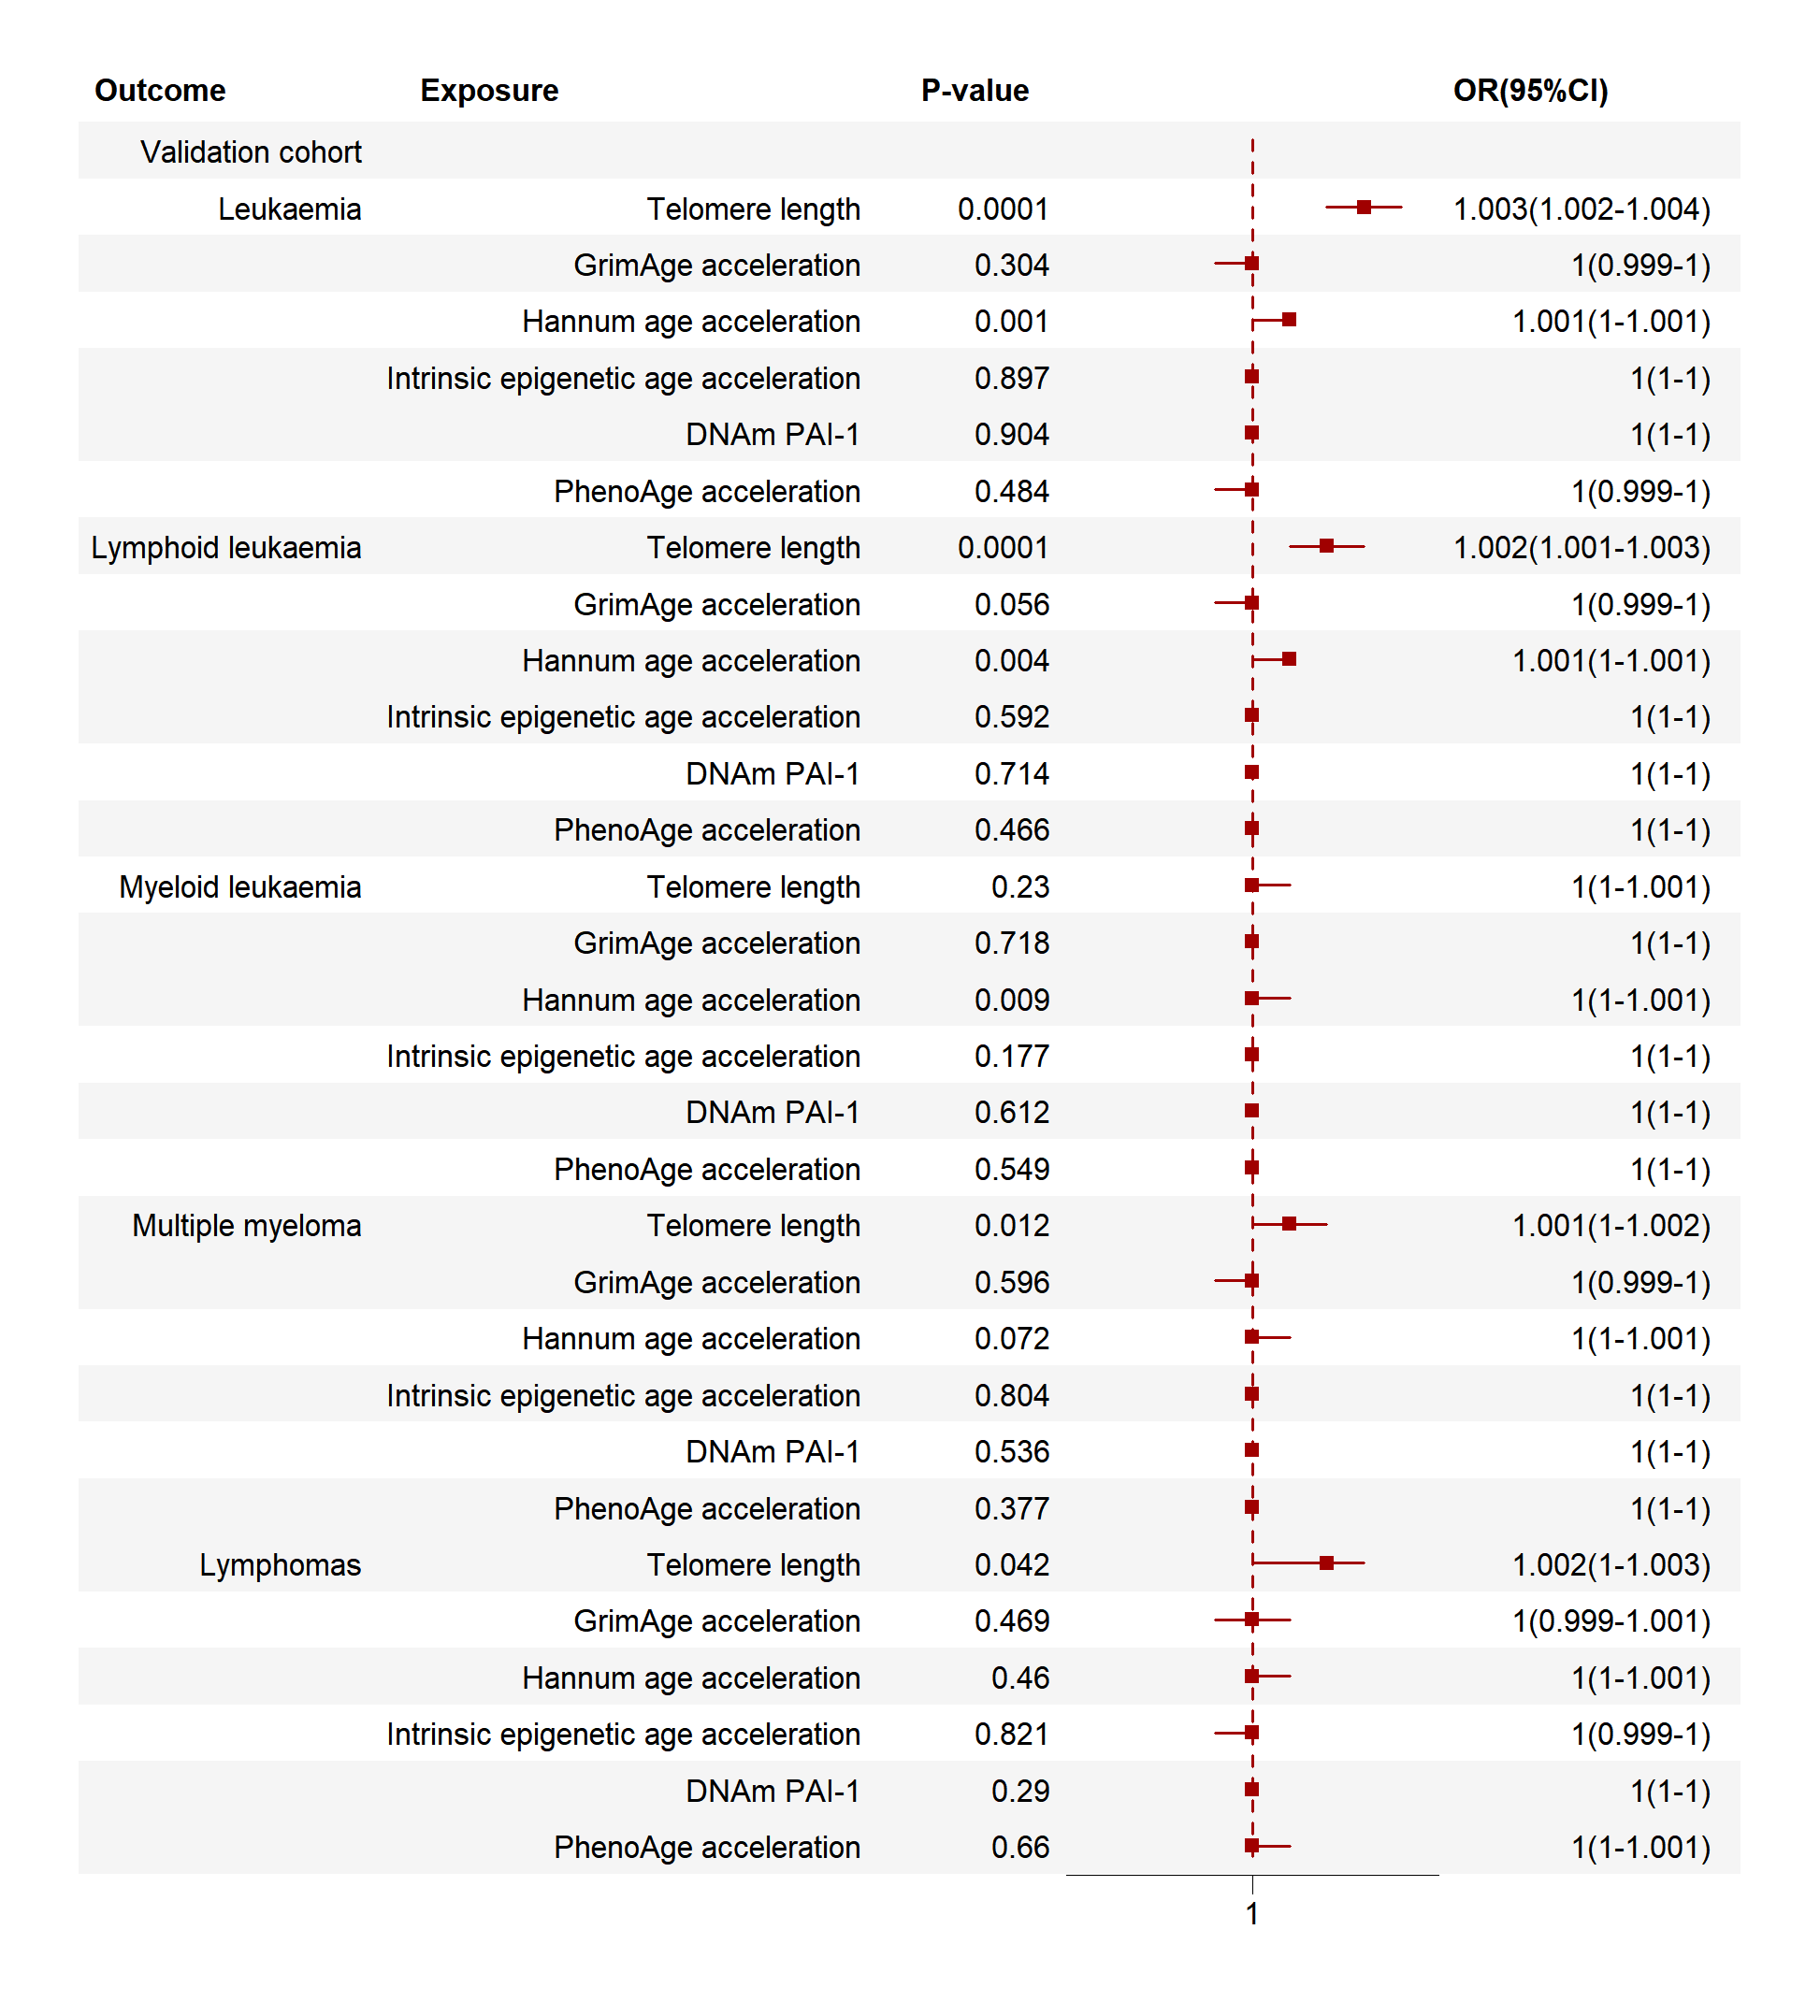
Supplementary Figure 6 displayed in Supplementary Figure 6.docx

