Supporting Information for
Integrating machine learning with analytical surface energy balance model improved terrestrial evaporation through biophysical regulation
Yun Bai^{1*}, Kanishka Mallick^{2*}, Tian Hu², Sha Zhang³, Shanshan Yang³, Arman Ahmadi⁴
- Hebei Technology Innovation Center for Remote Sensing Identification of Environmental Change, Hebei Key Laboratory of Environmental Change and Ecological Construction, and Hebei Key Research Institute of Humanities and Social Sciences at Universities: GeoComputation and Planning Center of Hebei Normal University, School of Geographic Sciences, Hebei Normal University, Shijiazhuang, China
- Remote Sensing & Natural Resources Modeling, Department ERIN, Luxembourg Institute of Science and Technology, Belvaux, Luxembourg
- Space Information and Big Earth Data Research Center, College of Computer Science and Technology, Qingdao University, Qingdao, China
- Biomet Lab, University of California, Berkeley, California, United States

* Correspondence to: Yun Bai (byron506@126.com; baiyun@hebtu.edu.cn) & Kanishka Mallick (kaniska.mallick@gmail.com)

Contents of this document
Supplementary texts (Sec. 1.1 – Sec. 1.6)
Fig. S1 – S8
Table S1 – S2
Introduction
This supporting document contains six supplementary sections, eight figures and two Tables.

Supplementary texts

An overview of STIC1.2
STIC is a one-dimensional, analytical Surface Energy Balance (SEB) model that integrates remotely sensed land surface temperature ($T_{R}$) into the Penman-Monteith Energy Balance Equation (PMEB)¹ to estimate ET. One crucial assumption in STIC is the first-order dependence of the two biophysical conductances (surface conductance $g_{Surf}$ and aerodynamic conductance $g_{A}$) in the PMEB equation on an aggregated moisture stress factor (M). In STIC, M is calculated based on $T_{R}$²⁻⁷. This calculation enables the direct integration of $T_{R}$ into the PMEB model. In STIC1.2, three additional remote sensing variables (surface albedo $α_{R}$, vegetation fractional cover $f_{C}$, surface emissivity $ε_{R}$) are incorporated to calculate surface net radiation ($R_{N}$). The core of the STIC model involves deriving analytical expressions for four key state variables: evaporative fraction (Λ), aerodynamic temperature ($T_{0}$), $g_{A}$, and $g_{Surf}$. These expressions are derived from four corresponding state equations, which are grounded on four biophysical principles, as mentioned earlier. Besides the four state variables Λ, $T_{0}$, $g_{A}$, and $g_{Surf}$, the equations also involve the unknowns M and Priestley-Taylor variable α. Solving for ET directly using the equations proves challenging due to the direct dependence of Λ on M and α. The iterative approach, detailed in Bhattarai, et al.⁸, Mallick, et al.⁶, and Mallick, et al.⁹, facilitates the numerical solution of ET by iteratively refining the values of M and α (Fig. 3a) until convergence is achieved.

Procedures to establish machine learning-based ${RH}_{0}$ model
Step-1: Data split
In the EST dataset, we organized the sites for each Plant Functional Type (PFT) into three distinct groups: the training, validation, and testing datasets. The proportions were approximately 61%, 19%, and 20%, respectively. Consequently, there were 81 sites in the training dataset, 25 in the validation dataset, and 26 in the testing dataset. The training and validation datasets were used to optimize the architecture of XGBoost. The training dataset was utilized to train the model, while validation dataset served as an independent set to evaluate the performance of the trained model.
Step-2: Optimize the architecture of XGBoost.
The performance of XGboost is primarily determined by four hyperparameters: the number of gradient boosted trees or boosting rounds ($n_{est}$), the maximum tree depth for base learners ($d_{max}$), and the booster. We conducted multiple iterations of training and validation using the designated training and validation datasets. The booster type was selected from three options: “gbtree”, “gblinear”, and “dart”. The number of boosting rounds (i.e., $n_{est}$) ranged from 100 to 2000 with an increment of 100, and $d_{max}$ varied from 2 to 12 with a step of 1. The determination of the best hyperparameter combination (or model architecture) involved evaluating the root mean squared deviation (RMSD) between the apparent and predicted ${RH}_{0}$ values for the validation (${RMSD}_{val}$) datasets. During this process, it became evident that, for a specific combination of $n_{est}$ and $d_{max}$, XGboost with the booster of “gbtree” consistently yielded smaller ${RMSD}_{val}$ compared to configurations with “gblinear” or “dart” boosters. Consequently, “gbtree” was identified as the best booster. The optimal combination of $n_{est}$ and $d_{max}$ was determined as follows.
- For each candidate value of $n_{est}$, we sort ${RMSD}_{train}$ and ${RMSD}_{val}$ in the ascending order of $d_{max}$. Subsequently, we calculate the change in ${RMSD}_{val}$ for each increasement in $d_{max}$.
- We identified optimal $d_{max}$ for each $n_{est}$ by selecting the minimum among three consecutive increases with a sum of changes in ${RMSD}_{val}$ smaller than 0.001. We found a linear relationship between optimum $d_{max}$ and $ln\left(n_{est}\right)$: $d_{max}=-1.040ln\left(n_{est}\right)+14.342, R^{2}=0.73$.
- Analogous to step b), we identified the optimum $n_{est}$ for each candidate $d_{max}$, and found another linear relationship between $d_{max}$ and $ln\left(n_{est}\right)$: $ln\left(n_{est}\right)=-0.0633d_{max}+14.343, R^{2}=0.74$.
- We integrated the above two equations and got $d_{max}$ and $n_{est}$ of 7.44 and 765.33, approaching the candidate combination of 8 and 800.
In this process, all features were input into the ML model, with a dynamic learning rate ($l_{r}$) that decayed from 0.1 to 0.01 as boosting rounds increased from 1 to $n_{est}$ during training. The dynamic $l_{r}$ values were randomly generated following the beta distribution, B (2, 5), for faster convergence.
Step-3: Features selection.
There are 56 candidate features in total (Table S2). It is impossible to test all combinations of these features. The following procedures were conducted to determine the best combinations of features.
- Train the XGBoost model with all candidates features on the training dataset and select the feature with the largest “feature importance” value.
- Train the model with the combination of - one feature from the rest candidates - and those selected in previous steps. The feature resulting in the smallest ${RMSD}_{val}$ was then selected from the rest candidates in current step.
- Repeat step (b) until the sum of changes in ${RMSD}_{val}$ of three consecutive iterations becomes zero or positive.
Finally, a total of 19 features were selected (Table S2), including a subset of the outputs of STIC1.2.

Derive the apparent ${RH}_{0}$ using the Ensemble Kalman Filter (EnKF)
We employed the Ensemble Kalman Filter (EnKF) to assimilate the tower-observed latent heat and sensible heat fluxes (λE and H) into HSTIC to invert the optima of ${RH}_{0}$ on an hourly/half-hourly step. The real time step of the assimilation process at a specific site matched the finest timescale of its available data. The details of EnKF can be found in our previous studies, i.e., Li, et al.¹⁰ and Yuan, et al.¹¹. The EnKF assimilation process in the study is done as follows:
- Ensemble Generation
Firstly, a set of random values of ${RH}_{0}$, termed an ensemble, is generated based on the value of ${RH}_{0}$ in the former time step, referred to as ${RH}_{0, init}$. Each ensemble member represents a potential value of ${RH}_{0}$. These ensemble members follow a normal distribution with a variance of $\left({RE}_{ob}{∙RH}_{0, init}\right)$ and a mean of ${RH}_{0, init}$, where ${RE}_{ob}$ is the relative errors of the observational fluxes set at 0.15 following Yuan, et al.¹¹. The ensemble size is set to 200. For the starting time, ${RH}_{0}$ was fixed to 0.5.
- Prediction
Using HSTIC and the ${RH}_{0}$ values in the ensemble, a set of model predictions with the same size as the ${RH}_{0}$ ensemble is generated.
- Data Assimilation
The observed fluxes (λE and H) are compared with the model predictions. By calculating the difference between the observed values and the predicted values, known as the observation residual, the covariance matrix of the prediction error is estimated.
- Updating
The ensemble members are adjusted based on the covariance matrix of the observation residual. This process effectively weights each member, giving higher weights to those that fit the observed data better and lower weights to those that fit poorly.
- Resampling
Based on the updated weights, the ensemble members are resampled (averaged) to obtain the optimum value of ${RH}_{0}$, which are used to generate the ensemble for the next time step.
By repeating the above steps in each time step, we obtained the time-series of the optima of hourly/half-hourly ${RH}_{0}$ at a specific flux site. However, performing EnKF hour by hour or half-hour by half-hour is time consuming, since we have got more than 5.5 million samples. To expedite the time-consuming EnKF assimilation process, we implemented parallel processing of 24 consecutive samples in each step. These samples used the average of the optimal ${RH}_{0}$ values from the previous processing of 24 samples as ${RH}_{0, init}$. But, in this way, the obtained ${RH}_{0, init}$ for each sample was not the true ${RH}_{0}$ optima from the previous time step. Each sample underwent up to five iterations, using its optimal ${RH}_{0}$ value from the previous iteration as the current ${RH}_{0, init}$. Iterations stopped if the count reached five or the difference between the current optimal ${RH}_{0, init}$ and the previous was less than 0.01. The final EnKF yielded satisfactory approximation for the optimal ${RH}_{0}$. Hourly/half-hourly λE and H estimated using HSTIC with the EnKF-derived ${RH}_{0}$ showed excellent agreement with the tower observations with $R^{2}$ (RMSE) of 0.96 (19.63 ${W m}^{-2}$) and 0.97 (19.63 ${W m}^{-2}$), 0.95 (21.29 ${W m}^{-2}$) and 0.97 (22.24 ${W m}^{-2}$), and 0.95 (24.01 ${W m}^{-2}$) and 0.96 (24.10 ${W m}^{-2}$) across training, validation, and testing datasets, respectively (Fig. S1).

Upscaling instantaneous ET and estimating ground heat fluxes (G)
HSTIC utilizes remotely sensed $T_{R}$ as a primary driver to simulate instantaneous λE and H, relying on MODIS daytime $T_{R}$ products, specifically MYD21A1D and MOD21A1D. As the biophysical principles are not applicable during nighttime, HSTIC focuses on the daytime $T_{R}$ products. For the long-term application of the model, instantaneous λE is upscaled to a daily time scale using the reference ET (${ET}_{0}$)-based method, as described by Bai, et al.¹². This method relies on the assumption that the “ratio of actual ET to ${ET}_{0}$” (reEF) remains constant throughout the day. The estimated instantaneous reEF is multiplied by daily-scale ${ET}_{0}$ to derive daily λE ^{13,14}. On days when both MODIS $T_{R}$ products are available, the reEF from these two $T_{R}$ products are averaged to obtain the daily reEF. When only one of the $T_{R}$ products is available, the sole available reEF is used to compute daily λE. For days when both MODIS $T_{R}$ products are unavailable, daily reEF is determined by linearly interpolating the available reEF values from the nearest days in time. Daily H is calculated as a residual of the daily surface net radiation ($R_{N}$), λE, and ground heat flux (G). The estimates of hourly or instantaneous G and the approach for temporal upscaling of instantaneous λE to a daily scale is detailed in Bai, et al.¹².

Identifying the ecosystem air temperature optima ($T_{opt,ECO}$) based on HSTIC $g_{Surf}$
To assess HSTIC’s representation of temperature optima across ecosystems (or flux sites), we determined ecosystem air temperature optima ($T_{opt,ECO}$) for HSTIC-derived $g_{Surf}$ at each flux site in the EVA dataset using hourly-scale $g_{Surf}$ obtained through a 5-fold cross-validation process. A quantile regression approach was used to identify $T_{opt,ECO}$ for a specific flux site, following Huang, et al.¹⁵ as described below:
- Removing data of non-growing seasons. The growing season for each site-year was defined as the period with $f_{c}> f_{c,min}+0.15\left(f_{c, max}-f_{c,min}\right)$, where $f_{c}$ is the fractional cover of vegetation estimated as $f_{c}=1.24NDVI-0.168$ ¹⁶ and NDVI denotes the normalized difference vegetation index; $f_{c, max}$ and $f_{c,min}$ are defined as the $f_{c}$ values at the 5th percentile and 95th percentile of non-zero $f_{c}$ in each site-year.
- Removing outliers. We plot $g_{Surf}$ and air temperature ($T_{A}$) in a rectangular coordinate system with $g_{Surf}$ and $T_{A}$being the vertical and horizontal axes respectively. Outliers, constituting the lowest 5% of samples by density, are excluded. The point density is defined as the number of points within squared area of $\frac{L_{x}}{50}×\frac{L_{y}}{50}$, where $L_{x}$ or $L_{y}$ denotes the length of x (horizontal) or y (vertical) axis and is defined as the difference between the 99% and 1% percentiles of $T_{A}$ or $g_{Surf}$.
- Obtaining high-percentile values of $g_{Surf}$ for multiple temperature levels. $T_{A}$ is divided into bins with a 1℃ interval the 1st and 99th percentiles. In each temperature bin, we calculated the value of $g_{Surf}$ at the 95th percentile, referred to as $g_{Surf,95th}$.
- Obtaining $T_{opt,ECO}$ through regression analysis. The derived $g_{Surf,95th}$ and the median value of temperature interval corresponding to each $g_{Surf,95th}$ value are entered into the following formula with reference to Bai, et al.¹⁷,
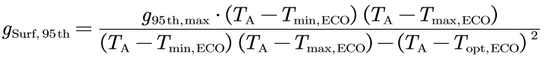
(S1)
and then fitted this equation using the least squares regression method to obtain $T_{opt,ECO}$, where $g_{95th,max}$, $T_{min,ECO}$, and $T_{max,ECO}$ are also fitted parameters, representing the maximum value of $g_{Surf,95th}$, minimum and maximum temperature of vegetation stomata opening.

The sources of uncertainties in HSTIC
HSTIC, like other thermal remote sensing-driven models, provides instantaneous λE outputs at satellite overpass. Continuous daily ET requires upscaling, which is currently done using a constant ratio (Λ or reEF) assumption¹⁸. However, this method may slightly underestimate daily λE (e.g., Fig. 6b,d) due to its limited consideration of diurnal variations in Λ or reEF, as highlighted in Yan, et al.¹⁴. Past attempts to address diurnal trends of λE by utilizing the diurnal variation of solar radiation at the top of the atmosphere¹⁹ had limitations, especially at nighttime. Future research is needed to investigate factors influencing the upscaling of instantaneous λE and develop improved methods for more accurate daily or larger timescale estimates using HSTIC.
Ground heat flux (G) is crucial for the surface energy balance, impacting λE estimation accuracy. Although G estimation in current HSTIC (Supplementary Sec. 1.4) is acknowledged as inaccurate, this issue is not adequately addressed in other ET models²⁰. While G is typically considered negligible at larger temporal scales (e.g., daily, monthly), its contribution is significant at the instantaneous scale during satellite overpass, particularly under conditions of water stress and low vegetation coverage (Fig. S3a)²¹. In our analysis, we compared two HSTIC versions: the version outlined in Supplementary Sec. 1.4 and a modified version using flux tower observations instead of modeled G to estimate hourly/half-hourly λE at satellite overpass (Fig. S3b). Results show deviations of 9.83 – 37.88 $W m^{-2}$ and 8.20 – 12.19 $W m^{-2}$ in estimating H and λE, respectively, when using modeled G compared to observational G at the satellite overpass. This modeled G issue could impact the accuracy of daily or larger timescale λE estimates upscaled from sub-daily estimates. While efforts have been made to address this problem for the STIC model at the regional scales²², a more accurate and globally applicable solution is needed.

Supplementary Figures
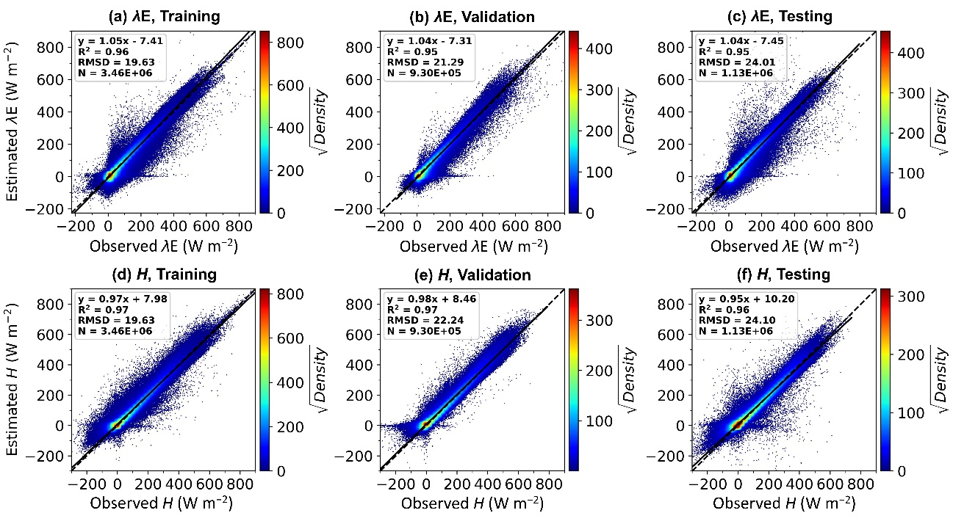
Fig. S1: Validating λE and H estimated using EnKF-derived RH₀ and HSTIC on training, validation, and testing datasets. The color bars indicate the square root of the point density ($\sqrt{Density}$) within a squared area of $\frac{L_{x}}{50}×\frac{L_{y}}{50}$, where $L_{x}$ and $L_{y}$ denote the lengths of x and y axis, respectively.

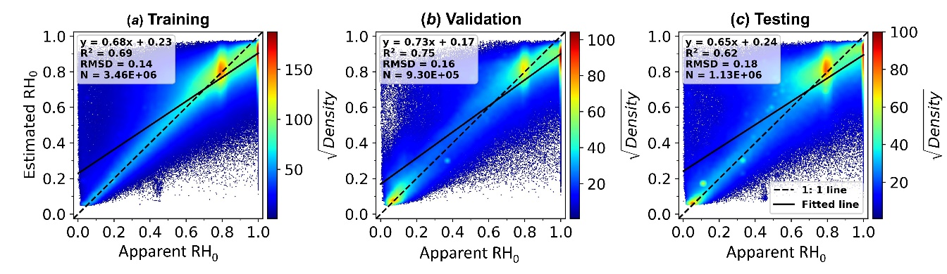
Fig. S2: Validating RH₀ estimated using ML-RH₀ on training (a), validation (b), and testing (c) datasets. Here the STIC1.2 outputs used by ML-${RH}_{0}$ were substituted for the STIC1.2 inputs, and ML-${RH}_{0}$ was retrained to use the new inputs. The color bars indicate the square root of the point density ($\sqrt{Density}$) within a squared area of $\frac{L_{x}}{50}×\frac{L_{y}}{50}$, where $L_{x}$ and $L_{y}$ denote the lengths of x and y axis, respectively.

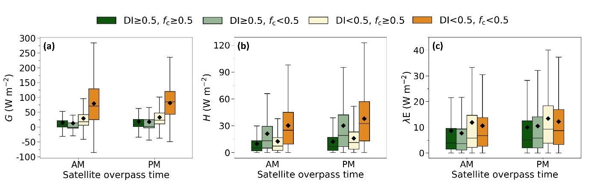
Fig. S3: Hourly/half-hourly soil heat flux G (a), and the absolute deviations in HSTIC-estimated H (b) and λE (c) between using observational G and HSTIC-modeled G at the satellite overpass time under different dryness DI and vegetation fractional cover $f_{c}$ conditions. “AM” and “PM” represent the satellite (Terra and Aqua) overpass time in the morning and afternoon respectively.

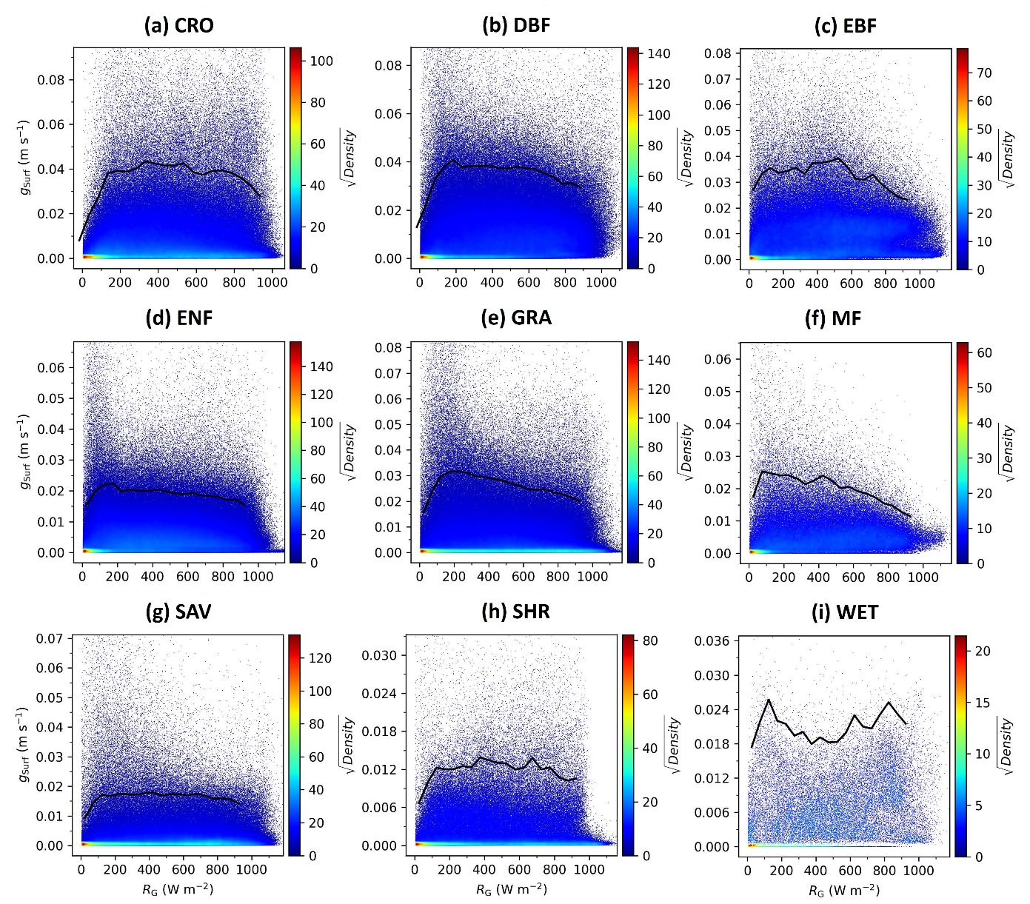
Fig. S4: HSTIC surface conductance ($g_{Surf}$) versus global solar radiation ($R_{G}$) on an hourly/half-hourly scale for six plant function types (PFTs) in EST dataset. Samples with vapor pressure deficit smaller than 3 hPa were removed. The solid lines represent the upper boundary of $g_{Surf}$, which consists of optimum $g_{Surf}$ acquired very 50 ${W m}^{-2}$ of $R_{G}$. Before determining the optimum $g_{Surf}$ at each $R_{G}$ bin, we computed the density of samples, and the lowest 5% of samples by density were identified as outliers and were then removed. The color bars indicate the square root of the point density ($\sqrt{Density}$) within a squared area of $\frac{L_{x}}{50}×\frac{L_{y}}{50}$, where $L_{x}$ and $L_{y}$ denote the lengths of x and y axis, respectively.
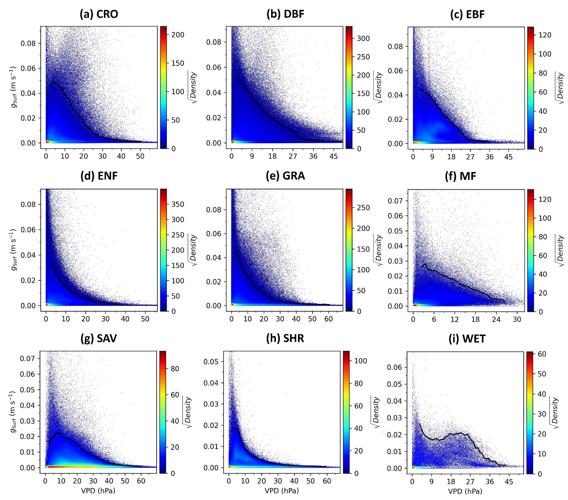
Fig. S5: HSTIC surface conductance ($g_{Surf}$) versus vapor pressure deficit (VPD) on an hourly/half-hourly scale for six plant function types (PFTs) in EST dataset. All available samples were retained. The solid lines represent the upper boundary of $g_{Surf}$, which consists of optimum $g_{Surf}$ acquired every 1 hPa of VPD. Before determining the optimum $g_{Surf}$ at each VPD bin, we computed the density of samples, and the lowest 5% of samples by density were identified as outliers and were then removed. The color bars indicate he square root of the point density ($\sqrt{Density}$) within a squared area of $\frac{L_{x}}{50}×\frac{L_{y}}{50}$, where $L_{x}$ and $L_{y}$ denote the lengths of x and y axis, respectively.

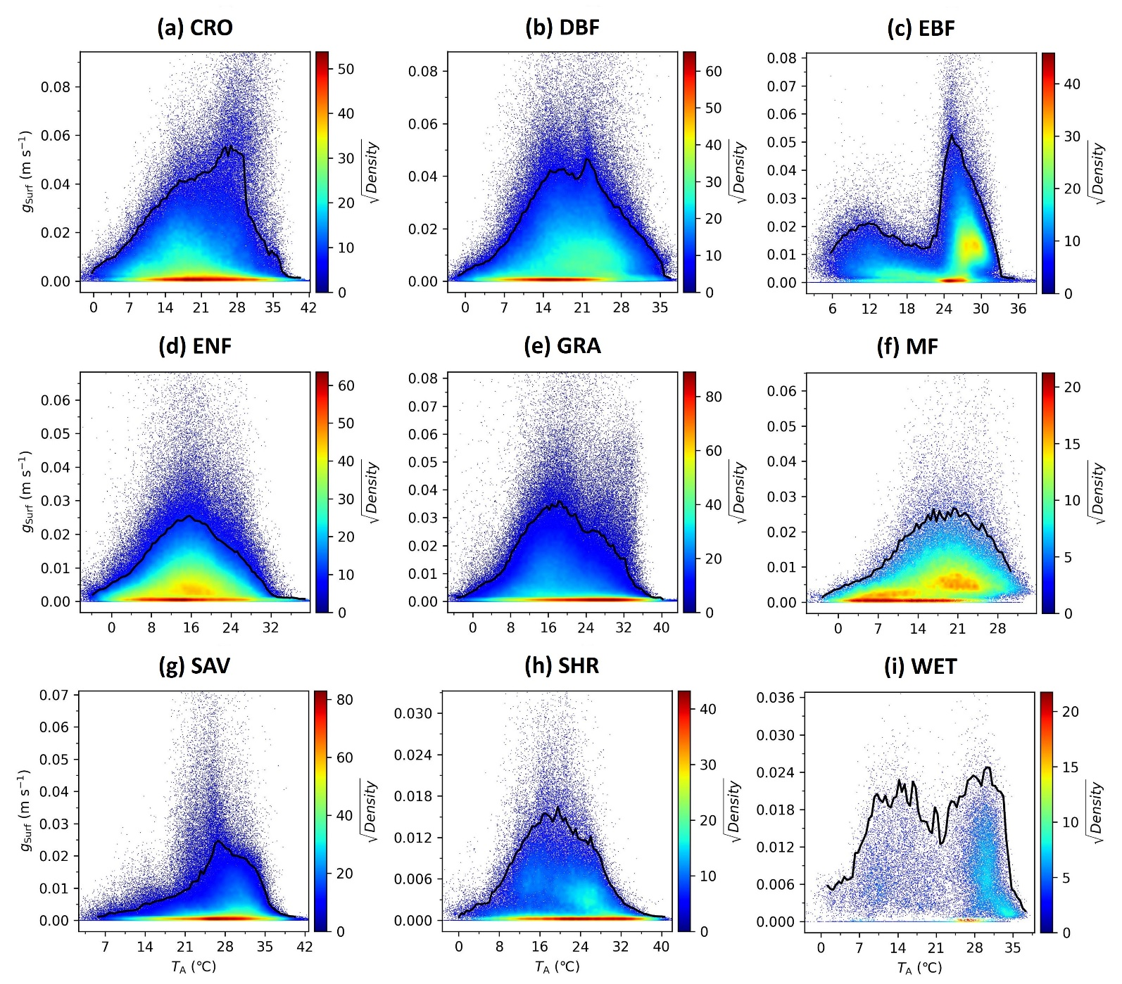
Fig. S6: HSTIC surface conductance ($g_{Surf}$) versus air temperature ($T_{A}$) on an hourly/half-hourly scale for six plant function types (PFTs) in EST dataset. Samples with vapor pressure deficit smaller than 3 hPa were removed. The solid lines represent the upper boundary of $g_{Surf}$, which consists of optimum $g_{Surf}$ acquired very 0.5℃ of $T_{A}$. Before determining the optimum $g_{Surf}$ at each $T_{A}$ bin, we computed the density of samples, and the lowest 5% of samples by density were identified as outliers and were then removed. The color bars indicate he square root of the point density ($\sqrt{Density}$) within a squared area of $\frac{L_{x}}{50}×\frac{L_{y}}{50}$, where $L_{x}$ and $L_{y}$ denote the lengths of x and y axis, respectively.

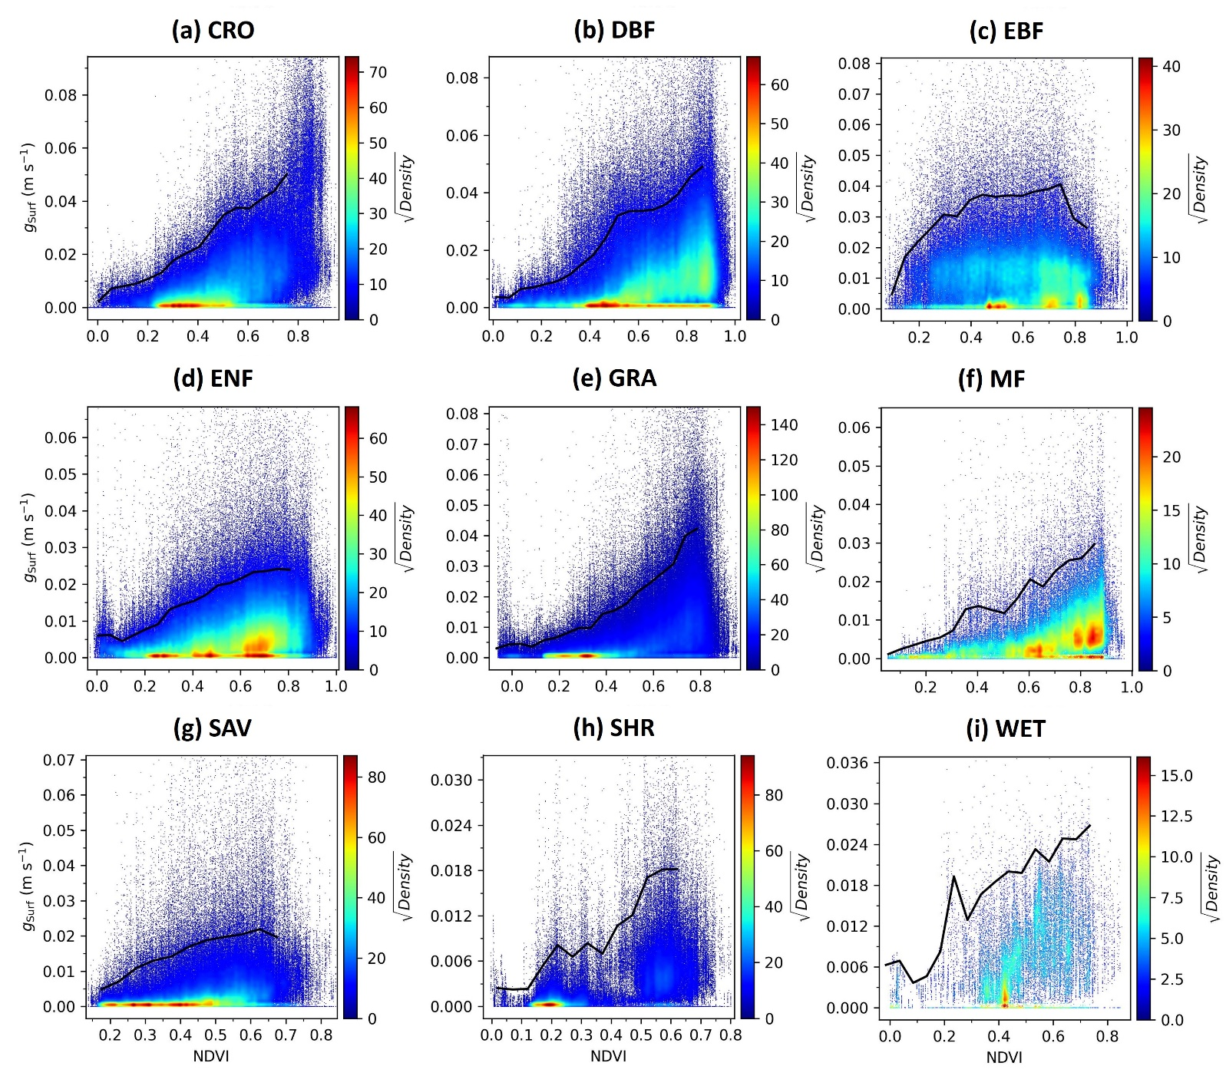
Fig. S7: HSTIC surface conductance ($g_{Surf}$) versus normalized vegetation index (NDVI) on an hourly/half-hourly scale for six plant function types (PFTs) in EST dataset. Samples with vapor pressure deficit smaller than 3 hPa were removed. The solid lines represent the upper boundary of $g_{Surf}$, which consists of optimum $g_{Surf}$ acquired very 0.05 of NDVI. Before determining the optimum $g_{Surf}$ at each NDVI bin, we computed the density of samples, and the lowest 5% of samples by density were identified as outliers and were then removed. The color bars indicate he square root of the point density ($\sqrt{Density}$) within a squared area of $\frac{L_{x}}{50}×\frac{L_{y}}{50}$, where $L_{x}$ and $L_{y}$ denote the lengths of x and y axis, respectively.

Supplementary Tables
Table S 1 List of the information of 200 flux sites from the FLUXNET2015 dataset. MAT and MAP denote the mean annual air temperature and mean annual precipitation, and they are limited to the years shown in this table. HH and HR in “Time Scale” are abbreviations of half-hourly and hourly. Due to the limit of the availability of MODIS data, we only used data after 1999/12/31. Labels “Train”, “Validate”, and “Test” in “Split for model development” indicate corresponding sites were grouped into the traning, validation, and testing subsets during the development of HSTIC. Lable “Fold-i” (i=1, 2, 3, 4, 5) in “Split for 5-fold cross validation” indicate corresponding sites were used as testing data during the 5-fold cross validation analyses.
No. | Site ID |  | Site name |  | PFT | Longitude | Latitude | Years | MAT  (℃) | MAP  (mm) | Time  Scale | Split for model development | Split for 5-fold cross validation
1 | AT-Neu |  | Neustift |  | GRA | 47.1167 | 11.3175 | 2002-2012 | 6.8 | 669 | HH | Train | Fold-3
2 | AU-Ade |  | Adelaide River |  | WSA | -13.0769 | 131.1178 | 2007-2009 | 27.0 | 1359 | HH | Test | Fold-2
3 | AU-ASM |  | Alice Springs |  | ENF | -22.2830 | 133.2490 | 2010-2014 | 22.4 | 390 | HH | Validate | Fold-1
4 | AU-Cpr |  | Calperum |  | SAV | -34.0021 | 140.5891 | 2010-2014 | 17.8 | 337 | HH | Train | Fold-3
5 | AU-Cum |  | Cumberland Plain |  | EBF | -33.6133 | 150.7225 | 2012-2014 | 18.1 | 615 | HH | Train | Fold-4
6 | AU-DaP |  | Daly River Savanna |  | GRA | -14.0633 | 131.3181 | 2007-2013 | 25.5 | 1373 | HH | Train | Fold-3
7 | AU-DaS |  | Daly River Cleared |  | SAV | -14.1593 | 131.3881 | 2008-2014 | 26.6 | 1452 | HH | Train | Fold-4
8 | AU-Dry |  | Dry River |  | SAV | -15.2588 | 132.3706 | 2008-2014 | 26.8 | 920 | HH | Test | Fold-2
9 | AU-Emr |  | Emerald |  | GRA | -23.8587 | 148.4746 | 2011-2013 | 21.6 | 661 | HH | Train | Fold-3
10 | AU-Fog |  | Fogg Dam |  | WET | -12.5452 | 131.3072 | 2006-2008 | 25.5 | 1443 | HH | Train | Fold-4
11 | AU-Gin |  | Gingin |  | WSA | -31.3764 | 115.7138 | 2011-2014 | 19.2 | 620 | HH | Validate | Fold-4
12 | AU-GWW |  | Great Western Woodlands, Western Australia, Australia |  | SAV | -30.1913 | 120.6541 | 2013-2014 | 19.9 | 365 | HH | Train | Fold-5
13 | AU-How |  | Howard Springs |  | WSA | -12.4943 | 131.1523 | 2001-2014 | 26.7 | 1715 | HH | Validate | Fold-1
14 | AU-Lox |  | Loxton |  | DBF | -34.4704 | 140.6551 | 2008-2009 | 17.0 | 161 | HH | Validate | Fold-1
15 | AU-RDF |  | Red Dirt Melon Farm, Northern Territory |  | WSA | -14.5636 | 132.4776 | 2011-2013 | 26.2 | 1430 | HH | Train | Fold-3
16 | AU-Rig |  | Riggs Creek |  | GRA | -36.6499 | 145.5759 | 2011-2014 | 15.6 | 445 | HH | Train | Fold-1
17 | AU-Rob |  | Robson Creek, Queensland, Australia |  | EBF | -17.1175 | 145.6301 | 2014 | 21.7 | 2194 | HH | Test | Fold-2
18 | AU-Stp |  | Sturt Plains |  | GRA | -17.1507 | 133.3502 | 2008-2014 | 26.1 | 729 | HH | Train | Fold-4
19 | AU-TTE |  | Ti Tree East |  | OSH | -22.2870 | 133.6400 | 2012-2014 | 24.3 | 278 | HH | Test | Fold-2
20 | AU-Tum |  | Tumbarumba |  | EBF | -35.6566 | 148.1517 | 2001-2014 | 9.5 | 963 | HR | Train | Fold-5
21 | AU-Wac |  | Wallaby Creek |  | EBF | -37.4259 | 145.1878 | 2005-2008 | 10.7 | 2775 | HH | Test | Fold-2
22 | AU-Whr |  | Whroo |  | EBF | -36.6732 | 145.0294 | 2011-2014 | 15.7 | 389 | HH | Validate | Fold-3
23 | AU-Wom |  | Wombat |  | EBF | -37.4222 | 144.0944 | 2010-2014 | 11.4 | 956 | HH | Validate | Fold-1
24 | AU-Ync |  | Jaxa |  | GRA | -34.9893 | 146.2907 | 2012-2014 | 17.3 | 692 | HH | Test | Fold-2
25 | BE-Bra |  | Brasschaat |  | MF | 51.3092 | 4.5206 | 2000-2014 | 10.9 | 805 | HH | Train | Fold-3
26 | BE-Lon |  | Lonzee |  | CRO | 50.5516 | 4.7461 | 2004-2014 | 11.4 | 766 | HH | Test | Fold-2
27 | BR-Sa3 |  | Santarem-Km83-Logged Forest |  | EBF | -3.0180 | -54.9714 | 2000-2004 | 25.8 | 1475 | HH | Train | Fold-2
28 | CA-Gro |  | Ontario - Groundhog River, Boreal Mixedwood Forest |  | MF | 48.2167 | -82.1556 | 2003-2014 | 3.2 | 821 | HH | Train | Fold-5
29 | CA-Oas |  | Saskatchewan - Western Boreal, Mature Aspen |  | DBF | 53.6289 | -106.1978 | 2000-2010 | 1.7 | 479 | HH | Train | Fold-3
30 | CA-Obs |  | Saskatchewan - Western Boreal, Mature Black Spruce |  | ENF | 53.9872 | -105.1178 | 2000-2010 | 1.1 | 496 | HH | Train | Fold-5
31 | CA-Qfo |  | Quebec - Eastern Boreal, Mature Black Spruce |  | ENF | 49.6925 | -74.3421 | 2003-2010 | 1.0 | 946 | HH | Train | Fold-4
32 | CA-SF1 |  | Saskatchewan - Western Boreal, forest burned in 1977 |  | ENF | 54.4850 | -105.8176 | 2003-2006 | -0.1 | 448 | HH | Train | Fold-3
33 | CA-SF2 |  | Saskatchewan - Western Boreal, forest burned in 1989 |  | ENF | 54.2539 | -105.8775 | 2001-2005 | 0.2 | 286 | HH | Train | Fold-5
34 | CA-SF3 |  | Saskatchewan - Western Boreal, forest burned in 1998 |  | OSH | 54.0916 | -106.0053 | 2001-2006 | 1.2 | 353 | HH | Train | Fold-1
35 | CA-TP4 |  | Ontario - Turkey Point 1939 Plantation White Pine |  | ENF | 42.7102 | -80.3574 | 2002-2014 | 8.5 | 1108 | HH | Train | Fold-5
36 | CA-TPD |  | Ontario - Turkey Point Mature Deciduous |  | DBF | 42.6353 | -80.5577 | 2012-2014 | 9.7 | 920 | HH | Train | Fold-3
37 | CH-Cha |  | Chamau |  | GRA | 47.2102 | 8.4104 | 2005-2014 | 9.5 | 1136 | HH | Test | Fold-2
38 | CH-Dav |  | Davos |  | ENF | 46.8153 | 9.8559 | 2000-2014 | 3.7 | 808 | HH | Test | Fold-2
39 | CH-Fru |  | Früebüel |  | GRA | 47.1158 | 8.5378 | 2005-2014 | 7.6 | 1295 | HH | Validate | Fold-1
40 | CH-Oe1 |  | Oensingen grassland |  | GRA | 47.2858 | 7.7319 | 2002-2008 | 9.3 | 1222 | HH | Train | Fold-4
41 | CN-Cng |  | Changling |  | GRA | 44.5934 | 123.5092 | 2007-2010 | 6.2 | 289 | HH | Train | Fold-5
42 | CN-Sw2 |  | Siziwang Grazed (SZWG) |  | GRA | 41.7902 | 111.8971 | 2010-2012 | 2.4 | 281 | HH | Train | Fold-5
43 | CZ-BK1 |  | Bily Kriz forest |  | ENF | 49.5021 | 18.5369 | 2004-2014 | 6.8 | 1292 | HH | Train | Fold-1
44 | CZ-BK2 |  | Bily Kriz grassland |  | GRA | 49.4944 | 18.5429 | 2004-2012 | 6.1 | 1222 | HH | Test | Fold-2
45 | CZ-wet |  | Trebon (CZECHWET) |  | WET | 49.0247 | 14.7704 | 2006-2014 | 8.4 | 606 | HH | Train | Fold-1
46 | DE-Akm |  | Anklam |  | WET | 53.8662 | 13.6834 | 2009-2014 | 9.2 | 648 | HH | Train | Fold-3
47 | DE-Geb |  | Gebesee |  | CRO | 51.1001 | 10.9143 | 2001-2014 | 9.7 | 531 | HH | Train | Fold-1
48 | DE-Gri |  | Grillenburg |  | GRA | 50.95 | 13.5126 | 2004-2014 | 8.6 | 943 | HH | Train | Fold-4
49 | DE-Hai |  | Hainich |  | DBF | 51.0792 | 10.4530 | 2000-2012 | 8.3 | 761 | HH | Train | Fold-3
50 | DE-Kli |  | Klingenberg |  | CRO | 50.8929 | 13.5225 | 2004-2014 | 7.8 | 811 | HH | Train | Fold-5
51 | DE-Lkb |  | Lackenberg |  | ENF | 49.0996 | 13.3047 | 2009-2013 | 4.6 | 1113 | HH | Validate | Fold-1
52 | DE-Lnf |  | Leinefelde |  | DBF | 51.3282 | 10.3678 | 2002-2012 | 8.2 | 622 | HH | Test | Fold-2
53 | DE-Obe |  | Oberbärenburg |  | ENF | 50.7836 | 13.7196 | 2008-2014 | 6.5 | 1046 | HH | Validate | Fold-1
54 | DE-RuR |  | Rollesbroich |  | GRA | 50.6219 | 6.3041 | 2011-2014 | 8.2 | 872 | HH | Train | Fold-5
55 | DE-RuS |  | Selhausen Juelich |  | CRO | 50.8659 | 6.4472 | 2011-2014 | 10.8 | 551 | HH | Test | Fold-3
56 | DE-SfN |  | Schechenfilz Nord |  | WET | 47.8064 | 11.3275 | 2012-2014 | 8.3 | 930 | HH | Validate | Fold-3
57 | DE-Spw |  | Spreewald |  | WET | 51.8923 | 14.0337 | 2010-2014 | 10.5 | 642 | HH | Train | Fold-1
58 | DE-Tha |  | Tharandt |  | ENF | 50.9636 | 13.5669 | 2000-2014 | 9.0 | 851 | HH | Train | Fold-5
59 | DE-Zrk |  | Zarnekow |  | WET | 53.8759 | 12.8890 | 2013-2014 | 9.4 | 609 | HH | Train | Fold-5
60 | DK-Sor |  | Soroe |  | DBF | 55.4859 | 11.6446 | 2000-2014 | 8.3 | 848 | HH | Test | Fold-2
61 | FI-Hyy |  | Hyytiala |  | ENF | 61.8475 | 24.2950 | 2000-2014 | 4.5 | 630 | HH | Train | Fold-3
62 | FI-Lom |  | Lompolojankka |  | WET | 67.9972 | 24.2092 | 2007-2009 | -0.1 | 534 | HH | Test | Fold-2
63 | FR-Gri |  | Grignon |  | CRO | 48.8442 | 1.9519 | 2004-2014 | 11.0 | 597 | HH | Validate | Fold-1
64 | FR-LBr |  | Le Bray |  | ENF | 44.7171 | -0.7693 | 2000-2008 | 13.2 | 938 | HH | Train | Fold-5
65 | FR-Pue |  | Puechabon |  | EBF | 43.7414 | 3.5958 | 2000-2014 | 13.8 | 922 | HH | Train | Fold-4
66 | GF-Guy |  | Guyaflux (French Guiana) |  | EBF | 5.2788 | -52.9249 | 2004-2014 | 25.6 | 3110 | HH | Validate | Fold-1
67 | GH-Ank |  | Ankasa |  | EBF | 5.2685 | -2.6942 | 2011-2014 | 25.3 | 1795 | HH | Train | Fold-5
68 | IT-BCi |  | Borgo Cioffi |  | CRO | 40.5238 | 14.9574 | 2004-2014 | 17.9 | 1199 | HH | Train | Fold-3
69 | IT-CA1 |  | Castel d'Asso1 |  | DBF | 42.3804 | 12.0266 | 2011-2014 | 15.0 | 768 | HH | Train | Fold-4
70 | IT-CA2 |  | Castel d'Asso2 |  | CRO | 42.3772 | 12.0260 | 2011-2014 | 14.8 | 768 | HH | Train | Fold-4
71 | IT-CA3 |  | Castel d'Asso3 |  | DBF | 42.3800 | 12.0222 | 2011-2014 | 14.8 | 709 | HH | Validate | Fold-1
72 | IT-Col |  | Collelongo |  | DBF | 41.8494 | 13.5881 | 2000-2014 | 7.4 | 1140 | HH | Test | Fold-2
73 | IT-Isp |  | Ispra ABC-IS |  | DBF | 45.8126 | 8.6336 | 2013-2014 | 13.4 | 2002 | HH | Validate | Fold-1
74 | IT-La2 |  | Lavarone2 |  | ENF | 45.9542 | 11.2853 | 2000-2002 | 7.1 | 1490 | HH | Train | Fold-4
75 | IT-Lav |  | Lavarone |  | ENF | 45.9562 | 11.2813 | 2003-2014 | 7.0 | 1283 | HH | Train | Fold-1
76 | IT-MBo |  | Monte Bondone |  | GRA | 46.0147 | 11.0458 | 2003-2013 | 5.2 | 974 | HH | Train | Fold-3
77 | IT-Noe |  | Arca di Noe - Le Prigionette |  | CSH | 40.6061 | 8.1515 | 2004-2014 | 16.4 | 571 | HH | Validate | Fold-4
78 | IT-Ren |  | Renon |  | ENF | 46.5869 | 11.4337 | 2000-2013 | 4.6 | 915 | HH | Train | Fold-4
79 | IT-Ro1 |  | Roccarespampani 1 |  | DBF | 42.4081 | 11.9300 | 2000-2008 | 15.6 | 811 | HH | Train | Fold-4
80 | IT-Ro2 |  | Roccarespampani 2 |  | DBF | 42.3903 | 11.9209 | 2002-2012 | 15.5 | 792 | HH | Validate | Fold-1
81 | IT-SR2 |  | San Rossore 2 |  | ENF | 43.7320 | 10.2910 | 2013-2014 | 15.5 | 1329 | HH | Train | Fold-4
82 | IT-SRo |  | San Rossore |  | ENF | 43.7279 | 10.2844 | 2000-2012 | 15.2 | 874 | HH | Train | Fold-1
83 | IT-Tor |  | Torgnon |  | GRA | 45.8444 | 7.5781 | 2008-2014 | 2.9 | 768 | HH | Train | Fold-5
84 | JP-MBF |  | Moshiri Birch Forest Site |  | DBF | 44.3869 | 142.3186 | 2003-2005 | 3.6 | 935 | HH | Train | Fold-3
85 | JP-SMF |  | Seto Mixed Forest Site |  | MF | 35.2617 | 137.0788 | 2002-2006 | 14.7 | 1534 | HH | Train | Fold-1
86 | MY-PSO |  | Pasoh Forest Reserve (PSO) |  | EBF | 2.9730 | 102.3062 | 2003-2009 | 25.3 | 1865 | HH | Test | Fold-4
87 | NL-Hor |  | Horstermeer |  | GRA | 52.2403 | 5.0713 | 2004-2011 | 10.6 | 1035 | HH | Validate | Fold-1
88 | NL-Loo |  | Loobos |  | ENF | 52.1666 | 5.7436 | 2000-2014 | 10.0 | 828 | HH | Train | Fold-3
89 | RU-Che |  | Cherski |  | WET | 68.613 | 161.3414 | 2002-2005 | -11.0 | 96 | HH | Train | Fold-4
90 | RU-Cok |  | Chokurdakh |  | OSH | 70.8291 | 147.4943 | 2003-2014 | -12.6 | 218 | HH | Train | Fold-3
91 | RU-Fyo |  | Fyodorovskoye |  | ENF | 56.4615 | 32.9221 | 2000-2014 | 5.2 | 564 | HH | Test | Fold-2
92 | RU-Sam |  | Samoylov |  | GRA | 72.3733 | 126.4978 | 2002-2014 | -11.9 | 261 | HH | Validate | Fold-1
93 | RU-SkP |  | Yakutsk Spasskaya Pad larch |  | DNF | 62.2550 | 129.1680 | 2012-2014 | -4.6 | 289 | HH | Test | Fold-2
94 | SE-St1 |  | Stordalen grassland |  | WET | 68.3541 | 19.0503 | 2012-2014 | 0.0 | 262 | HH | Test | Fold-2
95 | US-AR1 |  | ARM USDA UNL OSU Woodward Switchgrass 1 |  | GRA | 36.4267 | -99.4200 | 2009-2012 | 15.3 | 509 | HH | Train | Fold-4
96 | US-AR2 |  | ARM USDA UNL OSU Woodward Switchgrass 2 |  | GRA | 36.6358 | -99.5975 | 2009-2012 | 15.1 | 412 | HH | Train | Fold-5
97 | US-ARM |  | ARM Southern Great Plains site- Lamont |  | CRO | 36.6058 | -97.4888 | 2003-2012 | 15.3 | 646 | HH | Train | Fold-5
98 | US-CRT |  | Curtice Walter-Berger cropland |  | CRO | 41.6285 | -83.3471 | 2011-2013 | 10.8 | 811 | HH | Train | Fold-4
99 | US-GBT |  | GLEES Brooklyn Tower |  | ENF | 41.3658 | -106.2397 | 2000-2006 | 0.4 | 511 | HH | Test | Fold-2
100 | US-GLE |  | GLEES |  | ENF | 41.3665 | -106.2399 | 2004-2014 | 0.0 | 1419 | HH | Train | Fold-5
101 | US-Goo |  | Goodwin Creek |  | GRA | 34.2547 | -89.8735 | 2002-2006 | 16.2 | 1428 | HH | Train | Fold-4
102 | US-Ivo |  | Ivotuk |  | WET | 68.4865 | -155.7503 | 2004-2007 | -9.3 | 263 | HH | Train | Fold-4
103 | US-Los |  | Lost Creek |  | WET | 46.0827 | -89.9792 | 2000-2014 | 5.1 | 749 | HH | Validate | Fold-3
104 | US-Me2 |  | Metolius mature ponderosa pine |  | ENF | 44.4523 | -121.5574 | 2002-2014 | 7.5 | 486 | HH | Test | Fold-2
105 | US-Me3 |  | Metolius-second young aged pine |  | ENF | 44.3154 | -121.6078 | 2004-2009 | 8.1 | 375 | HH | Train | Fold-3
106 | US-Me6 |  | Metolius Young Pine Burn |  | ENF | 44.3233 | -121.6078 | 2010-2014 | 7.7 | 408 | HH | Train | Fold-4
107 | US-MMS |  | Morgan Monroe State Forest |  | DBF | 39.3232 | -86.4131 | 2000-2014 | 12.4 | 1093 | HR | Train | Fold-4
108 | US-Ne1 |  | Mead - irrigated continuous maize site |  | CRO | 41.1651 | -96.4766 | 2001-2013 | 10.5 | 846 | HR | Test | Fold-2
109 | US-Ne2 |  | Mead - irrigated maize-soybean rotation site |  | CRO | 41.1649 | -96.4701 | 2001-2013 | 10.3 | 876 | HR | Validate | Fold-1
110 | US-Ne3 |  | Mead - rainfed maize-soybean rotation site |  | CRO | 41.1797 | -96.4397 | 2001-2013 | 10.4 | 699 | HR | Train | Fold-2
111 | US-NR1 |  | Niwot Ridge Forest (LTER NWT1) |  | ENF | 40.0329 | -105.5464 | 2000-2014 | 2.3 | 726 | HH | Test | Fold-2
112 | US-Oho |  | Oak Openings |  | DBF | 41.5545 | -83.8438 | 2004-2013 | 10.5 | 834 | HH | Train | Fold-5
113 | US-ORv |  | Olentangy River Wetland Research Park |  | WET | 40.0201 | -83.0183 | 2011 | 12.4 | 1386 | HH | Train | Fold-5
114 | US-Prr |  | Poker Flat Research Range Black Spruce Forest |  | ENF | 65.1237 | -147.4876 | 2010-2014 | -2.7 | 310 | HH | Train | Fold-3
115 | US-SRC |  | Santa Rita Creosote |  | OSH | 31.9083 | -110.8395 | 2008-2014 | 19.7 | 318 | HH | Train | Fold-5
116 | US-SRG |  | Santa Rita Grassland |  | GRA | 31.7894 | -110.8277 | 2008-2014 | 18.8 | 388 | HH | Validate | Fold-1
117 | US-SRM |  | Santa Rita Mesquite |  | WSA | 31.8214 | -110.8661 | 2004-2014 | 19.0 | 333 | HH | Validate | Fold-5
118 | US-Syv |  | Sylvania Wilderness Area |  | MF | 46.2420 | -89.3477 | 2001-2014 | 4.4 | 665 | HH | Train | Fold-3
119 | US-Tw1 |  | Twitchell Wetland West Pond |  | WET | 38.1074 | -121.6469 | 2012-2014 | 15.7 | 444 | HH | Train | Fold-4
120 | US-Tw2 |  | Twitchell Corn |  | CRO | 38.1047 | -121.6433 | 2012-2013 | 15.2 | 389 | HH | Validate | Fold-4
121 | US-Tw3 |  | Twitchell Alfalfa |  | CRO | 38.1159 | -121.6467 | 2013-2014 | 16.0 | 345 | HH | Train | Fold-3
122 | US-Tw4 |  | Twitchell East End Wetland |  | WET | 38.1030 | -121.6414 | 2013-2014 | 15.8 | 243 | HH | Validate | Fold-3
123 | US-UMB |  | Univ. of Mich. Biological Station |  | DBF | 45.5598 | -84.7138 | 2000-2014 | 7.2 | 613 | HR | Test | Fold-2
124 | US-UMd |  | UMBS Disturbance |  | DBF | 45.5625 | -84.6975 | 2007-2014 | 7.1 | 718 | HH | Train | Fold-5
125 | US-Var |  | Vaira Ranch- Ione |  | GRA | 38.4133 | -120.9507 | 2000-2014 | 15.8 | 572 | HH | Validate | Fold-3
126 | US-WCr |  | Willow Creek |  | DBF | 45.8059 | -90.0799 | 2000-2014 | 5.5 | 691 | HH | Train | Fold-5
127 | US-Whs |  | Walnut Gulch Lucky Hills Shrub |  | OSH | 31.7438 | -110.0522 | 2007-2014 | 17.6 | 288 | HH | Train | Fold-5
128 | US-Wkg |  | Walnut Gulch Kendall Grasslands |  | GRA | 31.7365 | -109.9419 | 2004-2014 | 17.3 | 292 | HH | Test | Fold-2
129 | US-WPT |  | Winous Point North Marsh |  | WET | 41.4646 | -82.9962 | 2011-2013 | 11.4 | 843 | HH | Train | Fold-5
130 | ZA-Kru |  | Skukuza |  | SAV | -25.0197 | 31.4969 | 2000-2013 | 21.8 | 481 | HH | Train | Fold-1
131 | ZM-Mon |  | Mongu |  | DBF | -15.4378 | 23.2528 | 2000-2009 | 22.3 | 582 | HH | Train | Fold-4
132 | AR-SLu |  | San Luis |  | MF | -33.4648 | -66.4598 | 2009-2011 | 19.7 | 361 | HH | − | −
133 | BE-Vie |  | Vielsalm |  | MF | 50.3051 | 5.9981 | 2000-2014 | 8.4 | 956 | HH | − | −
134 | CA-Man |  | Manitoba - Northern Old Black Spruce (former BOREAS Northern Study Area) |  | ENF | 55.8796 | -98.4808 | 2000-2008 | -1.1 | 326 | HH | − | −
135 | CA-NS1 |  | UCI-1850 burn site |  | ENF | 55.8792 | -98.4839 | 2001-2005 | 0.9 | 284 | HH | − | −
136 | CA-NS2 |  | UCI-1930 burn site |  | ENF | 55.9058 | -98.5247 | 2001-2005 | -2.7 | 321 | HH | − | −
137 | CA-NS3 |  | UCI-1964 burn site |  | ENF | 55.9117 | -98.3822 | 2001-2005 | -2.2 | 197 | HH | − | −
138 | CA-NS4 |  | UCI-1964 burn site wet |  | ENF | 55.9144 | -98.3806 | 2002-2005 | -1.4 | 274 | HH | − | −
139 | CA-NS5 |  | UCI-1981 burn site |  | ENF | 55.8631 | -98.4850 | 2001-2005 | -1.8 | 289 | HH | − | −
140 | CA-NS6 |  | UCI-1989 burn site |  | OSH | 55.9167 | -98.9644 | 2001-2005 | -0.4 | 255 | HH | − | −
141 | CA-NS7 |  | UCI-1998 burn site |  | OSH | 56.6358 | -99.9483 | 2002-2005 | -1.7 | 302 | HH | − | −
142 | CA-TP1 |  | Ontario - Turkey Point 2002 Plantation White Pine |  | ENF | 42.6609 | -80.5595 | 2002-2014 | 8.8 | 1108 | HH | − | −
143 | CA-TP2 |  | Ontario - Turkey Point 1989 Plantation White Pine |  | ENF | 42.7744 | -80.4588 | 2002-2007 | 8.6 | 928 | HH | − | −
144 | CA-TP3 |  | Ontario - Turkey Point 1974 Plantation White Pine |  | ENF | 42.7068 | -80.3483 | 2002-2014 | 8.9 | 1108 | HH | − | −
145 | CH-Lae |  | Laegern |  | MF | 47.4783 | 8.3644 | 2004-2014 | 7.8 | 1175 | HH | − | −
146 | CH-Oe2 |  | Oensingen crop |  | CRO | 47.2863 | 7.7343 | 2004-2014 | 9.6 | 2063 | HH | − | −
147 | CN-Cha |  | Changbaishan |  | MF | 42.4025 | 128.0958 | 2003-2005 | 4.4 | 466 | HH | − | −
148 | CN-Dan |  | Dangxiong |  | GRA | 30.4978 | 91.0664 | 2004-2005 | 2.2 | 520 | HH | − | −
149 | CN-Din |  | Dinghushan |  | EBF | 23.1733 | 112.5361 | 2003-2005 | 20.4 | 1374 | HH | − | −
150 | CN-Du2 |  | Duolun_grassland (D01) |  | GRA | 42.0467 | 116.2836 | 2006-2008 | 3.2 | 332 | HH | − | −
151 | CN-Du3 |  | Duolun Degraded Meadow |  | GRA | 42.0551 | 116.2809 | 2009-2010 | 2.3 | 502 | HH | − | −
152 | CN-Ha2 |  | Haibei Shrubland |  | WET | 37.6086 | 101.3269 | 2003-2005 | -1.5 | 527 | HH | − | −
153 | CN-HaM |  | Haibei Alpine Tibet site |  | GRA | 37.3700 | 101.1800 | 2002-2004 | -1.0 | 595 | HH | − | −
154 | CN-Qia |  | Qianyanzhou |  | ENF | 26.7414 | 115.0581 | 2003-2005 | 18.2 | 1170 | HH | − | −
155 | DE-Seh |  | Selhausen |  | CRO | 50.8706 | 6.4497 | 2007-2010 | 10.3 | 574 | HH | − | −
156 | DK-Eng |  | Enghave |  | GRA | 55.6905 | 12.1918 | 2005-2008 | 8.6 | 828 | HH | − | −
157 | ES-Amo |  | Amoladeras |  | OSH | 36.8336 | -2.2523 | 2007-2012 | 18.1 | 294 | HH | − | −
158 | ES-LgS |  | Laguna Seca |  | OSH | 37.0979 | -2.9658 | 2007-2009 | 6.2 | 516 | HH | − | −
159 | ES-LJu |  | Llano de los Juanes |  | OSH | 36.9266 | -2.7521 | 2004-2013 | 11.7 | 595 | HH | − | −
160 | ES-Ln2 |  | Lanjaron-Salvage logging |  | OSH | 36.9695 | -3.4758 | 2009 | 9.1 | 546 | HH | − | −
161 | FI-Jok |  | Jokioinen |  | CRO | 60.8986 | 23.5134 | 2000-2003 | 4.6 | 622 | HH | − | −
162 | FI-Let |  | Lettosuo |  | ENF | 60.6418 | 23.9597 | 2009-2012 | 4.6 | 548 | HH | − | −
163 | FI-Sod |  | Sodankyla |  | ENF | 67.3624 | 26.6386 | 2001-2014 | 0.7 | 529 | HH | − | −
164 | FR-Fon |  | Fontainebleau-Barbeau |  | DBF | 48.4764 | 2.7801 | 2005-2014 | 11.4 | 685 | HH | − | −
165 | IT-Cp2 |  | Castelporziano2 |  | EBF | 41.7043 | 12.3573 | 2012-2014 | 16.1 | 852 | HH | − | −
166 | IT-Cpz |  | Castelporziano |  | EBF | 41.7052 | 12.3761 | 2000-2009 | 15.3 | 826 | HH | − | −
167 | IT-PT1 |  | Parco Ticino forest |  | DBF | 45.2009 | 9.0610 | 2002-2004 | 14.0 | 782 | HH | − | −
168 | RU-Ha1 |  | Hakasia steppe |  | GRA | 54.7252 | 90.0022 | 2002-2004 | 2.0 | 384 | HH | − | −
169 | RU-Tks |  | Tiksi |  | GRA | 71.5943 | 128.8878 | 2010-2014 | -11.5 | 272 | HH | − | −
170 | RU-Vrk |  | Seida/Vorkuta |  | CSH | 67.0547 | 62.9405 | 2008-2008 | -3.7 | 646 | HH | − | −
171 | SD-Dem |  | Demokeya |  | SAV | 13.2829 | 30.4783 | 2005-2009 | 27.4 | 285 | HH | − | −
172 | SN-Dhr |  | Dahra |  | SAV | 15.4028 | -15.4322 | 2010-2013 | 28.3 | 276 | HH | − | −
173 | US-ARb |  | ARM Southern Great Plains burn site- Lamont |  | GRA | 35.5497 | -98.0402 | 2005-2006 | 16.1 | 711 | HH | − | −
174 | US-ARc |  | ARM Southern Great Plains control site- Lamont |  | GRA | 35.5465 | -98.0400 | 2005-2006 | 15.7 | 763 | HH | − | −
175 | US-Atq |  | Atqasuk |  | WET | 70.4696 | -157.4089 | 2003-2008 | -10.4 | 107 | HH | − | −
176 | US-Blo |  | Blodgett Forest |  | ENF | 38.8953 | -120.6328 | 2000-2007 | 11.3 | 1339 | HH | − | −
177 | US-Cop |  | Corral Pocket |  | GRA | 38.0900 | -109.3900 | 2001-2007 | 13.6 | 203 | HR | − | −
178 | US-Ha1 |  | Harvard Forest EMS Tower (HFR1) |  | DBF | 42.5378 | -72.1715 | 2000-2012 | 8.2 | 1215 | HR | − | −
179 | US-IB2 |  | Fermi National Accelerator Laboratory- Batavia (Prairie site) |  | GRA | 41.8406 | -88.2410 | 2004-2011 | 9.4 | 972 | HH | − | −
180 | US-KS1 |  | Kennedy Space Center (slash pine) |  | ENF | 28.4583 | -80.6709 | 2002-2002 | 23.2 | 1186 | HH | − | −
181 | US-KS2 |  | Kennedy Space Center (scrub oak) |  | CSH | 28.6086 | -80.6715 | 2003-2006 | 21.8 | 1146 | HH | − | −
182 | US-Lin |  | Lindcove Orange Orchard |  | CRO | 36.3566 | -119.8423 | 2009-2010 | 17.1 | 413 | HH | − | −
183 | US-Me1 |  | Metolius - Eyerly burn |  | ENF | 44.5794 | -121.5000 | 2004-2005 | 9.1 | 171 | HH | − | −
184 | US-Me4 |  | Metolius-old aged ponderosa pine |  | ENF | 44.4992 | -121.6224 | 2000 | 8.0 | 379 | HH | − | −
185 | US-Me5 |  | Metolius-first young aged pine |  | ENF | 44.4372 | -121.5668 | 2000-2002 | 7.7 | 402 | HH | − | −
186 | US-Myb |  | Mayberry Wetland |  | WET | 38.0498 | -121.7651 | 2010-2014 | 15.3 | 382 | HH | − | −
187 | US-PFa |  | Park Falls/WLEF |  | MF | 45.9459 | -90.2723 | 2000-2014 | 5.5 | 600 | HR | − | −
188 | US-Sta |  | Saratoga |  | OSH | 41.3966 | -106.8024 | 2005-2009 | 5.8 | 507 | HH | − | −
189 | US-Ton |  | Tonzi Ranch |  | WSA | 38.4316 | -120.9660 | 2001-2014 | 16.4 | 546 | HH | − | −
190 | US-Twt |  | Twitchell Island |  | CRO | 38.1087 | -121.6530 | 2009-2014 | 14.7 | 359 | HH | − | −
191 | US-Wi0 |  | Young red pine (YRP) |  | ENF | 46.6188 | -91.0814 | 2002-2002 | 3.5 | 726 | HH | − | −
192 | US-Wi1 |  | Intermediate hardwood (IHW) |  | DBF | 46.7305 | -91.2329 | 2003-2003 | 4.5 | 304 | HH | − | −
193 | US-Wi2 |  | Intermediate red pine (IRP) |  | ENF | 46.6869 | -91.1528 | 2003-2003 | 3.4 | 434 | HH | − | −
194 | US-Wi3 |  | Mature hardwood (MHW) |  | DBF | 46.6347 | -91.0987 | 2002-2004 | 5.2 | 668 | HH | − | −
195 | US-Wi4 |  | Mature red pine (MRP) |  | ENF | 46.7393 | -91.1663 | 2002-2005 | 5.7 | 703 | HH | − | −
196 | US-Wi5 |  | Mixed young jack pine (MYJP) |  | ENF | 46.6531 | -91.0858 | 2004-2004 | 4.6 | 670 | HH | − | −
197 | US-Wi6 |  | Pine barrens #1 (PB1) |  | OSH | 46.6249 | -91.2982 | 2002-2003 | 3.5 | 673 | HH | − | −
198 | US-Wi7 |  | Red pine clearcut (RPCC) |  | OSH | 46.6491 | -91.0693 | 2005 | 3.7 | 875 | HH | − | −
199 | US-Wi8 |  | Young hardwood clearcut (YHW) |  | DBF | 46.7223 | -91.2524 | 2002-2002 | 5.4 | 764 | HH | − | −
200 | US-Wi9 |  | Young Jack pine (YJP) |  | ENF | 46.6188 | -91.0814 | 2004-2005 | 4.0 | 755 | HH | − | −

Table S2 Candidate features of the machine learning (ML)-based approach to estimating the relative humidity at the source sink/height (ML-${RH}_{0}$). The “Selected” column indicates the candidate features were selected for training ML-${RH}_{0}$ (Yes) or not (No).
Selected | No. | Features | Definitions or descriptions | Dimension
Yes | 1 | $$Λ_{STIC1.2}$$ | Evaporative fraction output by STIC1.2 | 0 – 1
 | 2 | $$g_{A,STIC1.2}$$ | Aerodynamic conductance estimated by STIC1.2 | $${m s}^{-1}$$
 | 3 | $$H_{STIC1.2}$$ | Sensible heat flux estimated by STIC1.2 | $${W m}^{-2}$$
 | 4 | $${RH}_{0,STIC1.2}$$ | Relative humidity at the source sink/height derived from STIC1.2 outputs:  ${RH}_{0,STIC1.2}={\left(e_{a}+\left(e_{0}^{*}-e_{a}\right)∙M\right)}/{e_{0}^{*}}$, where $e_{a}$ and $e_{0}^{*}$ denote the actual air vapor pressure at the reference height and the saturated vapor pressure at the source/sink height, and M denotes surface moisture factor. $e_{0}^{*}$ and M are estimated by STIC1.2. | 0 – 1
 | 5 | $$α_{R, NIR}$$ | Surface albedo for near-infrared spectrum | 0 – 1
 | 6 | $$α_{R, VIS}$$ | Surface albedo for visible spectrum | 0 – 1
 | 7 | gNDVI | $gNDVI={\left(r_{nir}-r_{green}\right)}/{\left(r_{nir}+r_{green}\right)}$, where $r_{nir}$ and $r_{green}$ denote the near-infrared and green bands, respectively. | 0 – 1
 | 8 | $${LN}_{{LST}/{EVI}}$$ | ${LN}_{{LST}/{EVI}}=sign\left(T_{R,C}\right)∙ln\left(f_{{LST}/{EVI}}+1\right)$,  where $T_{R,C}$ denotes the land surface temperature in ℃ | -
 | 9 | $${LN}_{TVDI_EVI}$$ | The logarithmic value of ${TVDI}_{EVI}$:  $${LN}_{TVDI_EVI}=ln\left(1+{TVDI}_{EVI}\right)$$ | -
 | 10 | $$r_{2,Nadir}$$ | Nadir BRDF-adjusted reflectance of MODIS band 2 | 0 – 1
 | 11 | $$r_{6,Nadir}$$ | Nadir BRDF-Adjusted Reflectance of MODIS band 6 | 0 – 1
 | 12 | $$T_{R}$$ | Radiometric land surface temperature | K
 | 13 | $$P_{A}$$ | The atmospheric pressure | kPa
 | 14 | RH | Relative humidity of air | 0 – 1
 | 15 | $${RH}_{[-7,-13]}$$ | Mean relative humidity of air between 7 days and 13 days ago, where the two endpoints are included. | 0 – 1
 | 16 | $$R_{G}$$ | Global solar radiation | $${W m}^{-2}$$
 | 17 | $${VPD}_{[0,-6]}$$ | Mean vapor pressure deficit of air between current day and 6 days ago, where the two endpoints are included. | hPa
 | 18 | $${COS}_{DoY}$$ | ${COS}_{DoY}=cos\left({DoY}/{366}×2π\right)$, where DoY denotes the day of year. | -1 – 1
 | 19 | $${COS}_{Zenith}$$ | ${COS}_{Zenith}=cos\left(θ\right)$, where θ denotes the solar zenith angle. | -1 – 1
No | 20 | $$α_{STIC1.2}$$ | Priestley-Taylor coefficient estimated by STIC1.2 | 0 – 1.26
 | 21 | $$g_{Surf,STIC1.2}$$ | Surface conductance estimated by STIC1.2 | 0 – 1
 | 22 | $${λE}_{STIC1.2}$$ | Latent heat flux estimated by STIC1.2 | $${W m}^{-2}$$
 | 23 | $$M_{STIC1.2}$$ | Surface moisture index estimated by STIC1.2 | 0 – 1
 | 24 | $$T_{0,STIC1.2}$$ | Aerodynamic temperature estimated by STIC1.2 | K
 | 25 | EVI | Enhanced vegetation index²³:  $EVI=1.5{\left(r_{nir}-r_{red}\right)}/{\left(r_{nir}+{6r}_{red}-7.5r_{blue}+1\right)}$,  where $r_{nir}$, $r_{red}$, and $r_{blue}$ denote the reflectance of near-infrared, red, and blue bands, respectively. | 0 – 1
 | 26 | kNDVI | Kernel normalized vegetation index²⁴:  $$kNDVI=tanh\left({NDVI}^{2}\right)$$ | 0 – 1
 | 27 | $${LN}_{{LST}/{NDVI}}$$ | ${LN}_{{LST}/{NDVI}}=sign\left(T_{R,C}\right)∙ln\left(f_{{LST}/{NDVI}}+1\right)$,  where $T_{R,C}$ denotes the land surface temperature in ℃ | -
 | 28 | $${LN}_{TVDI_NDVI}$$ | The logarithmic value of ${TVDI}_{NDVI}$:  ${LN}_{TVDI_NDVI}=ln\left(1+{TVDI}_{NDVI}\right)$ | -
 | 29 | LSWI | Land surface water index²⁵:  $LSWI={\left(r_{nir}-r_{swir}\right)}/{\left(r_{nir}+r_{swir}\right)}$,  where $r_{nir}$ and $r_{swir}$ denote the reflectance of near-infrared and shortwave infrared bands, respectively. | 0 – 1
 | 30 | NDVI | Normalized vegetation index²³:  $NDVI={\left(r_{nir}-r_{red}\right)}/{\left(r_{nir}+r_{red}\right)}$,  where $r_{nir}$ and $r_{red}$ denote the reflectance of near-infrared and red bands, respectively. | 0 – 1
 | 31 | $$f_{NDVI∙EVI}$$ | $$f_{NDVI∙EVI}=NDVI×EVI$$ | 0 – 1
 | 32 | $${NIR}_{V}$$ | Vegetation near-infrared reflectance²⁶:  ${NIR}_{V}=\left(NDVI-{NDVI}_{S}\right){×r}_{nir,Nadir}$, where ${NDVI}_{S}$ denotes the $NDVI$ value of soil, fixed to 0.05, and $r_{nir,Nadir}$ denotes the nadir BRDF-adjusted reflectance of near-infrared band. | 0 – 1
 | 33 | $$r_{1,Nadir}$$ | Nadir BRDF-adjusted reflectance of MODIS band 1 | 0 – 1
 | 34 | $$r_{3,Nadir}$$ | Nadir BRDF-adjusted reflectance of MODIS band 3 | 0 – 1
 | 35 | $$r_{4,Nadir}$$ | Nadir BRDF-adjusted reflectance of MODIS band 4 | 0 – 1
 | 36 | $$r_{5,Nadir}$$ | Nadir BRDF-adjusted reflectance of MODIS band 5 | 0 – 5
 | 37 | $$r_{7,Nadir}$$ | Nadir BRDF-adjusted reflectance of MODIS band 7 | 0 – 1
 | 38 | SAVI | Soil adjusted vegetation index:  $SAVI={\left(r_{nir}-r_{red}\right)}/{\left(r_{nir}+r_{red}+L\right)}\left(1+L\right)$, where $r_{nir}$ and $r_{red}$ denote the reflectance of near-infrared and red bands. | 0 – 1
 | 39 | $$T_{A,[0,-6]}$$ | Mean $T_{A}$ between current day and 6 days ago, where the two endpoints are included. | ℃
 | 40 | $$f_{{LST}/{EVI}}$$ | $f_{{LST}/{EVI}}={T_{R,C}}/{EVI}$, where $T_{R,C}$ denotes the land surface temperature in ℃. | -
 | 41 | $$f_{{LST}/{NDVI}}$$ | $f_{{LST}/{NDVI}}={T_{R,C}}/{NDVI}$, where $T_{R,C}$ denotes the land surface temperature in ℃. | -
 | 42 | $${TVDI}_{EVI}$$ | Temperature-vegetation index dryness index²⁷ based on EVI:  ${TVDI}_{EVI}={\left(T_{R,C}-T_{A}\right)}/{\left(\left(1-f_{c}\right)∙{TD}_{max}\right)}$, ${TD}_{max}=50℃$,  $f_{c}=1.25EVI-0.125$. | 0 – 1
 | 43 | $${TVDI}_{NDVI}$$ | Temperature-vegetation index dryness index²⁷ based on NDVI:  ${TVDI}_{NDVI}={\left(T_{R,C}-T_{A}\right)}/{\left(\left(1-f_{c}\right)∙{TD}_{max}\right)}$, ${TD}_{max}=50℃$,  $f_{c}={\left(\frac{NDVI-{NDVI}_{S}}{{NDVI}_{V}-{NDVI}_{S}}\right)}^{2}$，${NDVI}_{V}=0.95$，${NDVI}_{S}=0.05$. | 0 – 1
 | 44 | $${RH}_{[0,-6]}$$ | Mean RH between current day and 6 days ago, where the two endpoints are included. | 0 – 1
 | 45 | $${RH}_{[-14,-20]}$$ | Mean relative humidity of air between 14 days and 20 days ago, where the two endpoints are included. | 0 – 1
 | 46 | $$R_{N}$$ | Net radiation | $${W m}^{-2}$$
 | 47 | $$R_{G,[0,-6]}$$ | Mean $R_{G}$ between current day and 6 days ago, where the two endpoints are included. | $${W m}^{-2}$$
 | 48 | $$R_{G,[-14,-20]}$$ | Mean $R_{G}$ between 14 days ago and 20 days ago, where the two endpoints are included. | $${W m}^{-2}$$
 | 49 | $$R_{G,[-14,-20]}$$ | Mean $R_{G}$ between 7 days and 13 days ago, where the two endpoints are included. | $${W m}^{-2}$$
 | 50 | $$T_{A}$$ | Air temperature | ℃
 | 51 | $$T_{A, [-14,-20]}$$ | Mean $T_{A}$ between 14 days and 20 days ago, where the two endpoints are included. | ℃
 | 52 | $$T_{A, [-7,-13]}$$ | Mean $T_{A}$ between 7 days and 13 days ago, where the two endpoints are included. | ℃
 | 53 | VPD | Vapor pressure deficit of air | hPa
 | 54 | $${VPD}_{[-14,-20]}$$ | Mean VPD between 14 days and 20 days ago, where the two endpoints are included. | hPa
 | 55 | $${VPD}_{[-7,-13]}$$ | Mean VPD between7 days and 13 days ago, where the two endpoints are included. | hPa
 | 56 | $${COS}_{Zenith_N}$$ | ${COS}_{Zenith_N}=cos\left(θ_{N}\right)$, where $θ_{N}$ denotes the solar zenith angle at noon. | 0 – 1

References
1 Monteith, J. L. Evaporation and environment. Symp. Soc. Exp. Biol. 19, 205-224, (1965).
2 Mallick, K. et al. Reintroducing radiometric surface temperature into the Penman-Monteith formulation. Water Resour. Res. 51, 6214-6243, (2015). doi:10.1002/2014WR016106.
3 Mallick, K. et al. A Surface Temperature Initiated Closure (STIC) for surface energy balance fluxes. Remote Sens. Environ. 141, 243-261, (2014). doi:https://doi.org/10.1016/j.rse.2013.10.022.
4 Mallick, K. et al. A Critical Evaluation on the Role of Aerodynamic and Canopy–Surface Conductance Parameterization in SEB and SVAT Models for Simulating Evapotranspiration: A Case Study in the Upper Biebrza National Park Wetland in Poland. Water 10, 1753, (2018). doi:10.3390/w10121753.
5 Mallick, K. et al. Canopy-scale biophysical controls of transpiration and evaporation in the Amazon Basin. Hydrol. Earth Syst. Sci. 20, 4237-4264, (2016). doi:10.5194/hess-20-4237-2016.
6 Mallick, K. et al. Bridging Thermal Infrared Sensing and Physically‐Based Evapotranspiration Modeling: From Theoretical Implementation to Validation Across an Aridity Gradient in Australian Ecosystems. Water Resour. Res. 54, 3409-3435, (2018). doi:10.1029/2017wr021357.
7 Trebs, I. et al. The role of aerodynamic resistance in thermal remote sensing-based evapotranspiration models. Remote Sens. Environ. 264, 112602, (2021). doi:https://doi.org/10.1016/j.rse.2021.112602.
8 Bhattarai, N., Mallick, K., Brunsell, N. A., Sun, G. & Jain, M. Regional evapotranspiration from an image-based implementation of the Surface Temperature Initiated Closure (STIC1.2) model and its validation across an aridity gradient in the conterminous US. Hydrol. Earth Syst. Sci. 22, 2311-2341, (2018). doi:10.5194/hess-22-2311-2018.
9 Mallick, K. et al. Canopy-scale biophysical controls of transpiration and evaporation in the Amazon Basin. Hydrol. Earth Syst. Sci. 20, 4237–4264, (2016). doi:10.5194/hess-20-4237-2016.
10 Li, H., Zhang, J., Zhang, S. & Bai, Y. Machine learning and remote sensing-based modeling of the optimal stomatal behavior of crops. Comput. Electron. Agric. 200, 107261, (2022). doi:10.1016/j.compag.2022.107261.
11 Yuan, D. et al. Improving the Gross Primary Productivity Estimate by Simulating the Maximum Carboxylation Rate of the Crop Using Machine Learning Algorithms. IEEE Trans. Geosci. Remote Sens. 60, 4413115, (2022). doi:10.1109/tgrs.2022.3200988.
12 Bai, Y. et al. Thermally derived evapotranspiration from the Surface Temperature Initiated Closure (STIC) model improves cropland GPP estimates under dry conditions. Remote Sens. Environ. 271, 112901, (2022). doi:https://doi.org/10.1016/j.rse.2022.112901.
13 Tang, R. & Li, Z. L. An improved constant evaporative fraction method for estimating daily evapotranspiration from remotely sensed instantaneous observations. Geophys. Res. Lett. 44, 2319-2326, (2017). doi:10.1002/2017gl072621.
14 Yan, H. et al. Comparison of evapotranspiration upscaling methods from instantaneous to daytime scale for tea and wheat in southeast China. Agric. Water Manage. 264, 107464, (2022). doi:10.1016/j.agwat.2022.107464.
15 Huang, M. et al. Air temperature optima of vegetation productivity across global biomes. Nat. Ecol. Evol. 3, 772-779, (2019). doi:10.1038/s41559-019-0838-x.
16 Sims, D. et al. Midday values of gross CO2 flux and light use efficiency during satellite overpasses can be used to directly estimate eight-day mean flux. Agr. Forest Meteorol. 131, 1-12, (2005). doi:10.1016/j.agrformet.2005.04.006.
17 Bai, Y., Zhang, J., Zhang, S., Yao, F. & Magliulo, V. A remote sensing-based two-leaf canopy conductance model: Global optimization and applications in modeling gross primary productivity and evapotranspiration of crops. Remote Sens. Environ. 215, 411-437, (2018). doi:10.1016/j.rse.2018.06.005.
18 Tang, R., Li, Z.-L., Sun, X. & Bi, Y. Temporal upscaling of instantaneous evapotranspiration on clear-sky days using the constant reference evaporative fraction method with fixed or variable surface resistances at two cropland sites. J. Geophys. Res.: Atmos. 122, 784-801, (2017). doi:10.1002/2016jd025975.
19 Ryu, Y. et al. On the temporal upscaling of evapotranspiration from instantaneous remote sensing measurements to 8-day mean daily-sums. Agr. Forest Meteorol. 152, 212-222, (2012). doi:http://dx.doi.org/10.1016/j.agrformet.2011.09.010.
20 Purdy, A. J., Fisher, J. B., Goulden, M. L. & Famiglietti, J. S. Ground heat flux: An analytical review of 6 models evaluated at 88 sites and globally. J. Geophys. Res. Bioegeo. 121, 3045-3059, (2016). doi:10.1002/2016jg003591.
21 Colaizzi, P. D., Evett, S. R., Agam, N., Schwartz, R. C. & Kustas, W. P. Soil heat flux calculation for sunlit and shaded surfaces under row crops: 1. Model development and sensitivity analysis. Agr. Forest Meteorol. 216, 115-128, (2016). doi:10.1016/j.agrformet.2015.10.010.
22 Bhattacharya, B. K. et al. A coupled ground heat flux–surface energy balance model of evaporation using thermal remote sensing observations. Biogeosciences 19, 5521-5551, (2022). doi:10.5194/bg-19-5521-2022.
23 Huete, A. et al. Overview of the radiometric and biophysical performance of the MODIS vegetation indices. Remote Sens. Environ. 83, 195-213, (2002).
24 Camps-Valls, G. et al. A unified vegetation index for quantifying the terrestrial biosphere. Sci. Adv. 7, eabc7447, (2021). doi:doi:10.1126/sciadv.abc7447.
25 Xiao, X. et al. Modeling gross primary production of temperate deciduous broadleaf forest using satellite images and climate data. Remote Sens. Environ. 91, 256-270, (2004). doi:10.1016/j.rse.2004.03.010.
26 Badgley, G., Field, C. B. & Berry, J. A. Canopy near-infrared reflectance and terrestrial photosynthesis. Sci. Adv. 3, e1602244, (2017). doi:10.1126/sciadv.1602244.
27 Zhu, W., Jia, S. & Lv, A. A Universal Ts-VI Triangle Method for the Continuous Retrieval of Evaporative Fraction From MODIS Products. J. Geophys. Res.: Atmos. 122, 10,206-210,227, (2017). doi:https://doi.org/10.1002/2017JD026964.

