Compound mortality impacts from extreme temperatures and pandemics
Y. T. Eunice Lo^{1,2,*}, Dann M. Mitchell^{1,3} and Antonio Gasparrini^{4,5,6}

¹ Cabot Institute for the Environment, University of Bristol, UK
² Elizabeth Blackwell Institute for Health Research, University of Bristol, UK
³ School of Geographical Sciences, University of Bristol, UK
⁴ Department of Public Health, Environments and Society, London School of Hygiene and Tropical Medicine, London, UK
⁵ Centre on Climate Change & Planetary Health, London School of Hygiene and Tropical Medicine, London, UK
⁶ Centre for Statistical Methodology, London School of Hygiene and Tropical Medicine, London, UK

Supplementary information
- Figure S1
- Table S1
- Table S2
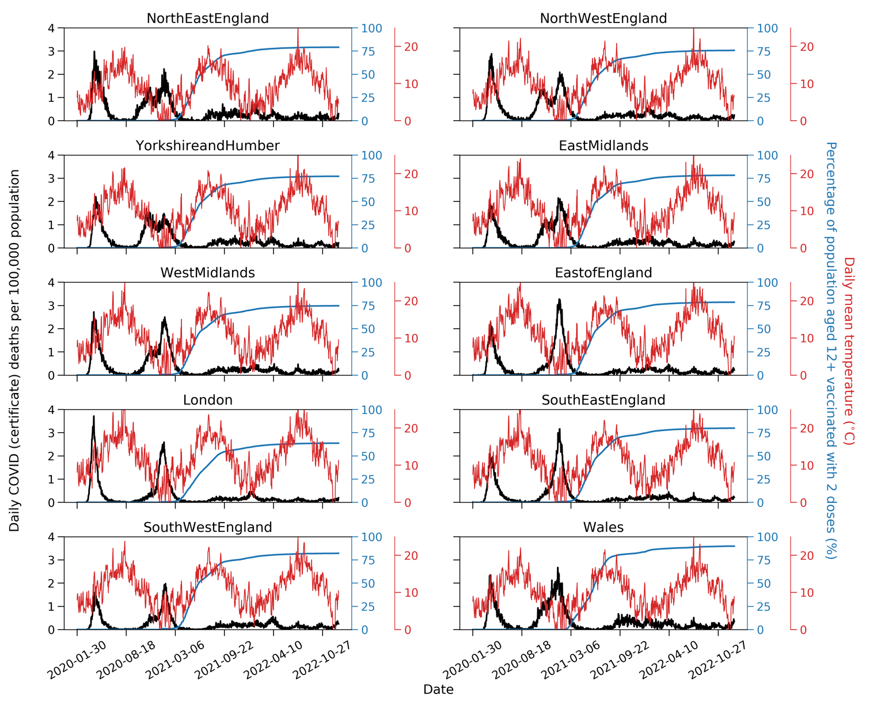
Figure S1. Time series of daily COVID-19 death occurrences indicated by death certificates, per 100,000 people in each region in England and Wales (black line), compared with regional daily mean temperature (red line), and the regional cumulated percentage of population aged 12+ who have had 2 doses of COVID-19 vaccines (blue line). This figure covers the study period, 30 January 2020 to 31 December 2022.

Table S1. The cumulative percentage of people aged 12 and above who have received two doses of COVID-19 vaccines as of 1 July 2021. The data are displayed by regions in England and Wales.
Region | Vaccine uptake (%) | Region | Vaccine uptake (%)
North East England | 53.9 | North West England | 50.9
Yorkshire and Humber | 51.8 | East Midlands | 53.1
West Midlands | 50 | East of England | 52.1
London | 35.9 | South East England | 51.8
South West England | 55 | Wales | 61.6

Table S2. Start and end dates of heatwaves and cold snaps between 30 January 2020 and 31 December 2022. All dates are in dd/mm/yyyy. “--” indicates no additional events that year.
 | Heatwaves |  | Cold snaps
Year | Start date | End date | Start date | End date
2020 | 23/06/2020 | 27/06/2020 | 29/12/2020 | 18/01/2021
2020 | 30/07/2020 | 01/08/2020 | -- | --
2020 | 05/08/2020 | 15/08/2020 | -- | --
2021 | 16/07/2021 | 23/07/2021 | 22/01/2021 | 02/02/2021
2021 | 06/09/2021 | 09/09/2021 | 08/02/2021 | 12/02/2021
2021 | -- | -- | 26/11/2021 | 29/11/2021
2021 | -- | -- | 20/12/2021 | 23/12/2021
2022 | 16/06/2022 | 19/06/2022 | 04/01/2022 | 10/01/2022
2022 | 10/07/2022 | 25/07/2022 | 13/01/2022 | 17/01/2022
2022 | 30/07/2022 | 05/08/2022 | 07/12/2022 | 18/12/2022
2022 | 08/08/2022 | 17/08/2022 | -- | --
2022 | 23/08/2022 | 25/08/2022 | -- | --

