Supplementary Material

patient | sex | age at operation | diagnosis
Nr. 1 | male | 3.5 months | Hirschsprung’s Disease
Nr. 2 | female | 6.0 months | Anorectal Malformation
Nr. 3 | male | 10.5 months | Hirschsprung’s Disease
Nr. 4 | female | 9.0 months | Anorectal Malformation
Nr. 5 | male | 3.0 months | Hirschsprung’s Disease

Tab. 2s: Patient characteristics from organoid original samples.

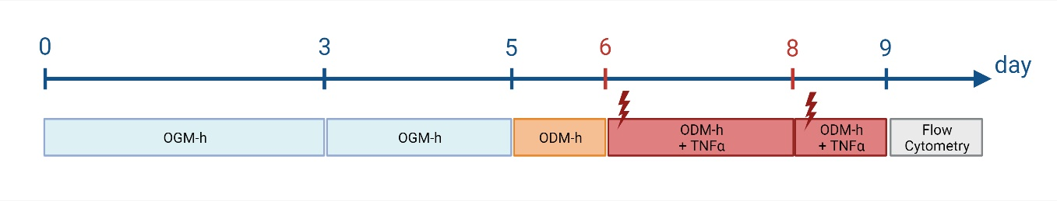
Fig.3s: Scheme of the medium changes and the addition of TNFα during the 9 days of experiment for determination of cytokine concentration. Growth medium (blue) and differentiation medium (orange) were changed on the indicated days. TNFα (red) was added on day 6 and 8 to induce proinflammatory stress. Figure created with BioRender.com.

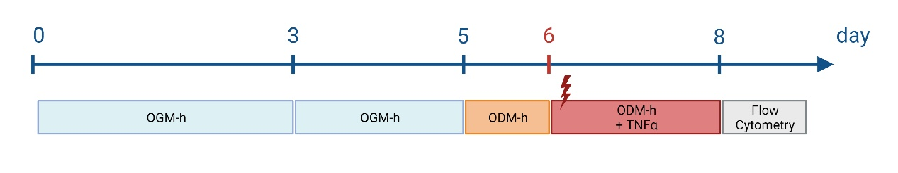
Fig. 4s: Scheme of the medium changes and the addition of TNFα during the 8 days of RIP3-Caspase3 assay experiment. Growth medium (blue) and differentiation medium (orange) were changed on the indicated days. TNFα (red) was added on day 6 to induce proinflammatory stress. Figure created with BioRender.com.

