- Appendix

Events | Type | Year | Dates | DC max (m) | Observed  Water |  |  | Observed Flow | Observed Winds
 |  |  |  |  | WASD | LWTV | SWPV | LF | LWTV or WASD
Great flood of 1936 | River | 1936 | 03/14-03/24 | 2.79 | Y | N | Y | Y | N
Blizzard of 1996 | River | 1996 | 01/14-01/25 | 2.04 | Y | Y | Y | Y | Y
Hurricane Agnes | River | 1972 | 06/10-06/02 | 2.22 | Y | N | Y | Y | N
Flood of 1937 | Compound | 1937 | 04/22-05/02 | 2.18 | Y | N | Y | Y | N
Hurricane Fran | Compound | 1996 | 09/04-09/15 | 2.04 | Y | Y | Y | Y | Y
Hurricane Isabel | Compound | 2003 | 09/15-09/27 | 2.7 | Y | Y | Y | Y | Y
TS Ernesto | Coastal | 2006 | 08/28-09/05 | 1.61 | Y | Y | Y | Y | Y
Hurricane Sandy | Coastal | 2012 | 10/20-11/11 | 1.44 | Y | Y | Y | Y | Y
Hurricane Florence | Coastal | 2018 | 09/05-09/20 | 1.48 | Y | Y | Y | Y | Y

Table A1. List of Stations in the Study area

Region | Station Full Name | Abbreviation | Longitude | Latitude | Observed Water | Observed Flow |  | Tide Prediction
Potomac Upper River Reach | Little Falls Pump Station, MD | LFMD | -77.13 | 38.95 | Y | Y | -
Potomac Upper River Reach | Wisconsin Ave, DC | WADC | -77.07 | 38.90 | Y | - | -
Anacostia River Reach | Northeast Branch Riverdale, MD | NEMD | -76.93 | 38.96 | - | Y | -
Anacostia River Reach | Northwest Branch Hyattsville, MD | NWMD | -76.97 | 38.95 | - | Y | -
Anacostia River Reach | Bladensburg, MD | BDMD | -76.94 | 38.93 | - | - | Y
Anacostia River Reach | East Lake, MD | ELMD | -76.96 | 38.91 | - | - | Y
Anacostia River Reach | Kingman Lake, MD | KLMD | -76.97 | 38.89 | - | - | Y
Anacostia River Reach | Washington Navy Yard, DC | WNDC | -76.99 | 38.87 | - | - | Y
Main Potomac River | Washington, DC | WASD | -77.02 | 38.87 | - | - | Y
Main Potomac River | Bellevue, DC | BEDC | -77.03 | 38.83 | - | - | Y
Main Potomac River | Alexandria, VA | ALVA | -77.04 | 38.80 | - | - | Y
Main Potomac River | Fourmile Run, VA | FMVA | 77.05 | 38.84 | Y | - | -
Main Potomac River | Fourmile Run, Stream Station, VA | FSVA | 77.09 | 38.84 | - | Y | -
Main Potomac River | Cameron St Dock at Alexandria, VA | CSVA | 77.04 | 38.81 | Y | - | -
Main Potomac River | Cameron Run at Alexandria, VA | CRVA | 77.11 | 38.80 | - | Y | -
Main Potomac River | Piscataway Creek, MD | PCMD | 76.97 | 38.71 | - | Y | -
Main Potomac River | Marshall Hall, MD | MHMD | -77.10 | 38.69 | - | - | Y
Main Potomac River | Indian Head, MD | IHMD | -77.19 | 38.60 | - | - | Y
Main Potomac River | Quantico, VA | QUVA | -77.29 | 38.52 | - | - | Y
Main Potomac River | Liverpool Point, MD | LPMD | -77.27 | 38.46 | - | - | Y
Main Potomac River | Clifton Beach, Smith Point, MD | CLMD | -77.27 | 38.41 | - | - | Y
Main Potomac River | Riverside, MD | RSMD | -77.14 | 38.39 | - | - | Y
Main Potomac River | Goose Creek, MD | GCMD | -77.05 | 38.45 | - | - | Y
Main Potomac River | Mathias Point, VA | MPVA | -77.06 | 38.40 | - | - | Y
Main Potomac River | Dalghren, VA | NCDV | -77.04 | 38.32 | Y | - | Y
Main Potomac River | Lower Cedar Point, MD | LCMD | -76.98 | 38.34 | - | - | Y
Main Potomac River | Colonial Beach, Potomac River, VA | COVA | -76.96 | 38.25 | - | - | Y
Main Potomac River | Colton Point, MD | CPMD | -76.75 | 38.22 | - | - | Y
Main Potomac River | Ragged Point, VA | RPVA | -76.61 | 38.14 | - | - | Y
Main Potomac River | Piney Point, MD | PPMD | -76.53 | 38.13 | - | - | Y
Main Potomac River | Lewisetta, VA | LWTV | -76.47 | 37.99 | Y | - | Y

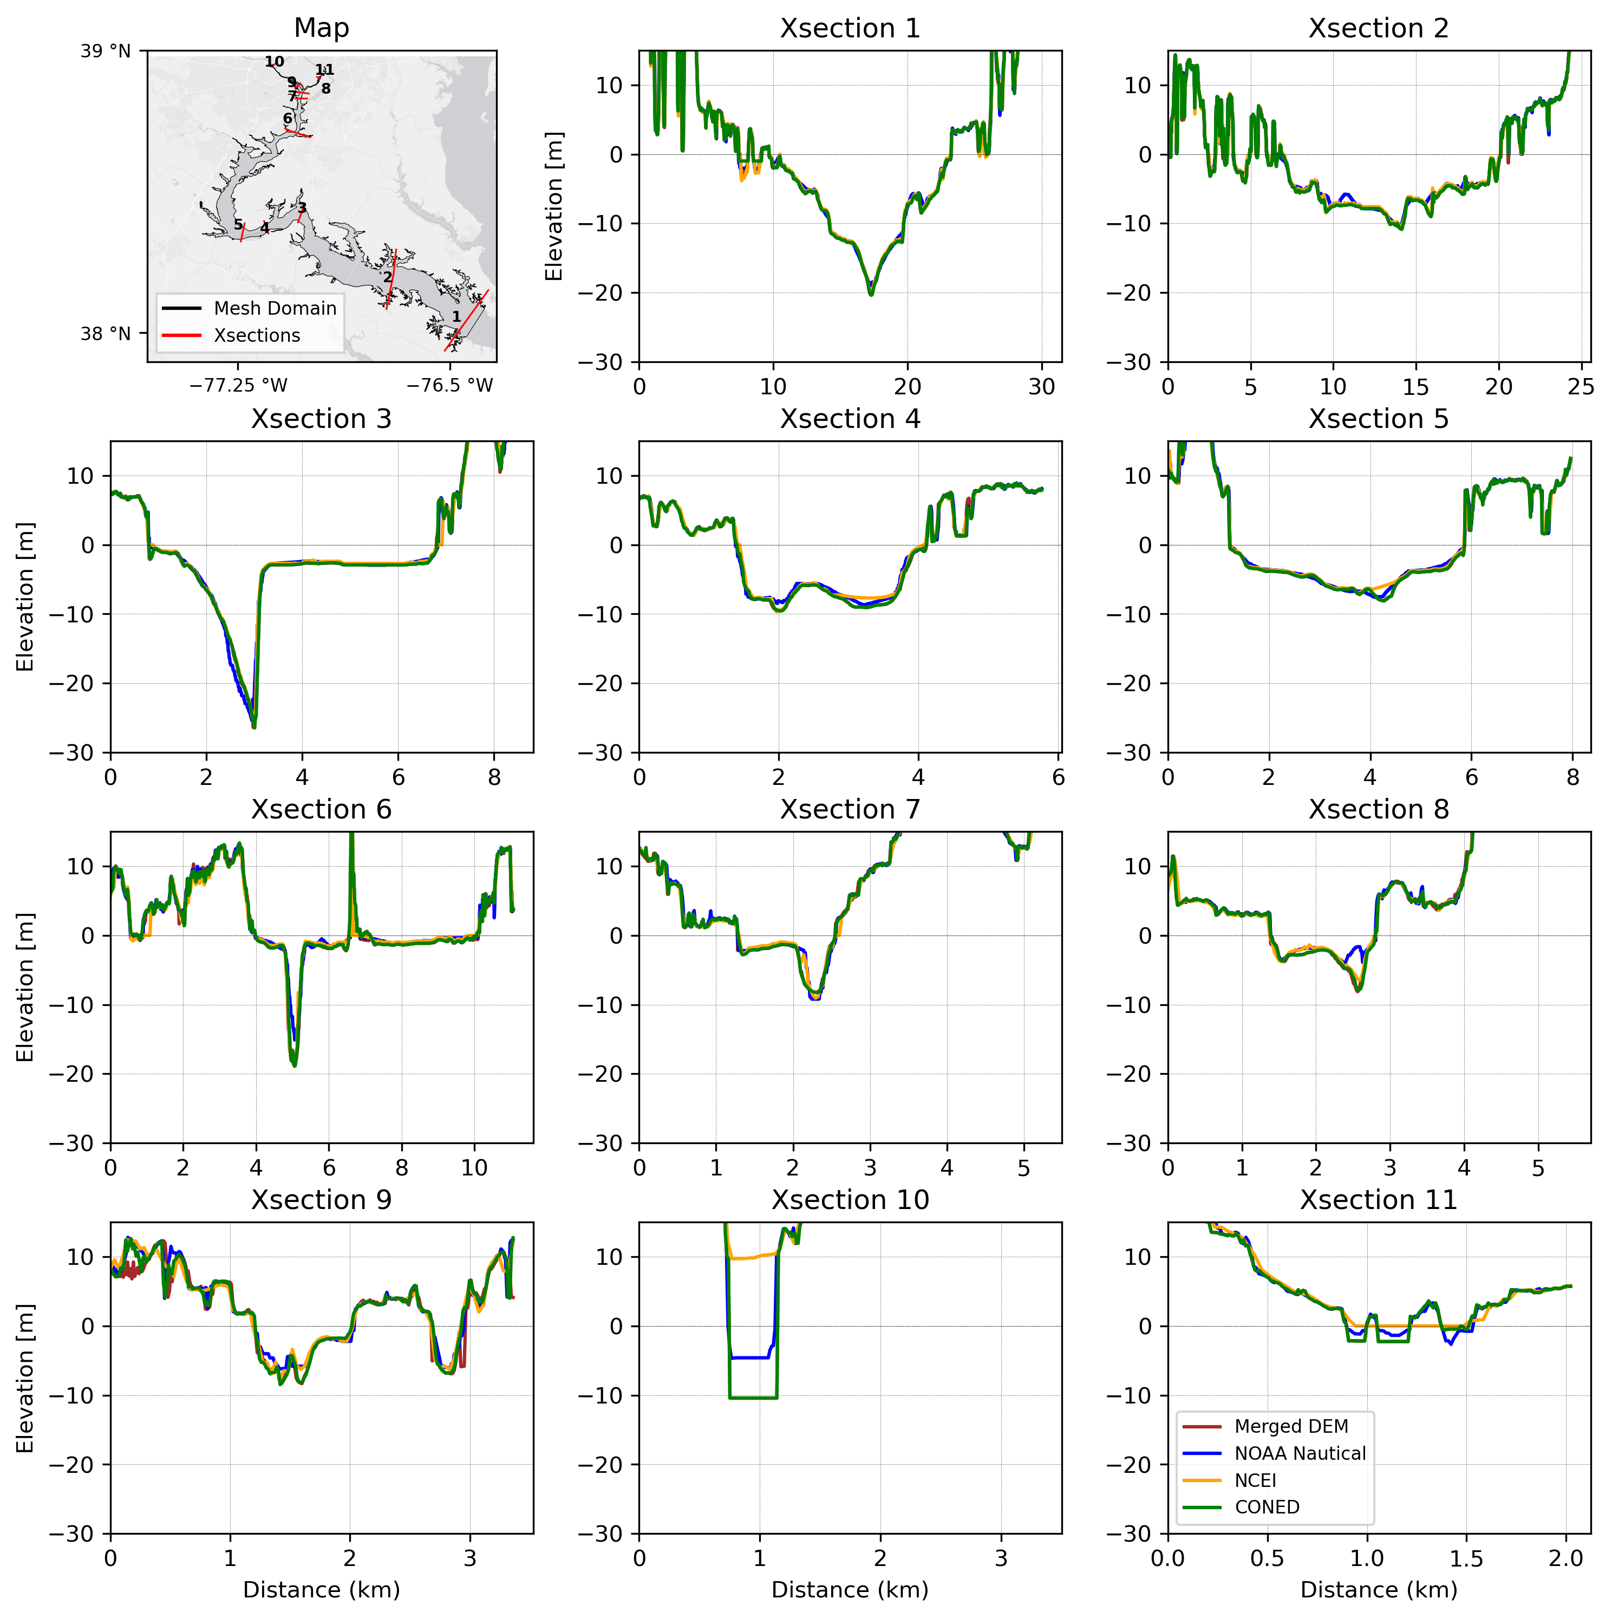
Figure A1. Cross-sections along the Potomac River comparing four bathymetry datasets (NOAA Nautical Charts, NCEI, CONED and Merged DEM)

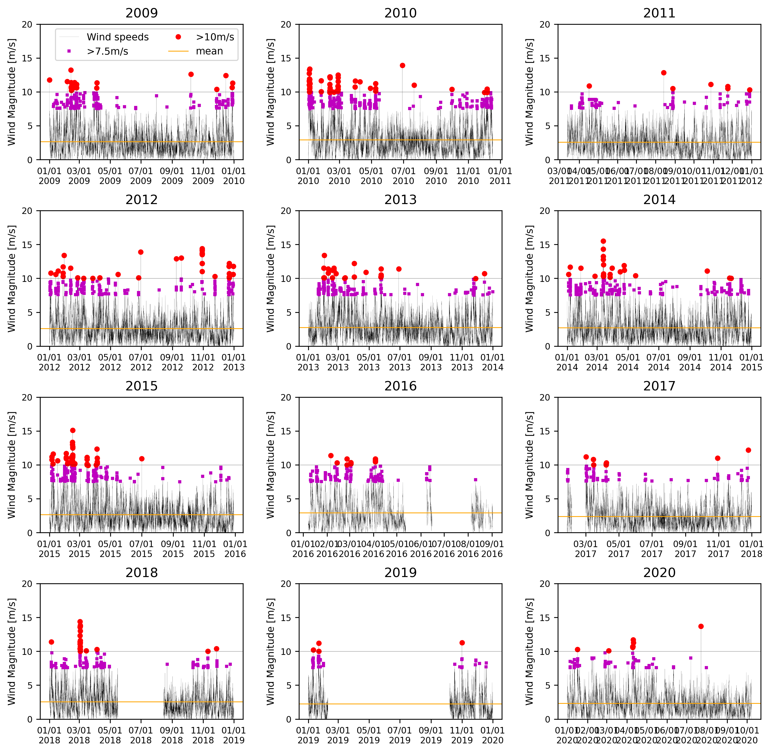
Figure A2. Observed wind speeds (above 10m height) at WASD during the period of 12 consecutive years (2009 to 2020)

