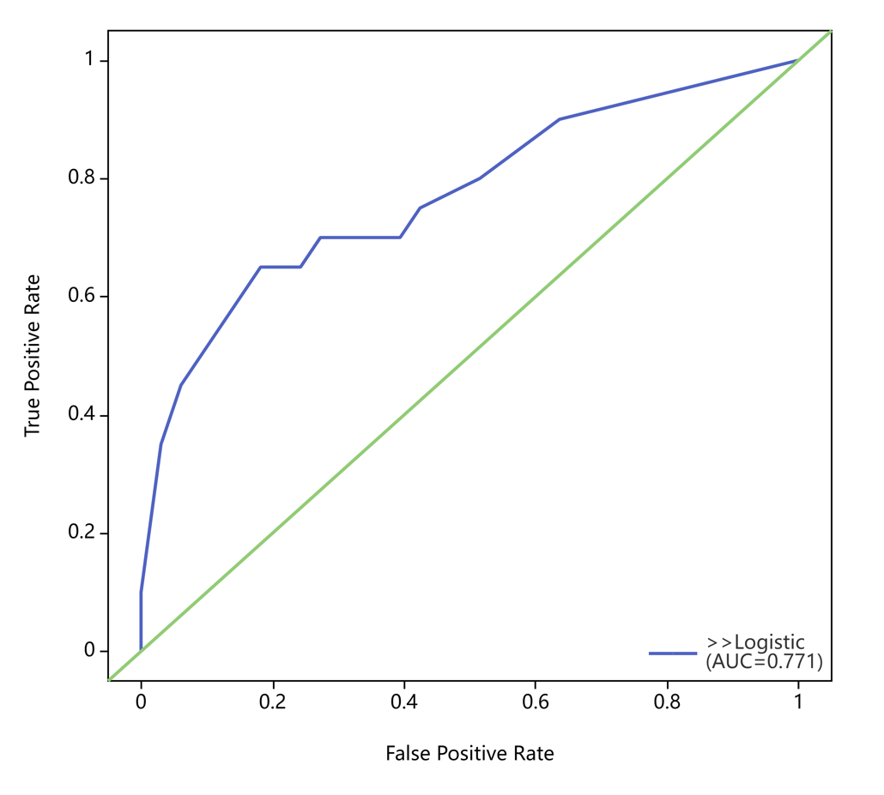
Figure 1
Receiver operating characteristic curve(test) of the nomogram for predicting pCR in breast cancer patients treated with NACT.
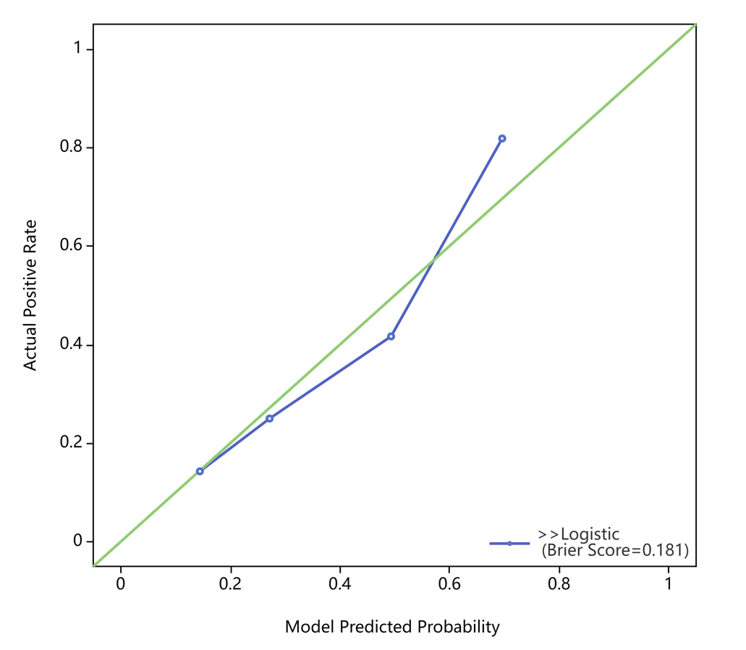
Figure 2
Bootstrap calibration curve(test) of the nomogram for predicting pCR in breast cancer received NACT.

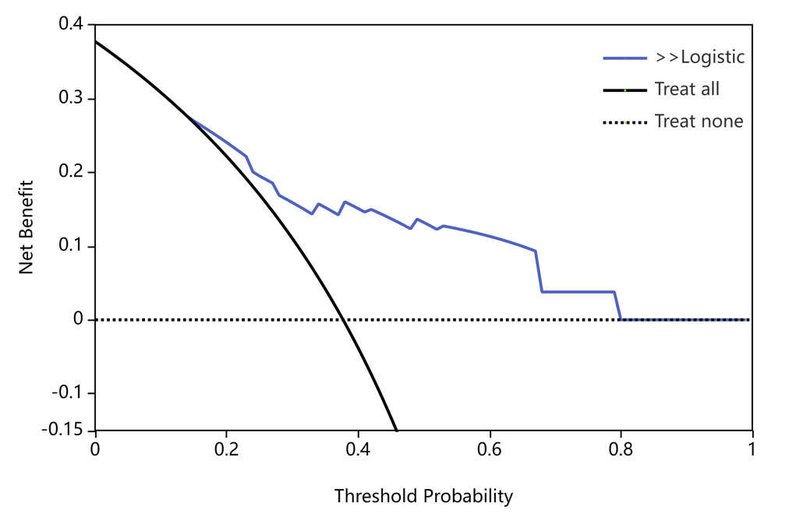
Figure 3
Decision curve(test) analysis of the nomogram for predicting pCR in breast cancer after NACT.

