Supplementary Data

Table of contents

Supplementary Figure 1. Selection process
Supplementary Table 1. Clinical characteristics of patients and matched controls in UGI subgroup
Supplementary Table 2. Clinical characteristics of patients and matched controls in LGI subgroup
Supplementary Table 3. Differences of AS accumulation layer by layer in the intestinal wall between patients with PD and controls
Supplementary Table 4. Differences of AS accumulation layer by layer in the intestinal wall and location of marginal blocks
Supplementary Table 5. Differences of AS accumulation layer by layer in the intestinal wall and location of marginal blocks in UGI subgroup
Supplementary Table 6. Differences of AS accumulation layer by layer in the intestinal wall and location of marginal blocks in LGI subgroup
Supplementary Table 7. Differences of clinical characteristics between UGI and LGI subgroups in patients with PD and AS accumulation in the GI tract
Supplementary Table 8. Differences of clinical characteristics between controls with and without AS accumulation in the GI tract
Supplementary Table 9. Frequency of AS accumulation in the discretized subgroups of duration from symptom onset to surgery in patients with PD

Supplementary Figure 1. Selection process. Abbreviations: N, number; PD, Parkinson’s disease; pAS, phosphorylated alpha-synuclein; NF, neurofilament.

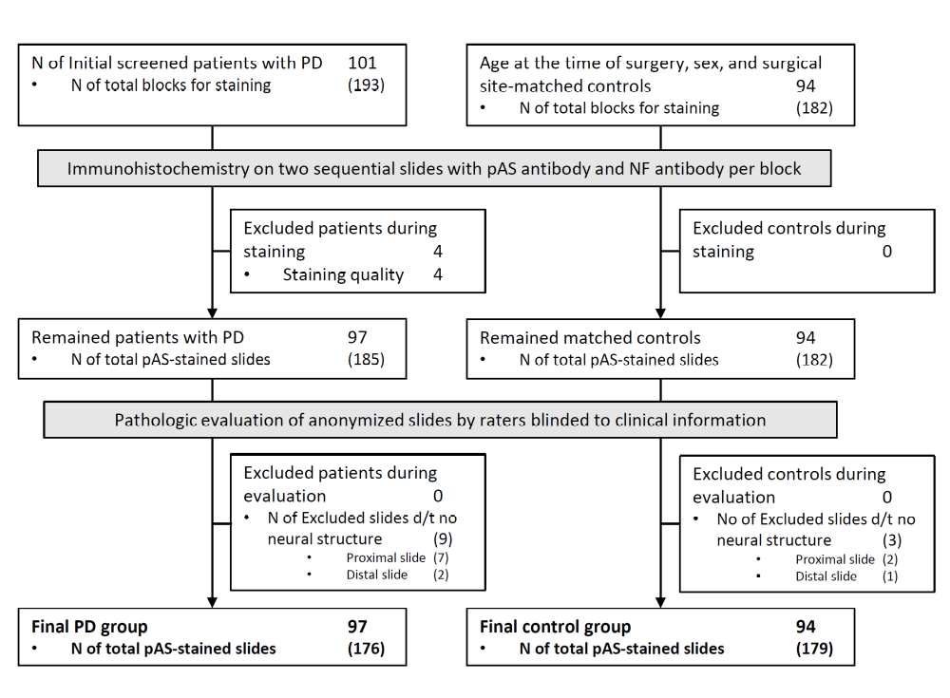

Supplementary Table 1. Clinical characteristics of patients and matched controls in UGI subgroup
Characteristic |  | Patients with PD (N=55) | Controls (N=53) | p-value
Sex, No. (%)
 | Male | 36 (65.5) | 40 (75.5) | 0.254
 | Female | 19 (34.5) | 13 (24.5) | 0.254
Age, mean (SD), y
 | At surgery | 71.1 (6.3) | 70.8 (6.1) | 0.767
 | At the final follow-up visit | 75.9 (7.2) | 77.9 (6.7) | 0.145
 | At symptom onset | 66.9 (8.4)
 | At diagnosis | 68.6 (8.3)
Duration, mean (SD), y
 | Onset to surgery | 4.2 (4.6)
 | Onset to diagnosis | 1.7 (1.7)
 | Onset to the final follow-up visit | 9.0 (4.7)
 | Surgery to the final follow-up visit | 4.8 (3.2) | 7.1 (2.0) | <0.001
Frequency of patients who underwent surgery before the symptom onset, No. (%) |  | 6 (10.9)
HY stage at the year of surgery (available in 18 patients, No. (%)
 | 1 | 3 (5.5)
 | 2 | 3 (5.5)
 | 2.5 | 8 (14.5)
 | 3 | 4 (7.3)
Surgical site, No. (%)
 | Stomach | 53 (96.4) | 53 (100) | 0.496
 | Esophagus | 2 (3.6) | 0 | 0.496
Abbreviations: UGI, upper gastrointestinal tract; PD, Parkinson’s disease; HY, Hoehn and Yahr.
Supplementary Table 2. Clinical characteristics of patients and matched controls in LGI subgroup
Characteristic |  | Patients with PD (N=42) | Controls (N=41) | p-value
Sex, No. (%)
 | Male | 21 (50.0) | 20 (48.8) | 0.912
 | Female | 21 (50.0) | 21 (51.2) | 0.912
Age, mean (SD), y
 | At surgery | 70.8 (7.7) | 71.0 (7.6) | 0.899
 | At the final follow-up visit | 75.6 (6.8) | 79.5 (7.6) | 0.016
 | At symptom onset | 66.7 (7.2)
 | At diagnosis | 68.6 (7.7)
Duration, mean (SD), y
 | Onset to surgery | 4.1 (5.3)
 | Onset to surgery | 1.9 (3.0)
 | Onset to diagnosis | 8.9 (4.8)
 | Onset to the final follow-up visit | 4.8 (4.0) | 8.5 (2.6) | <0.001
Frequency of patients who underwent surgery before the symptom onset, No. (%) |  | 6 (14.3)
HY stage at the year of surgery (available in 11 patients), No. (%)
 | 1 | 1 (2.4)
 | 2 | 4 (9.5)
 | 2.5 | 1 (2.4)
 | 3 | 5 (11.9)
Surgical site, No. (%)
 | ªRLGI | 12 (28.6) | 33 (80.5) | <0.001
 | ^{b}LLGI | 30 (71.4) | 6 (14.6) | <0.001
 | ^{c}others | 0 | 2 (4.9) | <0.001
ªRLGI includes surgical specimens acquired by right hemi-colectomy.
^{b}LLGI includes surgical specimens acquired by anterior resection, lower anterior resection, ultra-lower anterior resection, Miles’ operation, Hartmann’s operation, or left hemi-colectomy.
^{c}others include surgical specimens acquired by total colectomy and subtotal colectomy.
Abbreviations: LGI, lower gastrointestinal tract; PD, Parkinson’s disease; GI, gastrointestinal; UGI, upper GI tract; LGI, lower GI tract; RLGI, right LGI; LLGI, left LGI.
Supplementary Table 3. Differences of AS accumulation layer by layer in the intestinal wall between patients with PD and controls
Region | Layer | Patients with PD |  |  | Controls |  | p-value
 |  | Total No. | AS+, No. (%) |  | Total No. | AS+, No. (%)
Entire GI tract
 | Full layer | 97 | 73 (75.3) |  | 94 | 8 (8.5) | <0.001
 | Mucosa / submucosa | 96 | 45 (46.9) |  | 94 | 5 (5.3) | <0.001
 | Muscularis | 96 | 72 (75.0) |  | 94 | 8 (8.5) | <0.001
 | Serosa | 87 | 31 (35.6) |  | 92 | 6 (6.5) | <0.001
UGI (stomach+esophagus)
 | Full layer | 55 | 46 (83.6) |  | 53 | 8 (15.1) | <0.001
 | Mucosa / submucosa | 54 | 35 (64.8) |  | 53 | 5 (9.4) | <0.001
 | Muscularis | 54 | 45 (83.3) |  | 53 | 8 (15.1) | <0.001
 | Serosa | 47 | 20 (42.6) |  | 53 | 6 (11.3) | <0.001
LGI (colon+rectum)
 | Full layer | 42 | 27 (64.3) |  | 41 | 0 | <0.001
 | Mucosa / submucosa | 42 | 10 (23.8) |  | 41 | 0 | 0.001
 | Muscularis | 42 | 27 (64.3) |  | 41 | 0 | <0.001
 | Serosa | 40 | 11 (27.5) |  | 39 | 0 | <0.001
Abbreviations: PD, Parkinson’s disease; AS, alpha-synuclein; GI, gastrointestinal; UGI, upper GI tract; LGI, lower GI tract.

Supplementary Table 4. Differences of AS accumulation layer by layer in the intestinal wall and location of marginal blocks
Block | Layer | PD Patients |  |  | Controls |  | p-value
 |  | Total N | AS+ (%) |  | Total N | AS+ (%)
One or more in both blocks
 | Full layer | 97 | 73 (75.3%) |  | 94 | 8 (8.5%) | <0.001
 | Mucosa / submucosa | 96 | 45 (46.9%) |  | 94 | 5 (5.3%) | <0.001
 | Muscularis | 96 | 72 (75.0%) |  | 94 | 8 (8.5%) | <0.001
 | Serosa | 87 | 31 (35.6%) |  | 92 | 6 (6.5%) | <0.001
Proximal block only
 | Full layer | 84 | 51 (60.7%) |  | 88 | 8 (9.1%) | <0.001
 | Mucosa / submucosa | 83 | 26 (31.3%) |  | 88 | 5 (5.7%) | <0.001
 | Muscularis | 78 | 50 (64.1%) |  | 88 | 8 (9.1%) | <0.001
 | Serosa | 66 | 20 (30.3%) |  | 79 | 3 (3.8%) | <0.001
Distal block only
 | Full layer | 91 | 62 (68.1%) |  | 91 | 7 (7.7%) | <0.001
 | Mucosa / submucosa | 91 | 38 (41.8%) |  | 91 | 5 (5.5%) | <0.001
 | Muscularis | 86 | 58 (67.4%) |  | 91 | 7 (7.7%) | <0.001
 | Serosa | 69 | 21 (30.4%) |  | 80 | 4 (5.0%) | <0.001
Abbreviations: PD, Parkinson’s disease; AS, alpha-synuclein.

Supplementary Table 5. Differences of AS accumulation layer by layer in the intestinal wall and location of marginal blocks in UGI subgroup
Block | Layer | PD Patients |  |  | Controls |  | p-value
 |  | Total No. | AS+, No. (%) |  | Total No. | AS+, No. (%)
One or more in both blocks
 | Full layer | 55 | 46 (83.6) |  | 53 | 8 (15.1) | <0.001
 | Mucosa / submucosa | 54 | 35 (64.8) |  | 53 | 5 (9.4) | <0.001
 | Muscularis | 54 | 45 (83.3) |  | 53 | 8 (15.1) | <0.001
 | Serosa | 47 | 20 (42.6) |  | 53 | 6 (11.3) | <0.001
Proximal block only
 | Full layer | 45 | 33 (73.3) |  | 49 | 8 (16.3) | <0.001
 | Mucosa / submucosa | 44 | 21 (47.7) |  | 49 | 5 (10.2) | <0.001
 | Muscularis | 39 | 32 (82.1) |  | 49 | 8 (16.3) | <0.001
 | Serosa | 32 | 13 (40.6) |  | 48 | 3 (6.3) | <0.001
Distal block only
 | Full layer | 50 | 40 (80.0) |  | 51 | 7 (13.7) | <0.001
 | Mucosa / submucosa | 50 | 29 (58.0) |  | 51 | 5 (9.8) | <0.001
 | Muscularis | 49 | 39 (79.6) |  | 51 | 7 (13.7) | <0.001
 | Serosa | 36 | 11 (30.6) |  | 45 | 4 (8.9) | 0.013
Abbreviations: AS, alpha-synuclein; UGI, upper gastrointestinal tract; PD, Parkinson’s disease.

Supplementary Table 6. Differences of AS accumulation layer by layer in the intestinal wall and location of marginal blocks in LGI subgroup
Block | Layer | PD Patients |  |  | Controls |  | p-value
 |  | Total No. | AS+, No. (%) |  | Total No. | AS+, No. (%)
One or more in both blocks
 | Full layer | 42 | 27 (64.3) |  | 41 | 0 | <0.001
 | Mucosa / submucosa | 42 | 10 (23.8) |  | 41 | 0 | 0.001
 | Muscularis | 42 | 27 (64.3) |  | 41 | 0 | <0.001
 | Serosa | 40 | 11 (27.5) |  | 39 | 0 | <0.001
Proximal block only
 | Full layer | 39 | 18 (46.2) |  | 39 | 0 | <0.001
 | Mucosa / submucosa | 39 | 5 (12.8) |  | 39 | 0 | 0.055
 | Muscularis | 39 | 18 (46.2) |  | 39 | 0 | <0.001
 | Serosa | 34 | 7 (20.6) |  | 31 | 0 | 0.012
Distal block only
 | Full layer | 41 | 22 (53.7) |  | 40 | 0 | <0.001
 | Mucosa / submucosa | 41 | 9 (22.0) |  | 40 | 0 | 0.002
 | Muscularis | 37 | 19 (51.4) |  | 40 | 0 | <0.001
 | Serosa | 33 | 10 (30.3) |  | 35 | 0 | <0.001
Abbreviations: AS, alpha-synuclein; LGI, lower gastrointestinal tract; PD, Parkinson’s disease.

Supplementary Table 7. Differences of clinical characteristics between UGI and LGI subgroups in patients with PD and AS accumulation in the GI tract
Characteristic |  | Patients with PD and AS+ |  | p-value
 |  | UGI (N=46) | LGI (N=27) | p-value
Sex, No. (%)
 | Male | 30 (65.2) | 15 (55.6) | 0.412
 | Female | 16 (34.8) | 12 (44.4) | 0.412
Age, mean (SD), y
 | At surgery | 70.6 (5.7) | 72.7 (8.1) | 0.195
 | At the final follow-up visit | 75.4 (6.5) | 76.7 (6.6) | 0.426
 | At symptom onset | 65.6 (7.5) | 67.8 (7.6) | 0.243
 | At diagnosis | 67.5 (7.6) | 70.1 (8.2) | 0.170
Duration, mean (SD), y
 | Onset to surgery | 5.0 (4.3) | 4.9 (5.9) | 0.980
 | Onset to diagnosis | 1.8 (1.7) | 2.3 (3.7) | 0.521
 | Onset to the final follow-up visit | 9.8 (4.5) | 8.9 (4.7) | 0.427
 | Surgery to the final follow-up visit | 4.8 (3.2) | 4.0 (3.7) | 0.309
Frequency of patients who underwent surgery before the symptom onset, No. (%) |  | 4 (8.7) | 4 (14.8) | 0.457
HY stage at the year of surgery (available in 22 patients), No. (%)
 | 1 | 2 (4.3) | 1 (3.7) | 0.242
 | 2 | 3 (6.5) | 2 (7.4) | 0.242
 | 2.5 | 7 (15.2) | 0 | 0.242
 | 3 | 3 (6.5) | 4 (14.8) | 0.242
Abbreviations: PD, Parkinson’s disease; AS, alpha-synuclein; GI, gastrointestinal; UGI, upper GI tract; LGI, lower GI tract; HY, Hoehn and Yahr.

Supplementary Table 8. Differences of clinical characteristics between controls with and without AS accumulation in the GI tract
Characteristic |  | Control |  | p-value
 |  | AS+ (N=8) | AS− (N=86) | p-value
Sex, No. (%)
 | Male | 7 (87.5) | 53 (61.6) | 0.251
 | Female | 1 (12.5) | 35 (38.4) | 0.251
Age, mean (SD), y
 | At surgery | 72.1 (8.0) | 70.7 (6.7) | 0.581
 | At the final follow-up visit | 78.4 (8.4) | 78.6 (7.0) | 0.951
Duration from surgery to the final follow-up visit, mean (SD), y |  | 6.3 (1.2) | 7.9 (2.4) | 0.072
Surgical site, No. (%)
 | UGI | 8 (100) | 45 (52.3) | 0.009
 | LGI | 0 | 41 (47.7) | 0.009
Abbreviations: AS, alpha-synuclein; GI, gastrointestinal; UGI, upper GI tract; LGI, lower GI tract.

Supplementary Table 9. Frequency of AS accumulation in the discretized subgroups of duration from symptom onset to surgery in patients with PD
Duration of onset to surgery (years) | N of patients with PD | Entire GI tract |  |  | UGI |  |  | LGI
Duration of onset to surgery (years) |  | AS+, No. (%) | AS−, No. (%) |  | AS+, No. (%) | AS−, No. (%) |  | AS+, No. (%) | AS−, No. (%)
before symptom onset | 12 | 8 (66.7) | 4 (33.3) |  | 4 (66.7) | 2 (33.3) |  | 4 (66.7) | 2 (33.3)
0–5 | 48 | 31 (64.6) | 17 (35.4) |  | 22 (78.6) | 6 (21.4) |  | 9 (45.0) | 11 (55.0)
6–10 | 26 | 23 (88.5) | 3 (11.5) |  | 14 (93.3) | 1 (6.7) |  | 9 (81.8) | 2 (18.2)
≥11 | 11 | 11 (100) | 0 |  | 6 (100) | 0 |  | 5 (100) | 0
Abbreviations: PD, Parkinson’s disease; AS, alpha-synuclein; GI, gastrointestinal; UGI, upper GI tract; LGI, lower GI tract.

