New dinuclear gold(III) complex with 1,5-naphthyridine as bridging ligand: Synthesis, characterization, DNA/BSA binding studies and anticancer activity

Snežana Radisavljević,*¹ Dušan Ćoćić,¹ Biljana Petrović,¹ Ina Kellner,² Ivana Ivanović-Burmazović,² Nikola Radenković,³ Danijela Nikodijević,³ Milena Milutinović³

¹University of Kragujevac, Department of Chemistry, Faculty of Science, Radoja Domanovića 12, 34000 Kragujevac, Serbia
²Department of Chemistry, Ludwig-Maximilians-Universität München (LMU),
81377 München, Germany
³University of Kragujevac, Department of Biology and Ecology, Faculty of Science, Radoja Domanovića 12, 34000 Kragujevac, Serbia

*Corresponding author:
Dr. Snežana Radisavljević, University of Kragujevac, Faculty of Science, Department of Chemistry, Radoja Domanovića 12, 34000 Kragujevac, Serbia.
Email: snezana.radisavljevic@pmf.kg.ac.rs

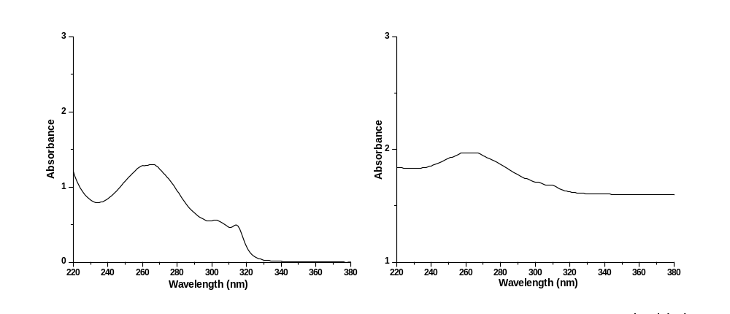

Fig. S1 UV-Vis spectra of dinuclear gold(III) complex in water (left) and in PBS (right) ([Au(III)] = 5×10⁻⁶ M)
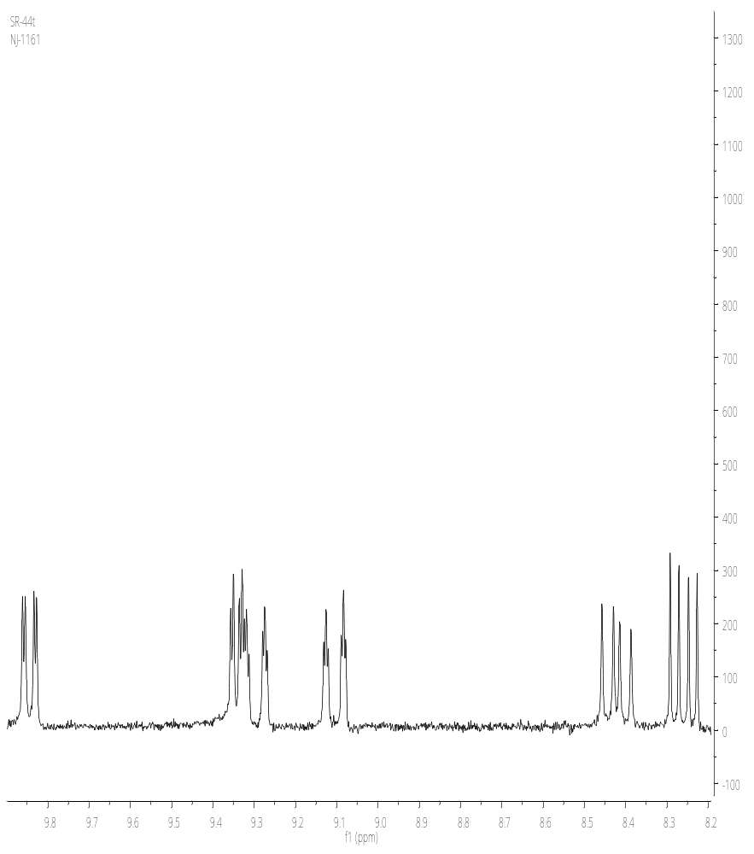
Fig. S2 ¹NMR spectrum of dinuclear gold(III) complex
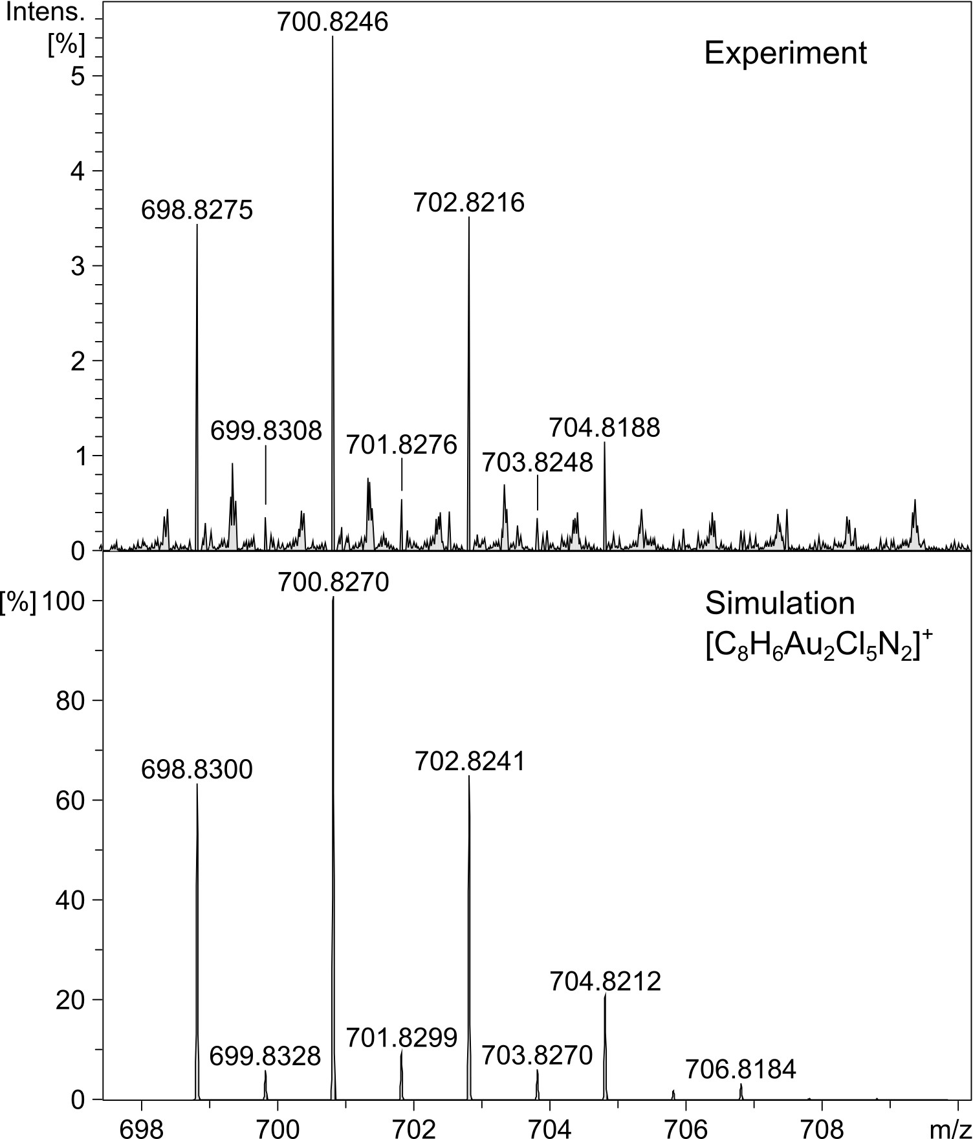
Fig. S3 Cryospray-MS spectrum of complex
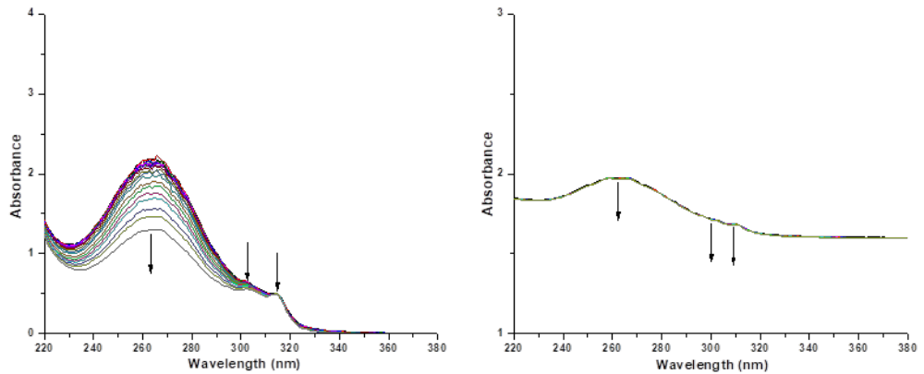Fig. S4 UV-Vis spectra of complex in water (left) and in PBS buffer (right) over a 6 hour period. [Au(III)] = 5×10⁻⁶ M

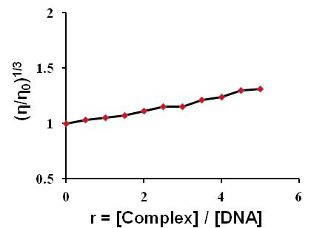
Fig. S5 Relative viscosity (ɳ/ɳ_{o})^{1/3} of CT-DNA (13.4 μM) in PBS buffer in the presence of increasing amount of dinuclear gold(III) complex (6.72 – 67 μM)

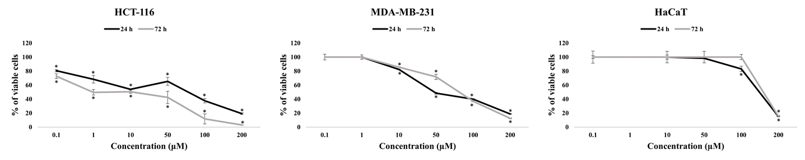
Fig. S6 Effect of dinuclear gold(III) complex on HCT-116, MDA-MB-231 and HaCaT cells viability. The results are presented as the mean ± standard error of three independent experiments. *Statistically significant difference (p<0.05) compared to control values

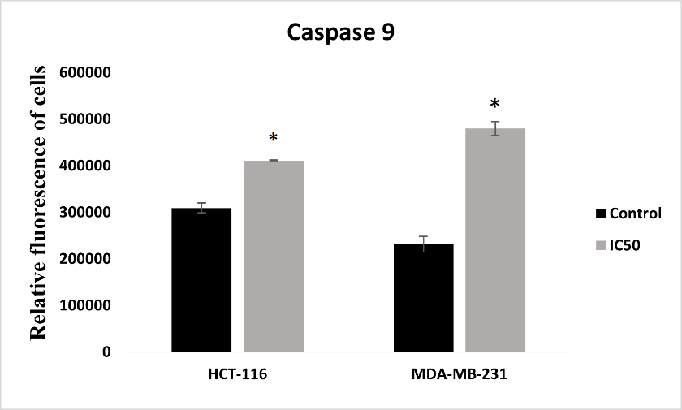
*
Fig. S7 The protein level of caspase 9 in HCT-116 and MDA-MB-231 control and cells treated with dinuclear gold(III) complex (IC₅₀ value), 24 h after treatment. The relative fluorescence of cells was calculated by the ImageJ computer program. The data means ± SE of more than 30 cells per control/treatment. * p<.05, statistically significant difference in relation to control values.

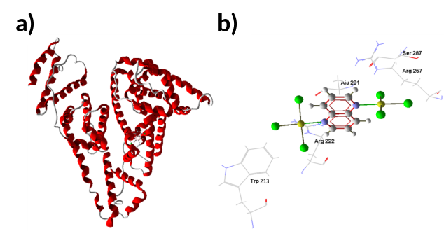
Fig. S8 Best pose with BSA docked into a subdomain IIA for dinuclear gold(III) complex according to Hbond values: A) molecular docking results illustrated regarding the BSA protein’s backbone; B) binding site of investigated complexes on BSA protein and selected amino acid residues (selected by applying an energy threshold of 0.625) represented by stick models (hydrogen bonds are shown as blue dotted lines.

Table S1 The percentage of viable, early apoptotic, late apoptotic and necrotic cells in the total number of control HCT-116 and MDA-MB-231 cells and cells treated by dinuclear gold(III) complex 24 h after applied treatment
 |  | Gold(III) complex
Cell line | µM | Viable cells | Early apoptosis | Late apoptosis | Necrosis
HCT-116 | 0 | 97.41±0.80 | 2.44±0.06 | 0.15±0.01 | 0
 | IC₅₀ | 55.23±0.82* | 38.66±0.54* | 4.52±0.15* | 1.59±0.01*
MDA-MB-231 | 0 | 92.82±0.42 | 4.45±0.77 | 1.71±0.18 | 1.00±0.53
 | IC₅₀ | 47.24±1.75* | 37.84±2.61* | 12.91±1.01* | 2.01±0.05*
The results are presented as the mean ± standard error of three independent experiments. *Statistically significant difference (p<0.05) compared to control values.

