Supporting Information

Cytochrome c-Mediated Dual Functions for Real-Time ROS Monitoring and Sustainable Energy Supply in Implantable Device
Taegyu Park¹, Dong Yeop Lee², Jung Ki Jo^{3,4}, Seon Jeong Kim^{1,2}, Yongwoo Jang^{4,5*}

¹Department of Electronic Engineering, College of Engineering, Hanyang University, Seoul 04763, South Korea
²Department of Biomedical Engineering, College of Engineering, Hanyang University, Seoul 04763, South Korea
³Department of Urology, College of Medicine, Hanyang University, Seoul 04736, Korea
⁴Department of Medical and Digital Engineering, College of Engineering, Hanyang University, Seoul 04736, Korea
⁵Department of Pharmacology, College of Medicine, Hanyang University, Seoul 04736, Korea

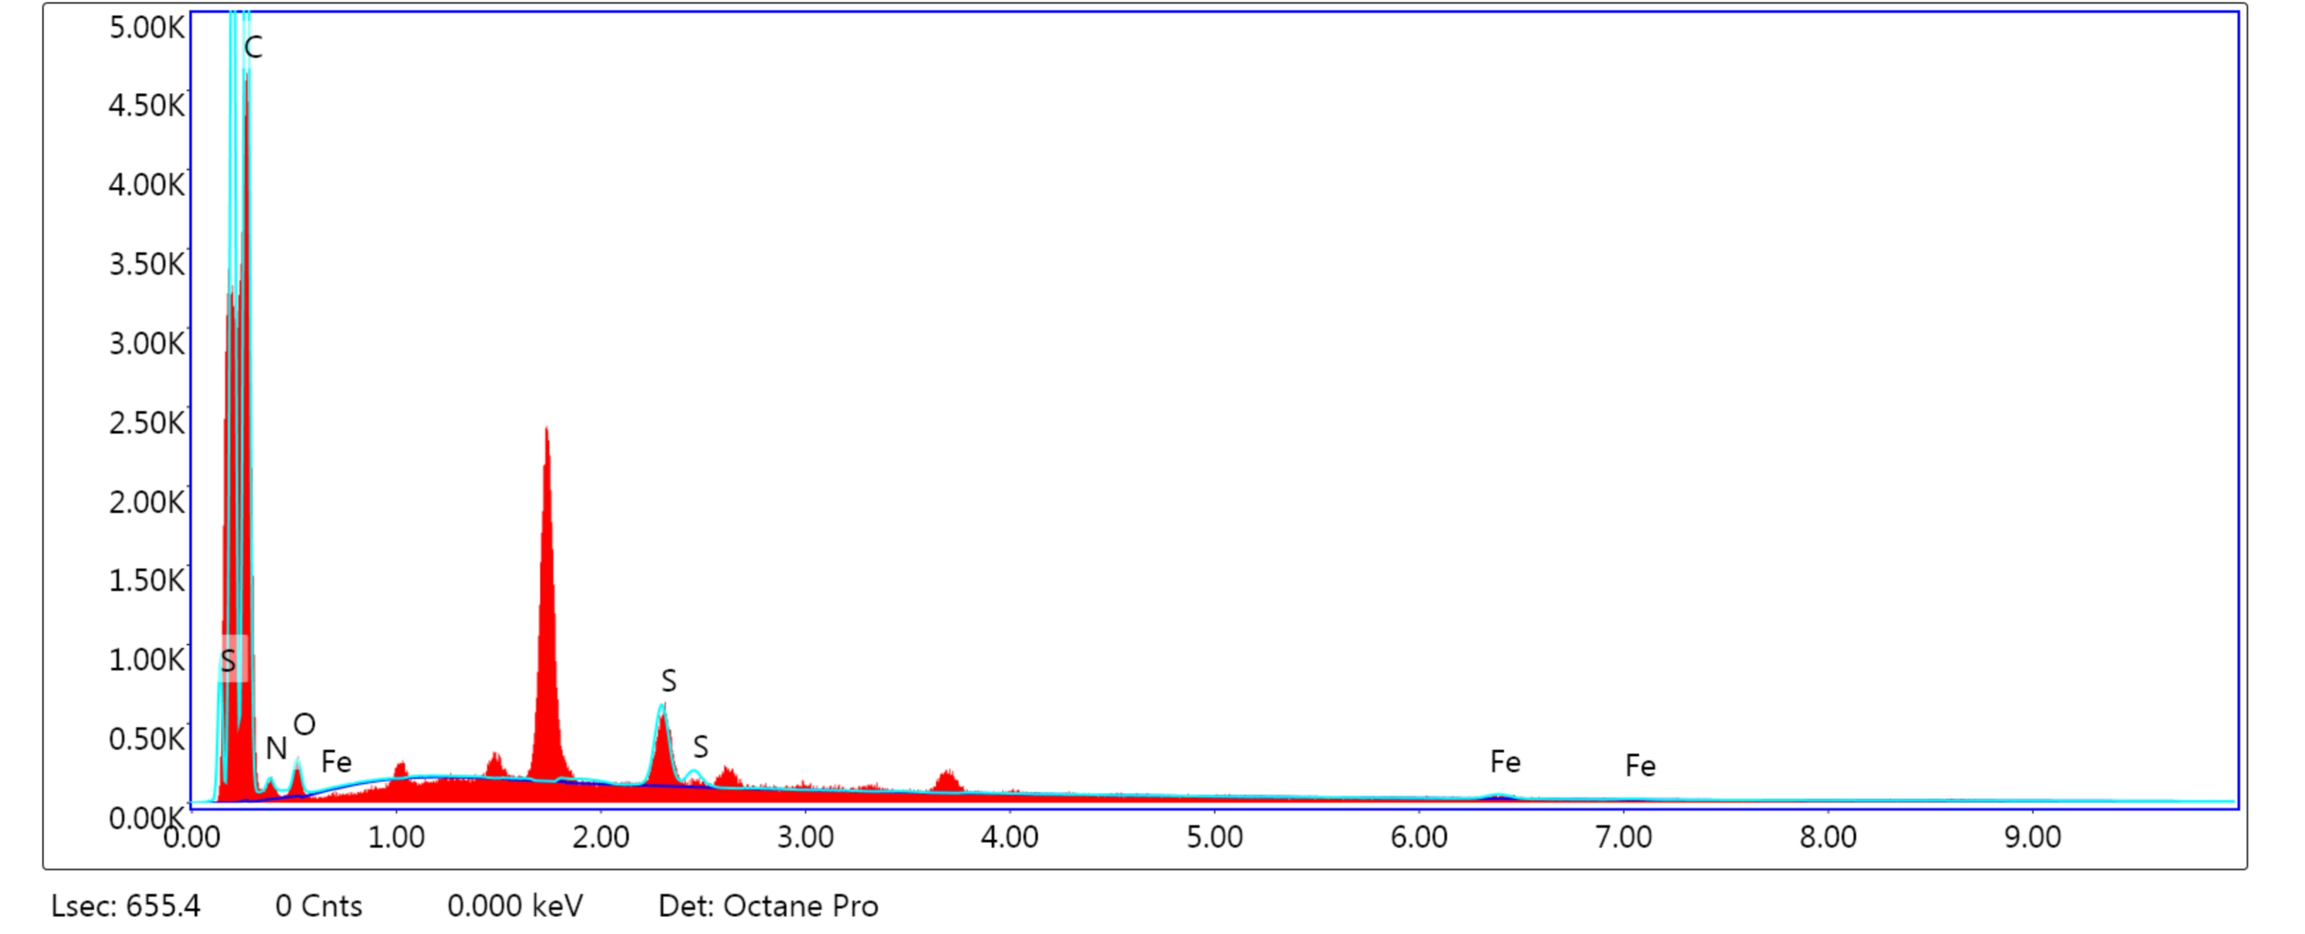
Figure S1. EDS analysis for Cyt.c/CNT electrode, EDS analysis shows the atomic percentage of C, N, O, S and Fe atoms in the electrode.

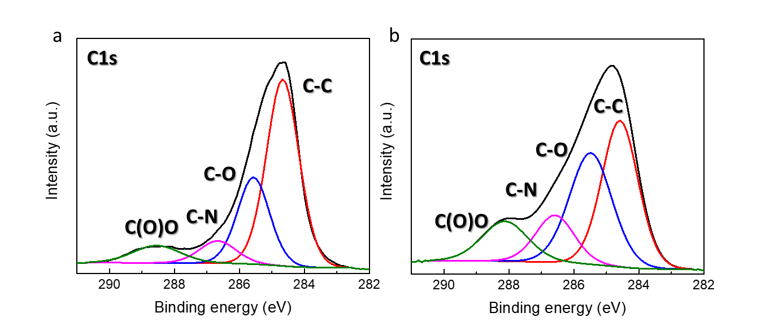
Figure S2. XPS spectrum of Cyt.c/CNT electrode after training: (a) C1s of before training, (b) C1s of after training.

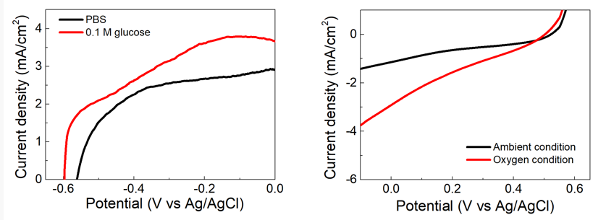
Figure S3. (a) Polarization curve of the anode in the PBS buffer solution not containing glucose (black line), in 0.1 M glucose concentration in PBS (red line). (b) Polarization curve of the cathode in ambient condition (black line), in oxygen condition (blue line),

