Temporal variability in air temperature lapse rates across the glacierized terrain of the Chandra basin, western Himalaya
Sunil N. Oulkar^{1,2}, Parmanand Sharma^{1*}, Sourav Laha¹, Bhanu Pratap¹ and Meloth Thamban¹
¹National Centre for Polar and Ocean Research, Ministry of Earth Sciences, Goa 403804, India.
²School of Earth, Ocean and Atmosphere Sciences, Goa University, Taleigao Plateau, Goa 403206, India.
*Corresponding Author: Parmanand Sharma (Emil Id: pnsharma@ncpor.res.in)
Supplementary information:
Catchment for temperature lapse rate estimation
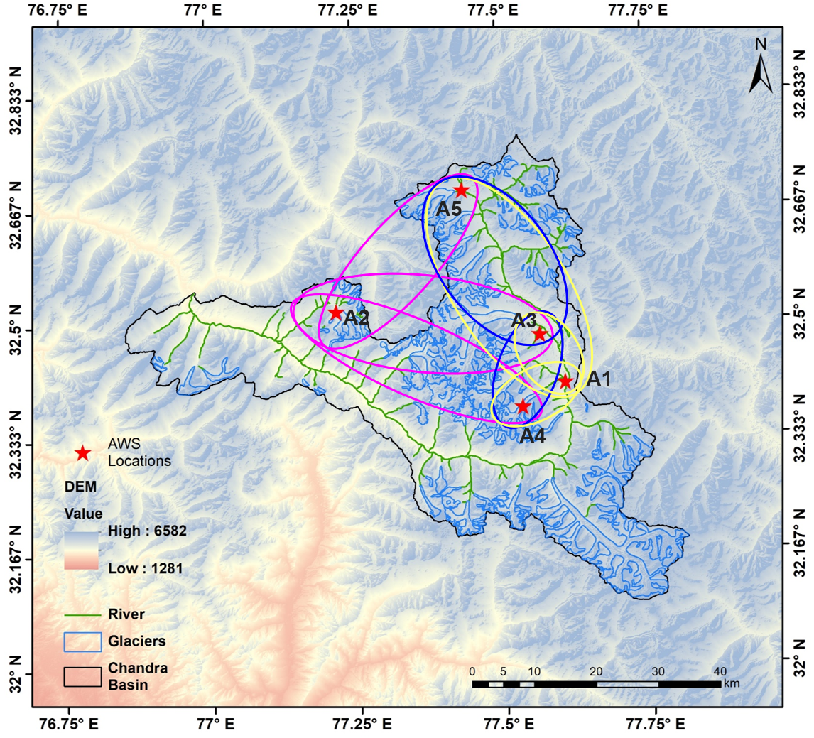
Fig. S1. The selected catchment for temperature lapse rate (TLR) (ºC km⁻¹) estimation. The AWSs pairs are A1-A3, A1-A4, A1-A5, A2-A3, A2-A4, A2-A5, A3-A4, and A3-A5.

Table S1. List of hydrometeorological variables measured at the AWSs sensors used in the study
Variables | Sensor Type | Measurement  Range | Accuracy
Air Temperature | Campbell HC2S3 | –50 ºC to 60 ºC | ±0.1 ºC
Relative Humidity | Campbell HC2S3 | 0-100% RH | ±0.8% RH
Wind Speed &  Wind Direction | RM Young Sensor 05103 | 0 to 100 ms⁻¹ | ±0.3 ms⁻¹&  ±3° Direction
Solar Radiation  (Incoming & Outgoing) | Kipp & Zonen CNR4 | 0 to 2000 Wm⁻² | ± 10%-day total
Longwave Radiation  (Incoming & Outgoing) | Kipp & Zonen CNR4 |  | ± 10%-day total

Table S2. Sesonal and annual mean of temperature lapse rate (TLR) (°C km⁻¹).
TLR | A1-A3 | A1-A4 | A1-A5 | A2-A3 | A2-A4 | A2-A5 | A3-A4 | A3-A5 | Mean
Summer | 5.8±0.2 | 4.6±0.1 | 5.7±0.1 | 0.9±0.3 | 2.2±0.1 | 3.7±0.1 | 3.1±0.2 | 5.6±0.2 | 4.4±0.2
Winter | 0.5±0.1 | -1.6±0.1 | 2.3±0.1 | 6.3±0.2 | 4.6±0.1 | 6.6±0.1 | 3.3±0.2 | 6.8±0.2 | 3.6±0.1
Annual | 1.6±0.3 | 2.4±0.2 | 3.9±0.2 | 3.7±0.6 | 4.2±0.3 | 5.5±0.2 | 3.3±0.5 | 6.4±0.4 | 3.8±0.3

Wind speed and direction
At A1 station wind direction flows from the south-southeast during the summer (Fig S2a). While during winter, the wind blows from the north-northeast, and indicates that there is a dominate downwind (Fig. S1, Fig. S2b).
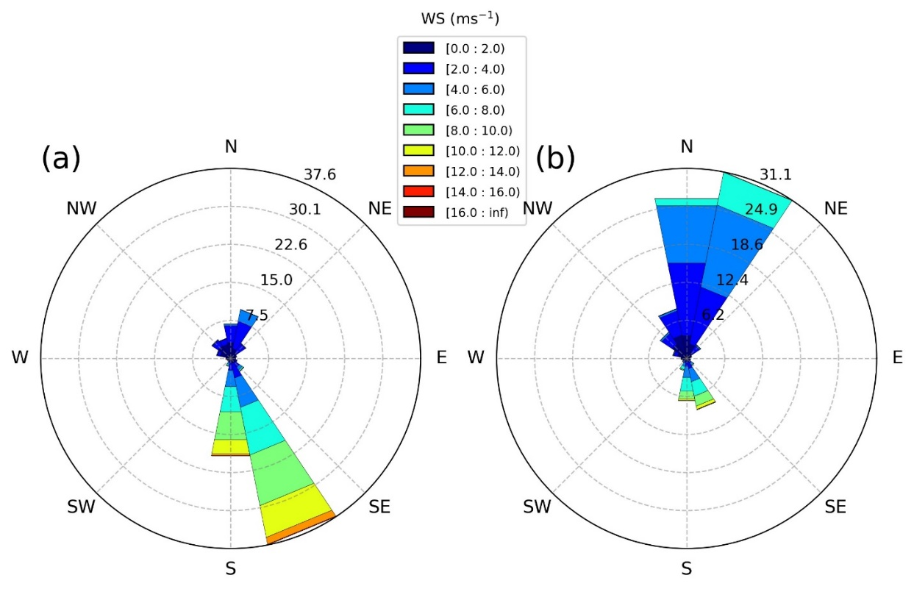
Fig. S2. Wind speed and directions at A1 AWS during a) summer and b) winter for study period from October 2020 to September 2022. The frequency of wind directions is expressed as percentage over the observational period (indicated on the radial axes).

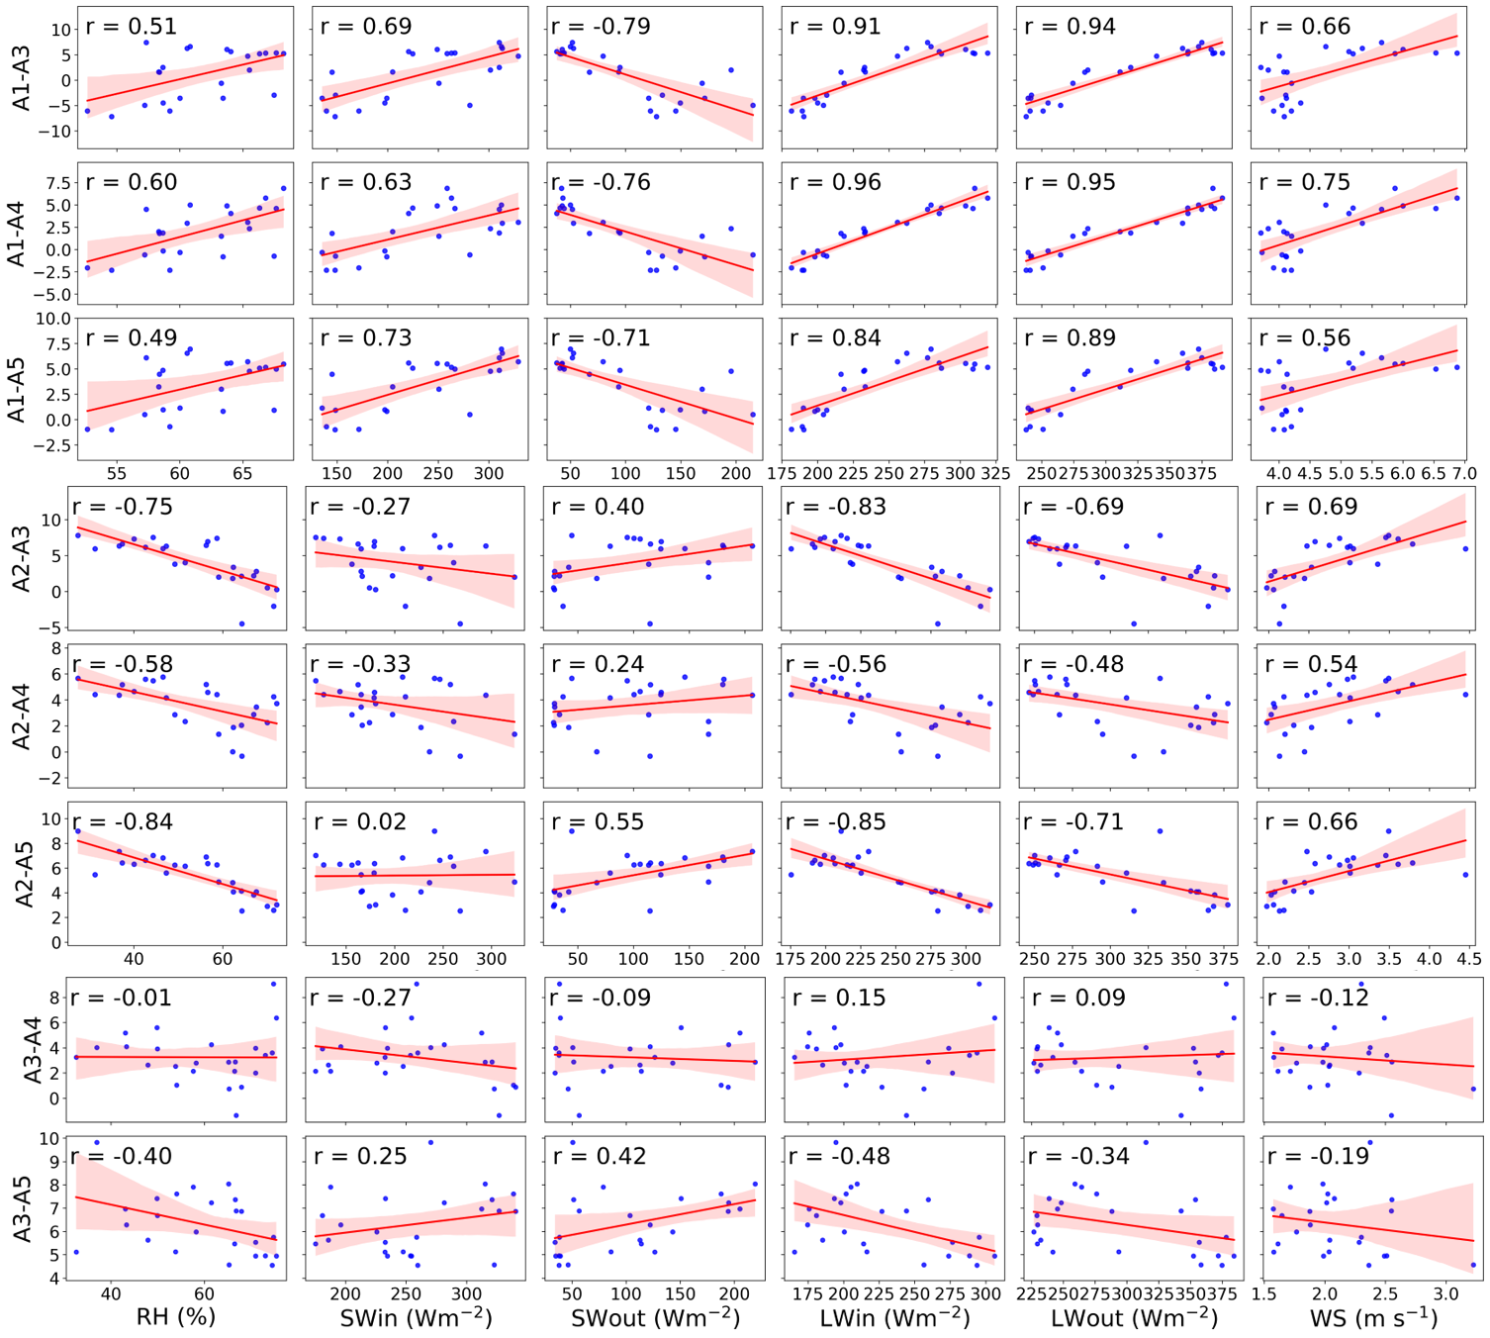
Fig. S3. Correlation between monthly mean temperature lapse rate (TLR) (ºC km⁻¹) and corresponding monthly mean meteorological parameters over the study period. The meteorological parameters are relative humidity (RH, %), incoming shortwave radiation (Sin, Wm⁻²), outgoing shortwave radiation (Sout, Wm⁻²), incoming longwave radiation (LWin, Wm⁻²), outgoing longwave radiation (LWout, Wm⁻²), and wind speed (WS, m s⁻¹).

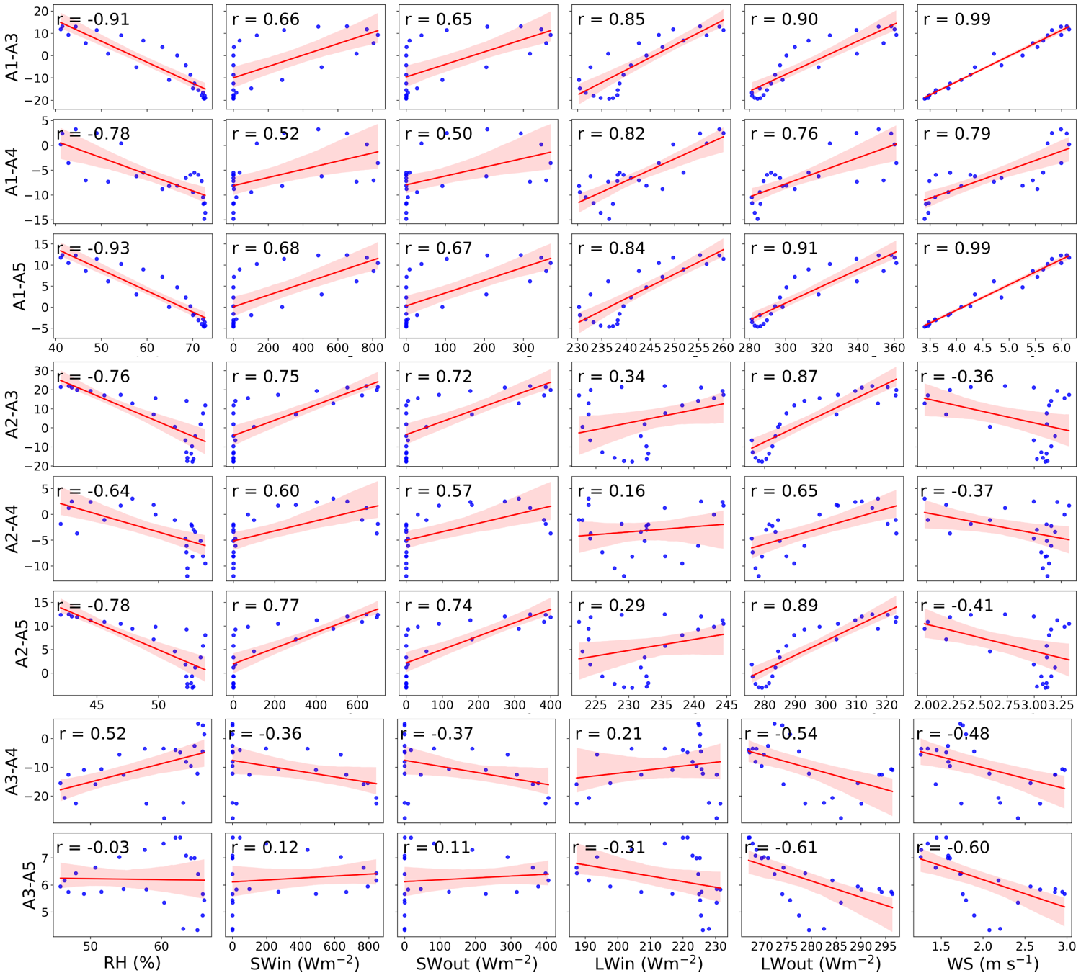
Fig. S4. Correlation between diurnal mean temperature lapse rate (TLR) (ºC km⁻¹) and corresponding diurnal mean meteorological parameters over the study period. The meteorological parameters are relative humidity (RH, %), incoming shortwave radiation (Sin, Wm⁻²), outgoing shortwave radiation (Sout, Wm⁻²), incoming longwave radiation (LWin, Wm⁻²), outgoing longwave radiation (LWout, Wm⁻²), and wind speed (WS, m s⁻¹).

Table S3: The glaciers mass balance studies in the Chandra basin using different methodologies.
MB Method | Region | Mass Balance  (m w.e. a⁻¹) | Year | Reference
Geodetic | Chandra basin | −0.47 ± 0.50 | 1989-2020 | Chandrasekharan and Ramsankaran (2023)
Energy balance | Sutri Dhaka | −0.82 ± 0.21 | 2015-2017 | Oulkar et al. (2022)
Energy balance | Eight glaciers | –0.59 ± 0.12 | 2013-2018 | Patel et al. (2021)
Glaciological | Five glaciers | −0.57 ± 0.12 | 2013-2017 | Sharma et al. (2020)
Glaciological | Chhota Shigri | −0.46 ± 0.40 | 2002-2019 | Mandal et al. (2020)
Geodetic | Chandra basin | −0.61 ± 0.46 | 1984-2012 | Tawde et al. (2017)
Geodetic | Chandra basin | −0.65 ± 0.43 | 2000-2012 | Vijay and Braun (2016)
Geodetic | Chandra basin | −0.68 ± 0.15 | 1999-2011 | Gardelle et al. (2013)

Reference
Chandrasekharan, A. and Ramsankaran, R., 2023. Reconstructing 32 years (1989-2020) of annual glacier surface mass balance in Chandra Basin, Western Himalayas, India. Regional Environmental Change, 23(4), doi:10.1007/s10113-023-02112-4.
Gardelle, J., Berthier, E., Arnaud, Y. and Kaab, A., 2013. Region-wide glacier mass balances over the Pamir-Karakoram-Himalaya during 1999-2011 (vol 7, pg 1263, 2013). Cryosphere, 7(6): 1885-1886, doi:10.5194/tc-7-1885-2013.
Mandal, A., Ramanathan, A., Azam, M.F., Angchuk, T., Soheb, M., Kumar, N., Pottakkal, J.G., Vatsal, S., Mishra, S. and Singh, V.B., 2020. Understanding the interrelationships among mass balance, meteorology, discharge and surface velocity on Chhota Shigri Glacier over 2002-2019 using in situ measurements. Journal of Glaciology, 66(259): 727-741, doi:10.1017/jog.2020.42.
Oulkar, S.N., Thamban, M., Sharma, P., Pratap, B., Singh, A.T., Patel, L.K., Pramanik, A. and Ravichandran, M., 2022. Energy fluxes, mass balance, and climate sensitivity of the Sutri Dhaka Glacier in the western Himalaya. Frontiers in Earth Science, 10, doi:10.3389/feart.2022.949735.
Patel, A., Goswami, A., Dharpure, J.K., Thamban, M., Sharma, P., Kulkarni, A.V. and Oulkar, S., 2021. Estimation of mass and energy balance of glaciers using a distributed energy balance model over the Chandra river basin (Western Himalaya). Hydrological Processes, doi:DOI: 10.1002/hyp.14058.
Sharma, P., Patel, L.K., Singh, A.T., Meloth, T. and Ravindra, R., 2020. Glacier response to climate in Arctic and Himalaya during last seventeen years: A case study of Svalbard, Arctic and Chandra Basin, Himalaya. In P. S. Goel, R. Ravindra, & S. Chattopadhyay (Eds.), Climate change and the white world (Springer): pp. 139–156.
Tawde, S.A., Kulkarni, A.V. and Bala, G., 2017. An estimate of glacier mass balance for the Chandra basin, western Himalaya, for the period 1984-2012. Annals of Glaciology, 58(75): 99-109, doi:10.1017/aog.2017.18.
Vijay, S. and Braun, M., 2016. Elevation Change Rates of Glaciers in the Lahaul-Spiti (Western Himalaya, India) during 2000-2012 and 2012-2013. Remote Sensing, 8(12), doi:10.3390/rs8121038.

