Immunohistochemistry
The working dilution of primary antibodys:
anti-NLRP3 Goat Polyclonal antibody (1:100, Servicebio, Wuhan, China), anti-PGC-1α Mouse Polyclonal antibody (1:100, Servicebio, Wuhan, China), anti-Occludin Mouse Polyclonal antibody (1:100, Servicebio, Wuhan, China), anti-ZO-1 Rabbit Polyclonal antibody (1:100, Servicebio, Wuhan, China)
The working dilution of secondary antibodys:
HRP-labeled rabbit anti-goat IgG (1:200, Servicebio, Wuhan, China) and either HRP-labeled goat anti-rabbit IgG (1:200, Servicebio, Wuhan, China) or HRP-labeled goat anti-mouse IgG (1:200, Servicebio, Wuhan, China)

Supplementary figures:
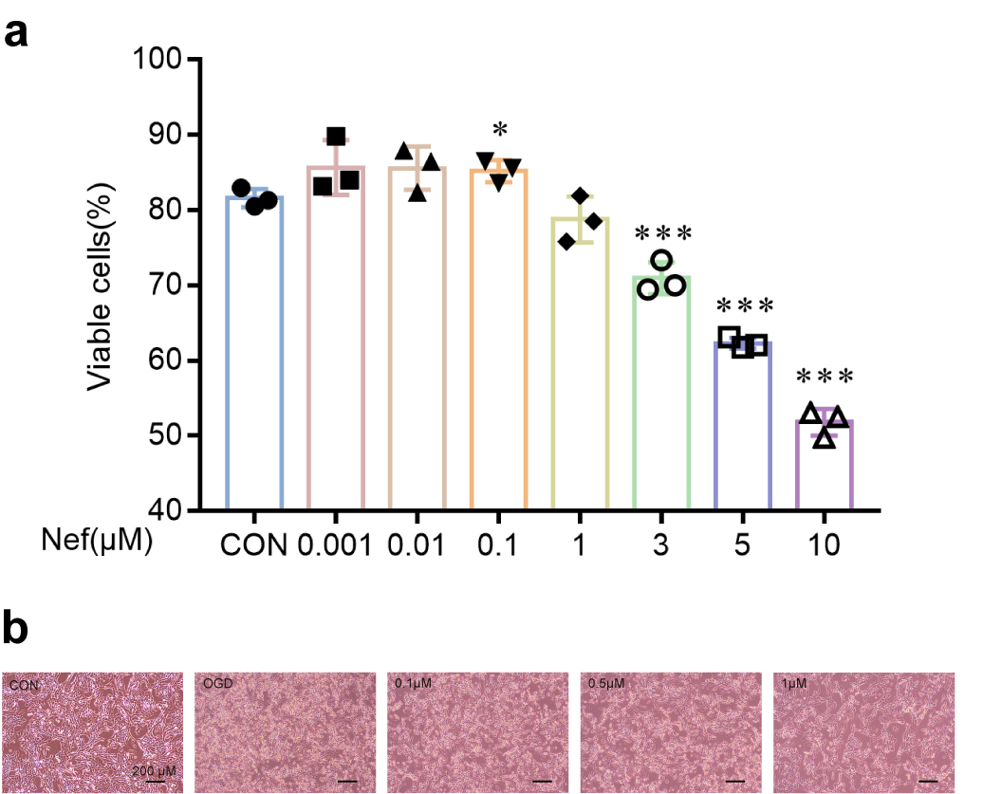
Figure S1：(A) The effect of Nef on the viability of bEnd.3 cells was revealed through the CCK8 assay, with a concentration range of 0.001μM to 10μM. (B) The cell viability was measured after 4–10 h of OGD by CCK8. (C) The morphology and growth status of cells in each group after 12 hours of reperfusion. ∗p < 0.05, ∗∗p < 0.01, ∗∗∗p < 0.001νs. Con, (n = 3).
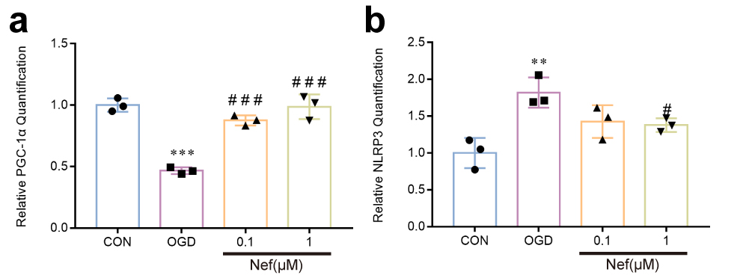
Figure S2：(A) The mRNA level of PGC-1α in each group. (B) The mRNA level of NLRP3 in each group. ∗p < 0.05, ∗∗p < 0.01, ∗∗∗p < 0.001νs. Con, #p < 0.05, ##p < 0.01, ###p < 0.001νs. OGD, (n = 3).

Original western blots
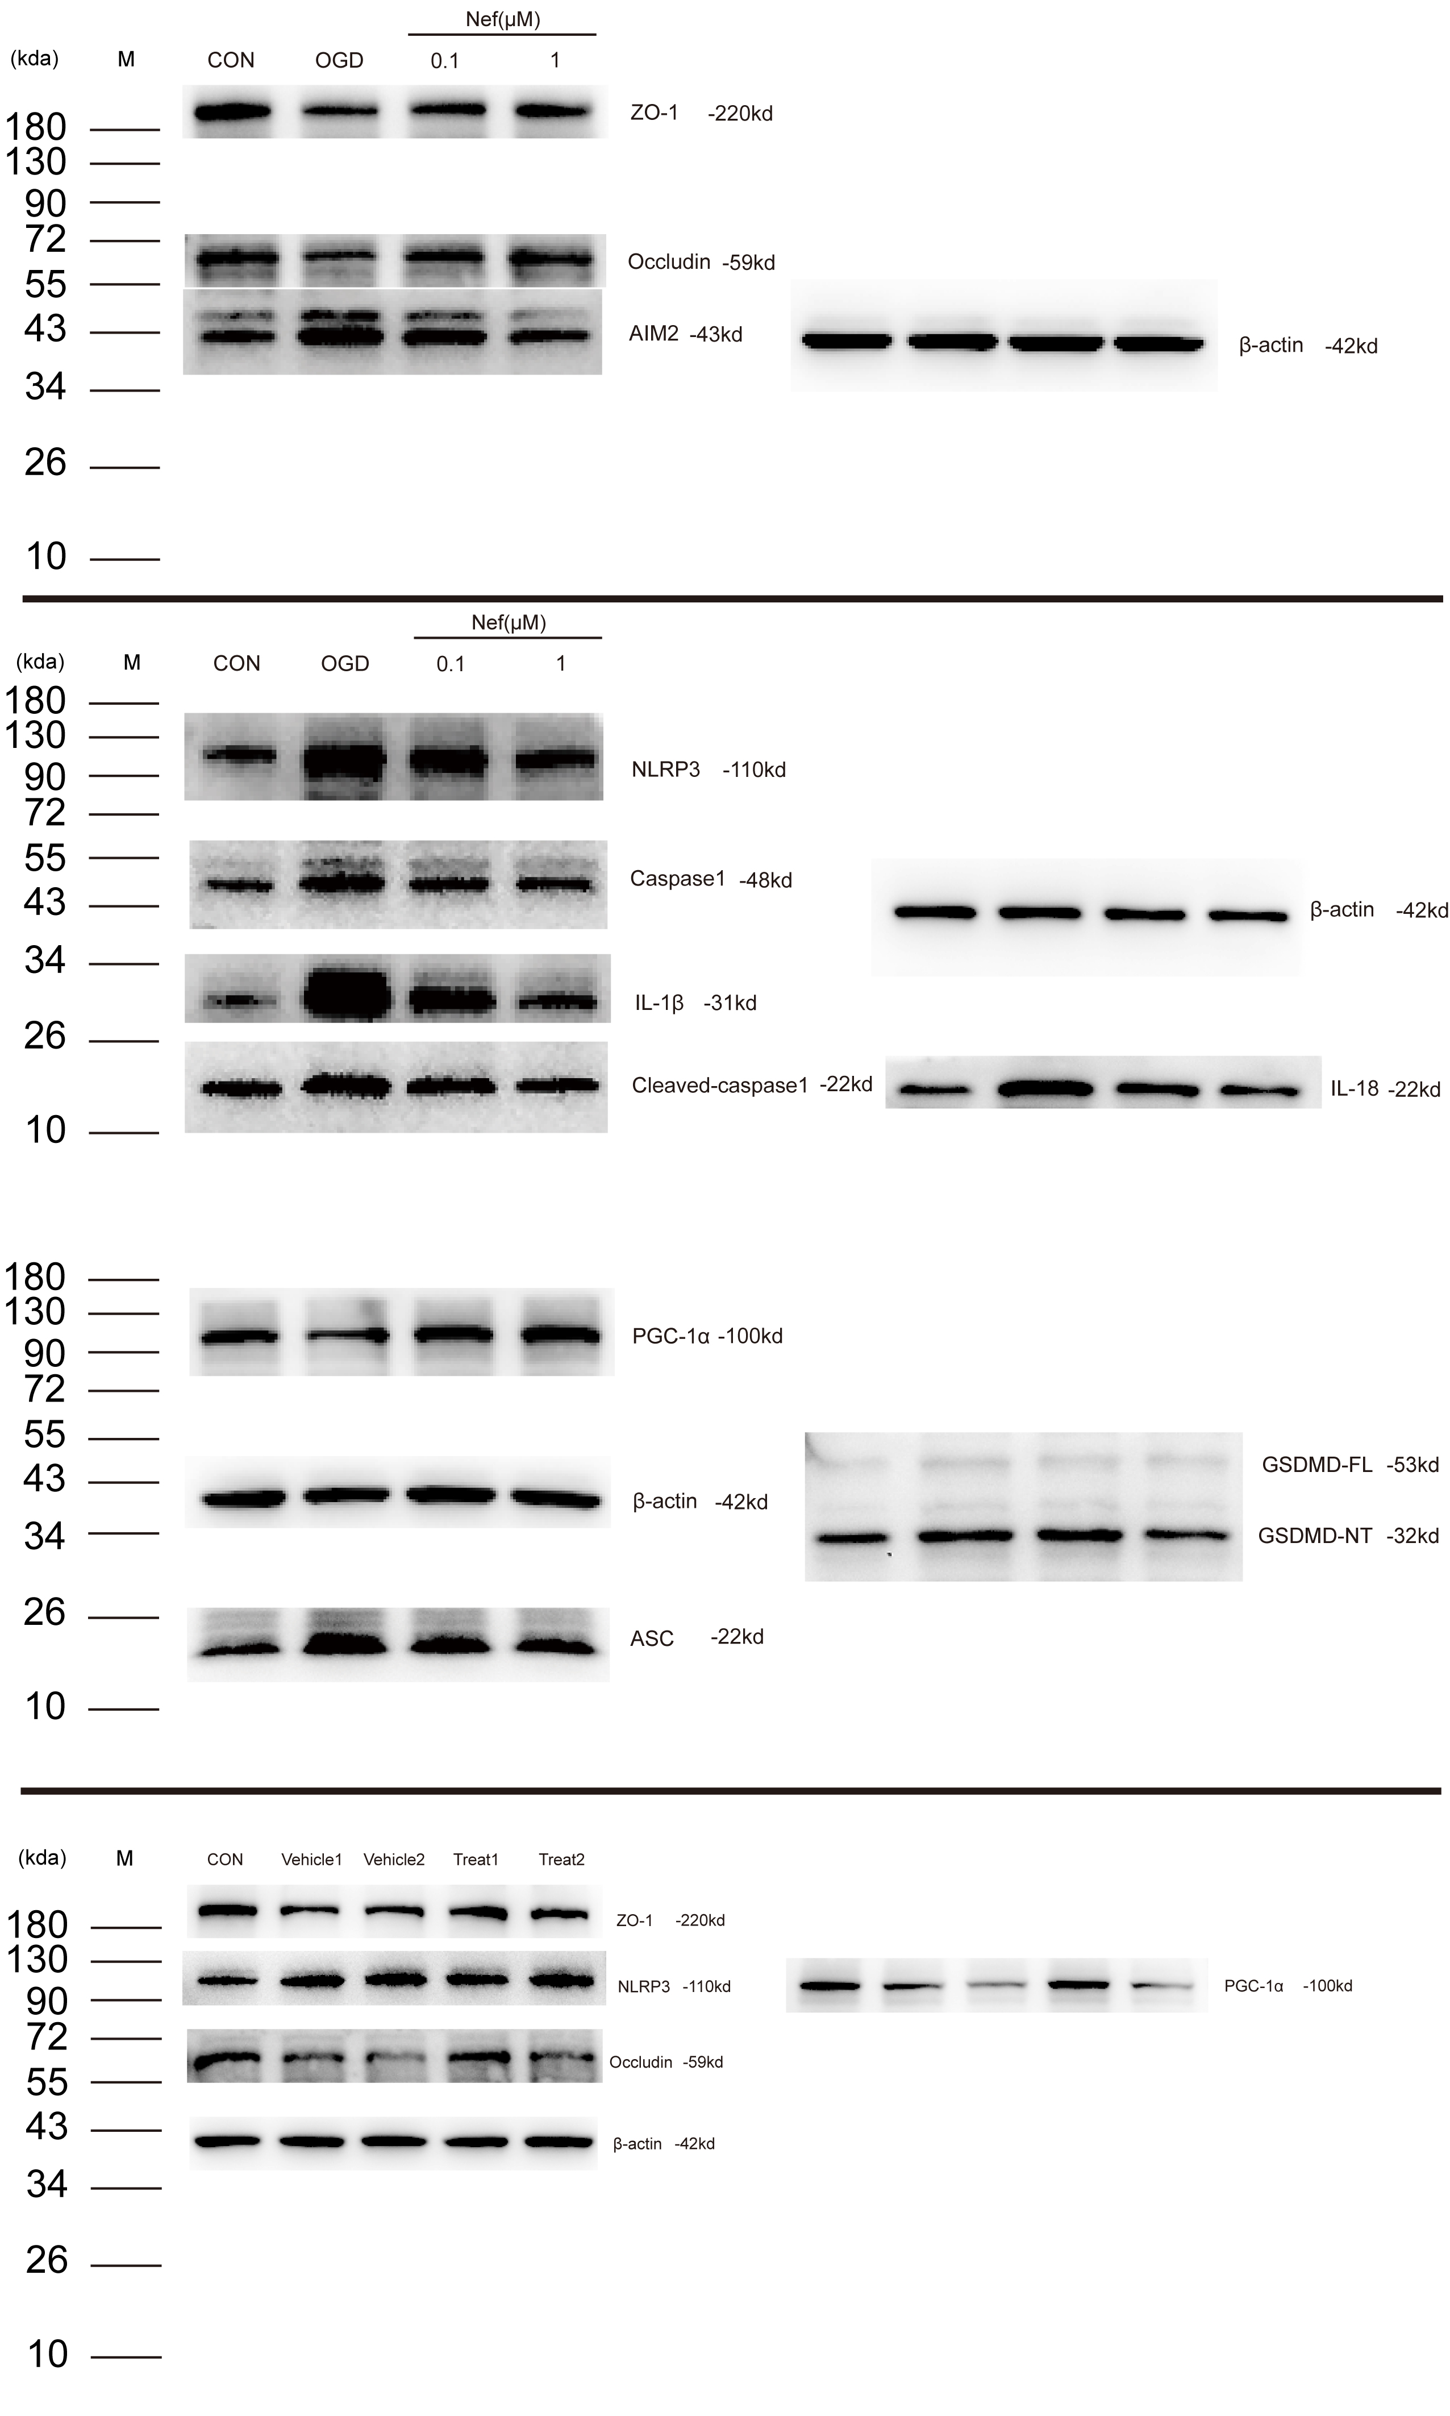
180
(kda) M CON OGD 0.1 1
Figure5-ZO-1，240kda
(kda) M CON OGD 0.1 1
55
72
72
(kda) M CON OGD 0.1 1
Figure5-Occludin 59kda
43
34
(kda) M CON OGD 0.1 1
Figure5-β-actin 42kda

110
90
(kda) M CON Veh1 Veh2 Tre1 Tre2
Figure6-NLRP3 110kda

72
55
(kda) M CON Veh1 Veh2 Tre1 Tre2
Figure6-Occludin 59kda

(kda) M CON Veh1 Veh2 Tre1 Tre2
90
130
Figure6-PGC-1α 100kda

180
(kda) M CON Veh1 Veh2 Tre1 Tre2
Figure6-ZO-1
34
43
(kda) M CON Veh1 Veh2 Tre1 Tre2
Figure6-β-actin 42kda

34
43
(kda) M CON OGD 0.1 1
Figure10-AIM2 43kda

26
17
(kda) M CON OGD 0.1 1
Figure10-ASC 22kda

26
43
34
55
34
(kda) M CON OGD 0.1 1
Figure10-GSDMD 53,32kda

26
17
(kda) M CON OGD 0.1 1
Figure10-Cleaved-caspase1 22kda

17
(kda) M CON OGD 0.1 1
26
34
26
(kda) M CON OGD 0.1 1
Figure10-IL-1β 31kda

(kda) M CON OGD 0.1 1
55
43
Figure10-Caspase1 48kda
130
90
(kda) M CON OGD 0.1 1
Figure10-PGC-1α 100kda

90
130
(kda) M CON OGD 0.1 1
Figure10-NLRP3 110kda

(kda) M CON OGD 0.1 1
43
34
Figure10-β-actin 42kda

